# **TASK No. – 01**

**Date:** 15-07-2024

**Team Members:** Nichenametla Yadhu Vamsi, Rashmi Singh, Chandan Kumar, Vishesh Chhaperwal, Kush Thakur, Ranga Sudharani, Khushi Prajapati

# **AD9650**

The AD9650 is a **high-performance** Analog-to-Digital Converter (ADC) designed by Analog Devices, known for its excellence in converting analog signals to digital data with precision and speed. Operating at sampling rates up to **125 MSPS** and offering **16-bit resolution**, the AD9650 excels in applications requiring high dynamic range and accuracy. It features a **wide input bandwidth** suitable for capturing signals across various frequency ranges, making it ideal for demanding applications in communications, radar systems, and scientific instrumentation.

With **low power consumption** and compact form factor, the AD9650 enables efficient integration into systems where space and power efficiency are critical considerations. Its reliability and capability make it a preferred choice in industries requiring robust signal conversion and **high-performance** digital data processing.

# Advanced Bipolar-CMOS-DMOS (BCD) Process

The AD9650 is manufactured using an **Advanced Bipolar-CMOS-DMOS (BCD)** technology. This process combines three types of transistors on a single chip:

* **Bipolar Transistors**: Provide high-speed switching and high linearity for analog signal processing.
* **CMOS Transistors**: Offer low power consumption for digital logic.
* **DMOS Transistors**: Used for high-voltage or high-current applications, though not directly used in AD9650, it is part of the BCD process.

**Benefits**:

* **Performance**: Combines the strengths of bipolar and CMOS technologies to achieve high speed and high resolution.
* **Integration**: Allows for the integration of high-speed analog and complex digital circuits on the same chip.

# High-Speed CMOS Technology

The **CMOS** technology used in AD9650 is optimized for high-speed digital circuits.

**Working:**

* Uses **Complementary Metal-Oxide-Semiconductor** technology to implement the digital logic components of the ADC.

**Advantages**:

* **Low Power Consumption**: CMOS technology ensures that the digital parts of the ADC consume minimal power.
* **High Integration Density**: Allows for the integration of complex digital circuits.

Analog Input | V Sample-and-Hold Circuit | V ADC Core (SAR or Pipeline SAR) | V Digital Output

# Analog Signal Processing Technologies

## Sample-and-Hold Circuit

The AD9650 features a **Sample-and-Hold Circuit** for capturing and stabilizing the input signal before conversion.

**Working**:

* Samples the analog input signal and holds it steady during the ADC conversion process.

**Advantages**:

* **Signal Integrity**: Ensures that the analog signal remains constant during the conversion phase, which is crucial for high-speed ADCs.

# APPLICATIONS:

## 1. KEYSIGHT 90000 X SERIES:

The Keysight 90000 X-Series oscilloscope is a high-performance test and measurement instrument designed for advanced electronic signal analysis. Here’s an overview of its capabilities, purpose, and typical applications:

### TYPICAL APPLICATIONS:

* **Telecommunications**: Used to analyse and verify the performance of communication systems operating at high frequencies, such as wireless networks, satellite communications, and radar systems.
* **Aerospace and Defense**: Critical for testing radar systems, electronic warfare systems, and avionics where high-frequency signal analysis and precise timing measurements are essential.
* **Semiconductor Testing**: Enables characterization and validation of high-speed digital circuits, including memory interfaces, microprocessors, and FPGA designs.
* **Research Institutions**: Widely used in universities and research laboratories for studying electromagnetic phenomena, antenna design, and advanced signal processing algorithms.

|  |  |  |
| --- | --- | --- |
| **Keysight 90000 X-Series Oscilloscope Requirement** | **Resolution Requirement** | **How AD9650 ADC Satisfies the Requirement** |
| **High Sampling Rate** | Up to 125 MSPS | AD9650 offers up to 125 MSPS, meeting high-speed signal capture needs for oscilloscope applications. |
| **Resolution** | Requires at least 8-bit resolution | Provides 16-bit resolution, ensuring accurate representation of analog signals with fine detail. |
| **Low Noise and Distortion** | Low noise figure and minimal distortion | Low noise figure of AD9650 preserves signal fidelity, crucial for precise measurements in oscilloscope. |
| **Integration with FPGA/DSP** | Compatibility with FPGA/DSP platforms | Compatible with FPGA/DSP platforms, facilitating real-time signal processing and advanced analysis capabilities. |
| **Suitability for High-Frequency Signals** | Requires sampling for high-frequency signals | Designed for high-frequency applications, supporting oscilloscope’s high-speed sampling rate up to 125 MSPS. |
| **Robust Performance in Challenging Environments** | Reliable operation in varying environmental conditions | Offers reliable performance across various environmental conditions, ensuring stable operation in demanding testing environments. |

## 2. 5G Base Stations:

5G base stations are integral to modern telecommunications, enabling ultra-fast, low-latency wireless services. They leverage high-frequency mmWave bands and advanced signal processing to enhance data rates and support numerous connected devices. Analog-to-Digital Converters (ADCs) are crucial in these stations, converting analog RF signals into digital data for precise signal manipulation and transmission. This ensures optimized network performance across diverse applications, from mobile broadband to critical IoT deployments, fostering seamless connectivity in today's digital landscape.

### APPLICATION:

* **Enhanced Mobile Broadband (eMBB):** 5G base stations deliver significantly faster data speeds and lower latency, enhancing user experience for streaming high-definition content, online gaming, and video conferencing on mobile devices.
* **Internet of Things (IoT) Connectivity:** They support the massive connectivity required for IoT devices, enabling smart city applications such as real-time traffic monitoring, smart grid management, and environmental monitoring systems.
* **Healthcare:** Facilitates telemedicine and remote surgery by enabling high-definition video conferencing and real-time data transmission of medical records and diagnostic images.
* **Augmented Reality (AR) and Virtual Reality (VR):** They support immersive AR/VR applications with seamless connectivity and high data throughput, offering realistic experiences in gaming, training, and remote collaboration scenarios.

The below table provides a comprehensive overview of how the AD9650 ADC meets the technical requirements of 5G base stations, including specific ranges for each requirement and how the ADC's capabilities align with these requirements:

|  |  |  |
| --- | --- | --- |
| **Requirement** | **Range in 5G Base Stations** | **How AD9650 ADC Solves the Requirement** |
| **Wide Frequency Range** | mmWave (24 GHz and higher) to sub-6 GHz | AD9650 supports a wide frequency range from DC up to GHz frequencies, suitable for mmWave and sub-6 GHz bands used in 5G communications. |
| **High Bandwidth Capability** | Up to 1 GHz or higher | Offers high bandwidth capabilities, suitable for digitizing signals with high data rates typical in 5G networks. |
| **High Dynamic Range** | 70 dB or higher | Provides high dynamic range (82 dBFS typical), ensuring accurate conversion of weak and strong signals, crucial for maintaining signal integrity. |
| **High Sampling Rate** | 1 GSPS (Giga Samples Per Second) or higher | Up to 125 MSPS sampling rate enables real-time processing of fast-changing signals characteristic of 5G communications. |
| **High Resolution** | 12 bits or higher | 16-bit resolution provides detailed signal representation necessary for decoding complex modulation schemes used in 5G systems. |
| **Low Power Consumption** | Less than 1 W per channel | Designed with low power consumption (710 mW at 125 MSPS), contributing to energy-efficient operation in base station equipment. |
| **Compact Size and Integration** | Miniaturized components for dense packing in equipment | Compact package size and integration capabilities allow for efficient integration into space-constrained 5G base station designs. |

## 3. Radar:

Radar systems rely on Analog-to-Digital Converters (ADCs) to convert incoming analog radio frequency (RF) signals, reflecting off objects, into digital data. This conversion is vital for precise detection, tracking, and analysis of targets in applications spanning military defense, weather monitoring, aviation, and automotive safety. ADCs used in radar systems must accurately capture high-frequency signals to discern minute variations in amplitude and phase, crucial for determining object distance, speed, and direction.

Modern ADCs offer high sampling rates, wide dynamic range, and high resolution, enhancing sensitivity and accuracy in radar signal processing. Their integration enables real-time data analysis, facilitating swift and informed decision-making in critical operational scenarios.

The below table shows an overview of how the AD9650 ADC meets the technical requirements of Radar:

|  |  |  |
| --- | --- | --- |
| **Specifications** | AD9650 | Radar |
| **Resolution** | 16 bits | 12-16 bits |
| **Sampling Rate** | 25 MSPS – 105 MSPS | 50 MSPS-4 GSPS |
| **Analog Supply Operation** | 1.8 V | Low voltage operation |
| **Signal Noise Ratio** | 82 dBFS at 30 MHz, 83 dBFS at 9.7 MHz | High SNR |
| **Power** | 119-328 mW | Low power (mW) |

## **4. (a) AD9650 in Medical Application**

**(Siemens Healthineers' SOMATOM go. CT scanners)**

Building on our core expertise in precision signal chains, our offerings for CT detector electronics are highly integrated, low noise, and low power, leading to lower dose, superior image quality, and easy-to-use solutions that reduce time to market. From discrete components and high channel count current-to-digital ASICs to fully integrated photons-to-digital modules, we have the portfolio to support low-cost and premium CT machines.

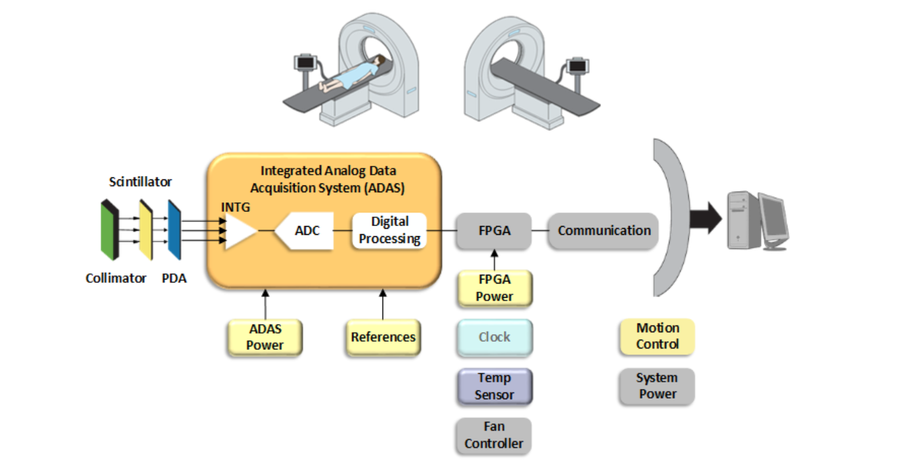Analog-to-Digital Converters (ADCs) play a crucial role in the operation of CT (Computed Tomography) scanners.

**X-ray Generation:**

* The X-ray tube generates a continuous or pulsed beam of X-rays that pass through the patient.

**Detection:**

* The detector array, which consists of multiple detector elements, captures the X-rays that emerge from the patient. Each detector element converts the received X-rays into an analog electrical signal proportional to the X-ray intensity.

**Analog-to-Digital Conversion:**

* The ADCs convert these analog signals from the detector elements into digital data. This involves sampling the signal at high speed and converting each sample into a digital value.

**Data Processing:**

* The digital data is transmitted to the CT scanner's computer system, where it is processed using image reconstruction algorithms to generate cross-sectional images of the patient's body.

**Image Display and Analysis:**

* The reconstructed images are displayed on a monitor for analysis by radiologists and other medical professionals. The high quality of the images, enabled by the precise conversion of analog signals to digital data, is critical for accurate diagnosis and treatment planning.

These ranges ensure that the ADCs used in SOMATOM go. CT scanners meet the stringent requirements for high-resolution, high-speed, low-noise signal conversion essential for producing detailed and accurate diagnostic images.

|  |  |  |
| --- | --- | --- |
| **Requirement** | **SOMATOM go. CT Scanners AD9650 ADC** | **Explanation** |
| **Resolution** | 16 bits | It requires 16-bit resolution for high precision in digitizing analog signals |
| **Sampling Rate** | Up to 125 MSPS | SOMATOM go. CT scanners typically require higher sampling rates, whereas the AD9650 offers up to 125 MSPS. |
| **Input Range** | ±2 V differential | It supports a wide input voltage range suitable for varying signal amplitudes in medical imaging. |
| **Dynamic Range** | Typical SNR around 76 dB | SOMATOM go. CT scanners aim for 70 dB to 100 dB or more, where AD9650 provides approximately 76 dB typical SNR |
| **Noise Performance** | Low noise performance | It requires low noise characteristics to ensure minimal artifacts in diagnostic images. |
| **Power Consumption** | Relatively low power consumption | SOMATOM go. CT scanners emphasize low power consumption to maintain operational stability and minimize heat generation. |

Specific models and configurations may vary depending on technological advancements and the specific design goals of the CT scanner system. For precise details on the ADCs integrated into SOMATOM go.

This comparison table outlines how the specifications of the AD9650 ADC align with the typical requirements for ADCs used in Siemens Healthineers' SOMATOM go.

CT scanners. Specific implementations may vary based on the exact model and version of the CT scanner, as well as specific application needs within medical imaging.

## **4.(b). AD9650 in MRI**

The AD9650 meets and often exceeds the typical requirements for ADCs used in 1.5T MRI scanners. Its high resolution, fast sampling rate, excellent SNR, and low power consumption make it a strong candidate for this application. The integrated features also simplify its implementation in complex MRI systems, ensuring high-quality imaging and efficient operation.

|  |  |  |
| --- | --- | --- |
| **Feature/Requirement** | **1.5T MRI Scanner Requirements** | **AD9650 Specifications** |
| **Resolution** | At least 14-bit resolution | 16-bit resolution |
| **Sampling Rate** | 40 to 100 MSPS | Up to 125 MSPS |
| **Signal-to-Noise Ratio (SNR)** | SNR above 70 dB | Approximately 77 dB |
| **Dynamic Range** | Wide dynamic range to capture varying signal strengths | High dynamic range suitable for various signal strengths |
| **Power Consumption** | Low power consumption to reduce heat and power demands | Low power consumption |
| **Data Throughput** | High data throughput to handle large volumes of data | High data throughput supported by high sampling rate |
| **Integration Features** | Easy integration with MRI system hardware and software | Integrated sample-and-hold circuit, flexible digital output interface |

1. **Signal Conversion**:
   * In an MRI machine, the radiofrequency (RF) coils detect signals emitted by hydrogen nuclei in the body's tissues. These signals are analog in nature and must be converted into digital form for further processing and imaging. The AD9650, with its high resolution and fast sampling rate, efficiently converts these analog signals into digital data.
2. **High-Resolution Imaging**:
   * The 16-bit resolution of the AD9650 allows for precise capture of signal variations, contributing to high-resolution images. This is critical in MRI where detailed images are needed to diagnose medical conditions accurately​.
3. **Noise Reduction**:
   * The AD9650's excellent signal-to-noise ratio (SNR) helps in minimizing noise and enhancing the quality of the digital signal. This leads to clearer and more accurate MRI images, which are essential for reliable diagnostics​.
4. **Efficient Data Processing**:
   * Once the signals are digitized by the AD9650, they can be processed by the MRI system's computer. The high sampling rate and wide input bandwidth of the AD9650 ensure that a large amount of data can be captured and processed quickly, improving the overall efficiency of the MRI machine​.
5. **Integration with MRI System**:
   * The AD9650's integrated features, such as the sample-and-hold circuit and flexible digital output interface, make it easier to integrate with the MRI system's existing hardware and software. This integration is crucial for seamless operation and high-quality imaging​.

By performing these functions, the AD9650 plays a vital role in ensuring that MRI machines produce high-quality images that are essential for accurate medical diagnostics and patient care.

## References:

AD9650: <https://www.analog.com/media/en/technical-documentation/data-sheets/ad9650.pdf>

5G Base Station: <https://www.mouser.com/pdfdocs/ADI-A105755.pdf>

Radar System: <https://www.analog.com/en/resources/technical-articles/select-the-best-adc-for-radar-phased-array-apps-part1.html#:~:text=Choosing%20the%20optimal%20ADC%20bit,footprint%20are%20also%20big%20factors>.

Keysight 90000 X-Series: <https://www.keysight.com/us/en/assets/7018-02436/data-sheets-archived/5990-5271.pdf>

Medical: <https://radiopaedia.org/articles/computed-tomography>