**Index:**

|  |  |
| --- | --- |
|  | Page # |
| 1. Executive Summary | 2 |
| 1. Product Requirement Document | *Work in Progress* |
| 1. Product Development Lifecycle | 4 |
| 1. Porter’s Five Forces | 7 |
| 1. Business Model | 8 |
| 1. Value Chain Assessment | 10 |
| 1. Value Proposition Canvas | 11 |
| 1. User Persona | 12 |
| 1. A/B Test | 13 |

**Executive Summary**

**Mission Statement**

The mission of The Neem Tree Candle Co. is to offer busy working professionals, stay- at- home individuals and caregivers a place to buy 100% natural, sustainable good-for-your-health bath soaps and luxurious looking soy candles that offer therapeutic/ medicinal and aroma therapy properties.

**Objective**:

The Neem Tree Candle Co.’s primary objective is to be an online source of organic and natural products that the customers can trust when finding solutions for health issues, for gifting options or for home decor. Our company focuses on using high quality ingredients and does not use any artificial fragrances in their products. This not only translates into ‘good for your health’ products, but also delivers on the mission of being an environmentally friendly brand providing sustainable products. Having started out with a brand that made paraffin wax candles with artificial fragrances and soaps with artificial fragrances, we have consciously moved away from this method and adopted a 100% holistic and natural approach by substituting all our materials with natural products. We use 100% biodegradable packaging, making this a truly sustainable brand. The introduction of this holistic concept company has helped achieve the following objectives:

* Satisfy the pressing need for aromatherapy and holistic products at a reasonable price that alleviate certain medical conditions for people.
* Provide luxurious candles that serve as home décor items, gifting options or just for personal use.
* Products are made of 100% biodegradable materials, making it an important player in the sustainable products world.

**Company Information:**

The Neem Tree Candle Co. is headed by Rashmi Deshpande who has an MS in Computer Engineering from UMass Lowell, and a **certification in Product Management from The Product School**. Drawing from her own experiences as a person dealing with health issues and going thru difficulties finding good quality aromatherapy soy candles at affordable prices to alleviate her headaches, Miss Rashmi came up with this online store that aims at providing high quality options to people who seek it.

**Products:**

1. Soy Wax Candles.
2. Soy Wax Candles with pure essential oils.
3. 100% natural soaps.
4. 100% natural soaps with essential oils.

**Growth Highlights:**

* Providing information on the 100% biodegradable packaging on the web site will attract and retain people who are conscious of living a healthy lifestyle that leaves a small carbon footprint.
* Spreading the word on social media about the brand, preparation- production information, increasing engagement with audience will get more traffic flowing to the website, which will translate into more conversion.
* Producing products with seasonal essential oils during relevant times of the year, including free samples of other products like wax melts, introducing a loyalty program will help deliver a more curated experience to the consumer.

**Conclusion:**

The Neem Tree Candle Co. is a brand that provides a holistic and beautiful experience to the customer thru their 100% homemade and natural products. In addition, we aim to provide people with existing health issues with products that give them therapeutic advantages.

**PRODUCT DEVELOPMENT LIFECYCLE**

|  |
| --- |
| **Understanding the trend:**   * Customers need to know about the product(s) existence. * Customers need variety in the soy candles: besides the existing cotton wick candles, customers also like wood wick candles.   **What do customers hate:**   * Customers hate that they might not get their money’s worth. * A big section of customers likes to shop on Amazon for the speed of delivery and hate waiting for the product to arrive after more than 2 days.   **Opportunity**:   * Develop the product website on Facebook and Instagram. Use personal Facebook account to actively market information about products, vlogs about the ‘behind the scenes’ creative process, solicit interaction with users. * Include free samples with the product: tea light candles, wax melts, sample size soaps. * Introduce wood wick candles to the existing collection. * Consider selling on Amazon. |

|  |
| --- |
| **Set Goal:**   * Get 5 new customers in the 1st month after launch. * Reach out to existing customers to inform them of the new improvements in the product, inquire about pain points, note them to come up with plans to solve them. * Get 100% of existing customers to interact and at least 50% to buy again. |

|  |
| --- |
| **Plan:**  **What needs to be built:**   * Wood wick soy candles, existing cotton wick soy candles with more natural scents, include seasonal essential oils. * Enhance product website on Etsy. * Link personal Facebook account to this Etsy account. * Add option to buy through Facebook.   **Dependencies:**   * Experimenting with wood wicks to come up with the most correct fit will take time, since raw material is available online. Look into local sources to buy raw material.   **Timeline: 04/01 – 05/10**   * Procurement of raw materials, developing product, creating marketing content while development, publishing on social media. |

|  |
| --- |
| **Develop/ Build:**   * 04/01/2022: Explore online options to buy wood wicks in 3 sizes: 4, 8, and 16 oz. Place order. Use existing inventory for cotton wicks and soaps, packaging. * 04/13/2022 – 04/30/2022: Develop product, test, make adjustments, repeat. Develop 10 Wood wick candles, 10 cotton wick candles, 15 soaps. * Video record the process of creation. Take product pictures. * 04/17/2022 – 04/30/2022: Edit video clips, pictures. |

|  |
| --- |
| **Launch:**  05/01/2022 – 05/05/2022: Publish new pictures and video content on Etsy website, publish links to this on Facebook.  05/05/2022: Interact with users, analyze comments, new customer interactions. Make notes of good/ bad comments on product. |

|  |
| --- |
| Assess & Learn:   * Prepare a spread sheet of product and user comments. * Analyze if something was missed, what can be improved. * Currently, packaging options remain as is since we have bought the material in wholesale. For future iterations, think about if product packaging/ label needs re-design. |

**PORTER’S FIVE FORCES**

|  |  |
| --- | --- |
| Threat of New Entrants | Very low entry barrier, excitement of products looking attractive to the customer, Improved products being offered. |
| Bargaining Power of Buyers | Plenty of good options, brand loyalty has no importance. |
| Threat of Substitute Products/ Services | Products copying our packaging, offering cheaper substitutes at lesser prices. |
| Bargaining Power of Suppliers | Existing market of suppliers is thriving with no dearth of buyers. |
| Rivalry among Existing Competitors | Better pricing, better packaging, better marketing, loyal customers. |

**BUSINESS MODEL**

|  |  |  |  |  |
| --- | --- | --- | --- | --- |
| *Key Partners*   * Online vendors for raw materials (soy, cotton wicks, wood wicks, essential oils) * Brick and mortar craft stores for containers * USPS, UPS * Online media: Etsy, Amazon * Credit card companies, PayPal, Apple Pay   *IT Infrastructure*   * 3G/4G mobile network * Wi-fi connection | *Key Activities*   * Development of product * Testing of product * Assembling and Packaging products * Etsy website maintenance * Mailing orders * Sending personal emails as notifications to customers, conveying tracking # * Checking in with customers about product satisfaction after 5 days of delivery. * Asking for reviews on social media if satisfied. * Pursuing case if customer is dissatisfied, making it right. * Monitoring for lower prices on material on the web. | *Value Proposition*   1. Development and testing at home bringing down the cost of production significantly. 2. Can afford to interact personally and give curated products to customers. | *Customer Relationship*   * Product website/blog/email * Social network * Telephone | *Customer Segments*   1. Men and women who like to live a clean healthy lifestyle and who like aromatherapy. 2. Professionals, single or married people who like to gift curated and beautiful art and other stuff. 3. Older people who like special products that bring calmness in their lives while alleviating certain medical conditions by using essential oil fragrances. |
| *Key Resources*   * Product development team * Social media marketing * Financing sources | *Channels*   * Social Media * Partner channels |
| *Cost Structure*   * Labor * Cloud service provider monthly fee * Freight, storage, distribution * Advertising and disclosure | | *Revenue Streams*   * Fee for additional curated services/ products, such as an essential oil composition in the product not offered. * Product sale. | | |

**VALUE CHAIN ASSESSMENT**

|  |  |
| --- | --- |
| Inbound Logistics | Inbound raw material ordered online depending on mailing services  Need to factor in lag between when material ordered and when it is delivered because of online availability. |
| Operations | Always seamless because of owning workspace. |
| Outbound Logistics | Calculating postage on individual orders.  Going to the post office to dispatch packages. |
| Marketing and Sales | Acknowledging order received from customer.  Sending info about dispatching orders.  Including a personalized hand-written note to thank the customer.  Providing tracking numbers.  Inquiring after 3-4 days via email about product satisfaction – taking appropriate steps if necessary if customer is dissatisfied.  Gently asking customer if they would leave a review on the website if they are satisfied.  Publishing link to good reviews on Facebook. |

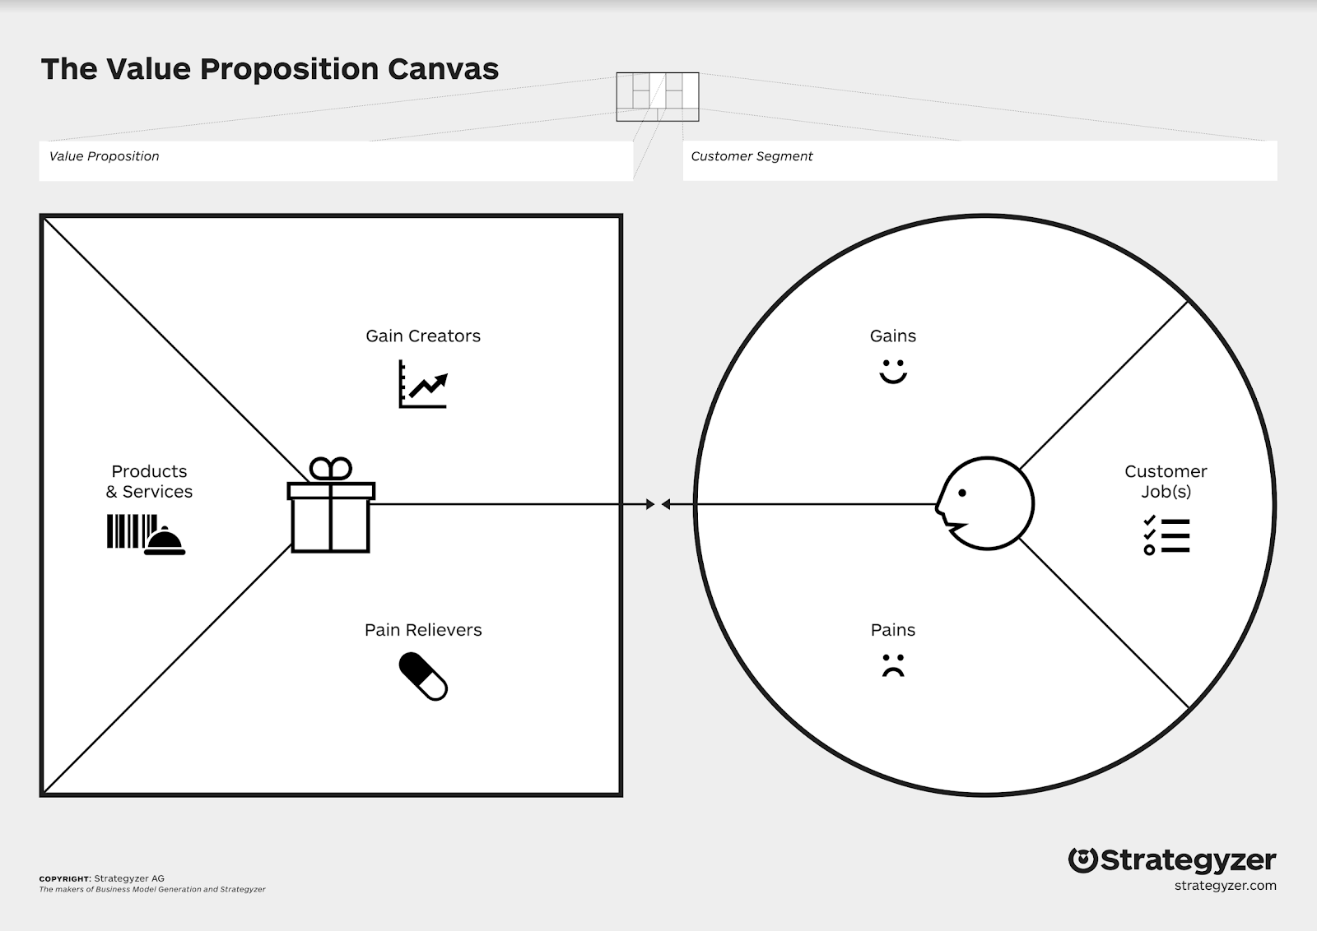

Benefits due to therapeutic & aromatherapy properties of products

Products and packaging are 100% natural and sustainable

Essential oils defusing medicinal scents

Unique gifting items.

Helps support a cleaner environment.

Make for a unique gift

Alleviating migraine headaches due to essential oil scents

Practicing aromatherapy

Using 100% clean and natural bath products.

Unique home décor items

Health issues due to chemicals in paraffin wax candles and commercial soaps.

Lack of personal customer support from commercial shops.

Personalized customer support available.

Luxurious looking candle

100% soy wax and natural soaps with essential oils and no artificial fragrances or colorants

Soy wax candles with pure essential oils

100% natural soaps with essential oils

**USER PERSONA**

**B2C**

|  |  |  |
| --- | --- | --- |
| 2,329,222 Businesswoman Stock Photos, Pictures &amp;amp; Royalty-Free Images -  iStock | **SALLY DESH**  Detail- oriented, perfectionist, loves challenges, loves aromatherapy, loves yoga.  **ABOUT**  Busy professional and mom 0f 2. Spends 50+hours working while managing 2 middle- school kids and a home with her husband. Loves to indulge in aesthetic products that bring calmness in her life and help her de-stress. Outside of work, she gravitates towards activities and things that provide comfort and balance out the hectic work life. | |
| “A Rolling stone gathers no moss”  **DEMOGRAPHIC DATA**  Age: *38*  Work: *Senior Software Engineer*  Civil Status:  *Married*  Location: *Framingham, Massachusetts*  Character: *Fearless.*  **FAVORITE BRANDS**    Is BareMinerals (Bare Escentuals) Cruelty-Free? | PETA | **GOALS**   * Find a high-quality pure soy wax candle with essential oils and no artificial fragrances or paraffin wax for aromatherapy and yoga sessions. * Find high quality hand soaps to eliminate using commercial bath soaps that have harmful chemicals. | **NEEDS**   * To explore and become a customer of soy candle and soap makers that sell on Etsy, since these products are tailored to the customer. * To adopt a healthy way of living by practicing yoga regularly, indulging in aromatherapy, eliminating toxins from her daily lifestyle and eating healthy. |
| **PAIN POINTS**   * Experiencing health issues because of using misleading ‘100% natural‘ labeled products. * Unable to decide on buying a new product because of uncertainty on quality/ price. * Uncertain about customer service on Etsy, about not being delivered what is promised. * Spending unnecessarily on shipping charges when Amazon can deliver for free. | **PREFERRED CHANNELS**   * Traditional Ads: 25% * Social Media: 40% * Referral: 25% * Guerilla Marketing: 10% |

**A/B Test for the storefront page for ‘The Neem Tree Candle Co. on Etsy.**

**The Goal**: The Neem Tree Candle Co wanted to resolve the issue of less traffic on the site and optimize its homepage for clicks and conversions.

Hypothesis:

***Adding a ‘free shipping’ option will help drive more traffic to the product site and increase add-to-cart events by 10%.***

The first version had all the listings and info, but no ‘free shipping’ options.

**Observations:** Making use of the performance metrics provided by Etsy, the following were key metrics observed:

# of Visits, # of ‘Added to Cart’ actions, Conversion rate.

The site was then tested after providing ‘free shipping over $35’ options and then reviewing the same metrics.

**Conclusion:** It was found that there was a 250% increase in the # of visits, a 20% increase in the Number of ‘Added to Cart’ actions, and a 5% increase in conversions.