

**Frankfurt University Of Applied Sciences**

**Masters of Information Technology**

**Software Engineering Project Report**

**on**

**Implementation of a simple solution for**

**Image Recognition on Accord Framework using**

**Deep Belief Network**

**Under the guidance of Mr. Damir Dobric**

**Presented By,**

**Chennenahalli NarasimhaMurthy Rashmi.**

**Frankfurt University of Applied Sciences**

Faculty of Computer Science and Engineering  
Nibelungenplatz 1  
60318 Frankfurt am Main  
**Germany**

**Contents**:

1. **Overview**
2. **Scope of The Project**
3. **Project Description**
4. **Implementation**
5. **Results**
6. **Conclusion**
7. **References**
8. **Overview**
   1. **Introduction:**

**Machine learning** is a method of automated detection of meaningful patterns in data. A statistical machine learning operates with a table of data and a prediction goal. The rows of the table correspond to independent observations and the columns correspond to hand crafted features of the underlying data set. Then a variety of machine learning algorithms can be applied to learn a model that maps each data row to a prediction. More importantly, the trained model will also make good predictions for unseen test data that is drawn from a similar distribution as the training data. Figure 1 illustrates this process. There are two types of Learning.

* + 1. **Supervised Learning**

Supervised learning algorithms are “trained” using labeled examples where the desired output is known. Supervised learning is commonly used in applications that use historical data to predict likely future events. The learning algorithm receives a set of inputs along with the corresponding correct outputs, and the algorithm learns by comparing its actual output with the correct outputs so it can find errors and modify the model accordingly. The inputs are called features in machine learning.

* + 1. **Unsupervised Learning**

Unsupervised learning is where you only have input data (X) and no corresponding output variables. The goal for unsupervised learning is to model the underlying structure or distribution in the data in order to learn more about the data. There is no distinction between training and test data. The learner processes input data with the goal of coming up with some summary, or compressed version of that data. Clustering a data set into subsets of similar objects is a typical example.

1. **Scope of the Project** 
   1. **To Develop a bit array dataset to feed the network as a training dataset and testing dataset**

The project reads each images in the folder and converts each images into gray images. Each converted gray image is again converted into binary bit array format and is written to a text file.

* 1. **To develop a solution using C# to train the network to recognize simple images**

The Training dataset bit array file is fed into a Deep belief network to make the network learn and memorize the images from the training data set

The Testing dataset bit array file is fed into the Deep belief network to test the algorithm

1. **Project Description**
   1. **Accord Framework**

The Accord.NET Framework is both a C# machine learning framework and a complete framework for building computer vision, computer audition, signal processing and statistical applications.

The framework comprises a set of libraries that are available in source code as well as via executable installers and NuGet packages. The main areas covered include numerical linear algebra, numerical optimization, statistics, machine learning, artificial neural networks, signal and image processing, and support libraries (such as graph plotting and visualization)

* 1. **Neural Network**

Neural networks are modeled similar to human brain’s biological neural networks. [13] In the same manner as central nervous systems, neural network consists of an interconnected group of nodes (neurons). Each node receives inputs from other nodes and the weights between nodes adapt so that the whole network learns to perform useful computations. There are several types of neural networks structures with corresponding learning algorithms.

* 1. **Deep Belief Network**

it is multi-layer belief networks. Each layer is Restricted Boltzmann Machine and they are stacked each other to construct DBN. The first step of training DBN is to learn a layer of features from the visible units, using Contrastive Divergence (CD) algorithm. Then, the next step is to treat the activations of previously trained features as visible unites and learn features of features in a second hidden layer. Finally, the whole DBN is trained when the learning for the final hidden layer is achieved.

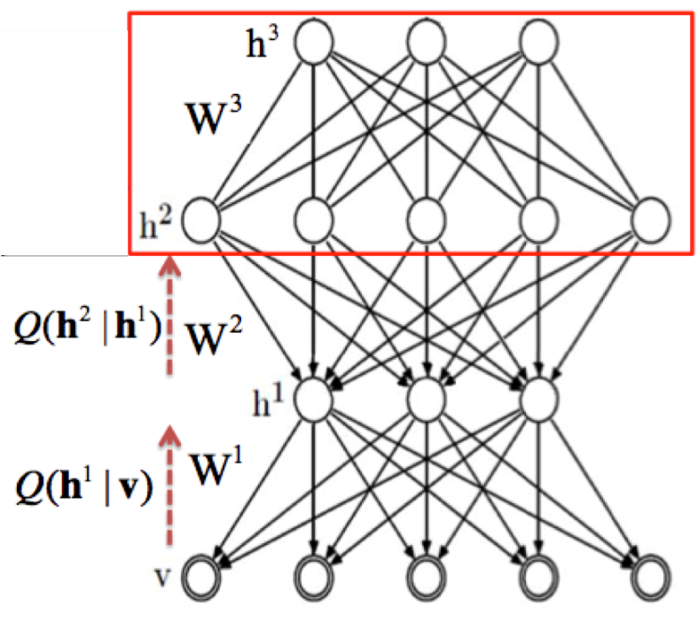

This simple greedy learning algorithm works for training DBN. This is because that training RBM using CD algorithm for each layer looks for the local optimum and the next stacked RBM layer takes those optimally trained values and again look for the local optimum. At the end of this procedure, it is likely to get the global optimum as each layer consistently trained to get the optimum value.

1. **Implementation**

Implementation of Image Recognition using Deep Belief Network on Accord framework is carried out using two steps

* 1. **Training**

The Network is trained using large set of simple data, The bit array data which is created from converting the image data is fed into the Deep Belief network with hidden layers to train the network about the image.

* 1. **Testing**

The project takes care of testing the algorithm with positive scenario and negative scenario testing

1. **Results**
   1. **Training Results**

The training Result is shown on the console screen which indicates two types of the training results

Supervised learning result is as show below:

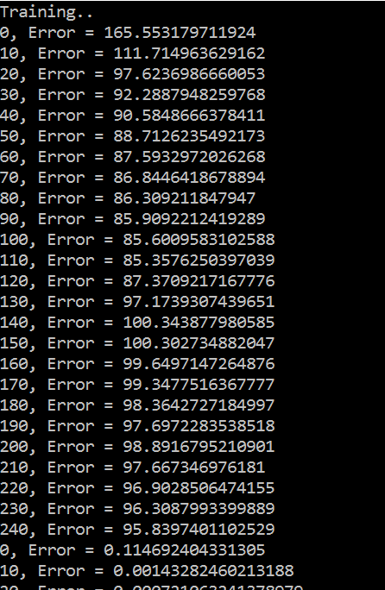

Unsupervised result is show as seen below:

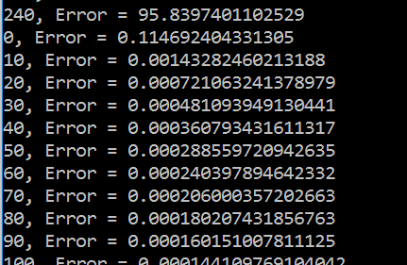

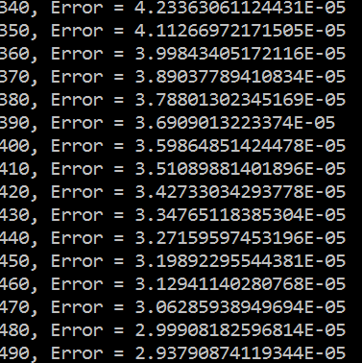

* 1. **Testing Results**

Result of Positive scenario testing is shown as seen below:



Result of Negative scenario testing is shown as seen below:



* 1. **Unit Testing**

Unit Testing is conducted to test for

* Creation of Bit Array file
* Positive Scenario Testing
* Negative Scenario Testing

1. **Conclution**

Successfully Implemented a solution to test Deep Belief Network for Image recognition on Accord Framework using C# code.

1. **References**
   * + 1. Arel, I., Rose, D. C. and Karnowski, T. P. (2010).Deep Machine Learning - A New Frontier in Artificial Intelligence Research. Computational Intelligence Magazine, IEEE: Vol. 5, pp. 13-18.
       2. Bengio, Y. (2009). Learning Deep Architectures for AI, Foundations and Trends in Machine Learning: Vol. 2: No. 1, pp. 1–127.
       3. Fernández-Redondo, M., Hernández-Espinosa, C. (2001). Weight Initialization Methods for Multilayer Feedforward. European Symposium on Artificial Neural Networks.pp. 119-124.
       4. Hinton G. E. (2007). Learning multiple layers of representation. Trends in Cognitive Sciences: Vol. 11, No. 10, pp. 428-434.
       5. Hinton, G. E. (2007). To recognize shapes, first learn to generate images. Computational Neuroscience: Theoretical Insights into Brain Function. Elsevier.
       6. Hinton, G. E. (2010). A Practical Guide to Training Restricted Boltzmann Machines.Department of Computer Science; University of Toronto.
       7. Hinton, G. E., Osindero, S. and Teh, Y. (2006). A fast learning algorithm for deep belief nets.Neural Computation, 18.
       8. Mohamed, A., Dahl, G. and Hinton G. E. (2009). Deep Belief Networks for phone recognition. Department of Computer Science; University of Toronto.
       9. Neural Networks for Machine Learning online course. Coursera online courses.www.coursera.org/course/neuralnets
       10. Deep Learning website. www.deeplearning.net
       11. Pattern Recognition and Machine Learning (2006). Christopher M.