Rsahmi Dhaduti
1BM18CS080

(A) Code

#include <stdio.h>
#include <unistd.h>
#include <fcntl.h>
#include <stdlib.h>
int main(int argc, char *argv[])
{
int f1, f2;
char buff[50];
long int n;
if(((f1 = open(argv[1], O_RDONLY)) == -1 || ((f2=open(argv[2], O_CREAT | O_WRONLY | O_TRUNC,
0700))== 1)))
{
perror("problem in file");
exit(1);
}
while((n=read(f1, buff, 50))>0)
if(write(f2, buff, n)!=n)
{
perror("problem in writing");
exit(3);
}
if(n==-1)
{
perror("problem in reading");
exit(2);
}
close(f2);
exit(0);
}

Output

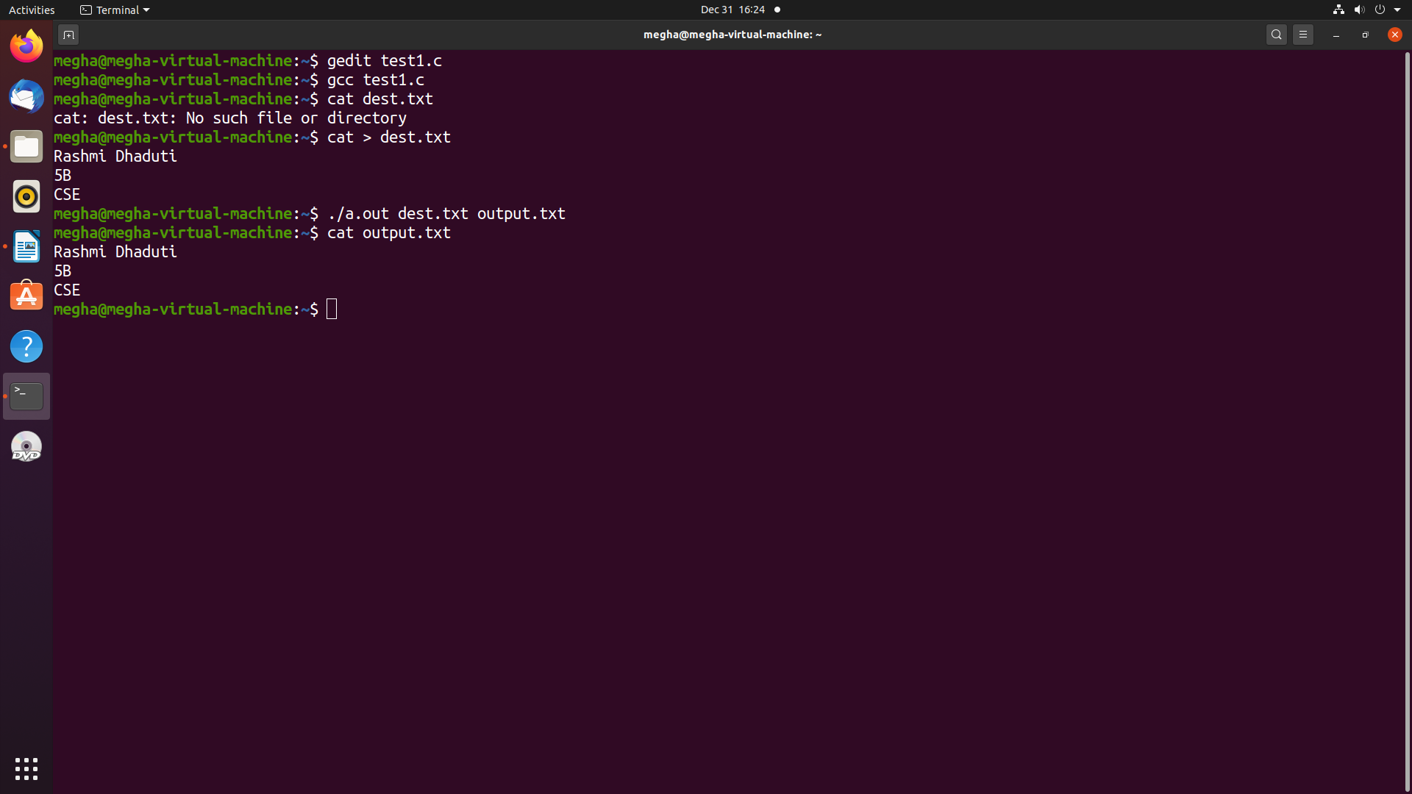

(B) Code

if [ $# -ne 2 ]
then
echo "Enter 2 filenames"
exit 1
fi
sort $1 > temp
sort $2 > temp1
sort -m temp temp1
rm temp temp1

Output

