**Prediction of Credit Risk Using South German Bank**

**Wireframe Documentation**

Table of Content

1. Home Page 3
2. Result page 4
3. Data Report Page 5

# Home Page

We have decided to create design of Prediction of Credit Risk Using South German Bank Data project front page in such way that user can insert their value to their requirement in flexible Manner.

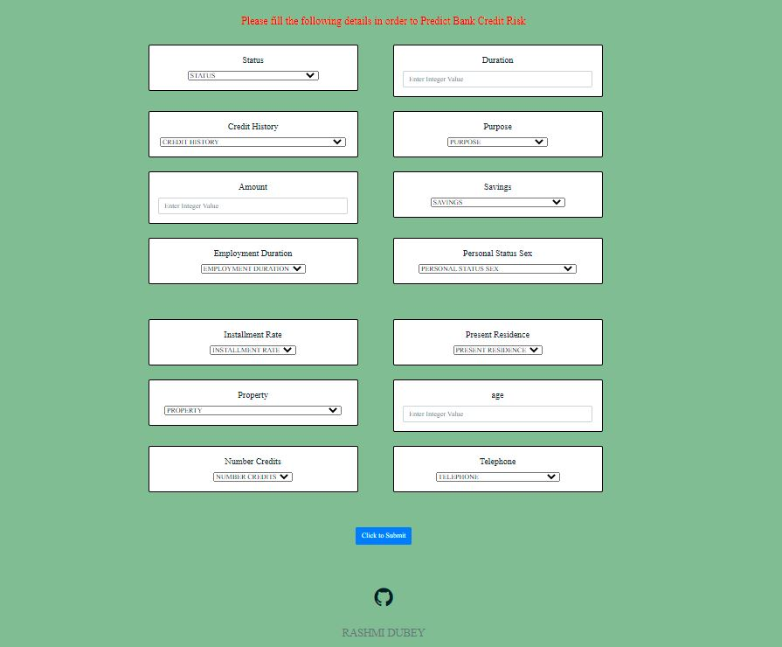

**Figure: - Front Page of Project**

# Result Page

# 

**Figure: - Result Page of Project**

# Data Report Page

We have created the API for the Data Report. So when the user hit the report API the user can get to direct to the report API page which is shown below.

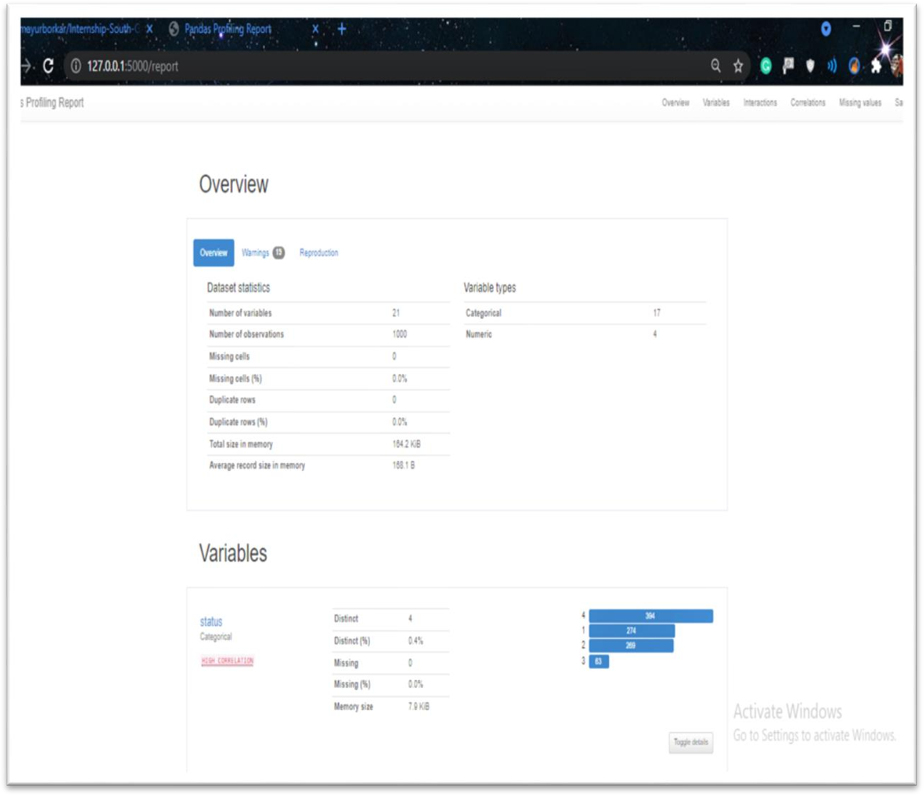

**Figure: - Report Page**