* Dell EMC openmanage to connect and manage DELL hardware :
* git clone -b devel --single-branch https://github.com/dell/dellemc-openmanage-ansible-modules.git
* cd dellemc-openmanage-ansible-modules
* python install.py

- name: Boot to Network ISO  
 dellemc_idrac_boot_to_nw_iso:  
 idrac_ip: "192.168.1.1"  
 idrac_user: "root"  
 idrac_pwd: "calvin"  
 share_name: "\\192.168.10.10\share"  
 share_user: "user1"  
 share_pwd: "password"  
 share_mnt: "/mnt/share"  
 iso_image: "uninterrupted_os_installation_image.iso"

Challenge and need more R $ D : OS installation seems achievable through Dell openmanage Ansible modules . However , how to place IP to establish ssh connection to perform network task and henceforth other task . for this pxe kickstart is required .

* ESxi configuration setting :

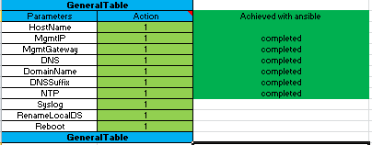

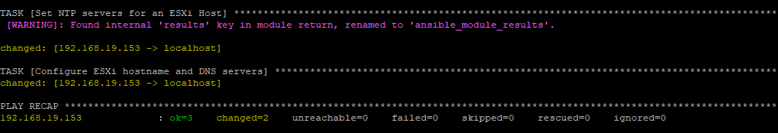

* Vswitch – portgroup and Vmkernel NIC creation :

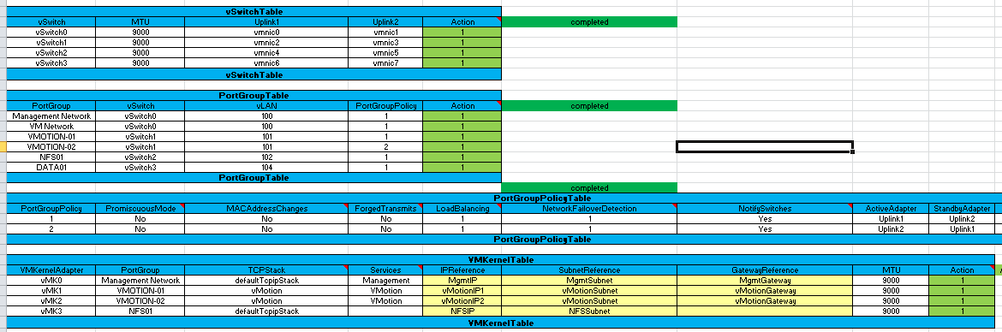



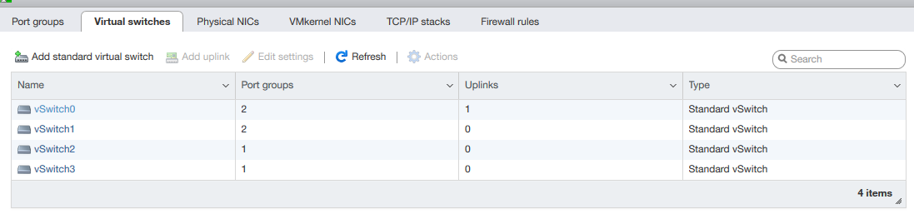

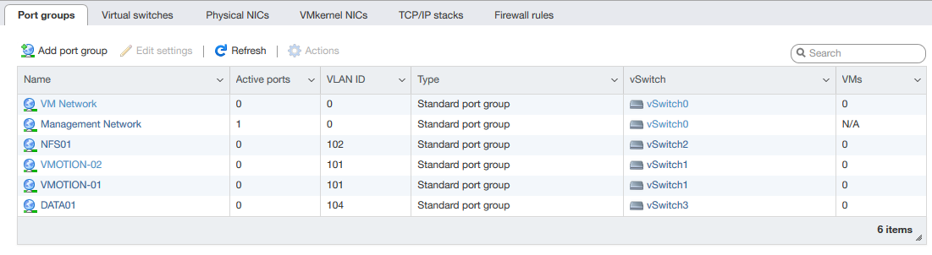

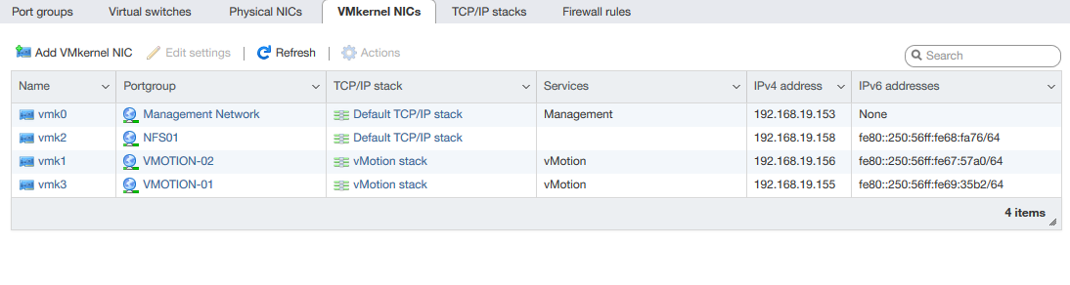

Challenge and need more R $ D : No challenges

* VCSA deployment and configuration :
* VCenter Deploy
* Create Datacenter
* Create Cluster

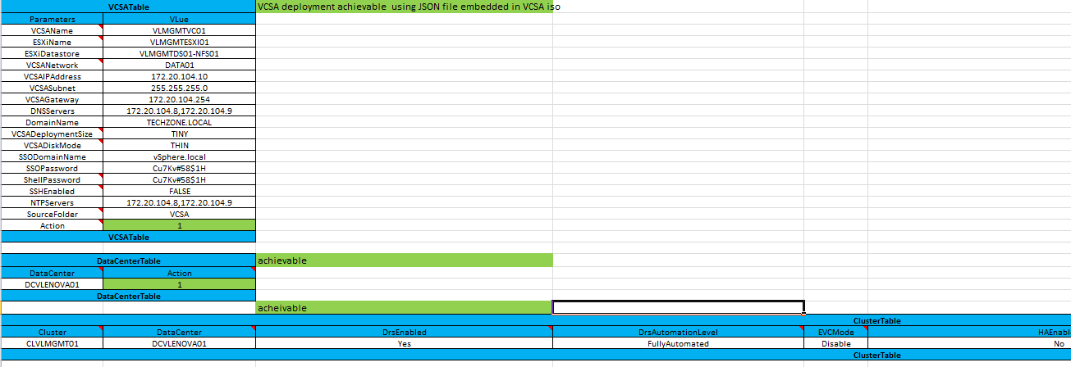

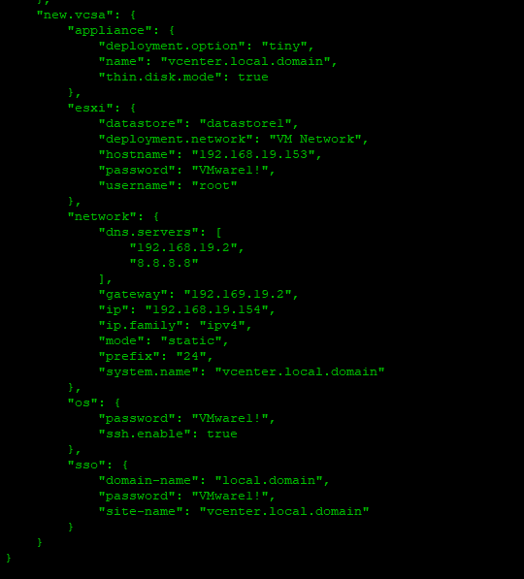

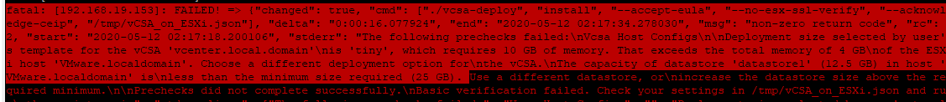

Challenge and need more R $ D : Hardware not sufficient

Deployment with CSV inputs on multiple Vcenter entries :

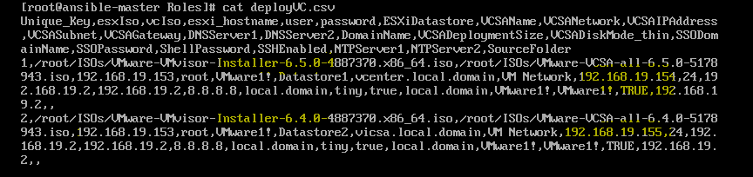

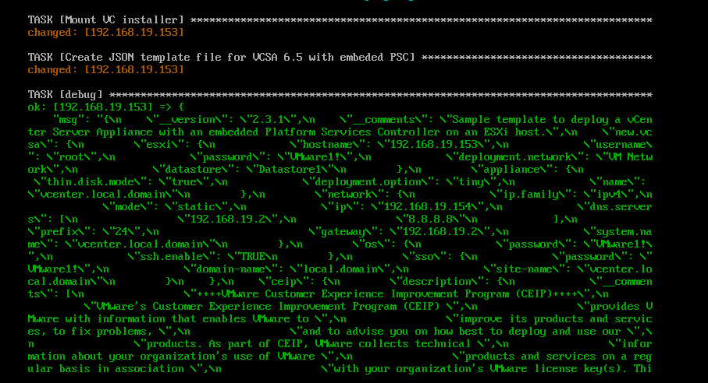

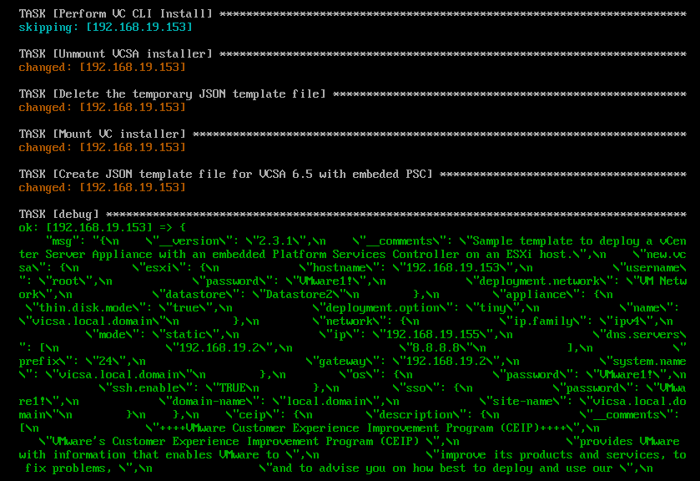

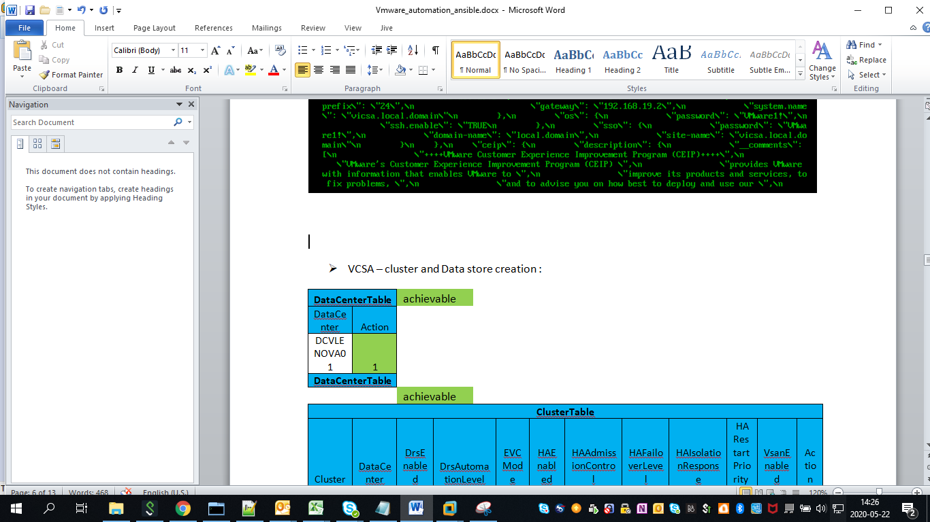

* VCSA – cluster and Data store creation :

|  |  |  |  |  |  |  |  |  |  |  |  |  |
| --- | --- | --- | --- | --- | --- | --- | --- | --- | --- | --- | --- | --- |
| **DataCenterTable** | | achievable | |  |  |  |  |  |  |  |  |  |
| DataCenter | Action |  | |  |  |  |  |  |  |  |  |  |
| DCVLENOVA01 | 1 |  | |  |  |  |  |  |  |  |  |  |
| **DataCenterTable** | |  | |  |  |  |  |  |  |  |  |  |
|  |  | achievable | |  |  |  |  |  |  |  |  |  |
| **ClusterTable** | | | | | | | | | | | | |
| Cluster | DataCenter | DrsEnabled | DrsAutomationLevel | | EVCMode | HAEnabled | HAAdmissionControl | HAFailoverLevel | HAIsolationResponse | HA  Restart  Priority | VsanEnabled | Action |
| CLVLMGMT01 | DCVLENOVA01 | Yes | FullyAutomated | | Disable | No | no | 1 | DoNothing | Medium | No | 1 |
| **ClusterTable** | | | | | | | | | | | | |

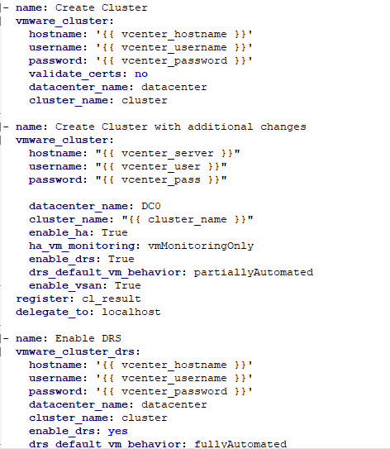

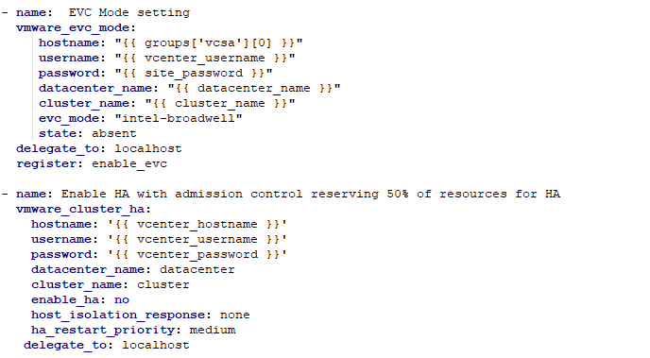

Challenge and need more R $ D : Refine more EVC and HA setting with conditional checks .

* Create dvswitch , portgroup and configure setting :

|  |  |  |  |  |  |  |  |  |  |  |
| --- | --- | --- | --- | --- | --- | --- | --- | --- | --- | --- |
| **dvSwitchTable** | | | | | | | | | |  |
| dvSwitch | DataCenter | NumUplinkPorts | MTU | Version | NIOC | DiscoveryProtocol | DiscoveryProtocolOperation | Uplinks | Action |  |
| VL_MGMT_ESXI | DCVLENOVA01 | 2 | 9000 | 6.6.0 | Yes | CDP | Listen | vmnic0,vmnic1 | 1 |  |
| VL_MGMT_VMOTION | DCVLENOVA01 | 2 | 9000 | 6.6.0 | Yes | CDP | Listen | vmnic2,vmnic3 | 1 |  |
| VL_MGMT_NFS | DCVLENOVA01 | 2 | 9000 | 6.6.0 | Yes | CDP | Listen | vmnic4,vmnic5 | 1 |  |
| VL_MGMT_DATA | DCVLENOVA01 | 2 | 9000 | 6.6.0 | Yes | CDP | Listen | vmnic6,vmnic7 | 1 |  |
| **dvSwitchTable** | | | | | | | | | |  |
|  |  | **achievable** |  |  |  |  |  |  |  |  |
| **dvPortGroupPolicyTable** | | | | | | | | | | |
| PortGroupPolicy | PromiscuousMode | MACAddressChanges | ForgedTransmits | LoadBalancing | NetworkFailoverDetection | FailBack | NotifySwitches | ActiveAdapter | StandbyAdapter | UnusedAdapter |
| 1 | No | No | No | 1 | 1 | Yes | Yes | dvUplink1,dvUplink2 |  |  |
| 2 | No | No | No | 1 | 1 | Yes | Yes | dvUplink1 | dvUplink2 |  |
| 3 | No | No | No | 1 | 1 | Yes | Yes | dvUplink2 | dvUplink1 |  |
| **dvPortGroupPolicyTable** | | | | | | | | | | |
|  |  | achievable |  |  |  |  |  |  |  |  |
| **dvPortGroupTable** | | | | | | | |  |  |  |
| dvSwitch | PortGroup | PortBinding | PortAllocation | NumPorts | vLAN | PortGroupPolicy | Action |  |  |  |
| VL_MGMT_ESXI | ESXI_100 | Static | Elastic | 20 | 100 | 1 | 1 |  |  |  |
| VL_MGMT_VMOTION | VMOTION1_101 | Static | Elastic | 20 | 101 | 2 | 1 |  |  |  |
| VL_MGMT_VMOTION | VMOTION2_101 | Static | Elastic | 20 | 101 | 3 | 1 |  |  |  |
| VL_MGMT_NFS | NFS_102 | Static | Elastic | 20 | 102 | 1 | 1 |  |  |  |
| VL_MGMT_DATA | DATA_104 | Static | Elastic | 20 | 104 | 1 | 1 |  |  |  |
| **dvPortGroupTable** | | | | | | | |  |  |  |

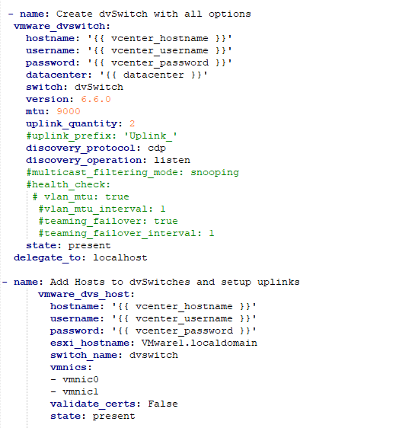

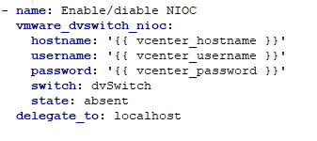

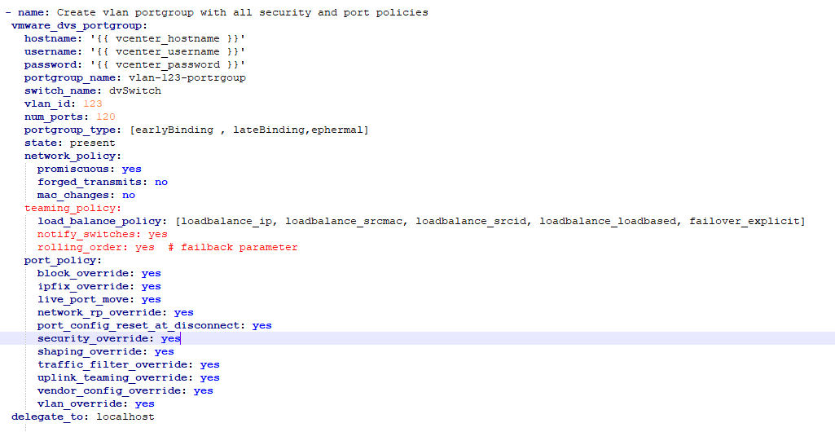

Challenge and need more R $ D : Active and standby adapters are not defined in the playbook module . However I have a found a way , but need to confirm if this will work on not by using module add host to dv switch and it asks for the vmnics . Does this do what we want to achieve from assigning uplinks .

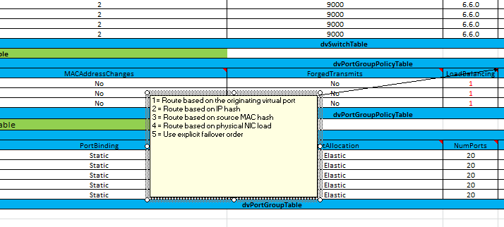

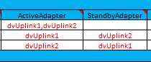

* Vswitch migration table

|  |  |  |
| --- | --- | --- |
| **vSwitchMigrationTable** | | |
| vSwitch | dvSwitch | DeletevSwitch |
| vSwitch0 | VL_MGMT_ESXI | Yes |
| vSwitch1 | VL_MGMT_VMOTION | Yes |
| vSwitch2 | VL_MGMT_NFS | Yes |
| vSwitch3 | VL_MGMT_DATA | Yes |
| **vSwitchMigrationTable** | | |

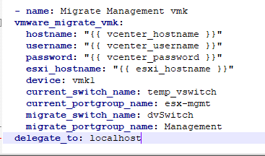

* Create cluster host Table :

|  |  |  |
| --- | --- | --- |
| **ClusterHostsTable** | | |
| HostName | Cluster | Action |
| VLMGMTESXI01 | CLVLMGMT01 | 1 |
| VLMGMTESXI02 | CLVLMGMT01 | 1 |
| VLMGMTESXI03 | CLVLMGMT01 | 1 |
| **ClusterHostsTable** | | |

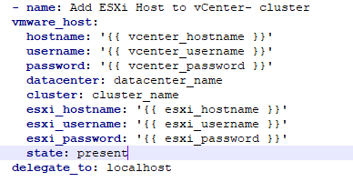

* DVswitch host table :



