**Assignment-02**

**Qn01 :** **Documentation is an important step in programming. Write a short comment about the first program you want to write!**

**Ans :** 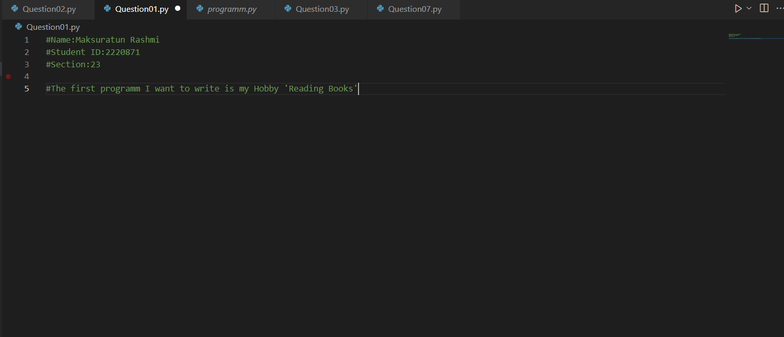

**Qn02 :** **Print the distinguished greeting “Hello world!”**

**Ans :**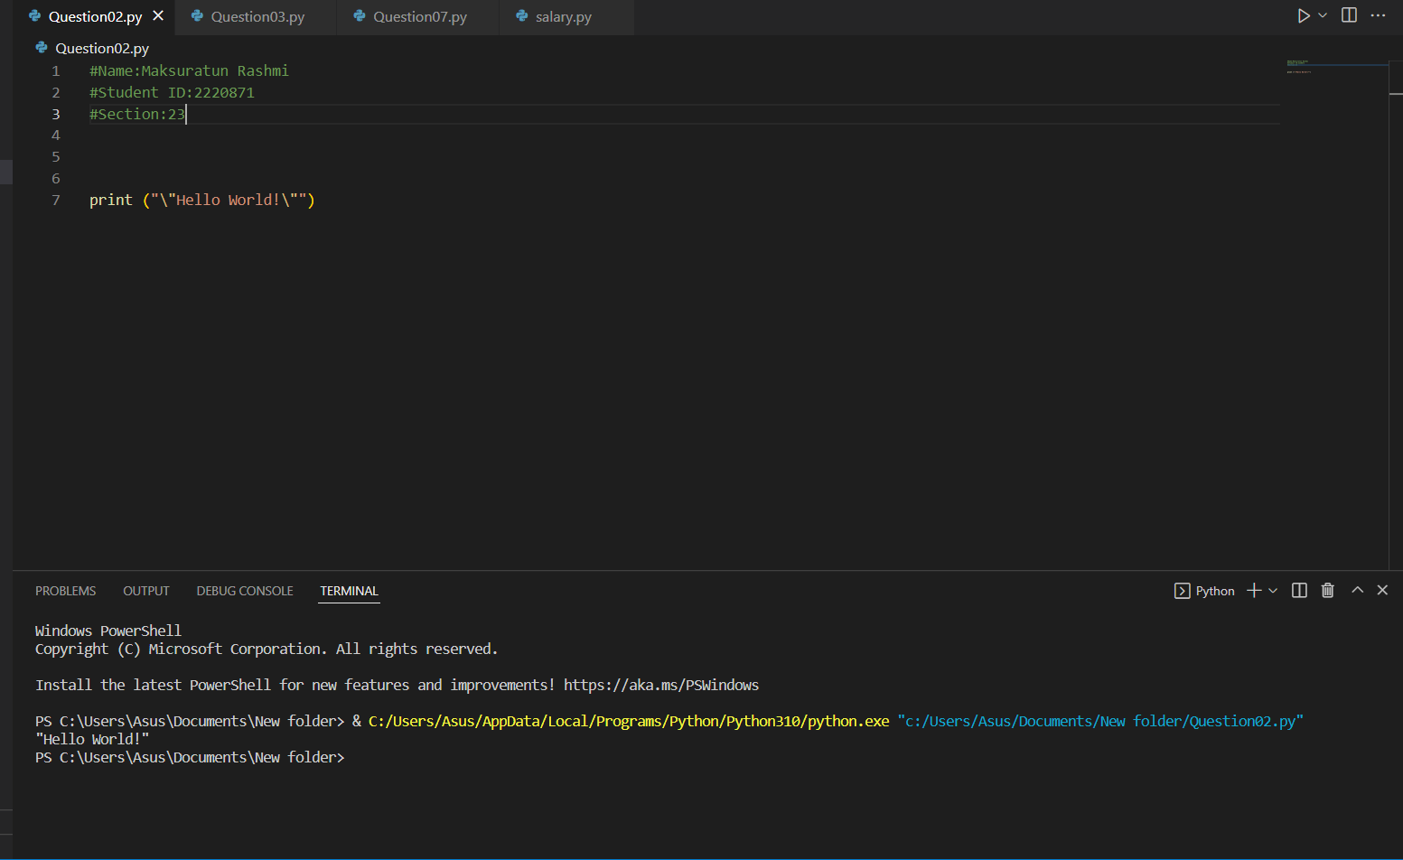

**Qn03 :** **Create three variables Breakfast, Lunch, and Dinner with a stored string of the items in it .**

**Ans :**

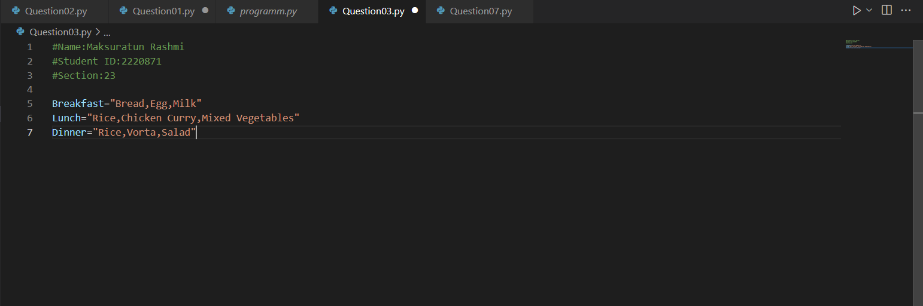

**Qn04 :** **State the difference between Syntax Error and Name Error.**

**Ans :** 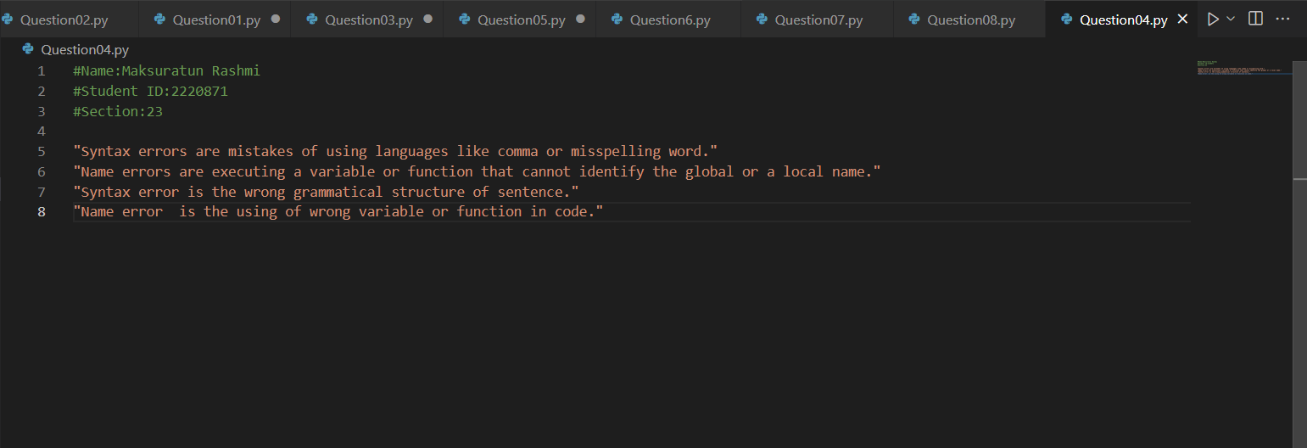**Qn05 :** **A recent movie-going experience has you excited to publish a review. You rush out of the cinema and hastily begin programming to create your movie-review website. Create the following variables and assign integer numbers to them: release_year, runtime and rating_out_of_10 assign either integer numbers or floats numbers to them and print each of the variables separately.**

**Ans :** 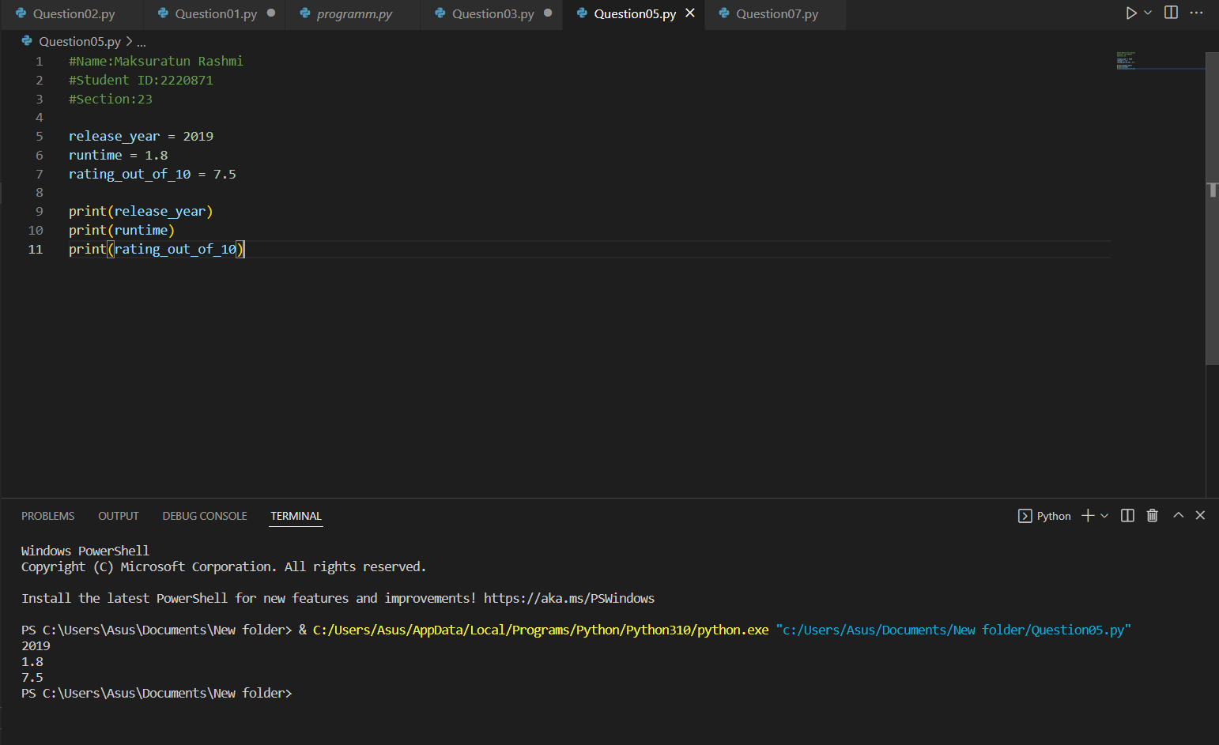

**Qn06 : Print out the result of this equation: 25 * 68 + 13 / 28.**

**Ans :** 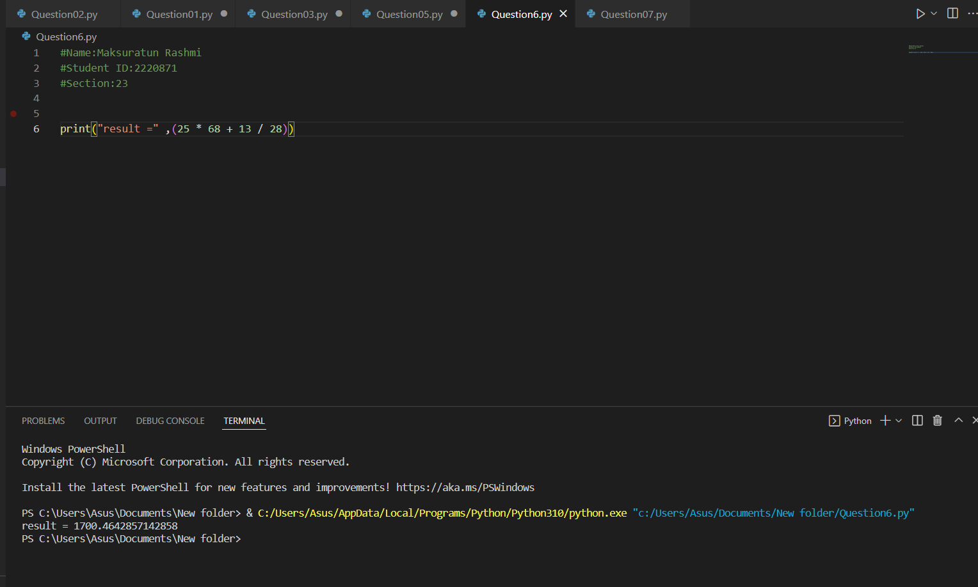

**Qn07 :** **The length of a rectangle is given by the variable rectangle_length and the width is given by rectangle_width. Assign a number to each of these variables and print the multiplication of them to find the area of this rectangle.**

**Ans:** 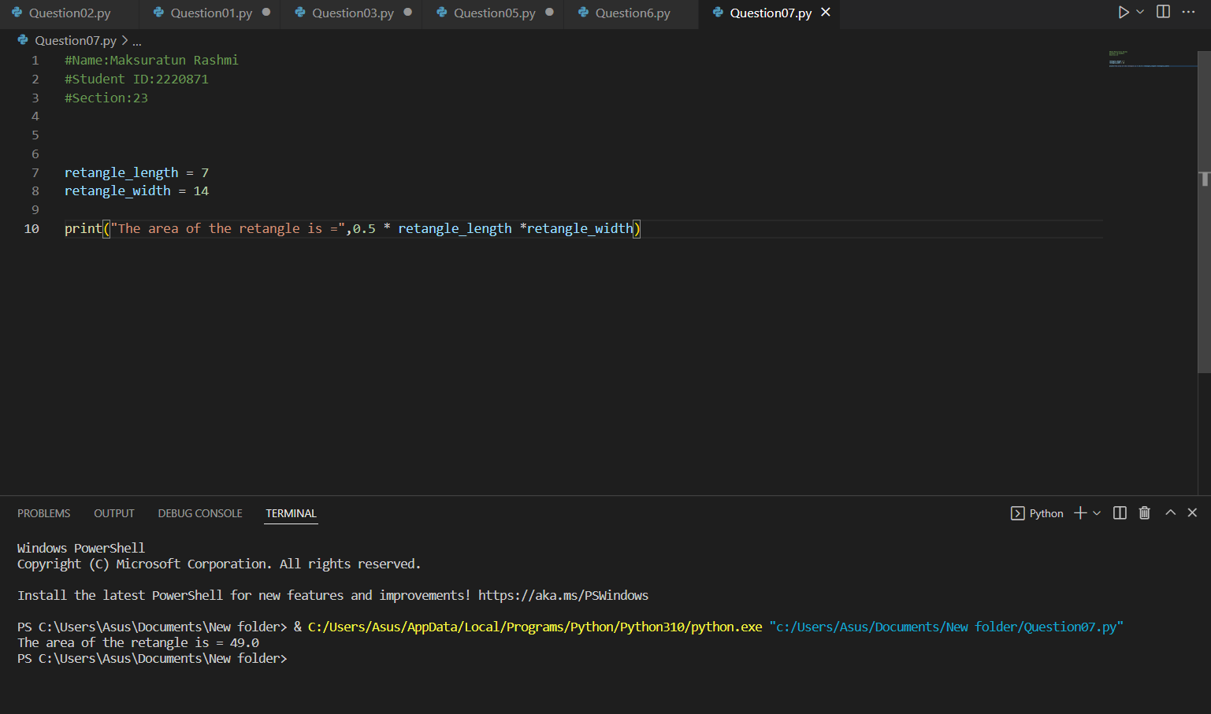

**Qn08 :** **Print out the square of the number 7 using exponent notation (**)**

**Ans :** 