A Small Experimental Study of
Section-Aware and Ontology-Enhanced RAG
for Sri Lankan Legal Document Retrieval
A proof-of-concept carried out while exploring the retrieval approach
for a more comprehensive final-year project
Student Research Draft
Scope: Sri Lankan Employees' Provident Fund Act, Sections 10-20

Abstract
Retrieval-Augmented Generation (RAG) allows a Large Language Model to answer questions using information retrieved from a separate knowledge base. While exploring ideas for my final-year project, I wanted to understand how different retrieval choices would behave with legal documents. Legal Acts already have a clear structure, and different sections can also be connected through responsibilities, consequences and protections.
For this small experiment, I used Sections 10 to 20 of the Sri Lankan Employees' Provident Fund Act and built three retrieval approaches. The first was a Basic RAG using fixed-size text chunks. The second was a Section-Aware RAG where one complete legal section was treated as one chunk. The third was an Ontology-Enhanced RAG that used the same section chunks together with legal concepts and relationships created in Protégé.
The systems were evaluated using Hit@1, Hit@3, Mean Reciprocal Rank (MRR) and Recall@3. A separate set of 20 unseen questions was used for the final comparison. On this unseen set, the Section-Aware RAG obtained the highest Hit@1 (0.600), while the Ontology-Enhanced RAG obtained the highest Hit@3 (0.950), MRR (0.733) and Recall@3 (0.950). The results suggest that preserving legal section boundaries helped direct retrieval, while ontology information was especially useful for keeping relevant and related provisions within the top retrieved results.
This is not the complete final-year project. It is a small proof of concept used to understand legal chunking, ontology integration and retrieval evaluation before developing a larger system.
Keywords: Retrieval-Augmented Generation, RAG, legal information retrieval, ontology, section-aware chunking, ChromaDB, Sri Lankan law

1. Introduction
Large Language Models can answer many general questions, but they do not always have reliable knowledge about a particular document or specialised domain. Retrieval-Augmented Generation is one way of addressing this problem. Instead of asking the language model to answer only from its internal knowledge, a RAG system first searches a knowledge base and provides relevant source material to the model.
A simple RAG flow is: question -> retrieval -> relevant document chunks -> Large Language Model -> answer. This means that retrieval is a very important part of the system. If the correct legal information is not retrieved, a language model can still produce an answer that sounds reasonable even though the supporting legal provision is missing.
While learning about RAG for my final-year project, I noticed that many basic implementations split documents by a fixed number of characters or tokens. This is convenient, but I was not sure that it was a good fit for legislation. A legal Act already contains meaningful boundaries such as sections and subsections. A section may contain a complete responsibility, restriction or consequence. Splitting it only because a character limit has been reached can separate information that belongs together.
I was also interested in another issue. Legal provisions do not exist independently. One section may establish a payment responsibility, another may define a penalty for failing to meet it, and another may describe recovery of the unpaid money. Normal semantic search can sometimes identify these connections, but it does not explicitly store the legal relationships. This led to the ontology part of the experiment.

2. Aim and Research Questions
The aim of this experiment was to compare three small legal RAG retrieval approaches and understand what changes when document structure and ontology knowledge are introduced.
- RQ1: Does keeping a complete legal section as one chunk perform better than fixed-size chunking for this legal knowledge base?
- RQ2: Can an ontology help the retriever keep related legal provisions in the top results?
- RQ3: What trade-offs appear when ontology information is combined with normal semantic vector similarity?
The intention was not to prove that one method is universally best. The experiment uses a small part of one Act, so the results are treated as observations from this prototype rather than general conclusions about all legal RAG systems.

3. Legal Knowledge Base Used in the Experiment
The knowledge base contains Sections 10 to 20 of the Sri Lankan Employees' Provident Fund Act. I kept the scope small because the purpose at this stage was to compare retrieval approaches, not to build a complete legal assistant. These eleven sections were useful because they cover connected topics such as contributions, payment, late-payment surcharges, recovery, interest, individual accounts and employee protections.
The descriptions below explain the sections in plain language so that the technical part of the experiment can be understood. They are simplified explanations for the project and are not intended as legal advice or as a replacement for the wording of the Act.
Section | What it mainly deals with | Ontology concept(s)
10 | Normal employee and employer contributions | EmployeeContribution; EmployerContribution
11 | Choosing contribution percentages above the normal rates | HigherContributionElection
12 | Reducing earnings in order to reduce EPF contributions | ReducedEarningsContribution
13 | Rounding fractional contribution amounts | ContributionRounding
14 | Interest on the balance in a member's individual account | FundInterest
15 | Deduction and payment of the employee contribution | MonthlyContributionPayment
16 | Surcharge when contributions are paid late | LateContributionSurcharge
17 | Legal recovery of money due to the Fund | RecoveryOfUnpaidContributions
18 | Crediting contributions and interest to an individual account | IndividualAccountCredit
19 | Protection against reducing earnings or benefits because of EPF liability | ProtectionFromEarningsReduction
20 | Employer cannot transfer its own contribution/surcharge liability to employee | EmployerLiabilityNonTransfer

3.1 Section 10 - Normal Employee and Employer Contributions
Section 10 is the starting point for the contribution system used in this experiment. It creates two separate contribution responsibilities. An employee covered by the Act contributes 8% of total monthly earnings, while the employer has a separate contribution responsibility of 12% of the employee's total monthly earnings. The employer contribution is due by the last day of the following month. The section also deals with when the contribution liability begins for a covered employment.
For the ontology, I represented the two responsibilities separately as EmployeeContribution and EmployerContribution. This is useful later because several other provisions are related specifically to the employer's own liability.

3.2 Section 11 - Choosing Higher Contribution Percentages
Section 11 allows an employee and employer to formally choose contribution percentages that are higher than the normal percentages in Section 10. The election is made through the required notice to the Commissioner. Once the election takes effect, it becomes irrevocable and the selected higher percentages become the contribution rates they are required to use.
The ontology concept HigherContributionElection represents this legal choice. It is different from the normal contribution concepts because it deals with voluntarily moving above the normal rates.

3.3 Section 12 - Reducing Earnings to Reduce Contributions
Section 12 deals with a situation where an employer reduces an employee's earnings for the purpose of reducing EPF contributions. Since contributions are calculated from earnings, lowering the earnings would also lower the calculated contribution. If the Commissioner is satisfied that the reduction was made for this purpose, the employer can be directed to pay the difference between what should have been paid using the previous earnings and what was actually paid.
The concept ReducedEarningsContribution represents this situation. It is important to distinguish it from Section 19: Section 12 focuses on reducing earnings to reduce the contribution calculation, while Section 19 provides broader protection against reducing earnings or benefits because the employer has EPF liabilities.

3.4 Section 13 - Rounding Contribution Amounts
Section 13 is a calculation rule. If a contribution calculation contains a fraction of a cent, a fraction below one-half of a cent is ignored, while a fraction equal to or above one-half of a cent is treated as one cent. This section is not a penalty or responsibility; it tells the system how the final contribution amount should be calculated.
I added the concept ContributionRounding so that questions about fractional or rounded contribution values can map directly to Section 13.

3.5 Section 14 - Interest
Section 14 deals with interest on the amount standing to the credit of a member's individual EPF account. The interest rate is fixed through the process stated in the Act and cannot be below 2.5% per year. The section also includes rules for particular timing situations and explains what happens if investment income is not enough to meet the required interest payment.
The ontology concept FundInterest represents this part of the Act. It becomes especially useful together with Section 18 because Section 18 explains that interest, together with contributions, is credited to the member's individual account.

3.6 Section 15 - Payment of the Employee Contribution
Section 15 deals with how the employee contribution is actually deducted and paid. The employer deducts the employee contribution from the employee's earnings and sends it to the Fund before the last day of the following month. A contribution paid by the employer on behalf of the employee is treated as having been paid by that employee.
I represented this as MonthlyContributionPayment. This concept is important because failing to complete the required payment on time can lead to the surcharge dealt with in Section 16.

3.7 Section 16 - Surcharge for Late Contributions
Section 16 explains what can happen when a required contribution is not paid by the deadline. If the employer cannot satisfactorily show that the failure was caused by circumstances beyond the employer's control, the employer must pay the contribution together with a surcharge. The percentage of the surcharge increases as the period of arrears becomes longer, reaching 50% when contributions remain in arrears for more than twelve months.
The concept LateContributionSurcharge represents this rule. In the ontology it is connected to MonthlyContributionPayment through hasConsequence, because the surcharge is a possible consequence of not meeting the normal payment requirement on time.

3.8 Section 17 - Recovery of Money Due to the Fund
Section 17 deals with recovery when money remains due to the Fund. Money owed to the Fund can be recovered as a debt due to the State through legal proceedings, and proceedings can be brought by the Commissioner or an authorised officer. It therefore moves beyond the late-payment penalty and deals with enforcement and recovery of money that remains unpaid.
The concept RecoveryOfUnpaidContributions is linked to LateContributionSurcharge using relatedTo. A user question about continued failure to pay may therefore involve both Section 16 and Section 17.

3.9 Section 18 - Individual Account Credit
Section 18 states that the member's own contribution, the employer contribution made in respect of that member and the interest on the contributions are credited by the Monetary Board to that member's individual account. This section is therefore about where the member's contribution-related value is recorded.
The concept IndividualAccountCredit is related to contribution and interest concepts in the ontology. This helps with questions that combine ideas from more than one section, such as what happens to interest or where employer and employee contributions are recorded.

3.10 Section 19 - Protection Against Reducing Earnings or Benefits
Section 19 protects the employee from an employer reducing earnings or negatively changing employment benefits simply because the employer has a liability to pay an EPF contribution or surcharge. In other words, the employer cannot respond to its EPF responsibility by making the employee worse off in this way.
The concept ProtectionFromEarningsReduction is related to EmployerContribution because the protection exists in the context of the employer's own EPF obligations.

3.11 Section 20 - Employer Liability Cannot Be Transferred to the Employee
Section 20 prevents the employer from deducting from the employee's earnings an amount that the employer itself is required to pay as a contribution or surcharge. It also says that an agreement that attempts to transfer part of the employer's legal liability to the employee is null and void.
The ontology concept EmployerLiabilityNonTransfer is therefore related to EmployerContribution. Section 10 creates the employer's own contribution responsibility, while Section 20 prevents that responsibility from simply being shifted to the employee.

4. What Is an Ontology?
In this project, an ontology is a structured way of representing legal knowledge. I found it easiest to think of it as a knowledge map. A normal document stores text, while an ontology stores important concepts and also records how those concepts are connected.
For example, LateContributionSurcharge and RecoveryOfUnpaidContributions are represented as separate legal concepts. The ontology can explicitly record that they are related. It can also record that LateContributionSurcharge is defined in Section 16 and that RecoveryOfUnpaidContributions is defined in Section 17.
The ontology used in this experiment contains four main relationship ideas. hasSection connects the EPF Act to its legal sections. definedIn connects a legal concept to the section where it is represented. relatedTo connects concepts that have a meaningful legal relationship. hasConsequence is used where one concept represents a consequence of another, such as the late-payment surcharge following the contribution payment obligation.
The ontology does not replace vector search. It adds another source of information. Vector search asks which legal text is semantically similar to the question. The ontology asks which legal concepts appear relevant and which other concepts are explicitly connected to them.

5. Ontology Built for the Prototype
The ontology was created in Protégé and processed in Python using RDFLib. The updated ontology contains a concept for every section from Section 10 to Section 20. Sections 13, 14 and 18 were also given explicit concepts so that the ontology did not leave those sections represented only as section nodes.
The hierarchy figure below shows the EPF Act, the eleven sections and the concept-to-section definedIn links. A second figure shows the explicit concept-to-concept relatedTo and hasConsequence relationships used by the final ontology.

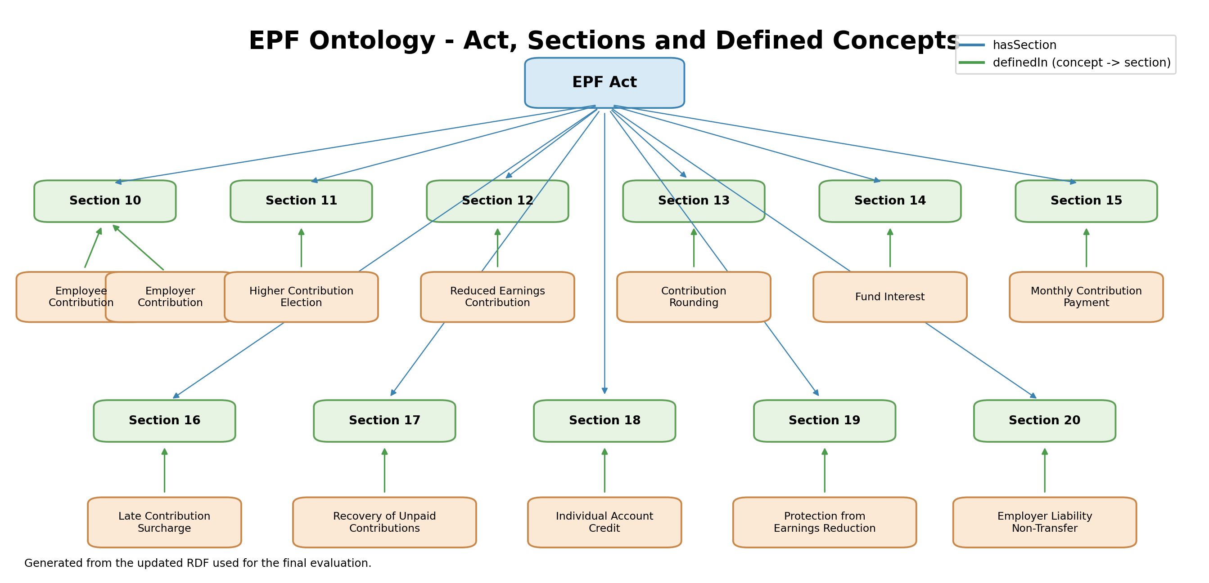
Figure 1. EPF ontology hierarchy: Act, Sections 10-20 and the concepts defined in each section.

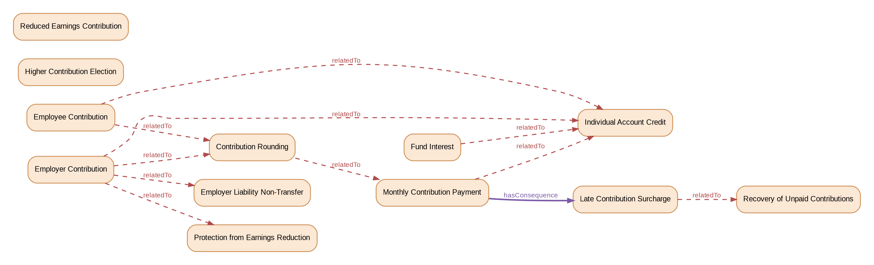
Figure 2. Explicit relatedTo and hasConsequence relationships between ontology concepts.

The relationship map is intentionally small. It does not attempt to represent every possible legal relationship in the Act. It only contains relationships added for this proof-of-concept retrieval experiment. This is important because the quality of ontology-enhanced retrieval depends on the quality of these relationships.

6. Why Chunking Matters for Legal Documents
Before storing a document in a vector database, the text normally has to be divided into smaller pieces called chunks. In the Basic RAG, I used chunks of 700 characters with a 100-character overlap. The overlap keeps some text from the end of one chunk in the next chunk, but the method still does not understand where a legal section begins or ends.
This can create two problems. A complete legal rule may be split across two chunks, or a single chunk may contain the end of one section and the beginning of another. For ordinary text this may sometimes be acceptable, but legal sections often have meaningful boundaries.
For the Section-Aware RAG, I kept each complete section as one chunk. This means Section 10 is one chunk, Section 11 is another chunk and so on. The embedding model and vector database were kept the same so that the chunking strategy could be compared more fairly.
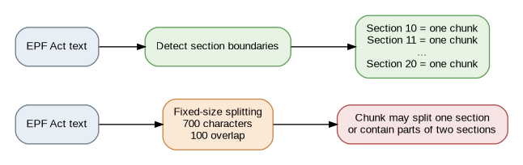
Figure 3. Fixed-size chunking compared with section-aware chunking.

7. The Three RAG Systems

7.1 Basic RAG
The Basic RAG is the baseline system. The text from Sections 10 to 20 is joined and divided into 700-character chunks with 100 characters of overlap. Each chunk is converted into an embedding using sentence-transformers/all-MiniLM-L6-v2 and stored in ChromaDB using cosine similarity. When a question is asked, the question is embedded and the three most similar chunks are retrieved.

7.2 Section-Aware RAG
The Section-Aware RAG uses the same embedding model, ChromaDB retrieval and top-three setting. The main change is that each complete legal section is used as one chunk. This makes the comparison useful because the retrieval technology is the same while the document segmentation strategy changes.

7.3 Ontology-Enhanced RAG
The Ontology-Enhanced RAG starts with the same section chunks as the Section-Aware system. It then adds ontology concept matching and relationship expansion before the final ranking. Normal semantic vector retrieval is still used. The ontology is an extra reranking signal rather than a replacement for vector search.

8. How a User Question Uses the Ontology
A question passes through vector retrieval and ontology matching at the same time. The vector side measures semantic similarity between the question and the legal sections. The ontology side compares the question embedding with embeddings created for ontology concepts.
Up to three ontology concepts are kept when their similarity is above the concept threshold of 0.30. A concept directly points to its legal section through definedIn. The system also checks one hop of relatedTo and hasConsequence relationships to find related concepts and the sections where they are defined.
Direct ontology sections receive a bonus of 0.20 and related ontology sections receive a smaller bonus of 0.10. The final reranking score is therefore: final score = vector similarity + ontology bonus. After reranking, the top three sections are passed to the answer generation stage.
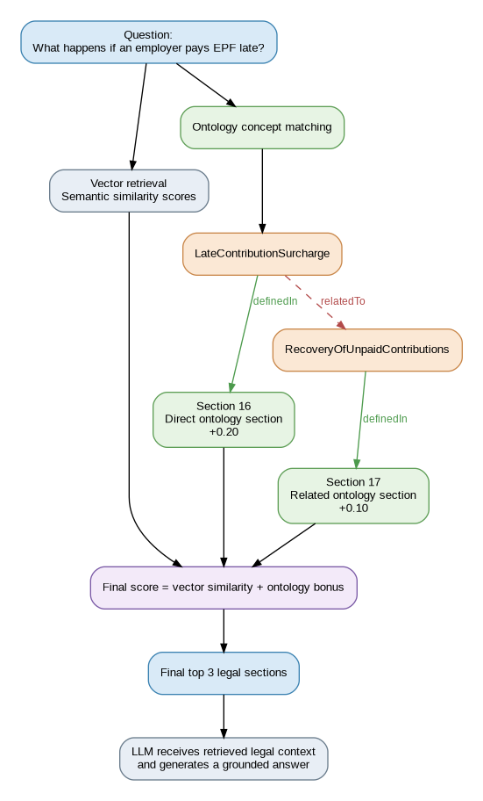
Figure 4. Example flow for the question "What happens if an employer pays EPF late?"

8.1 Example: Late EPF Payment
For the question "What happens if an employer pays EPF late?", the ontology matcher can identify LateContributionSurcharge. That concept is defined in Section 16, so Section 16 becomes a direct ontology section and receives the stronger bonus. LateContributionSurcharge is also related to RecoveryOfUnpaidContributions, which is defined in Section 17. Section 17 can therefore receive the smaller related-section bonus. The normal vector score still matters; the ontology only adjusts the ranking.

8.2 Example: Employer Trying to Transfer Its Own Contribution
For a question such as "Can my employer deduct their own EPF contribution from my salary?", the ontology can match EmployerLiabilityNonTransfer, which is defined in Section 20. The concept is also related to EmployerContribution in Section 10. This helps keep both the rule creating the employer contribution responsibility and the rule preventing transfer of that liability within the retrieved context.

8.3 Example: Interest and the Individual Account
For a question about what happens to interest earned on EPF money, FundInterest points to Section 14 and is related to IndividualAccountCredit in Section 18. This is an example where a useful answer can require more than one legal provision, which is one reason Recall@3 is important in the evaluation.

9. Experimental Setup
Setting | Value
Legal scope | EPF Act Sections 10-20 (11 sections)
Embedding model | sentence-transformers/all-MiniLM-L6-v2
Vector database | ChromaDB with cosine similarity
Final retrieved contexts | TOP_K = 3
Basic chunking | 700 characters with 100-character overlap
Ontology candidate sections | CANDIDATE_K = 11
Ontology concepts kept | ONTOLOGY_TOP_K = 3
Concept similarity threshold | 0.30
Direct ontology bonus | +0.20
Related ontology bonus | +0.10
Ontology tools | Protégé and RDFLib
Answer generation | Groq using openai/gpt-oss-20b

The same final top-three context size was used for all three systems. The answer-generation prompt was also kept the same so that the main comparison remained focused on retrieval.

10. Evaluation Method
I created question sets where the expected legal section or sections were already known. The development set contains 30 questions and was used while checking the retrieval system and ontology. A separate set of 20 unseen questions was then used for the final comparison. Keeping a separate unseen set reduces the chance of judging the system only on questions that were repeatedly seen during development.

10.1 Hit@1
Hit@1 checks whether at least one expected section is the first retrieved result. If Section 16 is expected and the first result is Section 16, Hit@1 is 1. If Section 16 appears second or third, Hit@1 is 0. I used this because it measures how often the retriever places a correct provision in its strongest position.

10.2 Hit@3
Hit@3 checks whether at least one expected section appears anywhere in the first three results. This matters for RAG because the language model receives several retrieved contexts. A correct section can still be useful even if it is ranked second or third.

10.3 Mean Reciprocal Rank (MRR)
Hit@3 treats rank 1 and rank 3 in the same way, so I also used Mean Reciprocal Rank. If the first correct result is rank 1, the reciprocal rank is 1.0. If it is rank 2, it is 0.5. If it is rank 3, it is about 0.333. These values are averaged across all questions. MRR therefore rewards systems that place the first correct result higher.

10.4 Recall@3
Recall@3 is important when a question requires more than one section. For example, if the expected sections are Section 16 and Section 17 and the top three contain only Section 16, the recall is 1/2 = 0.5. If both Section 16 and Section 17 are found, Recall@3 is 1.0. Hit@3 asks whether something correct was found; Recall@3 asks how much of the required legal information was found.

11. Final Unseen-Test Results
After completing the ontology coverage for Sections 13, 14 and 18, I reran the separate 20-question final test set. The final aggregate retrieval results are shown below.
System | Hit@1 | Hit@3 | MRR | Recall@3
Basic RAG | 0.450 | 0.650 | 0.533 | 0.575
Section-Aware RAG | 0.600 | 0.800 | 0.692 | 0.750
Ontology-Enhanced RAG | 0.550 | 0.950 | 0.733 | 0.950

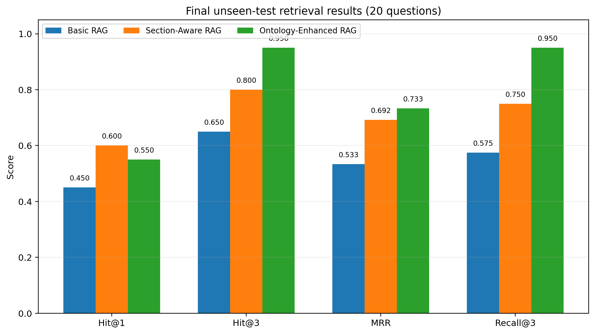
Figure 5. Retrieval performance on the 20 unseen final-test questions.

12. Discussion

12.1 Fixed-Size Chunking Was the Weakest Approach in This Experiment
Basic RAG had the lowest score on every final metric: Hit@1 = 0.450, Hit@3 = 0.650, MRR = 0.533 and Recall@3 = 0.575. The Section-Aware RAG improved these to 0.600, 0.800, 0.692 and 0.750 respectively. The embedding model and vector database were the same, so the main difference was how the legal text was divided.
This result supports the idea that the natural structure of the Act was useful for this small legal knowledge base. A complete section normally keeps a responsibility, condition or consequence together, while fixed-size chunks can split those ideas or mix neighbouring sections. I would not claim from this experiment that fixed-size chunking is always the worst choice for legal RAG. Some sections can be very long and may need subsection-level or hierarchical chunking. However, for the Sections 10-20 used here, section-aware chunking was clearly stronger than the fixed-size baseline.

12.2 Section-Aware RAG Had the Best Hit@1
The Section-Aware system produced the highest Hit@1 score of 0.600. The Ontology-Enhanced system obtained 0.550. This means that adding the ontology did not make the system better on every metric. In some questions, promoting a related provision can move it above the most directly relevant provision. This is a useful limitation of the current reranking method rather than something to hide.

12.3 Ontology RAG Improved Top-Three Coverage
The strongest ontology result was the coverage of relevant sections within the first three results. Ontology RAG achieved Hit@3 = 0.950 and Recall@3 = 0.950. Section-Aware RAG achieved 0.800 Hit@3 and 0.750 Recall@3, while Basic RAG achieved 0.650 and 0.575. Ontology RAG also obtained the highest MRR at 0.733.
This suggests that the ontology was especially useful when the question was connected to more than one legal concept or provision. Explicit relationships such as MonthlyContributionPayment -> hasConsequence -> LateContributionSurcharge and LateContributionSurcharge -> relatedTo -> RecoveryOfUnpaidContributions give the retriever information that is different from plain text similarity.

12.4 Why Several Metrics Were Necessary
If I had looked only at Hit@1, I might have concluded that the Section-Aware RAG was the strongest system. If I looked only at Recall@3, the Ontology-Enhanced RAG would look much stronger. Looking at Hit@1, Hit@3, MRR and Recall@3 together shows the real trade-off: section-aware retrieval was slightly better at putting a correct section first, while ontology-enhanced retrieval was better at keeping the wider set of relevant provisions inside the top three.

13. Limitations
This experiment has several limitations. The legal knowledge base contains only eleven sections from one Act. The development set contains 30 questions and the final unseen set contains 20 questions. These numbers are suitable for a proof of concept but not enough to make broad conclusions about every legal RAG system.
The ontology was also manually created. Its usefulness therefore depends on the concepts and relationships chosen during development. The current reranking method is simple: a direct section receives +0.20 and a related section receives +0.10. These values are experimental rather than theoretically optimal.
Relationship expansion is limited to one hop. A larger legal ontology may contain longer chains, exceptions, conditions, actors and hierarchical concepts. Expanding too far could also introduce irrelevant sections, so this would need careful evaluation.
Finally, the main evaluation in this study is retrieval evaluation. A full legal RAG study should also evaluate the generated answer itself, including whether the answer is supported by the retrieved context, whether it directly answers the question and whether it introduces unsupported legal statements.

14. Connection to the Final-Year Project and Future Work
This prototype is only a small research exercise carried out while deciding how to design a more comprehensive final-year project. Working with a small part of the EPF Act allowed me to test retrieval ideas before moving to a larger legal collection.
The next stage can expand the legal knowledge base and use a richer ontology. Instead of representing only sections and a small set of relationships, a larger ontology could represent actors, obligations, conditions, exceptions, consequences and links between provisions across more than one legal document.
Chunking can also be improved. One complete section worked well for this experiment, but very long sections may need subsection-aware or hierarchical chunking. The reranking method could also move beyond fixed bonuses by learning or calibrating how strongly ontology information should influence vector similarity.
Another important step is answer-level evaluation. Metrics such as faithfulness and response relevancy, together with manual checking of legal citations, could be used to evaluate whether the final generated response is actually supported by the retrieved legal context.

15. Conclusion
This small experiment compared Basic fixed-size RAG, Section-Aware RAG and Ontology-Enhanced RAG using Sections 10 to 20 of the Sri Lankan Employees' Provident Fund Act. The results showed that retrieval design matters before information ever reaches the language model.
For this knowledge base, preserving complete legal sections performed better than fixed-size character chunks. The Section-Aware RAG achieved the best Hit@1 result, showing strong direct retrieval. The Ontology-Enhanced RAG did not improve Hit@1, but it achieved the strongest Hit@3, MRR and Recall@3, showing better coverage of relevant and related provisions within the top three results.
The main lesson I take from this prototype is that a legal RAG system is not simply "document -> embeddings -> vector database -> LLM". The way the legal text is divided and the way relationships between legal provisions are represented can change what information the model receives. The experiment therefore gives a useful starting point for designing a larger ontology-enhanced legal RAG system as part of the final-year project.

References and Project Sources
1. Employees' Provident Fund Act, No. 15 of 1958 (Sri Lanka), with the sections used in this prototype limited to Sections 10-20.
2. Protégé was used to create and inspect the RDF ontology. RDFLib was used to process the ontology in Python.
3. Sentence Transformers (all-MiniLM-L6-v2) was used to create embeddings, ChromaDB was used for vector retrieval, and Groq was used for the answer-generation stage.

