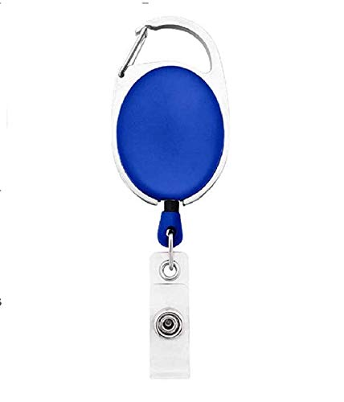

Swara Solutions

**Intern ID - _EmpCode**

|  |  |
| --- | --- |
| **_Name** | PHOTO |
| **_Department** |
| **_DOJ** |
| **_BloodGrp** |
| **_Contact** |

Questions / Queries – Drop an email to hr@swarasoluions.com