**Assignment 3**

**Name:** Rashmi Ravindra Kawale

**ID:** c0779859

1. Create 2 tables. The first table shows how many salespeople have attrition. Store this information in a column called “attrition”. The second table counts how many salespeople have no attrition. Store this information in a column called “Non Attrition”.

Query:

SELECT COUNT(attrition) as attrition

FROM employee

WHERE attrition LIKE “%YES%”;

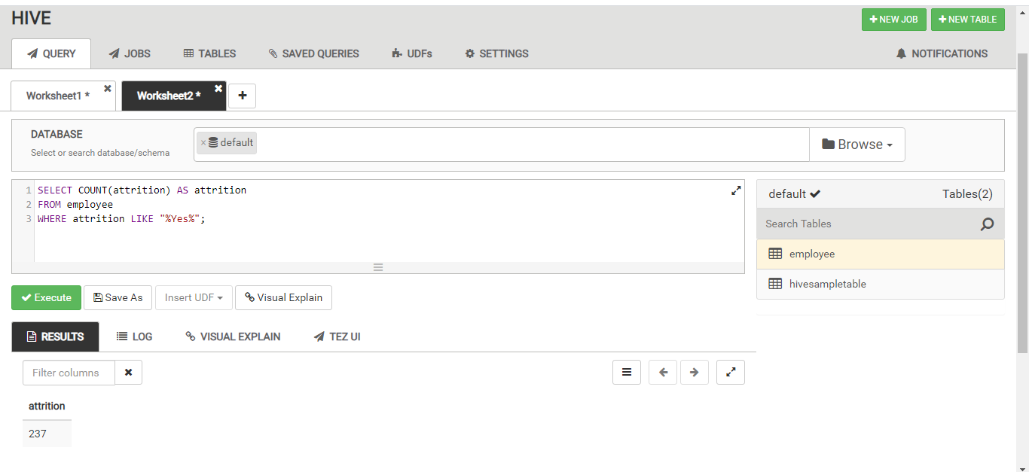

Query:

SELECT COUNT(attrition) as non_attrition

FROM employee

WHERE attrition LIKE “%No%”;

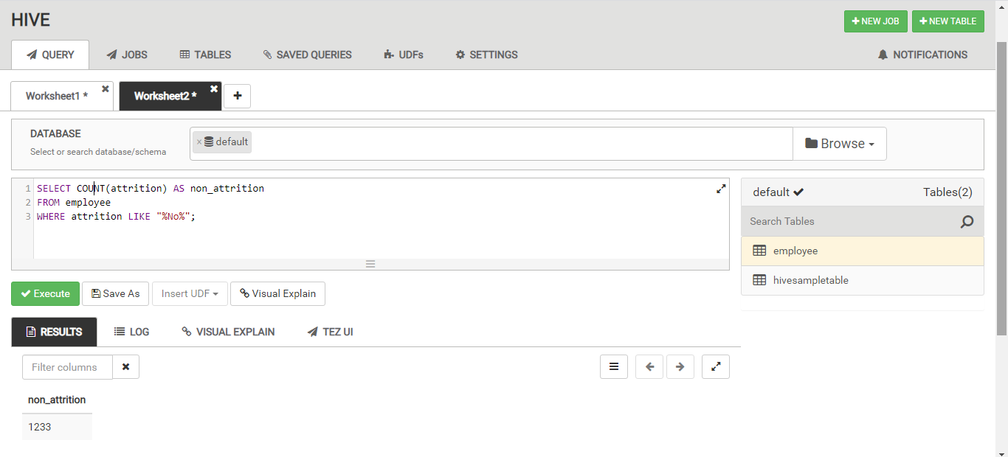

1. Create 3 statistics tables (average, min, max) showing the monthly income for: all salespeople, those with attrition and those without attrition. For each table, label the columns “average_monthly_income”, “min_monthly_income”, and “max_monthly_income”.

Query:

SELECT AVG(monthlyincome) AS average_monthly_income, MIN(monthlyincome) AS min_monthly_income, MAX(monthlyincome) AS max_monthly-income

FROM employee;

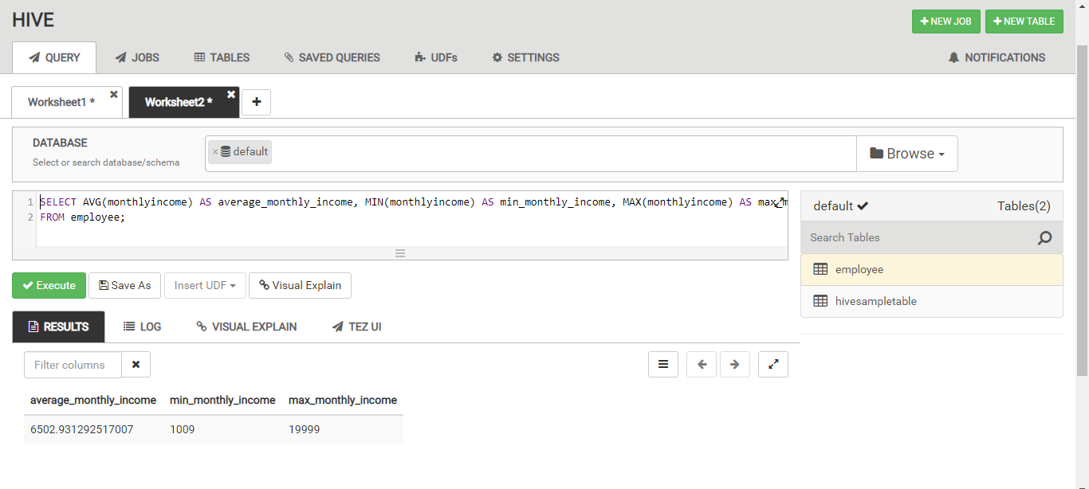

Query:

SELECT AVG(monthlyincome) AS average_monthly_income, MIN(monthlyincome) AS min_monthly_income, MAX(monthlyincome) AS max_monthly-income

FROM employee

WHERE attrition LIKE “%Yes%”;

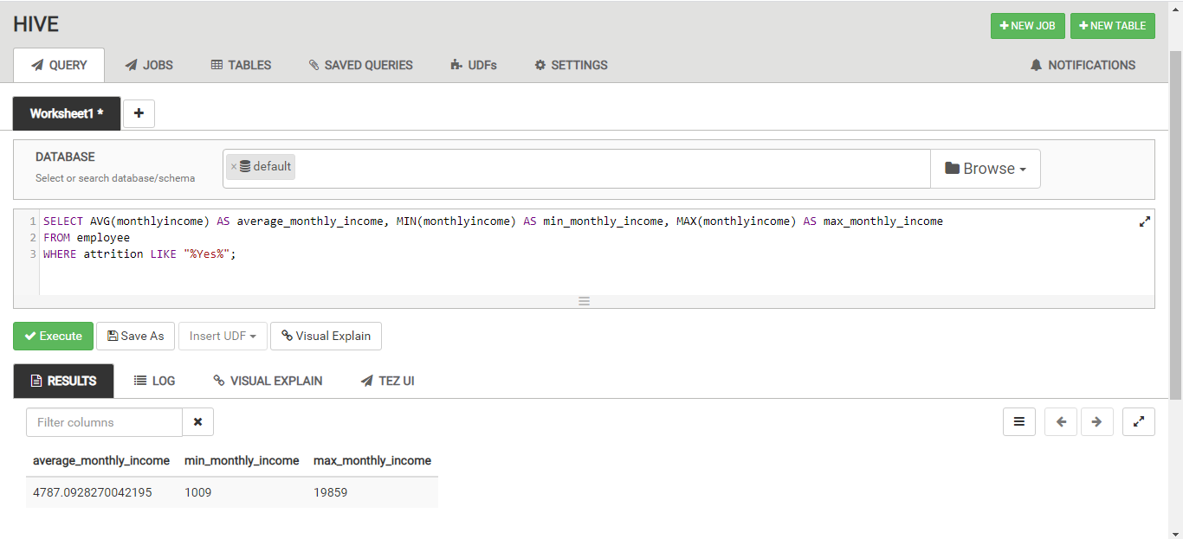Query:

SELECT AVG(monthlyincome) AS average_monthly_income, MIN(monthlyincome) AS min_monthly_income, MAX(monthlyincome) AS max_monthly-income

FROM employee

WHERE attrition LIKE “%No%”;

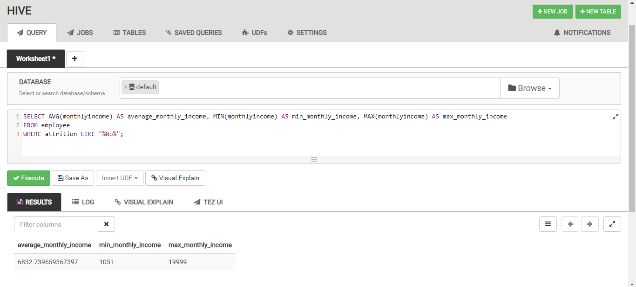

1. Create 2 tables containing the monthly income and count of salespeople making that monthly income for: salespeople with attrition and salespeople without attrition. Label the columns as: “monthlyincome” and “count”

Query:

SELECT monthlyincome, COUNT(monthlyincome) AS count

FROM employee

WHERE attrition LIKE “%Yes%”

GROUP BY monthlyincome;

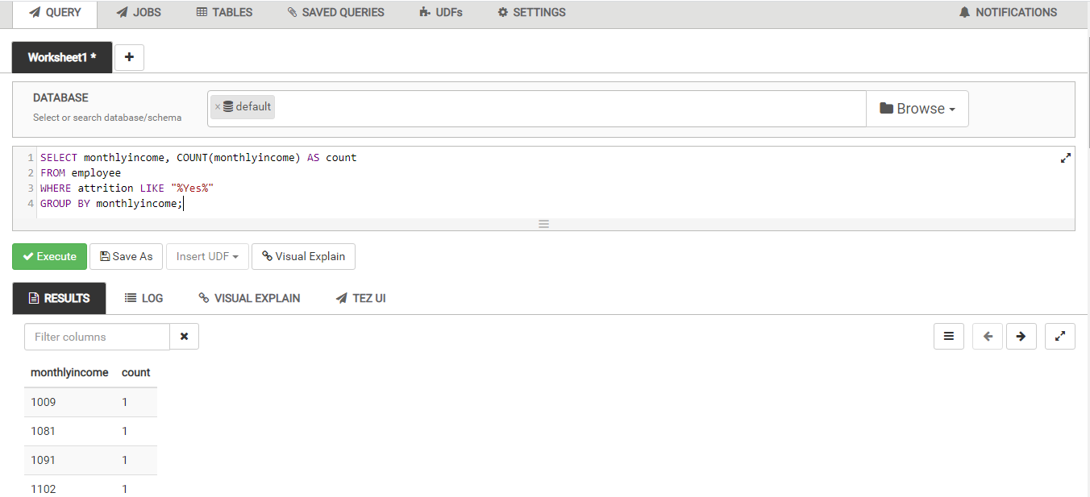

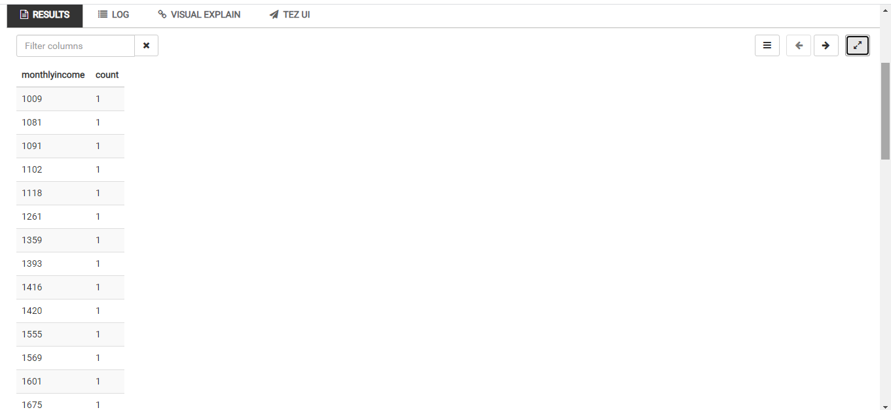

Query:

SELECT monthlyincome, COUNT(monthlyincome) AS count

FROM employee

WHERE attrition LIKE “%No%”

GROUP BY monthlyincome;

