3/12/2024

Author

Rashmi Navale

**Employee Management System**

Employee Management System

*Introduction:*

Employee Management System Project in ReactJS and Spring Boot Full Stack Project. It helps us to provide Employee’s basic information. Information includes first name, last name and email.

The Project employee can perform operations such as add employee, update employee’s information, delete the employee’s information and also able to view details of employees.

*Frontend Technologies Used:*

* + - React JS
    - Vite JS
    - Bootstrap CSS
    - JavaScript
    - NPM
    - Axios

*Backend Technologies Used:*

* Spring boot
* Spring Security
* JSON Web Token
* Spring Data JPA
* MySQL
* Maven
* Postman Client

*Software Used in Employee Management System:*

* **STS (Spring Tool Suite):**

### **For developing our backend, employee management system project using Spring Boot, we have used STS (Spring Tool Suite)**

* **VS Code (Visual Studio Code):**

### **For developing our frontend, employee management system** **project using react js, we have used VS Code (Visual Studio Code).**

* **MySQL Workbench:**

### **For efficient querying and manipulation of our Project's information, we have used MySQL Workbench.**

* **Postman Client:**

For sending HTTP Requests, setting parameters and viewing responses, we have used Postman Client to test the API’s.

*CRUD Features:*

* **Create Employee**
* **List Employee**
* **Update Employee**
* **Delete Employee**
* **View Employee**

*Functional Modules:*

**1] Create Employee**

**Create Employee functionality can create Employee. This feature is basically used for new Employee.**

**2] List Employee**

**List of Employees can show list of employees available in system.**

**3] Update Employee**

**Update Employee can update the information of Employee. If there is any kind of mistake occurred, then we can update it easily.**

**4] Delete Employee**

**Delete Employee can delete the employee details from System.**

**5] View Employee**

**View Employee can show employee complete details by providing his/her name and email address.**

*Screenshots:* 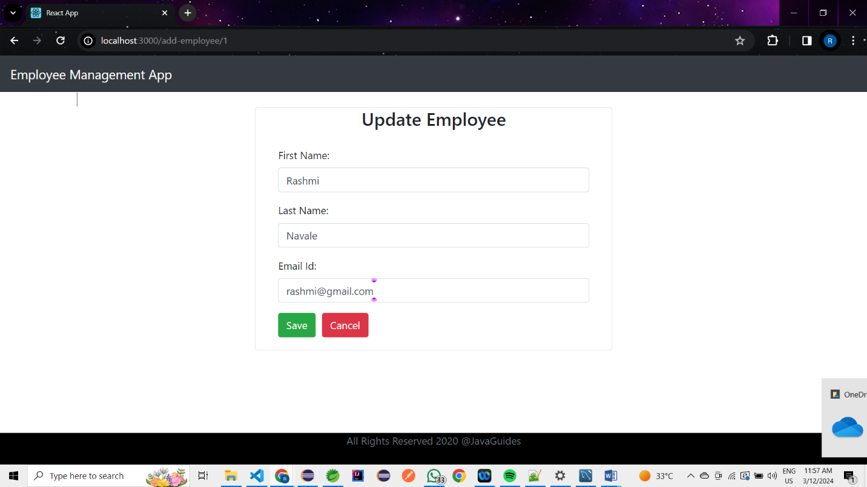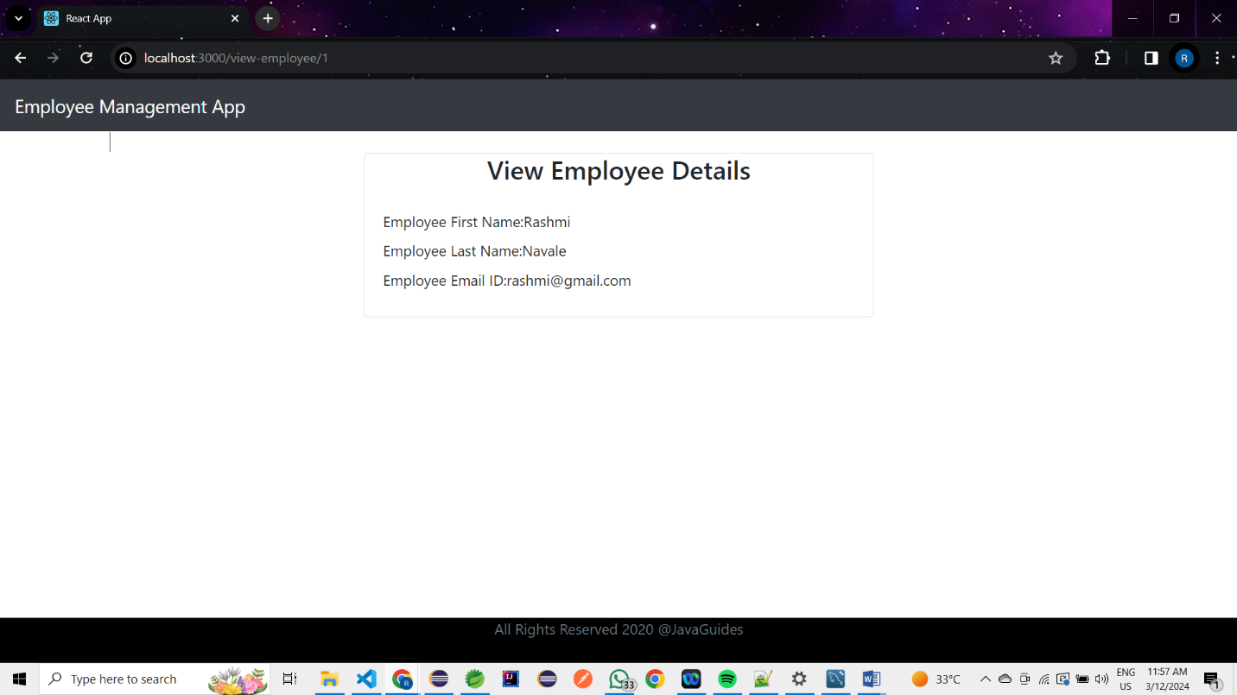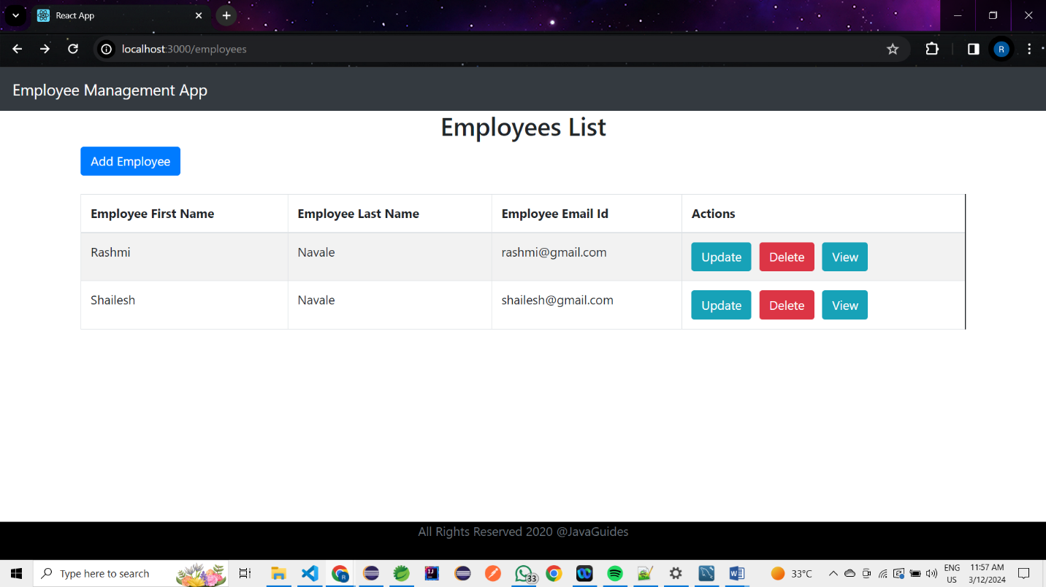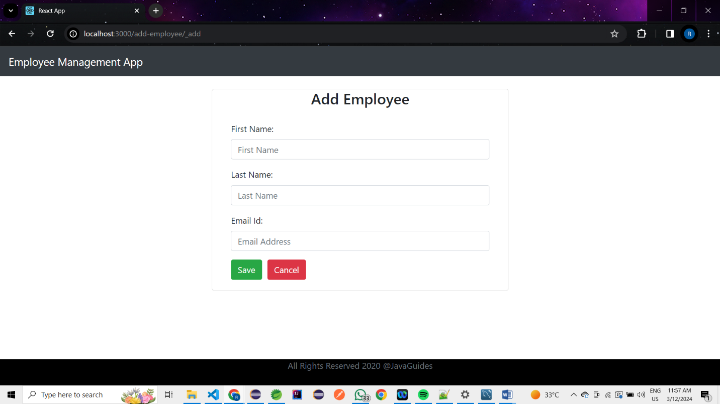

*Overview:*

The Employee Management System Project using React JS and Spring Boot is project where Admin can add the employee to the employee management system. After adding the tasks to the system, and now Admin will update the employee if necessary. He can delete the employee as well if it’s not necessary.

It helps us to provide Employee’s basic information. Information includes first name, last name and email.

The Project employee can perform operations such as add employee, update employee’s information, delete the employee’s information and also able to view details of employees. At the end, Admin/Employees will be able to see all the functionalities in the dashboard.

🙫🙫🙫