A
MINI PROJECT REPORT

ON

GLOBAL AIR QUALITY MONITOR

Submitted in Partial Fulfillment of the Requirements for the Degree of

BACHELOR OF SCIENCE

IN

COMPUTER SCIENCE

By

ASWIN VIJITH.P

REG.NO: 23083111802111017

Under the Guidance of

Ms MELLBA

Department of Computer Science(Aided)
(Professor)


DEPARTMENT OF COMPUTER SCIENCE(AIDED)

NESAMONY MEMORIAL CHRISTIAN COLLEGE
MINI PROJECT REPORT

Title:
GLOBAL AIR QUALITY MONITOR

Name:
ASWIN VIJITH.P

Roll Number:
23083111802111017

Department:
Computer Science

Semester:
5th Semester

College / University:
NESAMONY MEMORIAL CHRISTIAN COLLEGE, MARTHADAM

Guide:
MELLBA

Date of Submission:
[Date]

DECLARATION

I hereby declare that this mini project report titled "GLOBAL AIR QUALITY MONITOR" is the result of my own work under the guidance of MELLBA , submitted in partial fulfillment for the degree of B.Sc / B.Tech in Computer Science.

Signature
ASWIN VIJITH.P
Date: [Date]

CERTIFICATE

This is to certify that the mini project titled "GLOBAL AIR QUALITY MONITOR" is a bonafide work done by ASWIN VIJITH.P of 5th semester, under my guidance.

Guide Name & Signature HOD Name & Signature

(With Institution Seal)

TABLE OF CONTENT

TABLE OF CONTENTS

- Introduction

- Objective

- Tools & Technologies Used

- System Design

- Project & API description.

- API Integration logic & error handling

- Implementation

- Screenshots

- Conclusion

- Future Scope

- References

INTRODUCTION

INTRODUCTION

The Global Air Quality Monitor is a cloud-based application designed to provide real-time insights into air quality across the globe. Environmental conditions, particularly air pollution levels, have become a critical concern for public health and climate studies. This project addresses the need for an accessible platform where users can quickly obtain reliable air quality data for any city worldwide.

The workflow is simple:

A user enters the name of a city.
The application calls the OpenWeather Geocoding API to obtain its latitude and longitude.
Using these coordinates, the OpenWeather Air Pollution API is invoked to fetch the real-time Air Quality Index (AQI) and pollutant concentration data.
This enables the application to deliver location-specific, up-to-date air quality information without requiring the storage or manual updating of vast datasets.

Role of Cloud in the Project

The project leverages cloud-hosted services to ensure reliability, scalability, and global data access. Instead of manually collecting and storing environmental data, the system relies on OpenWeather’s cloud infrastructure, which provides:
- Global Coverage: Access to air quality data from thousands of monitoring stations worldwide.
- Real-Time Updates: Instant access to the latest measurements without delay.
- Scalability: Ability to serve multiple users simultaneously without performance issues.
- No Local Storage Overhead: Reduces the need for setting up databases and servers for environmental data.
The cloud ensures that the application remains lightweight and accessible, while still providing high-quality insights.

Role of APIs in the Project

APIs (Application Programming Interfaces) act as the backbone of this system by enabling seamless communication between the application and the cloud data providers. Two major APIs are integrated:

OpenWeather Geocoding API
Input: City name (e.g., Delhi)
Output: Latitude and Longitude (e.g., 28.7041, 77.1025)

OpenWeather Air Pollution API
Input: Latitude and Longitude
Output: Air Quality Index (AQI) and concentrations of pollutants like CO, NO₂, O₃, and PM2.5.

OBJECTIVE

2. OBJECTIVE

1. Main Aim

The primary objective of this project is to develop a web-based application that connects to a cloud database through an API to perform real-time data operations such as Create, Read, Update, and Delete (CRUD). The application specifically focuses on monitoring global air quality levels by integrating cloud-hosted APIs from OpenWeather. By combining cloud computing and web technologies, the system aims to deliver accurate, scalable, and user-friendly solutions for environmental monitoring.

2. Detailed Objectives

1. Real-Time Data Retrieval

- Integrate the OpenWeather Geocoding API to convert user-input city names into geographical coordinates (latitude and longitude).

- Use the OpenWeather Air Pollution API to fetch live air quality data, including AQI (Air Quality Index) and pollutant concentrations..

- Ensure that data updates dynamically without requiring manual refresh or offline storage.

2. Cloud-Based Storage & Processing

- Store fetched data (such as city details, AQI history, and timestamps) in a cloud-hosted database for easy access and scalability.

- Leverage cloud infrastructure to ensure high availability and low-latency operations.

- Implement a structured data model that supports CRUD operations, allowing users or administrators to add, view, edit, or delete stored information.

3. User Interaction via Web Application

- Design an intuitive frontend interface where users can input city names, view AQI results, and track environmental conditions in real time.

- Provide data visualization using tables, graphs, and charts for better interpretation.

- Enable user-friendly functionalities such as search, filters, and comparisons between different cities or time periods.

4. Scalability and Accessibility

- Ensure the web application is cloud-deployed, making it accessible globally via browsers or mobile devices.

- Design the system so that multiple users can access data simultaneously without performance degradation.

- Prepare the architecture to support future expansions, such as mobile app integration, IoT devices, or predictive AI models.

5. Environmental Awareness and Decision Support

- Provide actionable insights about air quality, including health warnings and interpretation of AQI levels.

- Assist individuals, organizations, and researchers in making informed decisions regarding air pollution and climate awareness.

- Contribute to global efforts for sustainable development and environmental monitoring.

3. Why Cloud + API for the Objective?

Cloud provides the backbone for data storage, scalability, and global access. Without maintaining a local server, the system can offer fast, reliable, and cost-efficient services to users worldwide.

API integration allows seamless data exchange between the application and external service providers. By relying on OpenWeather’s APIs, the project ensures accurate, up-to-date, and globally available datasets.

Together, cloud and APIs make it possible to handle real-time operations efficiently while maintaining flexibility for future enhancements.

OVERVIEW OF WEB DEVELOPMENT

Introduction to Web Development

Web development is the process of creating and maintaining websites and web applications that can be accessed over the internet. It involves a combination of programming, design, and problem-solving skills to build interactive and user-friendly digital experiences. In today's digital world, web development plays a vital role in nearly every industry, serving as the digital face and functional platform for businesses, education, and social interaction.

Modern Web Development
Modern web development is typically split into three main areas, each requiring different skills and tools:
Area | Description | Example Technologies
Front-End Development (Client-Side) | Deals with the user interface and user experience—everything the user sees and interacts with in their browser. | HTML, CSS, JavaScript
Back-End Development (Server-Side) | Focuses on the server, application logic, and database. It manages data, security, and authentication. | Python (Django/Flask), PHP, Node.js, Java
Database Management | Responsible for storing, organizing, and retrieving data for the web application. | MySQL, MongoDB, PostgreSQL

The growth of web technologies has transformed websites from simple static pages into dynamic applications that support e-commerce, social networking, online education, and more. Understanding web development is essential for anyone interested in technology, as it provides the foundation for building modern digital solutions and shaping the future of the internet.

Front-End Development

Front-end development, also known as client-side development, is the process of creating the visual layer of a website or web application. It focuses heavily on the User Experience (UX) and User Interface (UI) design, ensuring that websites are aesthetically pleasing, easy to navigate, and highly performant.

1. Purpose and Role
The main goal of front-end development is to convert a website's static graphic design into a fully functional, interactive digital interface. Designers may create mockups using tools like Figma or Sketch, but front-end developers bring these designs to life using code. They ensure that the site looks consistent across different devices and browsers, loads quickly, and provides smooth interaction for users.
Front-end developers work as a bridge between web designers and Back-end developers:
- They take design concepts and translate them into code that the browser can render.
- They communicate with back-end developers to properly integrate the UI with server-side logic and APIs for data exchange.

2. The Core Trio of Front-End Development
Front-end development is built on three key web technologies that work together in harmony:
Technology | Role/Analogy | Core Function
HTML (HyperText Markup Language) | Structure (The Skeleton) | Defines the logical structure and content of a webpage.
CSS (Cascading Style Sheets) | Presentation (The Skin/Clothes) | Adds visual style, layout, and formatting to the HTML content.
JavaScript | Behavior (The Muscles/Nervous System) | Enables dynamic content, interactivity, and communication with the server.

3. Advanced Tools and Frameworks
Modern web development uses powerful frameworks and libraries to streamline development, manage complex user interfaces, and improve performance. These tools build upon the core trio of HTML, CSS, and JavaScript.
- CSS Frameworks: Tools like Bootstrap or Tailwind CSS provide pre-designed components and utility classes to speed up styling and ensure responsive design out of the box.
- JavaScript Libraries: jQuery simplifies DOM manipulation, while React (a library, not a full framework) helps in building complex, interactive user interfaces by managing state and using a component-based architecture.

- JavaScript Frameworks: Angular and Vue.js are comprehensive frameworks that offer structure, state management, and routing to build large-scale, single-page applications (SPAs).
These tools help developers build efficient, scalable, and maintainable front-end codebases.

Key Concepts in Front-End Development
- Responsive Design: Ensuring that websites work smoothly and look great on all devices (mobile, tablet, desktop) by using flexible grids, images, and media queries.
- Cross-Browser Compatibility: Making sure the website functions identically across different web browsers (Chrome, Firefox, Safari, Edge).
- Performance Optimization: Reducing page load times by minimizing file sizes (HTML, CSS, JS), optimizing images, and utilizing caching.
- Accessibility (A11y): Designing and coding websites so that people with disabilities can easily access and interact with them, often by adhering to standards like the Web Content Accessibility Guidelines (WCAG).

Connection with Back-End
Front-end development does not work alone. It communicates with the back-end using APIs (Application Programming Interfaces). The front-end sends requests to the back-end (e.g., to fetch user data or submit a form), and the back-end processes the request, interacts with the database, and sends a response (usually in JSON format) back to the front-end, which then updates the UI.

Importance
Front-end development is essential for creating a positive user experience. A poorly designed or slow-loading front end can drive users away, no matter how strong the back-end functionality is. It is the face of the application and directly impacts user satisfaction and engagement.

The Core Technologies Explained

1. HTML (HyperText Markup Language)
HTML is the backbone of any web page, responsible for providing the structure and content of a site. It is a markup language, which means it uses predefined tags (e.g., <h1>, <p>, <img>) to describe the various elements on a webpage.
- Purpose: To organize and arrange content so that web browsers can interpret and display it correctly.
- Function: It defines what appears on the page, such as titles, sections, links, or embedded media, but does not dictate how these elements will look.
- Significance: Without HTML, a webpage would have no framework for presenting text, multimedia, or interactive elements. It ensures that content is accessible and logically structured for both users and search engines.
  - HTML also provides the ability to create semantic elements (e.g., <header>, <main>, <footer>), which gives meaning to different parts of the content, improving Accessibility and Search Engine Optimization (SEO).

2. CSS (Cascading Style Sheets)
CSS is a style language used to control the visual presentation of an HTML document. While HTML determines the structure, CSS defines how that structure should look on the screen.
- Purpose: To make web pages visually attractive and to enhance the user experience by adding design and layout.
- Function: CSS specifies colors, fonts, spacing, margins, borders, backgrounds, and positioning of elements on a webpage. It allows designers to create consistent visual styles across multiple pages of a site using style rules.
- Significance: CSS separates the design layer from the content layer, which makes it much easier to maintain and update the look of a website without altering the underlying structure.
  - An important feature of CSS is its ability to create responsive designs. Using flexible layouts (like Flexbox or Grid) and media queries, CSS ensures that websites adapt seamlessly to different screen sizes and devices, which is essential for a smooth browsing experience.

3. JavaScript
JavaScript is a high-level programming language that adds dynamic functionality and interactivity to web pages. While HTML provides content and CSS adds style, JavaScript brings life to a website by allowing real-time changes and user-driven actions.
- Purpose: To make web pages interactive and capable of responding to user input.
- Function: JavaScript enables features such as animations, form validation, interactive maps, and real-time data updates without a full page reload (known as AJAX). It manipulates the DOM (Document Object Model)—the programming interface for HTML and XML documents—to dynamically change the content and style of the page.
- Significance: It transforms a static website into a rich web application by handling tasks like updating content, processing user actions, and communicating with servers.
  - JavaScript can also interact with external services using APIs (Application Programming Interfaces), making it possible to fetch live data—for example, displaying weather updates, stock prices, or social media feeds directly on a webpage.

Back-End Development (Server-Side)
This layer is the "engine room" of a web application. It handles the logic, data storage, user authentication, and communication with the front-end. Back-end code runs on a server, not the user's browser.

Key Responsibilities:
- Application Logic: Implementing the business rules (e.g., how a transaction is processed, how user data is validated).
- API Management: Creating the endpoints (URLs) that the front-end uses to send and receive data (e.g., /api/users, /api/products).
- Data Interaction: Communicating with the database to store and retrieve information.
- Security and Authentication: Managing user logins, permissions, and protecting data.

Understanding APIs (Application Programming Interfaces)
APIs are the contract and communication channel between the front-end and the back-end (and between different services).

REST (Representational State Transfer)
- Definition: The most common architectural style for web APIs. It is simple, stateless, and relies on standard HTTP methods.
- Endpoints: Specific URLs that represent resources (e.g., /users).
- HTTP Methods (CRUD Operations):
  - GET: Read/Retrieve a resource (e.g., fetch a list of products).
  - POST: Create a new resource (e.g., submit a new user registration).
  - PUT/PATCH: Update an existing resource.
  - DELETE: Delete a resource.
- Data Format: Data is typically exchanged using JSON (JavaScript Object Notation), a lightweight, human-readable format.

The Request-Response Cycle:
- Request: The user interacts with the UI (Front-End).
- The Front-End sends an HTTP request (e.g., a GET request) to the Back-End API endpoint.
- Processing: The Back-End receives the request, runs the application logic, and queries the database.
- Response: The Back-End sends an HTTP response containing the requested data (in JSON format) back to the Front-End.
- Rendering: The Front-End uses JavaScript to update the DOM and display the new data.

Database Management Systems (DBMS)
The database is the structured storage for all application data (user profiles, products, orders, etc.).

1. Relational Databases (SQL - Structured Query Language):
- Concept: Data is organized into structured tables with predefined schemas. Relationships are defined between tables.
- Strengths: Data integrity, reliable ACID properties (Atomicity, Consistency, Isolation, Durability).
- Examples: PostgreSQL, MySQL, SQL Server.

2. Non-Relational Databases (NoSQL - Not Only SQL):
- Concept: Data is stored in flexible formats (documents, key-value pairs, graphs). No rigid schema.
- Strengths: High scalability, better performance for large amounts of data, flexible for rapidly changing data structures.
- Examples:
  - Document: MongoDB (stores data as flexible JSON-like documents).
  - Key-Value: Redis.

ORM (Object-Relational Mapping):
A tool or library (like Django's ORM or SQLAlchemy in Python) that allows developers to interact with the database using their programming language's objects, rather than writing raw SQL code. This simplifies development and reduces errors.

The Development Environment and Tools
Professional web development requires a specialized environment and set of tools to write, test, and manage code efficiently.

1. Code Editors and IDEs (Integrated Development Environments):
- Visual Studio Code (VS Code): The most popular choice due to its speed, vast extensions marketplace, and excellent support for all languages.
- IDE Features: Integrated terminal, debugger, code intelligence (autocompletion), and built-in Git integration.

2. Version Control (Git):
- Purpose: A system that tracks changes to source code over time. It allows developers to collaborate, revert to previous versions, and manage different features simultaneously.
- GitHub/GitLab/Bitbucket: Cloud-based platforms that host Git repositories, enabling team collaboration and code backup.
- Core Commands: git clone, git branch, git add, git commit, git push/pull.

3. Package Managers:
- npm (Node Package Manager): Used for managing JavaScript dependencies (libraries and frameworks) in both front-end and back-end (Node.js) projects.
- pip (Python): Used for managing Python packages.
- Function: Automates the process of installing, updating, and configuring project dependencies.

Testing
Writing code requires writing tests to ensure stability and prevent bugs.
- Unit Tests: Test individual components or functions in isolation.
- Integration Tests: Test how different parts of the application (e.g., front-end communicating with back-end) work together.
- End-to-End (E2E) Tests: Simulate a full user journey through the application (e.g., "log in, add an item to the cart, and check out").

Web Security Fundamentals
Security is paramount in web development. Developers must protect against common vulnerabilities.

1. Common Front-End Vulnerabilities:
- Cross-Site Scripting (XSS): Injecting malicious client-side scripts into a web page viewed by others. Prevention: Input sanitization and proper encoding of user data before rendering.
- Insecure Dependencies: Using outdated libraries with known vulnerabilities. Prevention: Regularly updating packages.

2. Common Back-End Vulnerabilities:
- SQL Injection (SQLi): Attacker exploits vulnerabilities to inject malicious SQL code to view or modify data. Prevention: Use parameterised queries (prepared statements).
- Cross-Site Request Forgery (CSRF): application where they are currently authenticated. Prevention: Use CSRF tokens.
- Insecure Direct Object Reference (IDOR): Attacker changes a parameter (like a user ID) to access data they are not authorized for. Prevention: Implement strict access control checks on the server side.

3. Authentication & Authorization:
- Authentication: Verifying the user's identity (login, password).
- Authorization: Determining what the authenticated user is allowed to do (permissions).
- Best Practice: Never store passwords in plain text; use strong, one-way hashing algorithms (e.g., bcrypt). Use JWT (JSON Web Tokens) for stateless authentication.

Hosting and Deployment (DevOps Basics)
After development, the application needs to be deployed (made available) on a server accessible to the public internet.

1. Deployment Steps:
- Build: Compiling and minifying front-end assets (HTML, CSS, JS) for production use.
- Configuration: Setting up server environment variables (database credentials, secrets).
- Transfer: Moving the application code to the server.
- Runtime: Starting the application server process (e.g., starting the Node.js or Python server).

2. Cloud Providers and Hosting:
- IaaS (Infrastructure as a Service): You manage the OS, runtime, and application (e.g., AWS EC2, Google Compute Engine).
- PaaS (Platform as a Service): The provider manages the infrastructure, OS, and scaling; you only deploy your code (e.g., Heroku, Google App Engine).
- Static Hosting: For simple front-end sites (HTML/CSS/JS) (e.g., Netlify, Vercel, GitHub Pages).

3. CI/CD (Continuous Integration/Continuous Deployment):
- Continuous Integration (CI): Automating the process of merging, building, and testing code whenever a developer makes a change.
- Continuous Deployment (CD): Automating the deployment of the code to production after CI tests pass successfully.
- Tools: GitHub Actions, GitLab CI, Jenkins. This practice speeds up the delivery cycle and ensures code quality.

Advanced Front-End Architectures
As applications grow, basic JavaScript doesn't suffice. Frameworks introduce better structure.

Single Page Applications (SPAs):
- Concept: The entire application loads once, and subsequent interactions dynamically rewrite the current page rather than loading new HTML pages from the server.
- Benefits: Faster user experience (feels like a desktop app), better separation of concerns.
- Frameworks: React, Angular, Vue.js.

Component-Based Architecture:
- Concept: Building the UI as a collection of independent, reusable, and self-contained components (e.g., a <Button>, a <Header>, a <ProductCard>).
- Benefits: Easier maintenance, reusability across the application, better collaboration.

State Management:
- Problem: In complex SPAs, data (state) needs to be shared across many components. Managing this flow becomes difficult.
- Solutions: Libraries like Redux (for React) or built-in context APIs provide a predictable way to manage a global application state.

Modern Backend Architectures
The way back-end systems are designed has also evolved for better scalability.

Monolithic Architecture:
- Concept: A single, large codebase that contains all the application's functionality (front-end, back-end, business logic).
- Drawbacks: Difficult to scale specific parts, slow development cycles, high barrier to adopting new technologies.

Microservices Architecture:
- Concept: Breaking the application into a collection of smaller, independent services, each running its own process and communicating via APIs.
- Benefits: Services can be developed, deployed, and scaled independently; teams can use the best technology for each service.
- Challenge: Increased complexity in deployment and network communication.

Search Engine Optimization (SEO)
Ensuring a website is easily discoverable by search engines is a crucial part of web development.

Technical SEO:
- Crawlability: Ensuring search engine bots (spiders) can easily access and index the site.
  - Use correct sitemaps and manage the robots.txt file.
- Site Speed: Google prioritizes fast-loading sites. This relies on efficient HTML/CSS/JS and server performance.
- Mobile-First Indexing: Ensuring the mobile version of the site is fully functional, as Google uses this as the primary index.

Content SEO:
- Semantic HTML: Using elements like <header>, <footer>, and <article> helps bots understand the page structure.
- Metadata: Using descriptive <title> tags and <meta name="description"> to accurately summarize the page content.
- Schema Markup: Adding structured data (JSON-LD) to help search engines understand the content's context (e.g., "this is a recipe," "this is a business address").

API INTEGRATION:

Integrating the Front-End with an Open Source API
The true power of the front-end trio (HTML, CSS, JS) is realized when it communicates with external data sources. This interaction transforms a static page into a dynamic web application.

Introduction to Open Source APIs and Data Fetching

What is an Open Source API?
An Open Source API (Application Programming Interface) is a publicly accessible set of rules and protocols that allows an application to access data or functionality from a server. For demonstration purposes, we often use "Public" or "Open" APIs that don't require complex authentication.

Data Format: JSON
When a front-end application requests data from an API, the server typically responds with data formatted in JSON (JavaScript Object Notation). JSON is a lightweight, human-readable format that is easy for JavaScript to parse and use.
JSON
{
"name": "Acme Weather",
"temperature": 25,
"unit": "Celsius",
"forecast": [
{"day": "Fri", "high": 27},
{"day": "Sat", "high": 29}
]
}

The fetch API in JavaScript
The modern standard for making HTTP requests from the browser is the fetch() API. It's a built-in browser function that uses Promises for asynchronous operations, meaning the browser can continue executing other code while waiting for the server's response.
Core Steps for Data Fetching:
- Request: Call fetch(url) with the API endpoint URL.
- Response: The initial response is received. Use the .then() method to handle the promise.
- JSON Conversion: Call the .json() method on the response to convert the raw data stream into a usable JavaScript object.
- Data Utilization: Use a final .then() to work with the data object and dynamically update the HTML/DOM.

Implementation: The JavaScript Core Logic
To implement this, we'll assume a project structure with three files: index.html, style.css, and script.js. The JavaScript file orchestrates the entire process.

Step 1: Define the Function and API Key
In script.js, create an asynchronous function to handle the request.
JavaScript
// Example using a hypothetical Open Weather API endpoint
const API_URL = 'https://api.example.com/weather?city=london';

async function fetchWeatherData() {
try {
// 1. Make the request
const response = await fetch(API_URL);

// Check if the request was successful (HTTP status 200)
if (!response.ok) {
throw new Error(`HTTP error! status: ${response.status}`);
}

// 2. Convert the response to JSON
const data = await response.json();

// 3. Process and display the data
displayWeather(data);

} catch (error) {
// Handle any network or parsing errors
console.error("Could not fetch data:", error);
document.getElementById('app').innerHTML = `<p>Error loading weather data. Please try again.</p>`;
}
}

// Execute the function when the page loads
fetchWeatherData();

Step 2: Dynamically Update the HTML (DOM Manipulation)
This function takes the parsed JSON data and injects it into the existing HTML structure.
JavaScript
function displayWeather(weatherData) {
// Get the main container element
const appContainer = document.getElementById('app');

// Use Destructuring for clean access to data
const { name, temperature, unit } = weatherData;

// Create the HTML content dynamically
const htmlContent = `
<div class="weather-card">
<h2>Weather in ${name}</h2>
<p class="temp">${temperature}°${unit}</p>
<button onclick="alert('Forecast coming soon!')">View Forecast</button>
</div>
`;

// Inject the new content into the container
appContainer.innerHTML = htmlContent;
}

The Full-Stack View (Front-End & API Integration)
This process represents a minimal Full-Stack Implementation because the application logic is split between two places:

1. The Client (Front-End - HTML, CSS, JS)
- HTML: Provides the basic structure, including a single empty container (<div id="app"></div>).
- CSS: Styles the container, the heading, and the temperature display (e.g., center alignment, font sizes).
- JavaScript: Acts as the Client-Side Controller. It:
  - Initiates the request to the external server (API).
  - Handles the API response.
  - Manipulates the DOM to render the data to the user.

2. The Server (API - Open Source External Server)
- API Endpoint: The specific URL that accepts the request.
- Server Logic: The remote server executes code to retrieve the London weather data from its database.
- Response: The server sends back a standardized JSON payload.

The Full-Stack Flow
- User opens index.html.
- script.js executes fetchWeatherData().
- Browser sends HTTP GET Request to https://api.example.com/weather?city=london.
- External Server processes the request and returns JSON Data.
- script.js receives the JSON, calls displayWeather().
- The browser updates the <div id="app"> with the new HTML, and style.css ensures it looks visually appealing.
This demonstrates the crucial dependency between the three front-end technologies and the external data source, forming a functional web application.

Enhancing UX with CSS and JavaScript
Once the basic integration works, the next step is to improve the User Experience (UX) using the respective strengths of CSS and JS.

CSS: Handling Loading States
A smooth UX requires acknowledging the asynchronous nature of API calls. The user shouldn't see an empty screen while waiting for data.
Initial HTML: Place a simple loader in the HTML container.
HTML
<div id="app">
<div class="loader">Loading weather...</div>
</div>

- CSS: Style the loader (e.g., a simple spinning animation).
- JavaScript Logic:
  - When the request starts (fetchWeatherData begins), ensure the loader is visible.
  - When the data is successfully received (in the displayWeather function), replace the loader with the actual content.
  - If an error occurs, replace the loader with an error message.

JavaScript: Input and Interaction
To make the application truly dynamic, let the user decide which city to view.
HTML: Add an input field and a button.
HTML
<input type="text" id="city-input" placeholder="Enter city name">
<button id="search-btn">Get Weather</button>

JavaScript: Attach an Event Listener to the button.
JavaScript
document.getElementById('search-btn').addEventListener('click', () => {
const city = document.getElementById('city-input').value;
// Re-run the fetch function with the new city name
fetchWeatherData(city);
});
// Note: The fetchWeatherData function must be updated to accept and use the 'city' parameter.

TOOLS & TECHNOLOGIES USED

3. TOOLS & TECHNOLOGIES USED

Frontend: HTML, CSS, JavaScript

Backend: php

Cloud Database: mysql

API Type: REST API

Tools: VS Code, GitHub, Postman

HTML (HyperText Markup Language)

1. Definition

HTML, or HyperText Markup Language, is the standard markup language used for creating web pages and web applications. It provides the structural foundation of a website, ensuring that all elements are arranged logically and can be rendered correctly by browsers.

Defines the skeleton of a webpage.

- Uses a system of tags and attributes to represent elements.

- Recognized universally across all modern browsers.

- Forms the base layer that is later styled with CSS and made interactive with JavaScript.

2. Role in Project

In the Global Air Quality Monitor application, HTML plays a central role in shaping the user interface (UI) and organizing how information is presented.

Application Structure

- Provides the overall framework of the web application.

- Defines separate sections for search input, AQI data, pollutant details, and charts.

Input Forms

- Allows users to type a city name through <form> and <input> tags.

- Ensures smooth interaction between the user and backend APIs.

Data Display

- Organizes and labels outputs such as:

- Air Quality Index (AQI) values.

- Pollutant concentration levels (CO, NO₂, PM2.5, O₃, etc.).

- Historical charts and comparative tables.

3. Why HTML?

Universal Browser Support

- Works seamlessly across Chrome, Firefox, Edge, Safari, and mobile browsers.

- Eliminates compatibility issues.

Lightweight & Easy Maintenance

- Quick to develop and modify.

- No complex configurations required.

Semantic Benefits

- Provides semantic tags such as <header>, <section>, <footer>.

- Enhances code readability and SEO ranking.

- Improves accessibility for screen readers and assistive technology

CSS (Cascading Style Sheets)

1. Definition
CSS, or Cascading Style Sheets, is a styling language used to control the visual presentation of web pages. While HTML provides the structure of the content, CSS defines how that content looks and feels to the user.
- Determines colors, fonts, spacing, and layouts.
- Makes applications responsive across devices (desktop, tablet, mobile).
- Separates content (HTML) from design (CSS) for cleaner code and easier maintenance.
- Supports animations, transitions, and effects to improve interactivity.

2. Role in Project
In the Global Air Quality Monitor application, CSS is essential for creating a user-friendly interface that is both functional and visually appealing.
- Page Layout & Structure
  - Defines consistent layouts using flexbox or grid systems.
  - Aligns elements like search boxes, data tables, and charts in a structured way.
- Styling of Input & Output
  - Enhances the appearance of the city name input form.
  - Styles the AQI data display, pollutant indicators, and result cards.
  - Improves readability of text and numerical data.
- Responsive Design
  - Ensures the application adapts seamlessly to different screen sizes.
  - Provides a smooth experience whether accessed on a laptop, tablet, or smartphone.
- Data Visualization Support
  - Styles charts and graphs to make them easy to interpret.
  - Uses color codes to highlight different AQI levels (e.g., green = good, red = hazardous).

3. Why CSS?
- Improved User Experience (UX)
  - Makes the interface clean, intuitive, and easy to navigate.
- Separation of Concerns
  - Keeps structure (HTML) separate from design (CSS).
  - Allows developers to make style changes without altering functionality.
- Responsive & Mobile-Friendly
  - CSS media queries allow designs to adapt to all devices.
  - Critical for global applications accessed by diverse users.
- Efficiency & Maintainability
  - Centralized styles can be applied across multiple pages.
  - Reduces redundancy and simplifies updates.
- Professional Appearance
  - Consistent typography, color schemes, and spacing establish trust.
  - Enhances the credibility of the project.

JavaScript (JS)

1. Definition

JavaScript is a high-level scripting language widely used to make web pages dynamic and interactive. Unlike HTML, which defines structure, and CSS, which defines style, JavaScript enables real-time functionality such as form validation, event handling, animations, and API communication. It runs directly in the browser without the need for additional software, making it one of the most important languages for modern web development.

- Provides interactivity and logic control.

- Supports integration with REST APIs for real-time data.

- Works seamlessly with HTML and CSS as part of the frontend stack.

2. Role in Project

In the Global Air Quality Monitor application, JavaScript is the driving engine that connects the user interface with live environmental data.

API Integration

- Sends requests to the OpenWeather Geocoding API to get latitude and longitude.

- Fetches air quality data using the Air Pollution API.

- Handles asynchronous operations with fetch() or AJAX calls.

Dynamic Data Updates

- Displays air quality results instantly without reloading the page.

- Updates AQI values, pollutant levels, and charts in real time.

User Interaction

- Captures city name input from users.

- Validates entries before sending API requests.

- Provides instant error messages if invalid data is entered.

Data Visualization

Uses libraries like Chart.js or D3.js to represent AQI trends graphically.

Employs color coding for air quality categories (e.g., green = safe, red = hazardous).

3. Why JavaScript?

- Real-Time Functionality – Essential for fetching and displaying live air quality data.

- Wide Compatibility – Runs on all browsers without installation.

- Rich Ecosystem – Large number of libraries and frameworks available.

- Event Handling – Allows instant response to user actions (e.g., button clicks).

- Lightweight & Fast – Executes directly in the client’s browser for better performance.

PHP
1. Definition

PHP is a server-side scripting language designed primarily for web development. It processes code on the server before sending the output (usually HTML) to the user’s browser. PHP is widely used due to its simplicity, open-source nature, and strong integration with databases like MySQL.

- Executes on the server, not the client’s browser.

- Supports embedding directly into HTML files.

- Known for handling dynamic web applications efficiently.

2. Role in Project

In the Global Air Quality Monitor application, PHP functions as the backend technology that connects the frontend with the database and APIs.

Data Processing

- Receives user input (city name) from the frontend.

- Processes responses from the OpenWeather APIs.

Database Communication

- Connects with MySQL cloud database to store or retrieve AQI records.

- Executes CRUD operations (Create, Read, Update, Delete) on stored environmental data.

Security & Efficiency

- Validates and sanitizes data before saving it.

- Prevents direct exposure of sensitive API keys.

3. Why PHP?

Easy Integration with MySQL – Smooth handling of relational databases.

Open Source & Cost-Effective – No licensing fees.

Wide Community Support – Large number of frameworks and libraries.

Proven Stability – Used in many production-level web applications.

MySQL Database
1. Definition

MySQL is an open-source relational database management system (RDBMS) that organizes data in structured tables. It uses Structured Query Language (SQL) to perform operations like querying, inserting, updating, and deleting records. MySQL is widely recognized for its speed, reliability, and scalability, making it a preferred choice for web-based applications.

2. Role in Project
In the Global Air Quality Monitor, MySQL serves as the cloud database for storing and managing environmental data.
- Data Storage: Saves user queries, city details, latitude/longitude, and corresponding air quality data.
- CRUD Operations: Supports real-time Create, Read, Update, and Delete functions for air quality records.
- Integration: Works seamlessly with PHP backend to fetch and display results to users.

3. Why MySQL?
- Free and open-source, reducing project costs.
- Strong integration with PHP for smooth backend operations.
- Highly scalable to handle growing datasets.
- Well-documented and supported by a large developer community.
Visual Studio Code (VS Code)

Definition:

VS Code is a free, lightweight, and powerful source code editor developed by Microsoft. It supports multiple programming languages, extensions, and integrated tools for efficient development.
Role in Project:
- Code Development: Used to write HTML, CSS, JavaScript, and PHP code.
- Debugging & Testing: Provides inbuilt debugging tools to identify errors.
- Extensions: Supports Git integration, linters, and API testing plugins.
- Terminal Access: Allows running scripts and connecting with cloud databases.

Why VS Code?

Free and cross-platform (Windows, Mac, Linux).
Lightweight and fast with a rich ecosystem of extensions.
Enhances productivity with smart code suggestions and shortcuts.

GitHub

Definition:

GitHub is a cloud-based version control platform built on Git, used to store, manage, and track changes in code.

Role in Project:

- Stores the project repository securely.
- Maintains version control for tracking updates.
- Enables collaboration and backup of code.

Why GitHub?

  - Cloud access ensures global availability.
  - Simplifies collaboration and code management.

SYSTEM DESIGN

Simple Block Diagram:

Back-End(API Integeration)
Back-end(API integration)
url : `http://api.openweathermap.org/geo/1.0/direct?q=${encodeURIComponent(city2)}&limit=1&appid=${apiKey}`
FrontEnd (clinet-side)
HTML, CSS & JavaScrpit
City Search input
Air Quality Data display
Compare city
Air quality Data of 2 display
REQUEST

LAT & LON
API AIR DATA QUALITY
aqi
Co
No2
O3
So2
Pm25
Pm10
Nh3
Location API
url: http://api.openweathermap.org/data/2.5/air_pollution?lat=${lat1}&lon=${lon1}&appid=${apiKey}`

PROJECT & API DESCRIPTION
GLOBAL AIR QUALITY MONITOR

DESCRIPTION

The Global Air Quality Monitor project is a web-based system developed to provide real-time insights into environmental conditions across different locations worldwide. With the rising concerns of pollution and its impact on human health, this application offers an accessible platform where users can check air quality data in a simple and interactive manner. The project integrates modern web technologies with cloud-based APIs to deliver accurate and reliable information.

Project Objectives
- The primary objectives of this project are:

- To provide real-time air quality data for global cities.

- To enable users to search by city name and access relevant environmental data.

- To ensure smooth data communication between frontend, backend, and cloud APIs.

- To present information in a structured and user-friendly format.
System Workflow

The project follows a step-by-step data flow to ensure accurate results:

1. User Input

The user enters a city name in the search box.

2. Geocoding API

The system sends this input to the OpenWeather Geocoding API, which returns latitude and longitude.

3. Air Pollution API

Using these coordinates, the application queries the Air Pollution API to retrieve Air Quality Index (AQI) and pollutant levels.

4. Data Processing

PHP backend processes the data and stores relevant records in the MySQL cloud database.

5. Result Display

The processed data is displayed to users in a clear, organized dashboard with charts and readings.
. Key Features

Real-Time Updates: Always displays the latest data from trusted sources.

Global Coverage: Works for cities across all continents.

Pollutant Details: Shows AQI along with PM2.5, PM10, CO, NO2, SO2, and O3 levels.

Data Storage: Maintains user queries and records in a cloud-based MySQL database.

FLOW CHART

[Start]
|
V
[User enters city name in search box]
|
V
[User clicks “Search” button]
|
V
[Fetch latitude & longitude from OpenWeather Geocoding API using fetch()]
|
V
[Did Geocoding API respond successfully?] ---No---> [Display error: “Location not found. Please try again.”]
|
Yes
|
V
[Extract latitude and longitude from API response]
|
V
[Fetch air quality data using OpenWeather Air Pollution API with lat/lon]
|
V
[Did Air Quality API respond successfully?] ---No---> [Display error: “Error retrieving air quality data.”]
|
Yes
|
V
[Is air quality data empty or missing?] ---Yes---> [Display: “No air quality data available for <city name>”]
|
No
|
V
[Display air quality data: AQI, main pollutant, etc.]
|
V
[End / Wait for next search]

API Description

Introduction to APIs

An Application Programming Interface (API) is a set of rules and protocols that allows different software systems to communicate with each other. In this project, APIs play a critical role in retrieving real-time geographical and environmental data from the cloud. Instead of building and maintaining a separate data infrastructure, the project leverages OpenWeather APIs, which are reliable, scalable, and globally accessible.

2. APIs Used in the Project

The project integrates two key APIs from OpenWeather to deliver its functionality:

Air Pollution API
Geocoding API

API INTEGRATION & ERROR HANDLING
API INTEGRATION
The project integrates two key APIs from OpenWeather to deliver its functionality:

a. Geocoding API (City to Coordinates)

Purpose: Converts human-readable city names into machine-readable geographical coordinates (latitude and longitude).

Functionality in Project:

User enters a city name (e.g., “Delhi”).

The Geocoding API returns its corresponding lat/lon values.

url : `http://api.openweathermap.org/geo/1.0/direct?q=${encodeURIComponent(city2)}&limit=1&appid=${apiKey}`

These coordinates are required for the next stage of data retrieval.

Significance:

Ensures precise data collection.

Handles cities with duplicate names by providing multiple options with country codes.

b. Air Pollution API (Coordinates to Air Quality Data)

Purpose: Provides air quality data based on geographical coordinates.

Functionality in Project:

Takes latitude and longitude from the Geocoding API.

Returns Air Quality Index (AQI) and pollutant concentrations such as PM2.5, PM10, CO, NO2, SO2, and O3.

Location API
url: http://api.openweathermap.org/data/2.5/air_pollution?lat=${lat1}&lon=${lon1}&appid=${apiKey}`

Significance:

- Offers real-time and historical air quality information.

- Provides data in a structured JSON format for easy integration.

Why OpenWeather APIs?

- Reliability: Backed by a global weather and environmental data provider.

- Scalability: Supports millions of requests worldwide

- Real-Time Data: Ensures users always get updated air quality information.

- Ease of Integration: REST-based APIs with simple request/response structure.

. API Workflow in the Project

1. User inputs a city name.

2. Geocoding API converts the city name into latitude and longitude.

3. Air Pollution API uses these coordinates to fetch real-time AQI and pollutant data.

4. Data is processed by the PHP backend and stored in the MySQL cloud database.

5. Results are displayed on the frontend dashboard.

.

ERROR HANDLING

Since API calls depend on external services and network reliability, robust error handling is required:

Invalid City Input

- If the user enters an invalid city name, the API may return an empty array.
- JavaScript checks if data is empty and displays: “City not found. Try again.”

Network or Server Errors

- If the API server is unreachable, the catch() block handles the error gracefully by showing: “Unable to connect. Please check your internet or try later.”

Invalid API Key / Unauthorized Access

- If an incorrect API key is used, the error is caught and logged, and a user-friendly message is displayed.

Empty Data or Null Values

- Before displaying AQI or pollutant values, JavaScript validates the data to prevent crashes.

IMPLEMENTATION

PROJECT STrucure

- Global-air-quality-monitor :
- Home.html
- Login.html
- Login.js
- Singup.html
- Singup.js
- Searchpage.html
- Searchpage.js
- Comparepage.html
- Comparepage.js
- About.html

Login html & js
<div class="login-card">
<h2>LOGIN</h2>
<form id="loginForm" action="register.php" method="POST" novali-date>
<input type="text" id="email" name="email" placeholder="Email" class="input" required />
<div id="emailError" class="error-msg">Please enter a valid email address.</div>

<input type="password" id="password" name="password" placehold-er="Password" class="input" required minlength="6" />
<div id="passError" class="error-msg">Password must be at least 6 characters.</div>

<button type="submit" id="submit">LOGIN</button>
</form>
</div>

form.addEventListener('submit', function(e) {
let valid = true;

// Reset error messages
emailError.style.display = 'none';
passError.style.display = 'none';

if (!validateEmail(emailInput.value)) {
emailError.style.display = 'block';
valid = false;
}

if (passInput.value.length < 6) {
passError.style.display = 'block';
valid = false;
}

if (!valid) {
e.preventDefault(); // Prevent form submission if invalid
}
});
Search page html & js

<div class="menu">
<input type="text" placeholder="Enter city or country" id="search">
<button id="search-btn" onclick="search()">Search</button>
</div>
<nav class="links" aria-label="Primary navigation">
<a href="home.html">Home</a>
<a href="homePage.html">Search</a>
<a href="compare.html">Compare</a>
</nav>
<div id="air-quality1">
<div class="box1">
<h1 id="txt">QUALITY OF AIR: <span id="txt2"></span></h1>
</div>
<div id="air-quality">
<div class="box"><p><b>CO:</b> <span id="co"></span></p></div>
<div class="box"><p><b>NO₂:</b> <span id="no2"></span></p></div>
<div class="box"><p><b>O₃:</b> <span id="o3"></span></p></div>
<div class="box"><p><b>SO₂:</b> <span id="so2"></span></p></div>
<div class="box"><p><b>PM2.5:</b> <span id="pm25"></span></p></div>
<div class="box"><p><b>PM10:</b> <span id="pm10"></span></p></div>
<div class="box"><p><b>NH₃:</b> <span id="nh3"></span></p></div>
</div>
Compare html & js
<div id="comparison-container">
<div class="city-box" id="city1-box">
<h2>City 1</h2>
<div class="air-quality">
<div class="box"><p>CO: <span id="co1">--</span></p></div>
<div class="box"><p>NO₂: <span id="no21">--</span></p></div>
<div class="box"><p>O₃: <span id="o31">--</span></p></div>
<div class="box"><p>SO₂: <span id="so21">--</span></p></div>
<div class="box"><p>PM2.5: <span id="pm251">--</span></p></div>
<div class="box"><p>PM10: <span id="pm101">--</span></p></div>
<div class="box"><p>NH₃: <span id="nh31">--</span></p></div>
</div>
</div>

<div class="city-box" id="city2-box">
<h2>City 2</h2>
<div class="air-quality">
<div class="box"><p>CO: <span id="co2">--</span></p></div>
<div class="box"><p>NO₂: <span id="no22">--</span></p></div>
<div class="box"><p>O₃: <span id="o32">--</span></p></div>
<div class="box"><p>SO₂: <span id="so22">--</span></p></div>
<div class="box"><p>PM2.5: <span id="pm252">--</span></p></div>
<div class="box"><p>PM10: <span id="pm102">--</span></p></div>
<div class="box"><p>NH₃: <span id="nh32">--</span></p></div>
</div>
</div>
</div>
Js
updateText('co1', components1.co);
updateText('no21', components1.no2);
updateText('o31', components1.o3);
updateText('so21', components1.so2);
updateText('pm251', components1.pm25);
updateText('pm101', components1.pm10);
updateText('nh31', components1.nh3);

// Update pollution components city2
updateText('co2', components2.co);
updateText('no22', components2.no2);
updateText('o32', components2.o3);
updateText('so22', components2.so2);
updateText('pm252', components2.pm25);
updateText('pm102', components2.pm10);
updateText('nh32', components2.nh3);

SCREENSHOTS

SCREENSHOTS

LOGIN page
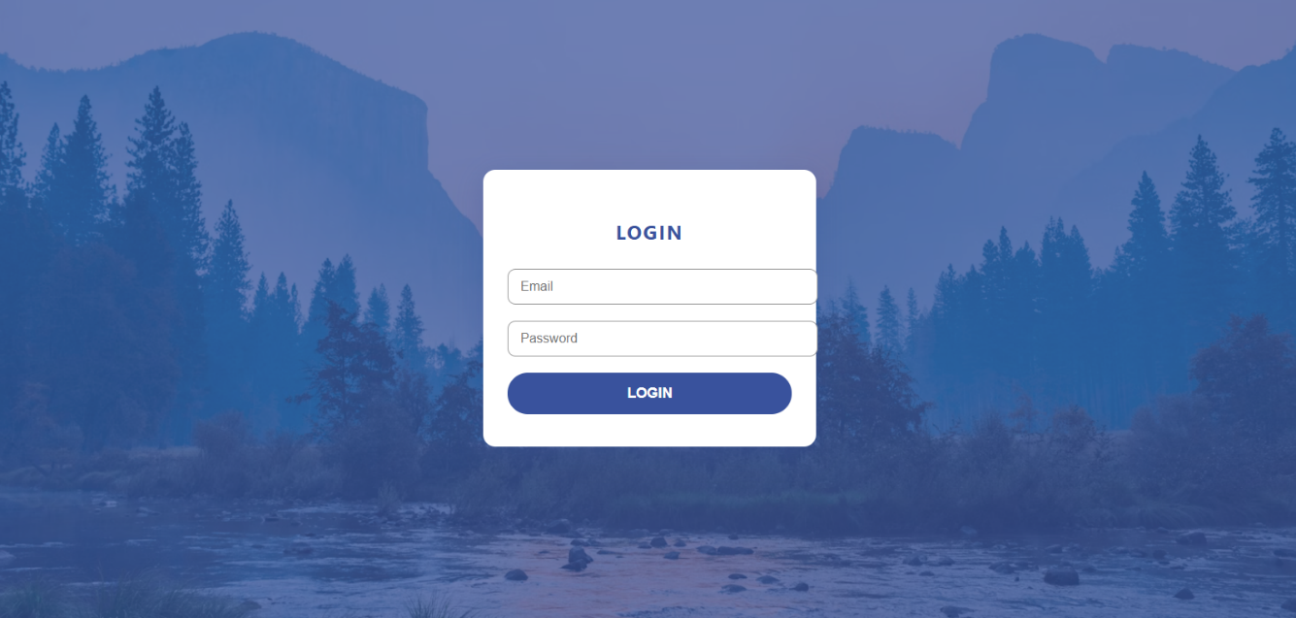

HOME page
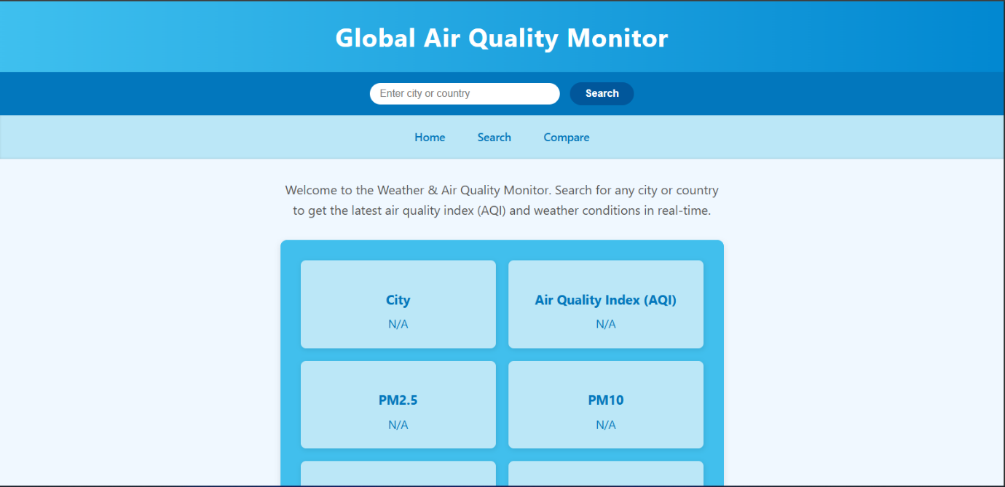

SEARCH page

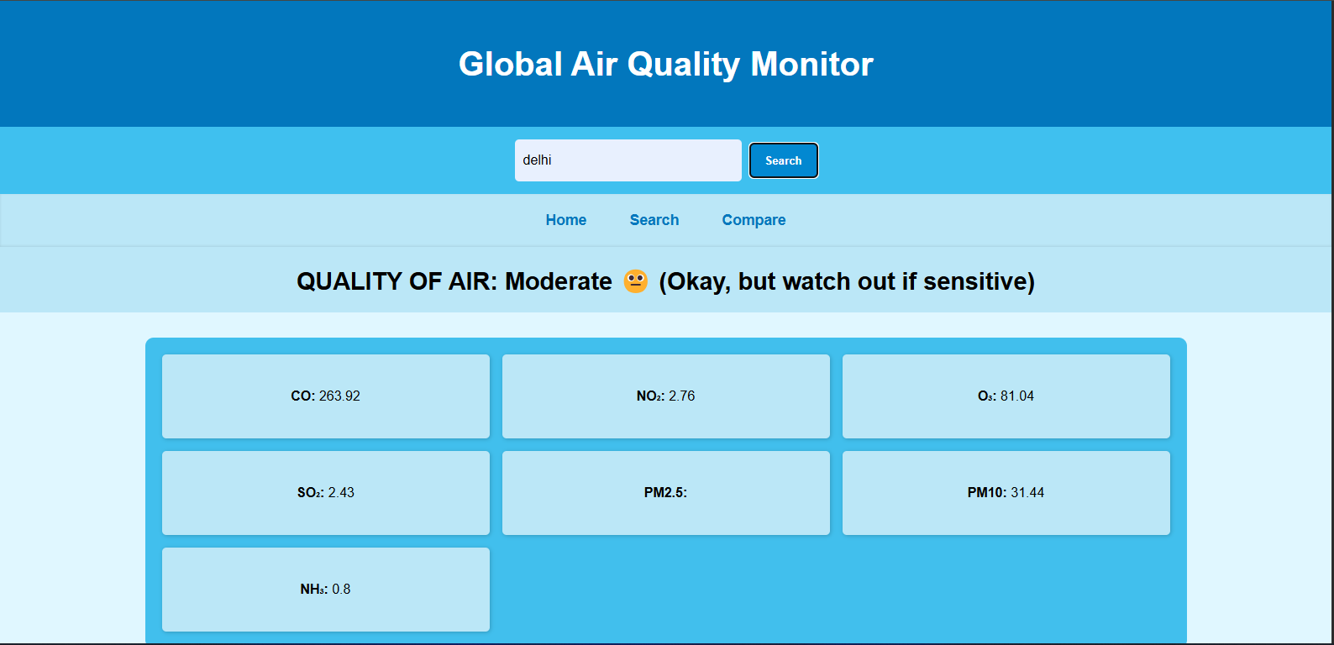

COMPARE page

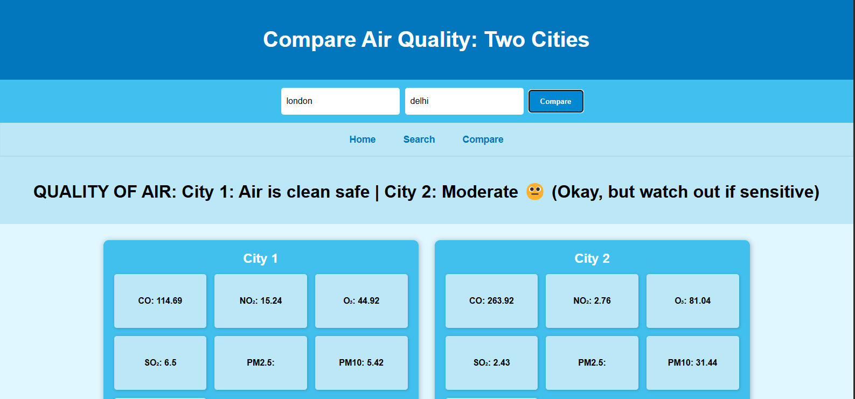

CONCLUSION

CONCLUSION
The Global Air Quality Monitor project has been completed successfully, fulfilling its objective of providing real-time air quality information through a simple and interactive web application. By integrating cloud-based APIs from OpenWeather, the system allows users to input a city name, retrieve geographical coordinates, and access accurate environmental data such as AQI values and pollutant levels. This demonstrates the effective use of external APIs to solve real-world problems.

Throughout the development process, valuable learning outcomes were achieved. A major milestone was understanding how to connect the frontend with a cloud-based backend using APIs. This involved handling asynchronous data flow, managing responses in JSON format, and ensuring reliable communication between client-side and server-side components. The project also emphasized the importance of error handling to maintain robustness and user trust.

In addition, this work provided hands-on experience with widely used web technologies, including HTML, CSS, JavaScript, PHP, and MySQL. The use of GitHub, VS Code, and Postman further enhanced practical skills in modern development workflows. Overall, the project not only achieved its technical goals but also contributed significantly to improving knowledge in full-stack development, cloud services, and real-world API integration.

FUTURE SCOPE

Future Scope

While the current version of the Global Air Quality Monitor achieves its primary goal of delivering real-time air quality data, there are several opportunities for future enhancements that can make the system more user-friendly, scalable, and efficient.

1. Enhanced User Interface (UI):

At present, the application relies on basic HTML and CSS for design. In future iterations, frameworks such as Bootstrap or Tailwind CSS can be integrated to provide a more responsive and visually appealing interface. This would improve accessibility across devices, enhance user experience, and reduce the development effort for styling.

2. Cloud Deployment of APIs:

Currently, the APIs are directly accessed within the application. Deploying the backend on cloud platforms like Render, Vercel, or AWS would allow for better scalability, performance optimization, and high availability. This ensures the application can handle a larger number of requests without compromising on speed or accuracy.

Reference

Reference
The Global Air Quality Monitor integrates two pivotal APIs from OpenWeather to deliver precise, real-time environmental data. The first component is the Geocoding API, which translates user-entered city names into accurate geographic coordinates—latitude and longitude. This step is crucial for enabling location-based queries by converting easily understood place names into precise spatial data.
Following coordinate acquisition, the system leverages the Air Pollution API to retrieve comprehensive air quality information corresponding to the specified geographic points. This API supplies detailed pollutant measurements, including particulate matter (PM2.5 and PM10), carbon monoxide (CO), nitrogen dioxide (NO₂), sulfur dioxide (SO₂), ozone (O₃), and ammonia (NH₃). In addition, it provides an Air Quality Index (AQI) rating that summarizes overall pollution levels on a standardized scale. Data provided by this service is regularly updated and sourced from a fusion of satellite observations, atmospheric modeling, and ground-based sensor networks.
Both APIs require authentication via an API key and offer generous free usage tiers suitable for development and moderate application deployment. Their thorough documentation and stable endpoints ensure seamless integration, empowering users worldwide to query any location and access reliable, up-to-date air quality metrics essential for health and environmental awareness.

