**OUTPUT**

1. Java program to create an array with the values (1, 2, 3, 4, 5, 6, 7) and shuffle it.

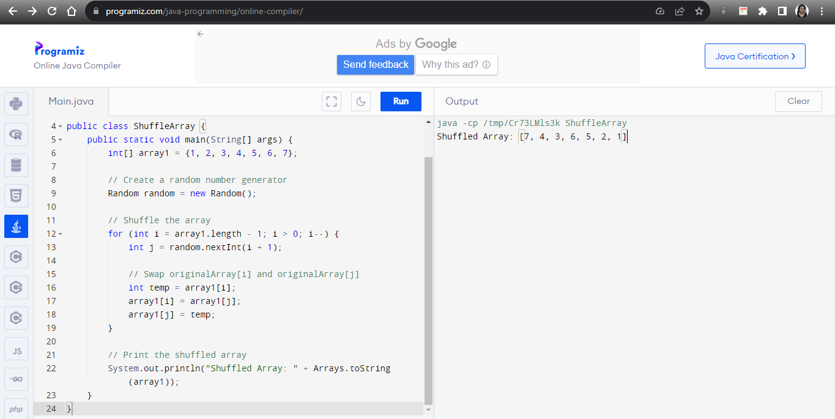

2. Java program to enter a Roman Number as input and convert it to an integer.

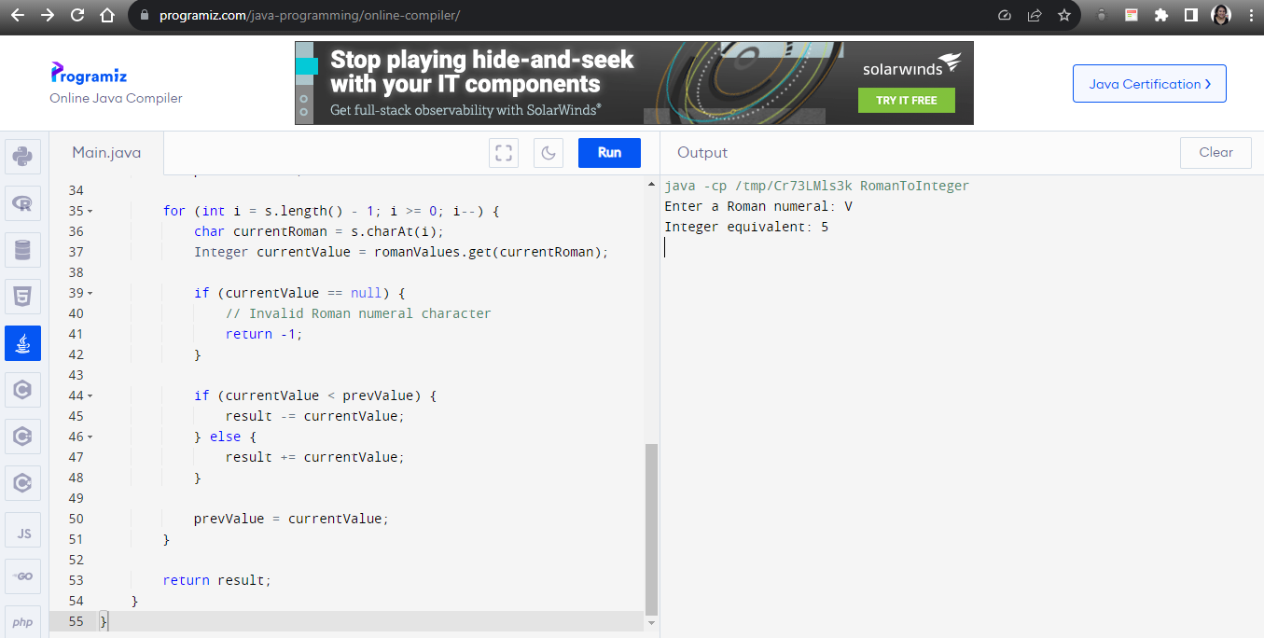

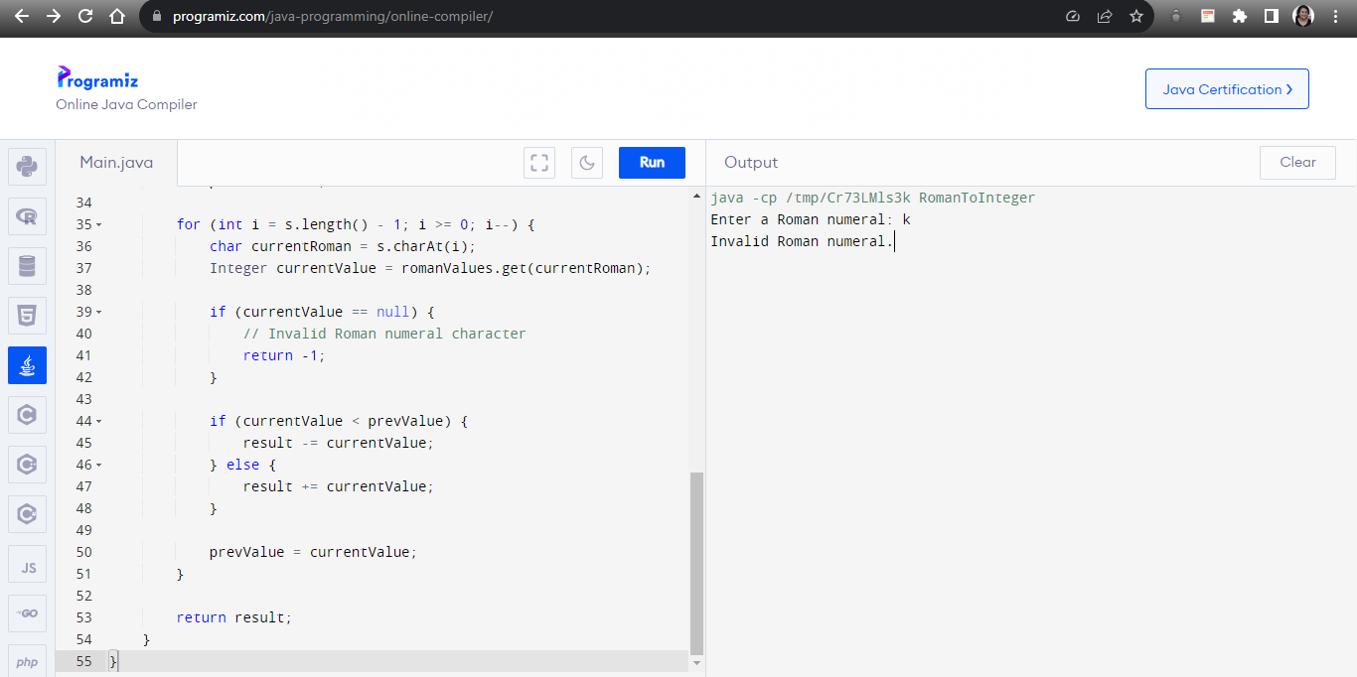

3. Java program to check if the input is pangram or not.

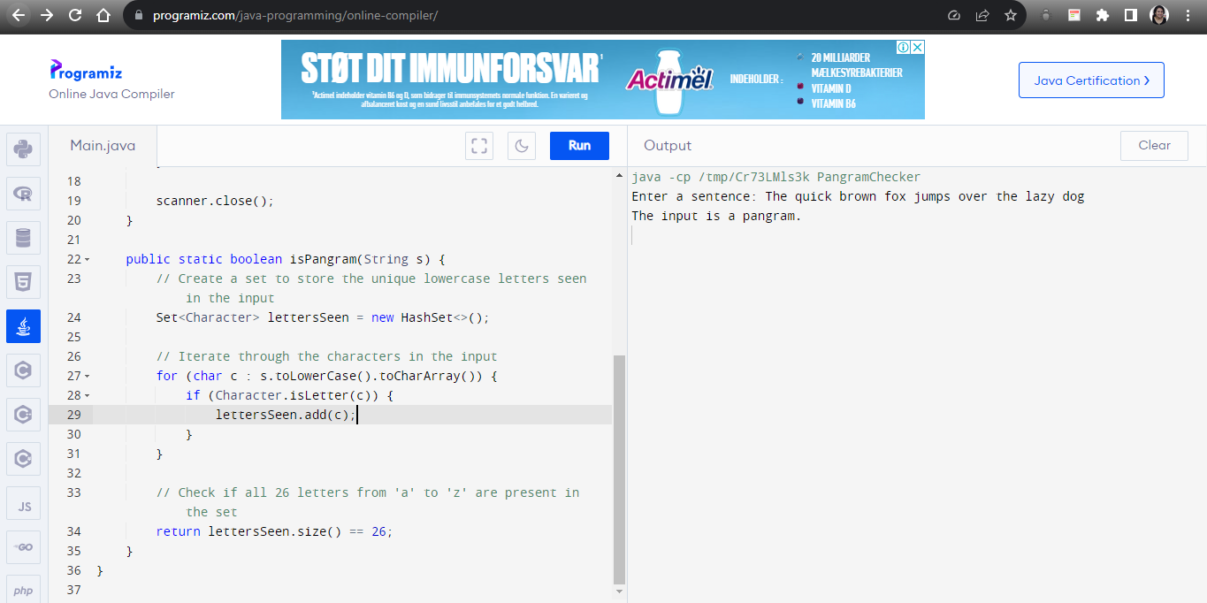

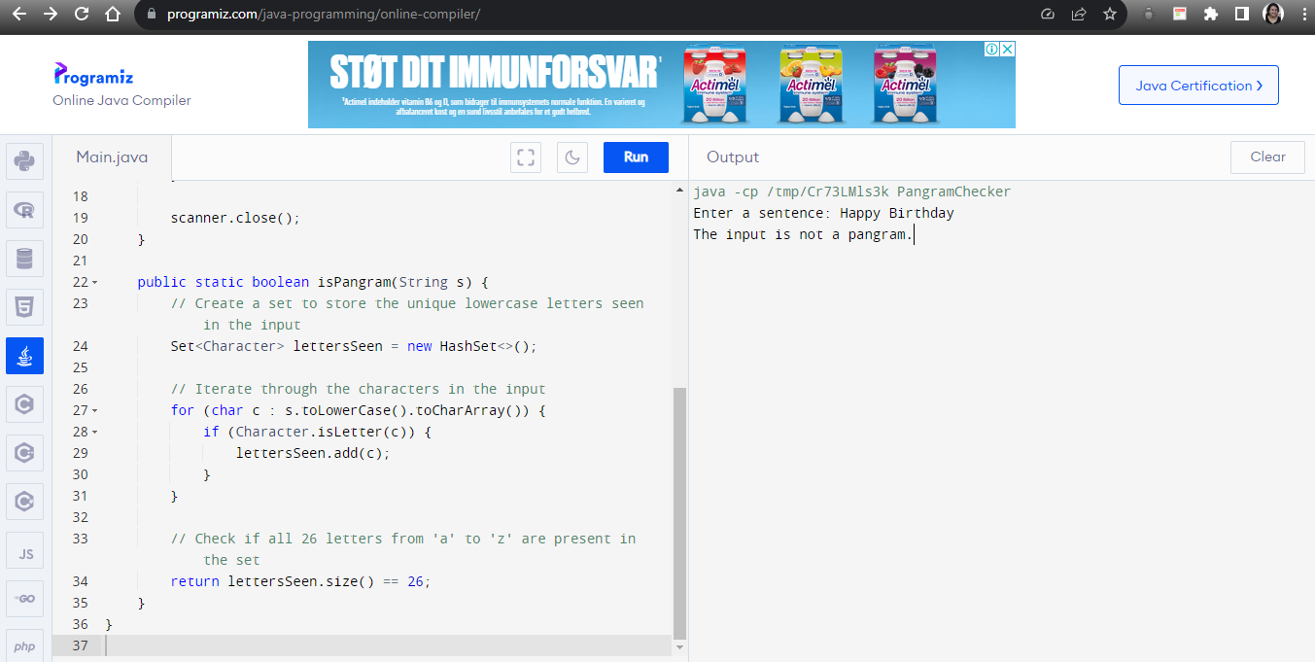

4. Javascript program to take a sentence as an input and reverse every word in that sentence.

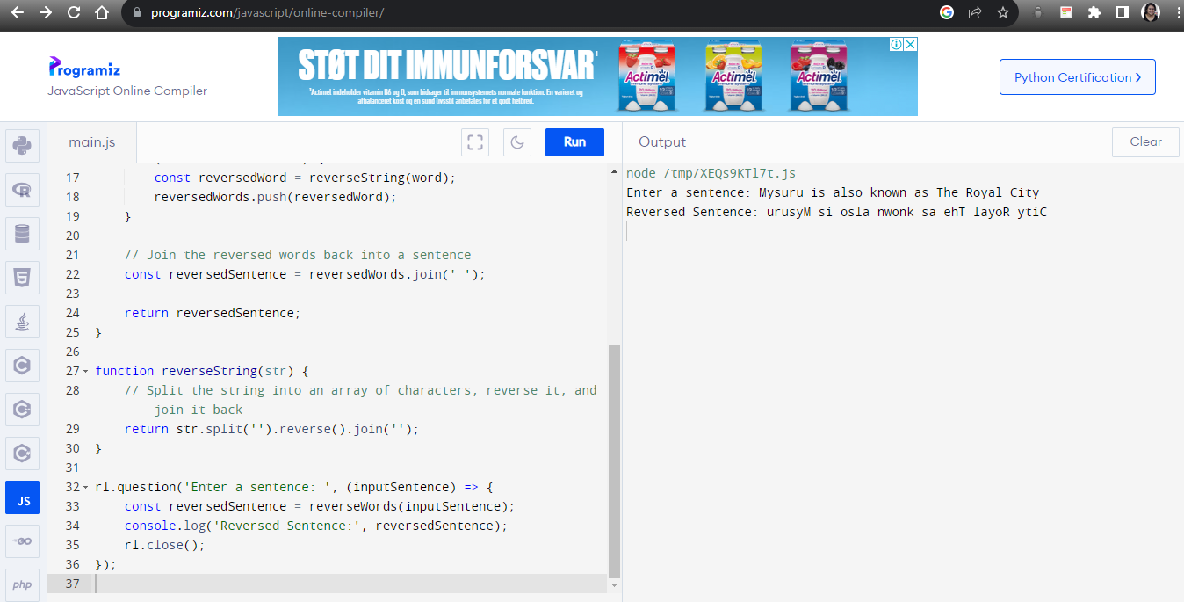

5. Javascript program to perform sorting of an array in descending order.

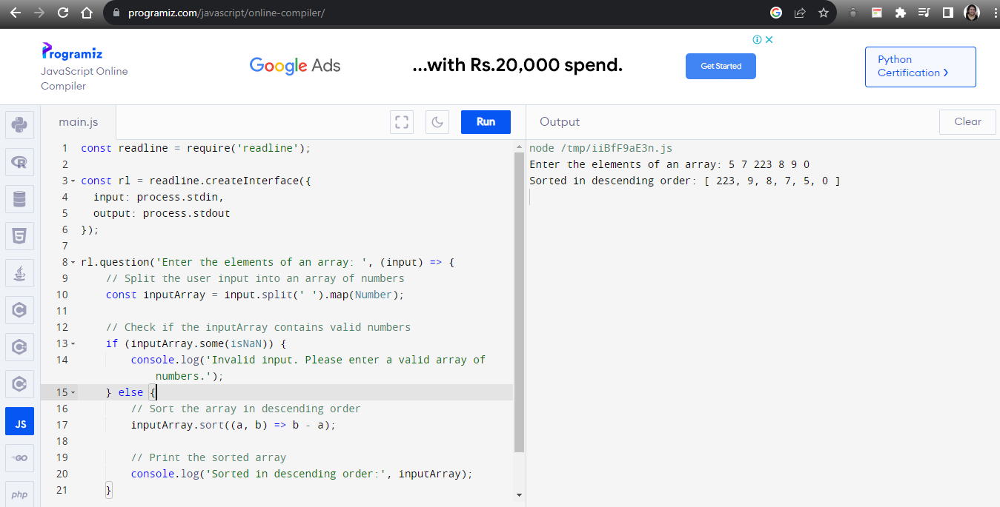

6. Create a basic calculator using HTML, CSS, and JavaScript with the functionality of add,subtract, multiply and divide.

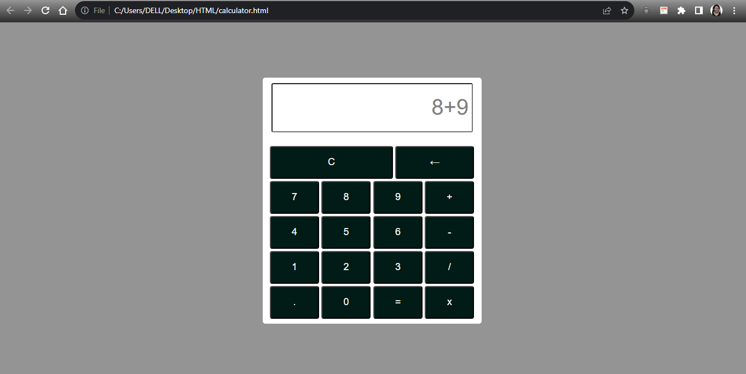

7. Create a survey form with Fields; First Name, Last Name, Date of Birth, Country(dropdown), Gender (checkbox), Profession, email, and mobile number. All the input fields are necessary to submit the form. Create two buttons Submit and Reset. Reset will reset the form while clicking on submit, first, it will check all the fields and necessary validations and then a popup will appear displaying all the selected values with labels in front of it. On closing the popup, the form should reset all the values.

