BIOLOGY

SET A
MAIN QUESTION PAPER

Time: 2 hours
Maximum Marks: 80

Name: ___________________________________________

Class / Section: _______________ Roll No.: _______________

Date: _______________

SECTION A
Q I
(20 marks)

1. Starch is digested by the enzyme amylase. Four identical mixtures of starch and amylase were kept at different temperatures.
The graph below shows the time taken for the starch to be digested at each temperature.
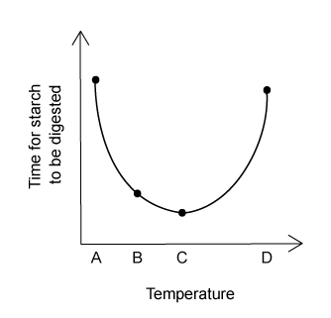
At which temperature is the rate of reaction highest?
(1 mark)

2. Four foods were tested for the following food molecules:
reducing sugar using Benedict’s reagent
protein using Biuret solution
fat using ethanol
Vitamin C using DCPIP
 | colour of food test result
 | brick-red/orange | purple/lilac | colourless | milky-white
A | ✓ | ✗ | ✓ | ✗
B | ✓ | ✗ | ✗ | ✓
C | ✗ | ✓ | ✓ | ✗
D | ✗ | ✗ | ✓ | ✓

Which food contains sugar and Vitamin C?
(1 mark)

3. Identify the arthropods shown using the key below.
1. Three pairs of legs... Class W
Four pairs of legs or more... Go to 2
2. Body plan consists of a head and a many-segmented body... Class X
Head and thorax are fused to form a cephalothorax... Go to 3
3. No antennae present... Class Y
Antennae present... Class Z
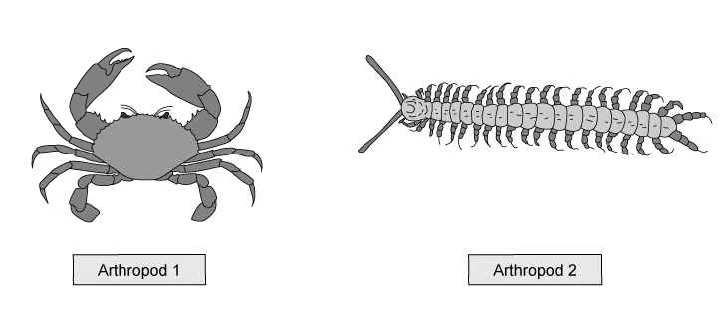
 | Arthropod 1 class | Arthropod 2 class
A | Y | X
B | X | Z
C | Z | W
D | Z | X

(1 mark)

4. Tomato fruit production was measured in five different environmental conditions.
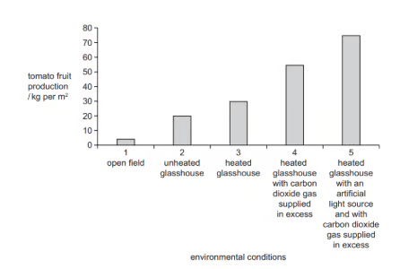
What is a correct conclusion for the data shown in the graph?
A. There are no limiting factors in 1, so tomato fruit production is the lowest.
B. Temperature is the limiting factor in 3.
C. Carbon dioxide is the limiting factor in all five environmental conditions.
D. Light is the limiting factor in 4.
(1 mark)

5. Liver cells produce an enzyme called catalase which breaks down toxic hydrogen peroxide into water and oxygen.
A student set up an experiment where cubes of cows' liver in a test tube were incubated with hydrogen peroxide at different temperatures.
The student counted the number of bubbles of oxygen released per minute at each temperature.
Their results are shown in the table below:
temperature / °C | 10 | 20 | 30 | 40 | 50
number of bubbles / minute | 35 | 68 | 79 | 63 | 5

The results suggest that the optimum temperature for catalase is between which two values?
A. 10°C and 40°C
B. 20°C and 30°C
C. 30°C and 40°C
D. 20°C and 40°C
(1 mark)

6. A student heats an amylase solution to 80 °C for 10 minutes, then cools it back to 25 °C before adding starch.
The reaction rate stays very low.
What is the best explanation for this?
A. Cooling stops amylase from working.
B. Starch has changed shape permanently.
C. Amylase was used up before starch was added.
D. Amylase was denatured at 80 °C.
(1 mark)

7. Four freshly cut potato cylinders were soaked for one hour in different salt solutions The potato cylinders were then pinned to cork blocks. Two of the potato cylinders are shown.
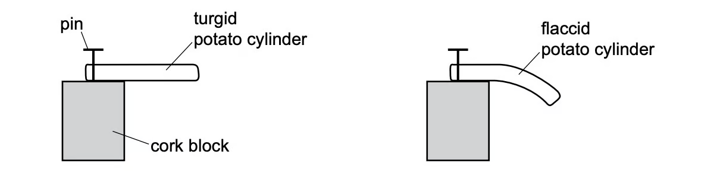
Which solution would cause the potato cylinder to be the most flaccid?
A. 0.1 mol per dm³ salt solution
B. 0.3 mol per dm³ salt solution
C. 0.7 mol per dm³ salt solution
D. 1.0 mol per dm³ salt solution
(1 mark)

8. Two test tubes are set up with two similar leaves inside them, as shown in the diagram below.
One test tube is exposed to light, while the other is kept in the dark.
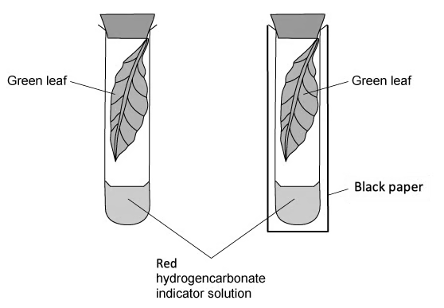
The test tubes are left for 4 hours.
What colour will the hydrogencarbonate indicator solution be in each test tube?
 | dark | light
A | purple | yellow
B | colourless | yellow
C | purple | colourless
D | yellow | purple

(1 mark)

9. A student cut a section through a plant, finding a group of long, microscopic structures which lacked end walls or any cell contents.
Which row of the table below correctly identifies the structure described in the statement above?
 | identification | description
A | xylem vessels | large surface area to absorb as much water by osmosis as possible
B | root hair cells | they can support the plant better without cytoplasm, mitochondria provide energy
C | root hair cells | hollowed, lignified tubes to allow uninterrupted flow of water
D | xylem vessels | hollowed, lignified tubes to allow uninterrupted flow of water

(1 mark)

10. A group of students carried out an investigation into osmosis using cylinders of potato.
The results from their experiment are shown below.
concentration of salt solution / mol dm⁻³ | length of potato cylinder at start / mm | length of potato cylinder after 24 hours / mm
? | 35 | 33

Which statement below correctly explains this change in length and shows the concentration of the salt solution?
 | concentration of salt solution | cause of this movement
A | 0.0 | the salt solution is more concentrated than the solution inside the potato.
B | 0.6 | the solution in the potato is more dilute than the solution around the potato.
C | 0.6 | the solution in the potato is less dilute than the solution around the potato.
D | 0.0 | the salt solution is less concentrated than the solution inside the potato.

(1 mark)

11. The diagram below shows the organs of the digestive system, including the alimentary canal and accessory organs.
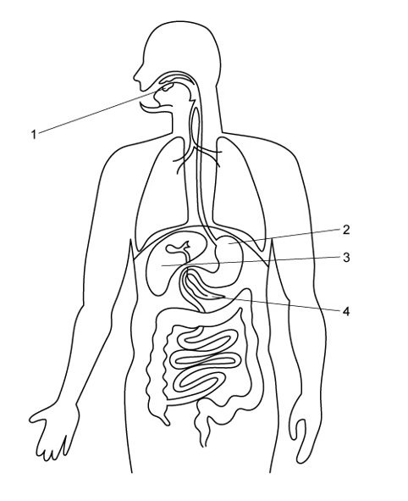
Where are most of the digestive lipase enzymes made in the body?
A. 2 only
B. 4 only
C. 3 and 4
D. 1 and 4
(1 mark)

12. Which of the following shows the correct role of a substance made during digestion?
 | substance | made by | effect
A | trypsin | stomach | digests proteins into amino acids
B | bile | gallbladder | neutralising acidic mixture of food entering the duodenum from the stomach
C | gastric juice | stomach | denaturing enzymes in harmful microorganisms and optimising pH for pepsin activity
D | bile | liver | neutralising alkaline mixture of food entering the duodenum from the stomach

(1 mark)

13. The diagram below shows a cross-section through a leaf as seen under a microscope.
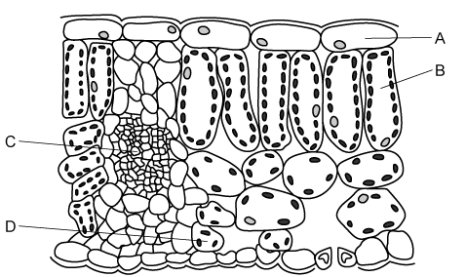
In which part of the leaf would the concentration of carbon dioxide be lowest on a warm, sunny day?
(1 mark)

14. The following could be used to write a balanced symbol equation for photosynthesis.
1. 6CO₂ + 6H₂O
2. CO₂ + 6H₂O
3. Light and chlorophyll
4. C₆H₁₂O₆ + 6O₂
5. 6C₆H₁₂O₆ + 6O₂
Which of the following show the correct balanced chemical equation for photosynthesis?
A. 2 → 5 in the presence of 3
B. 2 → 4 in the presence of 3
C. 1 → 5 in the presence of 3
D. 1 → 4 in the presence of 3
(1 mark)

15. The graph shows the effect of increasing light intensity on the rate of photosynthesis.
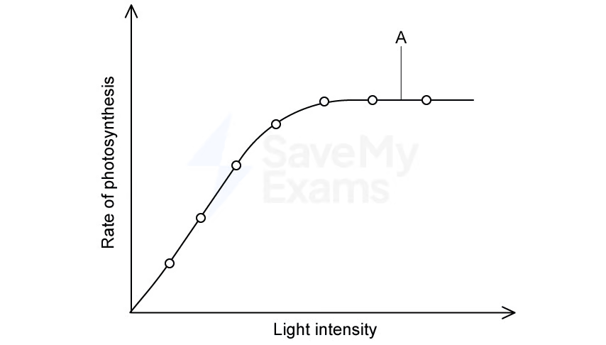
Which does point A show?
A. Light is no longer the limiting factor.
B. Light has stopped reaching the leaf.
C. Photosynthesis has stopped completely.
D. Chlorophyll has been used up.
(1 mark)

16. A student found four different worms in a sample of soil and drew diagrams of them. The diagrams were drawn with different magnifications.
Which worm was the longest?
 | length of diagram / mm | magnification
A | 60 | x3
B | 70 | x1
C | 100 | x2
D | 120 | x5

(1 mark)

17. The image below shows a palisade mesophyll cell found in the leaves of plants.
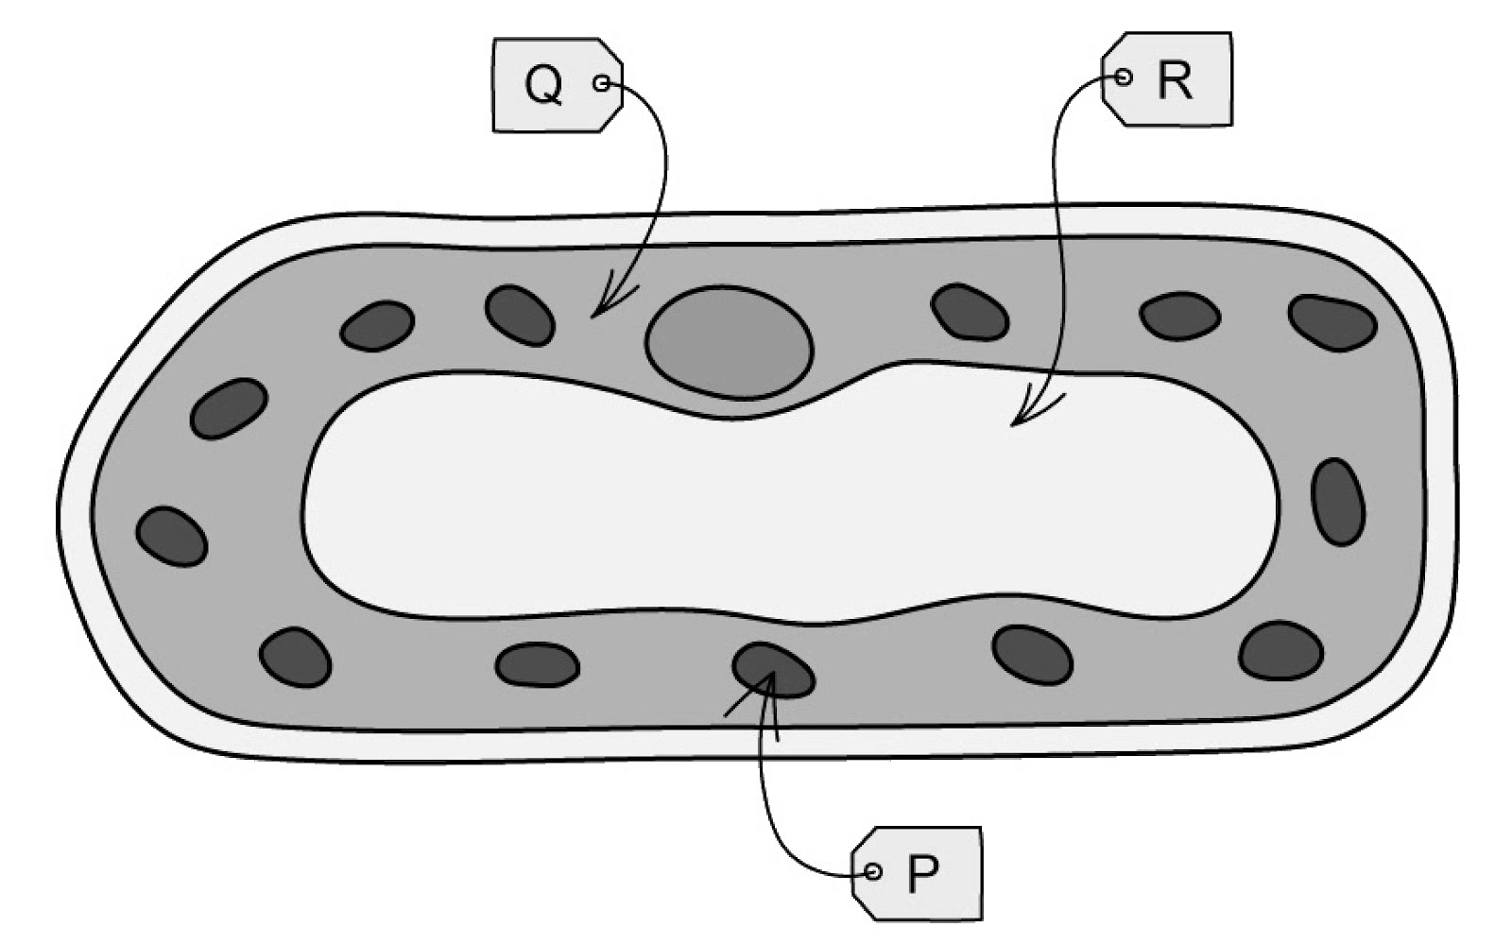
Which row of the table below correctly identifies the structures labelled on the cell in the image above?
 | P | Q | R
A | mitochondrion | nucleus | vacuole
B | chloroplast | vacuole | nucleus
C | chloroplast | cytoplasm | vacuole
D | mitochondrion | ribosome | nucleus

(1 mark)

18. A student carries out food tests on an unknown sample. The results are shown below.
Test | Result
Iodine solution | Brown
Benedict’s solution | Brick-red
Biuret | Blue
Ethanol emulsion | Cloudy white emulsion
DCPIP | Blue

Which statement is correct?
A. The sample contains reducing sugar and fat.
B. The sample contains starch, reducing sugar and fat.
C. The sample contains reducing sugar, protein and fat.
D. The sample contains reducing sugar, fat and vitamin C.
(1 mark)

19. The diagram shows an organism.
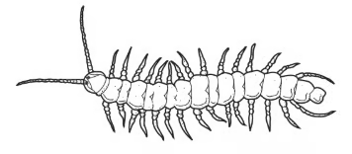
Which type of arthropod is this organism?
A. Myriapod
B. Insect
C. Crustacean
D. Arachnid
(1 mark)

20. A plant with striped leaves was kept in bright light for six hours.

A leaf was taken from the plant and the chlorophyll was removed. The leaf was then tested for starch using iodine solution.
Which diagram shows the result of the test?
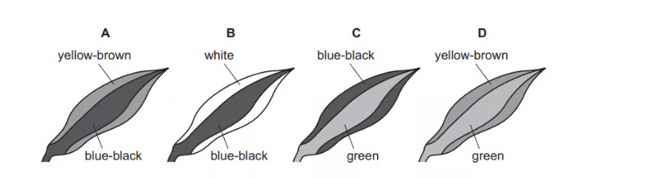
(1 mark)

SECTION B
Q II
(20 marks)

(a) Define the term chemical digestion.
(2 marks)

(b) Explain the importance of chemical digestion.
(2 marks)

(c) The pancreas is an organ that produces enzymes used in digestion.
Explain the importance of enzyme specificity in the digestion of food.
(4 marks)

(d) Pancreatic cancer develops when a malignant tumour grows inside the pancreas.
One symptom of pancreatic cancer is weight loss.
With reference to enzymes, explain how pancreatic cancer may cause a person to lose weight.
(4 marks)

(e) Certain types of antibodies, called monoclonal antibodies, have been used to treat pancreatic cancer.
Compare the activity and nature of antibodies with those of enzymes.
(3 marks)

(f) Outline the process of starch digestion in the human body.
(5 marks)

Q III
(20 marks)

(a) Particulate matter (PM) refers to the small particles in air pollution which can irritate the airways and caused damage to the alveoli. Alveoli are tiny air sacs in the lungs across which gas exchange by diffusion occurs.
Fig. 1 shows the structure of an alveolus with a capillary running next to it.
Fig. 1
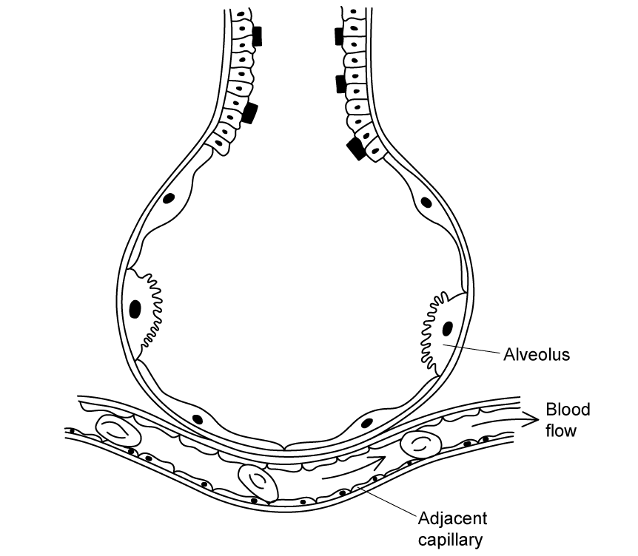
If concentrations of PM are high, the epithelium cells of the alveoli may be killed and replaced with unspecialised cells resulting in:
Fewer functioning alveoli
Thickening of alveolar walls
Explain how particulate matter would affect the process of gas exchange in human lungs.
(3 marks)

(b) Fig. 2 shows the results of an investigation into the concentration of particulate matter and the percentage of dead alveolar epithelium cells after 48 of exposure.
Fig. 2
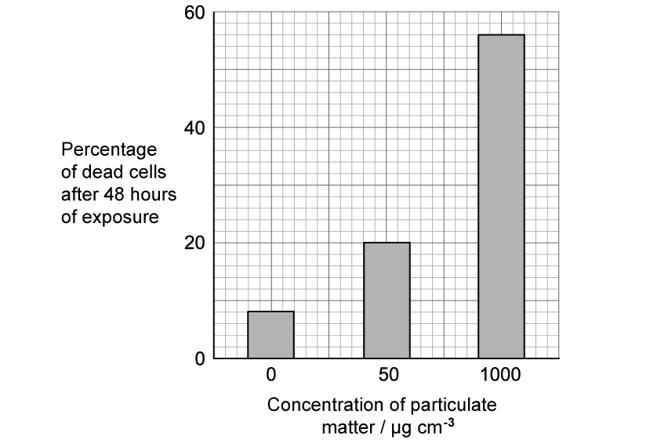
Scientists studied 31 080 alveolar epithelium cells in this study.
Calculate how many more cells died after 48 hours of exposure to 1 000 µg cm⁻³ of particulate matter than after 48 hours of exposure to 50 µg cm⁻³ of particulate matter.
(3 marks)

(c) Oxygen is required for the process of cellular respiration in cells. People living in urban areas with high levels of air pollution will often suffer from fatigue (feeling tired).
Use the information provided in part (a) and (c) to suggest an explanation for this.
(2 marks)

(d) Other than diffusion, movement of molecules in the body could also occur by osmosis and active transport.
Compare osmosis and active transport with each other.
(4 marks)

(e) Fig. 3 shows some parts of the human body.
Fig. 3
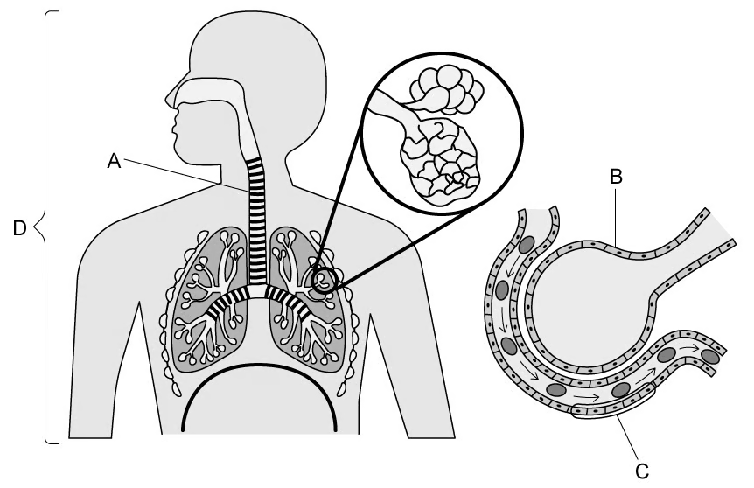
Identify each structure and which level of organisation each one belongs to.
Structure | Name of structure | Level of organisation
A
B
C
D

(4 marks)

(f) Explain how two separate organs of the musculoskeletal system, muscles and bones, work together to perform the function of movement.
(2 marks)

(g) A new-born baby is thought to have around 1 250 000 000 000 (1.25 × 10¹²) cells. That same baby, as an adult male, is estimated to have 37 000 000 000 000 (3.7 × 10¹³) cells. If the new-born baby had a mass of 3.1kg at birth, estimate the mass of the adult male. Give your answer in appropriate units to the nearest whole number.
(2 marks)

SECTION C
Q IV
(20 marks)

Young mammals feed on milk containing protein.
Some mammals produce an enzyme called rennin. Rennin changes the protein in milk so that it can be digested by another enzyme.
The action of rennin causes small lumps or clots to form in the milk.
An investigation was carried out to find the effect of pH on the activity of the enzyme rennin.
Step 1 | Three test-tubes were labelled P, Q and R.
Step 2 | A syringe was used to add 5cm³ of milk to each of these test-tubes.
Step 3 | A dropping pipette was used to add two drops of acid to test-tube P.
Step 4 | A dropping pipette was used to add two drops of distilled water to test-tube Q.
Step 5 | A dropping pipette was used to add two drops of alkali to test-tube R.
Step 6 | Another three test-tubes were labelled P1, Q1 and R1.
Step 7 | A clean syringe was used to add 1cm³ of 0.1% rennin solution to each of test-tubes P1, Q1 and R1.
Step 8 | All six test-tubes were placed into a water-bath at 40°C and left for three minutes.
Step 9 | The contents of test-tube P1 were added to test-tube P. The contents of test-tube Q1 were added to test-tube Q. The contents of test-tube R1 were added to test-tube R.
Step 10 | Test-tubes P, Q and R were kept in the water-bath and a stop-clock was started.
Step 11 | After one minute, test-tube P was removed from the water-bath. It was tipped and rotated as shown in Fig. 1. The appearance of the milk was observed, and the stage of clotting was decided by comparing it to the diagrams in Fig. 1.

Fig. 1
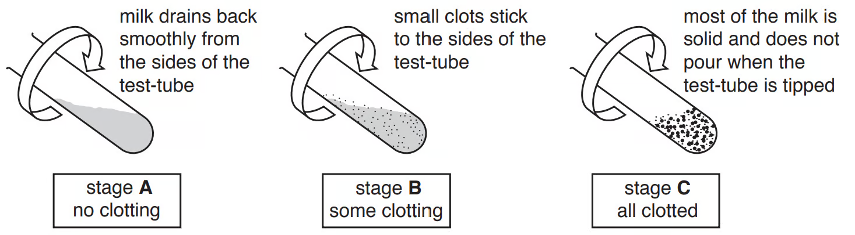
Step 12 | Test-tube P was returned to the water-bath.
Step 13 | Steps 11 and 12 were repeated for test-tubes Q and R.
Step 14 | Steps 11, 12 and 13 were repeated every minute for five minutes.

The results are shown in Fig. 2.
Test-tube P had some clotting at one minute and was all clotted at two minutes. Test-tube Q had no clotting at one, two or three minutes but some clotting at four and five minutes. Test-tube R had no clotting throughout the investigation, and remained unchanged after five minutes.
Fig. 2
(a) Prepare a table in which to record these results. Use the information in Fig. 2 to complete this table.
(3 marks)

(b) State a conclusion for these results.
(2 marks)

(c) (i) Suggest why, in step 8, all of the test-tubes were placed into a water-bath for three minutes before mixing the contents together in step 9.
[1]

(ii) State two variables that were kept constant in this investigation.
[2]
(3 marks)

(d) Identify four sources of error in this investigation.
(4 marks)

(e) Identify one hazard associated with this procedure that would require the use of eye protection.
(1 mark)

(f) Clotting separates milk into a solid part and a liquid part.
Describe how you could find out if there was any protein remaining in the liquid part.
(2 marks)

(g) State the name of the test that would be used to test the milk for the presence of fat.
(1 mark)

(h) Fig. 3 shows the four different types of human teeth.
Fig. 3
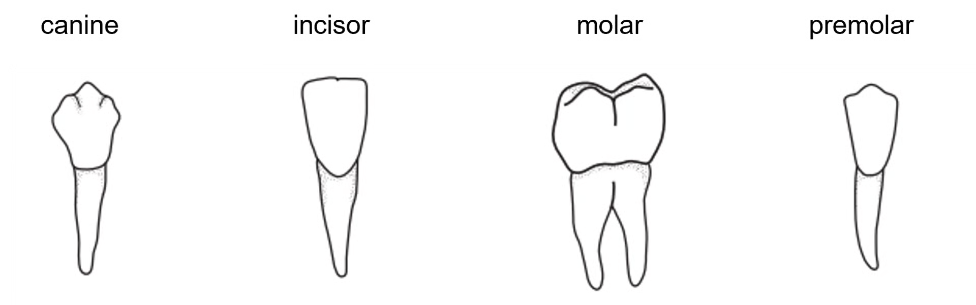
Fig. 4 shows a diagram of the position of the different types of teeth in the mouth.
Fig. 4
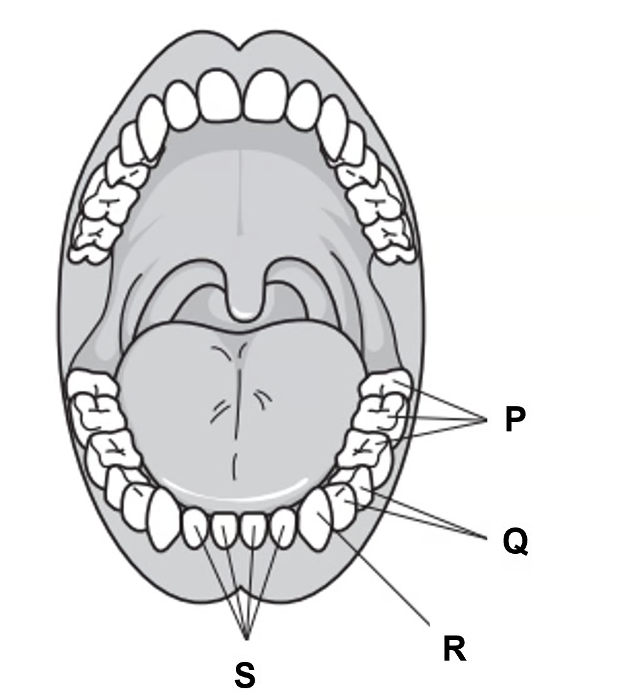
Complete Table 1 by writing the names, positions and functions of the different types of teeth in the mouth shown in Fig. 4.
Table 1
Name of type of tooth | Letter on Fig. 4 | Function
 | R
Incisor
 |  | Grinding
Premolar |  | Tearing and grinding

(4 marks)

