BIOLOGY
ANNUAL EXAMINATION

SET B
SAMPLE QUESTION PAPER

Subject: Biology
Time Allowed: 2 hours
Maximum Marks: 80

Name: ___________________________________________
Class / Section: _______________ Roll No.: _______________
Date: _______________ Invigilator's Signature: _______________

GENERAL INSTRUCTIONS

1. This page is the cover page. The question paper begins on Page 2.
2. All questions are compulsory. There is no overall choice.
3. The paper has three sections:
Section A (Q I) - Multiple Choice Questions - 20 marks
Section B (Q II and Q III) - Theory - 40 marks
Section C (Q IV) - Diagram Based / Alternative to Practical - 20 marks
4. The marks allotted to each question are given in brackets at the end of the question.
5. Write your answers in the space provided after each question.
6. In Section A, write only the letter (A, B, C or D) of the correct option.
7. Draw all diagrams in pencil and label them clearly.
8. Calculators may be used. Show all working in numerical questions.

BIOLOGY - SET B (SAMPLE QUESTION PAPER)
Time: 2 hours Maximum Marks: 80
————————————————————————————————————————
SECTION A - MULTIPLE CHOICE QUESTIONS
(20 marks)

Q I. Choose the correct option in each of the following questions and write the letter (A, B, C or D) of your answer in the space provided. (20 × 1 = 20)

1. A student looks at an image of a cross-section of a leaf in her Biology textbook. The actual thickness of this leaf is 450 µm, but the image in the textbook has a depth of 83 mm. What would be the correct magnification of the image? (1)
A. × 5
B. × 184
C. × 0.184
D. × 500
Answer: ____________

2. In a person with coeliac disease the villi of the small intestine are badly damaged and are much shorter and flatter than the villi of a healthy small intestine. A person with coeliac disease may become undernourished even if they eat enough food. Which is the best explanation? (1)
A. The surface area exposed to food is reduced, which stops chemical digestion from taking place in the small intestine.
B. The damaged villi prevent enough digestive enzymes from being secreted into the small intestine.
C. The surface area of the small intestine is reduced so fewer digested nutrients are absorbed into the blood.
D. The damaged villi cause food to move through the intestine too slowly to be digested.
Answer: ____________

3. Four freshly cut potato cylinders were soaked for one hour in different salt solutions. The potato cylinders were then pinned to cork blocks. Which solution would cause the potato cylinder to be the most flaccid? (1)
A. 0.1 mol per dm³ salt solution
B. 0.3 mol per dm³ salt solution
C. 0.7 mol per dm³ salt solution
D. 1.0 mol per dm³ salt solution
Answer: ____________

4. Two test-tubes are set up, each containing hydrogencarbonate indicator solution and a similar leaf. One test-tube is exposed to light, while the other is kept in the dark. The test-tubes are left for 4 hours. What colour will the hydrogencarbonate indicator solution be in each test-tube? (1)
row | dark | light
A | purple | yellow
B | colourless | yellow
C | purple | colourless
D | yellow | purple

A. Row A
B. Row B
C. Row C
D. Row D
Answer: ____________

5. Use the key below to identify the group to which fish belong.
1. Fur absent … go to 2 / Fur present … mammals
2. Eggs do not have hard shells … go to 3 / Eggs have hard shells … group A
3. Reproduction occurs in water … go to 4 / Reproduction occurs on land … group B
4. Scaly skin … group C / Smooth skin … group D (1)
A. group A
B. group B
C. group C
D. group D
Answer: ____________

6. A group of students tested four different foods using some common food tests. Their results are shown in the table below. Which food contains reducing sugar and vitamin C but not protein or starch? (1)
food | Benedict's test | Biuret test | Iodine test | DCPIP test
A | brick-red | purple | brown | colourless
B | brick-red | blue | brown | colourless
C | blue | blue | black | blue
D | brick-red | blue | black | colourless

A. Food A
B. Food B
C. Food C
D. Food D
Answer: ____________

7. The shape and structure of molecules allows them to carry out their specific functions. Which row of the table below correctly describes a feature of each molecule that makes it specific? (1)
row | enzyme | antibody | DNA
A | binding site | active site | base order
B | active site | binding site | base order
C | active site | base order | binding site
D | binding site | base order | active site

A. Row A
B. Row B
C. Row C
D. Row D
Answer: ____________

8. A student found four different worms in a sample of soil and drew diagrams of them. The diagrams were drawn with different magnifications, as shown in the table below. Which worm was the longest? (1)
worm | length of diagram / mm | magnification
A | 60 | ×3
B | 70 | ×1
C | 100 | ×2
D | 120 | ×5

A. Worm A
B. Worm B
C. Worm C
D. Worm D
Answer: ____________

9. A student looks at an image of a cell in his textbook. The image is 43 mm wide and has been magnified 2500 times. What is the actual width of the cell? (1)
A. 0.0172 µm
B. 1.72 mm
C. 58.1 mm
D. 17.2 µm
Answer: ____________

10. A group of students carried out an investigation into osmosis using cylinders of potatoes. The potato cylinders were put into a solution of salt. The results from their experiment are shown in the first table below. Which row of the second table correctly explains this change in mass? (1)
concentration of salt solution / mol dm⁻³ | mass of potato cylinder at start / g | mass of potato cylinder after 24 hours / g
0.2 | 2.5 | 2.7

row | direction of movement of water | cause of this movement
A | out of the potato cells | the salt solution has a lower water potential than the potato cells
B | out of the potato cells | the salt solution has a higher water potential than the potato cells
C | into the potato cells | the salt solution has a lower water potential than the potato cells
D | into the potato cells | the salt solution has a higher water potential than the potato cells

A. Row A
B. Row B
C. Row C
D. Row D
Answer: ____________

11. Two food tests are carried out on solution X. In test 1, biuret solution is added to solution X and a purple colour is produced. In test 2, Benedict's solution is added to solution X and the mixture is heated, producing a red colour. Which nutrients are present in solution X? (1)
A. protein and starch
B. protein and sugar
C. starch and fat
D. starch and sugar
Answer: ____________

12. A student cut a section through a plant, finding a group of long, microscopic structures which lacked end walls or any cell contents. Which row of the table below correctly identifies the structure described in the statement above? (1)
row | identification | description
A | xylem vessels | large surface area to absorb as much water by osmosis as possible
B | root hair cells | they can support the plant better without cytoplasm, mitochondria provide energy
C | root hair cells | hollowed, lignified tubes to allow uninterrupted flow of water
D | xylem vessels | hollowed, lignified tubes to allow uninterrupted flow of water

A. Row A
B. Row B
C. Row C
D. Row D
Answer: ____________

13. To investigate the effect of light and dark conditions on gas exchange in an aquatic plant, a test-tube is set up as follows:
1. The test-tube is filled with hydrogencarbonate indicator solution.
2. A cutting from a green aquatic plant is added.
3. The tube is covered with aluminium foil and closed with a bung.
4. The tube is exposed to sunlight for 24 hours.
What result will the test-tube show after 24 hours? (1)
A. no colour change
B. colour change to yellow
C. colour change to red
D. colour change to purple
Answer: ____________

14. Identify the two arthropods shown below using the key.
1. Three pairs of legs … Class W / Four pairs of legs or more … go to 2
2. Body plan consists of a head and a many-segmented body … Class X / Head and thorax are fused to form a cephalothorax … go to 3
3. No antennae present … Class Y / Antennae present … Class Z (1)
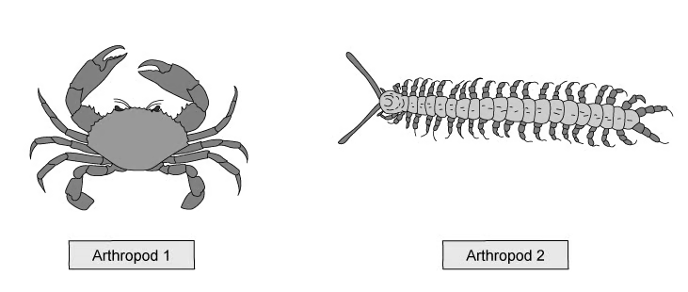
row | Arthropod 1 class | Arthropod 2 class
A | Y | X
B | X | Z
C | Z | W
D | Z | X

A. Row A
B. Row B
C. Row C
D. Row D
Answer: ____________

15. The diagrams below show an amylase enzyme catalysing the breakdown of part of a starch molecule into smaller molecules of maltose. Which diagram has three correct labels? (1)
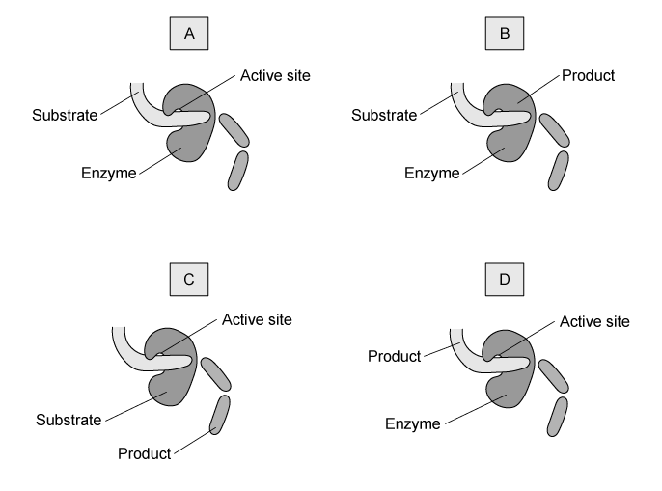
A. A
B. B
C. C
D. D
Answer: ____________

16. The image below shows a leaf from a plant. Identify the plant to which the leaf belongs using the dichotomous key that follows it. (1)

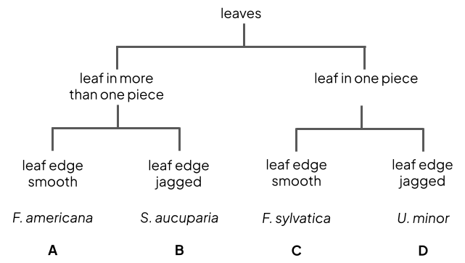
A. F. americana
B. S. aucuparia
C. F. sylvatica
D. U. minor
Answer: ____________

17. The diagram below shows the organs of the digestive system, including the alimentary canal and accessory organs. Where are most of the digestive lipase enzymes made in the body? (1)
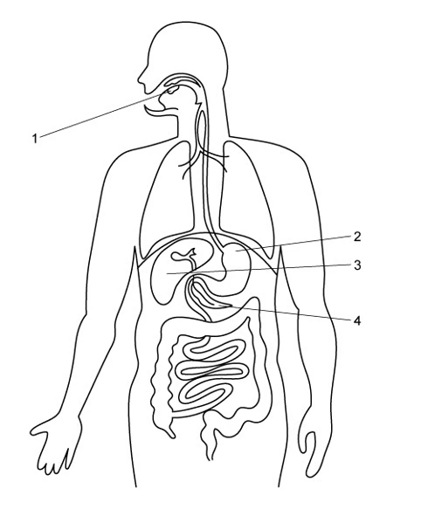
A. 2 only
B. 4 only
C. 3 and 4
D. 1 and 4
Answer: ____________

18. The image below shows a palisade mesophyll cell found in the leaves of plants. Which row of the table below correctly identifies the structures labelled on the cell in the image above? (1)
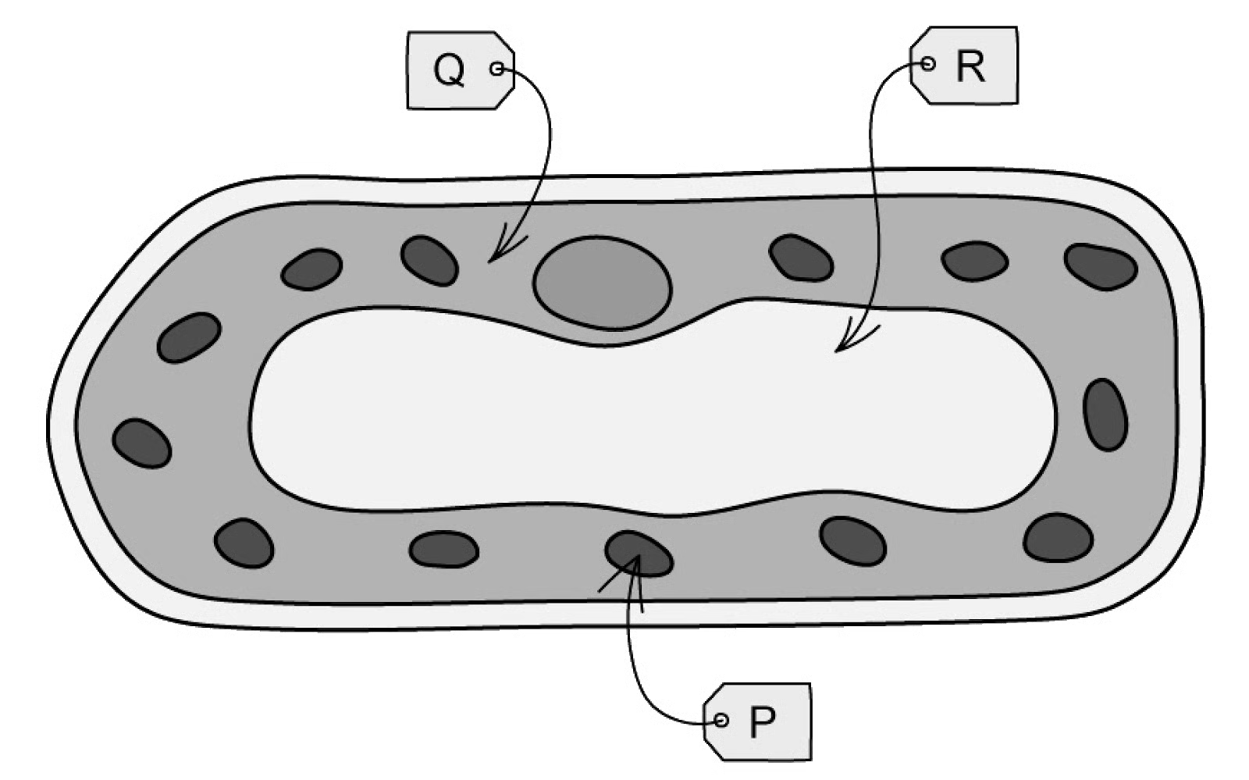
row | P | Q | R
A | mitochondrion | nucleus | vacuole
B | chloroplast | vacuole | nucleus
C | chloroplast | cytoplasm | vacuole
D | mitochondrion | ribosome | nucleus

A. Row A
B. Row B
C. Row C
D. Row D
Answer: ____________

19. The diagram below shows an organism. Which type of arthropod is this organism? (1)
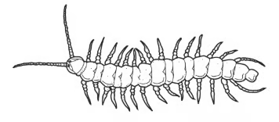
A. Myriapod
B. Insect
C. Crustacean
D. Arachnid
Answer: ____________

20. The image below shows molecules in two solutions separated by a fully permeable membrane. In which direction would there be movement? (1)
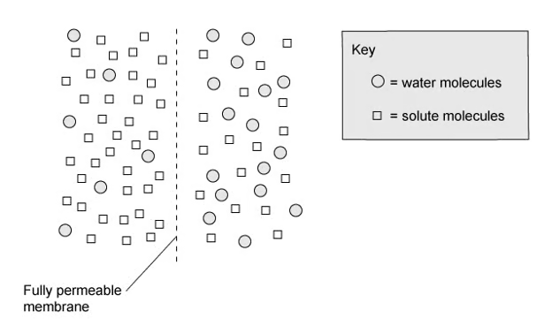
row | water molecules | solute molecules
A | right to left | no net movement
B | left to right | right to left
C | left to right | no net movement
D | right to left | left to right

A. Row A
B. Row B
C. Row C
D. Row D
Answer: ____________

SECTION B - THEORY
(40 marks)

Q II. Answer all parts of this question. (20)

(a) The gallbladder is a small organ found in the human digestive system, close to the liver. Explain the purpose of the gallbladder. (2)

(b) The gallbladder may become inflamed or blocked by gallstones, which may cause much pain. In such cases, it is best to surgically remove the gallbladder. Doctors may recommend that patients with no gallbladder follow a low fat diet after surgery. Suggest a possible reason for this recommendation. (3)

(c) Certain vitamins are known as fat soluble vitamins. They are often found in food with a high fat content and are best absorbed into the blood along with digested lipids. Based on the information provided in parts (a) and (b), explain why people without gallbladders may develop deficiencies in these vitamins. (2)

(d) Vitamin D is an example of a fat soluble vitamin. In some cases, children may need to have their gallbladders removed due to inflammation. In most cases this will not have a significant impact on their long term health, but in some extreme cases it might. Suggest a possible impact that this may have on their health. (3)

(e) Certain types of antibodies, called monoclonal antibodies, have been used to treat pancreatic cancer. Compare the activity and nature of antibodies with those of enzymes. (3)

(f) Explain how two separate organs of the musculoskeletal system, muscles and bones, work together to perform the function of movement. (2)

(g) A new-born baby is thought to have around 1 250 000 000 000 (1.25 × 10¹²) cells. That same baby, as an adult male, is estimated to have 37 000 000 000 000 (3.7 × 10¹³) cells. If the new-born baby had a mass of 3.1 kg at birth, estimate the mass of the adult male. Give your answer in appropriate units to the nearest whole number. (2)

(h) State two ways in which the body can defend itself against pathogens. (2)

(i) State one factor, other than temperature, that affects enzyme activity. (1)

Q III. Answer all parts of this question. (20)

An investigation was carried out to test the effect of temperature on the rate of photosynthesis of pondweed. The volume of oxygen produced per hour was measured. The results can be seen in Table 1.
Table 1
temperature / °C | rate of photosynthesis / cm³ hour⁻¹
 | test 1 | test 2 | test 3 | mean
20 | 18.4 | 19.3 | 19.6 | 19.1
25 | 31.6 | 35.1 | 31.9 | 32.8
30 | 42.9 | 44.2 | 44.9 | 44.0
35 | 40.6 | 39.8 | 42.0 | 40.8
40 | 23.1 | 20.5 | 22.4 | 22.0
45 | 1.9 | 14.2 | 2.2 | X

(a) Calculate the mean rate of photosynthesis per hour when the temperature was 45 °C. Show your working. (2)

(b) Describe and explain the results shown in Table 1. (4)

(c) A farmer growing strawberries in his greenhouse used the results in Table 1 to decide on the best temperature for his greenhouse. He decided to heat the greenhouse to 30 °C. When the farmer measured the rate of photosynthesis of his plants, he found the rate to be 11.5% slower than the data suggested. Calculate the rate of photosynthesis that the farmer actually achieved at 30 °C. Show your working. (4)

(d) Suggest why the farmer may not have achieved a rate of photosynthesis as high as the data in Table 1 predicted. (2)

(e) Cholera is a transmissible disease.
(i) State the type of pathogen that causes cholera. (1)

(ii) One of the symptoms of cholera is diarrhoea. Describe what is meant by the term diarrhoea. (1)

(iii) Outline the treatment for diarrhoea. (2)

(f) In a separate investigation, students counted the number of bubbles of gas produced by an aquatic plant in two minutes at different temperatures. The number of bubbles produced fell sharply between 30 °C and 40 °C. Use your knowledge of enzymes to suggest an explanation for this result. (2)

(g) The students added sodium hydrogencarbonate (NaHCO₃) to the water surrounding the aquatic plant. State the purpose of this. (1)

(h) Explain why an enzyme such as catalase shows no activity at 60 °C. (1)

SECTION C - DIAGRAM BASED / ALTERNATIVE TO PRACTICAL
(20 marks)

Q IV. Answer all parts of this question. (20)

(a) Fig. 1 is a diagram of a palisade mesophyll cell. Identify and label the nucleus and a chloroplast on Fig. 1. (2)
Fig. 1
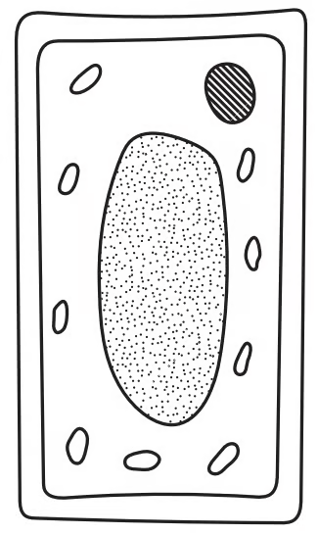

(b) Fig. 2 shows the same palisade mesophyll cell after it has been placed in a concentrated sugar solution for twenty minutes.
Fig. 2
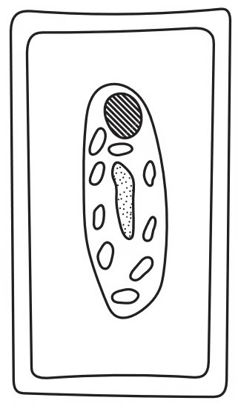
(i) Describe the changes that have taken place in the cell between Fig. 1 and Fig. 2. (2)

(ii) Explain why the cell in Fig. 2 has changed. (3)

(iii) Suggest how the cell in Fig. 2 could be treated so that it returned to its original appearance in Fig. 1. (1)

(c) Fig. 3 shows drawings of sections through a root, a stem and part of a leaf in a dicotyledonous plant. Identify and label, with the letter W, the position of the water transport tissue in each of the root, the stem and the leaf on Fig. 3. (3)
Fig. 3
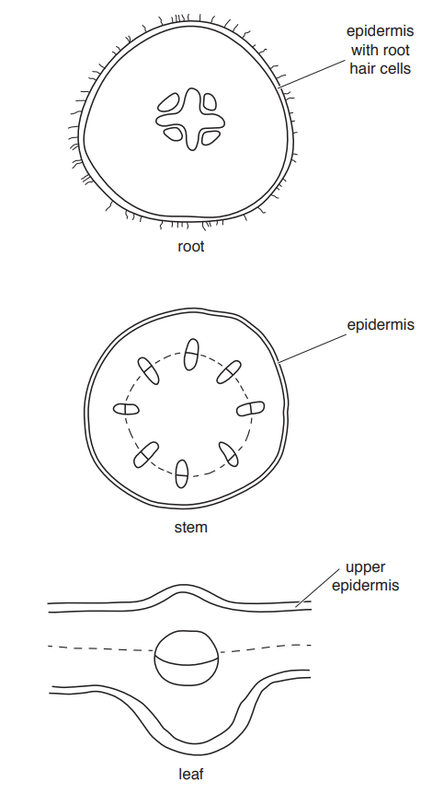

(d) Fig. 4 shows the stages of an enzyme-catalysed reaction. State the names of A to D in Fig. 4. (4)
Fig. 4
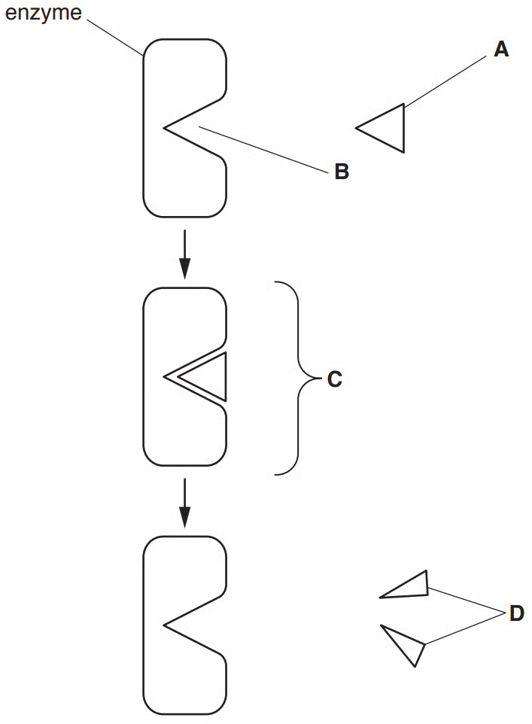
A ..............................................................
B ..............................................................
C ..............................................................
D ..............................................................

(e) Digestive enzymes are used in chemical digestion to break down large insoluble molecules into smaller soluble molecules. The boxes in Fig. 5 show some large insoluble molecules, some digestive enzymes and some smaller soluble molecules that are produced during digestion. Draw one straight line from each enzyme to the insoluble molecule it acts on. Draw another line from each enzyme to the smaller soluble molecule that is produced. Draw a total of six lines. (5)
Fig. 5
insoluble molecule | enzyme | soluble molecules
fat | amylase | amino acids
protein | lipase | fatty acids and glycerol
starch | protease | sugars

————————————————————————————————————————
END OF QUESTION PAPER - SET B
————————————————————————————————————————

