ECE 573: INTERNET PROTOCOLS

PROJECT 2 REPORT

GO-BACK-N IMPLEMENTATION USING UDP SOCKET

NAME: PURNA MANI KUMAR GHANTASALA STUDENT_ID: 200066404

NAME: RASHMI SANDILYA STUDENT_ID: 200084902

Server: Ubuntu 14.04 Base

Server IP address: 152.46.18.151

Client: Windows PC (Private IP)

Client IP address: 192.68.1.8

Round Trip Time from: Approximately 40 milliseconds

Timeout time: 0.5 (500 milliseconds)

File tested size: 1048576 bytes

Results, Graphs and Explanation of each task starts from next page.

Prints in the files:

Prints used in the gbn_server.py

Packet dropped due to probability: Packet loss, sequence number = 15

Packet dropped due to checksum failure: Checksum failed, sequence number = 15

Duplicate packet received: Received duplicate packet with sequence number = 15

Future (sequence greater than expected) packet: Received future packet with sequence number = 15

File transfer done: File received successfully

Prints used in the gbn_timeout.py

Timeout: Timeout, sequence number is 15

**Task1: Effect of Window Size N**

**Probability of packet loss = 0.05; MSS = 500 bytes**

Results:

|  |  |
| --- | --- |
| Window Size (N) | Total time for file transfer(seconds) |
| 1 | 125 |
| 2 | 123 |
| 4 | 120 |
| 8 | 117 |
| 16 | 126 |
| 32 | 159 |
| 64 | 184 |
| 128 | 241 |
| 256 | 252 |
| 512 | 260 |
| 1024 | 275 |

Graph:

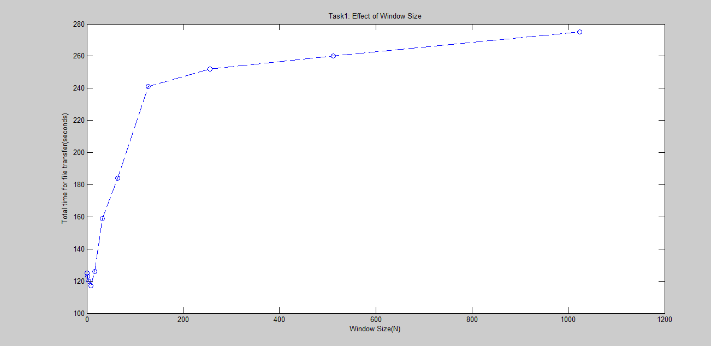

Explanation on Effect of N (Task 1):

Here timeout for each packet is 500 milliseconds. Round trip time is 50 milliseconds.

Hence the graph is decreasing until Window Size is 8 and later it is increasing till the end. Until window size is 8, the delay is very less because the retransmissions are very less.

When the window size is increased, retransmissions are increasing and more timeouts are seen.

Hence more time to retransmit and more retransmissions leads to increase in total time taken to transmit file.

**Task 2: Effect of MSS:**

**Window Size N = 64; Probability of packet loss = 0.05**

Results:

|  |  |
| --- | --- |
| MSS | Total time for file transfer(seconds) |
| 100 | 345 |
| 200 | 218 |
| 300 | 201 |
| 400 | 188 |
| 500 | 174 |
| 600 | 174 |
| 700 | 173 |
| 800 | 173 |
| 900 | 172 |
| 1000 | 171 |

Graph:

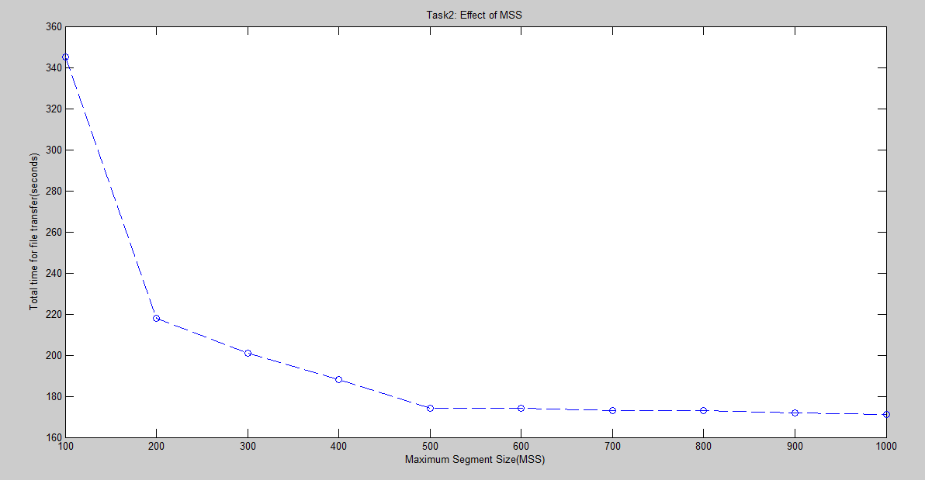

Explanation on effect of MSS (Task 2):

Initially graph is decreasing and later it is almost constant.

When MSS is small, total number of packets are more and due to loss of packets, more number of packets are to be sent. Hence total time for file transfer is large when MSS is small.

As MSS increases, the time for calculating checksum and forming packet and transmitting increases and timeouts are seen even when packet size is increased. This is the expected result. When the MSS is small, there are more number of packets to send, hence, packet loss is high which results in more re-transmissions.

**Task 3: Effect of Probability**

**Window size (N) = 64; MSS = 500 bytes**

Results:

|  |  |
| --- | --- |
| Probability of packet loss | Total time for file transfer(seconds) |
| 0.01 | 143 |
| 0.02 | 147 |
| 0.03 | 158 |
| 0.04 | 166 |
| 0.05 | 174 |
| 0.06 | 186 |
| 0.07 | 197 |
| 0.08 | 210 |
| 0.09 | 224 |
| 0.1 | 244 |

Graph:

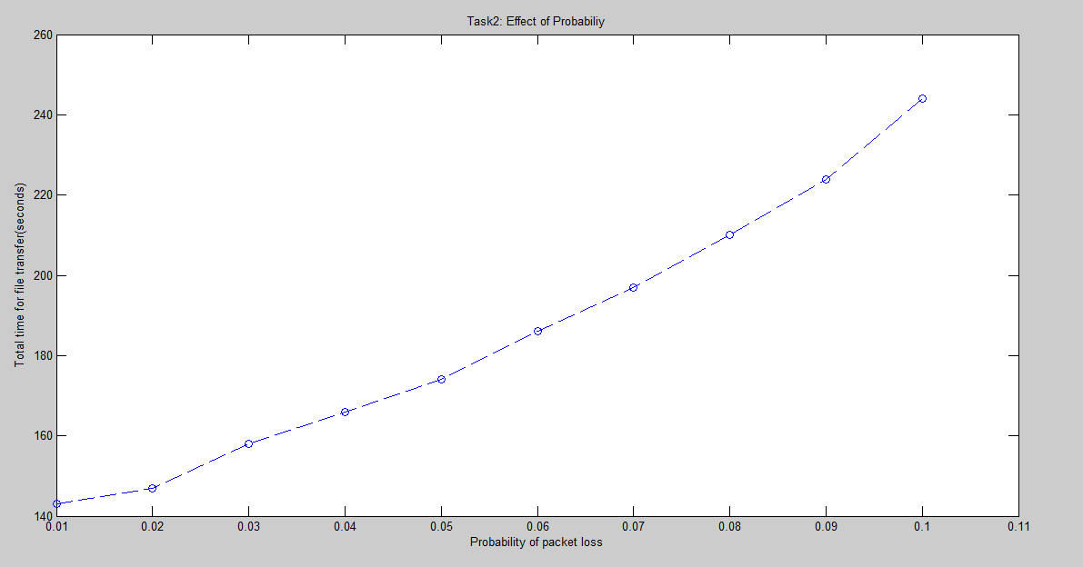

Explanation on Effect of Probability (Task 3):

From the graph, we can see that as the probability of packet loss increases, total time for file transfer is increasing.

This is expected behavior. When the probability of packet loss is increases, more number of packets are lost and retransmissions are to be done again for the lost packets. Hence the total time for file transfer increases when probability of loss is increased.