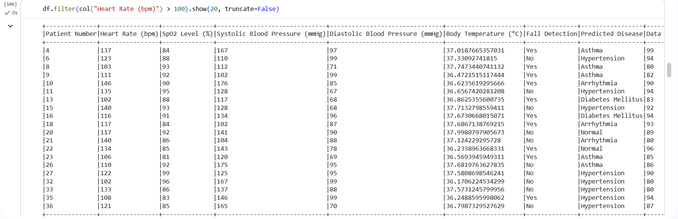
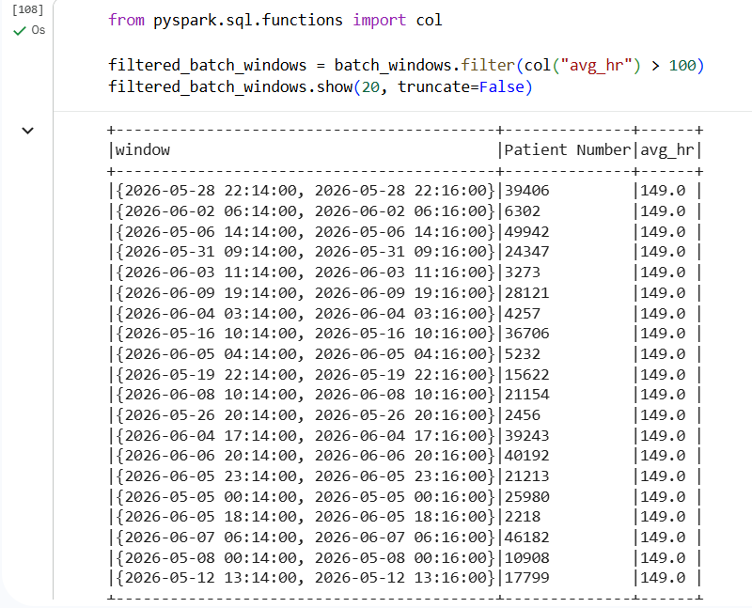
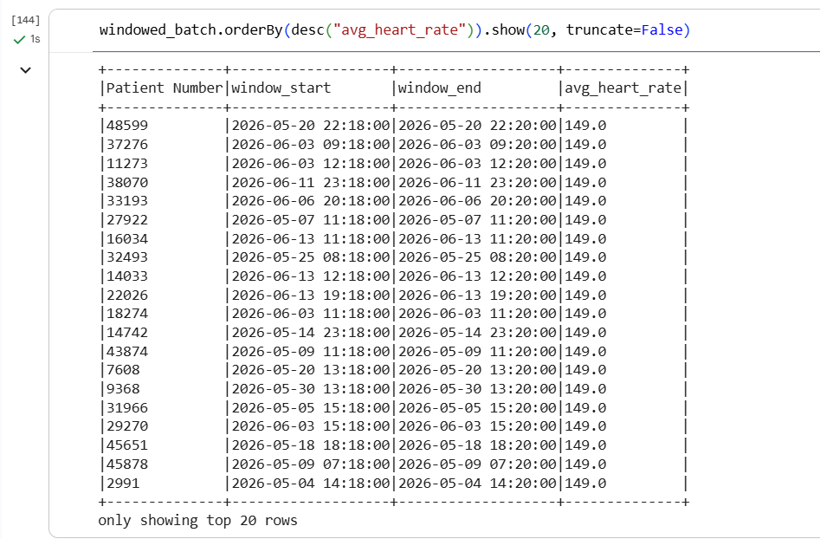
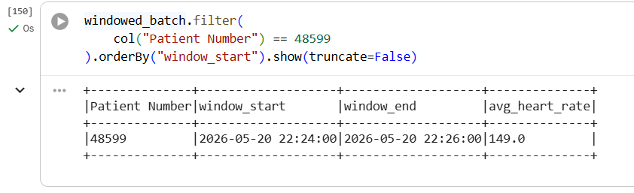
====================================
CLINICAL ALERTS
Sustained Elevated HR (>100 bpm)
Across Two Consecutive Windows
====================================
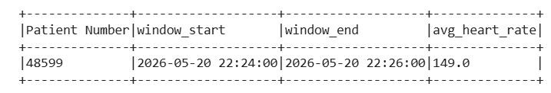
Total Clinical Alerts Generated: 1

