NEO CONNECT PROJECT
Purpose: -
It provides a platform where user can exchange their currency to other desired currency and can also do buy crypto currency.
Technology Used: -
Frontend | Backend
React (^18.2.0) | Nodejs (^20.11.1)
Vite (^5.1.4) | Express (^4.18.2)
Tailwind CSS (^3.4.1) | MongoDB (^6.4.0)

React: React is a popular JavaScript library for building user interfaces. It was developed by Facebook. It follows the Virtual DOM (Document object model) approach, which optimizes rendering performance by minimizing DOM updates.
Vite: Vite is a build in tool created by Evan you. It is the next-generation frontend tooling that provides a lightning-fast dev server, bundling and resolves the server cold start issue.
MUI: Material UI is an open-source react Component library that implements Google’s Material Design guidelines. It was designed from the ground up to be fast, small and developer friendly.
TypeScript: TypeScript is a trendy open-source language maintained and developed by Microsoft. Basically, it’s a superset of JavaScript that adds new capabilities to the language. It makes our code more secure and robust by preventing many bugs before the code is even shipped. It catches problems during code development and integrates wonderfully with code editors like Visual Studio Code.
System Requirements: -
OS: Any modern version of MacOS, Windows, Linux
Processor: Intel Celeron
Memory: 2GB RAM
Storage: Around 200MB of free space for project files.
Recommended Hardware Requirements for an optimal experience with hands-on labs and other practical activities, we recommended the following configuration:
OS: MacOS or a popular Linux distribution Like Ubuntu
Processor: 2.7 GHz Intel Core i5
Memory: 8GB RAM
Storage: Around 500MB of free spaces for project files.
Software Requirements:
Operating System: Any modern version of MacOS, Windows, or Linux
Browser: Any modern browser such as Chrome, Firefox, Safari, Opera etc.
A Code editor of IDE such as Atom, Visual Studio Code
NodeJS Version >= 6.0.0 and a package manager such npm or yarn
Useful links:-
Node: https://nodejs.org/en/download/package-manage/
NPM: https://www.npmjs.com/
Yarn: https://yarnpkg.com/lang/en/docs/install/
User Guide: -
Login: -
Two types of logins exist in this project that is User Login & Member Login
User Login: -
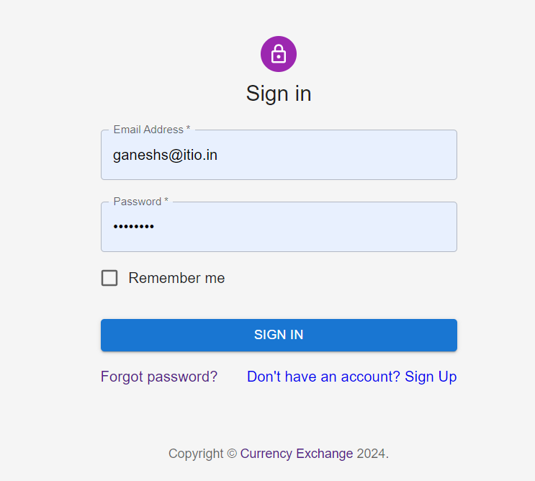
Figure 1.

User Signup:-
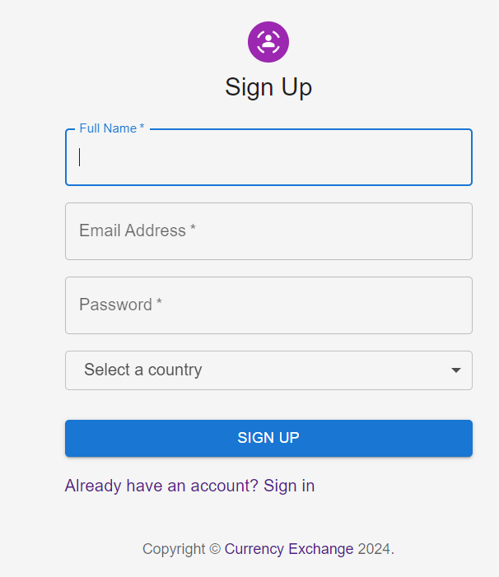
Figure 2

Home Page:-
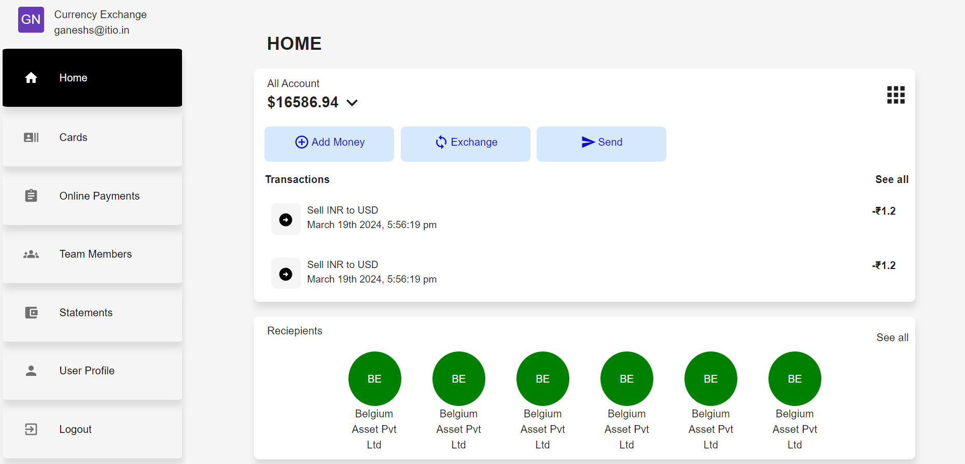
Figure 3
Points about the Home Page of User
On Top Left the user email will appear
On Left a Sidebar which have 6 Tabs with Logout button also.
When user click on Home Tab on the right hand side Content will appear as we have seen in above Screenshot Figure 3
On Right Hand Side content consists of following functionality for user
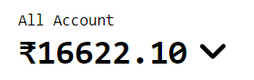
Figure 4
This is converted value of all account of user.
For example:-
User have 3 accounts one is Indian Currency account, Second is American Dollar Currency account and third one is China Currency Account.
If User set Indian currency as an default currency, then American dollar and Chinese Yuan will convert into INR and after that sum of all amount will display on all account balance. (see figure 4 and 5)
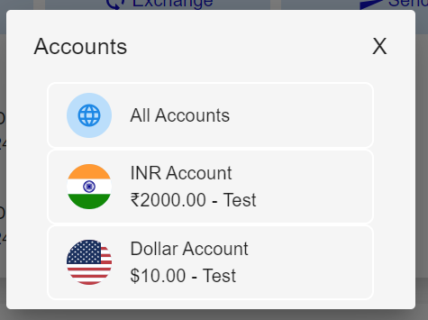
Figure 5
After click on arrow down icon user can switch another available account.


Figure 6
When User click On Top Right Icon it will navigate user to All accounts page, where user can see their created accounts list and their related account info (See figure 6 and 7)
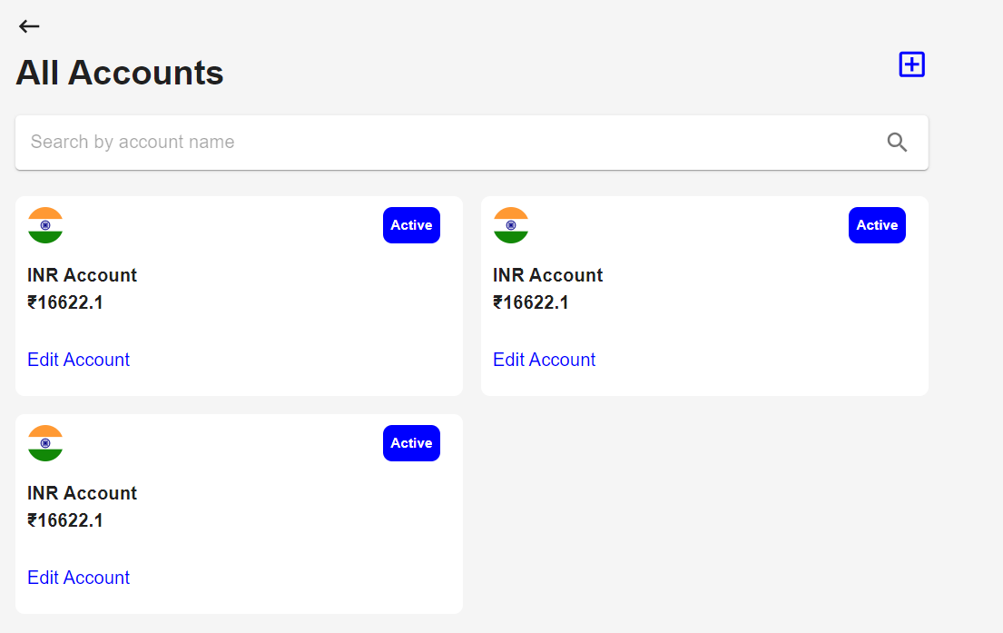
Figure 7
On this figure 7 User can create account , edit / upate their account info and when place on mouse to respective particular account box after click can see their account info. (See figure 8)

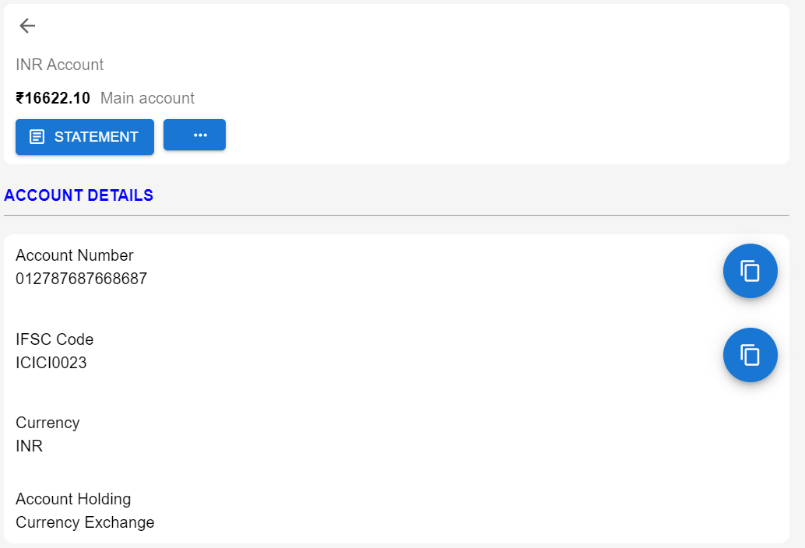

Figure 8

Figure 9

Add money Button (Pending)
This is related for Add money in your wallet for respective account

Exchange Button:-
This is for exchange currency balance to desired currency. (See Figure 10)
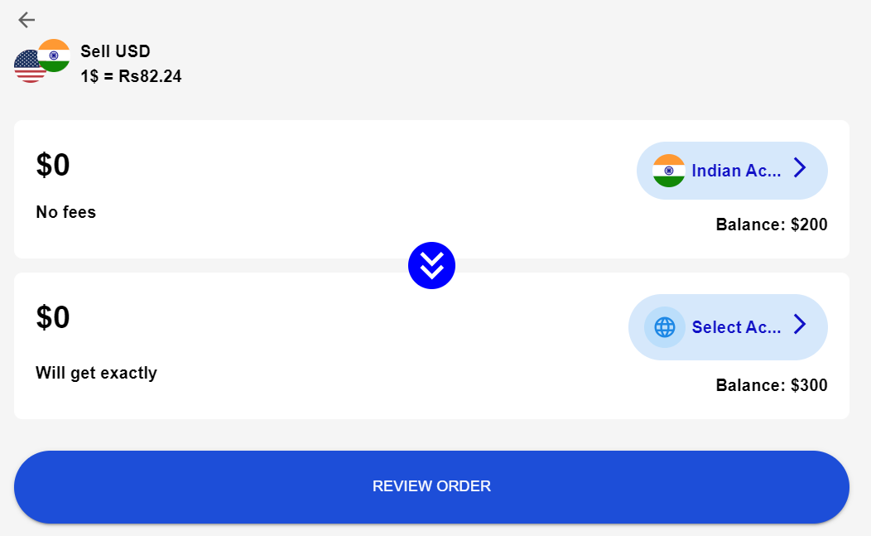
Figure 10
User have to click on bottom right button to select account on which they want to convert currenct currency balance amount.
Here, user can’t edit their amount all amount is converted in one go.
On top left we can see current real time conversion rate of currencies.
After that user can click on review order button in order to view review currency conversion page. (see Figure 11)
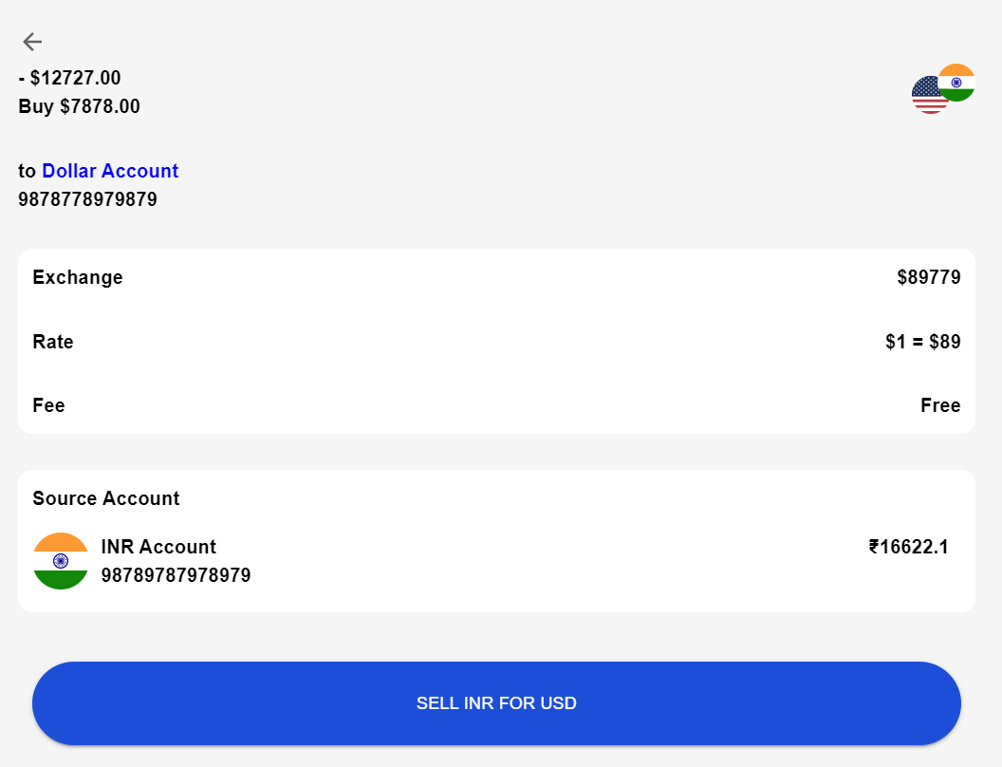
Figure 11
Here all review is displayed , like conversion rate, converted amount and their conversion fee, source account and their balance.

After click on sell INR for USD Order is places and received account will receive the amount.

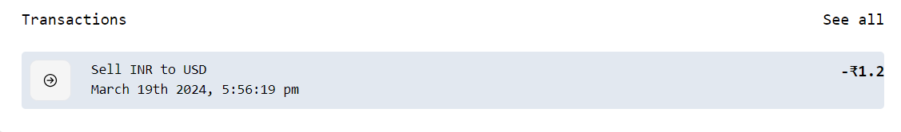
Figure 12

In figure 12 user can see their account last transaction details , it will display transaction list according to selection of account list by the user, see figure 4, On right hand side we can see seal all, on click this user will navigate to all transaction list page where they can see other parts (see Figure 13)
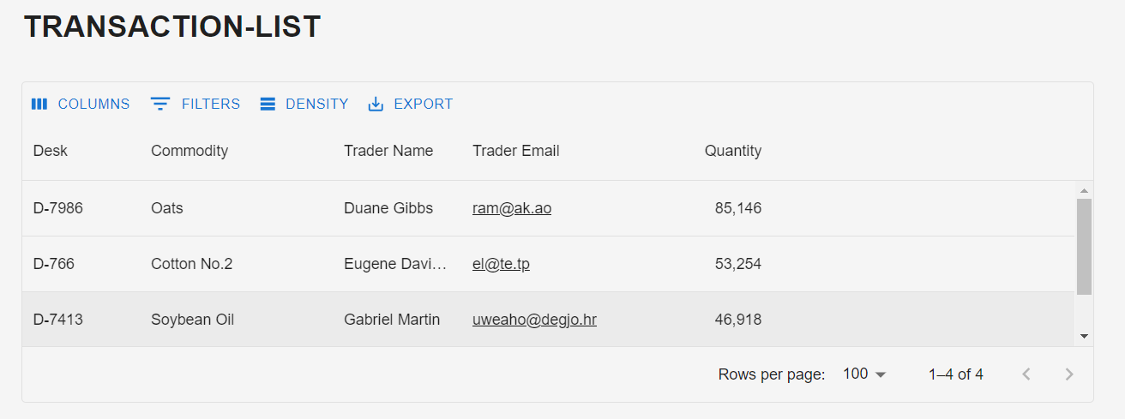

Figure 13

Figure 14
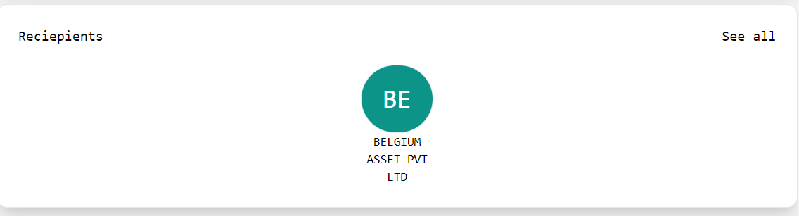

This part is related to receipients lists. Receipient referes to beneficiary account. If User want to transfer amount o their beneficiary account for that purpose user can create receipient account. (see figure 14 & 15)
Figure 15
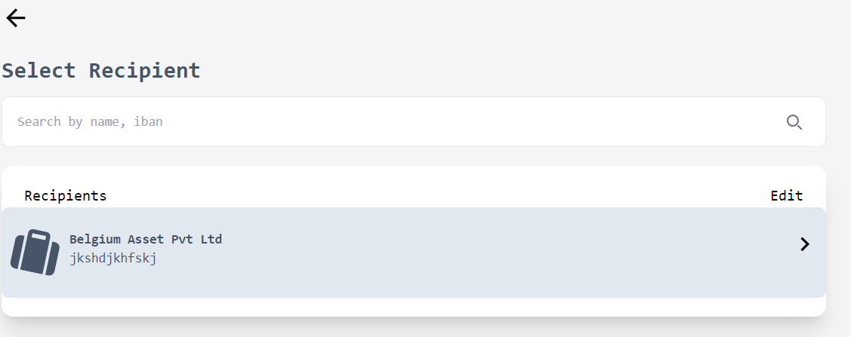
Figure 16
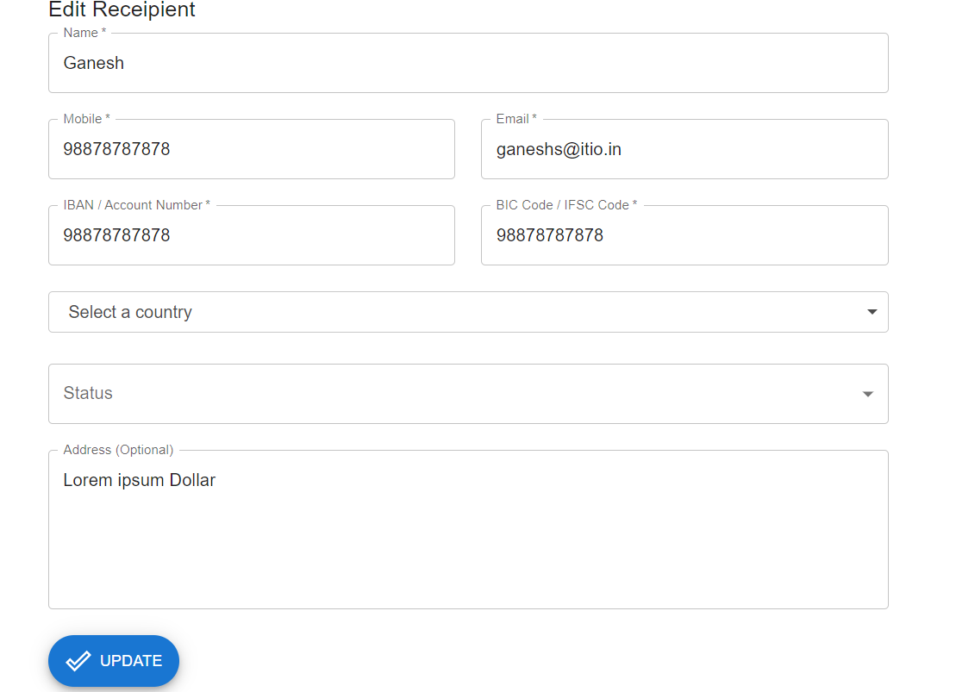
Figure 17
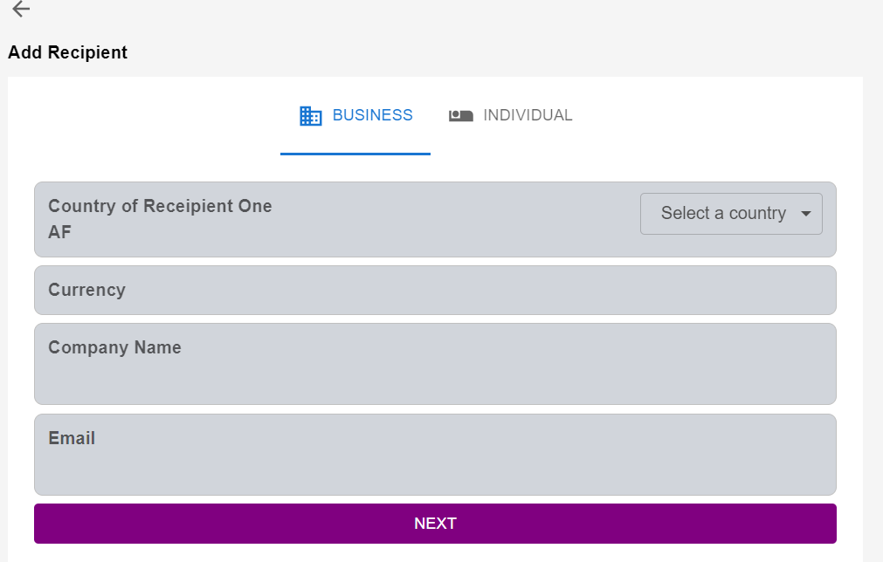
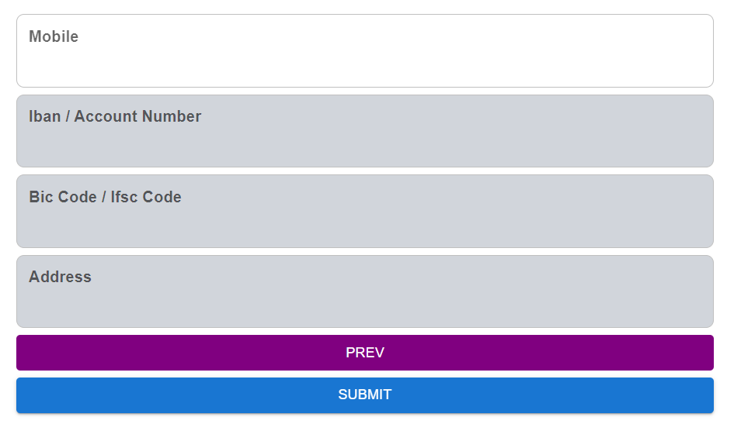

Figure 18

After click on send button on window will open (See figure 20)
It is consist four pats,
- Create a beneficairy account
- Transfer amount into the recepient bank account
- My accounts page
- Exchange (Already we know about on figure 10)

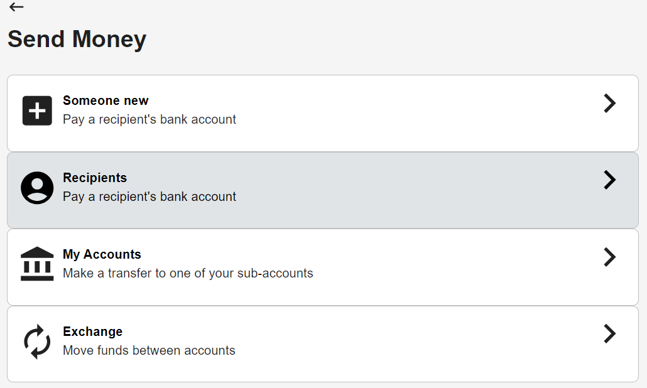
Figure 19
My Accounts Page Overview:-

From here user can change their default account currency, here we also display user sub account list with their name , balance and other
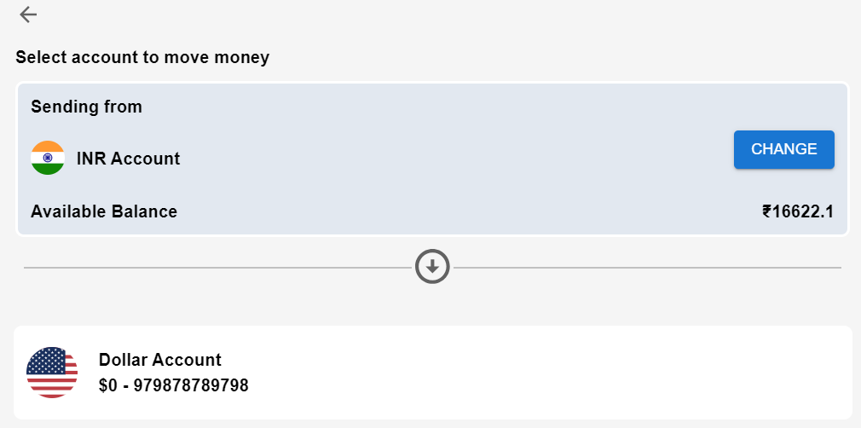
Figure 20
Now move to Sidebar Second Tab

Cards:-

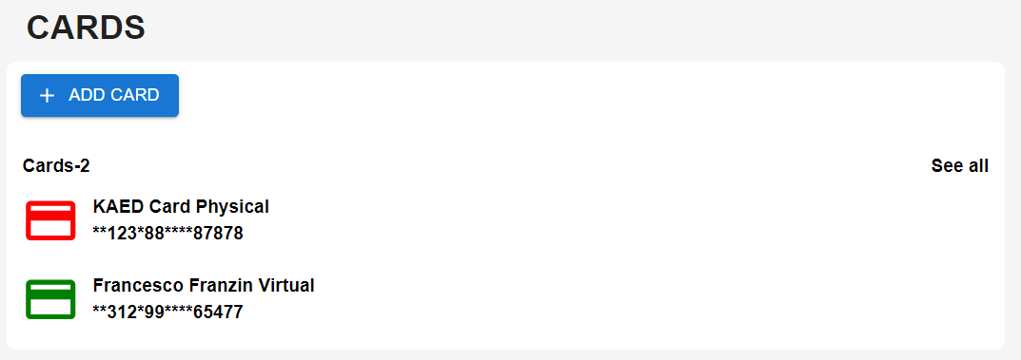
Figure 21
Here, user can add their cards which may use in future for their transactions like add money
Add Card Modal
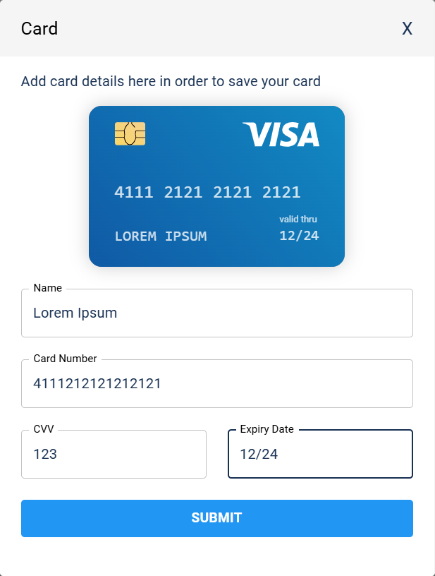

Online Payments:-
This part is pending
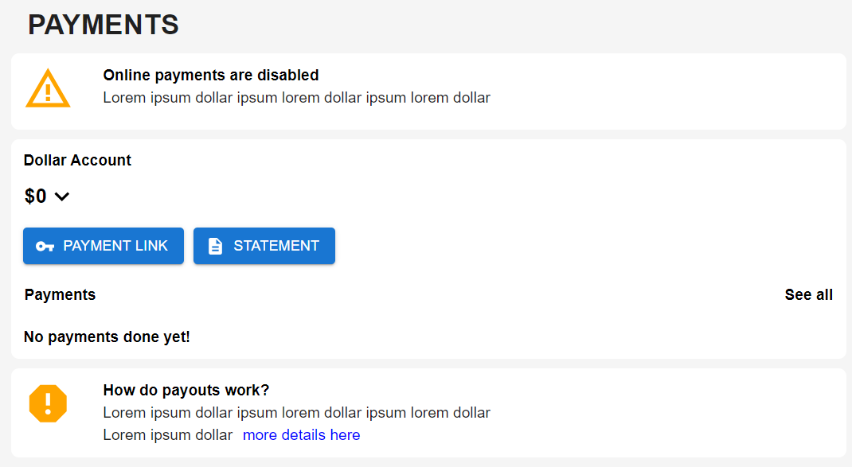
Figure 22
Team Members:-
Here User can their team members in order to allow them to login and use their account on behalf of him. (see figure 23 & 24)
Here we can see Add team member and their member list.
Be default today added member list will appear. If user want to see all list then they can use filter option.

Figure 23
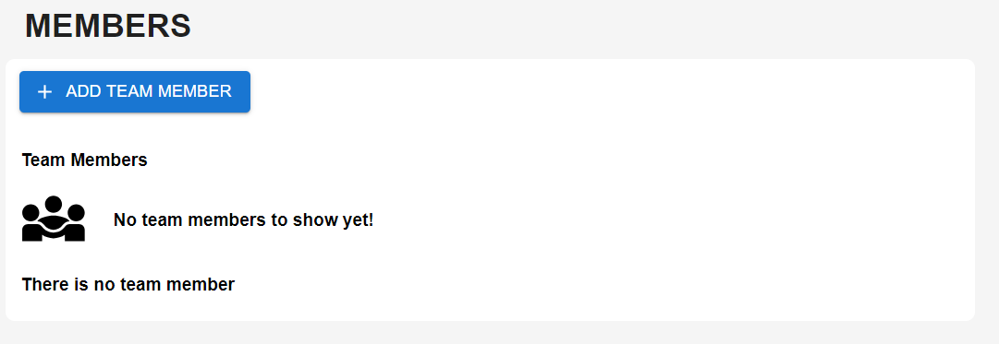

Figure 24

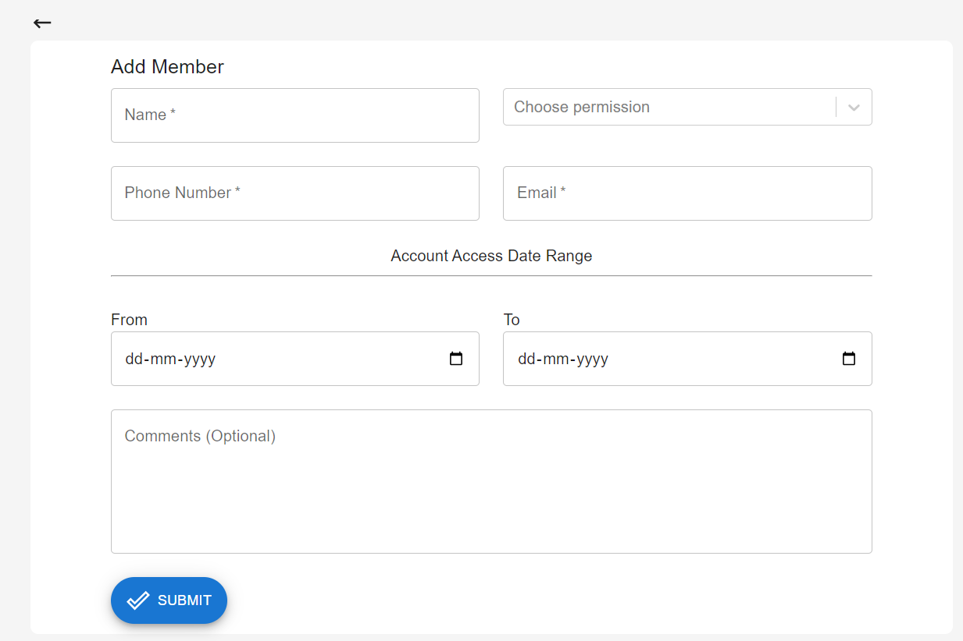

This is Add team member form, here user can add permission like sidebar tabs which tab member can use (See figure 25) , and other functionality we have added validatity of login period/duration
If user want their particular team member can use their account on 2024-01-01 to 2024-01-02 (for 2 days) . After last date member could not be able to login account which was created by the user.

Figure 25:-
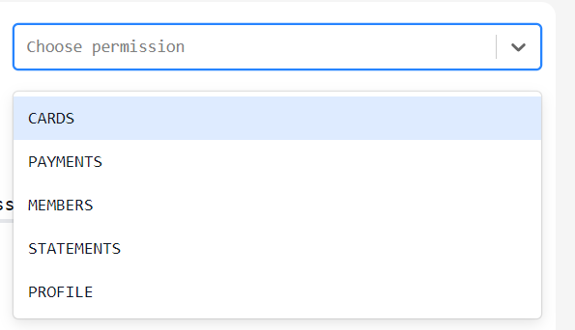

Statements:-
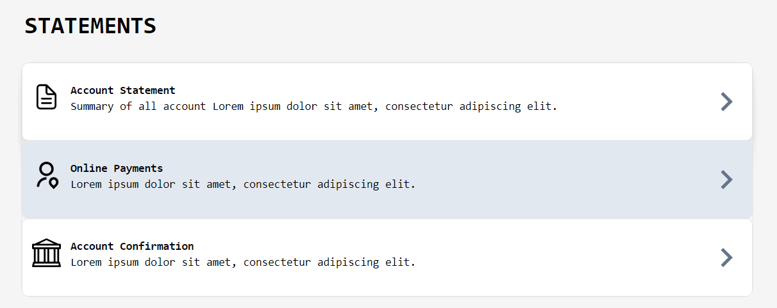
Figure 26
It consists of three parts, Account statement, Online Payments and Account Confirmation.
On Account Statement user can see their account statement and download pdf of selected period (see figure 27)
The pdf will send user registered email address.
Here user can select their all account one by one and can generate statement. If user doesn’t have any transaction is particular date then statement will not generated. Statement is only generated when selected account have done transaction on particular period.
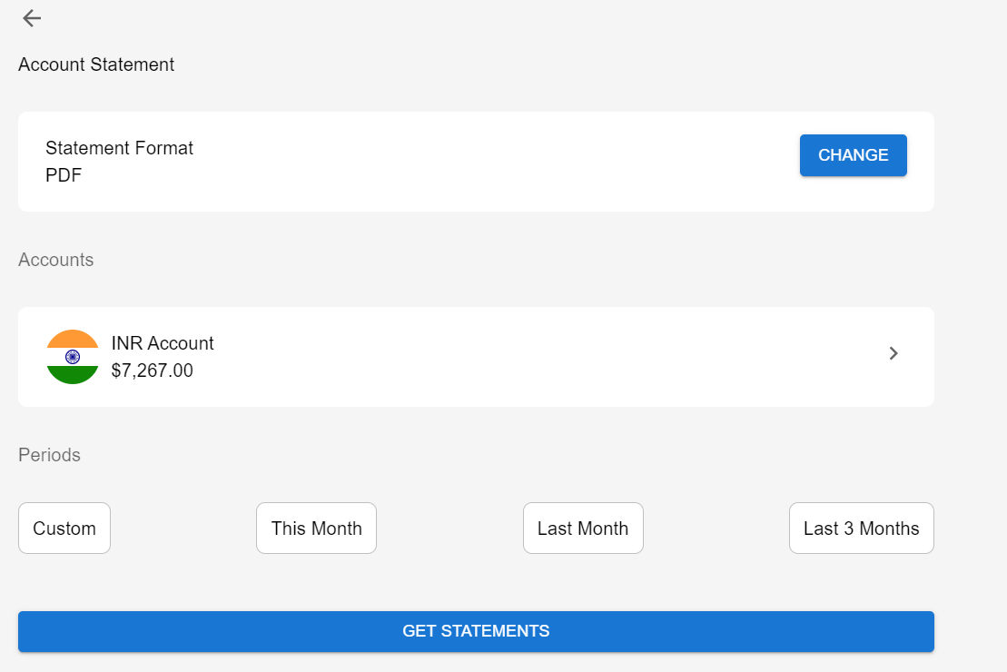
Figure 27

KYC:-
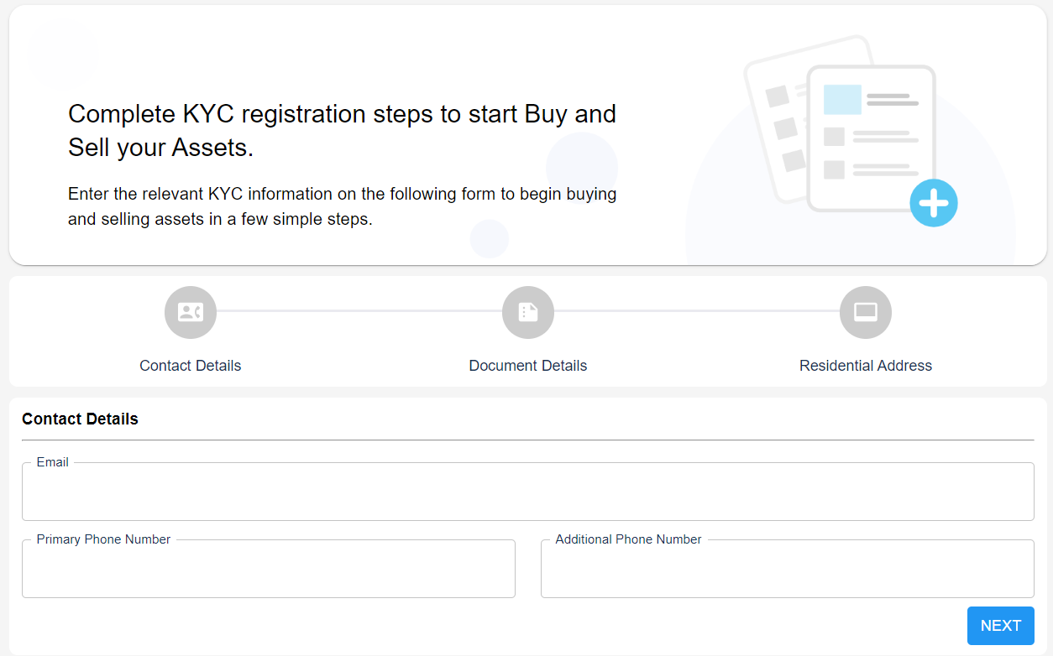
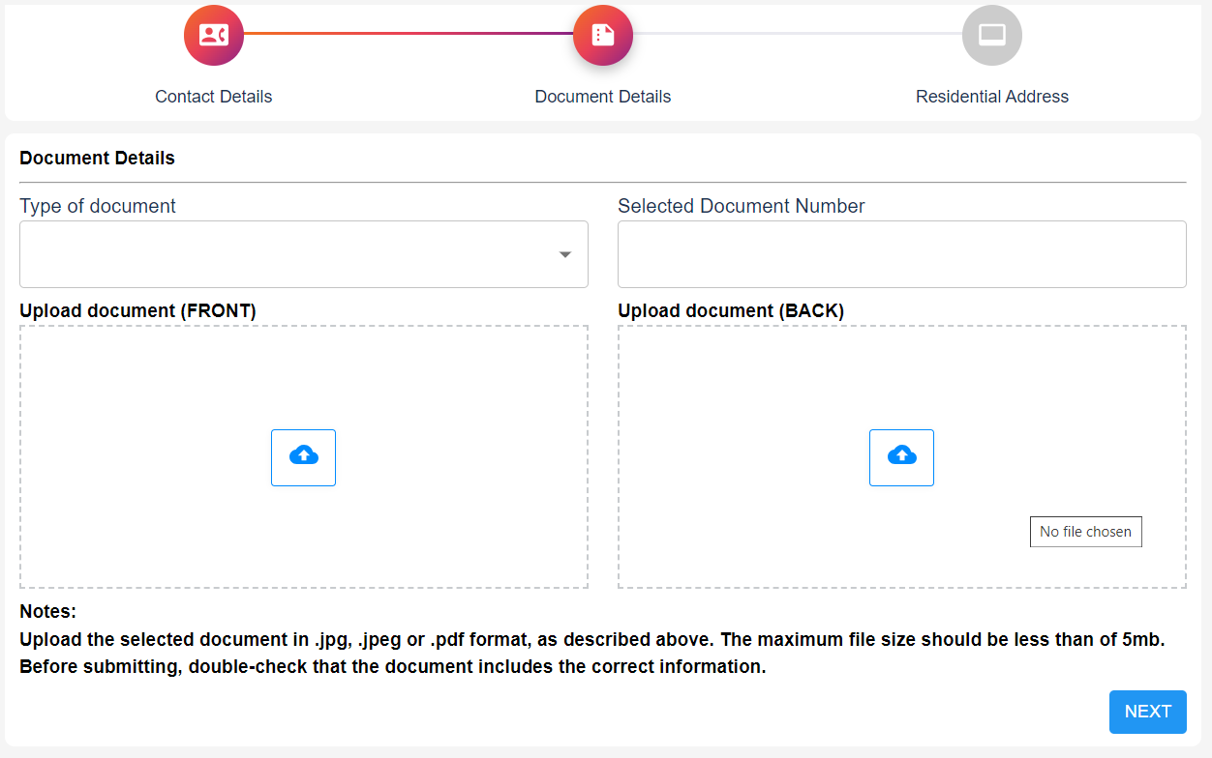

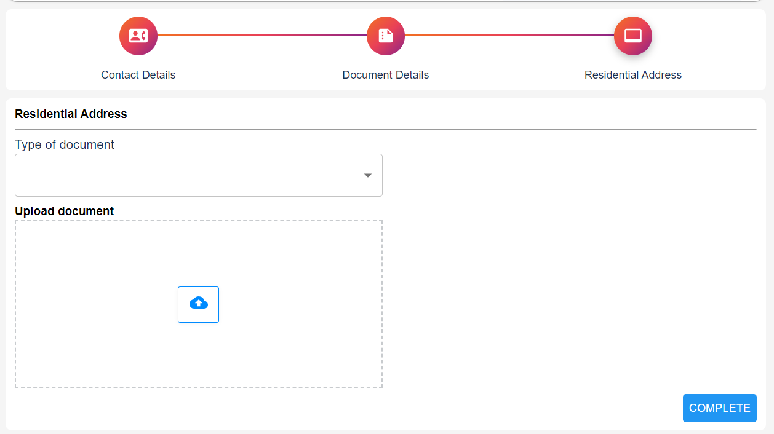

Help Center
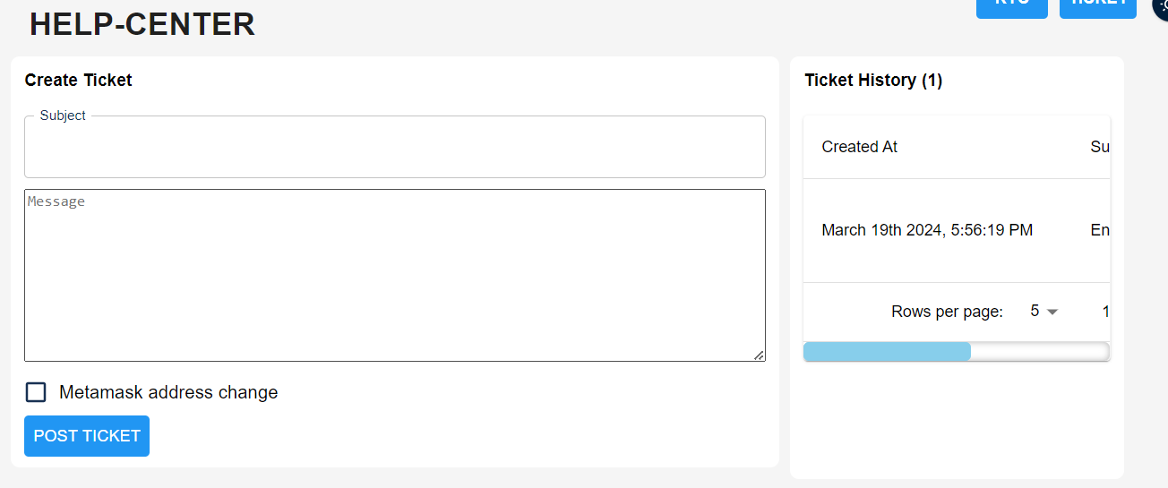

User Profile Tab:-
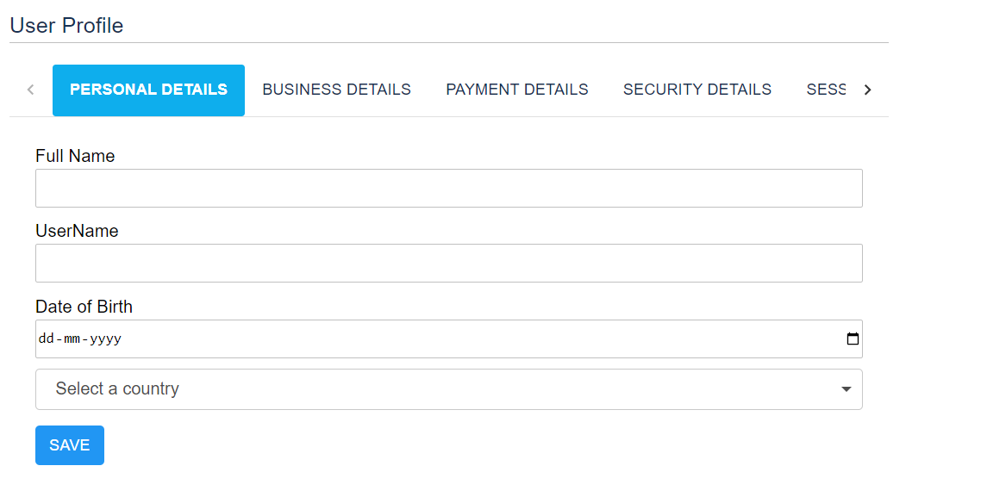
Here user can see and update their profile related info and also change their default currency. On selection of country currency will save as default account currency.
Refer & Earn:-
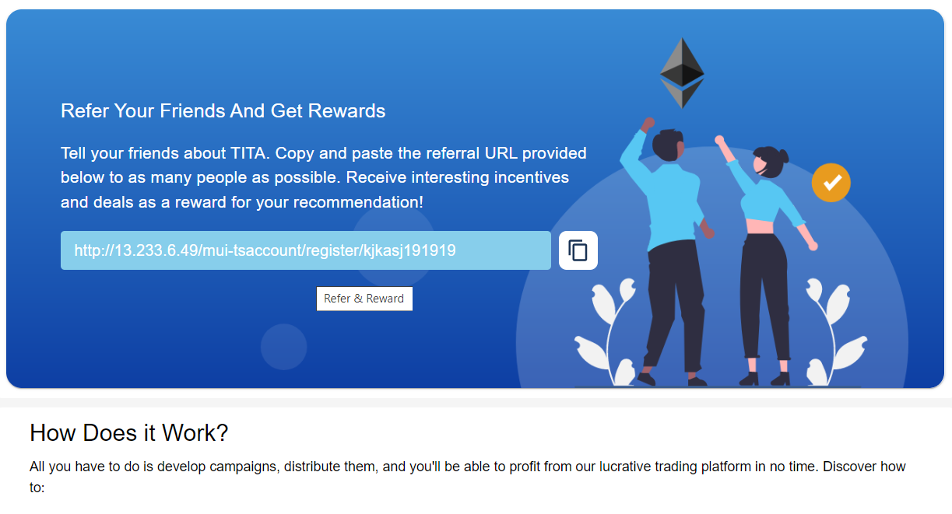

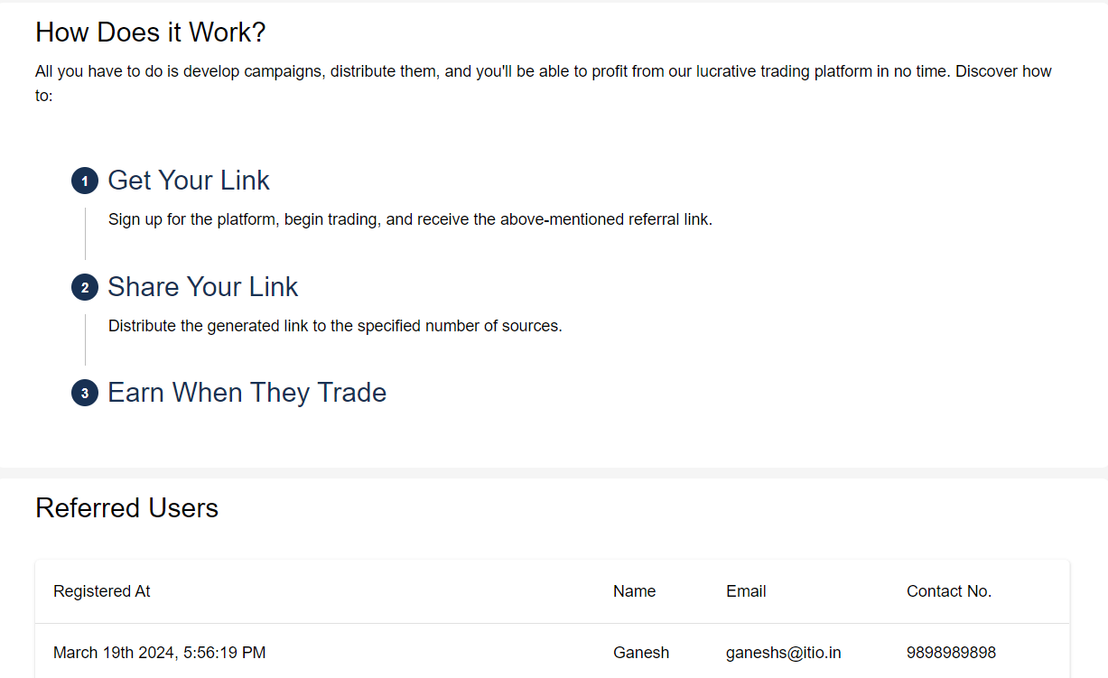

Logout Tab:-
This is for logout from their account.
Project setup on Live:-
This project is based on MERN Technology. Below we have mentioned how we deploy our project on live aws.
- User must have github account
- Aws account

Steps to upload on server:-
- sudo apt update
- sudo apt install nodejs
- nodejs -v
- npm -v
- curl -o- https://raw.githubusercontent.com/nvm-sh/nvm/v0.35.3/install.sh | bash
- sudo npm install -g npm@latest
- sudo npm i pm2 -g
- sudo apt install nginx
- nginx -v
10) sudo nano /etc/nginx/sites-available/default
11) sudo systemctl restart nginx

Paste below code :
server {
listen 80 default_server;
server_name 3.70.98.224; // server ip or host name
# react app & front-end files
location / {
root /home/ubuntu/mern-project/frontend/dist;
try_files $uri /index.html;
}
# node api reverse proxy
location /api/ {
proxy_pass http://localhost:5000/;
}
}
Above all command need to run on root folder
After that clone your project which is on github account.
Command like run git clone `git clone path`
After clone mern-project directory visible
cd mern-project
two directory visible one is for backend and other name is frontend
then run cd backend
npm i
this will install all dependencies from package.json file
after installation gp back cd ..
cd frontend
then run npm install
this will install frontend dependencies which is mentioned on package.json file
after installation go back cd ..
now we setup our project it’s time to run process manager pm2, this will run our project.
Run command
pm2 start --name <app name> npm – start

Project setup on local:-
- npm create vite@latest
- after select react javascript
- add project name frontend
- add directory backend
- cd frontend
- npm install
- npm install @mui/material @emotion/react @emotion/styled
- npm install @fontsource/roboto (Material UI uses the Roboto font by default)
- npm install @mui/icons-material
10) run command npm start
11) open another terminal and go to frontend folder
cd frontend
and run command npm run dev
this will run frontend http://localhost:5173

