/\*

//ReactDOM.render(<h1-Hello ever1</h1>, document.getElementById("root"))

//ReactDOM.render(<ul><li>apple</li><li>rose</li></ul>,document.getElementById("root"))

//function MainContent(){

  //return(

    //<h1>I'm learning react</h1>

  //)

//}

//ReactDOM.render(<div><MainContent/></div>  ,document.getElementById("root"))

  //jsx

  //const navbar=(

    //<nav>

      //<h1>BlackPink</h1>

     // <ul>

       // <li>pricing=100000000000</li>

       // <li>About-Pop/Rock/Modern Funk</li>

        //<li>Contact-bp@inyourarea.com</li>

      //</ul>

      //</nav>

  //)

  //ReactDOM.render(navbar,document.getElementById("root"))

  //const Content=(

    //<rae>

      //<img src="logo192.png" width={"160px"}/>

    //<h1>Fun facts about React</h1>

    //<ul>

      //<b>

//      <li>Was first released in 2013</li>

  ///    <li>Was originally created by jordan walke</li>

     // <li>Has well over 100K on github</li>

     //<li>

      //  is maintained by facebook</li>

       // </b>

   // </ul>

    //</rae>

  //  )

  //ReactDOM.render(Content,document.getElementById("root"))

/\*  function PageComponent(){

    return(

      <div>

        <Header/>

        <Body/>

        <Footer/>

      </div>

    )

  }

  ReactDOM.render(<PageComponent/>,document.getElementById("root"))\*/

Index.js

Header.js

export default function  Header(){

    return(

       <header>

         <nav className='nav'>

         <img src="logo192.png" />

         <ul className='hli'>

           <li>Pricing</li>

           <li>About </li>

           <li>Contact</li>

         </ul>

         </nav>

       </header>

     )

}

Footer.js

export default function Footer(){

    return(

      <footer className='footer'>"© 2022 development. All rights reserved."</footer>

    )

  }

Body.js

export default function Body(){

    return(<div className='bodyStyle'>

      <h1>Reasons to love react</h1>

          <ul>

            <li>Fun</li>

            <li>Easy</li>

            <li>Challenging</li>

          </ul>

    </div>)

  }

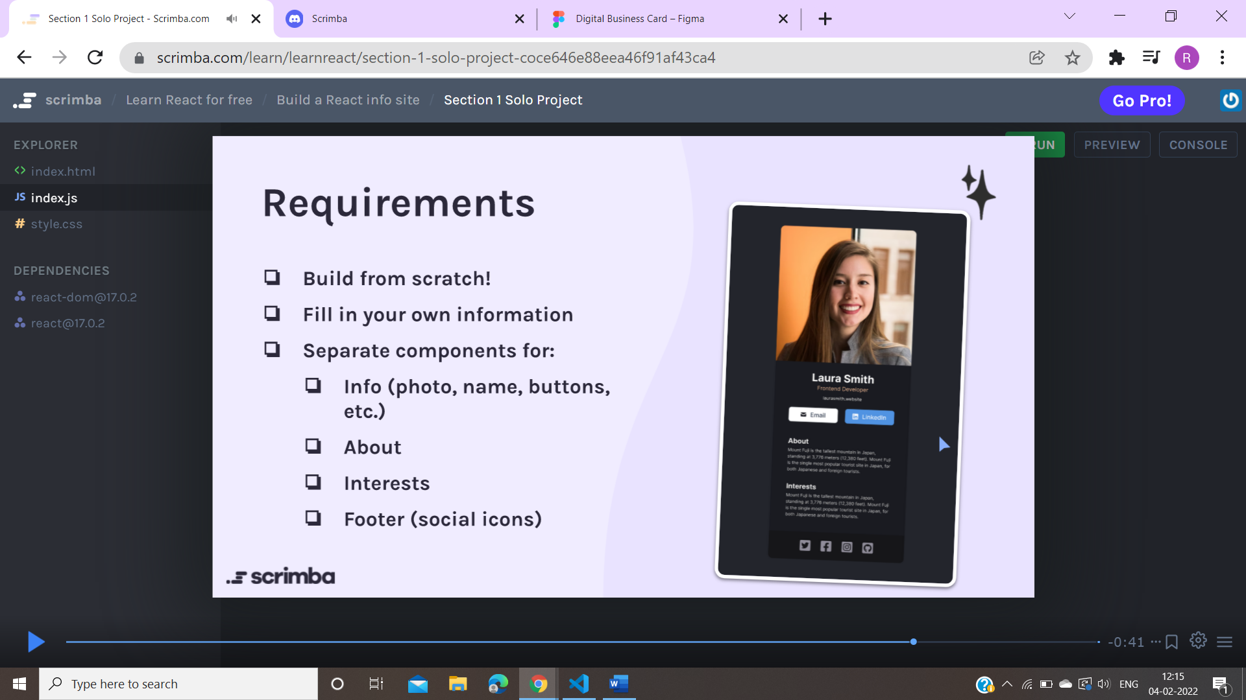

/\*body {

  margin: 0;

  font-family: -apple-system, BlinkMacSystemFont, 'Segoe UI', 'Roboto', 'Oxygen',

    'Ubuntu', 'Cantarell', 'Fira Sans', 'Droid Sans', 'Helvetica Neue',

    sans-serif;

  -webkit-font-smoothing: antialiased;

  -moz-osx-font-smoothing: grayscale;

}

code {

  font-family: source-code-pro, Menlo, Monaco, Consolas, 'Courier New',

    monospace;

}

.hli{

  list-style: none;

  display: flex;

}

.nav{

  display: flex;

  justify-content: space-between;

  align-items: center;

  background-color: rgb(182, 224, 189);

}

.hli >li{

  padding: 10px;

}

.nav >img{

  width: 140px;

}

.bodyStyle{

  margin: auto;

  width: 150%;

  border: 3px dodgerblue ;

  background-color: rgb(181, 223, 209);

  padding: 10px;

}

.bodyStyle >li{

  text-align: center;

}

.footer{

  text-align: center;

  border: 3px solid rgb(152, 212, 214);

  background-color: rgb(162, 212, 196);

}\*/

/\*

.navbar{

  display: flex;

  font-style: Inter;

  justify-content: space-between;

  color: aliceblue;

  background-color: black;

  margin: 0;

 }

 .list{

   color: white;

   background-blend-mode: normal;

   background-color: #282D35;

   align-items: flex-start;

 }

 .list >li{

 padding-bottom:11px;

 margin: 0px;

 }

 .list >li::marker{

    color: rgb(0, 204, 255);

    font-size: 1.2em;

 }

 body{

   background-color:  #282D35;

 }

 \*/

 .infos{

  text-align: center

 }

 .abt{

   text-align: center;

   border: ivory;

 }

 /\*.sol{

   font-style: normal;

   color: purple;

   background-color: black;

   border-style: solid;

   box-sizing: border-box;

 }

 .int{

   text-align: center;

   border: 2px solid #ccc;

   padding: 10px;

   width: 20em;

   width: -moz-fit-content;

  width: fit-content;

  background-color: #8ca0ff;

  padding: 5px;

  margin-bottom: 1em;

 }

 .foot{

   text-align: center;

 }\*\*/

     <Contact

     img="./images/mr-whiskerson.png"

     name="Mr. Whiskerson"

     phone="(212) 555-1234"

                email="mr.whiskaz@catnap.meow"

     />

     <Contact

     img="./images/mr-whiskerson.png"

     name="Mr. Fluffhead"

     phone="(212) 588-1234"

                email="mr.fgkaz@catnap.meow"

     />

     <Contact

     img="./images/mr-whiskerson.png"

     name="Mr. Bubblegum"

     phone="(212) 2578-1234"

                email="mr.bubkaz@catnap.meow"/>

     <Contact

     img="./images/mr-whiskerson.png"

     name="Mr. Rackentein"

     phone="(212) 488-1234"

                email="mr.rakaz@catnap.meow"/>

joke

import Joke from './components/Joke';

function Appd() {

  return (

    <div>

      <Joke

      setup="Why do bees stay in the hive in the winter?"

      punchline=" Swarm."

      isPun={true}

      comments={[{author:"sj",body:"",title:""}]}

      upvotes={10}

      />

      <Joke

      setup="Why don't pirates travel on mountain roads?"

      punchline=" Scurvy."/>

      <Joke

      setup="How did the hacker escape the police?"

      punchline=" He just ransomware!"/>

      <Joke

      setup="I got my daughter a fridge for her birthday."

      punchline=" I can't wait to see her face light up when she opens it."/>

      </div>

  )

}

  ReactDOM.render(<Appd />, document.getElementById("root"))

export default function Joke(props){

    return(

        <div className="jokestyle">

           < h1>{props.setup}</h1>

        <p>{props.punchline}</p>

        </div>

    )

}

export default function Contact(props){

    return(

        <div className="contacts">

            <div className="contact-card">

                <img src={props.img}/>

                <h3>{props.name}</h3>

                <div className="info-group">

                    <img src="./images/phone-icon.png" />

                    <p>{props.phone}</p>

                </div>

                <div className="info-group">

                    <img src="./images/mail-icon.png" />

                    <p>{props.email}</p>

                </div>

            </div>

            </div>

    )

}

import React from 'react';

import ReactDOM from 'react-dom';

import './index.css';

import 'bootstrap/dist/css/bootstrap.min.css';

import 'bootstrap/dist/js/bootstrap.bundle.min';

import Navbar from './components/Navbar';

import Card from './components/Card';

import Hero from './components/Hero';

//  return name.charAt(0).toUpperCase+name.slice(1)

/\*const names = ["alice", "bob", "charlie", "danielle"]

const caps= names.map(function(name){

  return name[0].toUpperCase() + name.slice(1)

})

console.log(caps)\*/

const pokemon = ["Bulbasaur", "Charmander", "Squirtle"]

const para=pokemon.map(function(para){

  return  `<p>${para}</p>`

})

console.log(para)

 function Page() {

  // <Hero/>

return (

<div>

  <Navbar />

  <Hero/>

  <Card

  imgsrc="bpiny.png"

  rating="5.0"

  reviewcount={6}

  country="India"

  title="Life Lessons with Katie Zaferes"

  price={136}

  />

</div>

)

}

ReactDOM.render(<Page/>,document.getElementById("root"))

8888888888

import React from "react"

import Joke from "./Joke"

import jokesData from "./jokesData"

/\*

Challenge: See if you can correctly pass the necessary props to the

Joke component in the .map() (and render the jokeElements array) so

the jokes show up on the page again

\*/

export default function App() {

const jokeElements = jokesData.map(joke => {

return <Joke setup={joke.setup} punchline={joke.punchline} />

})

return (

<div>

{jokeElements}

</div>

)

}

// <Joke

// punchline="It’s hard to explain puns to kleptomaniacs because they always take things literally."

// />

// <Joke

// setup="I got my daughter a fridge for her birthday."

// punchline="I can't wait to see her face light up when she opens it."

// isPun={false}

// />

// <Joke

// setup="How did the hacker escape the police?"

// punchline="He just ransomware!"

// isPun={true}

// />

// <Joke

// setup="Why don't pirates travel on mountain roads?"

// punchline="Scurvy."

// isPun={true}

// />

// <Joke

// setup="Why do bees stay in the hive in the winter?"

// punchline="Swarm."

// isPun={true}

// />

// <Joke

// setup="What's the best thing about Switzerland?"

// punchline="I don't know, but the flag is a big plus!"

// isPun={false}

// />

 const cardData=data.map(car=>{

    return (

   < Card imgsrc={car.coverImg}

    rating={car.stats.rating}

    reviewcount={car.stats.reviewCount}

    country={car.location}

    title={car.title}

      price={car.price}/>)

  })

 {badgeText &&<div className="card--badge">{badgeText}</div>}

