Postman curl cmd :

CREATE :

curl --location 'http://localhost:8080/invoices' \

--header 'Content-Type: application/json' \

--data '{

"amount": 199.99,

"dueDate": "2025-01-18"

}'

GET :

curl --location 'http://localhost:8080/invoices' \

--header 'Content-Type: application/json'

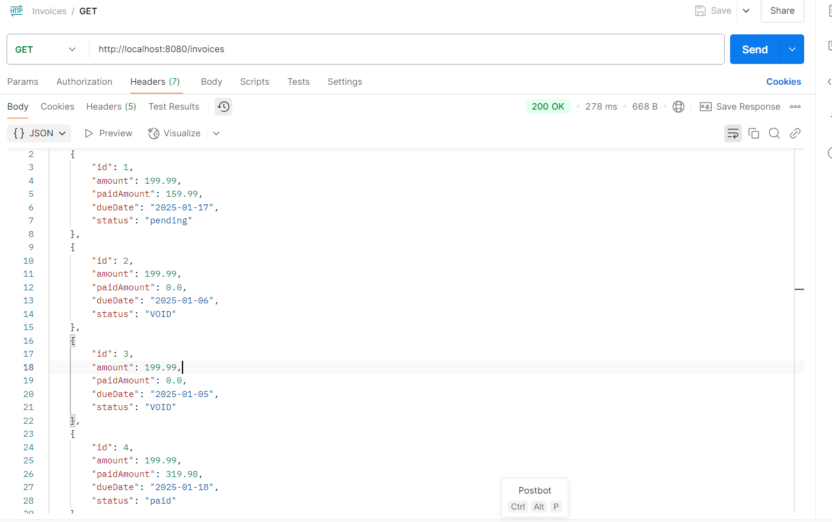

PUT :

curl --location --request PUT 'http://localhost:8080/invoices/4/payments' \

--header 'Content-Type: application/json' \

--**data** '{

    "amount": 159.99

}'

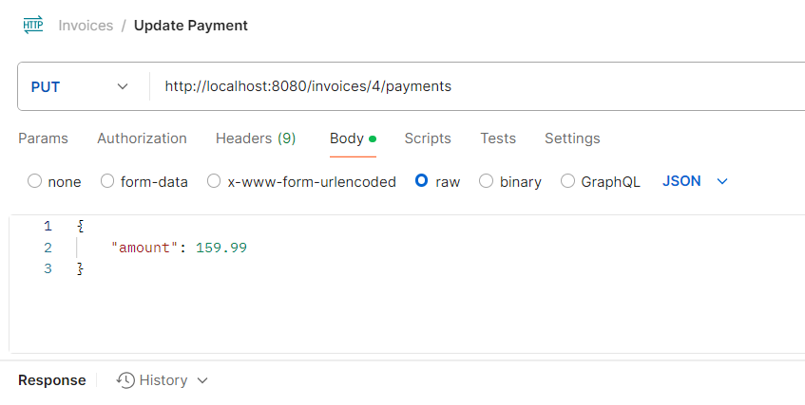

OVERDUE :

curl --location 'http://localhost:8080/invoices/process-overdue' \

--header 'Content-Type: application/json' \

--**data** '{

"late_fee": 10.5,

"overdue_days": 10

}'

DB :

