Postman curl cmd :

CREATE :

curl --location 'http://localhost:8080/invoices' \

--header 'Content-Type: application/json' \

--data '{

"amount": 199.99,

"dueDate": "2025-07-19"

}'

GET :

curl --location 'http://localhost:8080/invoices' \

--header 'Content-Type: application/json'

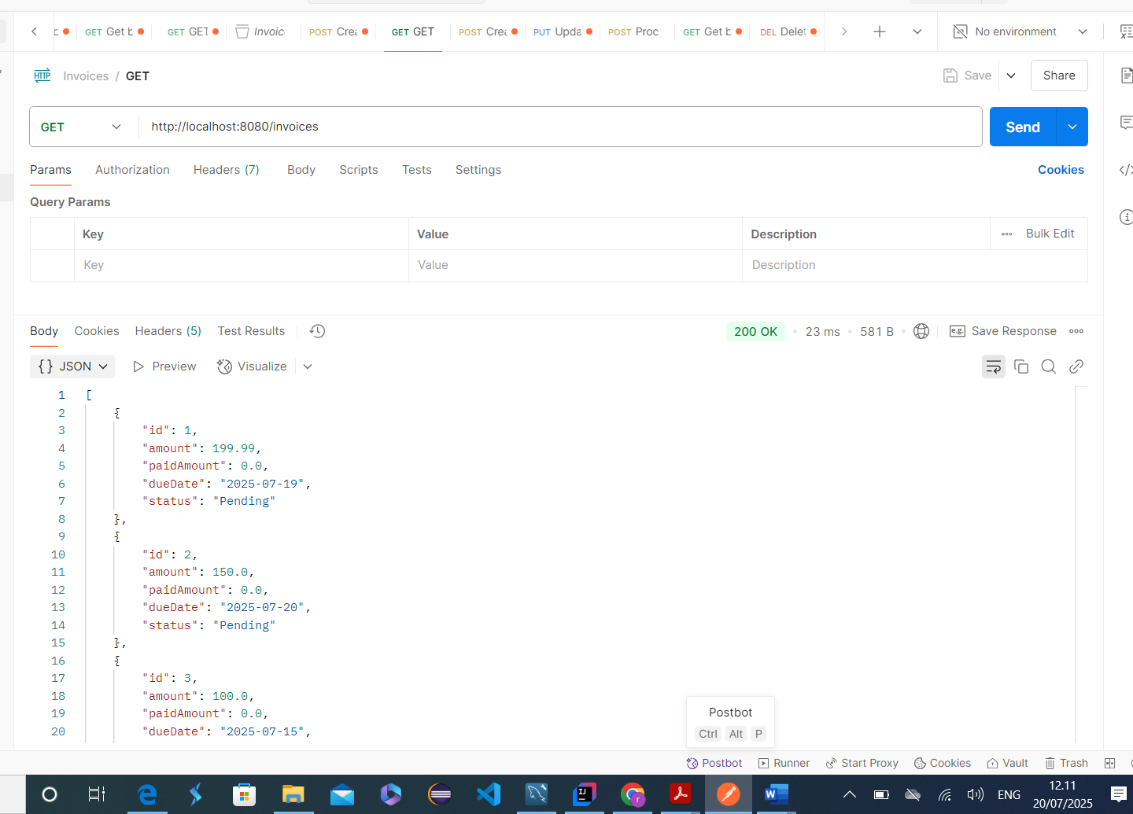

GET by ID :

curl --location 'http://localhost:8080/invoices/1' \

--header 'Content-Type: application/json'

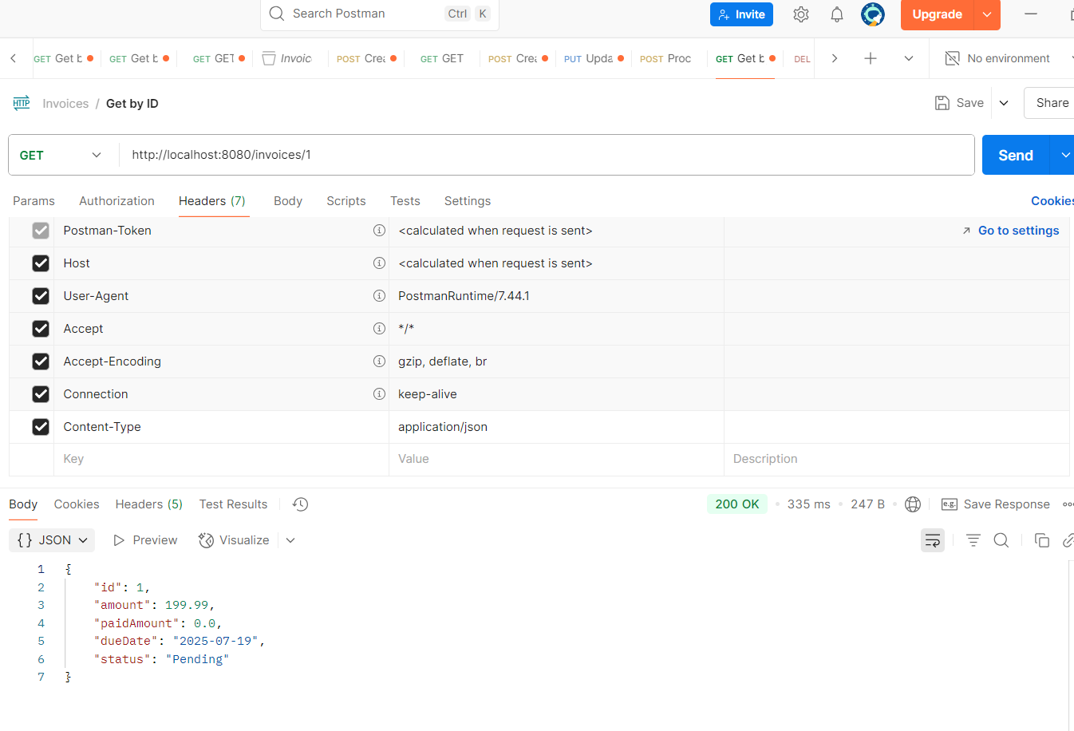

PUT :

curl --location --request PUT 'http://localhost:8080/invoices/4/payments' \

--header 'Content-Type: application/json' \

--**data** '{

    "amount": 15.99

}'

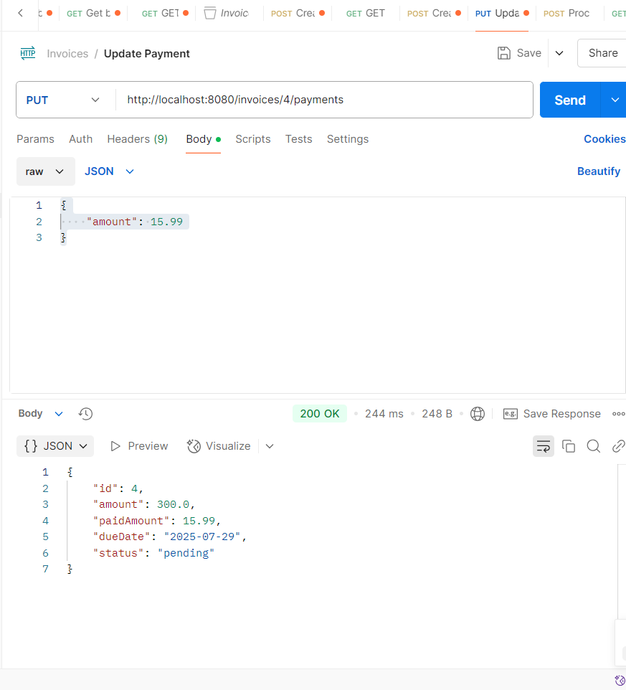

DB before processing overdue :

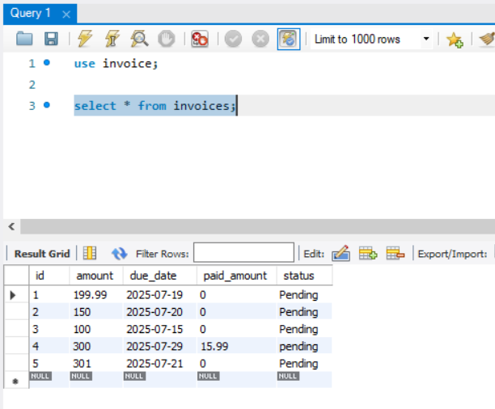

Process OVERDUE :

curl --location 'http://localhost:8080/invoices/process-overdue' \

--header 'Content-Type: application/json' \

--**data** '{

"late_fee": 10.5,

"overdue_days": 10

}'

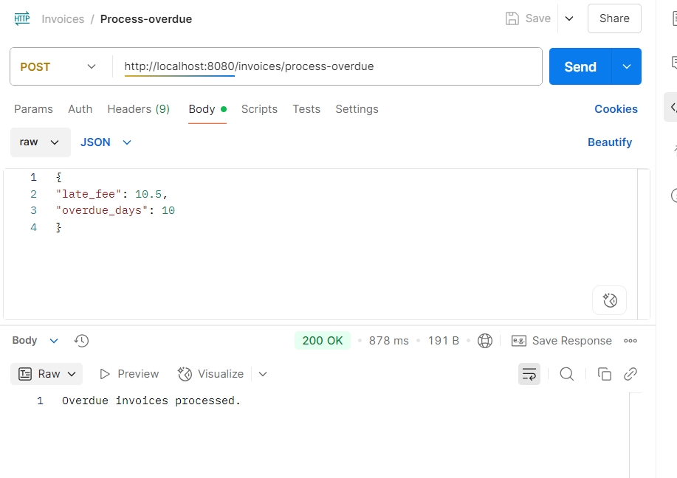

DB updates after process overdue :

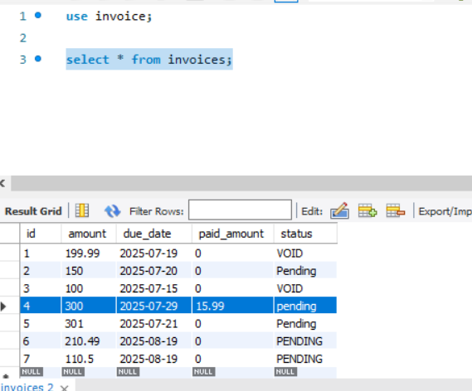

Created 2 entries and paid partial amount.  
8,9 column in below DB.  
