Rashmi Thakur

Manufacturing Performance dashboard

TABLE OF CONTENTS

- Project Overview
- Project Objective
- Dataset Description
- Tools used in the Project
- Data Preparation and Modeling
- Dashboard Overview
  - Production Dashboard
  - Quality & Maintenance Dashboard
  - Cost & Efficiency Dashboard
Conclusion
Recommendation for Future Improvement

- Project Overview

The Manufacturing Performance Dashboard is developed using Microsoft Power BI to visualize key manufacturing data such as production, quality, maintenance, and costs. It helps managers monitor performance and identify operational issues.
- Project Objective

The objective of this project is to build an interactive dashboard that analyzes production performance, machine efficiency, product quality, and operational costs to support better decision-making.
- Tools Used
Microsoft Power BI – Used to create the interactive dashboard, perform data modeling, and generate visualizations such as charts and KPI cards for analyzing manufacturing performance.
Microsoft Excel – Used to prepare and organize the dataset before importing it into Power BI.
- Dataset Description

The dataset contains sample manufacturing data related to production, quality, maintenance, and operational costs. It is divided into three categories: Production Data, Quality & Maintenance Data, and Cost & Efficiency Data.

- Data Preparation and Modeling

Data Preparation
The dataset was organized in Microsoft Excel and then imported into Power BI using the Get Data feature. Basic data cleaning was performed to ensure correct data types and structured tables.

Data Modeling
Relationships were created between tables using a DimDate table as the central date dimension. This follows a star schema model, which enables time-based analysis and improves dashboard performance.

Role of the Date Dimension Table
The DimDate table contains date-related attributes such as month, quarter, and year, allowing users to analyze manufacturing performance over different time periods
- Dashboard Overview
The Manufacturing Performance Dashboard built in Microsoft Power BI provides a visual overview of production, quality, maintenance, and cost data. It is divided into three sections—Production, Quality & Maintenance, and Cost & Efficiency.
6.1 Production Data

Purpose
The Production Dashboard helps monitor manufacturing output, machine efficiency, and production performance across different plants.

Key Metrics (KPIs)
Total Production
shows the total number of units produced during the selected time period.
Production Variance
Represents the difference between actual production and the planned production target.
Downtime
Indicates the percentage of time machines were not operational.
Machine Utilization
Shows how much of the machine capacity is being used for production.
Capacity Utilization
Represents how efficiently the plant’s total production capacity is utilized.

Visualizations and Insights

Units Produced vs Target Over Time
This line chart compares actual production with production targets across different months.
Insight: Production levels fluctuate slightly but generally remain close to the target.

Production by Plant
This bar chart shows total production output for each manufacturing plant.
Insight: Plant A has the highest production, followed by Plant B and Plant C.

Rejection Rate by Month
This column chart shows the percentage of defective units produced each month.
Insight: The rejection rate ranges between 3% and 3.7%, with the lowest rate recorded in May.
Screenshot
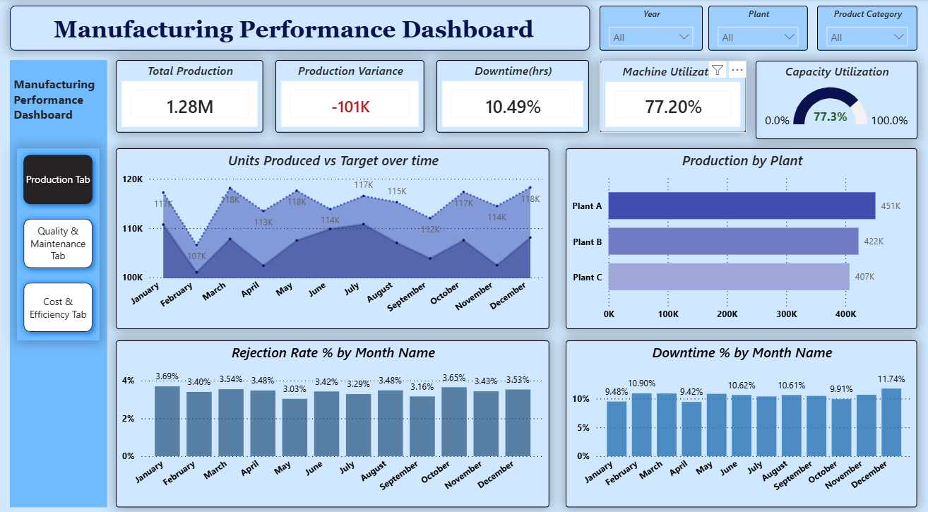

Conclusion
The Production Dashboard provides clear insights into production performance, machine utilization, downtime, and plant-wise output. It helps managers identify production gaps and improve operational efficiency for better manufacturing performance.

Recommendations for Future Improvement
- Add real-time production monitoring to track live production performance.
- Use predictive analytics to forecast future production trends and targets.

6.2 Quality & Maintenance Data

Purpose
The Quality & Maintenance Dashboard helps monitor product quality and machine maintenance performance. It allows managers to identify defects, track breakdowns, and analyze maintenance costs to improve production efficiency.

Key Metrics (KPIs)
Rejection Rate
Shows the percentage of products that were rejected due to quality issues.
Defective Units
Indicates the total number of units identified as defective during quality inspection.
Maintenance Cost
Represents the total cost spent on machine maintenance and repairs.
Breakdown Incidents
Shows the number of times machines stopped due to failures or breakdowns.
Capacity Utilization
Indicates how efficiently the available production capacity is being used.

3. Visualizations and Insights
Defective Units Trend (Monthly)
This line chart shows how the number of defective units changes each month, helping identify periods with higher quality issues.
Maintenance Cost by Plant
This bar chart compares maintenance expenses across different plants to identify which plant has higher maintenance costs.
Breakdown Incidents
This visualization displays the total number of machine breakdowns during the selected period.
Breakdown Incident Trend
This line chart shows how breakdown incidents change over time, helping identify patterns in machine failures.

Screenshot
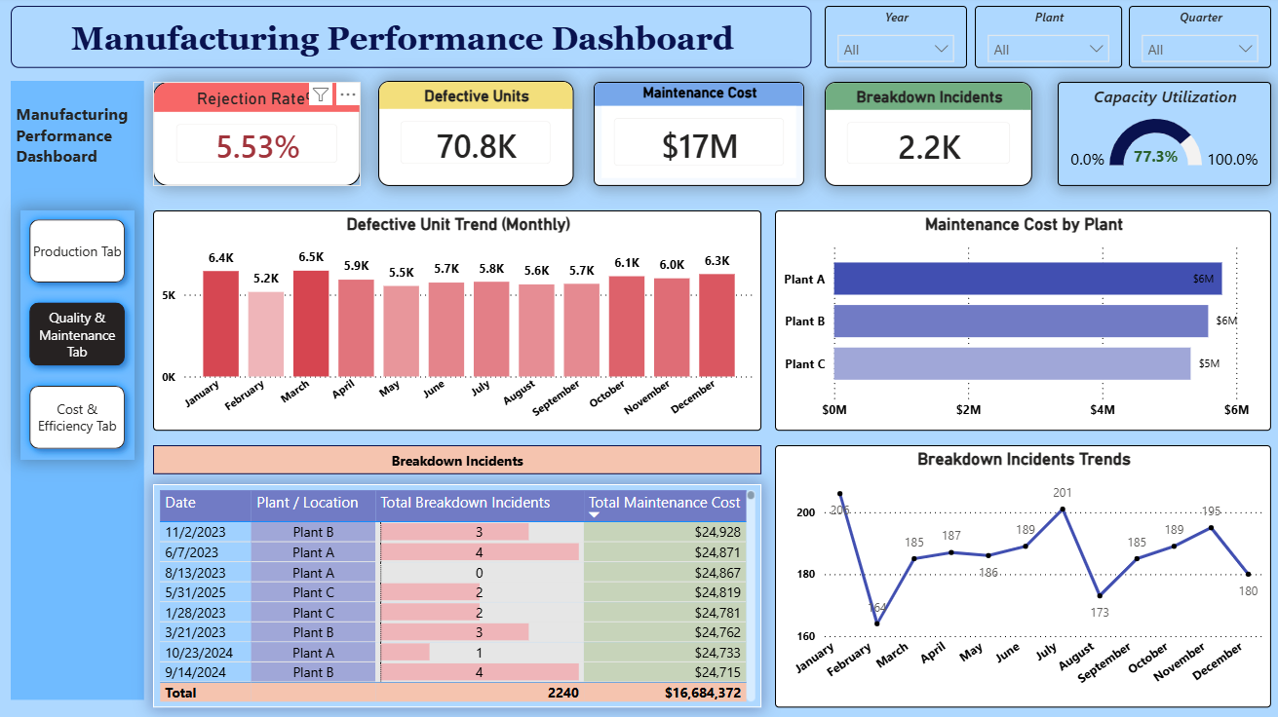

Conclusion
The Quality & Maintenance Dashboard helps monitor product quality and machine performance by tracking defects, maintenance costs, and breakdown incidents. These insights help managers take corrective actions and improve operational efficiency.

Recommendations for Future Improvement
- Include predictive maintenance analysis to prevent breakdowns.
- Integrate supplier quality data for deeper quality analysis.
6.3 Cost & Efficiency Data

Purpose
The Cost & Efficiency Dashboard helps analyze manufacturing costs and production efficiency. It allows managers to monitor expenses, evaluate cost per unit, and track on-time production performance.

Key Metrics (KPIs)
Manufacturing Cost
Shows the total cost involved in the manufacturing process, including labor, material, and operational costs.
Cost per Unit
Indicates the average cost required to produce a single unit of product.
On-Time Production (%)
Represents the percentage of production completed within the scheduled time.
Downtime Cost Impact
Shows the financial impact caused by machine downtime during production.
Capacity Utilization
Indicates how efficiently the available manufacturing capacity is being used.

Visualizations and Insights
Manufacturing Cost Breakdown
This chart shows the distribution of manufacturing costs such as labor, material, and operational expenses.
Cost per Unit
This visualization displays the average cost required to produce each unit.
On-Time Production Trend
This line chart shows how on-time production performance changes over different time periods.
Downtime Cost Impact Trend
This chart shows how downtime affects overall manufacturing costs over time.

Screenshot

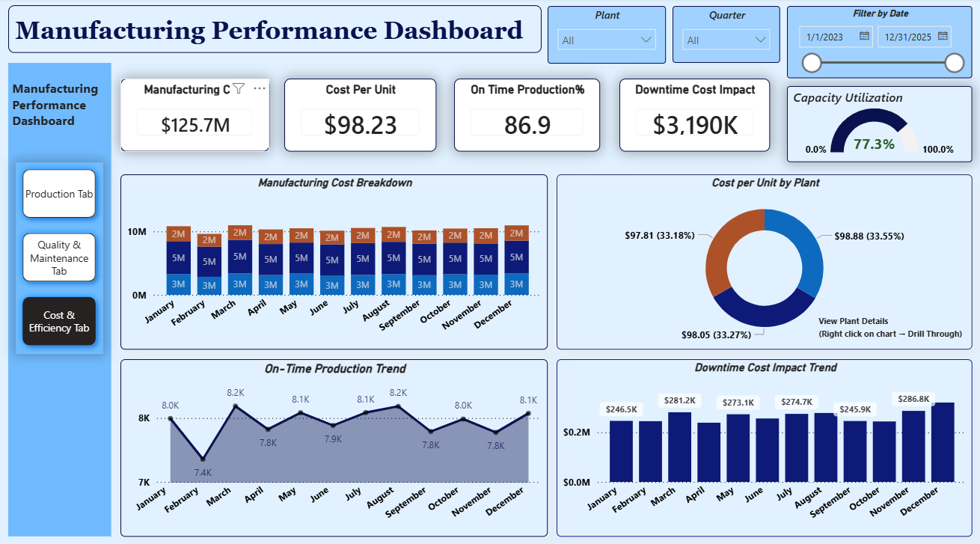

Conclusion
The Cost & Efficiency Dashboard provides insights into manufacturing expenses and production efficiency, helping managers control costs and improve operational performance.

Recommendations for Future Improvement
- Add detailed cost analysis by product category.
- Include predictive cost forecasting using historical data.

Drill Through – Plant Cost Details (Cost per Unit)
To provide deeper insights into manufacturing costs, a drill-through functionality has been implemented in the Cost per Unit visualization. This feature allows users to explore detailed plant-level cost analysis through the following charts:
Cost Breakdown by Month
This chart shows how total manufacturing cost (labor, material, and operational cost) changes across different months.
Cost per Unit by Month Name
This chart displays the average cost required to produce one unit for each month.
Detail Cost Table
This table provides detailed plant-wise cost information including different cost components.
Downtime Cost Impact Trend by Month
This chart shows how machine downtime impacts manufacturing costs over different months.
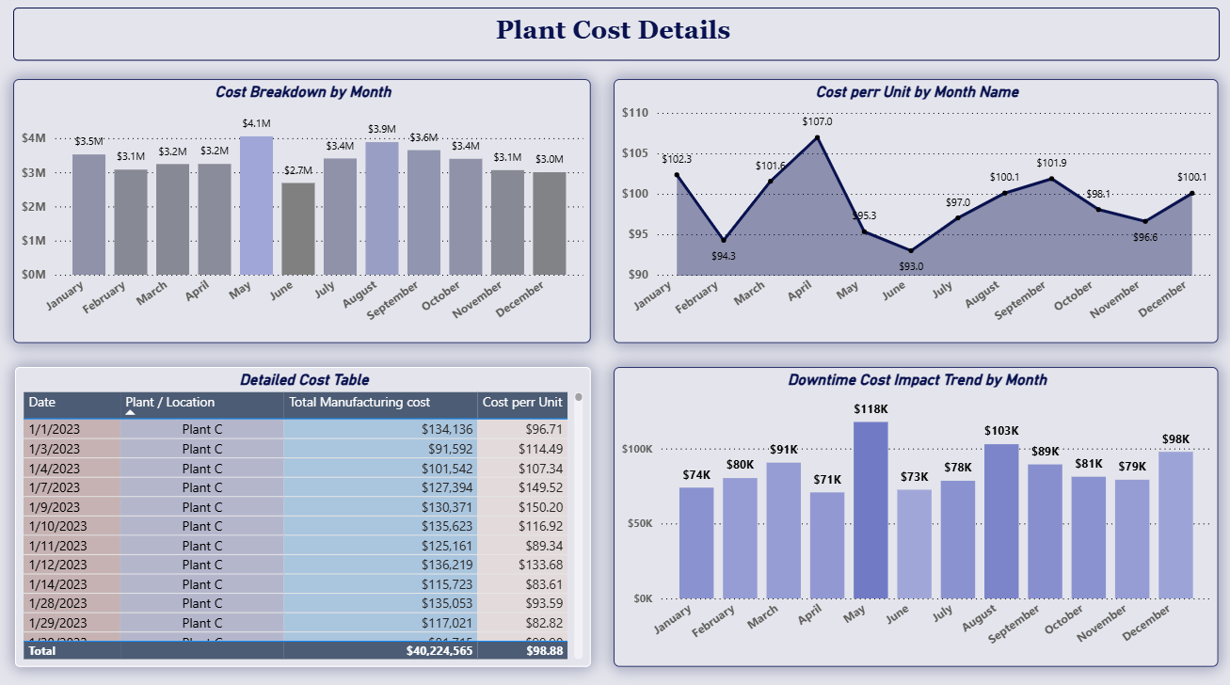

Conclusion
The drill-through feature helps analyze plant-level costs, monthly cost trends, and downtime impact, supporting better cost analysis and decision-making.

