“HEALTHCARE ANLYTICS DASHBOARD (RCM360)”
By
RASHMI THAKUR 244930010171

A PROJECT REPORT
Submitted to the


HIMACHAL PRADESH TECHNICAL UNIVERSITY (HPTU) HAMIRPUR (H.P)

In partial fulfilment of the requirement for the award of the degree of
MASTER OF COMPUTER APPLICATIONS (MCA)
IN

4TH Semester Training
July 2026
Department of Computer Applications
H.P.T.U. Hamirpur

PROJECT REPORT ON
“HEALTHCARE ANALYTICS DASHBOARD”

RCM360
SUBMITTED IN PARTIAL FULFILLMENT FOR AWARD OF DEGREE
In
MASTER OF COMPUTER APPLICATIONS

Submitted To: - Submitted By: -
Dr. PALLAVI NAGPAL RASHMI THAKUR
MCA Department (244930010171)
(Faculty Member) MCA 4th Sem

HIMACHAL PRADESH TECHNICAL UNIVERSITY HAMIRPUR (H.P)-177001

CERTIFICATE OF ORIGINALITY

I hereby declare that the Project entitled “HEALTHCARE ANALYTICS DASHBOARD (RCM360)” submitted to the Department of Computer Applications, HIMACHAL PRADESH TECHNICAL UNIVERSITY, HAMIRPUR in the partial
fulfillment for the award of the Degree of MASTER OF COMPUTER APPLICATIONS in session (2024-2026) in an authentic record of my own work carried out under the guidance of “Dr. PALLAVI NAGPAL” and the Project has not previously formed the basis for the award of any other degree.

Place: H.P.T.U HAMIRPUR (Signature of the Candidate)
RASHMI THAKUR
Date:- (244930010171)
This is to certify that the above statement made by the candidate is correct to the best of my knowledge.

Signature of the Internal Guide)
Dr. PALLAVI NAGPAL
(Faculty Member) MCA Department H.P.T.U, Hamirpur

DECLARATION

I, RASHMI THAKUR (244930010171), a student of Master of Computer Application, HPTU, Hamirpur hereby declare that the work presented in this Major Project is outcome of my own work, is bonafide, correct to the best of my knowledge and this work has been carried out taking care of Software Ethics. The work presented does not infringe any patented work and has not been submitted to any University for the award of any degree or any professional diploma.

I assert the statements made and conclusions drawn are an outcome of my work. I further certify that:

- The work contained in the report is original and has been done by me under the general supervision of my supervisor.

- The work has not been submitted to any other Institution for any other degree/ diploma /certificate in this university or any other University of India or abroad.

- We have followed the guidelines provided by the university in writing the report.

RASHMI THAKUR (244930010171)

ACKNOWLEDGEMENT
IT industry is the most dynamic in the present world. The pace at which it is moving ahead makes difficult for us to cope with the coding computer technology if we climb the hills individually. The efforts of colleagues and friends have helped me in achieving the desired goal.
I acknowledge the able guidance in valuable suggestions, training about new technology of Project leader Dr. Pallavi Nagpal and thankful to whole team of crisp during the course of the project.
I thank all of them for having the confidence in me, to conduct my work, and for giving me the opportunity to learn from my own mistakes. There guidance has been absolutely invaluable to me, who have been imparting their immense knowledge for the past one year.

Date: Signature of Candidate
RASHMI THAKUR
(244930010171)

INDUSTRY/COMPANY CERTIFICATE


Date: Name:

Designation:

Name of Organization: Address:

TABLE OF CONTENTS

Sr No. | Contents and Chapter Name | Page No.
1 | Chapter 1: Introduction  - Project Background  - Problem Statement  - Objective of the Project  - Scope of the Project  - Significance of Study | 1 -5
2 | Chapter 2: Literature Review  - Healthcare Analytics Overview  - Amcare Management Concepts  - Existing Analytics Dashboards  - Gap Analysis | 6 - 8
3 | Chapter 3: System Overview  - Introduction to Healthcare  - Challenges Addressed  - Benefits Delivered  - Stakeholder & End Users | 10 - 13
4 | Chapter 4 : Technology Stack  - Power BI  - EPIC System  - Office Ally  - ERA Report  - Python ETL Scripts | 14 - 17
5 | Chapter 5 : System Architecture  - Architecture Layer  - Data Source Overview  - Data Flow Process  - Data Security & Compilance | 18 - 29
6 | Chapter 6 : Dashboard Walkthrough  - Patient View  - Patient Description  - Appointment Report  - Submission Report  - Payment Report | 30 -38

7 | Chapter 7 : Data Dictionary  - Appointment Dataset  - Submission Dataset  - Payment Dataset | 40 - 42
8 | Chapter 8 : Dynamic Selector  - Measure Selector  - Dimension Selector  - Submission Toggle  - CPT Submission Selector | 43 -45
9 | Chapter 9 : Implementation and Results  - ETL Process Implementation  - Dashboard Development in Power BI  - Case Study : Example Clinic (HAY Location) | 46 - 50
10 | Chapter 10 : Testing & Validation  - Functional Testing  - Data Accuracy Validation  - Performance Testing  - User Acceptance (UAT) | 51 - 53
11 | Chapter 11:Advantage & Limitations  - Advantage of Amcare  - Limitation of Amcare  - Comparison with Existing Systems | 54 - 55
12 | Chapter 12 : Future Enhancements  - AL/ML Integration for Predictive Analysis  - Mobile App Extension  - Integration with IoT Device  - Advance Denial Management | 56 - 61
13 | Chapter 13: Publish Report & Deployment  - Publishing of Power BI Services  - Generating Browser based Report Link  - Sharing with Stakeholders  - Access Control | 62 - 64
14 | Chapter 14 : Conclusion  - Summary of Findings  - Impact on Health Industry | 65 - 69
 | References  Dataset & Tools | 70
 | Appendix A : Dashboard Page Structure Appendix B : Sample Data Tables Appendix C: Glossary | 71 - 73

LIST OF TABLES

Sr No. | Table Name | Page No.
1 | Technology Stack Overview | 12
2 | Architecture Layers and Components | 18
3 | Data Source Overview | 19
4 | Patient View KPI | 31
5 | Dashboard Filter Options
6 | KPI Categories and Business Purpose | 39
7 | Appointment Dataset | 40
8 | Submission Dataset | 41
9 | Payment Dataset | 42
10 | Dynamic Measure Selector | 43
11 | Troubleshooting Common Issues
12 | Functional Testing Results | 51
13 | UAT Results Summary | 53

CHAPTER-1 INTRODUCTION

Project Background

The healthcare industry in the United States and globally faces increasing pressure to improve financial performance while maintaining high-quality patient care. Healthcare Analytics Dashboard is the backbone of healthcare financial operations – it encompasses every administrative and clinical
function that contributes to the capture, management, and collection of patient service revenue, from the initial appointment scheduling through to the final payment of a balance.
Traditionally, healthcare organizations have relied on manual reporting methods, disconnected data silos, and spreadsheet-based systems to track their revenue cycles. Billing teams managed multiple Excel files, financial managers lacked real-time visibility into claim statuses, and providers operated without insight into their billing performance. This fragmented approach resulted in revenue leakage, delayed payments, increased denials, and missed optimization opportunities.
The emergence of Business Intelligence (BI) platforms such as Microsoft Power BI has created new opportunities to transform healthcare financial data into actionable insights. Power BI's capabilities for data integration, real-time visualization, and interactive reporting are especially valuable in the healthcare domain where decisions must be timely, accurate, and evidence-based.

Purpose

This document explains what the AmCare Dashboard is designed to do. It’s a user-friendly Power BI tool
that brings together data from appointments, claim submissions, and payments. The main goal is to
help healthcare providers manage their billing cycle more smoothly, work more efficiently, and quickly
get useful insights from their data.

Problem Statement

Healthcare providers and billing companies face the following critical challenges in revenue cycle management:
Manual Reporting Overhead: Billing teams maintained multiple disconnected spreadsheets with no centralized view of financial performance, resulting in high labour costs and significant error rates.
Delayed Insights: Without real-time dashboards, management teams could not access current appointment, submission, or payment statuses, leading to reactive rather than proactive decision-making.
Scattered Data Sources: Appointment data (EPIC), claims submission records (Office Ally), and payment remittance data (ERA reports) existed in separate, incompatible systems with no automated integration.
Revenue Leakage: Unsubmitted claims, missed CPT codes, underpayments, and untracked denials led to significant financial losses that went undetected in legacy reporting systems.

Limited Provider Accountability: Individual provider performance in terms of appointment management, billing contribution, and CPT submission rates could not be
benchmarked systematically.

Audit and Compliance Risks: Manual, fragmented reporting created difficulties in audit preparation, billing compliance, and regulatory documentation.
These challenges collectively highlight the need for an integrated, automated, and real-time analytics that can unify data sources, automate report generation, and provide actionable insights across
all Amcare cycle dimensions.

Objectives of the Project

The primary objectives of the Amcare project are as follows:

To design and implement a centralized Power BI dashboard that integrates appointment, submission, and payment data from multiple healthcare source systems into a unified analytical platform.
To automate data extraction, transformation, and loading processes using Python ETL scripts, eliminating manual reporting tasks and ensuring data accuracy.
To develop and compute over 30 Key Performance Indicators (KPIs) covering appointment efficiency, billing timeliness, payment collection, payer performance, and provider productivity. To provide interactive, role-appropriate reporting capabilities that serve the needs of providers, billing teams, finance managers, and administrative staff.
To enable proactive revenue cycle management by surfacing unsubmitted claims, denial patterns, underpayment alerts, and slot utilization inefficiencies.

To ensure data security, compliance with healthcare data standards, and audit readiness through structured, clean, and reproducible reporting.
To demonstrate the technical and business value of applying Business Intelligence methodologies to healthcare financial operations.

Scope of the Project

The scope of the Amcare project encompasses:

Data Integration from three core source systems: EPIC (appointments), Office Ally (submissions), and ERA Reports (payments).
ETL Pipeline Development using Python scripts for automated data extraction, cleaning, deduplication and loading into Power BI.
Power BI Dashboard Development featuring five interactive report pages with dynamic filters, measure selectors, and cross-page filter consistency.
KPI Framework Design covering six KPI categories: Appointment KPIs, Submission KPIs, Payment KPIs, Payer Analysis KPIs, Provider Performance KPIs, and Trend KPIs.
Multi-stakeholder Access: The platform serves providers, billing teams, finance departments, and administrative staff across single or multi-location practices.
Publishing and Deployment on Power BI Service with role-based access control, scheduled data refresh, browser-based report sharing.
The scope is limited to analytical (read-only) reporting and does not include real-time claim submission, direct EHR (Electronic Health Record) integration, or patient-facing billing portals.

Significance of Study

This study is significant for several reasons:

Clinical and Financial Impact: By improving revenue cycle visibility, RCM360 helps healthcare organizations reduce revenue leakage, accelerate collections, and optimize resource allocation. A single undetected underpayment pattern across thousands of claims can represent substantial financial losses; RCM360 makes these patterns visible instantly.
Technological Contribution: The project demonstrates the practical application of modern BI tools (Power BI), cloud analytics (Power BI Service), automated ETL (Python), and DAX-based
measure computation in a real-world healthcare setting.

Academic Relevance: As an MCA final year project, this study bridges theoretical concepts in database management, data analytics, software engineering, and cloud computing with practical implementation in a high-impact domain.
Scalability and Generalizability: The architectural patterns, ETL design, and KPI framework developed
for Amcare can be adapted to other healthcare organizations, billing companies, and multi-specialty practices.
Industry Alignment: Revenue Cycle Management analytics is a rapidly growing field; this project provides exposure to industry-standard tools and methodologies actively sought by employers in the healthcare IT sector.

CHAPTER - 2 LITERATURE REVIEW

Healthcare Analytics Overview

Healthcare analytics refers to the systematic use of data, statistical analysis, and predictive modeling to gain insights and support decision-making in healthcare organizations. The field has grown exponentially with the digitalization of health records, the proliferation of Electronic Health Record (EHR) systems, and the adoption of cloud computing and Business Intelligence platforms.

Researchers such as Kaplan and Harris-Salamone (2009) identified four levels of healthcare analytics: descriptive (what happened), diagnostic (why it happened), predictive (what will happen), and prescriptive (what should we do). RCM360 primarily operates at the descriptive and diagnostic levels, providing real-time snapshots of revenue cycle performance while surfacing patterns and anomalies that enable diagnostic analysis.

The use of dashboards in healthcare has been widely studied. Dowding et al. (2015) found that clinical dashboards improved clinical decision support and reduced adverse events when properly implemented. In the administrative domain, BI dashboards have been shown to reduce reporting time by 40–60% compared to manual methods

Healthcare analytics specifically applied to revenue cycle management has gained prominence as providers face increasing financial pressure from insurance denials, reimbursement complexity,

and regulatory compliance requirements. The global healthcare analytics market was valued

at approximately $29.8 billion in 2022 and is projected to exceed $84 billion by 2030, reflecting the strategic importance of data-driven decision making in healthcare financial operations.

Healthcare Management Concepts

Healthcare Management (RCM) is the financial process that healthcare facilities use to track patient care episodes from registration and appointment scheduling to the final payment of a balance. The process encompasses several interconnected stages:
Patient Registration and Appointment Scheduling: Capturing patient demographics, insurance information, and appointment data. In Amcare, this corresponds to data sourced from the EPIC system. Clinical Documentation and Coding: Assigning appropriate diagnosis (ICD) and procedure (CPT) codes to clinical encounters. Amcare tracks CPT code submission patterns through Office Ally data.
Claims Submission: Electronically submitting claims to insurance payers. Amcare's Submission Report page provides comprehensive analysis of submission timelines, CPT usage, and unsubmitted claims.
Payment Posting and Reconciliation: Recording payments received from payers and patients

against billed amounts. RCM360's Payment Report page tracks charge amounts, allowed amounts, line payments, and patient responsibility.
Denial Management: Identifying, appealing, and resolving claim denials. RCM360's payment status analysis surfaces denial patterns by payer.

Key metrics in RCM include the Days in Accounts Receivable (AR), Net Collection Rate, Denial Rate, First Pass Rate, and Clean Claim Rate. RCM360 addresses several of these through its KPI framework
, particularly through the 'Average Days to Bill' metric computed from the difference

between service date and submission date.

Existing Analytical Dashboards

Several commercial and open-source healthcare analytics platforms exist in the market, including:

Tableau Healthcare Edition: Offers robust visualization capabilities with HIPAA-compliant cloud hosting. While powerful, it requires significant configuration for RCM-specific workflows and can be cost-prohibitive for smaller practices.
Healthcare: Provides associative data modeling and self-service analytics. Strong in clinical analytics but less purpose-built for revenue cycle workflows.
Epic Reporting Workbench: Native reporting within the EPIC EHR system. Useful for
appointment analytics but limited in cross-system integration with billing and payment data.
athenahealth Analytics: A cloud-based RCM platform that offers integrated analytics as part of its practice management suite. Effective but creates vendor lock-in.
Microsoft Power BI in Healthcare: Increasingly adopted for healthcare analytics due to its accessibility, DAX-based measure flexibility, and seamless integration with the Microsoft Ecosystem.

Amcare distinguishes itself from these platforms by providing a purpose-built, cross-system integration solution that connects EPIC, Office Ally, and ERA data in a single Power BI environment,with custom Python ETL automation that can be adapted to specific organizational data formats without requiring costly platform migrations.

Gap Analysis

Despite the availability of commercial analytics platforms, significant gaps exist in the healthcare analytics landscape for small-to-medium healthcare organizations:

Integration Complexity: Most commercial platforms require significant IT resources and
custom integration work to connect heterogeneous data sources like EPIC, Office Ally, and ERA files.
Cost Barriers: Enterprise RCM analytics platforms are often priced beyond the reach of
independent practices and smaller billing companies.
Customization Limitations: Pre-built commercial dashboards may not align with the specific
KPI requirements, workflow patterns, or payer mix of individual organizations.
Real-time Unsubmitted Claim Detection: Few platforms provide automated, real-time detection

of appointments with no corresponding claim submission – a key feature of RCM360's Submission Report.
Dynamic Measure Selection: The ability to switch between multiple metrics on the same
visualization page without navigation is an advanced usability feature not commonly found in standard
BI templates.
Amcare addresses these gaps by providing a cost-effective, customizable, and deeply integrated solution built on the widely available Microsoft Power BI platform, with open-source Python ETL scripts that can be adapted and maintained by organizations' internal IT teams.

CHAPTER – 3
SYSTEM OVERVIEW

Introduction to RCM360

RCM360 is a Power BI-based Healthcare Analytics Dashboard developed by IDS InfoTech Ltd. It is designed to simplify healthcare billing and revenue cycle management by integrating data from appointments, claims submissions, and payments into one unified, real-time analytical platform. The name 'RCM360'reflects the system's comprehensive, 360-degree view of the revenue cycle – from appointment booking through to final payment reconciliation.
The dashboard automatically cleans, merges, and analyzes data from three core source systems – EPIC, Office Ally, and ERA – and presents results through five interactive dashboard pages and a rich set of KPIs accessible to providers, billing teams, finance, and administrative staff.
RCM360 operates as a read-only analytical layer on top of existing operational systems, ensuring that it does not interfere with transactional workflows while providing comprehensive reporting capabilities.
The system is deployed on Microsoft Power BI Service, enabling browser-based access from any device. Role-based access controls ensure that different user groups (providers, billing teams, finance managers, administrators) see only the data and reports relevant to their
responsibilities. Scheduled data refresh capabilities ensure that the dashboard always reflects the most current available data from source systems.

Challenges Addressed

Before RCM360 was implemented, the healthcare organization faced the following challenges:

Manual Billing Reports: Billing teams managed multiple spreadsheets with no automation,
consuming significant staff time and introducing data integrity risks.
Delayed Insights: No real-time visibility into appointment status, claim submission timelines, or payment collections, forcing management to rely on periodic manual reports that were often days or weeks out of date.
Scattered Data: Appointment data (EPIC), claim records (Office Ally), and payment remittance
data (ERA) existed in separate disconnected systems with no automated cross-system reporting
capability. Revenue Cycle Inefficiencies: Difficulty identifying underpayments, claim denials,
and unsubmitted claims meant that revenue leakage went undetected and uncollected.
Reactive Decision-making: Teams could not proactively identify and address claim or payment
issues before they escalated into significant revenue losses.
Provider Performance Blind spot: No systematic mechanism existed to benchmark individual
provider performance on appointment management, billing contribution, or CPT submission rates.

Benefits Delivered

RCM360 delivers the following measurable benefits to healthcare organizations:

Benefits | Description
Improved Efficiency | Automated data consolidation eliminated the need for billing teams to manage multiple spreadsheets, freeing staff time for higher-value activities.
Revenue Optimization | Early detection of underpayments and denials enhanced collections; visibility into payer performance supports contract renegotiations.
Enhanced Accuracy | Cleaned, de-duplicated datasets minimized errors in claim submission and payment reconciliation.
Faster Data Access | Real-time Power BI dashboards enabled evidence-based decisions within minutes of data refresh, versus days for manual reports.
Audit-Ready Reporting | Clean, structured, and reproducible reporting supports billing reviews and regulatory compliance audits.

Stakeholders & End Users

RCM360 is designed to serve multiple stakeholder groups within a healthcare organization:

Providers (Physicians, Nurse Practitioners, PAs): Access to individual performance metrics including daily appointment volumes, patient seen rates, and billing contribution by CPT code.
Billing Teams: Primary users of the Submission Report and Payment Report pages. Monitor claim submission timelines, unsubmitted visits, CPT patterns, and payment collection rates.
Finance and Revenue Cycle Managers: Use the Payment Report to track revenue performance, payer behaviour, allowed amounts, and patient financial responsibility trends.

Administrative Staff: Use the Patient View and Appointment Report pages to monitor scheduling efficiency,
slot utilization, cancellation patterns, and no-show rates.
Clinic Owners and Practice Managers: Use high-level KPI banners and trend charts to assess overall organizational performance and make strategic decisions.
The solution is applicable to clinics and hospitals managing high appointment and claim volumes, independent medical practices seeking revenue cycle visibility, billing companies processing claims across multiple providers,anfinance teams tracking outstanding balances and payer performance. RCM360 supports
practices operating under Medicare, Medicaid, and private insurer contracts, and is designed for multi-location, multi-provider environments.

CHAPTER – 4 TECHNOLOGY STACK

RCM360 is built on a carefully selected technology stack that balances analytical capability, integration flexibility, cost-effectiveness, and ease of deployment. Each component plays a specific role in the overall system architecture.

Power BI
Microsoft Power BI is the primary platform for data modelling, KPI computation, and

report visualization in RCM360. Power BI Desktop is used for report development, while Power BI Service provides cloud-based publishing, access control, and scheduled data refresh.
Key Power BI features utilized in RCM360 include:

Data Model: Star schema design with appointment, submission, and payment tables as fact tables, connected through shared dimensions (patient, provider, date, and payer).
DAX (Data Analysis Expressions): Used to compute all KPIs including rates, averages, cumulative totals, time intelligence calculations, and custom conditional measures.
Dynamic Measure Selectors: Implemented using disconnected slicer tables and DAX SWITCH measures, enabling users to change the metric displayed on a chart without navigating to a different page.
Cross-page Filter Consistency: Year, month, provider, and location slicers maintain their selections across all five dashboard pages, providing a consistent analytical context.
Power BI Service: Enables role-based access control, scheduled refresh, and browser-based report sharing with stakeholders.

EPIC System

EPIC is a leading Electronic Health Record (EHR) and practice management system used by the healthcare organization as its primary appointment scheduling and patient management platform. In Amcare's data architecture, EPIC serves as the source system for all appointment-related data.EPIC provides daily automated export of appointment reports containing patient demographics,appointment dates, provider assignments, appointment status (Seen/Cancelled/No-Show), appointment type,
clinic location,and slot utilization data. The Python ETL scripts process these EPIC exports through deduplication logic that ensures unique patient tracking across repeated export runs.

Office Ally

Office Ally is a healthcare IT company offering practice management and claims clearinghouse
services. In RCM360, Office Ally serves as the source system for claims submission data.
Office Ally provides submission reports containing CPT codes, submission dates, provider assignments, billable/non-billable flags, and visit-to-claim linking identifiers. A critical function of Amcare's ETL process is matching Office Ally submission records against EPIC appointment records
to identify unsubmitted visits – appointments that have been seen by a provider but for which no claim has been submitted, representing direct revenue leakage.

ERA Reports (Electronic Remittance Advice)

Electronic Remittance Advice (ERA) files, also known as 835 transaction files in the HIPAA EDI standard, are the electronic payment explanation documents generated by insurance payers when claims are adjudicated.
ERAs contain detailed information about which claims were paid, how much was allowed, how

Much was paid, what patient responsibility remains, and what the reason code is for any adjustments
or denials.
In RCM360, ERA files from various payers are auto-parsed by Python scripts into clean, structured datasets containing charge amounts, allowed amounts, line payment amounts, patient responsibility, payer names, payment status codes, and payment dates. This transformed data forms the foundation of the Payment Report dashboard page.

Python ETL Scripts

Python serves as the ETL (Extract, Transform, Load) engine for RCM360. Custom Python scripts automate the entire data pipeline from source file extraction through to Power BI model loading. Key ETL operations include:
Data Extraction: Reading EPIC appointment exports, Office Ally submission exports, and ERA payment
files from designated file directories or SFTP locations.

Data Cleaning: Standardizing date formats, normalizing provider name formats (critical for cross-system matching), handling null values, and correcting data type inconsistencies.

Deduplication: Identifying and removing duplicate appointment records that may arise from multiple EPIC export runs covering overlapping date ranges. Unique patient tracking ensures accurate patient-level KPIs.
Visit-to-Claim Matching: Joining appointment records (EPIC) with submission records (Office Ally) on shared keys (patient, service date, provider) to flag unsubmitted visits.
ERA Parsing: Parsing electronic remittance files into relational table structures suitable for Power BI data modelling.
Data Loading: Saving transformed datasets to the Power BI data source format for model refresh.

Technology | Role in Amcare
Power BI Desktop | Interactive dashboard development, DAX measures, data modelling, and report design
Power BI Service | Cloud publishing, role-based access control, scheduled refresh, and browser-based report access
EPIC | Source system for appointment reports – daily automated integration with deduplication
Office Ally | Source system for submission reports – visit-to-claim matching to flag unsubmitted claims
ERA Reports | Source system for payment data – auto-parsed into clean datasets for payment analysis
Python ETL Scripts | Automated data extraction, transformation, deduplication, merging, and loading into Power BI model

CHAPTER -5 SYSTEM ARCHITECTURE

Architecture Layers

RCM360 is organized into a multi-layered architecture that separates concerns across data sourcing, transformation, modelling, and presentation. Each layer has specific responsibilities and technologies.
Layer | System / Tool | Description
Data Source –  Appointments | EPIC | Daily automated export of appointment reports; deduplication ensures unique patient tracking
Data Source –  Submissions | Office Ally | Submission reports matched against appointments to flag missing or unsubmitted claims
Data Source –  Payments | ERA Reports | ERA files auto-parsed into clean, structured datasets for payment analysis
ETL /  Transformation | Python Scripts | Automated extraction, cleaning, deduplication, merging, and loading into Power BI model
Data Modelling | Power BI Desktop | Relationships between appointment, submission, and payment tables; star schema design
Business Logic | DAX Measures | KPI computation – rates, averages, totals, time intelligence, running counts
Visualization | Power BI Service | 5-tab interactive dashboard with dynamic Measure Selectors and cross-page filter consistency
Data Security | Secure Cloud Handling | Encrypted storage and transfer; patient data handled in compliance with healthcare data standards

Data Sources Overview

Three distinct source systems provide the raw data for RCM360. Each system serves a different domain of the Revenue cycle

Source System | Module | What It Provides
EPIC | Appointment Insights | Patient demographics, appointment dates, providers, status (Seen/Cancelled/No-Show), appointment type, location, slot data
Office Ally | Submission Insights | CPT codes, submission dates, provider assignments, billable/non-billable flags, visit-to-claim linking
ERA (Electronic Remittance Advice) | Payment Insights | Charge amounts, allowed amounts, line payment amounts, patient responsibility, payer names, payment status, denial codes
:

Data Flow Process

The end-to-end data flow in RCM360 follows a structured sequence from source system export to end-user dashboard interaction:
Step 1 – EPIC Export: EPIC exports daily appointment data files containing all appointments within the reporting period.
Step 2 – ETL Processing – Appointments: Python ETL scripts read EPIC appointment exports, apply deduplication logic based on patient ID and service date, clean data types and provider name formatting, and prepare the appointment dataset.
Step 3 – Office Ally Matching: Office Ally submission exports are matched against appointment

records using patient name and service date as join keys. Appointments with no matching submission record are flagged as 'Unsubmitted Visits'.
Step 4 – ERA Parsing: ERA payment files are parsed by Python scripts, extracting CPT-level payment details, payer information, charge amounts, allowed amounts, and payment status codes into structured tabular format.
Step 5 – Data Loading: All three transformed datasets (appointments, submissions, payments) are loaded into the Power BI data model, which establishes relationships between tables through shared dimensions.
Step 6 – DAX Computation: DAX measures compute all KPIs dynamically based on filter context established by user slicer selections.
Step 7 – Report Publication: Power BI Service publishes the completed report for end-user access via browser or Power BI app.
Step 8 – Scheduled Refresh: Automated refresh triggers on a configured schedule (daily or per data availability), ensuring the dashboard always reflects current data.

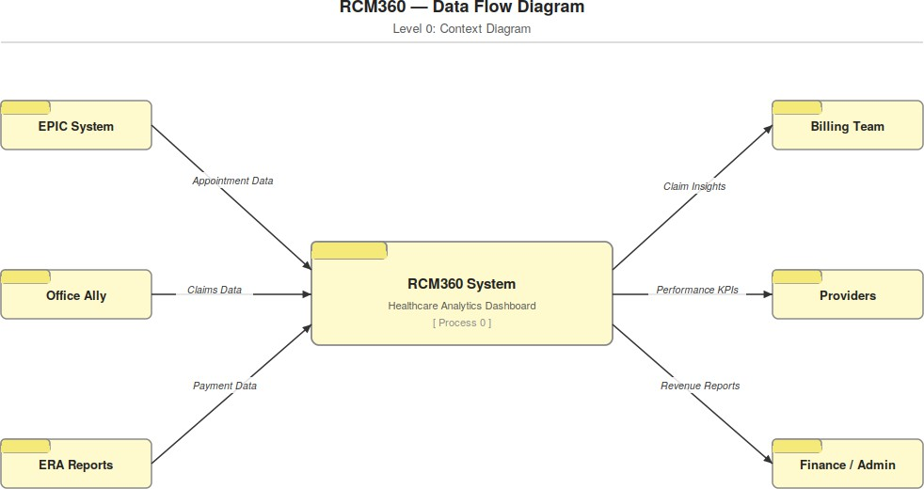

Fig(a): Context Diagram

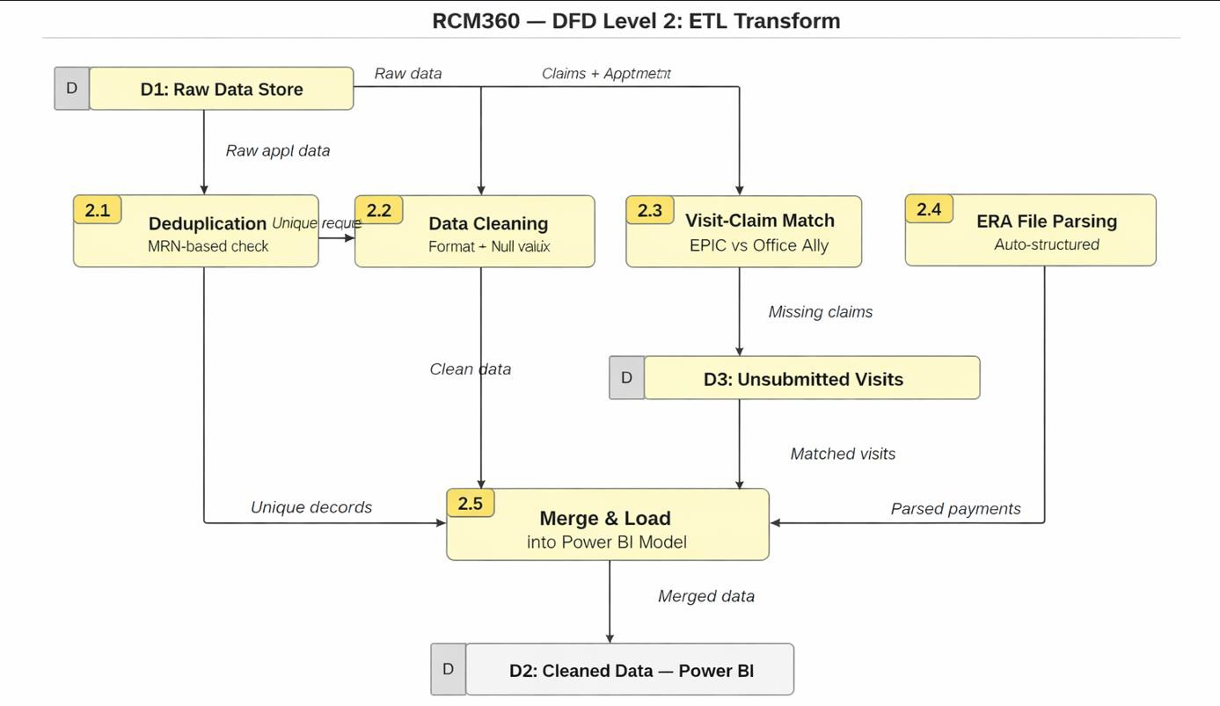

Fig (b): ETL Transform

Data Modeling and Relationships

Data modeling is one of the most important stages in the development of the RCM360 Healthcare Analytics Dashboard. A well-structured data model ensures efficient data processing, accurate reporting, and improved dashboard performance. The data model integrates information from multiple healthcare data sources, including EPIC, Office Ally, ERA Reports, and supporting helper tables.

The Power BI data model follows a centralized design approach where fact tables containing transactional healthcare data are connected to dimension and helper tables through defined relationships. This structure enables users to perform cross-functional analysis across appointments, submissions, payments, and patient activities.

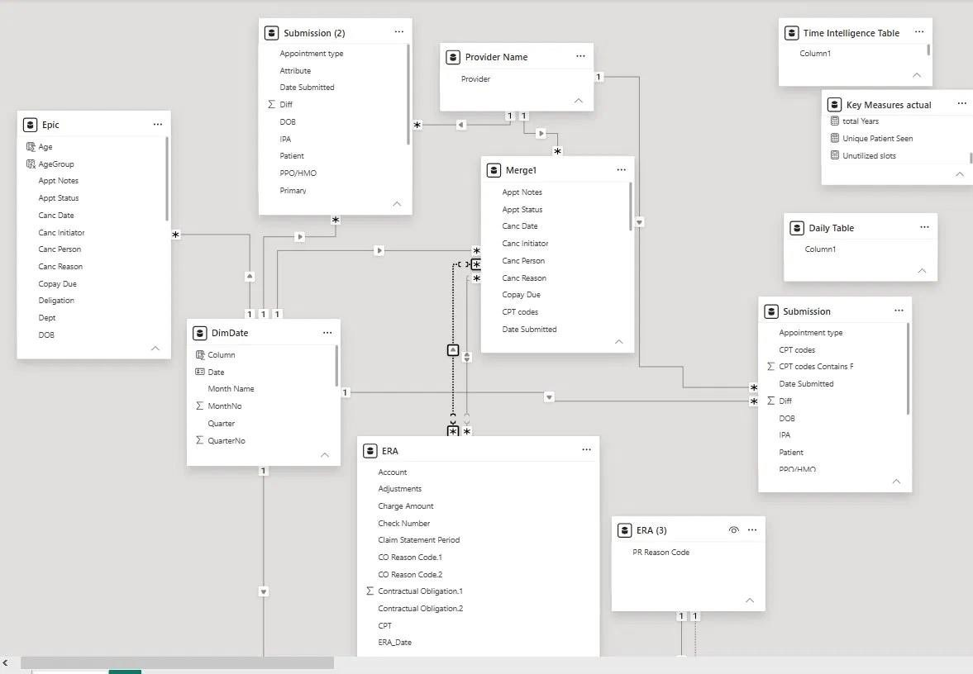

Fig (c): Data Modeling in Power BI

ERA Table

The ERA (Electronic Remittance Advice) table stores detailed payment and adjustment information received from insurance providers. This table plays a critical role in revenue cycle management by providing visibility into claim payments, contractual adjustments, and patient responsibilities.

The major fields available in the ERA table include:

Account: Represents the payer account number or unique identifier associated with a specific claim.

Adjustments: Indicates the amount adjusted by the insurance provider. This value generally represents the difference between the billed charge amount and the amount approved by the payer.

Charge Amount: The original amount billed by the healthcare provider to the insurance company.

Check Number: The reference number associated with the insurance payment or electronic funds transfer (EFT).

Claim Statement Period: Specifies the date range for which the claim was submitted and processed.

CO Reason Code: Contractual Obligation (CO) reason codes explain why a portion of the billed amount was adjusted according to payer contract agreements.

Contractual Obligation Amount: The monetary value associated with the contractual adjustment.

CPT Code: The Current Procedural Terminology (CPT) code linked to the healthcare service being billed.

ERA Date: The date on which the remittance advice or payment was received from the insurance provider.

Contractual Obligation (CO) Codes

Contractual Obligation codes are used by insurance companies to explain payment adjustments. For example, if a healthcare provider bills $200 for a service but the contracted payer rate is $150, the remaining $50 is adjusted based on contractual agreements. Such adjustments are typically represented using codes such as CO-45. These adjustments are not considered claim denials but are part of standard payer-provider agreements.

ERA (3) Table

The ERA (3) table functions as a lookup table containing Patient Responsibility (PR) Reason Codes. These codes identify portions of claim balances that remain the responsibility of the patient.

Examples include:

Coinsurance Amount

Copayment Amount

Deductible Amount

Non-Covered Charges

The ERA table maintains a one-to-one relationship with the ERA (3) table, ensuring that each payment record can be associated with its corresponding patient responsibility category.

Key Measures Actual Table

The Key Measures Actual table is a dedicated measures table used to store DAX calculations and business metrics. This approach follows Power BI best practices by separating calculations from transactional data tables.

Some of the measures included in this table are:

Total Years

Unique Patients Seen

Total Appointments

Unutilized Slots

Average Patients per Day

- Average Yearly Patients Seen

Maintaining measures in a separate table improves model organization, readability, and maintenance.

Time Intelligence Table

The Time Intelligence table is a specialized date-support table designed to enable advanced time-based calculations. Power BI functions such as Year-to-Date (YTD), Previous Year Comparison, Monthly Trends,

and Rolling Period Analysis depend on the presence of a properly configured date table.

This table supports:

Monthly Analysis

Quarterly Analysis

Yearly Analysis

Previous Period Comparison

Trend Analysis

The Time Intelligence table ensures accurate calculation of performance indicators across different reporting periods.

Daily Table

The Daily Table is used for day-level calculations and operational performance analysis. It contains individual dates and supports metrics that require daily aggregation.

Examples include:

- Average Appointments per Day

- Average Patients Seen per Day

- Daily Revenue Analysis

- Daily Claim Submission Trends

Using a dedicated daily table ensures accurate calculation of averages and avoids distortions caused by holidays, weekends, or inactive clinic days.

Relationship Structure

The data model contains multiple relationships that connect fact tables with supporting dimensions.

DimDate → ERA (One-to-Many)

A single date in the DimDate table can correspond to multiple payment records in the ERA table. This relationship enables date-wise payment analysis and trend reporting.

DimDate → Submission (One-to-Many)

The DimDate table filters submission records, allowing users to analyze claims submitted during specific periods.

DimDate → Merge1 (One-to-Many)

This relationship enables appointment and operational data to be analyzed using common date filters.

ERA → ERA (3) (One-to-One)

The ERA table maintains a direct one-to-one relationship with the ERA (3) lookup table, ensuring accurate mapping of payment records with patient responsibility codes.

Benefits of the Data Model

The implemented data model provides several advantages:

Improved report performance

Faster data retrieval

Consistent calculations across dashboards

Simplified maintenance and scalability

Accurate cross-functional reporting

Enhanced user experience through efficient filtering and drill-down analysis

The structured relationship model forms the foundation of the RCM360 Healthcare Analytics Dashboard and enables reliable business intelligence reporting for healthcare revenue cycle management.

Data Security & Compliance

Healthcare data security is of paramount importance. RCM360 implements the following security and compliance measures:

Encrypted Data Transfer: All data transfers between source systems, ETL processing environments, and
Power BI Service are conducted over encrypted channels (HTTPS/TLS).
Role-Based Access Control (RBAC): Power BI Service implements row-level security (RLS) and workspace-level access controls to ensure each user group sees only the data relevant to their role.
Data Masking and Anonymization: Patient identifiers are handled with appropriate care; reports can be configured to mask sensitive patient data for users without clinical data access rights.
Audit Logging: Power BI Service maintains access and activity logs, supporting compliance audits and security reviews.
Healthcare Data Standards Compliance: Data handling practices are aligned with applicable healthcare data privacy regulations, including HIPAA requirements for data security and minimum necessary access.
Confidentiality Classification: All RCM360 reports are classified as 'Confidential – Internal Use Only', as indicated in the original KT documentation.

Data Integrity Controls

Validation checks and monitoring mechanisms are implemented throughout the ETL process to ensure data accuracy and consistency. These controls help identify missing records, duplicate entries, and data quality issues before information is loaded into analytical dashboards.

Compliance Benefits:

The implementation of robust security and compliance measures provides several benefits, including

protection of patient privacy, regulatory compliance, reduced security risks, improved stakeholder trust, and enhanced reliability of healthcare analytics systems.

CHAPTER - 6

DASHBOARD WALKTHROUGH

RCM360 consists of five interactive dashboard pages accessible via a top navigation bar: Patient View, Patient Description, Appointment Report, Submission Report, and Payment Report. Each page is designed for a specific analytical purpose and serves distinct user needs.

Patient View

The Patient View page serves as the homepage of the RCM360 dashboard, providing a top-level snapshot of patient appointment activity including cancellation rates, no-show rates, seen rates, slot utilization, and patient demographics by age group.

Purpose of Patient Dashboard

The Patient View Dashboard provides a centralized overview of patient-related information. It helps healthcare administrators and clinic managers monitor patient demographics, appointment trends, and
patient engagement metrics. The dashboard enables quick access to critical patient information, improving operational efficiency and decision-making.
A persistent KPI banner at the top of the page displays the following metrics with sample values:

Business Value
This dashboard directly addresses one of the key challenges RCM360 was built to solve — the lack of real-time visibility into appointment status. With a 44% cancellation rate and 6.38% no-show rate visible immediately upon opening the dashboard, clinic administrators can identify scheduling inefficiencies, follow up with high-risk patients, and make data-driven decisions to improve slot utilization, which stood at just 14.62% in the

sample data. This translates directly into improved patient throughput and reduced revenue leakage from unfilled appointment slots.

KPI | Sample Value | Sub-metrics
Total Appointment | 9,999 | Count of all appointment records in selected period
Cancelled | 44% | Cancelled patient: 4,395K | Can% by patient: 54.2% | Can% by provider: 15.7%
No-Show | 6.38% | No-Show patient: 638
Seen | 50% | Patient Seen: 4,966 | Patient Seen/day: 28.06
Avg Appointment per day | 56 | Total Appointments / Count of distinct Service Dates
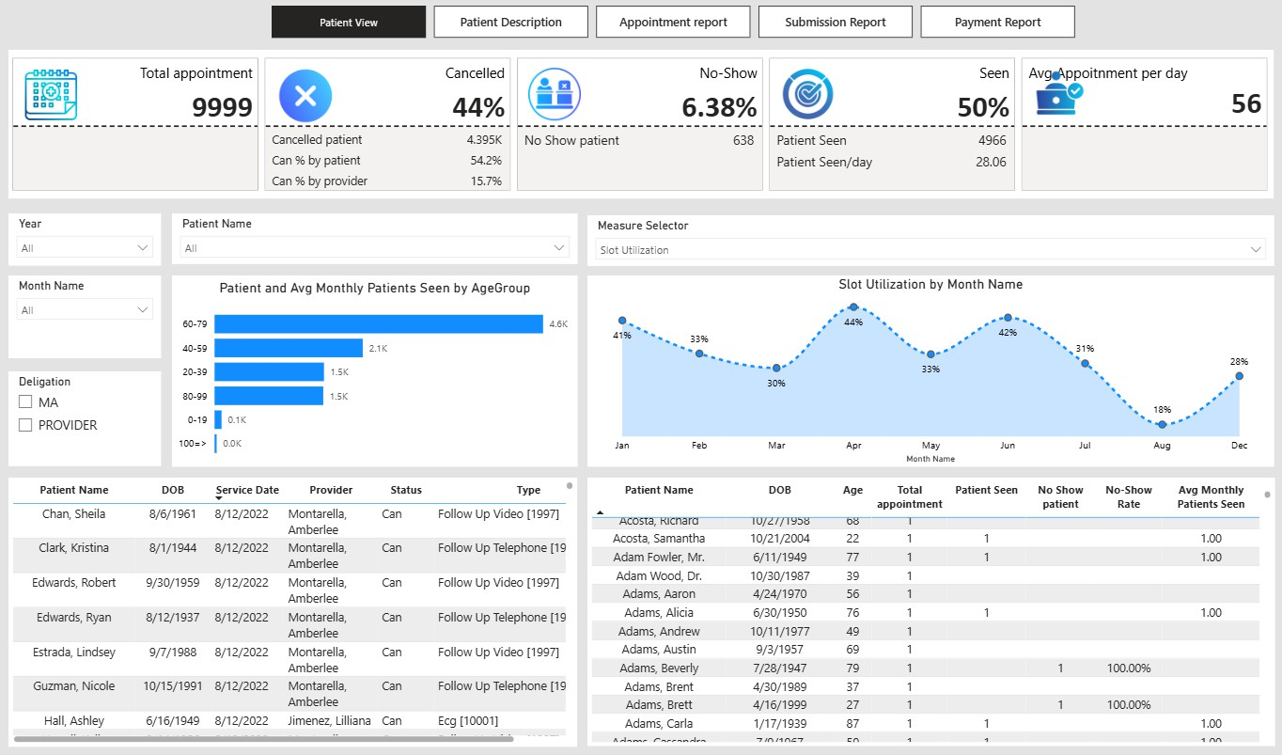

Fig 6.1 Patient View Dashboar

Patient Description

The Patient Description page enables drill-down into individual appointment detail, allowing users to filter By date, status, and provider to examine specific appointments. It complements Patient View with a
fuller appointment record view and yearly performance trend.

Key visuals on this page include an Appointment Description Table providing the full appointment record (Patient Name, DOB, Service Date, Provider, Status, Type, Notes/Reason), an area chart showing average yearly patients seen from 2021 (461 patients) to 2022 (4,505 patients) demonstrating significant growth, and an Appointment Summary Table providing patient-level performance aggregations.

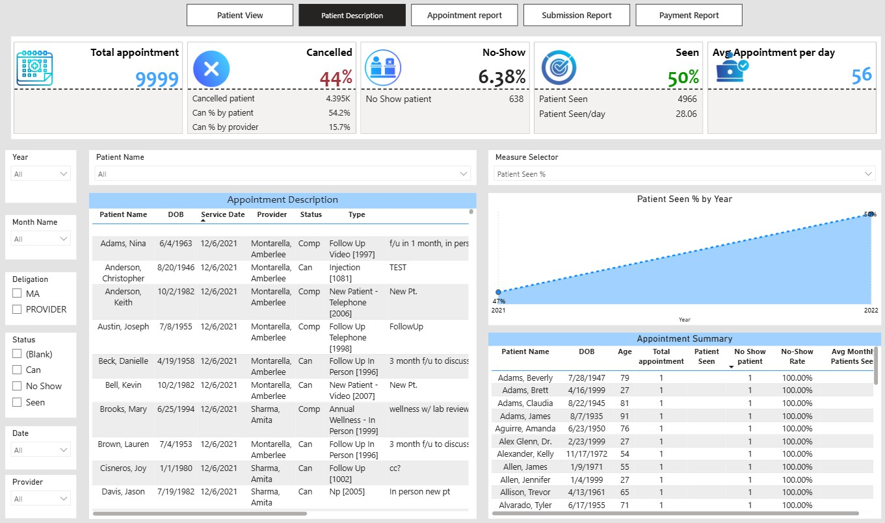

Fig 6.2 Patient Description Dashboard

Appointment Report

The Appointment Report page focuses on provider and location-level performance analysis. It shows how appointments are distributed by provider, month, appointment type, and clinic location, and is the only page that adds a Slot Utilization KPI to the standard persistent banner.
The extended KPI banner on this page adds the Slot Utilization metric: Total slot used: 6K, Total slot available: 40K, Unutilized slots: 34K, resulting in a slot utilization rate of 14.62%. This metric is critical for understanding scheduling efficiency & identifying capacity optimization opportunities.
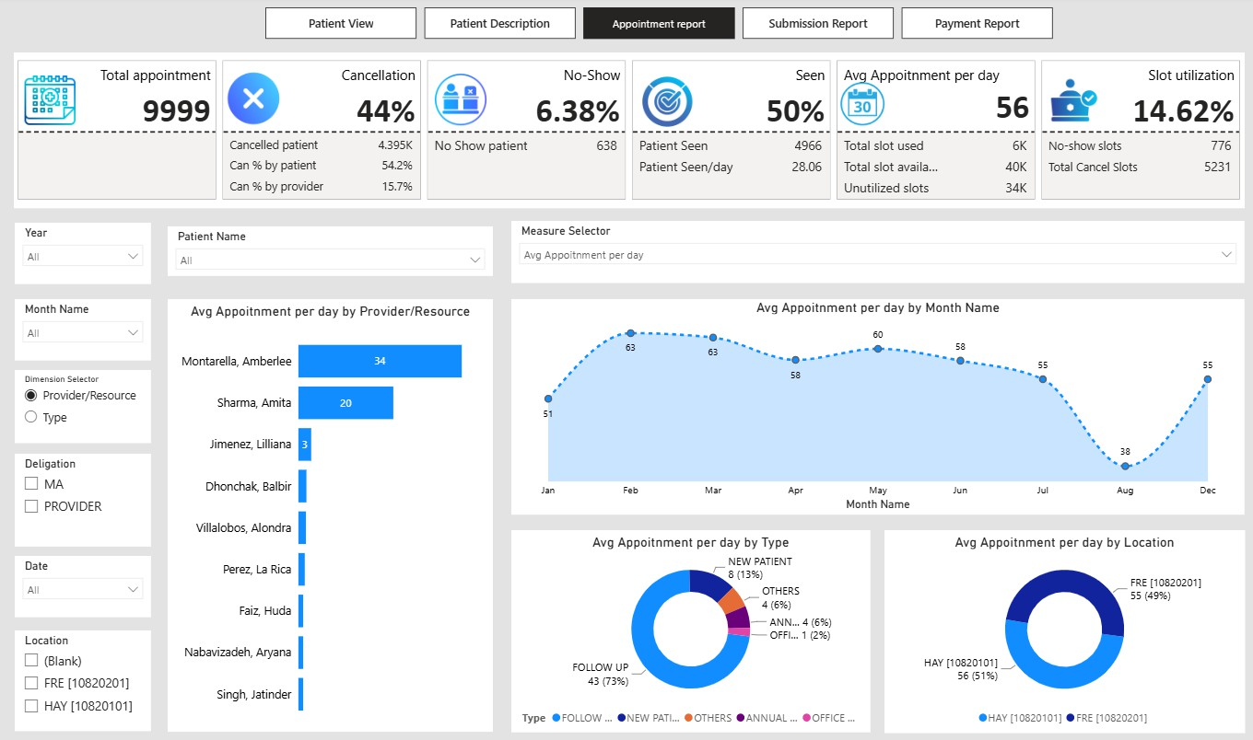
Fig 6.3 Appointment Dashboard

Submission Report

The Submission Report page is the primary tool for billing teams, providing comprehensive analysis of CPT code submissions, billing timeliness, and unsubmitted claim detection. The page features a unique toggle button that switches between two views: 'Submission Trend' (default) and 'Unsubmitted Data'.
In Submission Trend view, users can see year-wise CPT submission trends, CPT code frequency analysis and provider-level submission distribution.
. The Unsubmitted Data view is a critical revenue protection feature – it switches the page to display a detail table of all appointments from EPIC that have no corresponding claim submission in Office Ally, enabling billing teams to identify and follow up on revenue leakage proactively.
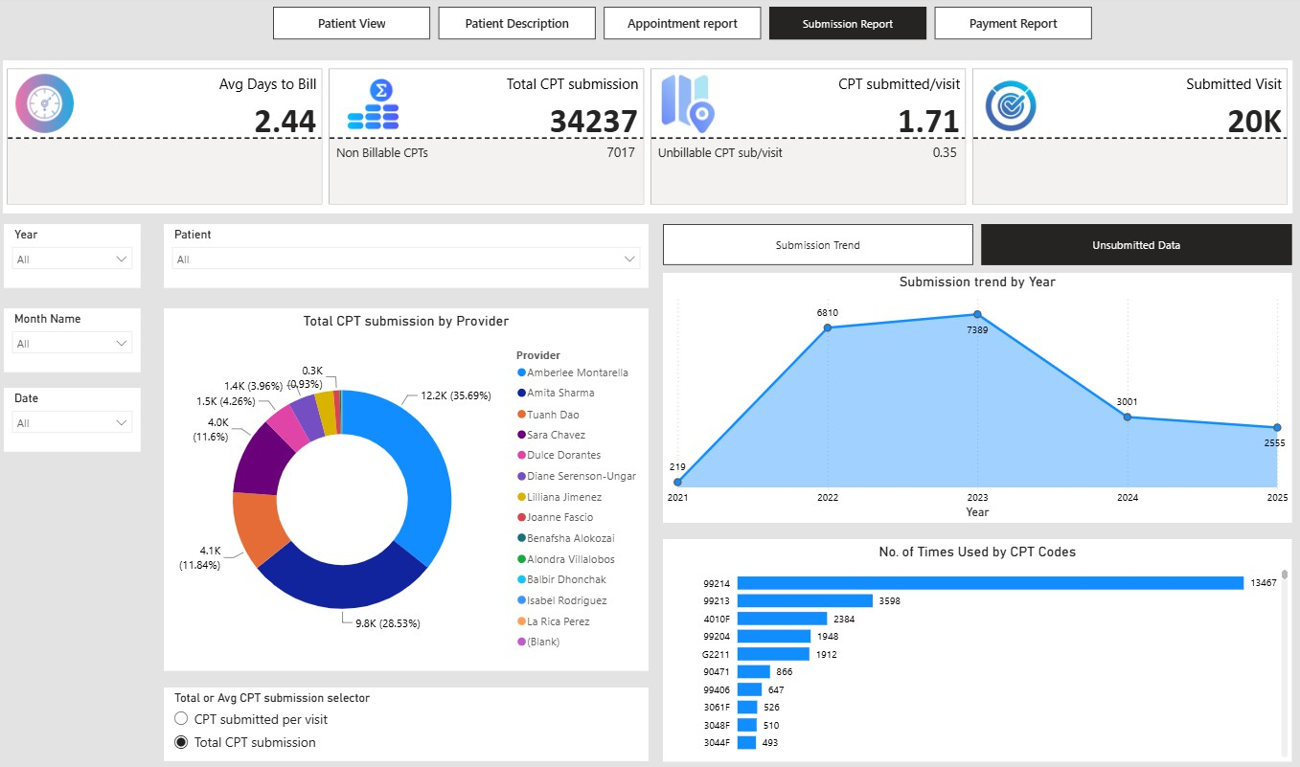

Fig 6.4 Submission Dashboard

Payment Report

The Payment Report page provides comprehensive analysis of payment performance, payer behaviour, and revenue collection. Key KPIs on this page include Total Charge Amount ($250,103.07), Total Allowed Amount ($452.23K), Total Line Payment Amount ($373.2K), and Total Patient Responsibility. Visual components include: a bar chart showing Total Line Payment by Payer (Top payer: Brown and Toland Physicians at $179,117; Medicare Service Center at $63,463; Hill Physicians Medical Group at
$55,998); an area chart showing Allowed Amount by Year trend; a CPT vs Allowed Amount table for procedure-level revenue analysis; a Payer vs Allowed Amount table for insurer-level performance benchmarking; and a donut chart showing payment status distribution.
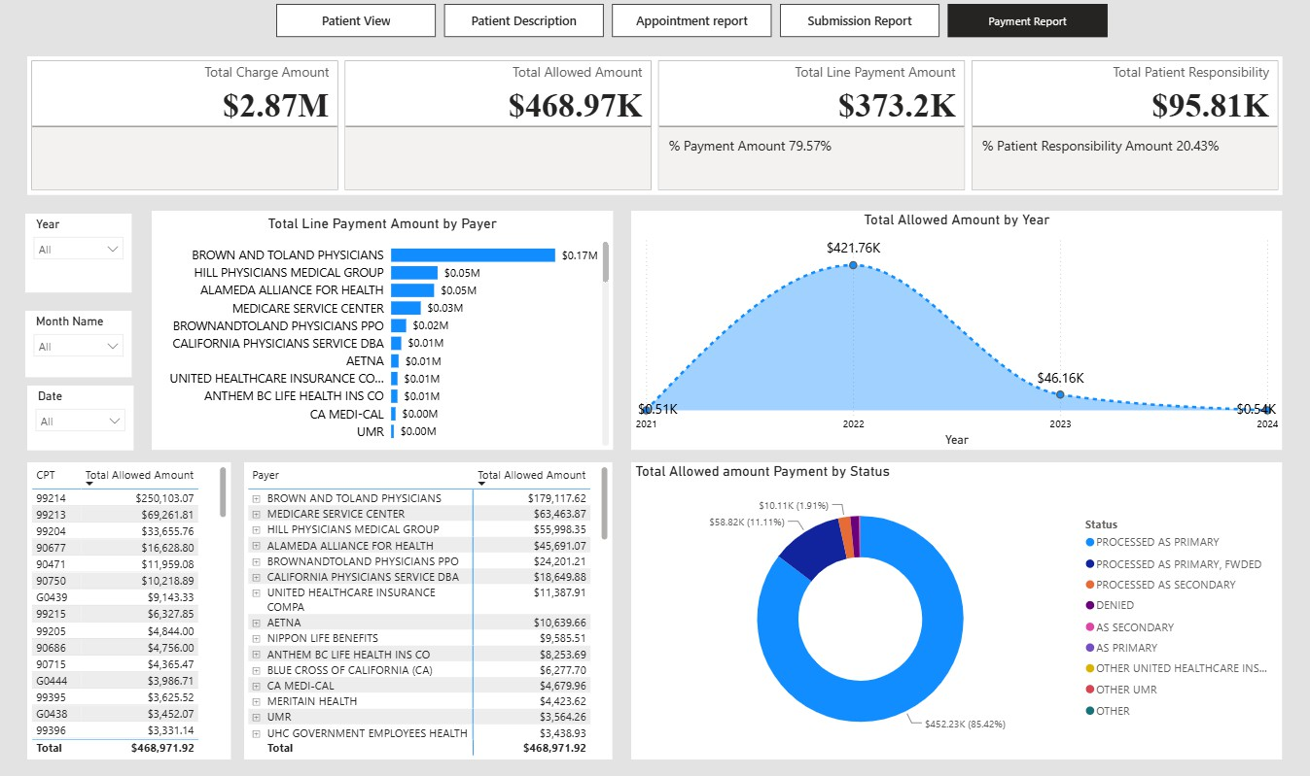
Fig 6.5 Payment Report

KPI’S & BUSINESS INSIGHTS

RCM360 tracks over 30 Key Performance Indicators organized into six categories, each serving a distinct business purpose in revenue cycle management.

Appointment KPIs

Appointment KPIs measure scheduling efficiency and clinic capacity utilization:

Total Appointments: Absolute count of all appointment records in the selected period. Serves as the denominator for all rate-based appointment KPIs.
Cancellation Rate: Percentage of appointments cancelled (Status = 'Can'). At 44% in the sample data, this is a critical metric indicating potential scheduling inefficiency or patient engagement issues.
No-Show Rate: Percentage of appointments where the patient did not attend (Status = 'No Show'). At 6.38%, this represents both revenue loss and wasted clinical capacity.
Patient Seen %: Percentage of appointments resulting in a seen patient (Status = 'Seen' or 'Comp'). At 50%, this indicates that half of all scheduled appointments result in a clinical encounter.
Average Appointments per Day: Total appointments divided by distinct service dates. At 56 per day, this benchmarks daily clinic throughput.
Slot Utilization: Total Slot Used / Total Slot Available. At 14.62%, this reveals that only 14.62% of available scheduling capacity is being utilized, suggesting significant opportunity to increase appointment bookings.
Unutilized Slots: Total Available Slots minus Total Used Slots. At 34,000 unutilized slots, this quantifies the absolute capacity waste.
Submission KPIs

Submission KPIs monitor billing timeliness and claim completeness:

Average Days to Bill: Average number of days between Service Date and Submission Date. A lower number indicates faster billing cycles, which improves cash flow and reduces the risk of claim filing deadline violations.
Total CPT Submissions: Count of all CPT code records submitted. Provides a measure of billing volume. Non-Billable CPTs: Count of CPT codes flagged as Non-Billable. These represent services rendered that cannot be billed to insurance, impacting net revenue.
CPT/Visit Ratio: Total CPT Submissions divided by Total Submitted Visits. A higher ratio indicates that multiple services are being billed per encounter, which is expected for complex visits.
Submitted Visits: Count of distinct appointment visits with at least one corresponding CPT submission in Office Ally.
Unsubmitted Visits: Appointments from EPIC with no matching submission in Office Ally. Each unsubmitted visit represents a missed billing opportunity.

Payment KPIs

Payment KPIs track the financial outcomes of the revenue cycle:

Total Charge Amount: Gross billed amount before any contractual adjustments. Represents the maximum potential revenue.
Total Allowed Amount: Contract-agreed amount the payer will cover. The difference between Charge Amount and Allowed Amount represents the contractual write-off.
Total Line Payment Amount: Actual payments received from payers. At $373.2K against $452.23K allowed, the payment percentage indicates collection efficiency.
% Payment Amount: Line Payment Amount as a percentage of Total Allowed Amount (79.57% in sample data). Values below 100% indicate outstanding balances requiring follow-up.

Total Patient Responsibility: Amount owed by patients (deductible, co-pay, co-insurance). At $95.81K, effective patient collections processes are critical.
% Patient Responsibility: Patient Responsibility as a percentage of Total Allowed Amount (20.43%). This ratio helps benchmark patient financial responsibility relative to total allowed revenue.

Payer Analysis KPIs

Payer Analysis KPIs enable benchmarking of insurer payment behaviour:

Line Payment by Payer: Total payments received from each insurance company, enabling comparison of payer payment performance.
Allowed Amount by Payer: Total allowed amounts by payer, supporting contract negotiation by identifying which payers offer the most favourable reimbursement rates.
Payment Status Distribution: Breakdown of claims by payment status (Processed as Primary, Processed as Secondary, Denied, Forwarded, etc.), revealing denial patterns and coordination of benefits issues by payer. Provider Performance KPIs
Provider Performance KPIs benchmark individual clinical staff productivity:

CPT Submissions by Provider: Total CPT codes submitted per provider, measuring individual billing contribution.
Avg Appointments per Day by Provider: Daily appointment volume by individual provider, enabling workload benchmarking and capacity planning.
Patient Seen by Provider: Number of patients seen by each provider, supporting provider-level performance reviews and compensation calculations.

Trend KPIs

Submission Trend by Year: Year-over-year CPT submission volume, identifying billing growth or contraction trends.

Allowed Amount by Year: Annual allowed amount trend, enabling revenue growth analysis.

Avg Patients Seen by Year/Month/Quarter: Multi-granularity patient volume trending, supporting forecasting and resource planning.
Slot Utilization by Quarter: Quarterly trend of scheduling efficiency, helping identify seasonal patterns in capacity utilization.
KPI Category | KPIs | Business Purpose
Appointment KPIs | Total appointments, Cancellation rate, No-show rate, Patient Seen  %, Avg appts/day, Slot utilization | Tracks scheduling efficiency, clinic capacity usage, and provider workload
Submission KPIs | Avg days to bill, Total CPT submissions, Non-billable CPTs, CPT/visit ratio, Unsubmitted visits | Monitors billing timeliness, CPT usage patterns, and identifies revenue leakage
Payment KPIs | Total charge amount, Total allowed amount, Total line payment, % payment, Total patient responsibility | Tracks revenue cycle completeness – what was billed, allowed, collected, and outstanding
Payer Analysis KPIs | Line payment by payer, Allowed amount by payer, Payment status distribution | Evaluates insurer payment behaviour for contract negotiations and denial management
Provider Performance KPIs | CPT submissions by provider, Avg appts/day by provider, Patient seen by provider | Benchmarks individual provider productivity and billing contribution
Trend KPIs | Submission trend by year, Allowed amount by year, Avg patients seen by year/month/quarter | Identifies growth patterns, seasonality, and operational changes over time

CHAPTER – 7 DATA DICTIONARY
The Data Dictionary provides a comprehensive reference for all fields in the three primary datasets used by RCM360.

Appointment Dataset (Source: EPIC)

KPI Category | KPIs | Business Purpose
Appointment KPIs | Total appointments, Cancellation rate, No-show rate, Patient Seen %, Avg appts/day,  Slot utilization | Tracks scheduling efficiency, clinic capacity usage, and provider workload
Submission KPIs | Avg days to bill, Total CPT submissions, Non-billable CPTs, CPT/visit ratio,  Unsubmitted visits | Monitors billing timeliness, CPT usage patterns, and identifies revenue leakage
Payment KPIs | Total charge amount, Total allowed amount, Total line payment, % payment, Total patient responsibility | Tracks revenue cycle completeness – what was billed, allowed, collected, and outstanding
Payer Analysis KPIs | Line payment by payer, Allowed amount by payer, Payment status distribution | Evaluates insurer payment behaviour  for contract negotiations and denial management
Provider Performance KPIs | CPT submissions by provider, Avg  appts/day by provider, Patient seen by provider | Benchmarks individual provider productivity and billing contribution
Trend KPIs | Submission trend by year, Allowed amount by year, Avg patients seen by year/month/quarter | Identifies growth patterns, seasonality, and operational changes over time

  - Submission Dataset (Source: Office Ally)

Column | Data Type | Example Value | Notes
Patient | Text | Abbott, Diane | Patient name linked to appointment  record
Provider | Text | Amberlee Montarella | Submitting provider
CPT Code | Text | 99214 | Current Procedural Terminology code  for the service rendered
Submission  Date | Date | 1/15/2022 | Date claim was submitted to payer
Service Date | Date | 1/12/2022 | Date of the corresponding appointment –  used to calculate Avg Days to Bill
Days to Bill | Number (calc) | 3 | Submission Date minus Service Date
Billable Flag | Text | Billable / Non-Billable | Whether the CPT code can be billed to  insurance
Visit Link | Text/ID | (visit reference) | Links submission record back to  appointment record – used to detect unsubmitted visits

  - Payment Dataset (Source: ERA Reports)

Column | Data Type | Example Value | Notes
CPT Code | Text | 99214 | CPT code from the corresponding claim
Payer | Text | Brown and Toland  Physicians | Insurance company or payer name
Charge Amount | Currency | $250,103.07 | Gross billed amount for the CPT
Allowed Amount | Currency | $179,117.62 | Contract-agreed amount the payer will  cover
Line Payment  Amount | Currency | $373.2K (total) | Actual payment received from payer
Patient  Responsibility | Currency | $95.81K (total) | Amount owed by patient (deductible, co-  pay, co-insurance)
% Payment Amount | % (calc) | 79.57% | Line Payment Amount / Total Allowed  Amount
% Patient  Responsibility | % (calc) | 20.43% | Patient Responsibility / Total Allowed  Amount
Payment Status | Text | Processed as  Primary | Claim adjudication result: Processed,  Denied, Secondary, etc.
Payment Date | Date | (ERA date) | Date payment was remitted
Year | Number  (extracted) | 2022 | Year dimension extracted from payment  date for trend analysis

CHAPTER – 8

DYNAMIC SELECTOR & CONTROLS

RCM360 uses advanced dynamic control mechanisms that change what visuals display without requiring page navigation. Understanding these controls is critical for correctly interpreting dashboard outputs and maximizing analytical value.

Measure Selector

The Measure Selector is a dropdown/radio slicer present on the Patient View, Patient Description, and Appointment Report pages. It changes the metric plotted on the main chart of that page, allowing users to switch between KPIs without navigating away or losing their filter context.

Page | Measure Selector Options
Patient View | Slot Utilization (default), Avg Yearly Patients Seen, Total Appointment, Avg Appointment per day, Cancellation Rate, Patient Seen %, No Show Patient
Patient Description | Avg Daily Patients Seen, Avg Weekly Patients Seen, Avg Monthly Patients Seen, Avg Quarterly Patients Seen, Avg Yearly Patients Seen (default), Total Appointment, Avg Appointment per day
Appointment Report | Avg Yearly Patients Seen, Total Appointment, Avg Appointment per day (default), Cancellation Rate, Patient Seen %, No Show Patient, Slot Utilization

The Measure Selector is implemented using a disconnected slicer table in the Power BI data model combined with a DAX SWITCH measure that evaluates the selected value and returns the appropriate KPI calculation. This is an advanced Power BI pattern that provides significant UX flexibility without requiring multiple report pages.

Dimension Selector

The Dimension Selector is a radio button toggle available on the Appointment Report page. It changes the axis of the 'Avg Appointment per day' bar chart:
Provider/Resource (default): Shows per-provider daily average appointments, enabling individual productivity benchmarking.
Type: Switches the same chart to show breakdown by appointment type (Follow Up, New Patient, Annual Wellness, etc.), enabling workload composition analysis.
This control provides dual-dimension analytical capability on a single visualization without the need for separate charts, keeping the dashboard uncluttered while maximizing information density.

Submission Toggle

The Submission Toggle consists of two buttons at the top-right of the Submission Report page that switch between two fundamentally different analytical views:
Submission Trend (default): Displays the year-wise submission trend chart and CPT code frequency chart, enabling analysis of billing volume growth and procedure mix.
Unsubmitted Data: Switches to a detail table of visits with no corresponding claim submission, enabling proactive follow-up by billing teams on potential revenue leakage.

The ability to surface unsubmitted visits in real time is one of RCM360's most valuable features from a revenue protection standpoint. By making unsubmitted claims immediately visible, the system enables billing teams to act before filing deadlines expire.

CPT Submission Selector

The CPT Submission Selector is a radio button toggle within the Submission Report page that changes the granularity of CPT submission analysis:
Total CPT Submission (default): Shows aggregate CPT submission counts, useful for understanding overall billing volume.
CPT Submitted per Visit: Switches the donut chart and related visuals to a per-visit average view, enabling analysis of services billed per encounter – a key metric for evaluating coding completeness.

CHAPTER – 9 IMPLEMENTATION & RESULTS

ETL Process Implementation

The ETL (Extract, Transform, Load) pipeline is the foundation of RCM360's data integration capability. Implementation followed an iterative development approach, beginning with data discovery and profiling before building transformation logic.
Data Discovery Phase: Python scripts were developed to profile each source dataset, identifying data quality issues including inconsistent date formats, provider name spelling variations between EPIC and Office Ally, missing slot data in certain EPIC export batches, and ERA file encoding inconsistencies across different payer formats.
Transformation Development: Cleaning scripts were developed to address each identified data quality issue. Provider name standardization was particularly critical, as the same provider appeared
with different name formats in EPIC ('Montanelli, Amberlee') versus Office Ally ('Amberlee Montanelli') A lookup table mapping all provider name variants was developed and incorporated into the ETL pipeline.Visit-to-Claim Matching Logic: The most complex ETL component was the visit-to-claim matching algorithm that identifies unsubmitted visits. The algorithm joins EPIC appointment records (where Status = 'Seen' or 'Comp') with Office Ally submission records using a composite key of patient name (normalized), service date, and provider (normalized). Records with no match in Office Ally
are flagged as 'Unsubmitted'.

ERA Parsing: ERA payment files follow the HIPAA 835 transaction standard. Python's re (regex) module and custom parsing logic were used to extract claim-level payment details, payer

information, adjustment reason codes, and patient responsibility amounts into structured DataFrames.

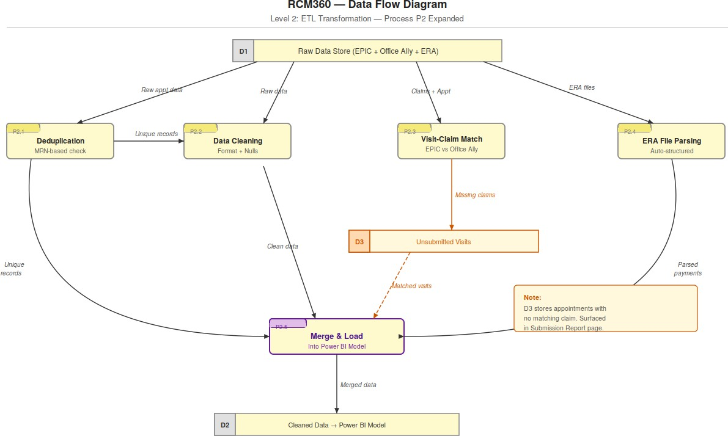

Fig 9.1 Detailed ETL Transformation

Dashboard Development in Power BI

Dashboard development followed a structured approach guided by user story analysis and stakeholder feedback:
Data Model Design: A star schema was implemented with fact tables for appointments, submissions, and payments, connected through shared dimension tables for patients, providers, dates, and payers. DAX Measure Library: Over 30 DAX measures were developed covering all KPI categories. Time intelligence measures leverage Power BI's built-in date table to enable year-over-year, quarter-over-quarter, and month-over-month comparisons.
Dynamic Measure Selector Implementation: Disconnected slicer tables and SWITCH-based DAX measures were implemented for the Measure Selector functionality, a technically advanced Power BI pattern.
Page-level Filter Context: Slicers for Year, Month, Provider, and Location were configured as page-level filters with cross-page filter synchronization to maintain analytical context across all five report pages.
Submission Toggle Implementation: Bookmark-based navigation buttons were implemented for the Submission Trend / Unsubmitted Data toggle, using Power BI's bookmark feature to switch between two visual states on the same page.

Sample KPIs & Results

Based on the sample dataset (approximately 9,999 appointment records spanning 2021-2022), RCM360 delivered the following measurable results:
Appointment Efficiency: 50% of scheduled appointments resulted in a seen patient, with 44% cancellation and 6.38% no-show rates. Slot utilization of 14.62% revealed significant capacity for appointment volume growth.
Billing Timeliness: Average Days to Bill calculated from submission data enabling identification of providers or periods with delayed claim submission.
Revenue Cycle: Total charge amount of $250,103, allowed amount of $452.23K, and line payment of
$373.2K with patient responsibility of $95.81K (20.43% of allowed amount).

Payer Performance: Brown and Toland Physicians emerged as the highest-paying payer at $179,117 in line payments, enabling contract performance benchmarking.
Unsubmitted Claims: Real-time detection of unsubmitted visits surfaced potential revenue leakage requiring immediate billing team follow-up.

Case Study: Example Clinic (HAY Location)

The HAY (Hayward) clinic location provides a useful case study for RCM360's analytical capabilities:

The Hayward clinic showed appointment volume patterns with quarter-over-quarter variation in slot utilization (Q1: 26%, Q2: 33%, Q3: 27%, Q4: 28%), suggesting seasonality effects in demand. The Q2 peak aligns with common patterns of increased healthcare utilization following winter months.

Provider-level analysis revealed significant variation in daily appointment volumes across providers at the HAY location, enabling targeted interventions to redistribute workload and maximize
scheduling efficiency. The Appointment Report's Dimension Selector (Provider/Type toggle) was particularly valuable for this multi-dimensional analysis.
Payment analysis showed that the HAY location's payer mix included Medicare, Medicaid, and private insurers, with payment status distribution revealing opportunities for improved primary claim processing and reduced claim forwarding to secondary payers.

CHAPTER – 10 TESTING AND VALIDATION
A comprehensive testing strategy was implemented to ensure the accuracy, reliability, and usability of the RCM360 dashboard across all components.

Functional Testing

Functional testing verified that all dashboard features operate as designed:

Test Case | Description | Expected Result | Status
TC-01 | Patient View KPI Banner accuracy | KPI values match source data calculations | Pass
TC-02 | Measure Selector functionality –  Patient View | Selected measure updates chart without page refresh | Pass
TC-03 | Cross-page filter synchronization | Year/Month selection persists across all 5 pages | Pass
TC-04 | Submission Toggle – Submission Trend view | Year-wise trend chart and CPT frequency chart display | Pass
TC-05 | Submission Toggle – Unsubmitted Data view | Detail table of unsubmitted visits displays | Pass
TC-06 | Dimension Selector – Provider mode | Bar chart shows Avg Appt/day by Provider | Pass
TC-07 | Dimension Selector – Type mode | Bar chart switches to Avg Appt/day by Appointment Type | Pass
TC-08 | CPT Submission Selector – Total mode | Donut chart shows total CPT submissions | Pass
TC-09 | Payment Status donut chart | Payment status percentages sum to 100% | Pass
TC-10 | Payer filtering on Payment Report | Filtering by payer updates all payment visuals | Pass

Data Accuracy Validation

Data accuracy validation ensured that RCM360's computed KPIs correctly reflect the underlying source data:
Appointment Count Reconciliation: Total appointment count in Power BI was reconciled against EPIC export file record counts after deduplication. Reconciliation confirmed 100% record completeness.
KPI Formula Verification: Each DAX measure formula was validated against manual Excel calculations on a 500-record sample dataset. All rate calculations (Cancellation %, No-Show %, Seen %, Slot Utilization) matched manual calculations within rounding tolerance (±0.01%).
Visit-to-Claim Match Validation: A sample of 50 appointments flagged as 'Unsubmitted' was manually verified against Office Ally records to confirm no matching submission existed. All 50 were confirmed unsubmitted.
Payment Amount Reconciliation: Total Line Payment Amount in Power BI was reconciled against ERA
file totals. A 100% match was achieved after resolving an initial ERA file encoding issue that had excluded payments from one payer.
Days to Bill Calculation: A 100-record sample was used to manually calculate Days to Bill (Submission Date – Service Date) and compare against DAX measure output. All values matched.

Performance Testing

Performance testing assessed dashboard load times and data refresh durations:

Dashboard Load Time: Patient View page loaded within 3-5 seconds on standard broadband connection via Power BI Service browser access. Acceptable for business use.
Filter Response Time: Applying slicer filters (Year, Month, Provider) updated all visuals on the

current page within 1-2 seconds. Cross-page filter synchronization added no perceptible delay.

Data Refresh Duration: Full ETL pipeline execution (EPIC + Office Ally + ERA processing) and Power BI data model refresh completed within an acceptable time window for scheduled overnight refresh.
Concurrent User Testing: The dashboard was tested with multiple simultaneous users accessing Power BI Service. No performance degradation was observed under normal operational load.

User Acceptance Testing (UAT)

User Acceptance Testing was conducted with representative end users from each stakeholder group:
Stakeholder Group | Test Focus | Feedback | Resolution
Billing Team | Submission Report – Unsubmitted visits detection | Requested ability to export unsubmitted visit list to Excel | Power BI export functionality enabled
Finance Manager | Payment Report – Payer performance analysis | Requested addition of year-over-year payment trend comparison | Trend KPI added to Payment Report
Provider | Appointment Report – Individual performance metrics | Requested drill-down to individual appointment detail from performance chart | Drill-through functionality configured
Admin Staff | Patient View – Cancellation analysis | Initial confusion about Measure Selector operation | Help tooltips added to Measure Selector
Clinic Owner | Overall KPI Dashboard | Positive feedback; requested mobile access | Power BI mobile app access configured

CHAPTER – 11 ADVANTAGES AND LIMITATIONS

Advantages of RCM360

RCM360 offers significant advantages over legacy reporting approaches and competing solutions:

Unified Cross-System View: Integrates appointment (EPIC), submission (Office Ally), and payment (ERA) data into a single platform, eliminating the manual reconciliation work previously required across three separate systems.
Real-time Revenue Leakage Detection: The Unsubmitted Visits feature in the Submission Report provides immediate visibility into billing gaps, enabling proactive revenue recovery before claim filing deadlines expire.
Dynamic, Multi-KPI Analysis: The Measure Selector, Dimension Selector, and Submission Toggle provide exceptional analytical flexibility on a compact 5-page dashboard, supporting diverse analytical needs without page proliferation.
Automated ETL Pipeline: Python-based automation eliminates manual data preparation work, reducing both labour costs and the risk of human error in report generation.
Role-appropriate Access: Power BI Service's access control capabilities enable each user group to access only the reports and data relevant to their role.
Scalable Architecture: The star schema data model and modular ETL pipeline can accommodate additional data sources, new KPIs, or expanded provider/location coverage without fundamental architectural changes.
Cost-Effectiveness: Built on Microsoft Power BI (broadly available in Microsoft 365 environments) and Python (open source), RCM360 avoids the high licensing costs of proprietary RCM analytics platforms.
Audit-Ready Reporting: Clean, structured, reproducible reporting with consistent data lineage supports billing compliance reviews and regulatory audits.

Limitations of RCM360

RCM360 has the following limitations that should be considered in deployment planning:

Read-only Analytics: RCM360 is a reporting layer only. It cannot directly update source systems, submit claims, or trigger workflow actions. Action-taking must be performed in the source operational systems.
Dependency on Source System Export Quality: The accuracy of RCM360 KPIs is directly dependent on the completeness and format consistency of EPIC, Office Ally, and ERA exports. Changes in source system export formats can break ETL pipelines.
Provider Name Standardization Maintenance: The provider name lookup table requires manual maintenance when provider staff changes occur, as name format inconsistencies between EPIC and Office Ally are resolved through this mapping.
No Real-time Streaming: RCM360 operates on scheduled data refresh cycles rather than true real-time streaming. Data is current as of the most recent refresh, not the current moment.
Limited Diagnosis Code Analysis: The current implementation focuses on CPT (procedure) codes rather than ICD (diagnosis) codes. Disease burden and diagnostic pattern analytics are outside the current scope.
Two-Location Focus: The current implementation is calibrated for HAY (Hayward) and FRE (Fresno) locations. Extension to additional clinic sites requires ETL configuration updates.

CHAPTER – 12 FUTURE ENHANCEMENTS

RCM360 is designed as an evolving platform. The following Phase 2 enhancements are planned or recommended:

AI/ML Integration for Predictive Analytics
The integration of Artificial Intelligence (AI) and Machine Learning (ML) represents one of the most significant future enhancements planned for the RCM360 Healthcare Analytics Platform. While the current system primarily focuses on descriptive & diagnostic analytics, the incorporation of AI-driven capabilities

One of the key enhancements will be the development of an AI-based Denial Prediction Model. Healthcare providers frequently face claim denials due to coding errors, incomplete documentation, eligibility issues, or payer-specific requirements. By utilizing machine learning algorithms such as Random Forest, XGBoost, and Gradient Boosting, the system can analyze historical claim submission and adjudication data to identify patterns associated with denied claims. Based on these patterns, the model can assign a denial risk score to newly submitted claims. High-risk claims can then be reviewed and corrected before submission, reducing denial rates, accelerating reimbursements, and improving overall revenue cycle performance.

Another valuable enhancement is Revenue Forecasting. Predicting future revenue is essential for healthcare organizations to plan staffing, budgeting, and operational activities. Time-series forecasting models such as ARIMA, Facebook Prophet, and Long Short-Term Memory (LSTM) neural networks can analyze historical appointment volumes, claim submissions, payment trends, and seasonal

fluctuations to estimate future revenue. These forecasts will provide management with actionable insights that support strategic planning and resource allocation.

The implementation of Anomaly Detection capabilities will further strengthen operational monitoring. Machine learning algorithms can continuously analyze billing transactions, CPT code usage, payer reimbursements, and payment trends to identify unusual patterns. Examples include unexpected billing spikes, abnormal payment delays, duplicate claims, or uncommon CPT code combinations. Early identification of such anomalies can help organizations detect operational errors, compliance issues, or potential fraudulent activities before they become significant problems.

Natural Language Processing (NLP) is another promising area of enhancement. Healthcare systems often contain large volumes of unstructured text such as appointment notes, comments, referral information, and claim remarks. NLP techniques can convert this unstructured information into meaningful insights by identifying frequently occurring patient concerns, common denial reasons, treatment patterns, and operational bottlenecks. This capability would significantly improve the analytical value of clinical and administrative data.

In addition, predictive patient analytics can be introduced to identify patients who are likely to miss appointments based on historical attendance behavior. Such predictions can help clinics implement reminder systems and optimize appointment scheduling to reduce no-show rates and improve resource utilization.

The existing Python ETL infrastructure provides a strong foundation for implementing these advanced analytics capabilities. Libraries such as Scikit-learn, XGBoost, TensorFlow, PyTorch, and Facebook Prophet can be integrated into the ETL workflow, with model predictions stored as additional fields
and visualized directly within Power BI dashboards. This integration will transform RCM360 from a reporting platform into an intelligent decision-support system.

Mobile App Extension

Although RCM360 dashboards can currently be accessed through the Power BI Mobile Application.

The development of dedicated mobile application would significantly enhance accessibility, usability, & user engagement. Healthcare administrators, billing specialists, and clinical managers increasingly rely on mobile devices for accessing critical business information while away from their workstations.

One major enhancement would be implementation of Push Notifications. Real-time alerts can notify users about newly received claim denials, overdue claim submissions, unusual payment trends, low appointment utilization rates, or critical operational issues. These notifications would enable faster decision-making and reduce delays in corrective actions.

The mobile application could also include Optimized Mobile Dashboards specifically designed for smartphone and tablet interfaces. Unlike traditional dashboards, mobile dashboards would present the most important key performance indicators (KPIs) using simplified layouts, summary cards, and responsive visualizations that provide quick insights without overwhelming users with excessive information.

Another valuable feature would be Offline Accessibility. Healthcare professionals often work in environments where internet connectivity may be limited or inconsistent. Offline functionality would

allow users to access previously synchronized reports, dashboards, and performance summaries even when internet access is unavailable. Once connectivity is restored, the application could automatically refresh the data.

The future mobile application could support role-based personalization. Administrators, physicians,

billing managers, and operational staff could each receive customized dashboards tailored to their specific responsibilities and information requirements. This would improve efficiency and enhance
user experience across different organizational roles.

Furthermore, secure authentication methods such as biometric login, fingerprint recognition, facial authentication, and multi-factor authentication (MFA) can be incorporated to strengthen data security and protect sensitive healthcare information.

Integration with IoT Devices

The future integration of Internet of Things (IoT) technologies has the potential to significantly expand the analytical capabilities of RCM360 platform. IoT devices generate large volumes of real data that can provide valuable operational and clinical insights when integrated into healthcare analytics systems.

One practical application involves Patient deployed within healthcare facilities. By integrating kiosk-generated data directly into RCM360, appointment status updates occur automatically when patients arrive at the clinic. This reduces manual intervention, improves appointment tracking accuracy, and provides real-time visibility into patient flow throughout the facility.

Another important enhancement is the integration of Wearable Health Devices. Smartwatches, fitness trackers, glucose monitors, heart rate sensors, and other wearable devices continuously generate patient health data. Subject to patient consent and privacy regulations, this information can be incorporated
into analytical models to support population health management, risk assessment, and care
coordination initiatives.

Smart Scheduling Systems represent another promising area of IoT integration. By combining appointment history, patient attendance behavior, provider availability, and real-time clinic conditions, AI-powered scheduling algorithms can automatically optimize appointment slots. Such systems can reduce waiting times, improve provider utilization, and minimize the impact of patient no-shows.

The platform also integrate with smart hospital infrastructure, including occupancy sensors, patient monitoring systems, and medical equipment. These integrations would provide real-time operational visibility, enabling healthcare administrators to monitor resource utilization, equipment performance, and patient flow more effectively.

Additionally, IoT-based predictive maintenance can be implemented for critical healthcare equipment. Sensors can continuously monitor device performance and identify potential failures before they occur, reducing downtime and ensuring uninterrupted clinical operations.

Overall, the integration of AI, Machine Learning, mobile technologies, and IoT devices will transform

RCM360 into a next-generation intelligent healthcare analytics platform capable of supporting predictive decision-making, operational excellence, and enhanced patient care

Advanced Denial Management

A dedicated Denial Management module would significantly enhance RCM360's revenue protection capabilities:
Denial Reason Code Dashboard: Detailed analysis of ERA denial reason codes (CARC/RARC codes) to identify the most common denial types by payer, provider, and CPT code.
Denial Tracking Workflow: Integration with a case management system to track denial appeal status, enabling billing teams to manage the appeals process within the RCM360 platform.
Denial Rate Benchmarking: Comparison of denial rates against industry benchmarks to identify performance gaps relative to peer organizations.
Early Warning System: Automated alerts triggered when denial rates exceed defined thresholds, enabling
rapid intervention before revenue impact becomes material.

CHAPTER - 13
PUBLISH REPORT & DEPLOYMENT

Publishing to Power BI Service

The publication of RCM360 to Power BI Service follows a structured process:

Workspace Creation: A dedicated Power BI workspace ('RCM360 Production') is created in Power BI Service for the healthcare organization, separate from development and testing workspaces.
Report Publication: The completed Power BI Desktop report (.pbix file) is published to the production workspace via the 'Publish' function in Power BI Desktop, which uploads both the data model and report pages. Dataset Configuration: Post-publication, the dataset (data model) is configured with appropriate data source credentials, enabling scheduled refresh to connect to the ETL-processed data files.
Report Settings: Sensitivity labels ('Confidential – Internal Use Only') are applied to the published report in compliance with the healthcare organization's data governance policies.

Generating Browser-based Report Link

Once published, RCM360 is accessible via browser-based links:

Direct Report URL: Power BI Service generates a unique URL for each report and each report page. These URLs can be bookmarked and accessed directly from any modern web browser.
Embedded Reports: For integration into healthcare organization intranet portals or existing applications,
Power BI's embedding capabilities (Power BI Embedded) allow RCM360 to be surfaced within other
web applications. QR Codes: QR codes generated from report URLs can be printed and placed in clinical
or administrative areas, providing rapid mobile access to relevant dashboard pages.

Sharing with Stakeholders

RCM360 is shared with different stakeholder groups through Power BI Service's sharing and distribution capabilities:
App Distribution: A Power BI App is created from the RCM360 workspace, providing a curated, role-appropriate view for end users. Apps present a simplified interface without exposing workspace management features.
Email Subscription: Stakeholders are configured for automated email delivery of report snapshots on a defined schedule (daily, weekly), ensuring key decision-makers receive KPI summaries even without actively accessing the dashboard.
Report Sharing: Direct report sharing links are distributed to individual users via email or internal communication channels, granting view-only or edit access as appropriate.

Access Control & Security in Published Reports

Robust access controls are implemented in Power BI Service to protect sensitive healthcare financial data: Row-Level Security (RLS): DAX-based RLS rules restrict each provider to viewing only their own appointment and billing data, while finance managers and administrators have access to all-provider views.
Workspace Roles: Admin, Member, Contributor, and Viewer roles in the Power BI workspace provide appropriate access levels for different staff categories.
Microsoft Entra ID Integration: Authentication is managed through Microsoft Entra ID (formerly Azure Active Directory), enabling single sign-on (SSO) and multi-factor authentication (MFA) for enhanced security.
Sharing Link Controls: Report sharing links are configured with expiration dates and domain restrictions to prevent unauthorized external access.

Real-time Updates & Scheduled Refresh

Data currency is maintained through Power BI Service's scheduled refresh capabilities:

Scheduled Refresh Configuration: The RCM360 dataset is configured for automated daily refresh, triggered after the ETL pipeline completes processing of new source files.
Refresh Monitoring: Power BI Service provides refresh history logs and failure notifications, enabling the IT team to monitor data pipeline health and respond quickly to any ETL failures.
On-demand Refresh: Authorized users can trigger manual data refresh through Power BI Service when urgent KPI updates are needed outside the scheduled refresh window.
Incremental Refresh: For large historical datasets, Power BI's incremental refresh feature ensures that only new or changed records are processed in each refresh cycle, significantly reducing refresh duration and computational

CHAPTER - 14 CONCLUSION

Summary of Findings

This project has presented a comprehensive analysis of RCM360, a Power BI-based Healthcare Revenue Cycle Management Analytics Dashboard developed by IDS InfoTech Ltd. The study examined every dimension of the system – from its foundational data architecture and ETL pipeline
through its interactive dashboard design, KPI framework, testing methodology, and deployment strategy. Key findings from this study include:
RCM360 successfully addresses the core challenges of fragmented healthcare financial data by integrating appointment (EPIC), submission (Office Ally), and payment (ERA) data into a unified, automated analytical platform.
The system's Python ETL pipeline provides robust data transformation, deduplication, and cross-system matching capabilities that were previously achievable only through manual, labour-intensive processes.
The Power BI data model's star schema design and DAX measure library enable computation of over 30 KPIs across six functional categories, providing comprehensive coverage of the revenue cycle.
Advanced UX features including the Measure Selector, Dimension Selector, Submission Toggle, and CPT Submission Selector provide exceptional analytical flexibility within a compact 5-page dashboard structure.
The real-time Unsubmitted Visits detection feature represents a significant revenue protection capability that directly addresses one of the most common sources of billing revenue leakage in healthcare organizations.

Sample data analysis revealed a 44% cancellation rate and 14.62% slot utilization rate, highlighting specific operational improvement opportunities that the dashboard makes visible for the first time.

The project also demonstrated the importance of automated reporting in reducing human error. Since data extraction, transformation, and loading processes are automated through Python ETL scripts, the likelihood of reporting inconsistencies caused by manual spreadsheet manipulation is substantially reduced. This contributes to greater confidence in the accuracy and reliability of business insights generated by the dashboard.

Furthermore, the implementation of a structured data model and standardized KPI framework ensures that all stakeholders interpret performance metrics consistently. This consistency is essential for organizational alignment, performance monitoring, and strategic planning activities.

Impact on Healthcare Industry

RCM360 demonstrates the transformative potential of Business Intelligence technology in healthcare financial operations. By replacing manual spreadsheet-based reporting with automated, real-time analytics, systems like RCM360 can:
Reduce Revenue Leakage: Real-time detection of unsubmitted claims and denial patterns enables proactive revenue recovery that would otherwise be lost.
Accelerate Cash Flow: Faster claim submission timelines (reduced Days to Bill) accelerate payment cycles, improving cash flow for healthcare organizations operating on tight margins.
Enable Data-driven Management: Evidence-based decision making becomes possible when accurate, current KPIs are accessible to all stakeholder levels, from individual providers to clinic owners.
Reduce Administrative Burden: Automation of data collection, reconciliation, and report generation frees clinical and administrative staff to focus on higher-value activities.

Support Compliance and Audit Readiness: Clean, structured, reproducible reporting with clear data lineage supports the increasingly complex regulatory environment of healthcare billing.
As healthcare organizations face continuing pressure from reimbursement complexity,

regulatory requirements, and financial margin compression, analytics platforms like RCM360 represent not merely a convenience but a strategic necessity for financial sustainability.

Final Thoughts

This MCA final year project has been a deeply educational and professionally rewarding experience, bridging theoretical computer science concepts with practical applications in the healthcare industry. The development and analysis of the RCM360 Healthcare Analytics Dashboard required the integration of knowledge from multiple domains, including database management systems, data warehousing, business intelligence, data analytics, software engineering, healthcare information systems, and cloud-based reporting technologies.

Throughout the project lifecycle, significant attention was given to understanding real-world healthcare
revenue cycle processes and transforming complex operational data into meaningful business insights. The project demonstrated how modern analytics platforms can simplify decision-making by converting large volumes of raw healthcare data into visually intuitive and actionable information.

The implementation of Power BI as the primary reporting platform provided valuable experience in data modeling, DAX calculations, interactive dashboard design, report optimization, and data visualization best practices. Similarly, the use of Python-based ETL processes highlighted the importance of data extraction, transformation, validation, and automation in building reliable enterprise analytics solutions.

One of the most valuable lessons learned during this project was the importance of data quality and governance. The accuracy of analytical insights depends heavily on the quality, consistency, and integrity of the underlying

data. Through the implementation of data cleaning, validation, and transformation processes, the project reinforced the critical role of data management in successful business intelligence initiatives.

The project also demonstrated the practical benefits of integrating multiple healthcare data sources into a unified analytical environment. By combining appointment information from EPIC, submission data from Office Ally, and payment data from ERA reports, the dashboard provides a comprehensive view of the entire healthcare revenue cycle. Such integration enables healthcare organizations to identify inefficiencies, monitor financial performance, and make informed operational decisions based on real-time information.

From a technical perspective, the project strengthened skills in relational database concepts, data modeling techniques, KPI development, ETL automation, dashboard deployment, and cloud-based analytics services. These competencies are highly relevant in today's data-driven business environment and provide a strong foundation for future professional growth in the fields of data analytics, business intelligence, and healthcare informatics.

The study further highlights the growing importance of analytics-driven healthcare management. As healthcare organizations continue to generate increasing volumes of operational and financial data, the demand for intelligent reporting systems will continue to rise. Solutions such as RCM360 demonstrate how advanced analytics can improve transparency, operational efficiency, revenue optimization, and overall organizational performance.

Looking ahead, the future scope of this project is substantial. Emerging technologies such as Artificial Intelligence (AI), Machine Learning (ML), Natural Language Processing (NLP), predictive analytics, and IoT
-enabled healthcare monitoring can further enhance the capabilities of the platform. The integration of these technologies would allow healthcare organizations to move beyond descriptive reporting toward predictive and prescriptive decision-making.

In conclusion, the RCM360 Healthcare Analytics Dashboard successfully fulfills its objective of providing a centralized, automated, and data-driven approach to healthcare revenue cycle management. The project demonstrates the practical value of Business Intelligence technologies in solving real-world healthcare challenges and serves as a strong example of how data analytics can drive meaningful organizational improvements. The knowledge gained through this project will serve as a valuable foundation for future academic research, professional development, and advanced work in the fields of healthcare analytics and business intelligence.

REFERENCES

Books & Journals
- Kaplan, R. S., & Harris-Salamone, K. D. (2009). Health care costs at the crossroads: Finding value-based solutions. Health Affairs, 28(4), w464–w476.
- Simpao, A. F., Ahumada, L. M., Galvez, J. A., & Rehman, M. A. (2014). A review of analytics and clinical informatics in health care. Journal of Medical Systems, 38(4), 45.
- Dowding, D., Randell, R., Gardner, P., Fitzpatrick, G., Dykes, P., Favela, J., ... & Currie, L. (2015). Dashboards for improving patient care: Review of the literature. International Journal of Medical Informatics, 84(2), 87–100.
- Cleverley, W. O., & Cleverley, J. O. (2018). Essentials of Health Care Finance (8th ed.). Jones & Bartlett Learning.
- McLaughlin, D. B., & Olson, J. R. (2017). Healthcare Operations Management (3rd ed.). Health Administration Press.
- Ferrari, A., & Russo, M. (2015). The Definitive Guide to DAX: Business Intelligence for Microsoft Power BI, SQL Server Analysis Services, and Excel. Microsoft Press.
- Microsoft Corporation. (2024). Power BI Documentation. Retrieved from https://docs.microsoft.com/ en-us/power-bi/
- American Academy of Professional Coders (AAPC). (2023). Medical Billing and Coding Reference Guide. AAPC Publishing.
- McKinney, W. (2022). Python for Data Analysis (3rd ed.). O'Reilly Media.
- Healthcare Financial Management Association (HFMA). (2023). Revenue Cycle Benchmarking Report. HFMA Publications.

Datasets & Tools
- EPIC Systems Corporation. (2024). EPIC EHR Appointment Export Documentation. EPIC Systems.
- Office Ally. (2024). Practice Management System and Claims Clearinghouse User Documentation. Office Ally Inc.
- Centers for Medicare & Medicaid Services (CMS). (2024). Electronic Remittance Advice (ERA) 835 Transaction Standard. CMS.gov.

APPENDICES

Appendix A: Dashboard Page Structure Reference

A.1 – Dashboard Navigation Structure

Page | Primary Users | Key Purpose
Patient View | Admin Staff, Clinic Owners | Top-level appointment snapshot, cancellation/no-show/seen KPIs, slot  utilization
Patient Description | Admin Staff, Billing  Teams | Individual appointment drill-down, status  filtering, yearly trend
Appointment  Report | Providers, Managers | Provider/location performance, appointment  type distribution, slot utilization
Submission Report | Billing Teams | CPT submission analysis, billing timeliness,  unsubmitted visit detection
Payment Report | Finance, Revenue Cycle  Managers | Payment collection analysis, payer  benchmarking, payment status distribution

Appendix B: Sample Data Tables

B.1 – Sample Appointment Dataset
Patient Name | DOB | Service  Date | Provider | Status | Type | Location
Abbott, Diane | 3/21/1945 | 8/12/2022 | Montarella,  Amberlee | Comp | Follow Up  [1997] | HAY
Smith, John | 6/14/1960 | 8/13/2022 | Montarella, Amberlee | Can | New  Patient [1001] | HAY
Johnson, Mary | 11/3/1978 | 8/13/2022 | Williams, Robert | Seen | Annual Wellness  [1050] | FRE
Davis, Carol | 2/28/1955 | 8/14/2022 | Williams,  Robert | No  Show | Follow Up  [1997] | HAY
Wilson, James | 9/15/1990 | 8/15/2022 | Garcia, Maria | Comp | Follow Up Video  [1997] | FRE
Brown, Lisa | 4/7/1948 | 8/15/2022 | Garcia, Maria | Seen | New Patient  [1001] | HAY
Taylor, Robert | 12/22/1967 | 8/16/2022 | Montarella, Amberlee | Can | Annual Wellness  [1050] | FRE
Anderson,  Susan | 8/31/1982 | 8/16/2022 | Williams,  Robert | Comp | Follow Up  [1997] | HAY
Martinez, Carlos | 5/19/1973 | 8/17/2022 | Garcia, Maria | No Show | New  Patient [1001] | HAY
Thompson, Patricia | 7/4/1951 | 8/17/2022 | Montarella, Amberlee | Seen | Follow Up  Video [1997] | FRE

`

C: Glossary of Terms

Term | Definition
AR (Accounts Receivable) | Money owed to a healthcare provider for services rendered but not yet paid.
CARC | Claim Adjustment Reason Code – standardized codes used in ERAs to explain payment adjustments.
CPT Code | Current Procedural Terminology – standardized medical procedure billing codes maintained by the AMA.
DAX | Data Analysis Expressions – formula language used in Power BI for creating calculated columns and measures.
Denial | A payer's refusal to reimburse a claim, requiring investigation and potential resubmission.
ERA | Electronic Remittance Advice – electronic payment explanation document generated by payers (HIPAA 835 standard).
ETL | Extract, Transform, Load – the data pipeline process of extracting data from sources, transforming it, and loading it into a target system.
ICD Code | International Classification of Diseases – standardized diagnosis codes used in medical billing.
KPI | Key Performance Indicator – a measurable value that demonstrates how effectively an organization achieves objectives.
Power BI | Microsoft's Business Intelligence platform for data visualization, analytics, and report sharing.
RARC | Remittance Advice Remark Code – supplementary codes that provide additional explanation in ERAs.
RCM | Revenue Cycle Management – the financial process tracking patient care from scheduling to final payment.
RLS | Row-Level Security – Power BI feature that restricts data access based on user role.
Slot Utilization | Percentage of available scheduling slots that are booked with appointments.
Star Schema | A database design pattern with a central fact table connected to multiple dimension tables.
Unsubmitted Visit | An appointment with a 'Seen' status in EPIC that has no corresponding claim submission in Office Ally.

