PROJECT NAME : Evergreen Simulator
DESCRIPTION : This is a game that player can move a object using mouse movements from start to end point avoiding obstacles and edges. (Inspired by the Ring Challenge)
MECHANICS : Player will move via mouse movements if the player collided with one of the edges of the road or an obstacle game will be over.
There’s a time limit so the player can’t take as much as time to complete the level and this will make the game more challenging.
THEME : Nautical theme (A ship sailing through canals.)

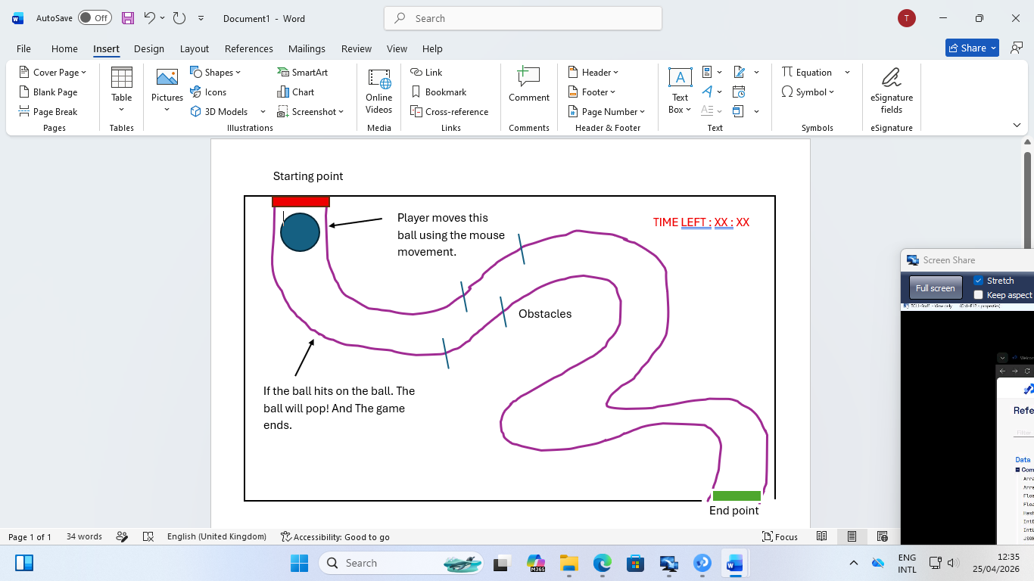

GROUP MEMBERS:
2024/ICTS/140 GGK SHEHARA GUNASEKARA
2024/ICTS/141 DM RASHMITHA SANDEEP DISSANAYAKA
2024/ICTS/028 JAD NISANKARA THINESH JAYASINGHE

