BUBBLE SMASH GAME



Project (Team # 9)

Team Members:

*Manasa Reddy Thipparthi*

*SaiJyothi Gudibandi*

*Rashmi Thipparthi*

*Ankitha Wankhede*

**Project Management**

**Project Proposal:**

Project Goal & Plan:

This project main goal is to develop a game for android mobiles & tablets by using **IONIC Framework**. The game aims to advance an interactive game for mobiles in Ionic and add new features using the technologies like Angular JS, Ionic Framework, HTML5 Sprite, Mongo DB, Fire Base.

Motivation:

By way of developing a game is intricate, it also brings lot of challenges and learning opportunities at a different level. Also as a team we want to explore different field of development than classic web application development.

Objectives:

There will be a bubble running at random speed on the app and user needs to tap on that bubble to smash it.

There will be three levels: Easy, Intermediate and Expert.

Two scoring modes: Classic, Timebound, As the level goes up the number of bubbles and the speed will increase making the levels more complex.

System Features:

In addition to the game, we are including following features utilizing the rest of the knowledge areas gained through this subject like MongoDB, REST services, UI design etc.

* User should be able to create different profile locally or can login from any social account.
* If user login through social account then the user should be able to see his/her friend progress as well.
* Profile should display a picture which can be captured using a camera or from gallery.
* User profile level and best score should be displayed.
* Game can be resumed from the point where user left.

**First Increment Report**

* User should register with his details
* Maintaining all the registered user details in Firebase
* User Login with the registered credentials
* User Login if he is a guest user
* User login through Facebook
* Creating level page having easy, intermediate, expert levels.

**Second Increment Report**

* User Login using MongoDB
* Creating easy page with single bubble at a time and making the bubble movement
* Creating settings page which contains Update user profile.
* Creating help page which contains information regarding the app.

**Third Increment Report**

* Bubble movement base on speed and limiting the bubble count
* Implementing Intermediate Level Which has 2 or 3 bubbles at a time with more speed.
* Implementing expert level which contains multiple bubbles
* Updating the score page with the score
* Navigating from score page to home or level page after the game is completed.

**Fourth Increment Report**

* Updating the user details like email, phone number, password etc
* Increasing the speeds of the bubble in expert level
* Displaying no. of hits, no. of escaped bubbles on gaming screen
* Updating the score page with top 5 user scores from mongo db.

**Presentation Slides:**

*https://drive.google.com/file/d/0B1ZPKLB98Nz2VVdJV0NmQWZnQjQ/view*

**GitHub URL:**

*https://github.com/ManasaReddyThipparthi/ASE-BubbleSmash*

**YouTube Project Video URL:**

*https://www.dropbox.com/s/ooyyo4hf4qn720u/ice_video_20161206-224649.webm?dl=0*

**Project Screen Shots:**

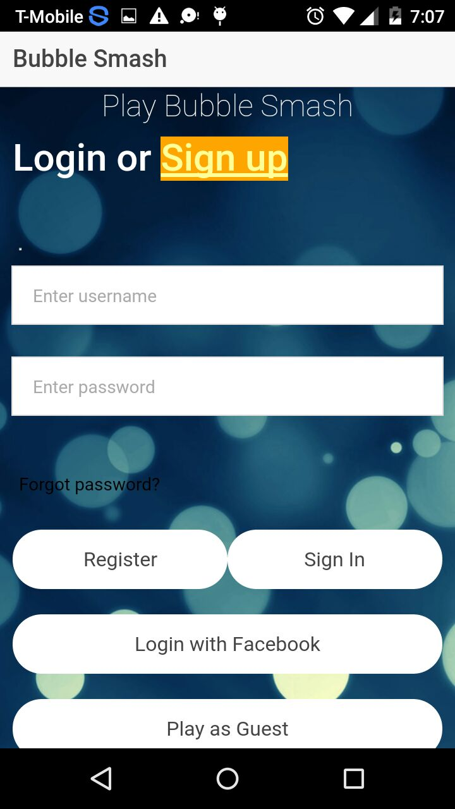**Login Page: Registration Page:**

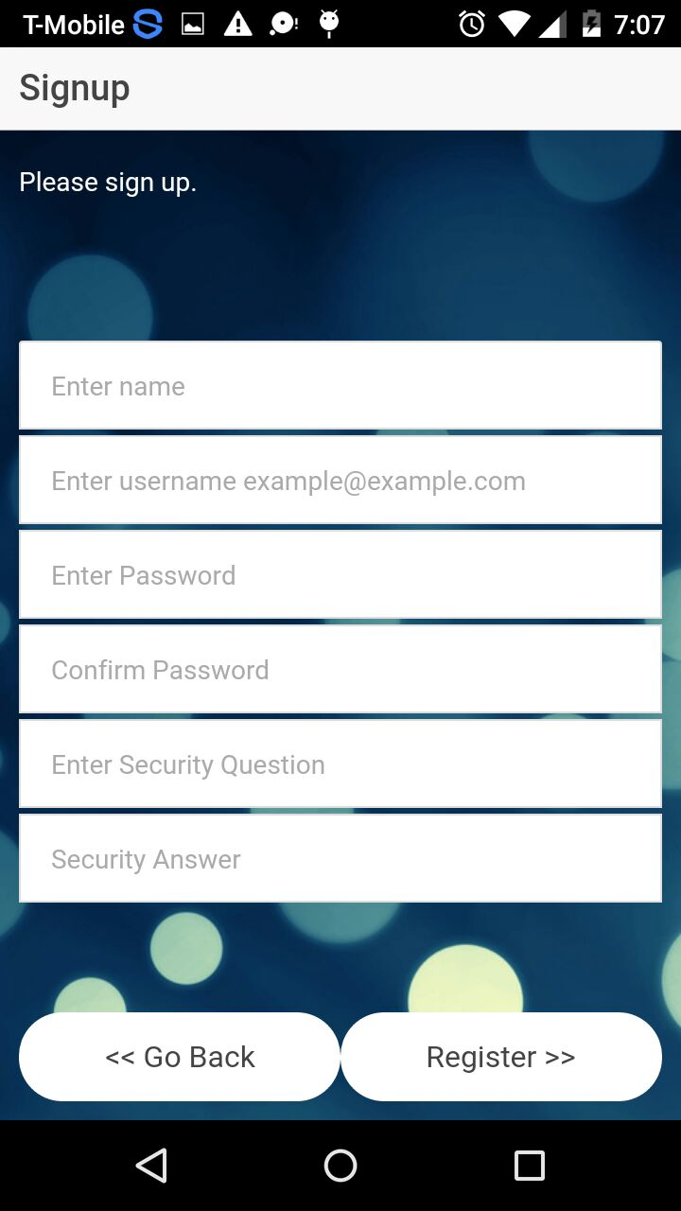

**Level Page: Help Page:**

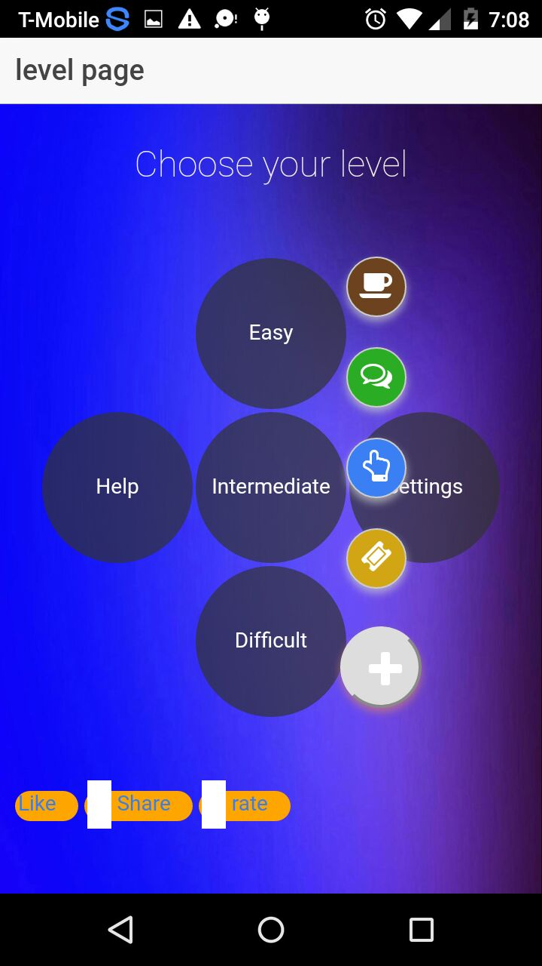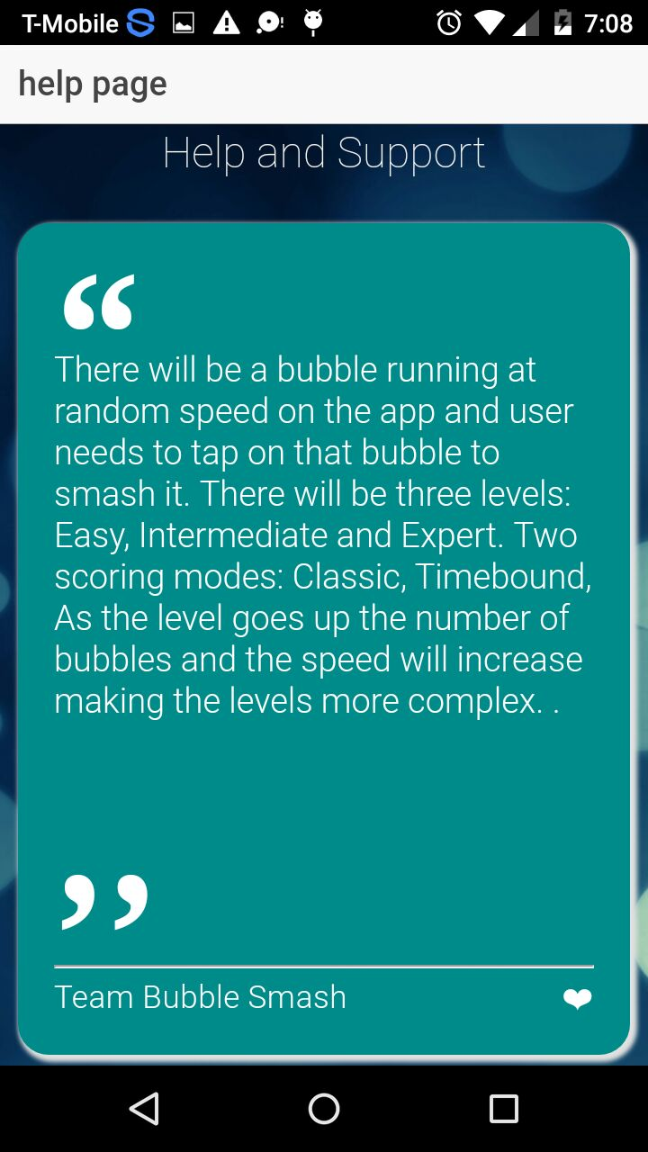

**Like Page: Settings Page:**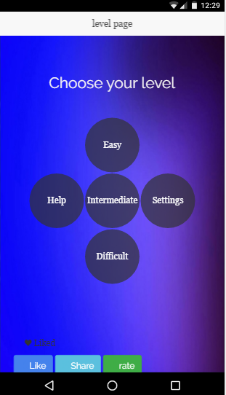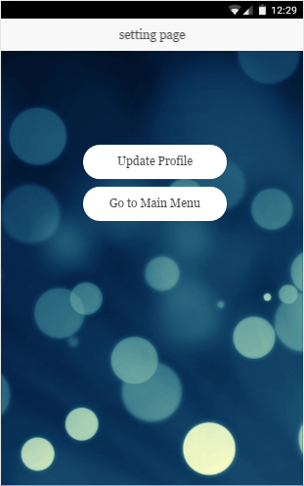

**Update Success Page: Rate App Page:**

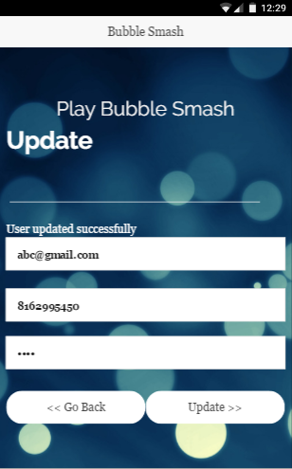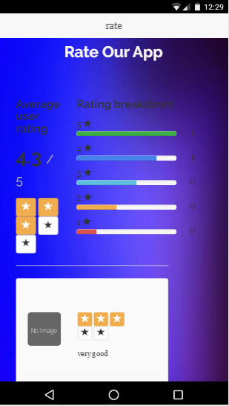

**Game Page: Score Page:**

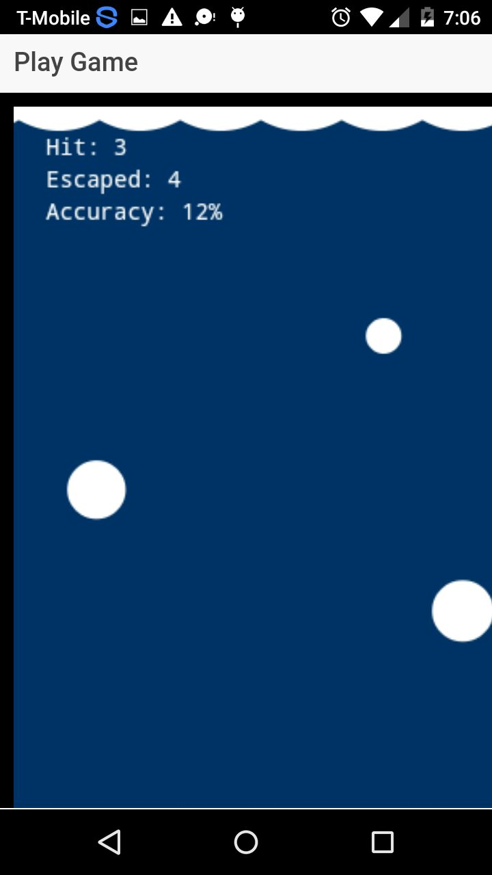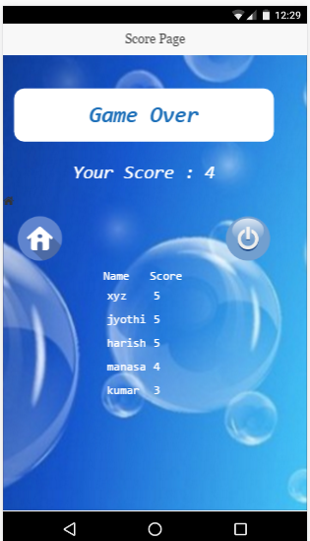

**Project Deployment:**

**Motivation & decision:**

“Projects are tough, but it feels so good when you finish them!”

There has never been a better time to learn how to program. Modern programming languages, coupled with powerful and widely available development environments, provide an excellent place to work. A wide range of operating environments, including mobile devices, cloud computing, robotics, embedded devices, and games, means that you can apply your programming-acquired skills in a huge range of different areas. Game development is one of the more interesting, advanced programming techniques that constantly challenges the software development industry. There are many programming platforms used to develop games, and there is a plethora of devices to play them on, but when it comes to playing games in a Mobile ionic framework development still leads the way. Ionic allows you to build typical business style mobile applications with all the user interface elements you would expect from a native mobile application. Phase allows you to create HTML5 games, which can easily be packaged as a mobile app using Phone Gap. As gaming development is complex, it also brings lot of challenges and learning opportunities at a different level. Also as a team we want to explore different field of development than classic web application development. To implement our idea, we used ionic framework, Firebase, Angular & Phone gap.

**The style of user interaction:**

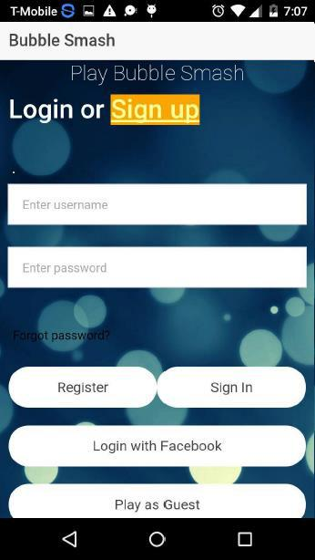The user can interact with our app by login their information. The user should register first, if they don't have an existing account or they will play as a guest and they can login through Facebook as well. This below screenshot of our app shows the login page where the user can login through the social media like Facebook. But that option is only for the existing user. The new user should have to register first and then login via social media. It emphasis that no need of going to our app every time for login.

The registration page contains the user's normal basic information. As shown in the below screenshot, user can enter their information along with their credentials. If there is any invalid data is entered, then the validation error will be thrown.

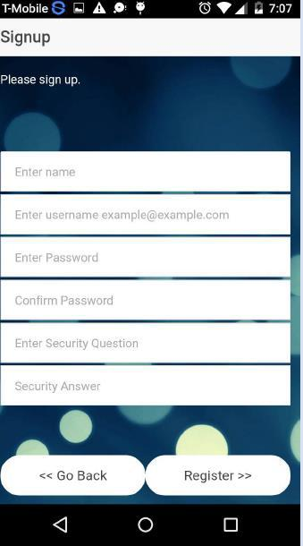

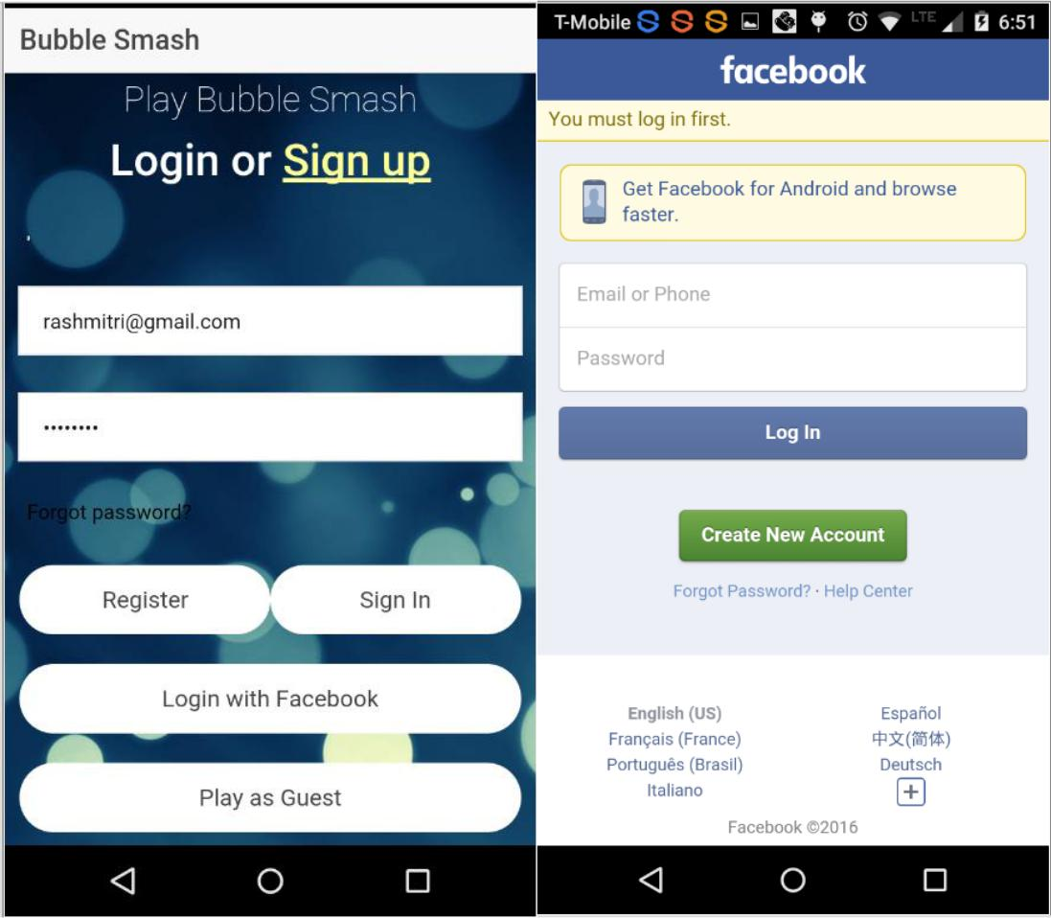After creating an account, the user can easily login through our app or login with Facebook after entering their credentials as shown in the below screenshot.

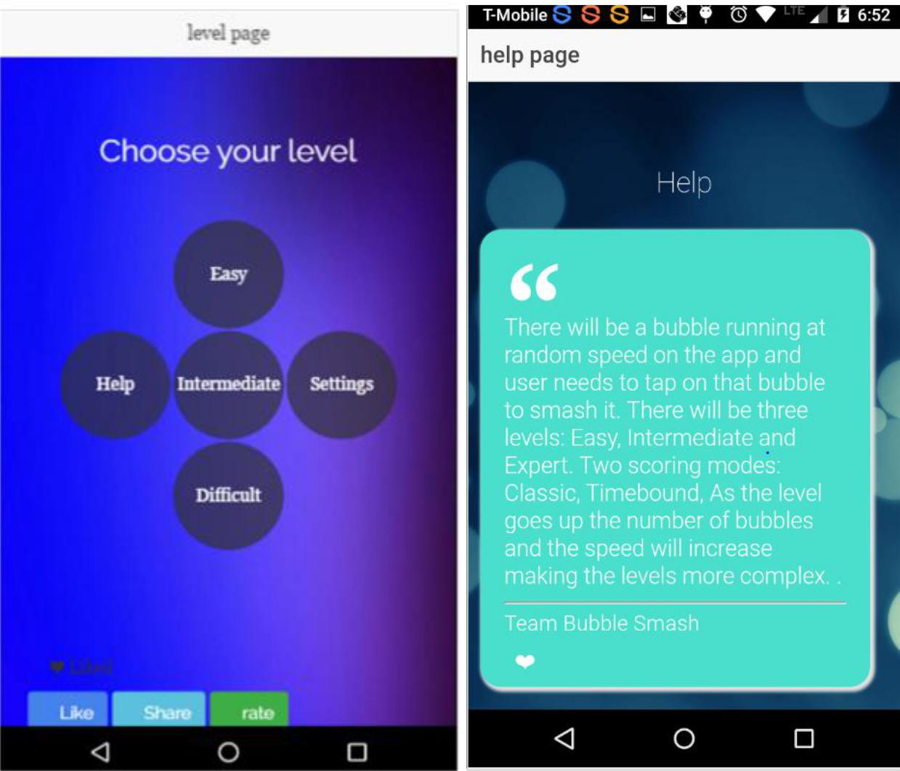After login, User will be able to select any level (Easy, Intermediate and Expert). Also, user can get to know about the game rules on clicking help option available in the level page as shown in the below screenshot.

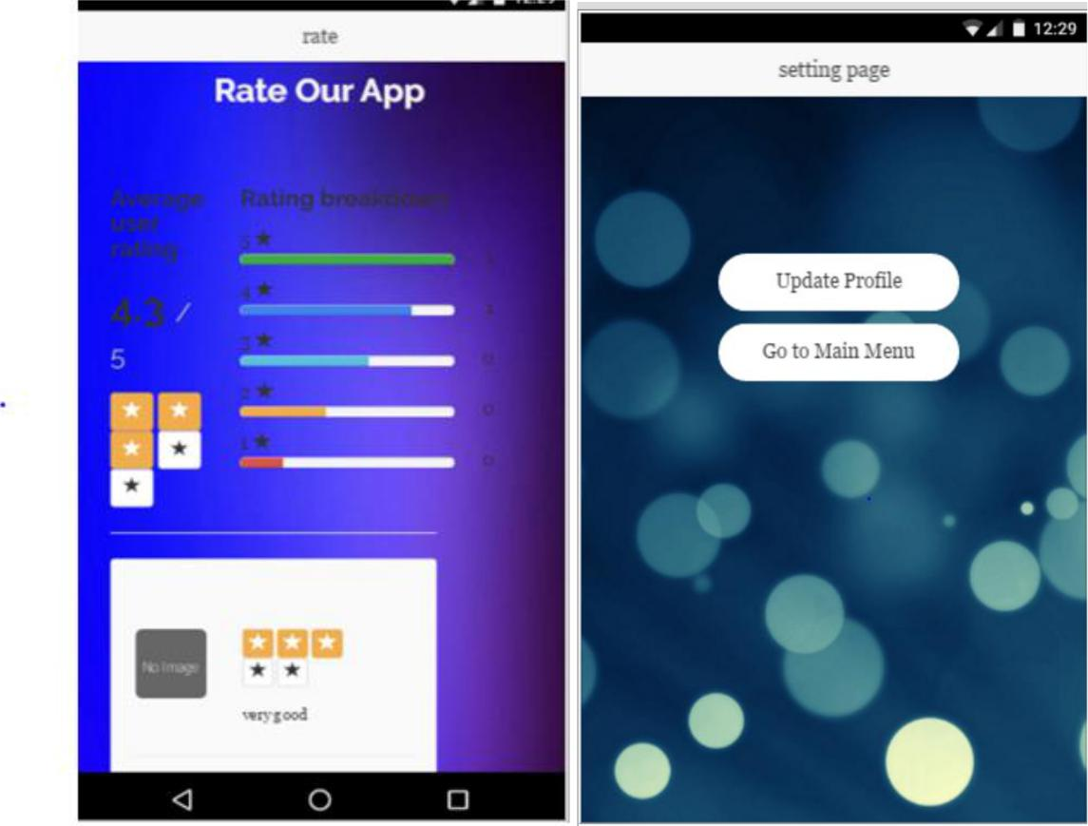User can also like our application on Facebook also he can share the link of this game to others. User can rate and review our application on clicking rate button on the level Page and update their profile in the settings Page below is the screenshot show like rate and setting page.

There will be a bubble running at random speed on your phone and user needs to tap on that bubble to smash it. There will be three levels: Easy, Intermediate and Expert. Each level is different from other. The rules of the bubble game are simple, you need to blast as many bubbles as possible, the more you pop, the higher your score is, Sounds easy?

Rest assured that people are spending hours blasting those bubbles and having the time of their lives.

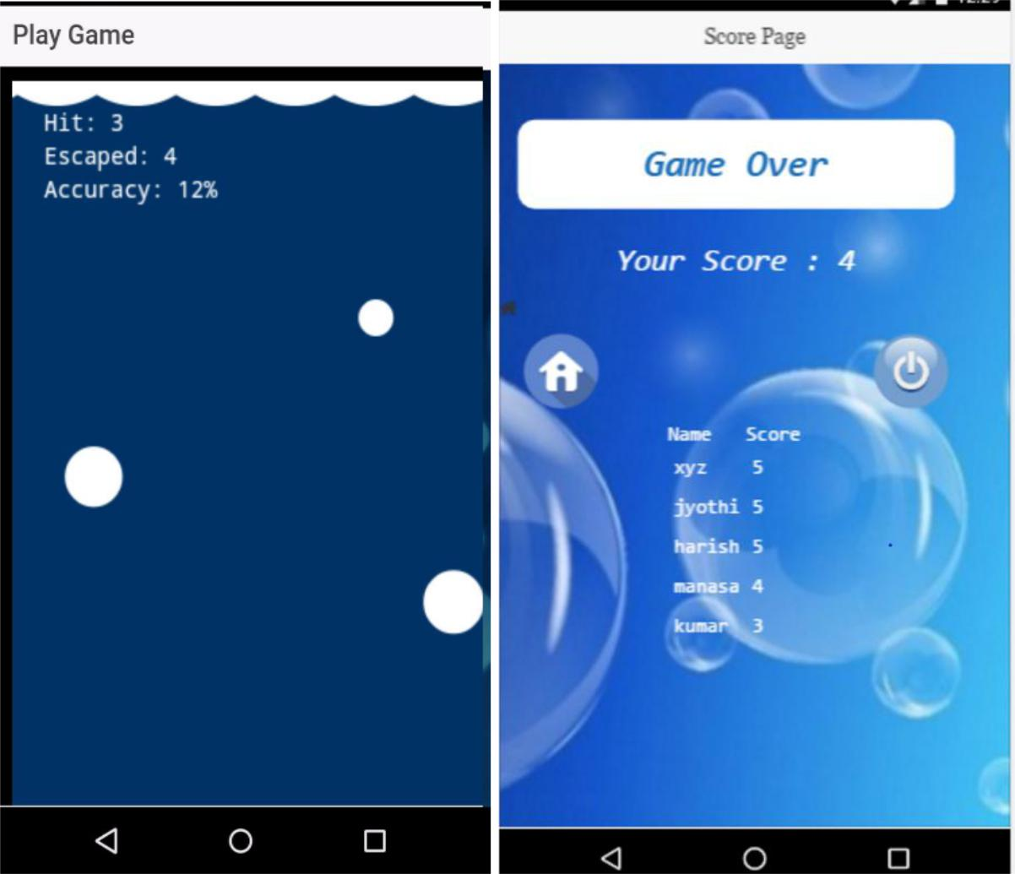Player will take actions, and the score will be updated dynamically on the score page. Below is the screenshot of gaming area and score page.

**Error recognition and handling:**

We have done validation for login page and Register page as well. If the user login without giving password, then the validation error will be thrown. In the Register page, if the user enters wrong format for email address and security Questions or make it blank then the error will be thrown.

**Sample interaction:**

If the user first select easy level based on the level the bubbles should come. Here the user is directly interacting with the backend service to know the Game score. Game score is stored in mongo DB after the game is over.

The screenshots above is the best example of the sample interaction.