1.How do you evaluate the performance of a project in agile?

The evaluation of the performance of a project in agile depends on the following points.
The key metrics of the agile project are
* velocity
* hitrate
* work time on remaining task
* project cost
By calucating the values of above metrics we come to know the values for cost performance index(CPI), schedule performance index(SPI) and earning business value(EBV). Once we calucated the values for CPI,SPI and EBV we can measure the performance of the project,
If project goes according to plan CPI and SPI would = 1 every Sprint
• If CPI>1, then we are spending less than what is expected for
each Story Point
• If CPI<1, then we are spending more than what is expected for
each Story Point
• If SPI>1, then we are finishing earlier than expected
• If SPI<1, then we are finishing later

2.Compare traditional monitoring & control with agile monitoring & control
with respect to metrics generation

- Agile provides more opportunities to monitor what is going on in the project than traditional methods and hence it offers more effective opportunities to intervene.
- Traditional project monitoring focuses on tracking how much effort is expended on each task, this is a waste of time. The agile offers several ways to monitor the project.
- The principles that agile project follows are frequent delivery,colocation,daily team meeting,time box meeting.
- In traditional method of monitoring & controling changing to adaptable requirements is not accepted.
- The key measures of agile project metrics are
* velocity:-Velocity is a useful planning tool for estimating how fast work can be completed and how long it will take to complete a project.
* hitrate:- It is percentage of work allocated to a timebox that was actually completed
* work time on remaining task:- Every day the team estimates the work remaining on each active task.
* project cost

3.With a total project budget of $ 175,000, and having
completed one out of four Iterations, we have this product backlog and these actuals:

In our example, after Iteration 1 we should be at 25% complete)
Calculate Planned Value
Actual % Complete
Earned Value

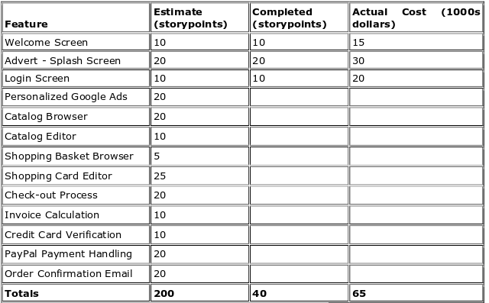

The total project budget is $1,75,000

Planned value = Budget at complete*Expected Percent Complete
= $175000*(Current sprint(n) / Total planned sprints)
= $175000*(1/4)
= $43,750

Actual % completed = Story points completed / Total planned story points
= 40/200
= 0.2
= 20%

Earned value = BAC * APC
= $175000 * 0.2
= $35,000

