**Daily Expense Tracker**

**PROJECT REPORT**

***Submitted by***

**Rashna Maharjan (6-2-0038-0238-2013)**

**Riju Maharjan (5-2-410-33-2014)**

**Nishu Bhagat (5-2-410-18-2014)**

*in partial fulfillment for the award of the degree*

*Of*

**BACHELOR OF SCIENCE COMPUTER SCIENCE AND INFORMATION TECHNOLOGY**

**IN**

**PRIME COLLEGE, KATHMANDU**

(TU AFFILIATION)



**TRIBHUVAN UNIVERSITY**

**June 2018**

BONAFIDE CERTIFICATE

Certified that this project report titled…………………………is the bonafide work of Mr./Ms………………………………..who carried out the research under my supervision. Certified further, that to the best of my knowledge the work reported herein

does not form part of any other project report or dissertation on the basis of which a degree or award was conferred on an earlier occasion on this or any other candidate.

………………….

**Ms. Dikshya Singh**

**Program Coordinator & Project Supervisor**

# ACKNOWLEDGEMENT

I would like to express my deepest appreciation to all those who provided me the possibility to complete this report.  A special gratitude I give to our final year project Supervisor, Mrs. Dikshya Singh, whose contribution in stimulating suggestions and encouragement, helped me to coordinate my project especially in writing this report. Furthermore, I would also like to acknowledge with much appreciation the crucial role of the staff of Prime College, who gave the permission to use all required equipment and the necessary materials to complete the task “*SPECIFY NAME*”.  We are thankful and fortunate enough to get constant support from our seniors and every teaching staff of B.Sc. CSIT department which helped us successfully complete our project. We would also like to extend our regards to all the non-teaching staff of B.Sc. CSIT department for their timely support. Special thanks go to my team mate, Riju Maharjan and Nishu Bhagat, who helped me to assemble the parts and gave suggestion about the task of designing, developing and documentation.  Last but not least, many thanks go to the head of the project, Rashna Maharjan who have invested her full effort in guiding the team in achieving the goal. I have to appreciate the guidance given by other supervisor as well as the panels especially in our project presentation that has improved our presentation skills thanks to their comment and advices. Our thanks and appreciations also go to each and every one of our colleagues for their encouragement and support in developing the project.

# ABSTRACT

“*Little effort to make a huge difference*.”

In today’s busy and expensive life we are in a great rush to make money. But at the end of the month we broke off. As we are unknowingly spending money on little and unwanted things. So, we have come over with the idea to track our earnings. Daily Expense Tracker (DET) aims to help everyone who are planning to know their expenses and save from it.

DET is an android app which users can execute in their mobile phones and update their daily expenses so that they are well known to their expenses. Here we will be providing some important categories like food, clothing, rent and bills where user only have to enter the money that has been spent and also can add some information in additional information to specify the expense. User will be able to see charts of expense of certain time duration like day, week, month or year.

Although this app is focused on new job holders, interns and teenagers, everyone who wants to track their expense can use this app.

Contents

ACKNOWLEDGEMENT 3

ABSTRACT 4

List of Figures 7

List of Tables 8

List of Abbreviations 9

1. Introduction 10

1.1 Background 10

1.2 Problem Definition 10

1.3 Objectives 10

1.4 Scope and Limitations 11

1.4.1 Scope 11

1.4.2 Limitations 11

1.5 Report Organization 11

2. Requirement Analysis and Feasibility Analysis 12

2.1 Literature Review 12

2.2 Data Collection Methods 12

2.2.1 Source of Data 12

2.3 Requirement Specification 12

2.3.1 Functional Requirements 12

2.3.2 Non-Functional requirements 12

2.4 Feasibility Analysis 13

2.4.1 Technical Feasibility 13

2.4.2 Operational Feasibility 13

2.4.3 Economic Feasibility 13

2.4.4 Scheduling Feasibility 13

2.5 Structured System Requirements 14

2.5.1 Data Modeling (ER Diagram) 14

2.5.2 Process Modeling (DFD-0 DFD-1) 14

3. System Design 15

3.1 System Architecture and Overview 15

3.2.1 Database Schema 15

3.2.2 Data Dictionary 15

3.2.2 Interface Design 16

3.2.3 Dialogue Design 16

3.2.4 UML class diagram 16

3.2.5 Physical DFDs 16

4. System Implementation and Testing 16

4.1 Implementation Overview 16

4.2 Tools Used 16

4.2.1 Front Tools 16

4.2.2 Back Tools 16

4.2 Module Description 16

# List of Figures

Figure 1: Gantt Chart 13

Figure 2: ER Diagram 14

# List of Tables

Table 1: Data Dictionary 15

# List of Abbreviations

DET Daily Expense Tracker

YNAB You Need a Budget

# Introduction

## Background

Expense tracker is a refined system which allows user to efficiently manage his/her expenses with ease. Tracking expenses daily can really help to us save lot of money. Once we start off by tracking our expenses each day, we will be able to get a better idea where you are spending your money, so you stay in control and achieve your goal. It will be able to generate your expense and saving report as time duration you selected. There will be a reminder that will help to save money for your pre-defined expenses.

## Problem Definition

Every earning people are mostly obsessed at the end of the month as the they cannot remember where all of their money have gone when they have spent and ultimately have to sustain in little money minimizing their essential needs. There is no as such complete solution present easily or we should say free of cost which enables a person to keep a track of its daily expenditure easily and notify them if they are going to have money shortage. To do so a person has to keep a log in a diary or in a computer, also all the calculations needs to be done by the user which may sometimes results in errors leading to losses. Due to lack of a complete tracking system, there is a constant overload to rely on the daily entry of the expenditure and total estimation till the end of the month.

## Objectives

Now a days for young adults especially, keeping track of spending is something nearly everyone can benefit from. To so do a person has to keep a log in a dairy or in a computer and also all the calculation should be done by person himself/herself which may sometimes results in error leading to losses. Due to lack of a complete tracking system there is a constant to rely or depend on the daily entry of expenditure and total estimation till the end of the month. So in an effort to fix the problem we tried to design a system that would make the task of keeping the expenses in check, efficient and delight task. DET is a personal finance tool on your mobile phone. By using this tool, we hope you can better manage your wealth. With DET managing personal finance is as easy as pie! Backup and restore your data. Tracking your daily expenses daily can save you money, but it can also help you set financial goals for the future. If you know exactly where your money is going every month, you can easily see where some cutbacks and compromises can be made. It will also give you good outlook on your spending habits and those impulse buys will stick out little red flags.

The objective of this system is

1. To know where the money is going
2. To reveal bad spending habits
3. To spend only on priorities
4. To keep awareness of fraud of unknown charges
5. To save money for pre-defined expenses
6. To plan on your future investments

## Scope and Limitations

### 1.4.1 Scope

This application can take a good market as it is usable by anyone who are willing to manage their expenses and aiming to save for the future investments and many more. There is not any range criteria or any kind of profession or gender are focused it will used hugely.

### 1.4.2 Limitations

* + - * User have to entry every record manually.
      * The category divided may be blunder or messy.

## Report Organization

# Requirement Analysis and Feasibility Analysis

## Literature Review

Tracking daily expense is not so innovative. Many traditional and technological approach is found to track our expenses and budget with their own functionality. From decades ago and today we have been writing our expenditure in a register to calculate the profit or saving. Not only this many desktop and mobile applications has been developed for this purpose. Quicken and Microsoft money were the first desktop applications was developed decades ago but was not so familiar with the users. Personal capital and dollar bird application were used to visualize the expenses in chart or graphs with the calendar system. Quickbooks were the application for the small business holder to wrap up their whole business. YNAB and Penny were the latest application which were embedded with AI and applicable for importing expenses automatically. However, Mint was the one which was widely used and trusted.

## Data Collection Methods

### Source of Data

* User

## Requirement Specification

### 2.3.1 Functional Requirements

* Dashboard panel
* Add bill
* Back
* Add group
* Exit group
* Expense planner
* Expense tracker
* Lent/owe
* Download pdf

### 2.3.2 Non-Functional requirements

* Usability
* Reliability
* Supportability
* Performance
* Availability

## Feasibility Analysis

### 2.4.1 Technical Feasibility

This assessment focuses on the technical resources available. It helps to determine whether the technical team is capable of converting the ideas into working systems. It also involves evaluation of the hardware, software and other technology requirements of the proposed system. Our application is technically feasible to the android users with android version 4.0 (Ice cream sandwich).

### 2.4.2 Operational Feasibility

This assessment involves undertaking a study to analyze and determine whether and how well the organizations needs can be met by completing the project. It also analyze how a project plan satisfies the requirements identified in the requirement analysis phase of application development. The user can track their expenses on regular basis and will be able to manage their unnecessary expenditure.

### 2.4.3 Economic Feasibility

This assessment typically involves benefit analysis of the project, helping organizations determine the viability, cost and benefit associated with a project before financial resources are allocated. It also helps decision makers determine the positive economic benefits to the organization that the proposed project will provide.

### 2.4.4 Scheduling Feasibility

Figure : Gantt Chart

## Structured System Requirements

### Data Modeling (ER Diagram)

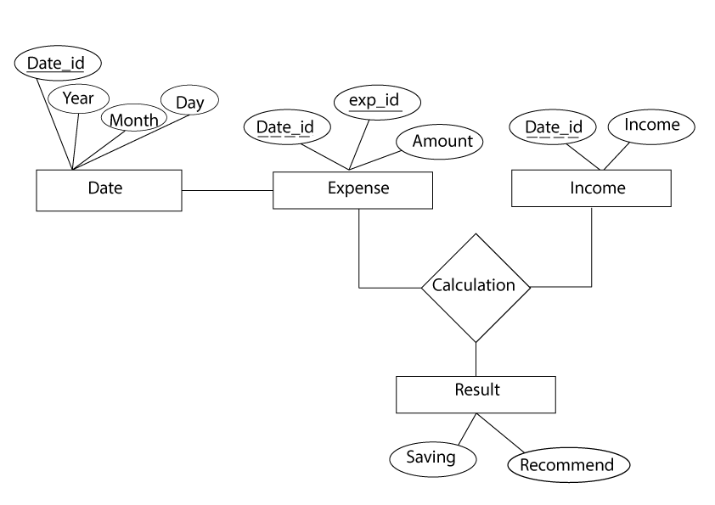

Figure 2: ER Diagram

### 2.5.2 Process Modeling (DFD-0 DFD-1)

# System Design

## System Architecture and Overview

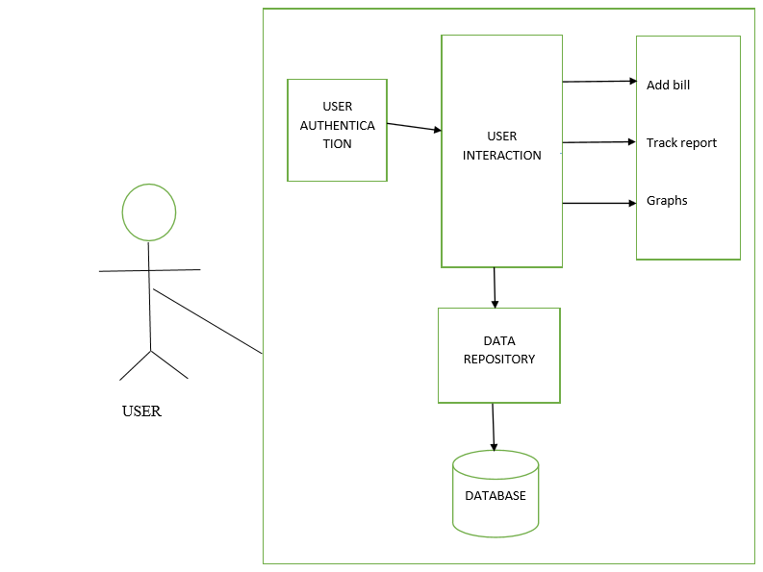

* 1. **System Design**

### Database Schema

### Data Dictionary

A data dictionary also known as metadata repository is a centralized repository of information about data such as meaning, relationship to other data, origin, usage and format. The term may have one of several closely related meanings pertaining to databases and database management system (DBMS):

* a document describing a database or collection of database.
* an integral component of a DBMS that is required to determine its structure.
* a piece of middleware that extends or supplants the native data dictionary of a DBMS.

A data dictionary is a collection of descriptions of the data objects or items in a data model for the benefit of programmers and others who need to refer to them. A first step in analyzing a system of objects with which users interact is to identify each object and its relationship to other objects. This process is called data modeling and results in a picture of object relationships. After each data object or item is given a descriptive name, its relationship is described (or it becomes part of some structure that implicitly describes relationship), the type of data (such as text or image or binary value) is described, possible predefined values are listed, and a brief textual description is provided. This collection can be organized for reference into a book called a data dictionary.

Table : Data Dictionary

|  |  |  |  |
| --- | --- | --- | --- |
| S.N | Entity | Attribute | Data type |
| 1 | Date | Date_id | int |
| Year | Int |
| Month | Varchar(10) |
| Day | int |
| 2 | Expense | Date_id | int |
| Exp_id | Int |
| Expense Amount | Long Int |
| 3 | Income | Date_id | Int |
| Income | Long Int |
| 4 | result | Saving | Long Int |
| Recommend | Varchar(50) |

### 3.2.2 Interface Design

### 3.2.3 Dialogue Design

### 3.2.4 UML class diagram

1. Use Case Diagram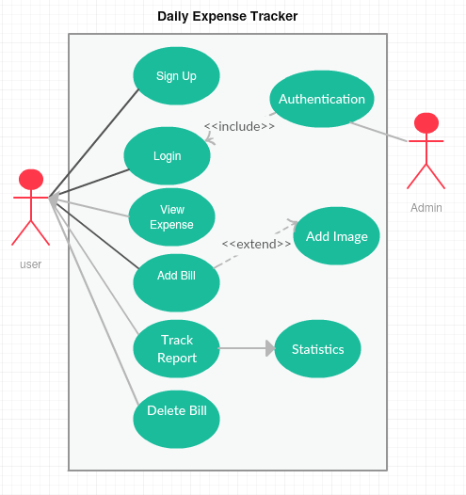

Figure : Use Case Diagram

1. Package Diagram

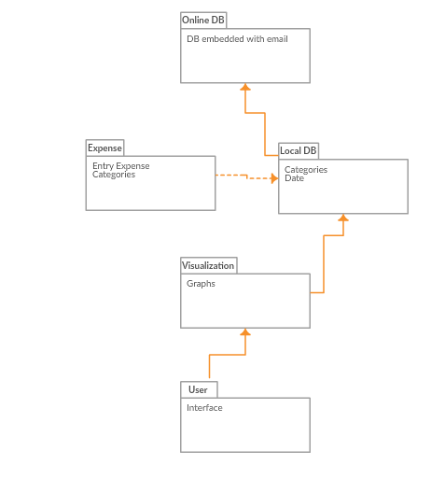

Figure : Package Diagram

1. Deployment Diagram

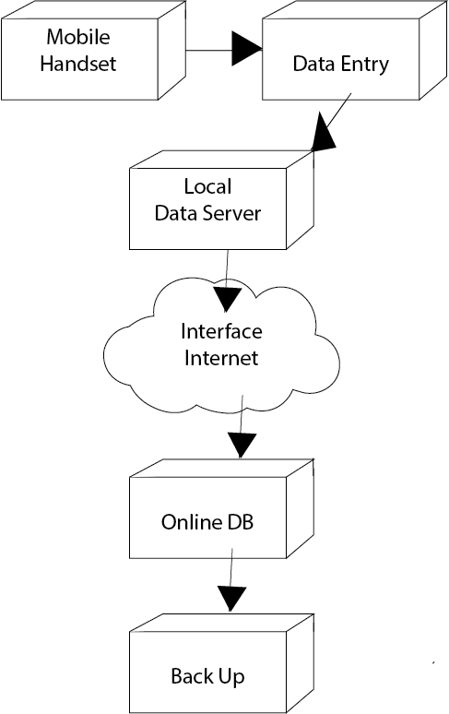

Figure : Deployment Diagram

### 3.2.5 Physical DFDs

# 4. System Implementation and Testing

## 4.1 Implementation Overview

## 4.2 Tools Used

### 4.2.1 Front Tools

### 4.2.2 Back Tools

## 4.2 Module Description

A modularization consists of well-defined manageable units with well-defined interfaces among the units.

Desirable property of modular system include

* 1. Each module is a well-defined sub-system.
  2. Single, well – defined purpose of each module.
  3. Modules can be separately compiled and stored in a library.
  4. Modules can use other module.
  5. Modules should be easier to use than to build.
  6. Modules should be simpler from outside then from inside.

The project can be decomposed in following modules:

• **Login module**: This module is responsible for a registered user to login to the web application and do the proceedings.

• **Signup module**: This module is responsible for registering a new user to the web application and create a new account for him/her

• **Sessions module**: This module is responsible for creating a session when a user logs in and continues till he/she logs out.

• **Add Bill**: This module is responsible to enable the user to add a new bill

• **Delete the bill**: This module is responsible for the pre-defined bill.

• **View Expense**: This module is responsible for viewing all the expenses in detail added to the log by a logged in user

• **Edit** : This module is responsible for editing a pre-defined bill.

• **Mail module**: This module is responsible for sending mail to the users mail id when he/she creates a new account and when he/she forgets the password and wants to rest it.

• **Categories module**: This module is responsible for various options in the select expense type or city option tab.

• **Excel Sheet module:** This module generate the excel format report of the expense period requested by the user**.**