Tic-tac-toe

THE GAME

**Submitted By:**

Rashok Katwal

Kailash Shiwakoti

Pravin Mahato

Sumit Yadav

GRADE-XII

**Table of Contents**

**1. Introduction3**

a) Objectives3

b) System Features2

**2. Methodology4**

a) System Design4

b) System development7

c) Tools and Technologies7

**3. Implementation8**

**4. Conclusion11**

**5. References12**

**Acknowledgement**

We would like to express our gratitude and thanks to our teacher **Apar Adhikari Sir** for giving us a great opportunity to excel in our learning through this project.

We have achieved a good amount of knowledge through the research and practice that we got from the project. This was a great experience to work on a real life project.

Our thanks and appreciations also go to our colleagues in developing the project and people who have willingly helped us out with their abilities.

1. **Introduction:** Tic-tac-toe is a world famous game, known by almost everyone. This project is a simple working design of the game created as a school project. It is played by 2 players by choosing one of the symbols among X and O by each players.
2. **Objectives:** Following are the objectives of this project.

* At first, this project was created for learning purposes. It helped to develop concepts about the projects that we are about to face in the near future.
* To develop basic web development and web designing skills and also to increase logical thinking.
* Also to reduce boredom and have fun with friends.

1. **System Features:** This program has the following features.

* Sign up page: This is the page where user can register himself in the database. It will create their own personal play space. To sign up, user has to enter a username and password for the username (the username should be unique).
* Login page: Here user can log into their account which they have created by signing up in the sign up page. They need to enter their username and password that they have registered in order to get to the play area.
* The game: After logging into the game, the user can play the game with their friend. The logic in the game will automatically detect whether the game has a winner or it is draw and also show who the winner is by drawing a line through the users’ symbol.
* Dashboard: In the main page, there is a button at the top-left corner of the page. If the button is clicked, the user can go through his profile.

1. **Methodology:**
2. **System Design:**

* Entity Relationship Diagram:

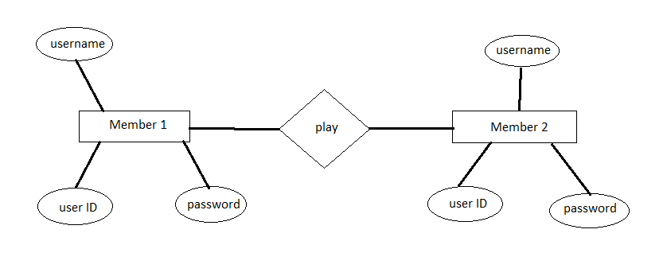

* Use Case Diagram: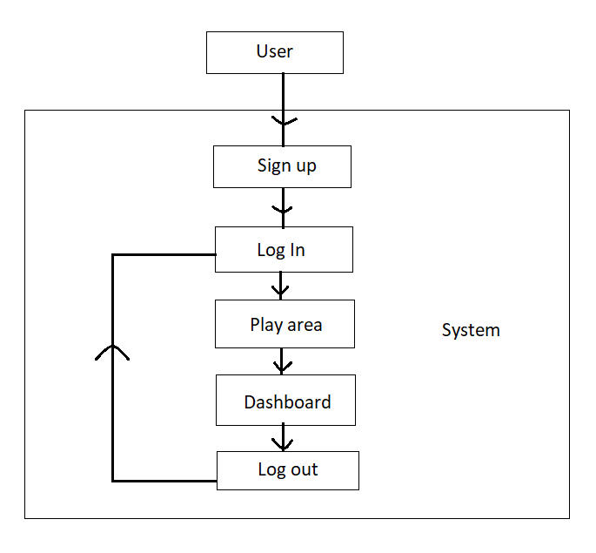
* Context Diagram:

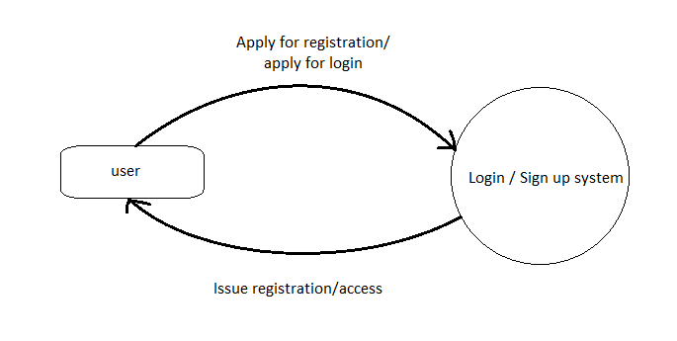

* Data Flow Diagram: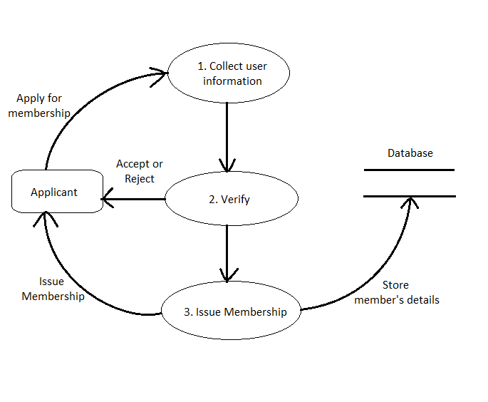

1. **System Development:** This program was developed on the basis of Agile model. It was continuously and repeatedly tested for better results. The code was tested by all the project members and thus final product was introduced.

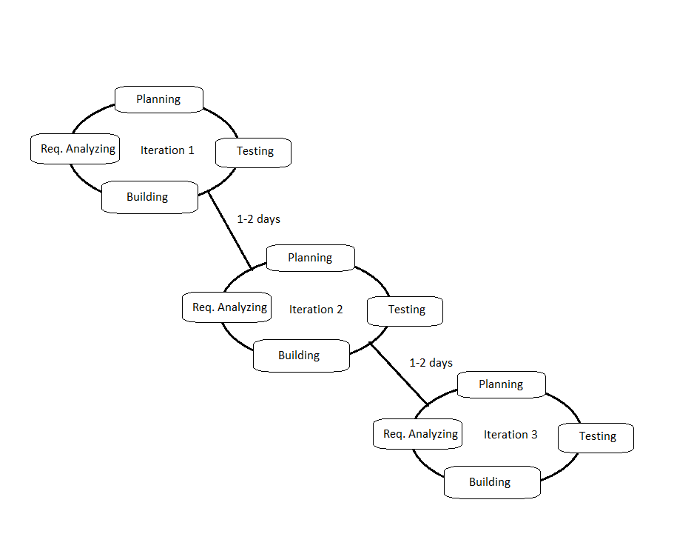

1. **Tools and Technologies:** This is a web project. It was developed to run on the browser. There are collection of pages that are used to run this program on the web. Those pages were written using **HTML5**, **CSS3** and **JavaScript** for client side scripting and **PHP** and **SQL** were used for server side scripting. **VScode** was used for writing all the codes and **XAMP** was used as server for testing the codes.
2. **Implementation:**

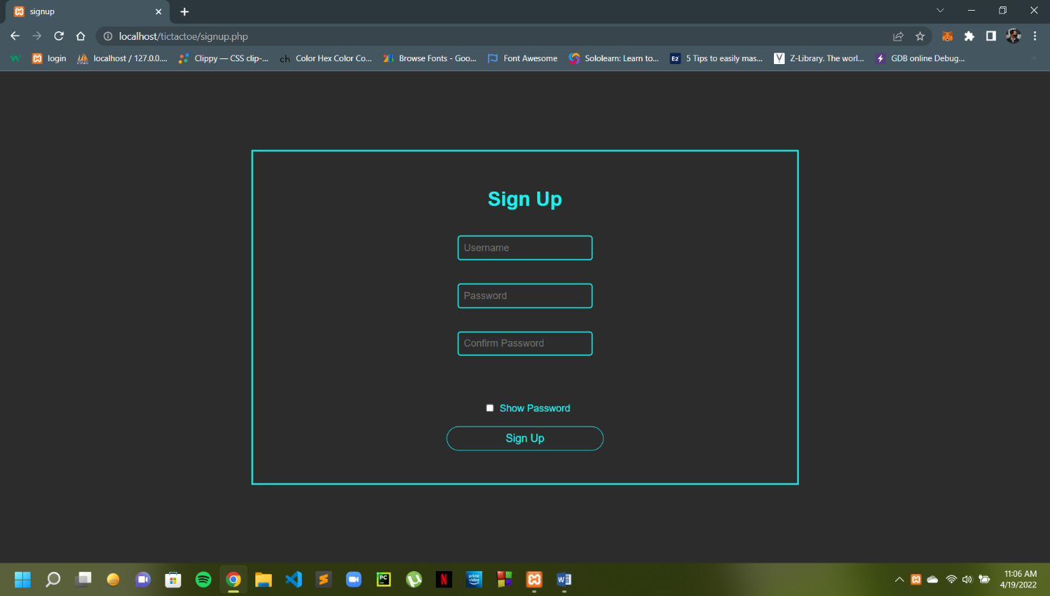

Sign Up Page

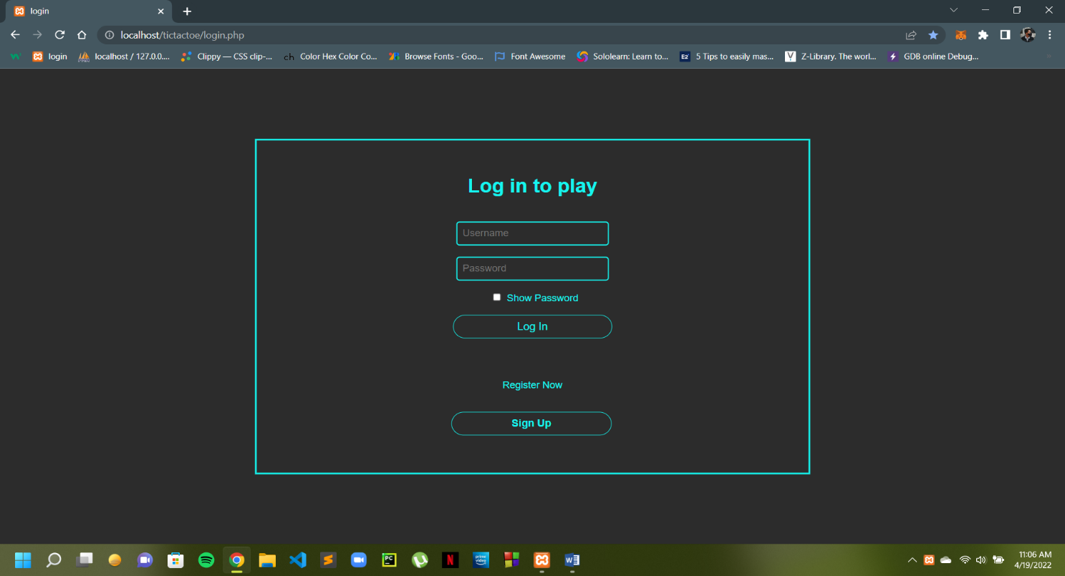

Login Page

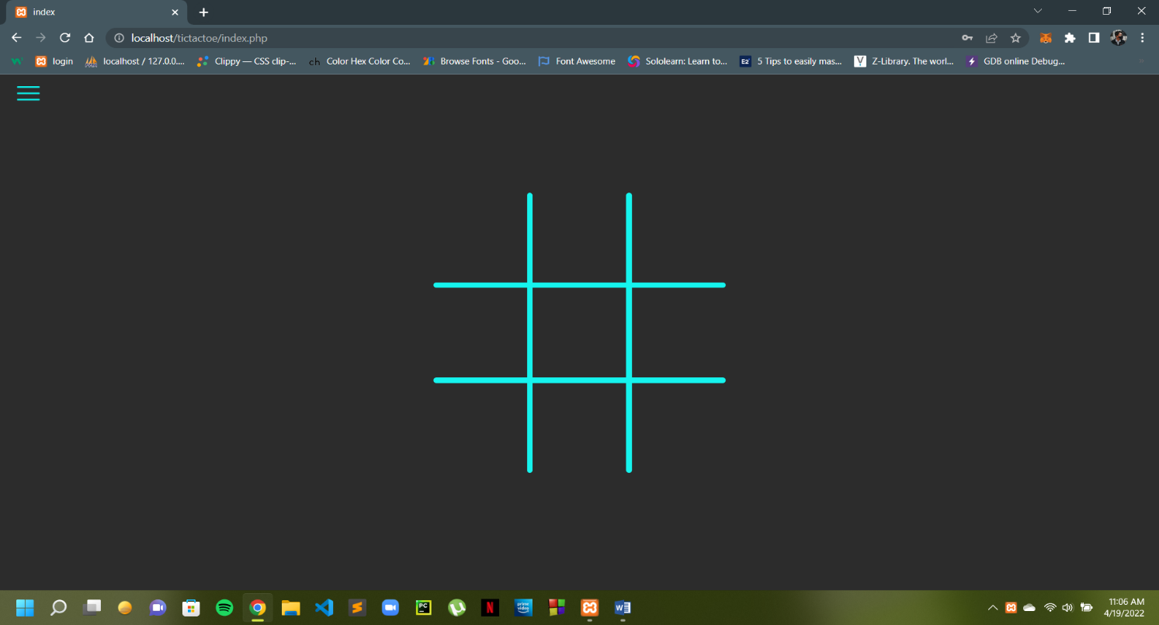

Play Area Page

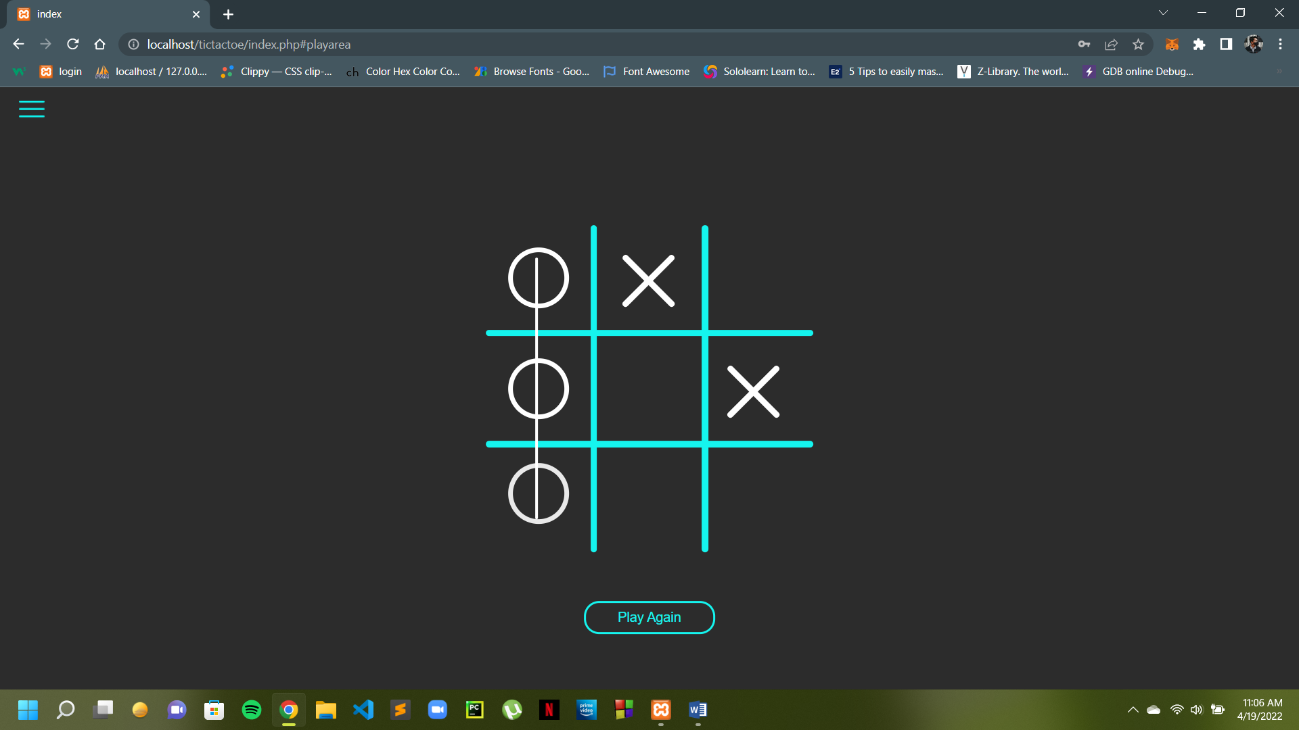

Player O winning

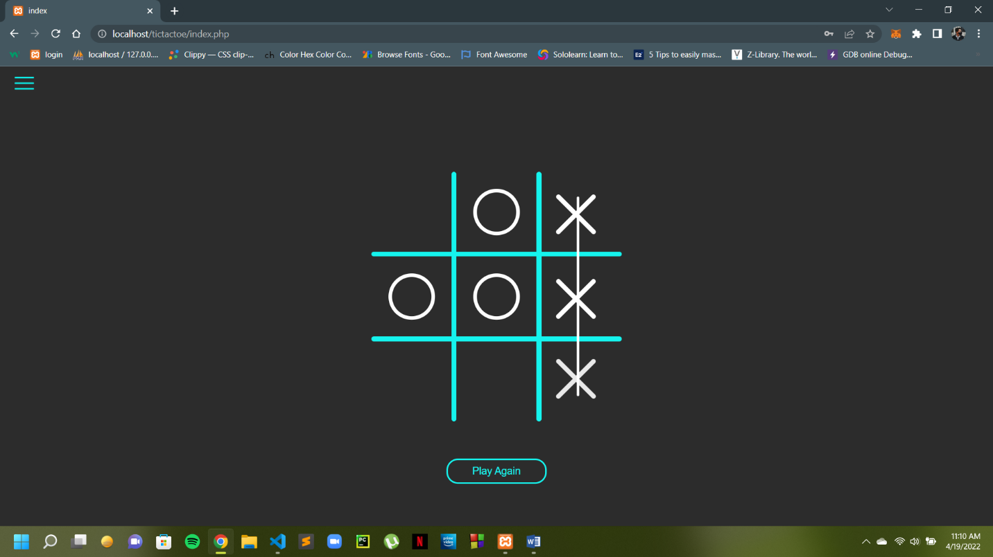

Player X winning

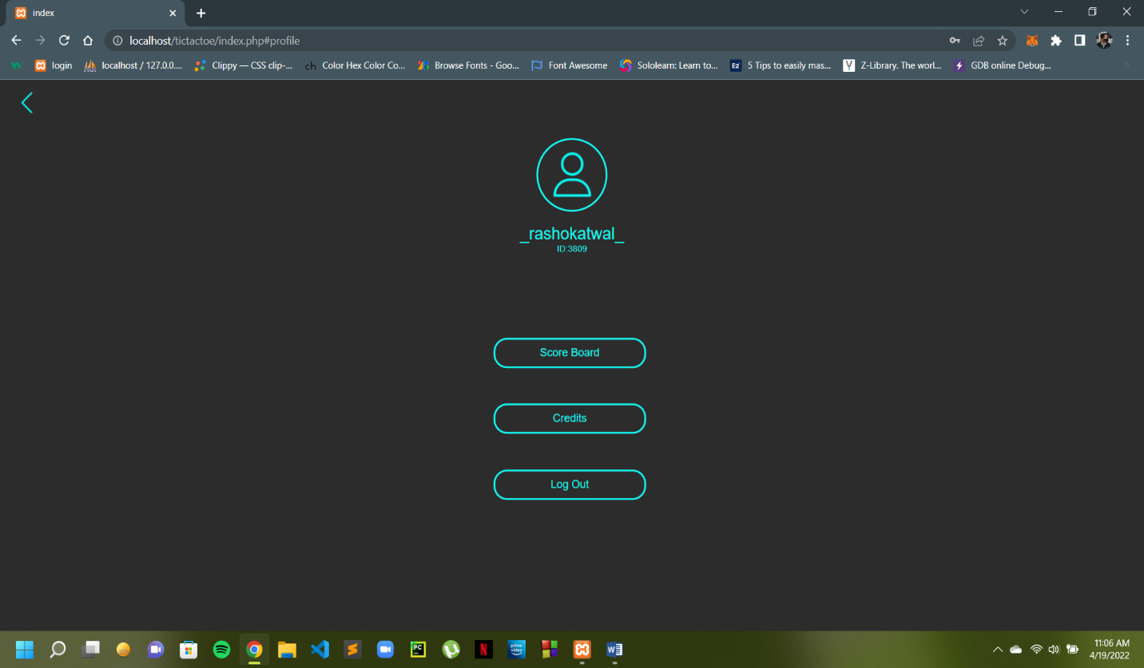

Player Dashboard

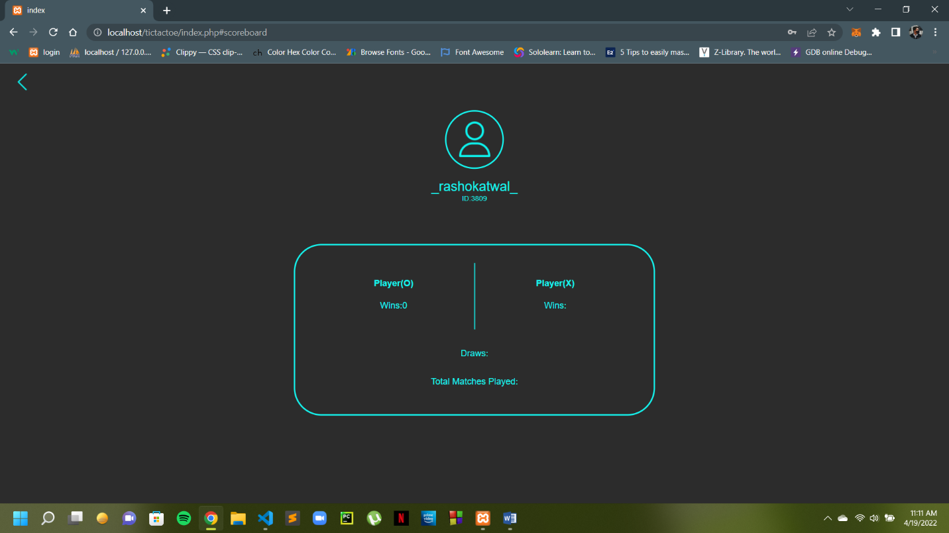

Score Board

1. **Conclusion:**

* This project fulfills almost all the basic requirements of the game we wanted to create. In the coming future more features can be added to the game like playing with an AI, additional colors in the design, different game items like design of the play box, symbols and even game currency can be added.
* The project has also helped us to tackle the real life challenges during the making of any kind of software. We learned about the languages used to develop and design web pages and also those which are used for scripting. We got ideas about the server side scripting, running a server and also about using database.

1. **References:** Almost all of the codes used in this project are original. Some sites were taken references for the game designs, layouts and concepts.

* **playtictactoe.org** (concept for the design of the play box).
* **stackoverflow.com** (examples to solve problems in the code).
* **w3schools.com** (concept about using the languages).
* **color-hex.com** (colors used in the design).