**Introduction**

An application to predict candidates and find functionalities for unknown proteins using input tsv files containing protein-protein interactions which is developed using python programming language. Based on file handling.

**Features and functionalities**

* Construct network graph related to the input file
* Based on two algorithms namely ‘Majority voting score’ and ‘Hishigaki algorithm’ where the user can select the preferred algorithm.
* Predict candidate genes for identified functionalities in the network from proteins with unknown functionalities greater than 80th percentile of the scores.
* Predict for multiple functionalities from unknown proteins in the network.
* Predict most accurate functionality for each protein.
* Taxonomy specific. (Here used taxon is *Arabidopsis thaliana*)

**Future improvements**

* User to specify taxon
* Connect to a data base and improve annotations for references for all available taxons
* Add a progress bar while user waits for results

**What the application looks like**

Home page

Accepts tsv files from the user specified location in the system and the preferred algorithm by the user.

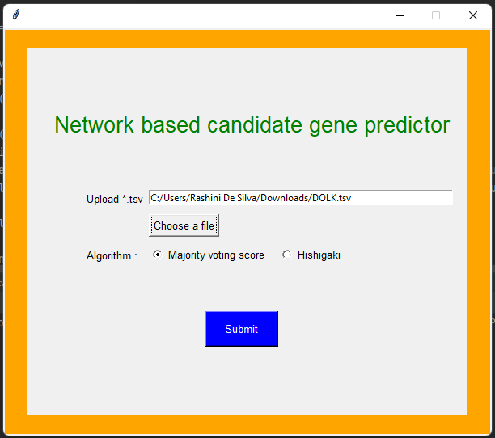

If a tsv file with an invalid content is submitted, an error message will pop up.

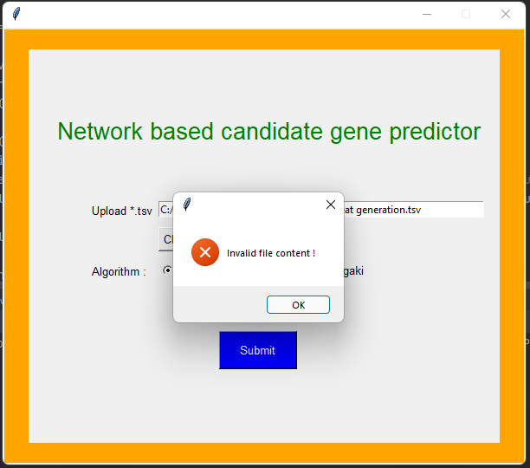

When the tsv file is valid, expected output will be displayed in the result page.

