AIGC Stage-III evaluation, Team Allotrope
Allotrope v1.0: Findings on Evaluation Dataset, 02 Nov 2026
Anomaly detection and material identification in hyperspectral satellite imagery
2 November 2026

Summary
The task is to find small, unusual objects in satellite hyperspectral images, with no list of targets given in advance, and say what material each one is made of. A satellite pixel covers about 30 m × 30 m of ground, so most targets fill only part of a pixel.
Indradhanu is our own spectral foundation model. It learns what ordinary ground looks like by rebuilding pixels it was not shown; what it cannot rebuild well is flagged. Each flagged pixel is then matched against USGS and ECOSTRESS library spectra in two ways: classic SAM (spectral angle), and the spectral namer, a small learned matcher that shares Indradhanu's spectral front end and also looks at the pixel's neighbours.
Main results on four labelled PRISMA scenes (909 objects, thick cloud excluded):
- Indradhanu V2 Heavy reaches a partial AUC of 0.189, against 0.170 for our previous release (difference +0.020, 95 % interval +0.007 to +0.032) and 0.139 with no model at all.
- It places 449 of 909 objects in its top 1 % of scores (previous release 418, no model 377, random ≈ 93).
- HyperSL, a public spectral foundation model, scored the same way, reaches 0.095 and 369 objects: its reconstruction makes detection worse than using no model.
- Naming man-made against natural at quarter-pixel fill, the namer finds 86–94 % of man-made targets against 66–77 % for the classical ACE detector. At 10 % fill it names the material class correctly 59–69 % of the time against 24–41 % for ACE.
- On planted sub-pixel targets in PRISMA scenes (10 % fill), the namer names the class correctly 53 % of the time; the best training-free method reaches 44 %, and HyperSL-based matching 27–30 %.
Indradhanu V2 Heavy is the detector we submit. HyperSL is not adopted for detection or matching. Every detected pixel carries both a SAM match and a namer call, because each fails where the other works: the namer is best on small targets in open ground; SAM and ACE are better on large, uniform man-made surfaces such as roads and roofs, where the namer's call is unreliable.

1 Data and evaluation
A hyperspectral sensor records each pixel as a spectrum of a few hundred narrow colour bands, from visible light to short-wave infrared. Materials leave fingerprints in these spectra: plastics, fuels and wood absorb at particular wavelengths. An anomaly is a pixel that does not fit its surroundings. The submission is a boolean map (anomaly or not) per scene, up to three results per scene, plus a material call per object; no heatmap is submitted.
Table 1. Sensors.
Sensor | Bands in the file | Pixel | Role here
PRISMA (ASI, satellite) | 239 (185 used by the model) | 30 m | Labelled test bench; fine-tuning; namer training
EnMAP (DLR, satellite) | 224 | 30 m | Pretraining data (SpectralEarth); fine-tuning; namer training
AVIRIS-NG (airborne) | 372 | varies | Fine-tuning; namer training; real-target study
Tanager (Planet, satellite) | 426 (368 good) | 30 m | Run end to end; never used in training

The test bench is four labelled PRISMA L2D scenes with 909 ground-truth objects in three difficulty tiers (easy, medium, subtle). Every method is scored on the same valid pixels and the same object maps. Table 2 defines the measures in plain terms.
Table 2. Detection metrics.
Measure | What it means | Chance level
pAUC (headline) | Area under the detection curve while false alarms stay at or below 1 % of background pixels, scaled so 1 is perfect. Rewards finding targets early in the ranking. | ≈ 0.005
Objects in top 1 % | An object counts as found if any of its pixels lies within 1 pixel of the top 1 % of scores. | 10.2 % (≈ 93 objects)
Objects in top 0.1 % | The same at a ten times stricter cut. | 1.1 %
ROC-AUC | Ranking quality over all thresholds. | 0.5
Paired bootstrap | Resample the 909 objects 2,000 times; score both methods on each draw; report the 95 % interval of the difference. Resolution on this bench: about ±0.005–0.01 pAUC. | -

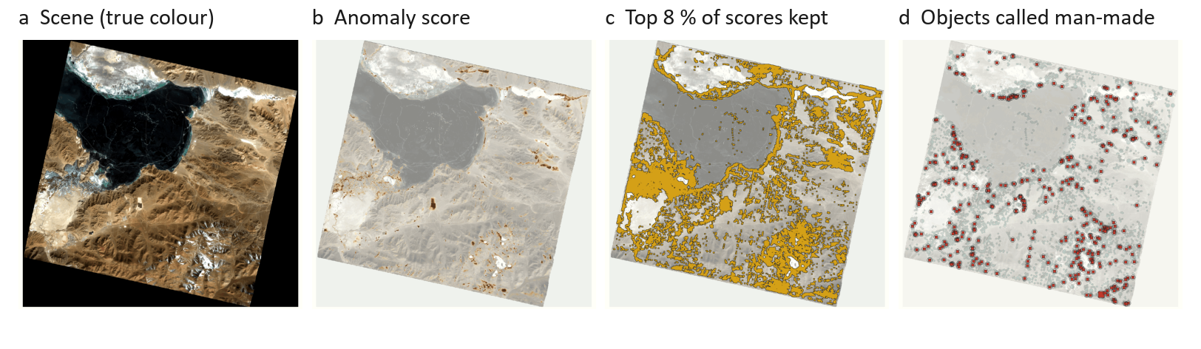
Figure 1. One PRISMA scene (14 Feb 2025, 1237 × 1202 pixels) through the chain. (a) True colour; 30.3 % of the frame is no-data. (b) Indradhanu V2 scores every pixel; thick cloud (4.9 %) is left out. (c) The analyst keeps the top 8 % of scores, 118,950 pixels. (d) 5,544 objects are named; 405 are called man-made (red).

2 The Indradhanu model
Indradhanu is a masked autoencoder. In training it hides 65 % of the pixels in an image patch and learns to rebuild their spectra from the visible ones. Because it is trained on ordinary ground, it rebuilds ordinary ground well and unusual objects badly. At inference every pixel is scored from a pass in which it was hidden, so it can never copy itself.
The leftover (the residual) is then scored by residual Mahalanobis: the residual is whitened in its 30 strongest directions, and each pixel is compared with a ring of neighbours (between a 21 × 21 and a 61 × 61 window). Scoring the residual's direction instead of its size lifted the mean ROC-AUC on the four scenes from 0.662 to 0.854 with the same model, at 3–4 s per scene.

2.1 Model versions
V1 needed every sensor resampled to one fixed grid of 165 bands. V2 reads any band list directly:
- a wavelength-aware spectral stem groups bands into 40 nm wavelength bins and summarises them with attention, so PRISMA's 185 native bands are read without resampling;
- band-list augmentation: 80 % of training batches see a random subset of bands. Before it, native PRISMA scored ROC-AUC 0.205 against 0.725 when resampled;
- a segmentation head labels land, water, cloud, thin cloud, shadow and snow (validation IoU: water 0.825, cloud 0.749), so cloud can be left out of the search;
- Heavy scaling: an encoder three times wider, 35.3 M parameters in all, pretrained for 80 epochs on SpectralEarth (EnMAP) and fine-tuned on EnMAP, PRISMA and AVIRIS-NG.
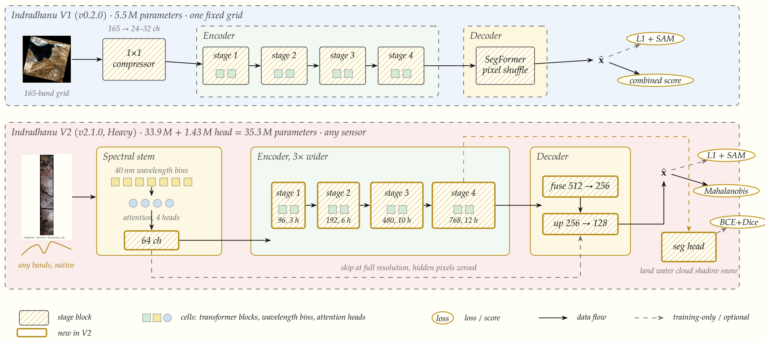
Figure 2. Indradhanu V1 (top) and V2 Heavy (bottom). Ochre outlines mark what is new in V2: the spectral stem, the wider encoder, the progressive decoder and the segmentation head.
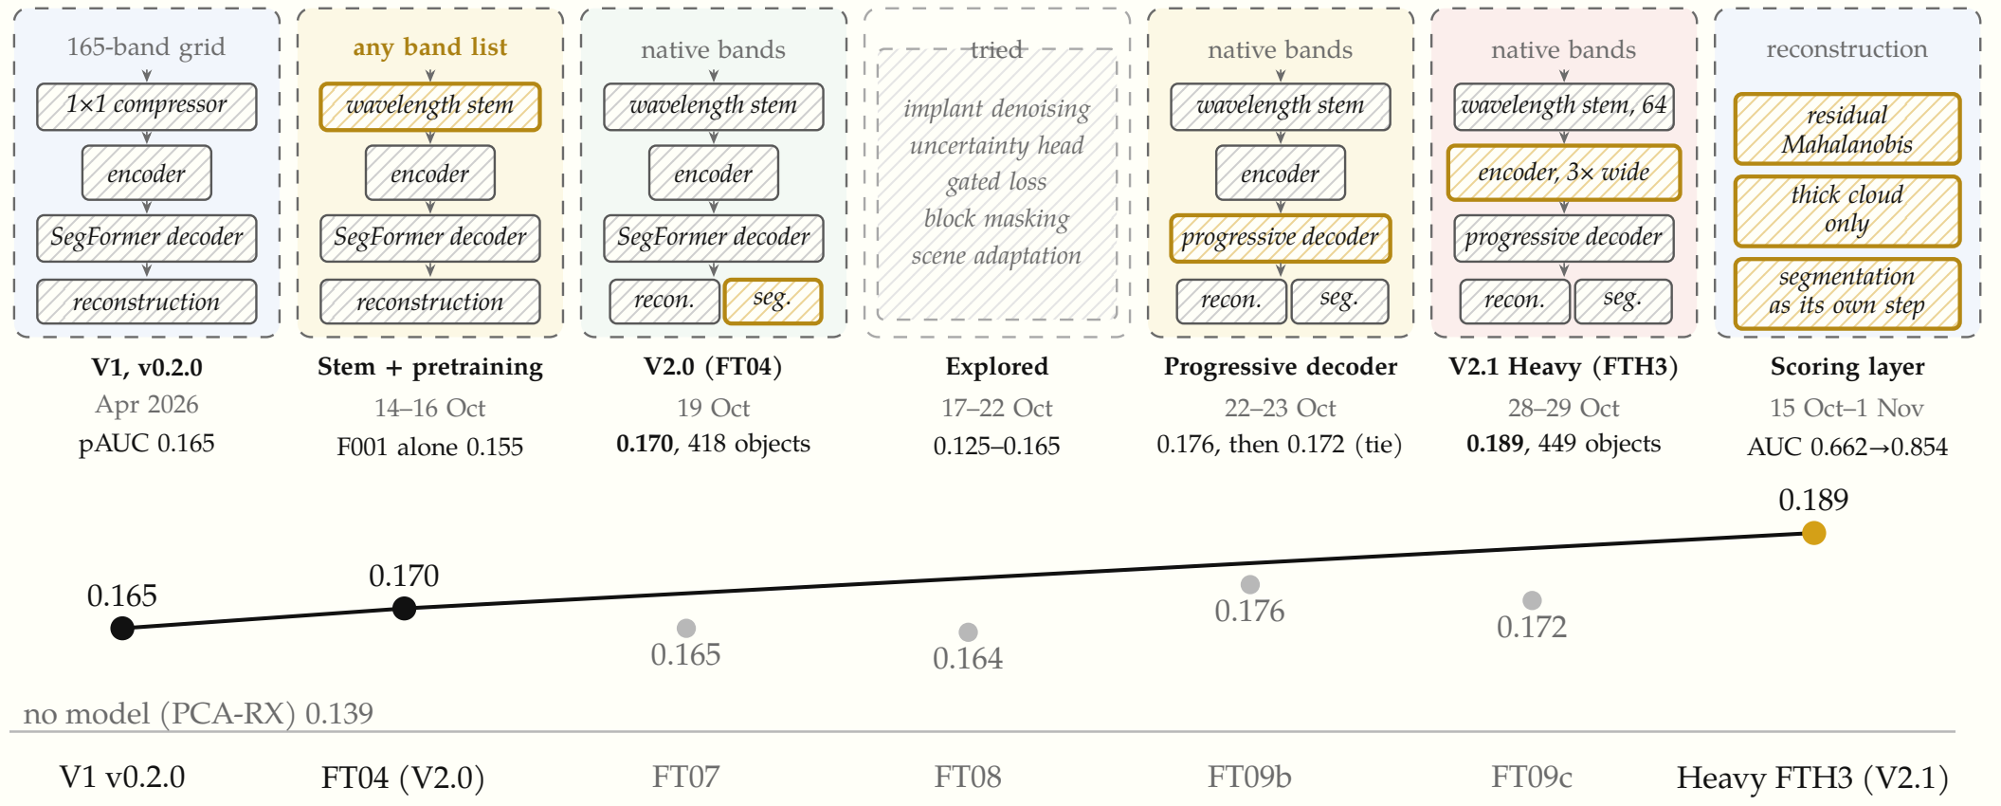
Figure 3. Model evolution. Each column adds the part outlined in ochre. Below: pAUC on the labelled bench with cloud left out; shipped generations in black, experiments that did not beat the shipped model in grey.
Table 3. Model generations and their detection score (pAUC, four PRISMA scenes, cloud excluded).
Generation | What changed | Parameters | pAUC | Shipped
V1 v0.2.0 | Fixed 165-band grid | 5.5 M | 0.165 | yes
Pretrained only | Wavelength stem, SpectralEarth pretraining, no fine-tuning |  | 0.155 | base
V2.0 (FT04) | Native bands, segmentation head | 5.9 M | 0.170 | yes
Uncertainty head | Per-pixel uncertainty used to rescale the residual |  | 0.125 / 0.163 | no
Gated loss / block masking | Training changes |  | 0.165 / 0.164 | no
Per-scene adaptation | Fine-tune on each test scene |  | ≈ 0.160 | no
Progressive decoder | Better decoder; gain gone five epochs later |  | 0.176 → 0.172 | no
Heavy, pretrained only | Three times wider encoder | 33.9 M | 0.166 | base
V2 Heavy (FTH3) | Heavy + decoder + fine-tuning; thick cloud only | 35.3 M | 0.189 | yes

2.2 Training
Indradhanu V2 Heavy was trained in two stages, pretraining and fine-tuning, on one rented NVIDIA H100 GPU (80 GB). Table 4 summarises the regime.
Pretraining used SpectralEarth, DLR's public collection of 539,755 EnMAP image patches of 128 × 128 pixels with 202 bands (EnMAP's 224 bands without the water-vapour bands). The collection was split by site, so every date of a place falls on one side: 512,849 patches for training and 26,906 for testing. The patches were packed into archive files of 150 patches (about 1 GB each; 3,419 for training) in cloud storage in the same region. Reading single patches from storage gave only 18 patches per second, far below what the GPU needs, so 200 archives at a time were copied to the machine's local disk and replaced by the next 200 every five epochs. Over the run 3,200 of the 3,419 archives were used, 30,000 patches per epoch.
In every patch 65 % of the pixels are hidden. The loss compares rebuilt and true spectra on the hidden pixels only: the absolute error (L1) plus a spectral-angle term whose weight rises from 0 to 0.5 over the first ten epochs. In 80 % of batches the model sees a random subset of the bands, with wavelengths shifted by up to 3 nm, so it never learns one fixed band list. Pretraining ran 80 epochs (learning rate 3 × 10⁻⁴ with cosine decay, batch 32, 16-bit arithmetic) at 369 s per epoch and 81 patches per second, using at most 18.4 GB of GPU memory: about nine hours. The validation spectral angle fell from 8.84° after the first epoch to 3.89°, below the 4.06° best of the smaller model. The epoch-72 checkpoint is the base for fine-tuning.
Fine-tuning adapts the model to three sensors at their own bands, using 128 × 128 tiles cut from our scene archive: EnMAP (210 scenes, 14,542 training tiles), PRISMA (223 scenes, 14,802) and AVIRIS-NG (79 flight lines, 22,377). Each batch mixes the sensors 40 / 35 / 25 %. Masked rebuilding continues, and the segmentation head learns alongside at weight 0.1 (binary cross-entropy plus Dice loss). Its labels are EnMAP's own cloud masks and, for PRISMA and AVIRIS-NG, labels from the previous model; the rare shadow and snow classes count three times. Scenes near the four test-bench scenes (within 30 km) are kept out of the PRISMA data, and the bench scenes themselves are not in the archive.
Fine-tuning ran 24 epochs in three runs at falling learning rates (10 epochs at 10⁻⁴, 8 at 5 × 10⁻⁵, 6 at 3 × 10⁻⁵), about 5.5 hours in all. Epoch 5 of the last run was selected on the labelled bench. Its neighbours, epochs 4 and 6, score within 0.005 pAUC of it (0.184 and 0.187), so the choice is not a lucky draw, but because the bench was used to pick it, its bench score is slightly optimistic.
Table 4. Training regime of Indradhanu V2 Heavy.
Stage | Data | Model | Epochs | Key settings | Hardware, time
Pretraining | SpectralEarth (EnMAP), 202 bands; 512,849 training patches, 30,000 per epoch | 33.9 M (encoder 29.6 M, decoder 4.3 M) | 80 | 65 % of pixels hidden; L1 + spectral angle; learning rate 3 × 10⁻⁴; batch 32 | 1 × H100, ≈ 9 h
Fine-tuning | EnMAP, PRISMA, AVIRIS-NG at native bands; 51,721 training tiles; mix 40 / 35 / 25 % | 35.3 M (adds 1.43 M segmentation head) | 10 + 8 + 6 | Same rebuilding loss + 0.1 × segmentation loss; learning rate 10⁻⁴ → 3 × 10⁻⁵ | 1 × H100, ≈ 5.5 h
Selection | Four labelled PRISMA scenes, 909 objects | 35.3 M | epoch 5 of 6 | Neighbouring epochs within 0.005 pAUC | pAUC 0.189

3 Detection results
All methods below are measured on the same bench and the same pixels. PCA-RX is the classical RX detector after a principal-component reduction: it is what our scorer gives when no model rebuilds the scene. Thick cloud is left out because it is not in scope; water stays in because vessels are targets.
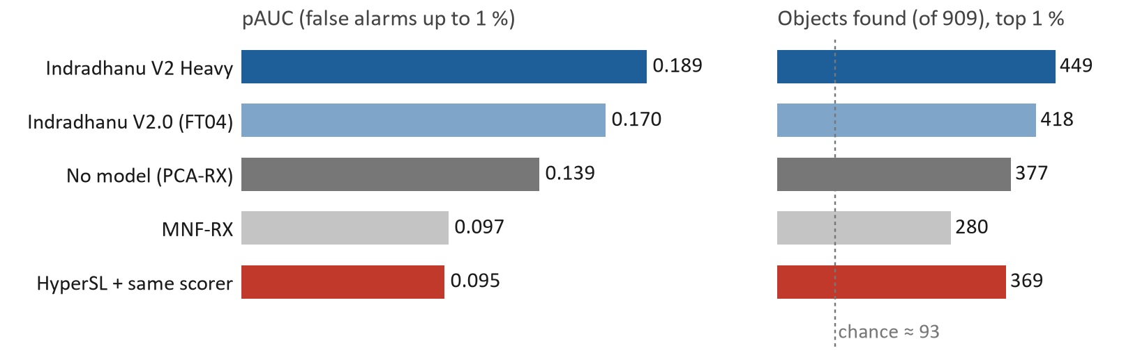
Figure 4. Detection on 909 labelled objects, thick cloud excluded. Left: partial AUC. Right: objects found in the top 1 % of scores; the dotted line is what random scores find.
Table 5. Detection measures. “All” = every valid pixel; “excl.” = thick cloud left out.
Method | pAUC all | pAUC excl. | Top 1 % all | Top 1 % excl. | Top 0.1 % excl. | ROC-AUC excl.
Indradhanu V2 Heavy | 0.175 | 0.189 | 422 | 449 | 16.0 % | 0.869
Indradhanu V2.0 (FT04) | 0.162 | 0.170* | 415 | 418* | 15.8 %* | 0.852*
No model (PCA-RX) | 0.128 | 0.139 | 361 | 377 | 8.5 % | 0.842
MNF-RX | 0.075 | 0.097 | 249 | 280 | 5.2 % | 0.753
HyperSL residual, same scorer | 0.083 | 0.095 | 350 | 369 | 6.7 % | 0.761
HyperSL own error (L2) | 0.018 | 0.018 | 130 | 137 | 4.3 % | 0.628
Random scores |  |  | ≈ 93 | ≈ 93 | 1.1 % | 0.5

* FT04 with its own cloud and thin-cloud mask.
Three checks confirm the gain:
- Paired bootstrap against FT04: +0.0196 [+0.0072, +0.0316]. The two neighbouring checkpoints also resolve: +0.0148 [+0.0029, +0.0259] and +0.0179 [+0.0055, +0.0292], so it is not one lucky checkpoint.
- The model adds over no model: no model minus V2 is −0.047 [−0.060, −0.033] pAUC and −6.7 [−8.8, −4.5] points of objects found.
- The gain holds in every difficulty tier (top 1 %): easy 58.2 → 62.2 %, medium 39.3 → 43.9 %, subtle 40.3 → 42.0 %. At the strictest cut (top 0.1 %) the two models tie (+0.1 points): the gain is in the broad ranking.
Per scene, V2 Heavy scores pAUC 0.2617, 0.1874, 0.0861 and 0.2217 (ROC-AUC 0.936, 0.874, 0.781, 0.888). The delivered processing chain reproduces these four numbers to four decimals.
Heavy's thin-cloud class also fires on haze: on Set-4 it covered 75.4 % of the pixels and 209 of the 230 targets. So only thick cloud is left out. That alone lifts pAUC from 0.175 to 0.189.

4 Material identification
Every detected pixel is matched against library spectra from USGS (splib07) and ECOSTRESS, resampled to the sensor's bands. The spectra are grouped into seven man-made classes (oil/fuel, plastic, textile/fabric, wood/paper, paint/coatings, metal, concrete/asphalt) and a natural shelf: 378 / 338 / 380 spectra for EnMAP / PRISMA / AVIRIS-NG. Answers come at two levels: level 1, man-made or natural; level 2, which class.

4.1 Methods
SAM (spectral angle mapper) measures the angle between the pixel's spectrum and each library spectrum and picks the smallest. It ignores brightness, needs no training and works with any library. It compares the whole pixel with a pure material, so it does not account for the ground that fills the rest of the pixel.
The spectral namer is a small learned model (347,685 parameters) built on Indradhanu V2's spectral stem. One tower reads the pixel together with the mean of its neighbours (a ring 3–7 pixels away); the other reads library spectra. Level 1 is the share of the pixel's match that falls on man-made spectra; level 2 is the best class. It was trained on library spectra planted into real EnMAP, PRISMA and AVIRIS-NG backgrounds at 5–100 % fill, with 20 % of each man-made class held out for testing. A new library spectrum needs no retraining. It runs in 8–9 s per scene.
We also compare the namer with ACE, a classical detector that, like the namer, uses the scene's own statistics. ACE was the baseline the namer had to beat before it shipped.

4.2 Held-out library spectra
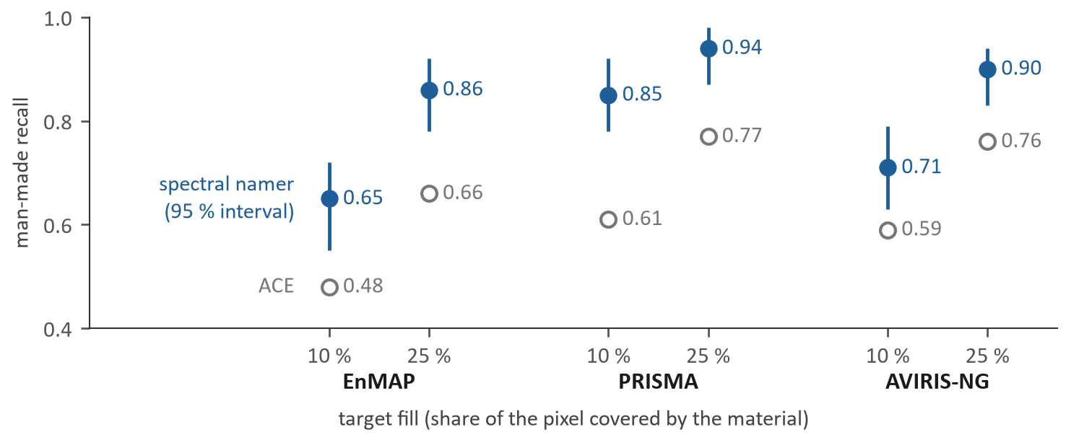
Figure 5. Level 1: share of man-made targets called man-made, at the false-alarm rate ACE itself produces on natural spectra. Filled: namer with 95 % interval (500 resamples of 221–254 spectra per sensor). Open: ACE.
Table 6. Level 2: material class correct on held-out spectra (namer, 95 % interval) against ACE.
Sensor | Fill 10 %: namer | ACE | Fill 25 %: namer | ACE
EnMAP | 0.59 [0.48, 0.70] | 0.24 | 0.68 [0.55, 0.79] | 0.47
PRISMA | 0.69 [0.53, 0.81] | 0.41 | 0.70 [0.54, 0.82] | 0.60
AVIRIS-NG | 0.65 [0.53, 0.76] | 0.38 | 0.70 [0.57, 0.82] | 0.58

The namer is clearly better than ACE at 10 % fill on all three sensors. At 25 % fill it is better on EnMAP; on PRISMA and AVIRIS-NG the intervals overlap. With about 34 unseen man-made spectra per sensor, the test cannot resolve differences much below 0.12.
A follow-up run (N003) mixed spectra within a class, warped wavelengths and added dropout, to help the namer generalise to unseen spectra. After 40 epochs it matched the shipped model (N001b) on EnMAP and did not improve it, so N001b ships.
Table 7. Library augmentation (N003) against the shipped namer (N001b), EnMAP, epoch 40.
Measure (EnMAP) | N001b (shipped) | N003 (augmented)
Level 1 accuracy, fill 10 % | 0.679 | 0.677
Level 2 class accuracy | 0.587 | 0.588
Man-made recall at ACE's false-alarm rate | 0.647 | 0.639

4.3 PRISMA example
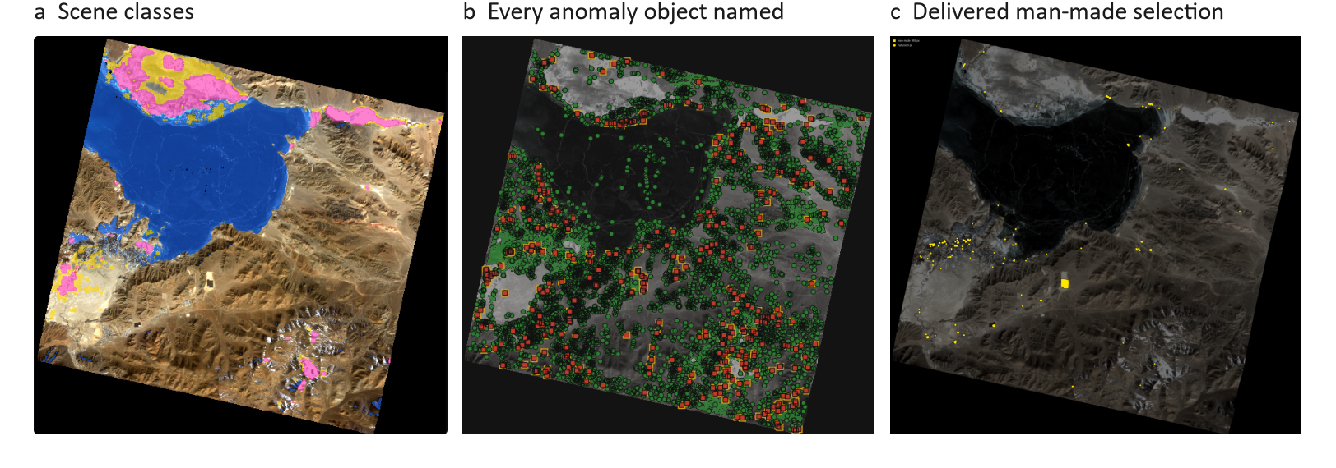
Figure 6. PRISMA example. (a) Indradhanu's scene classes: water blue, cloud pink (left out), thin cloud or haze yellow. (b) All 5,544 anomaly objects: red squares called man-made (405), green circles natural. (c) A delivered man-made selection (yellow) from an end-to-end test of the same scene.
In the example scene the 405 man-made objects split into concrete/asphalt 244, oil/fuel 116, plastic 25, metal 16, textile 3 and wood/paper 1. The same chain ran on three sensors (Table 8).
Table 8. Anomaly objects and namer calls on three sensors.
 | Tanager | PRISMA | AVIRIS-NG
Anomaly objects | 1,103 | 5,544 | 2,375
Called man-made (P > 0.5) | 272 | 405 | 1,290
Called man-made, very sensitive (P > 0.25) | 585 | 2,263 | 1,716
Oil/fuel or plastic | 247 | 141 | 936

4.4 Field targets
Planted targets are a controlled test. A separate study ran the matchers on real targets laid out in the field, using two data sets. The namer in this study is the variant with textile held out (N002), so textile is an unseen class for it; the background pixels are assumed natural.
- HySU is an airborne data set from DLR: a test field with deployed targets of bitumen, red-painted metal and blue, red and green synthetic fabric, each laid out as squares from 0.25 m to 3 m on a side and imaged at 0.7 m pixels. We used its 135 visible and near-infrared bands (417–903 nm), a range the namer was not trained on. In all: 22 targets, 236 target pixels and 3,000 background pixels.
- Gudalur is an AVIRIS-NG flight over the Nilgiris (2018) at 4 m pixels, with five 16 × 16 m sheets laid out on the ground (green, red, yellow and black nylon; white cotton) whose spectra were also measured in the field. At 4 m each sheet covers 16 pixels, 80 in all (353 bands, 402–2445 nm). The same data were also coarsened to 32 m at four grid offsets, where each sheet fills at most a quarter of a pixel: 27 target pixels from 19 sheet–offset pairs. This 32 m set is anecdotal.
Each method was scored on the man-made call (level 1, AUC against background) and on the class (level 2; nylon may count as plastic or textile, bitumen as concrete/asphalt or oil, painted metal as paint or metal), first with the shared library and then with the site's own field spectra added (Table 9, Figure 7).
Table 9. Field targets. L1: AUC of the man-made call. L2: class correct. Count: targets whose majority vote is right. Each cell: shared library / with field spectra.
Method | Gudalur 4 m L1 | L2 | Count | Gudalur 32 m L1 | L2 | Count | HySU L1 | L2 | Count
SAM | 0.69 / 0.70 | 0.40 / 0.45 | 2 / 2 | 0.39 / 0.39 | 0.15 / 0.15 | 2 / 2 | 0.65 / 0.73 | 0.38 / 0.58 | 7 / 13
ACE | 0.58 / 0.89 | 0.94 / 0.94 | 5 / 5 | 0.58 / 0.86 | 0.96 / 0.96 | 18 / 18 | 0.63 / 0.81 | 0.44 / 0.61 | 10 / 12
Spectral namer | 0.15 / 0.15 | 0.47 / 0.47 | 3 / 3 | 0.17 / 0.18 | 0.18 / 0.41 | 1 / 6 | 0.58 / 0.61 | 0.48 / 0.47 | 12 / 12
HyperSL, direct | 0.62 / 0.64 | 0.33 / 0.39 | 1 / 1 | 0.57 / 0.57 | 0.11 / 0.11 | 3 / 3 | 0.72 / 0.78 | 0.51 / 0.65 | 12 / 16
HyperSL, mixture bank | 0.51 / 0.59 | 0.46 / 0.57 | 3 / 4 | 0.15 / 0.19 | 0.18 / 0.22 | 3 / 4 | 0.57 / 0.80 | 0.63 / 0.77 | 16 / 18

Targets per set: Gudalur 4 m 5, Gudalur 32 m 19, HySU 22.
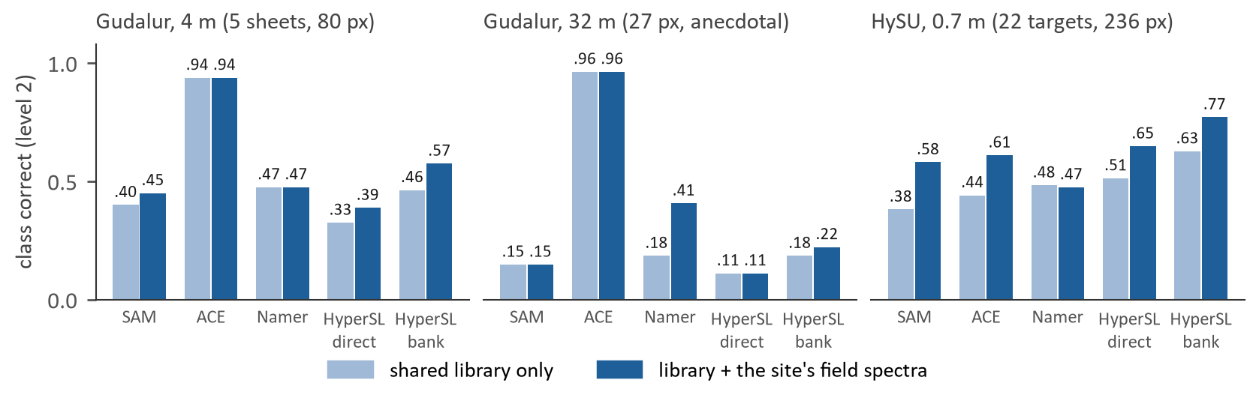
Figure 7. Field targets: material class correct (level 2) per method, with the shared library (light) and with the site's own field spectra added (dark).
ACE, which uses the scene's own statistics, names the Gudalur sheets best at both pixel sizes (5 of 5 at 4 m, 18 of 19 at 32 m), and field spectra lift its man-made call to AUC 0.86–0.89. The namer's man-made call is inverted on the sheets at both sizes (AUC 0.15–0.18): background pixels look more man-made to it than the sheets do. On the visible/near-infrared HySU set the HyperSL mixture bank names the most targets (16 of 22; 18 with field spectra). The namer barely changes when field spectra are added, while the direct matchers improve. On the pure road pixels of the public Jasper scene SAM is almost perfect (level 1 AUC 0.97, class 1.00), the namer's class call is good (0.92) but its man-made call weaker (0.78). These sets are small: treat them as examples, not rates.

5 Comparison with HyperSL
HyperSL is a public spectral foundation model: a per-pixel masked autoencoder with 9.2 M parameters, trained on EnMAP and DESIS reflectance. It hides 95 % of a pixel's bands and rebuilds them from the rest of the same pixel. We used its published checkpoint and code unmodified and asked two questions: does it detect anomalies, and does it help name materials?

5.1 Design differences
- Self-reconstruction. Because the hidden bands are rebuilt from the same pixel, an unusual pixel is rebuilt as well as an ordinary one. HyperSL's own training loss used as a score finds 63 objects, fewer than the ≈ 93 that random scores find (ROC-AUC 0.501). Indradhanu hides whole pixels instead.
- Per-scene min-max scaling. Each band is stretched to 0–1 using that scene's darkest and brightest value. The same spectrum (0.20, 0.50) becomes (0.5, 1.0) in one scene and (0.43, 0.75) in another, and one bright anomaly changes every other pixel's input. In a worked example the angle between two pixels moves from 15.1° to 36.9° with no change in reflectance. A library spectrum has no scene at all: forcing ECOSTRESS spectra into a scene's frame clipped 41 % of their values.
- Band order instead of wavelength. HyperSL groups neighbouring bands by their place in the list. Once water-vapour bands are removed, list neighbours can sit on either side of a gap, and each sensor puts different wavelengths at the same position. Indradhanu groups bands by wavelength.
- Cloud-free pretraining. On EnMAP's cloud labels, a classifier on HyperSL features recalls 28.9 % of cirrus, against 67.9 % from the raw bands (thick cloud: 87.1 % against 80.4 %).

5.2 Anomaly detection
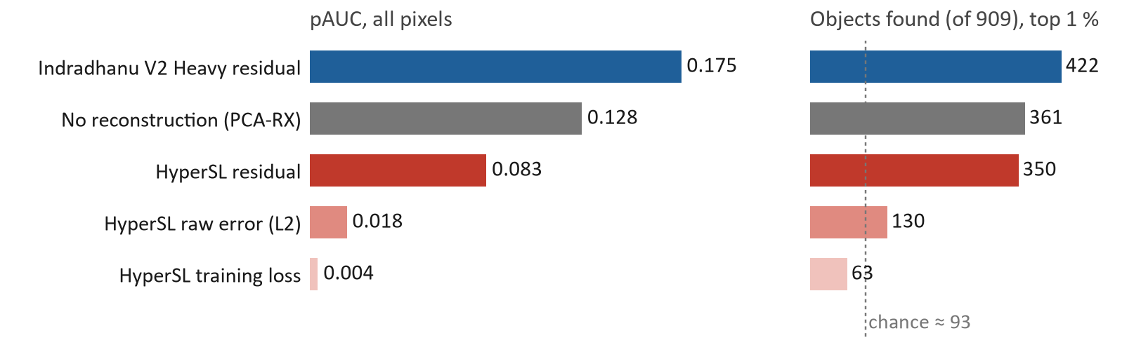
Figure 8. HyperSL on the same 909-object bench and the same scorer, all pixels. Its residual scores below no reconstruction at all; its own error is near or below chance.
Table 10. Paired differences in pAUC and objects found (top 1 %), 95 % intervals.
Comparison | pAUC difference | Objects found (points)
HyperSL minus no model | −0.045 [−0.059, −0.032] | −1.2 [−4.0, +1.5]
HyperSL minus Indradhanu V2 Heavy | −0.092 [−0.106, −0.078] | −7.9 [−10.8, −5.2]
Same, thick cloud excluded | −0.094 [−0.109, −0.080] | −8.8 [−11.7, −6.2]

Against the same baseline Indradhanu's reconstruction adds 0.047 pAUC and HyperSL's removes 0.045. HyperSL is lower than both on every scene, and the subtle tier suffers most (29.7 % found, against 35.0 % with no model).

5.3 Unmixing and identification
If a model's internal space kept mixing linear, half grass plus half asphalt would sit halfway between the two. In HyperSL's space the path bends away from the straight line by 0.4–0.7 of its length, and fractions recovered there are off by 0.08–0.21. Unmixing in that space is worse than the same unmixing on reflectance on every public set tested (Table 11).
Table 11. Unmixing error (abundance RMSE, lower is better) with the true endmembers.
Data set | Reflectance (best physical method) | HyperSL internal space
DC1 / DC2 / DC3 (synthetic) | 0.000 / 0.000 / 0.000 | 0.253 / 0.113 / 0.261
EGU (synthetic) | 0.018 | 0.142
Jasper (AVIRIS) | 0.050 | 0.106
Urban (HYDICE) | 0.059 | 0.170

For sub-pixel identification, library spectra were planted into real background pixels at fills from 2 % to 100 %, and each method had to name the class out of eight choices with the target's own spectrum removed from the library. What matters most is how well the method estimates the background: using the ring of neighbours beats the scene mean, which beats nothing. At every level, matching in HyperSL's space is worse than the same method on reflectance.
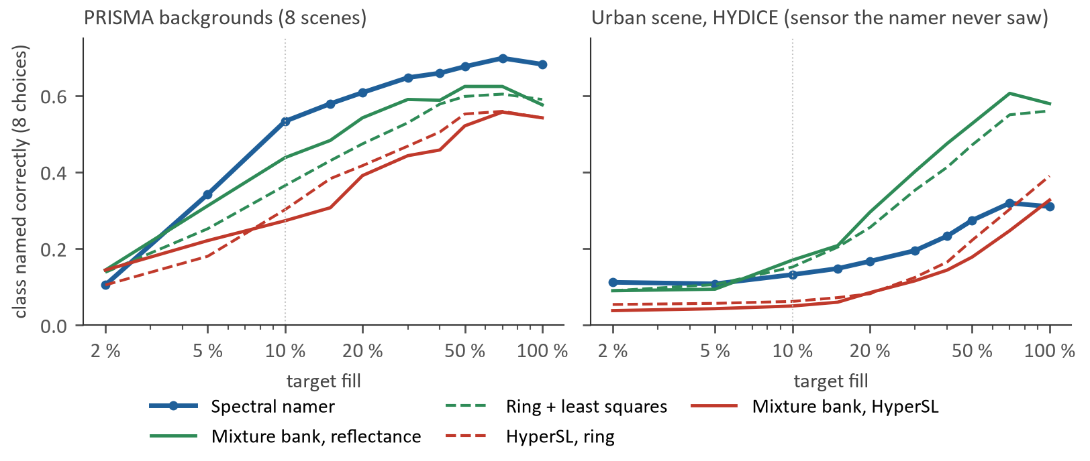
Figure 9. Planted targets: class named correctly against fill. Blue: spectral namer. Green: reflectance methods without training. Red: the same methods in HyperSL's space. Left: PRISMA backgrounds; right: an urban HYDICE scene, a sensor the namer never saw.
Table 12. Planted targets at 10 % fill: class named correctly (8 choices).
Method | Jasper | Urban | PRISMA
Spectral namer (with ring) | 0.39 | 0.13 | 0.53
Mixture bank, reflectance | 0.30 | 0.17 | 0.44
Ring + least squares, reflectance | 0.19 | 0.15 | 0.36
ACE (scene statistics) | 0.17 | 0.09 | 0.35
HyperSL, ring | 0.14 | 0.06 | 0.30
HyperSL, mixture bank | 0.17 | 0.05 | 0.27
Spectral namer, ring removed | 0.07 | 0.11 | 0.01

The namer is best on PRISMA and Jasper, the sensor families it was trained on. Without its ring it collapses (0.01 on PRISMA): its man-made call is, in effect, “this pixel differs from its neighbours”. On the unseen HYDICE sensor it is weak. About 40 % of targets cannot be named even when pure, because their nearest other-class spectrum is closer than any same-class one; that caps every method near 0.6.
HyperSL is therefore not adopted. It makes detection worse than no model, its internal space does not keep mixing linear, and its matching trails plain reflectance. Its one win is the visible/near-infrared HySU set (16 of 22 targets; 18 of 22 when the set's own field spectra are added to the library), which rests on 22 targets. The fixes it would need (a fixed scaling, wavelength-aware bands, whole hidden pixels, cloud in pretraining) are the design Indradhanu already has.

6 Matcher comparison
The AIGC brief asks for detected pixels to be matched to spectral libraries by a spectral foundation model and by SAM, with the pros and cons of each. Table 13 sets the learned namer, SAM and HyperSL-based matching side by side, with the numbers behind each point.
Table 13. Strengths and weaknesses of the three matchers (evidence in Sections 4 and 5).
 | Spectral namer (foundation-model based) | SAM (classical) | HyperSL-based matching
How it works | Learned matcher on Indradhanu's spectral stem; reads pixel and neighbours; two levels | Smallest angle between pixel and library spectrum | Match in the internal space of a public per-pixel foundation model
Pros | Best on small targets: man-made recall +0.14 to +0.20 over ACE at 25 % fill; class 0.59–0.69 at 10 % fill (ACE 0.24–0.41); 0.53 on planted PRISMA targets. New spectra need no retraining. 8–9 s per scene. | No training; any library; ignores brightness; transparent (one angle per spectrum). Near perfect on pure, extended surfaces (road: level 1 AUC 0.97, class 1.00). | Ready-made public model, no training of our own. Best on the visible/near-infrared HySU set (16 of 22 targets, 18 of 22 with field spectra).
Cons | Man-made call is inverted on extended man-made surfaces (Gudalur sheets AUC 0.15, urban asphalt and roofs 0.16). Weak on sensors it never saw. Unseen materials get the nearest known class; abstention catches only 1–4 %. | Ignores the background that fills the rest of the pixel, so it is weak on sub-pixel targets (Gudalur at 32 m 2 of 19; HySU 7 of 22). No notion of man-made vs natural. | Per-scene scaling gives library spectra no consistent input (41 % of ECOSTRESS values clipped). Worse than plain reflectance at every background level (0.27–0.30 vs 0.36–0.44 at 10 % fill). Makes detection worse (0.083 vs 0.128).
Best use | Small targets in open ground on trained sensors | Large, uniform targets; a check on the namer | Not used

ACE, the classical detector with scene statistics, sits between the two: it is the most reliable namer on the real Gudalur sheets and is also delivered with every pixel. In the delivered files each pixel and object carries the namer call, its class and confidence, the ACE family match and the best SAM match with its angle.

7 Limitations
- Namer on large targets. The namer's man-made call compares a pixel with its neighbours. It fails on extended man-made surfaces (roads, roofs, large sheets) and at high resolution, where a target fills many pixels; SAM and ACE are the better guide there.
- Open set. An unseen material is given the nearest of the seven classes. With textile held out, 46–47 % of textile was still called man-made and then given a wrong class with confidence; abstention flagged only 1–4 %. Results are reported as the “closest known class”. Adding 50 in-scene solar-panel spectra changed nothing (P(man-made) 0.248 → 0.248).
- No gain from augmentation. Library augmentation (N003) gave no improvement over the shipped namer (Table 7).
- Small real-target sets. The real-target sets are small: 5 sheets (80 pixels) at Gudalur and 22 targets at HySU. The planted-target study uses 1–8 scenes per group and about 160–200 distinct spectra.
- Bench size. Four labelled PRISMA scenes, PRISMA only. The bench resolves about ±0.005–0.01 pAUC. The bootstrap does not cover checkpoint-to-checkpoint variation, which is why three neighbouring checkpoints were checked.
- Threshold. The detection threshold behind each boolean map is an analyst choice; the evaluation scenes have no ground truth to tune it on.
- Cost. Heavy costs 454 s per PRISMA scene on a 16-thread CPU, against 274 s for FT04.
- HyperSL settings. HyperSL was run on a 149-band PRISMA axis with its default mask ratio. None of these settings was tuned on the bench.

8 Conclusions
Indradhanu V2 Heavy is the best detector we have measured: pAUC 0.189 and 449 of 909 labelled objects in the top 1 % of its scores, a resolved gain over our previous release and a clear gain over using no model. Most of the progress came from reading each sensor's own bands, leaving out only thick cloud, scoring the residual against its neighbourhood, and a wider pretrained encoder.
For material naming no single method wins everywhere. The learned namer is clearly better than classical methods on small targets in open ground, where most detections at 30 m sit. SAM and ACE are better on large, uniform surfaces, where the namer's neighbourhood test breaks down. We therefore deliver both, side by side, for every detected pixel.
HyperSL, measured on the same data with the same scorer, does not help: its reconstruction lowers detection below no model, and matching in its space trails plain reflectance. The reasons are design choices (per-pixel self-rebuilding, per-scene scaling, band-position grouping) that Indradhanu was built to avoid.
Next steps are field spectra for camouflage and coatings, a glass and solar-panel class, and a larger labelled bench beyond PRISMA.

