AI StudyBuddy
AI assistant for smarter learning and study support

Description
AI StudyBuddy is an AI-powered learning assistance platform designed to simplify the study process for students by combining modern web technologies with Generative AI. The application provides an intelligent backend that lets students upload their study materials and receive AI-generated learning support, while administrators manage users and monitor the platform.
The backend is built with Node.js and Express.js following a RESTful API architecture, which keeps the system scalable, maintainable and easy to integrate with any frontend. MongoDB is used as the NoSQL database and Mongoose ODM provides schema definition, validation and database operations.
Security is a core part of the design. The application uses JWT (JSON Web Token) authentication with separate short-lived access tokens and long-lived refresh tokens, together with Role-Based Access Control (RBAC) to separate student and administrator privileges. User passwords are never stored in plain text; they are hashed with bcryptjs before being saved.
A key highlight of AI StudyBuddy is its integration with the Google Gemini AI API. Instead of relying on predefined templates, the backend communicates with a Gemini model through a dedicated utility module to generate educational content from the material supplied by the student. File uploads are handled with Multer.

Scenario-Based Case Study

Background
Ananya is a final-year engineering student preparing for semester examinations while also getting ready for placement interviews. Her study materials are spread across lecture notes, PDFs, textbooks and online articles. With so much content and so little time, it is hard for her to identify the important concepts, prepare revision notes and check how well she has understood a topic.
Traditional preparation demands a lot of manual effort: summarising long chapters, writing practice questions and planning revision. This work is repetitive, time-consuming and often leads to inconsistent results.

Problem
- Difficulty understanding lengthy study materials within limited time.
- Manual preparation of notes consumes a large part of the study time.
- Creating revision questions and practice material is repetitive and labour-intensive.
- No single, secure place to store study resources and AI-generated content.
- Switching between several applications for notes, questions and planning reduces productivity.
- No controlled way to manage users and their data on the platform.

Solution
The AI StudyBuddy backend provides a centralised, AI-powered learning platform. Authenticated users can upload study material and use the Google Gemini AI API to obtain learning support automatically. The backend exposes secure REST APIs that:
- Register and authenticate users with JWT-based security and hashed passwords.
- Restrict sensitive operations to administrators through role-based authorization.
- Accept study material uploads and store the related records in MongoDB.
- Send study content to the Google Gemini model through a dedicated AI utility module.
- Give administrators APIs to list users, delete users together with their materials, and view platform statistics.
Authentication, routing, business logic, database access and AI processing are kept in separate modules, which makes the code easier to maintain, extend and debug.

Usage

Student Usage
Students register and log in to receive access and refresh tokens. After authentication they can upload study material and use the AI-powered features provided by the platform. Their own materials remain linked to their account.

Administrator Usage
Administrators can view all registered users (passwords are excluded from the response), delete a user along with all materials uploaded by that user, and view platform statistics such as the number of students and the number of stored materials. These routes are protected by both authentication and admin-only authorization.

Outcome
AI StudyBuddy reduces the manual effort involved in preparing study resources and lets students concentrate on understanding concepts. JWT authentication, RBAC, bcrypt password hashing and MongoDB data management ensure that user data is handled securely, while the Gemini integration provides consistent, on-demand AI assistance.
Because the backend is modular, new AI-powered learning features can be added with minimal changes to the existing architecture, making AI StudyBuddy a scalable foundation for personalised learning.

Software Requirements
- Operating System: Windows 10/11, macOS or Linux (cross-platform).
- Node.js (v16 or above): JavaScript runtime used to run the server.
- npm (v8 or above): Package manager used to install and manage dependencies.
- Express.js: Web framework used to build the RESTful API.
- MongoDB (Atlas): NoSQL database that stores users and study materials.
- Thunder Client / Postman: API testing tools used to verify endpoints.
- Code Editor: Visual Studio Code or a similar IDE.

Hardware Requirements
- Processor: Intel Core i5 (8th Gen or above) / AMD Ryzen 5 or equivalent.
- RAM: 8 GB minimum (16 GB recommended).
- Storage: 1 GB of free disk space.
- Internet: Required for MongoDB Atlas and the Google Gemini API.

Epic 1: Project Architecture
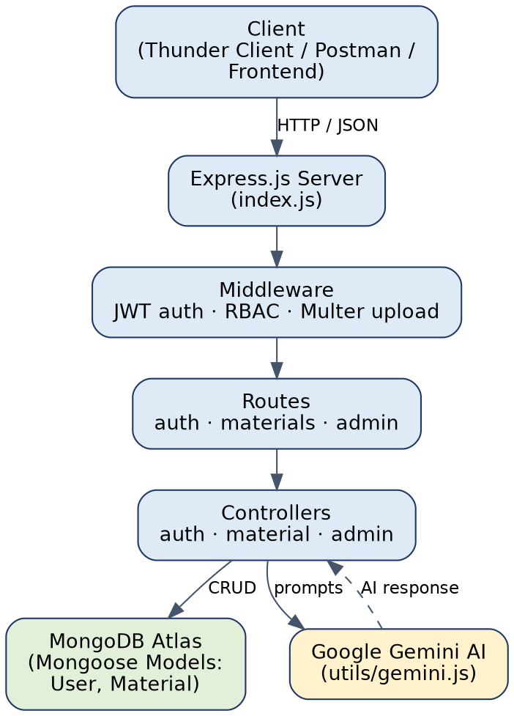
Figure 1: AI StudyBuddy system architecture
The AI StudyBuddy backend follows a modular RESTful architecture. Client requests reach the Express.js server, pass through middleware for authentication and file handling, are routed to the appropriate controller, and the controller interacts with MongoDB through Mongoose models and, when needed, with the Google Gemini API.

Components Definition
- Client Application: Sends HTTP/JSON requests to the API (tested with Thunder Client; a frontend can consume the same endpoints).
- Express Server: Entry point (index.js) that configures middleware, registers routes, exposes a health-check route and handles errors globally.
- Authentication Middleware: protect verifies the Bearer JWT access token, and adminOnly restricts routes to users whose role is admin.
- Route Handlers: Separate route files for authentication, study materials and administration.
- Controllers: authController, materialController and adminController contain the business logic.
- AI Service Layer: utils/gemini.js communicates with the Google Gemini AI API.
- Database Layer: MongoDB with Mongoose models (User and Material).

Entity-Relationship (ER) Diagram
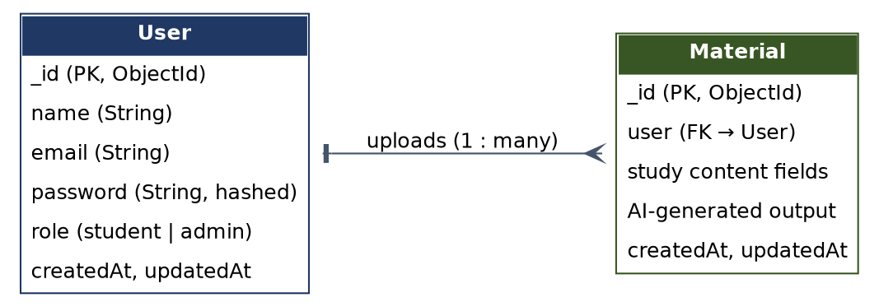
Figure 2: Entity-relationship diagram

1. User Entity
Stores registered students and administrators.
- _id (Primary Key, ObjectId)
- name (String)
- email (String)
- password (String, hashed with bcrypt)
- role (String: student or admin, default student)
- createdAt and updatedAt (added automatically by Mongoose timestamps)

2. Material Entity
Stores the study material uploaded by a user. Each material references its owner through the user field.
- _id (Primary Key, ObjectId)
- user (Foreign Key → User)
- Study content and AI-generated output fields
- createdAt and updatedAt

Key Relationships
- User → Material (One-to-Many): a user can upload many study materials.
- Cascade delete: when an administrator deletes a user, all materials belonging to that user are deleted as well.

Key Features
- Secure Authentication: JWT access tokens (15 minutes) and refresh tokens (7 days) with bcrypt-hashed passwords.
- Role-Based Access Control: Separate privileges for students and administrators.
- Study Material Management: Upload handling with Multer and storage of material records in MongoDB.
- AI Integration: Google Gemini API used to generate learning content from study material.
- Admin Management: List users, delete users with their materials, and view statistics.
- Centralised Error Handling: A global error handler returns consistent JSON error responses.
- Modular Structure: Controllers, middleware, models, routes and utilities are kept separate.

Roles and Responsibilities

Student
The default role. Students register, log in securely, upload study materials and use the AI-powered features. They cannot access administrative routes; such requests are rejected with a 403 "Admins only" response.

Administrator
Administrators manage the platform: they can list all users, delete users and their materials, and view statistics on the number of students and materials.

User Flow
The user registers or logs in and the server issues JWT tokens. Every protected request carries the access token in the Authorization header. Based on the role stored in the token, the user is either allowed to use student features or the administrator features.
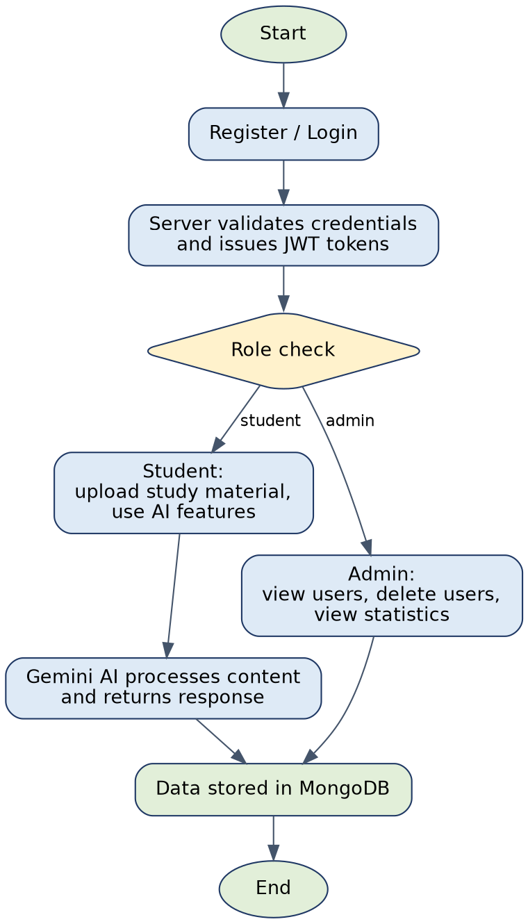
Figure 3: User flow of AI StudyBuddy

MVC Architecture Pattern
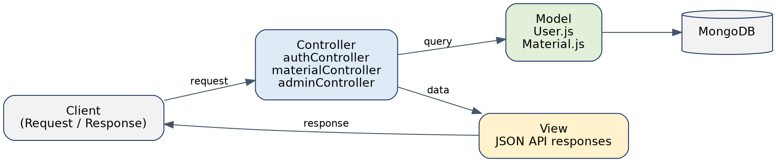
Figure 4: MVC architecture of the backend

Model Layer
Mongoose schemas (User.js and Material.js) define the collections, validation rules and database interactions.

View Layer
AI StudyBuddy is a REST API, so the view layer is the structured JSON returned to the client.

Controller Layer
Controllers process requests, use the models, call the Gemini service where required and return the response.

Benefits
Separating data, logic and responses improves readability, simplifies testing and lets new features be added without disturbing existing modules.

Epic 2: Project Setup and Configuration

Creating the Project Folder
- Create a new folder named AI StudyBuddy.
- Open the folder in Visual Studio Code.
- Initialise the project with Node.js and install the required dependencies.

Project Initialisation
Open the integrated terminal in the project folder and run:
npm init -y

Install the required dependencies:
npm install express mongoose bcryptjs jsonwebtoken cors dotenv multer express-async-errors @google/genai @google/generative-ai

The installed packages and their versions are listed in package.json, and the start script runs node index.js:
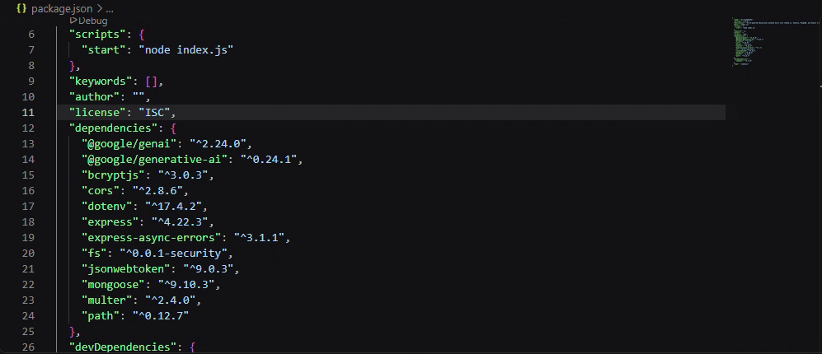
Figure 5: package.json with scripts and dependencies

Folder Structure
The source code is organised under the src folder, with uploaded files stored in the uploads folder.
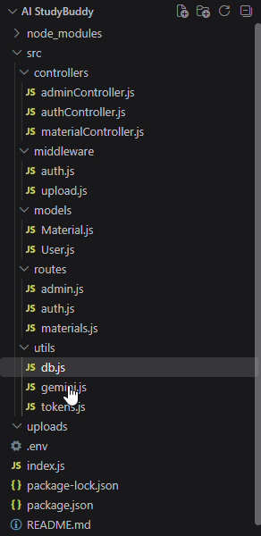
Figure 6: Project folder structure

Environment Configuration
Create a .env file in the project root and configure the environment variables. These values are private and must never be committed to a public repository.
PORT=5000
MONGO_URI=your_mongodb_connection_string
JWT_ACCESS_SECRET=your_access_token_secret
JWT_REFRESH_SECRET=your_refresh_token_secret
GEMINI_API_KEY=your_gemini_api_key

Epic 3: Backend Development
The backend is developed with Node.js, Express.js and MongoDB using a modular structure. Routing, controllers, middleware, models and utilities are placed in separate folders to improve maintainability. The backend exposes secure REST APIs for authentication, study material management, AI features and administration.

Core System Script Implementations

1. Application Entry Point (index.js)
index.js is the entry point. It creates the Express application, registers the routes, provides a health-check route at "/" that returns "AI StudyBuddy API is running", and defines a global error handler that returns a JSON message with the appropriate status code. The server starts listening (default port 5000) only after connectDB() has successfully connected to MongoDB.
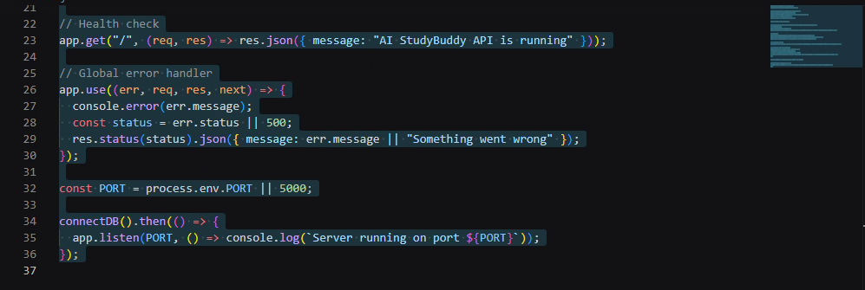
Figure 7: index.js: health check, global error handler and server start

2. Database Connection (src/utils/db.js)
This module loads environment variables with dotenv and connects to MongoDB using Mongoose and the MONGO_URI value. On success it logs the connected host name.
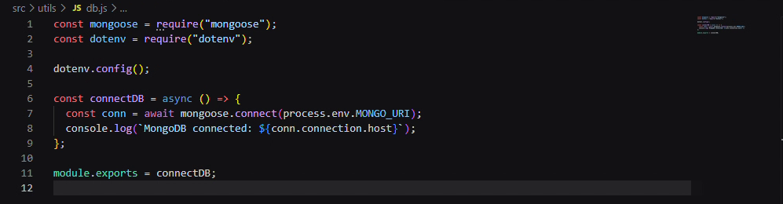
Figure 8: db.js: MongoDB connection using Mongoose

3. Token Generation (src/utils/tokens.js)
generateTokens creates two JWTs containing the user id and role: an access token signed with JWT_ACCESS_SECRET that expires in 15 minutes, and a refresh token signed with JWT_REFRESH_SECRET that expires in 7 days.
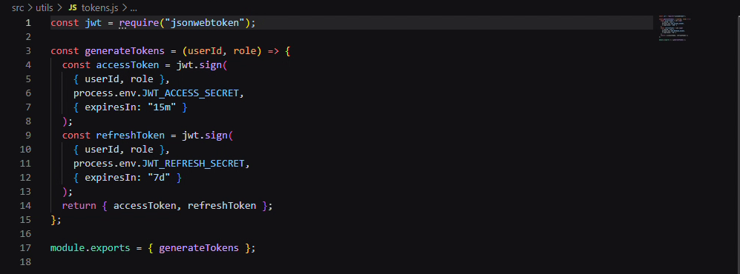
Figure 9: tokens.js: access and refresh token generation

4. Authentication Middleware (src/middleware/auth.js)
The protect middleware reads the Authorization header, checks for the Bearer scheme, verifies the token with JWT_ACCESS_SECRET and attaches the decoded payload to req.user. Missing tokens return 401 "Not authenticated" and invalid or expired tokens return 401 "Invalid or expired token". The adminOnly middleware returns 403 "Admins only" when the user role is not admin.
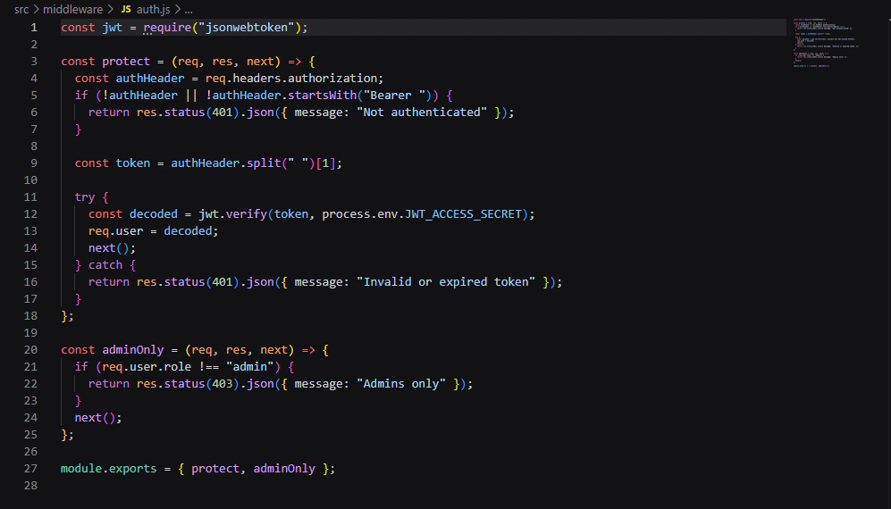
Figure 10: auth.js: protect and adminOnly middleware

5. Admin Routes (src/routes/admin.js)
All admin routes are protected with protect and adminOnly, so only authenticated administrators can reach them.
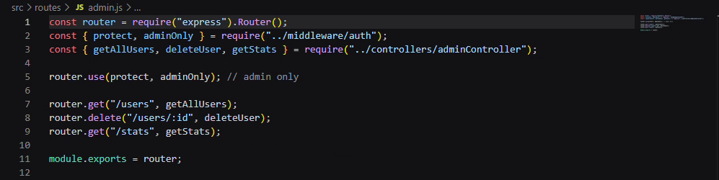
Figure 11: admin.js: admin-only routes

6. Admin Controller (src/controllers/adminController.js)
getAllUsers returns all users without the password field, sorted by newest first. deleteUser removes a user by id and also deletes that user's materials. getStats returns the number of student users and the total number of materials.
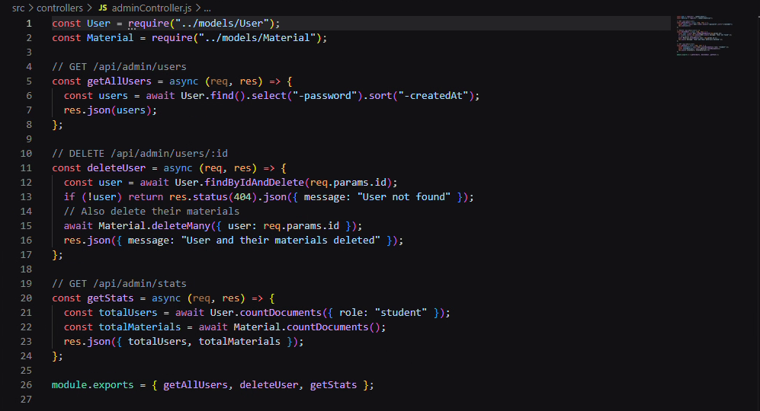
Figure 12: adminController.js: getAllUsers, deleteUser and getStats

7. AI Integration (src/utils/gemini.js)
This utility connects the backend to the Google Gemini API using the GEMINI_API_KEY. It sends prompts built from the student's study material and returns the generated response to the controller.

8. File Upload Middleware (src/middleware/upload.js)
The upload middleware uses Multer to receive study material files and store them in the uploads folder before they are processed.

Epic 4: Database Configuration
AI StudyBuddy uses MongoDB (hosted on MongoDB Atlas) as its database and Mongoose ODM for data modelling and validation. Mongoose provides schemas, validation rules and simple query methods.

Configure MongoDB
Install Mongoose:
npm install mongoose

The connection is created in src/utils/db.js (see Epic 3) and is initialised during server start-up so that requests are only accepted once the database is available.

Mongoose Schema Definitions

1. User Schema (models/User.js)
The User schema stores name, email, password and role. The role is restricted to "student" or "admin" with student as the default, and timestamps are enabled. A pre-save hook hashes the password with bcrypt (10 salt rounds) whenever it is modified, and the matchPassword method compares a plain password with the stored hash during login.
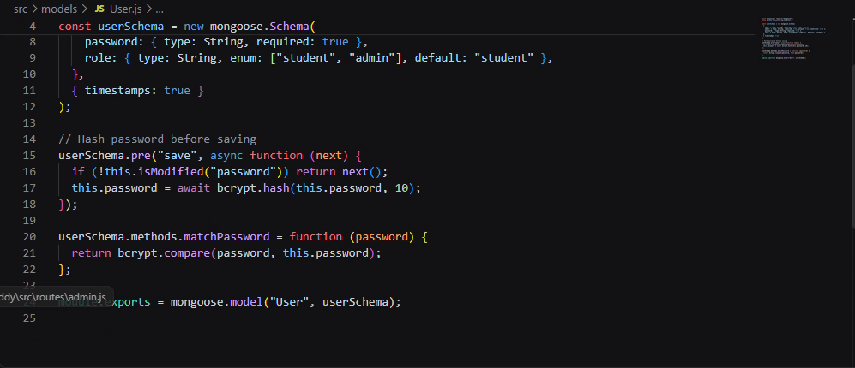
Figure 13: User.js: schema, password hashing and matchPassword

2. Study Material Schema (models/Material.js)
The Material schema stores the study content uploaded by a user, linked to the owner through the user field. This content is the input for the AI features.

Database Collections
- Users – account and authentication details of students and administrators.
- Materials – study materials uploaded by users.

API Route Interface Endpoints
Module | Endpoint | Description
Authentication | /api/auth/register | Register a new user and receive JWT tokens.
Admin | /api/admin/users | GET – list all users (admin only).
Admin | /api/admin/users/:id | DELETE – delete a user and their materials (admin only).
Admin | /api/admin/stats | GET – total students and total materials (admin only).
Health | / | Returns a message confirming that the API is running.

Additional authentication and study-material routes are defined in routes/auth.js and routes/materials.js.

Epic 5: Project Execution
The backend runs locally with Node.js. Before starting, make sure the .env file is configured and that the MongoDB connection string is valid. The APIs are tested with Thunder Client (Postman can be used in the same way).

Running the Backend Server
Install all dependencies:
npm install

Start the server:
npm start

On success, the terminal shows that MongoDB is connected and that the server is running on port 5000.
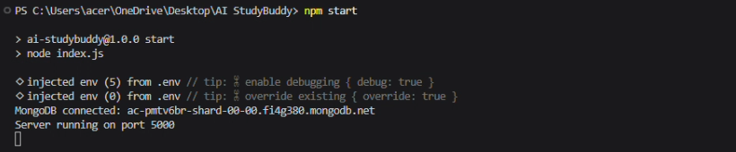
Figure 14: Server started successfully and connected to MongoDB

API Testing

1. User Registration
Registers a new user. The password is hashed before it is stored, and the response returns the JWT tokens together with the user id, name and role.
Endpoint: POST /api/auth/register
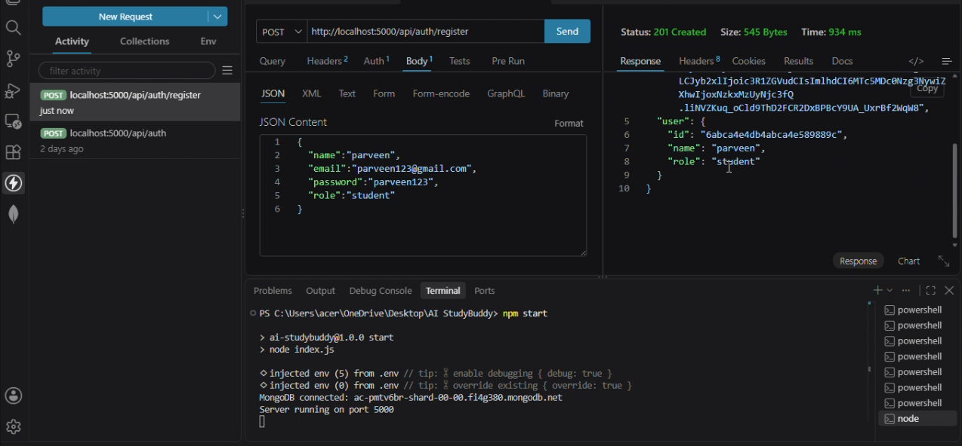
Figure 15: Register API – 201 Created

2. User Login
Authenticates a registered user and returns the JWT access token that is used to call protected APIs.
Endpoint: POST /api/auth/login

3. Get All Users (Admin)
An administrator sends the access token as a Bearer token. The API returns all users without their passwords.
Endpoint: GET /api/admin/users
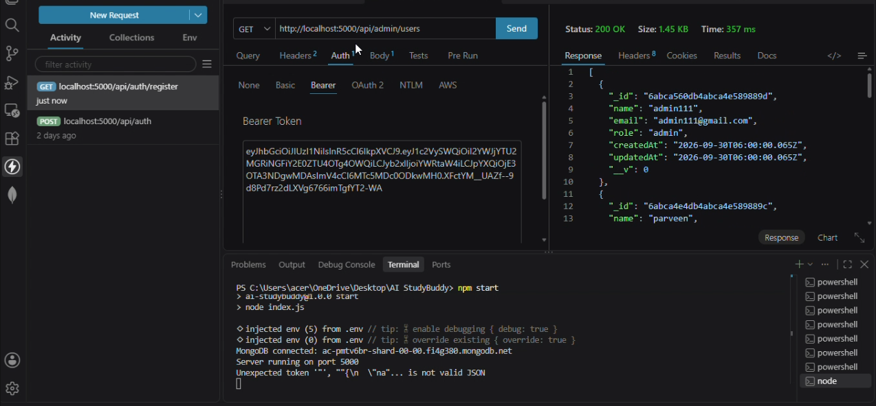
Figure 16: Get all users API with Bearer token – 200 OK

4. Delete User (Admin)
Deletes the selected user and all study materials belonging to that user.
Endpoint: DELETE /api/admin/users/:id
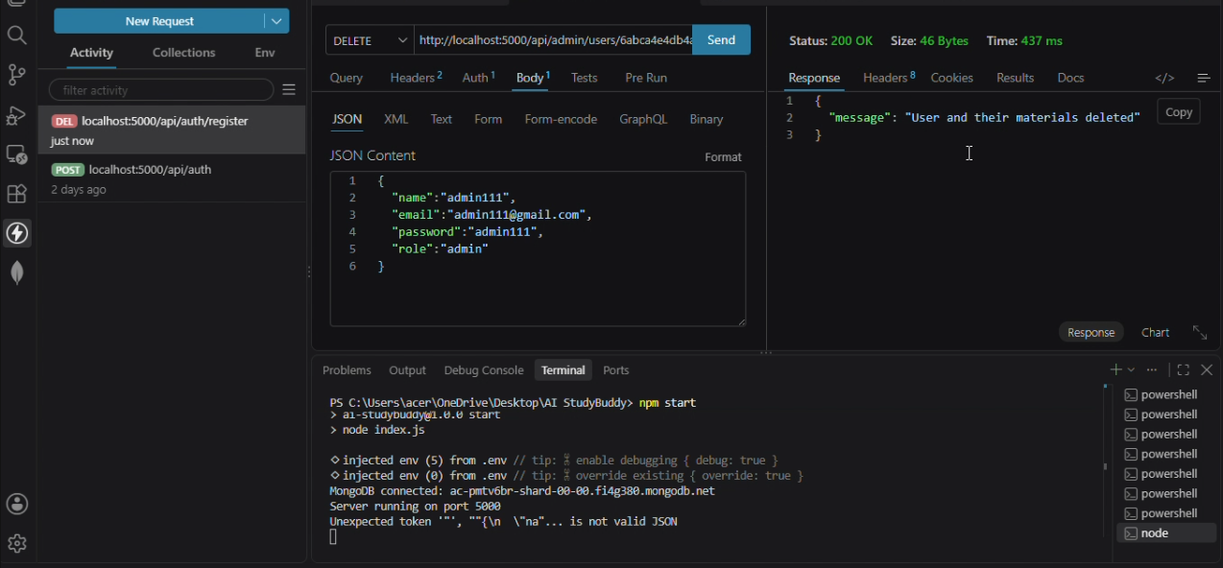
Figure 17: Delete user API – 200 OK

5. Study Material and AI Features
Authenticated users upload study material and request AI-generated content through the study-material routes.

