VISVESVARAYA TECHNOLOGICAL UNIVERSITY
BELAGAVI 590 018

An Assignment Project Report o n
“SMART HOME AUTOMATION SYSTEM”
Submitted in partial fulfillment of the award of the Degree of Bachelor of Engineering
In
ELECTRONICS & COMMUNICATION ENGINEERING
By

Rasika Bhaskar Sushmita Shetty
Rhutuja Amboji
Vaishnavi Talukar
USN:2JI24EC408 USN:2JI24EC416 USN:2JI24EC409
USN:2JI23EC166








Under the Guidance of
Prof. Girish Kadakol

Department of Electronics andCommunication Engineering Jain CollegeofEngineering
Belagavi-590014

2025-26

Shri Bhagwan Mahaveer Jain Educational & Cultural Trust ®

JAIN COLLEGE OF ENGINEERING, BELAGAVI

T.S.NAGAR, MACHHE – 590014, KARNATAKA

Department of Electronics and Communication Engineering
CERTIFICATE
This is to certify that the assignment project entitled “CONTACTLESS DOORBELL ” presented bySushmita Shetty(2JI24EC416),Rasika Bhaskar(2JI24EC408),Rhutuja Amboji (2JI24EC409), Vaishanvi Talukar(2JI23EC166) are bonafide students of Department of Electronics and Communication Engineering, Jain College of Engineering,Belagavi, in partial fulfilment for the award of Bachelor of Engineeringof the VisvesvarayaTechnological University, Belagavi during the academic year 2025-2026. It iscertified thatallcorrections/suggestions indicated for assignment project have been incorporated in the report.Thereport has been approved as it satisfies the academic requirements in respect of assignmentprojectprescribedfor the Bachelor of Engineering degree.

Prof.Girish.Kadkol
Project Guide
Dept. of E&CE, JCE Belagavi
Prof. V.R.Bagali
HOD, Dept. of E&CE
JCE, Belagavi
Dr. J. Shivakumar Principal & Director JCE, Belagavi

Table of Contents

Sl No | Content
1. | Introduction
2. | Components and Tools used
3. | System Architecture
4. | System Working
5. | Output and Results
6. | Code
7. | Conclusion

INTRODUCTION

A contactless doorbell is an advanced electronic system designed to allow visitors to
ring a doorbell without physically touching any switch. In traditional doorbell systems,
a person must press a button to alert the people inside the house. However, this direct
contact can lead to the spread of germs and bacteria, especially in public places and during
health crises like the COVID-19. Therefore, there is a growing need for touch-free and
hygienic solutions in everyday devices.

The contactless doorbell overcomes this problem by using an ultrasonic sensor, which can
detect the presence of a hand or object placed near it. The sensor works by sending
ultrasonic waves and measuring the distance based on the reflected signal. When a person
brings their hand within a certain range, the system automatically activates a buzzer and an
LED, indicating that someone is at the door. This eliminates the need for physical contact
and improves safety and convenience.

This project uses simple and affordable components such as an Arduino
microcontroller, ultrasonic sensor, buzzer, and LED. It is easy to build, cost-effective, and
highly useful in places like homes, hospitals, offices, and public buildings. The
contactless doorbell not only enhances hygiene but also represents the practical use of
modern technology in daily life.

COMPONENTS AND TOOLS USED

Simulated Components (Virtual) Breadboard
Ultrasonic sensor
Buzzer
Arduino
Software Tool
Tinkercad

SYSTEM ARCHITECTURE / BLOCK DIAGRAM

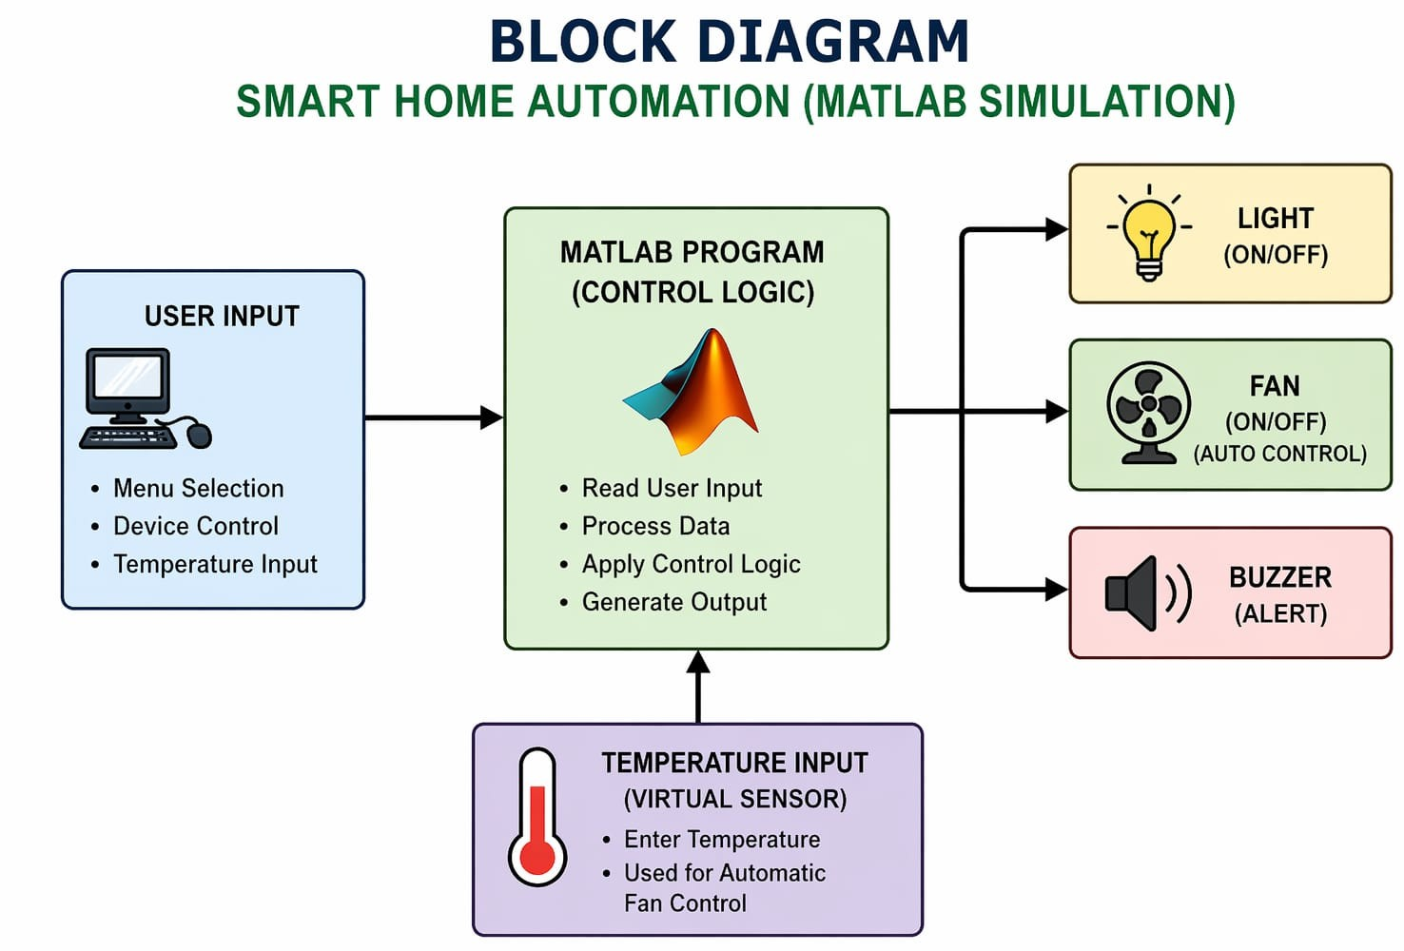
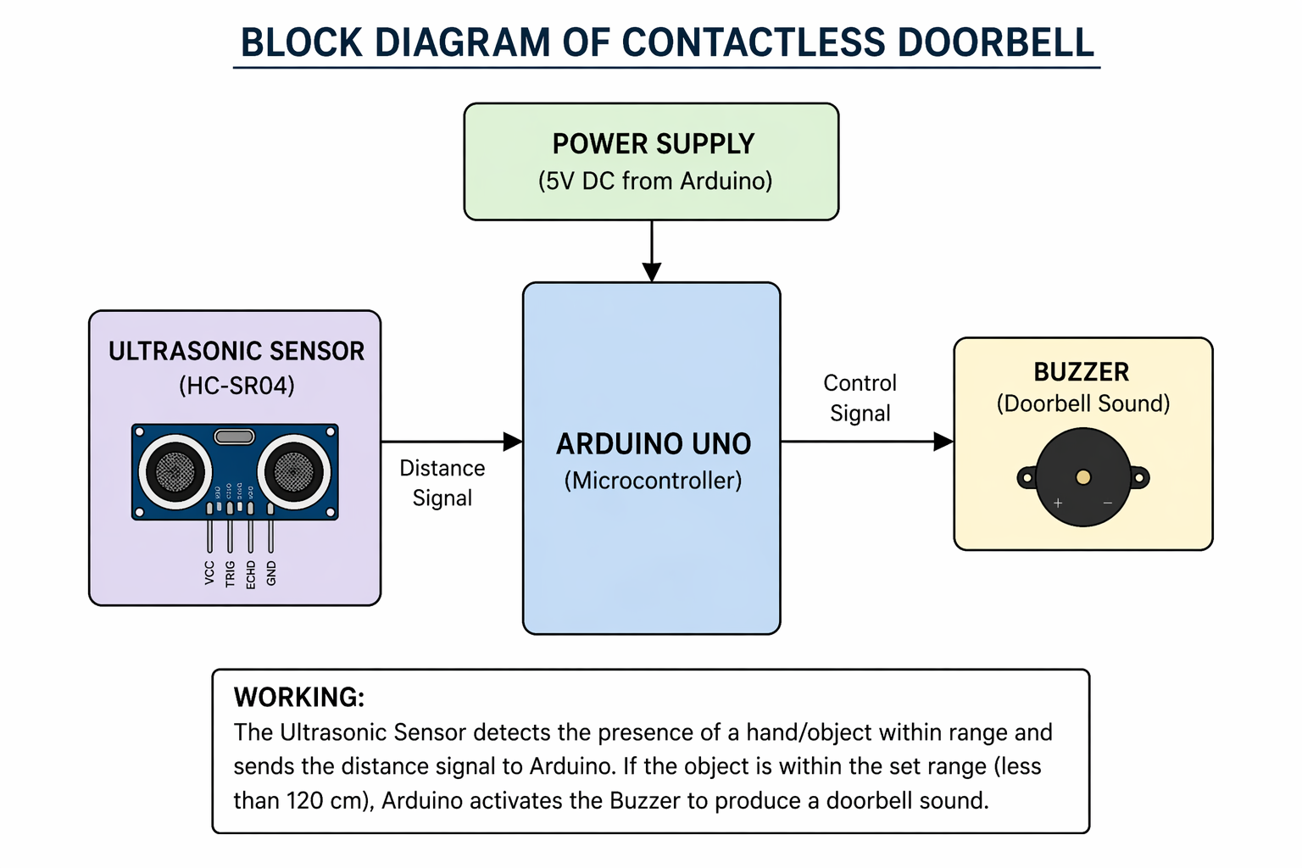

SYSTEM WORKING AND OPERATION MODE
The contactless doorbell system operates based on the principle of distance measurement using an ultrasonic sensor and decision-making using a microcontroller
When the system is powered ON, the Arduino UNO initializes all the components and starts the operation. The ultrasonic sensor continuously emits high-frequency sound waves (ultrasonic waves) into the surrounding environment through its transmitter. These waves travel in air and reflect back when they encounter an object such as a human hand.
The receiver of the ultrasonic sensor captures the reflected waves and measures the time taken for the signal to return. This time duration is sent to the Arduino, which calculates the distance using a predefined formula.
The Arduino continuously monitors this distance value. If the detected distance is within a specified threshold (for example, less than 120 cm), it interprets this as the presence of a visitor near the door.
Once a valid detection is confirmed:
  - The Arduino sends a signal to activate the buzzer.
  - The buzzer produces a sound, functioning as a doorbell alert.
If no object is detected within the set range:
  - The Arduino does not trigger any output.
  - The system remains in standby mode.
This process repeats continuously in a loop, ensuring real-time detection and response. The system is designed to be fast, accurate, and reliable for everyday use.

RESULTS AND OUTPUT

The contactless doorbell system was successfully designed and implemented using
an ultrasonic sensor and Arduino UNO. The system operates effectively by detecting
the presence of a hand or object without requiring any physical contact.
During testing, it was observed that when an object (such as a hand) is brought
within the predefined distance range (approximately less than 120 cm), the
ultrasonic sensor accurately detects it and sends the signal to the Arduino. The
Arduino processes this input and activates the buzzer, producing a clear doorbell
Sound When no object is present within the specified range, the system remains
inactive, and the buzzer does not produce any sound. This ensures that false triggering
is minimized.
The system response was found to be quick and reliable, with minimal delay
between detection and buzzer activation. The output was consistent under
normal conditions, making the system suitable for real-time applications.Overall,
the project demonstrates a simple, efficient, and hygienic solution for a modern
doorbell system, eliminating the need for physical contact.

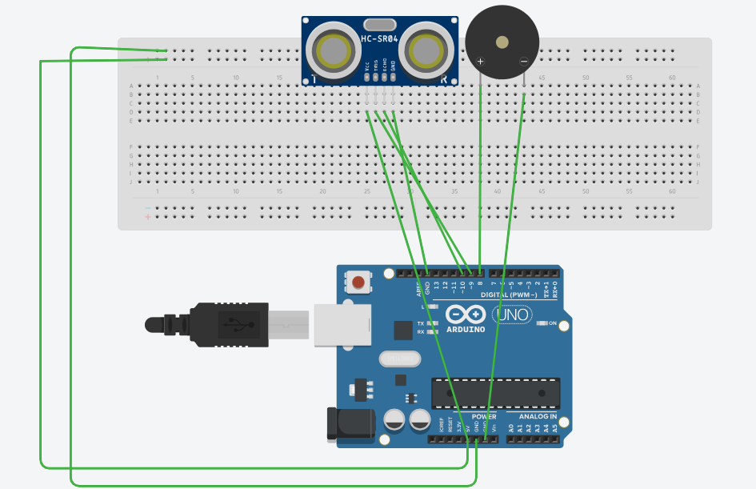
CODE

const int trigPin = 9;
const int echoPin = 10;
const int buzzer = 8;
const int led = 7;

long duration;
int distance;

void setup() {
pinMode(trigPin, OUTPUT);
pinMode(echoPin, INPUT);
pinMode(buzzer, OUTPUT);
pinMode(led, OUTPUT);
Serial.begin(9600);
}

void loop() {
digitalWrite(trigPin, LOW);
delayMicroseconds(2);

digitalWrite(trigPin, HIGH);
delayMicroseconds(10);
digitalWrite(trigPin, LOW);

duration = pulseIn(echoPin, HIGH);
distance = duration * 0.034 / 2;

Serial.print("Distance: ");
Serial.println(distance);

if (distance > 0 && distance < 120) {
tone(buzzer, 1000); // sound
digitalWrite(led, HIGH); // LED ON
delay(1000);
noTone(buzzer);
digitalWrite(led, LOW);
delay(1000);
}
}

CONCLUSION
The contactless doorbell system was successfully designed and implemented using an ultrasonic sensor and Arduino UNO. The system is able to detect the presence of a person without any physical contact and activates the buzzer effectively. This makes it a hygienic and user-friendly alternative to traditional doorbells.
The project is simple, low-cost, and reliable, making it suitable for practical use in homes, offices, and public places. It also demonstrates the effective use of sensors and automation in improving everyday systems. Overall, the project achieves its objective of providing a safe and contactless solution for doorbell operation.

