Exercise 1: Control Structures

Scenario 1: The bank wants to apply a discount to loan interest rates for customers above 60 years old.
  - Question: Write a PL/SQL block that loops through all customers, checks their age, and if they are above 60, apply a 1% discount to their current loan interest rates.
CODE:
DECLARE
CURSOR customer_cursor IS SELECT c.customerID,c.DOB,l.loanID,l.InterestRate FROM customers c JOIN Loans l ON c.customerID = l.customerID;
v_age NUMBER;
BEGIN
FOR rec IN customer_cursor LOOP
v_age := FLOOR(MONTHS_BETWEEN(SYSDATE,rec.DOB)/12);
IF v_age > 60 THEN
UPDATE Loans SET InterestRate = InterestRate - 1 WHERE loanId = rec.loanId;
END IF;
END LOOP;
COMMIT;
END;
/
OUTPUT:
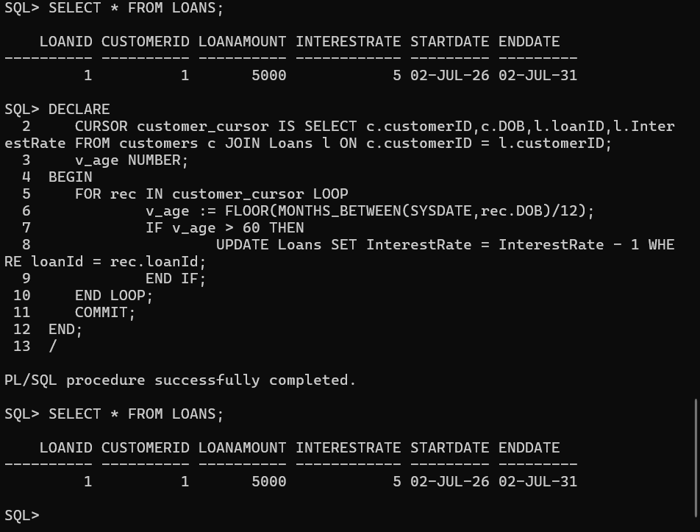
Scenario 2: A customer can be promoted to VIP status based on their balance.
  - Question: Write a PL/SQL block that iterates through all customers and sets a flag IsVIP to TRUE for those with a balance over $10,000.
CODE:
WE HAVE TO ALTER THE TABLE STRUCTURE OF CUSTOMER TO ADD COLUMN ISVIP
DECLARE
CURSOR customer_ISVIP IS SELECT c.customerID,c.name,c.balance FROM customers c;
balance NUMBER;
BEGIN
FOR rec IN customer_ISVIP LOOP
balance := rec.balance;
IF balance > 10000 THEN
UPDATE customers SET ISVIP = 'T' WHERE customerID = rec.customerID;
END IF;
END LOOP;
COMMIT;
END;
/
OUTPUT:
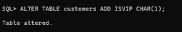
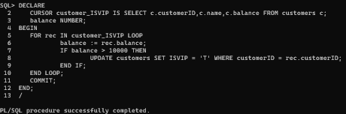
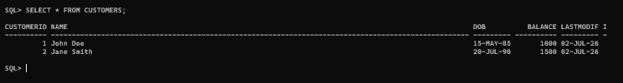
Scenario 3: The bank wants to send reminders to customers whose loans are due within the next 30 days.
  - Question: Write a PL/SQL block that fetches all loans due in the next 30 days and prints a reminder message for each customer.
CODE:
DECLARE
CURSOR customer_reminder IS SELECT c.customerID,c.name,l.loanID FROM customers c JOIN LOANS l ON c.customerid = l.customerid AND l.ENDDATE BETWEEN SYSDATE AND SYSDATE +30;
BEGIN
FOR rec IN customer_reminder LOOP
DBMS_OUTPUT.PUT_LINE('REMINDER TO : ' || rec.name || ' having customer ID : ' || rec.customerid || ' loan id : ' || rec.loanid ||' THAT ONLY 30 DAYS LEFT TO END THE LOAN');
END LOOP;
COMMIT;
END;
/
OUTPUT:
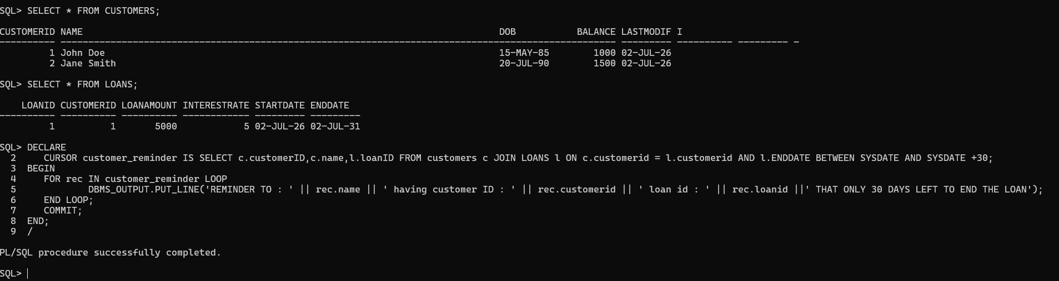
Exercise 3: Stored Procedures
Scenario 1: The bank needs to process monthly interest for all savings accounts.
  - Question: Write a stored procedure ProcessMonthlyInterest that calculates and updates the balance of all savings accounts by applying an interest rate of 1% to the current balance.
CODE:
CREATE OR REPLACE PROCEDURE ProcessMonthlyInterest
IS
BEGIN
UPDATE ACCOUNTS SET balance = balance * ((101)/100) WHERE accounttype = 'Savings';
COMMIT;
DBMS_OUTPUT.PUT_LINE('Saving accounts are updated');
EXCEPTION
WHEN OTHERS THEN
ROLLBACK;
DBMS_OUTPUT.PUT_LINE('No saving account to update');
END;
/
--EXCECUTION
BEGIN
ProcessMonthlyInterest();
END;
/
OUTPUT: 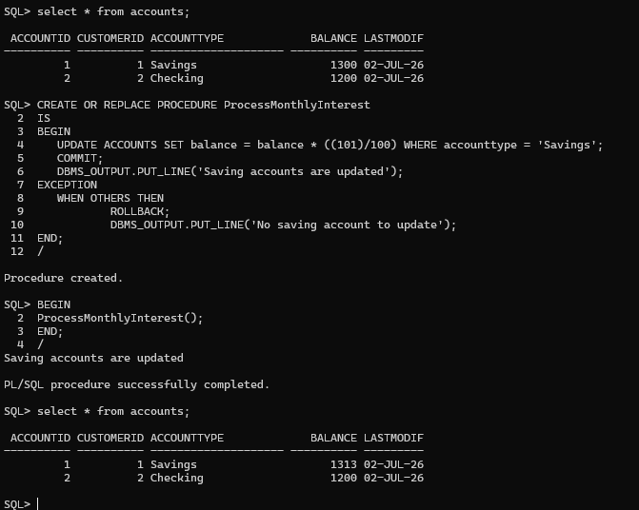
Scenario 2: The bank wants to implement a bonus scheme for employees based on their performance.
  - Question: Write a stored procedure UpdateEmployeeBonus that updates the salary of employees in a given department by adding a bonus percentage passed as a parameter.
CODE:
CREATE OR REPLACE PROCEDURE UpdateEmployeeBonus (p_department IN VARCHAR2,p_increment IN NUMBER)
IS
BEGIN
UPDATE EMPLOYEES SET salary = salary * ((100 + p_increment)/100) WHERE department = p_department;
COMMIT;
DBMS_OUTPUT.PUT_LINE('Salary updated');
EXCEPTION
WHEN OTHERS THEN
ROLLBACK;
DBMS_OUTPUT.PUT_LINE('INCORRECT EMPLOYEE ID');
END;
/
--EXECUTION
BEGIN
UpdateEmployeeBonus('IT',5);
END;
/
OUTPUT:
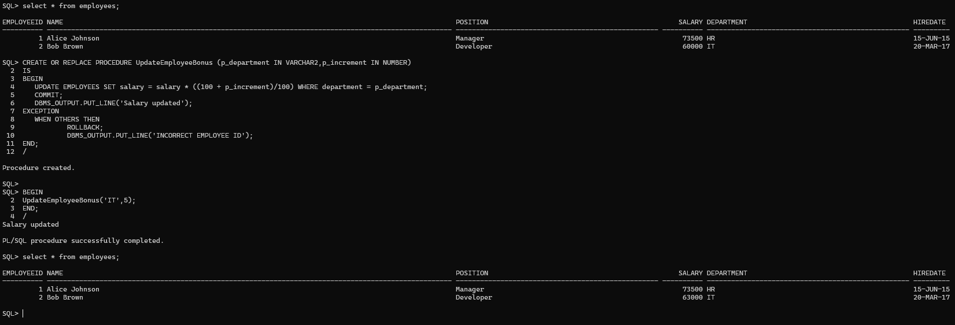
Scenario 3: Customers should be able to transfer funds between their accounts.
  - Question: Write a stored procedure TransferFunds that transfers a specified amount from one account to another, checking that the source account has sufficient balance before making the transfer.
CODE:
CREATE OR REPLACE PROCEDURE TransferFunds (p_customerid IN NUMBER,p_toaccount IN NUMBER, p_fromaccount IN NUMBER,p_amount IN NUMBER)
IS
v_balance NUMBER;
BEGIN
SELECT balance INTO v_balance FROM Accounts WHERE accountID = p_fromaccount AND customerid = p_customerid;
IF v_balance < p_amount THEN
RAISE_APPLICATION_ERROR(-20001,'INSUFFICIENT BALANCE');
END IF;
UPDATE ACCOUNTS SET balance = balance + p_amount WHERE accountid = p_toaccount AND customerid = p_customerid;

IF SQL%ROWCOUNT = 0 THEN
RAISE_APPLICATION_ERROR(-20002,'Destination account not found.');
END IF;

UPDATE ACCOUNTS SET balance = balance - p_amount WHERE accountid = p_fromaccount AND customerid = p_customerid;
IF SQL%ROWCOUNT = 0 THEN
RAISE_APPLICATION_ERROR(-20002,'Source account not found.');
END IF;
COMMIT;
DBMS_OUTPUT.PUT_LINE('FUND TRANSFER SUCCESSFULLY');
EXCEPTION
WHEN OTHERS THEN
ROLLBACK;
DBMS_OUTPUT.PUT_LINE('ERROR : ' || SQLERRM);
END;
/
--EXECUTION
BEGIN
TransferFunds(1,1,3,300);
END;
/
--EXECUTION
BEGIN
TransferFunds(1,2,3,300);
END;
/
OUTPUT: 