Exercise 1: Control Structures

Scenario 1: The bank wants to apply a discount to loan interest rates for customers above 60 years old.
  - Question: Write a PL/SQL block that loops through all customers, checks their age, and if they are above 60, apply a 1% discount to their current loan interest rates.
CODE:
DECLARE
CURSOR customer_cursor IS SELECT c.customerID,c.DOB,l.loanID,l.InterestRate FROM customers c JOIN Loans l ON c.customerID = l.customerID;
v_age NUMBER;
BEGIN
FOR rec IN customer_cursor LOOP
v_age := FLOOR(MONTHS_BETWEEN(SYSDATE,rec.DOB)/12);
IF v_age > 60 THEN
UPDATE Loans SET InterestRate = InterestRate - 1 WHERE loanId = rec.loanId;
END IF;
END LOOP;
COMMIT;
END;
/
OUTPUT:
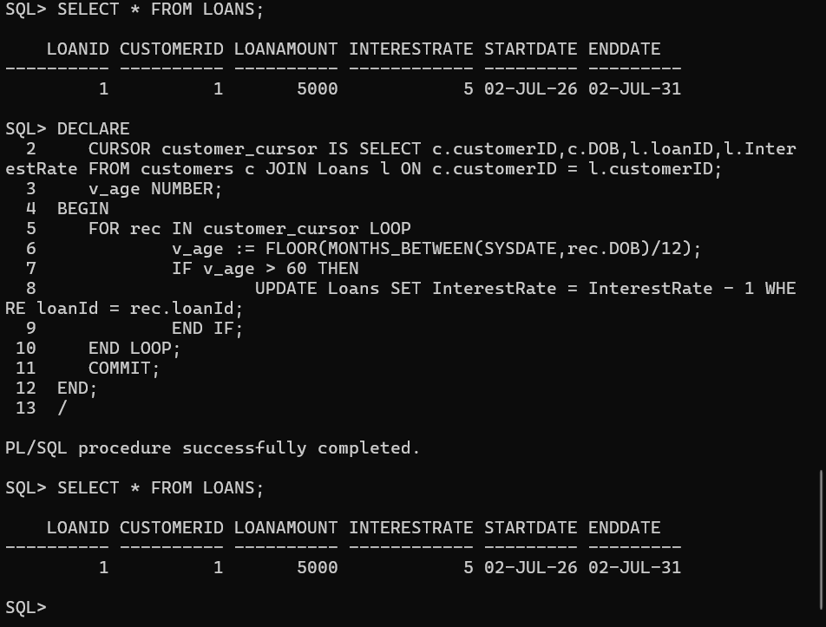
Scenario 2: A customer can be promoted to VIP status based on their balance.
  - Question: Write a PL/SQL block that iterates through all customers and sets a flag IsVIP to TRUE for those with a balance over $10,000.
CODE:
WE HAVE TO ALTER THE TABLE STRUCTURE OF CUSTOMER TO ADD COLUMN ISVIP
DECLARE
CURSOR customer_ISVIP IS SELECT c.customerID,c.name,c.balance FROM customers c;
balance NUMBER;
BEGIN
FOR rec IN customer_ISVIP LOOP
balance := rec.balance;
IF balance > 10000 THEN
UPDATE customers SET ISVIP = 'T' WHERE customerID = rec.customerID;
END IF;
END LOOP;
COMMIT;
END;
/
OUTPUT:
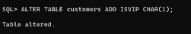
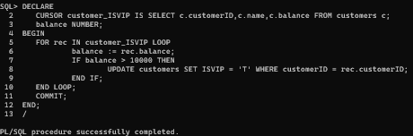
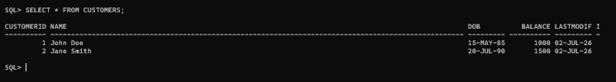
Scenario 3: The bank wants to send reminders to customers whose loans are due within the next 30 days.
  - Question: Write a PL/SQL block that fetches all loans due in the next 30 days and prints a reminder message for each customer.
CODE:
DECLARE
CURSOR customer_reminder IS SELECT c.customerID,c.name,l.loanID FROM customers c JOIN LOANS l ON c.customerid = l.customerid AND l.ENDDATE BETWEEN SYSDATE AND SYSDATE +30;
BEGIN
FOR rec IN customer_reminder LOOP
DBMS_OUTPUT.PUT_LINE('REMINDER TO : ' || rec.name || ' having customer ID : ' || rec.customerid || ' loan id : ' || rec.loanid ||' THAT ONLY 30 DAYS LEFT TO END THE LOAN');
END LOOP;
COMMIT;
END;
/
OUTPUT:
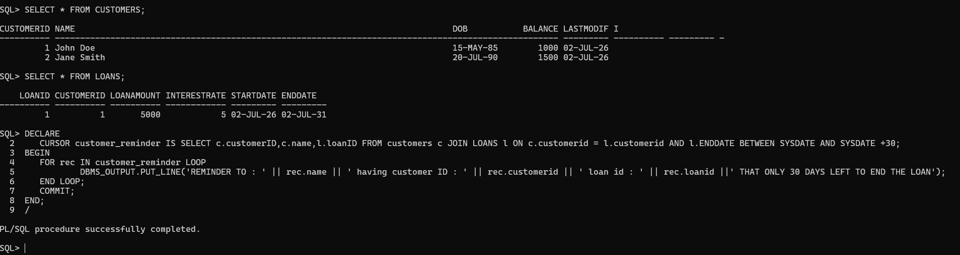
Exercise 2: Error Handling

Scenario 1: Handle exceptions during fund transfers between accounts.
  - Question: Write a stored procedure SafeTransferFunds that transfers funds between two accounts. Ensure that if any error occurs (e.g., insufficient funds), an appropriate error message is logged and the transaction is rolled back.
CODE:
CREATE OR REPLACE PROCEDURE SAFETRANSFERFUNDS (ptoaccount IN NUMBER, pfromaccount IN NUMBER,p_amount IN NUMBER)
IS
v_balance NUMBER;
BEGIN
SELECT balance INTO v_balance FROM Accounts WHERE accountID = pfromaccount;
IF v_balance < p_amount THEN
RAISE_APPLICATION_ERROR(-20001,'INSUFFICIENT BALANCE');
END IF;
UPDATE ACCOUNTS SET balance = balance + p_amount WHERE accountid = ptoaccount;
UPDATE ACCOUNTS SET balance = balance - p_amount WHERE accountid = pfromaccount;
COMMIT;
DBMS_OUTPUT.PUT_LINE('FUND TRANSFER SUCCESSFULLY');
EXCEPTION
WHEN OTHERS THEN
ROLLBACK;
DBMS_OUTPUT.PUT_LINE('ERROR : ' || SQLERRM);
END;
/
--execution
BEGIN
SAFETRANSFERFUNDS(1,2,300);
END;
/
OUTPUT: 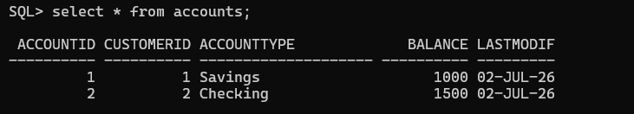
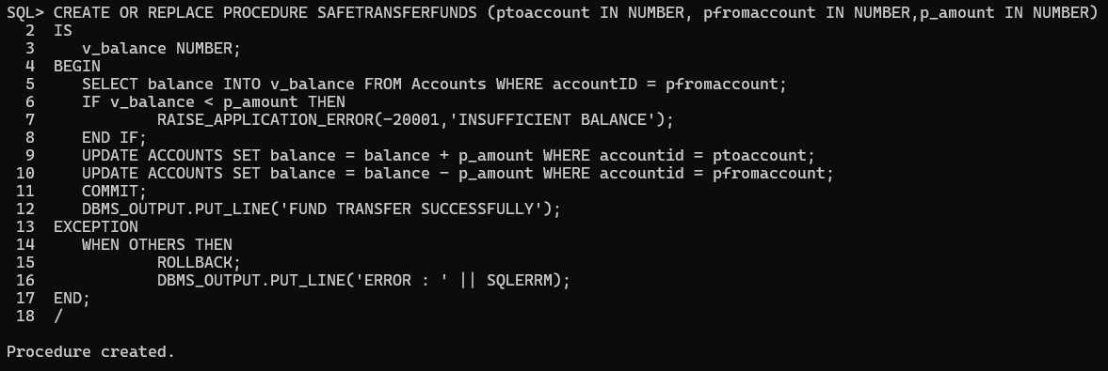
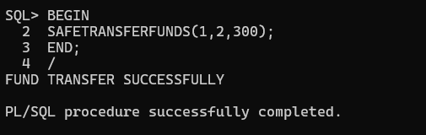
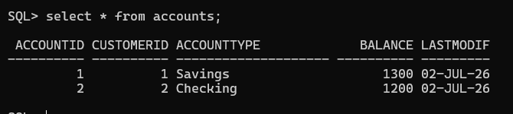
Scenario 2: Manage errors when updating employee salaries.
  - Question: Write a stored procedure UpdateSalary that increases the salary of an employee by a given percentage. If the employee ID does not exist, handle the exception and log an error message.
CODE:
CREATE OR REPLACE PROCEDURE UPDATESALARY (pemployeeid IN NUMBER,p_increment IN NUMBER)
IS
v_salary NUMBER;
BEGIN
SELECT salary INTO v_salary FROM EMPLOYEES WHERE employeeID = pemployeeid;
IF v_salary = NULL THEN
RAISE_APPLICATION_ERROR(-20001,'INCORRECT EMPLOYEE ID');
END IF;
UPDATE EMPLOYEES SET salary = salary * ((100 + p_increment)/100) WHERE employeeid = pemployeeid;
COMMIT;
DBMS_OUTPUT.PUT_LINE('Salary updated');
EXCEPTION
WHEN OTHERS THEN
ROLLBACK;
DBMS_OUTPUT.PUT_LINE('INCORRECT EMPLOYEE ID');
END;
/

FOR INCORRECT EMPLOYEEID
BEGIN
UPDATESALARY(3,5);
END;
/
FOR CORRECT EMPLOYEEID
BEGIN
UPDATESALARY(1,5);
END;
/
OUTPUT:
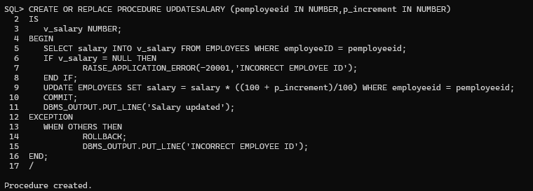
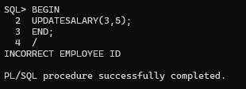
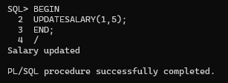
Scenario 3: Ensure data integrity when adding a new customer.
  - Question: Write a stored procedure AddNewCustomer that inserts a new customer into the Customers table. If a customer with the same ID already exists, handle the exception by logging an error and preventing the insertion.
CODE:
CREATE OR REPLACE PROCEDURE ADDNEWCUSTOMER (p_customerid IN NUMBER,p_name IN VARCHAR2, P_dob IN DATE,p_balance IN NUMBER, p_isvip IN CHAR)
IS
BEGIN
INSERT INTO Customers (CustomerID, Name, DOB, Balance, LastModified, ISVIP)
VALUES (p_customerid,p_name,p_dob,p_balance,SYSDATE,p_isvip);
COMMIT;
DBMS_OUTPUT.PUT_LINE('Customer Added');
EXCEPTION
WHEN OTHERS THEN
ROLLBACK;
DBMS_OUTPUT.PUT_LINE('DUPLICATE CUSTOMER');
END;
/
--FIRST TIME INSERTION
BEGIN
ADDNEWCUSTOMER(3, 'Bob Peter',TO_DATE('1990-07-20', 'YYYY-MM-DD'), 3000,'F');
END;
/
--DUPLICATE INSERTON
BEGIN
ADDNEWCUSTOMER(3, 'Bob Peter',TO_DATE('1990-07-20', 'YYYY-MM-DD'), 3000,'F');
END;
/
OUTPUT: 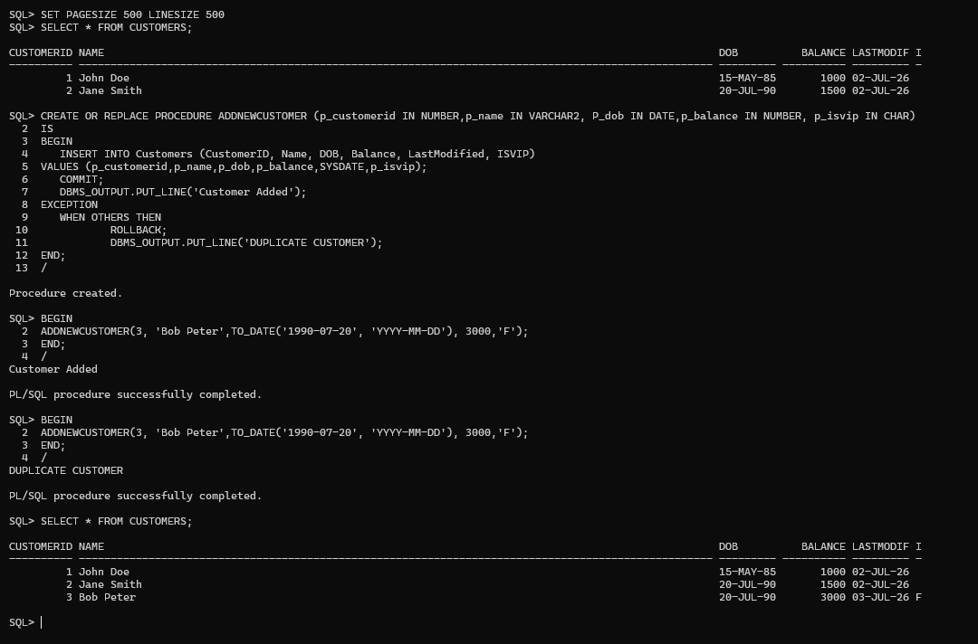
Exercise 3: Stored Procedures
Scenario 1: The bank needs to process monthly interest for all savings accounts.
  - Question: Write a stored procedure ProcessMonthlyInterest that calculates and updates the balance of all savings accounts by applying an interest rate of 1% to the current balance.
CODE:
CREATE OR REPLACE PROCEDURE ProcessMonthlyInterest
IS
BEGIN
UPDATE ACCOUNTS SET balance = balance * ((101)/100) WHERE accounttype = 'Savings';
COMMIT;
DBMS_OUTPUT.PUT_LINE('Saving accounts are updated');
EXCEPTION
WHEN OTHERS THEN
ROLLBACK;
DBMS_OUTPUT.PUT_LINE('No saving account to update');
END;
/
--EXCECUTION
BEGIN
ProcessMonthlyInterest();
END;
/
OUTPUT: 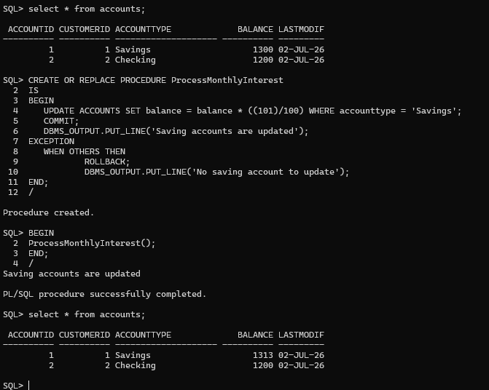
Scenario 2: The bank wants to implement a bonus scheme for employees based on their performance.
  - Question: Write a stored procedure UpdateEmployeeBonus that updates the salary of employees in a given department by adding a bonus percentage passed as a parameter.
CODE:
CREATE OR REPLACE PROCEDURE UpdateEmployeeBonus (p_department IN VARCHAR2,p_increment IN NUMBER)
IS
BEGIN
UPDATE EMPLOYEES SET salary = salary * ((100 + p_increment)/100) WHERE department = p_department;
COMMIT;
DBMS_OUTPUT.PUT_LINE('Salary updated');
EXCEPTION
WHEN OTHERS THEN
ROLLBACK;
DBMS_OUTPUT.PUT_LINE('INCORRECT EMPLOYEE ID');
END;
/
--EXECUTION
BEGIN
UpdateEmployeeBonus('IT',5);
END;
/
OUTPUT:
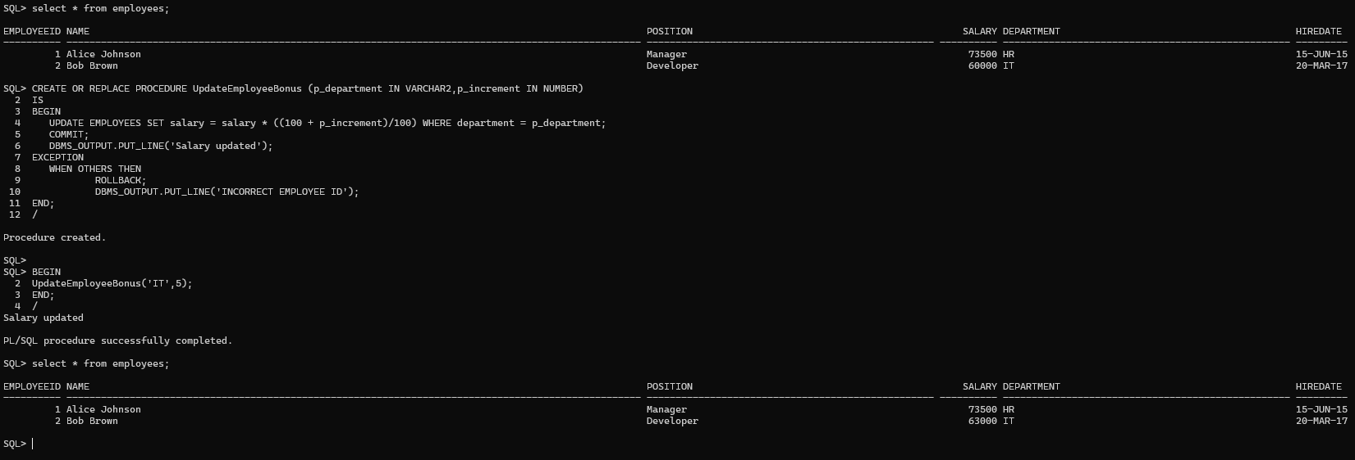
Scenario 3: Customers should be able to transfer funds between their accounts.
  - Question: Write a stored procedure TransferFunds that transfers a specified amount from one account to another, checking that the source account has sufficient balance before making the transfer.
CODE:
CREATE OR REPLACE PROCEDURE TransferFunds (p_customerid IN NUMBER,p_toaccount IN NUMBER, p_fromaccount IN NUMBER,p_amount IN NUMBER)
IS
v_balance NUMBER;
BEGIN
SELECT balance INTO v_balance FROM Accounts WHERE accountID = p_fromaccount AND customerid = p_customerid;
IF v_balance < p_amount THEN
RAISE_APPLICATION_ERROR(-20001,'INSUFFICIENT BALANCE');
END IF;
UPDATE ACCOUNTS SET balance = balance + p_amount WHERE accountid = p_toaccount AND customerid = p_customerid;

IF SQL%ROWCOUNT = 0 THEN
RAISE_APPLICATION_ERROR(-20002,'Destination account not found.');
END IF;

UPDATE ACCOUNTS SET balance = balance - p_amount WHERE accountid = p_fromaccount AND customerid = p_customerid;
IF SQL%ROWCOUNT = 0 THEN
RAISE_APPLICATION_ERROR(-20002,'Source account not found.');
END IF;
COMMIT;
DBMS_OUTPUT.PUT_LINE('FUND TRANSFER SUCCESSFULLY');
EXCEPTION
WHEN OTHERS THEN
ROLLBACK;
DBMS_OUTPUT.PUT_LINE('ERROR : ' || SQLERRM);
END;
/
--EXECUTION
BEGIN
TransferFunds(1,1,3,300);
END;
/
--EXECUTION
BEGIN
TransferFunds(1,2,3,300);
END;
/
OUTPUT: 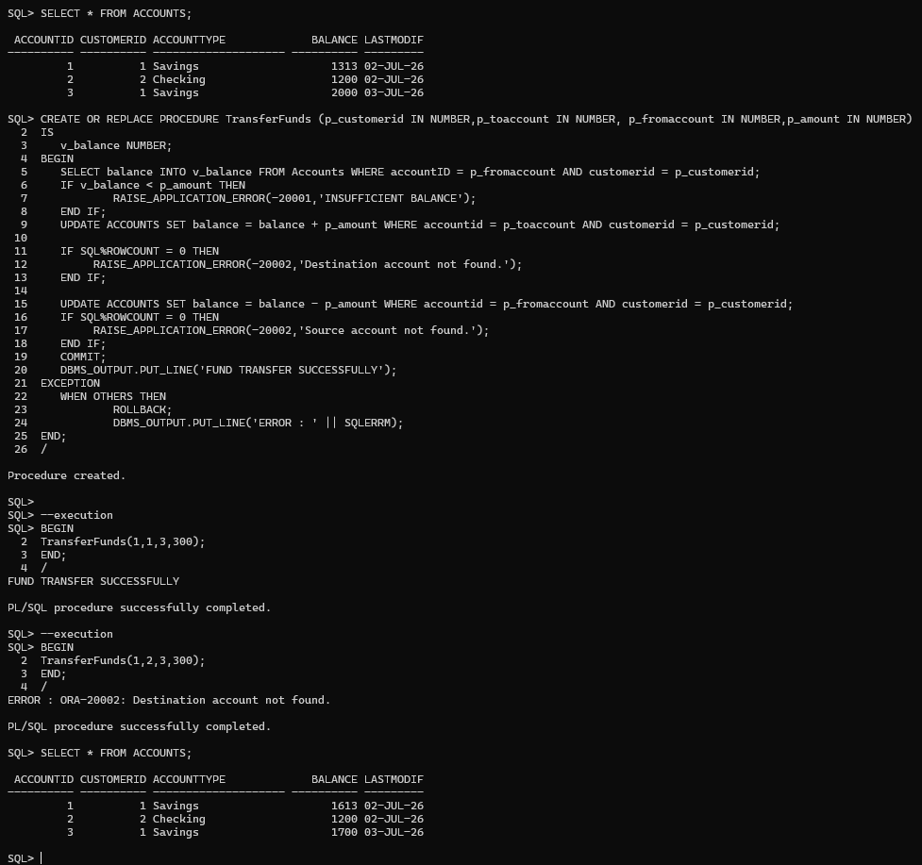

Exercise 4: Functions

Scenario 1: Calculate the age of customers for eligibility checks.
  - Question: Write a function CalculateAge that takes a customer's date of birth as input and returns their age in years.
CODE:
CREATE OR REPLACE FUNCTION CalculateAge(DOB DATE) RETURN NUMBER
IS
v_age NUMBER;
BEGIN
v_age := FLOOR(MONTHS_BETWEEN(SYSDATE,DOB)/12);
RETURN v_age;
END;
/
--EXECUTION
DECLARE
BEGIN
DBMS_OUTPUT.PUT_LINE('AGE OF CUSTOMER IS : ' || CalculateAge(TO_DATE('2015-06-15','YYYY-MM-DD')));
END;
/
OUTPUT: 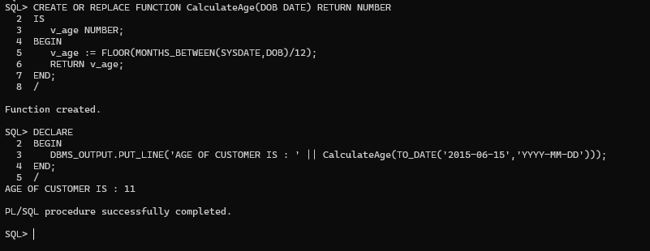

Scenario 2: The bank needs to compute the monthly installment for a loan.
  - Question: Write a function CalculateMonthlyInstallment that takes the loan amount, interest rate, and loan duration in years as input and returns the monthly installment amount.
CODE:
CREATE OR REPLACE FUNCTION CalculateMonthlyInstallment(AMOUNT NUMBER,INTERESTRATE NUMBER,DURATION NUMBER) RETURN NUMBER
IS
v_installment NUMBER;
v_amount NUMBER;
BEGIN
v_amount := (AMOUNT*INTERESTRATE*DURATION)/100;
v_installment := v_amount/12;
RETURN v_installment;
END;
/
--EXECUTION
DECLARE
BEGIN
DBMS_OUTPUT.PUT_LINE('MONTHLY INSTALLMENT IS : ' || CalculateMonthlyInstallment(5000,5,5));
END;
/
OUTPUT:
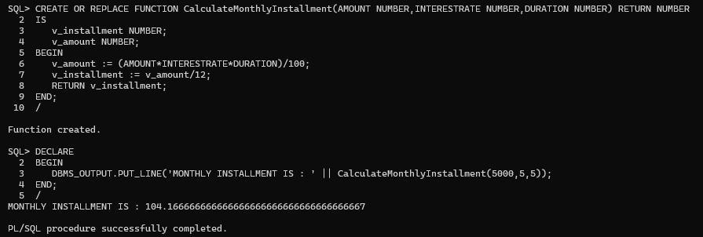
Scenario 3: Check if a customer has sufficient balance before making a transaction.
  - Question: Write a function HasSufficientBalance that takes an account ID and an amount as input and returns a boolean indicating whether the account has at least the specified amount.
CODE:
CREATE OR REPLACE FUNCTION HasSufficientBalance
(
p_accountid IN NUMBER,
p_amount IN NUMBER
)
RETURN BOOLEAN
IS
v_balance NUMBER;
BEGIN
SELECT Balance
INTO v_balance
FROM Accounts
WHERE AccountID = p_accountid;

IF v_balance >= p_amount THEN
RETURN TRUE;
ELSE
RETURN FALSE;
END IF;

EXCEPTION
WHEN NO_DATA_FOUND THEN
RETURN FALSE;
END;
/
--EXECUTION
DECLARE
v_result BOOLEAN;
BEGIN
v_result := HasSufficientBalance(1,500);

IF v_result THEN
DBMS_OUTPUT.PUT_LINE('Has Sufficient Balance: TRUE');
ELSE
DBMS_OUTPUT.PUT_LINE('Has Sufficient Balance: FALSE');
END IF;
END;
/
OUTPUT:
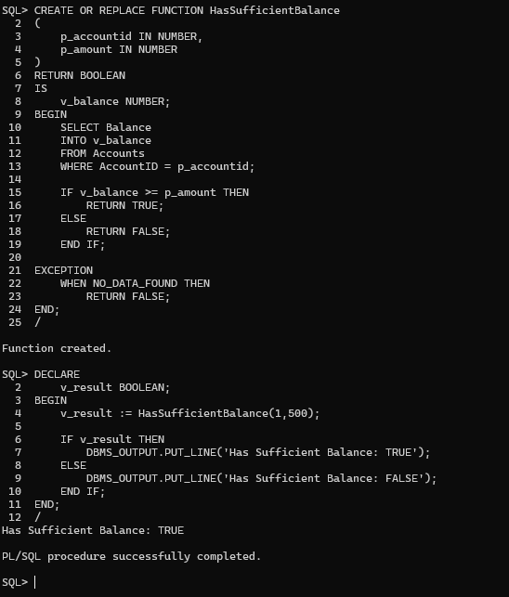
Exercise 5: Triggers
Scenario 1: Automatically update the last modified date when a customer's record is updated.
  - Question: Write a trigger UpdateCustomerLastModified that updates the LastModified column of the Customers table to the current date whenever a customer's record is updated.
CODE:
CREATE OR REPLACE TRIGGER UpdateCustomerLastModified
BEFORE UPDATE
ON Customers
FOR EACH ROW
BEGIN
:NEW.LastModified := SYSDATE;
END;
/
--TESTING
UPDATE Customers
SET Balance = 5000
WHERE CustomerID = 1;
COMMIT;
SELECT * FROM customers;
OUTPUT:
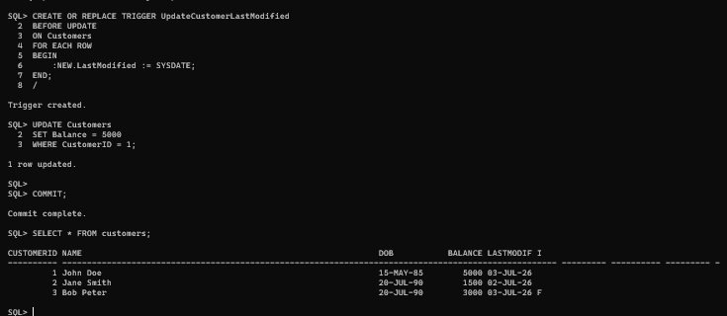
Scenario 2: Maintain an audit log for all transactions.
  - Question: Write a trigger LogTransaction that inserts a record into an AuditLog table whenever a transaction is inserted into the Transactions table.
CODE:

OUTPUT:
Scenario 3: Enforce business rules on deposits and withdrawals.
  - Question: Write a trigger CheckTransactionRules that ensures withdrawals do not exceed the balance and deposits are positive before inserting a record into the Transactions table.
CODE:
CREATE OR REPLACE TRIGGER LogTransaction
AFTER INSERT
ON Transactions
FOR EACH ROW
BEGIN
INSERT INTO AuditLog (TransactionID,AccountID,TransactionDate,Amount,TransactionType) VALUES (:NEW.TransactionID,:NEW.AccountID,:NEW.TransactionDate,:NEW.Amount,:NEW.TransactionType);
END;
/
--TESTING
INSERT INTO TRANSACTIONS (TRANSACTIONID,ACCOUNTID,TRANSACTIONDATE,AMOUNT,TRANSACTIONTYPE) VALUES (3,1,SYSDATE,400,'withdrawal');
OUTPUT: 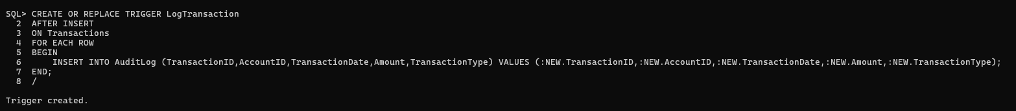
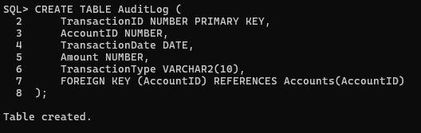
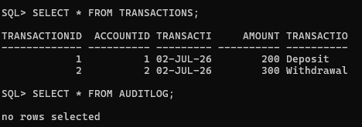
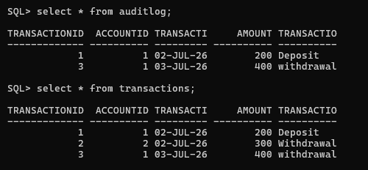
Exercise 6: Cursors
Scenario 1: Generate monthly statements for all customers.
  - Question: Write a PL/SQL block using an explicit cursor GenerateMonthlyStatements that retrieves all transactions for the current month and prints a statement for each customer.
CODE:
DECLARE
CURSOR GenerateMonthlyStatements IS
SELECT c.customerid,c.Name,t.transactionID,t.transactiondate,t.amount,t.transactiontype
FROM CUSTOMERS c JOIN ACCOUNTS a ON c.customerID = a.customerID JOIN TRANSACTIONS t ON a.accountID = t.accountID WHERE EXTRACT(MONTH FROM t.transactionDate) = EXTRACT(MONTH FROM SYSDATE) AND EXTRACT(YEAR FROM t.transactionDate) = EXTRACT(YEAR FROM SYSDATE);
BEGIN
FOR rec IN GenerateMonthlyStatements LOOP
DBMS_OUTPUT.PUT_LINE('Customer ID : ' || rec.customerID || '| Name : ' || rec.Name || ' | Transaction ID : ' || rec.transactionID || ' | Date : ' || TO_CHAR(rec.TransactionDate,'DD-MON-YYYY') || ' | Amount : ' || rec.amount || ' | Type : ' || rec.Transactiontype);
END LOOP;
END;
/
OUTPUT:
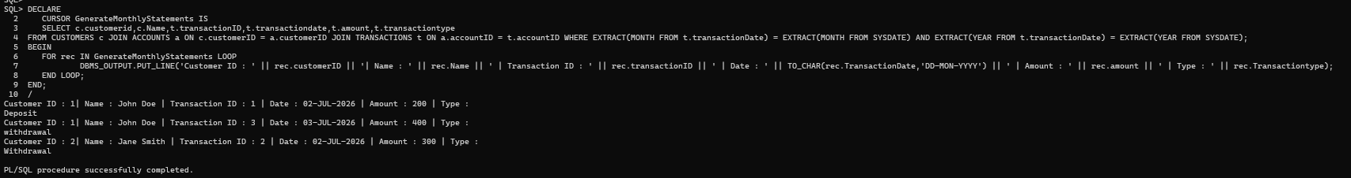
Scenario 2: Apply annual fee to all accounts.
  - Question: Write a PL/SQL block using an explicit cursor ApplyAnnualFee that deducts an annual maintenance fee from the balance of all accounts.
CODE:
DECLARE
CURSOR ApplyAnnualFee IS
SELECT ACCOUNTID,BALANCE FROM ACCOUNTS FOR UPDATE;
v_fee NUMBER := 100;
BEGIN
FOR rec IN ApplyAnnualFee LOOP
UPDATE ACCOUNTS SET BALANCE = BALANCE - v_fee WHERE CURRENT OF ApplyAnnualFee;

DBMS_OUTPUT.PUT_LINE('Annual fee deducted from account: '|| rec.accountID);
END LOOP;
COMMIT;
END;
/
OUTPUT: 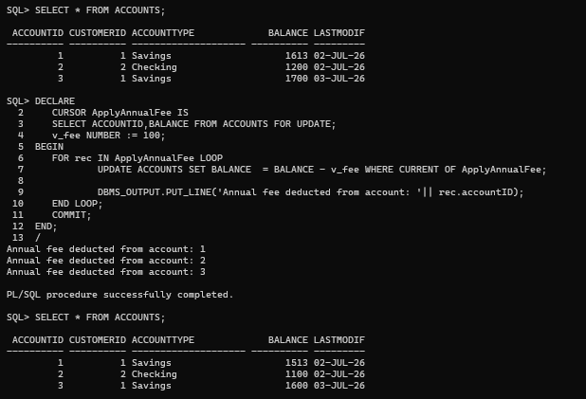
Scenario 3: Update the interest rate for all loans based on a new policy.
  - Question: Write a PL/SQL block using an explicit cursor UpdateLoanInterestRates that fetches all loans and updates their interest rates based on the new policy.
Assume the new policy increases every loan's interest rate by 0.5%.
CODE:
DECLARE
CURSOR UpdateLoanInterestRates IS
SELECT loanid,interestrate FROM loans FOR UPDATE;
increment NUMBER := 0.5;
BEGIN
FOR rec IN UpdateLoanInterestRates LOOP
UPDATE Loans SET Interestrate = Interestrate + (increment/100) WHERE CURRENT OF UpdateLoanInterestRates;
DBMS_OUTPUT.PUT_LINE('Increment the loan '|| rec.loanid);
END LOOP;
COMMIT;
END;
/
OUTPUT: 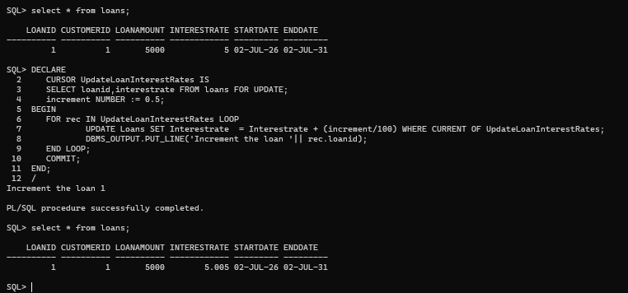

Exercise 7: Packages
Scenario 1: Group all customer-related procedures and functions into a package.
  - Question: Create a package CustomerManagement with procedures for adding a new customer, updating customer details, and a function to get customer balance.
CODE:
CREATE OR REPLACE PACKAGE CustomerManagement AS

PROCEDURE AddCustomer(p_customerid NUMBER,p_name VARCHAR2,p_dob DATE,p_balance NUMBER, p_isvip CHAR);

PROCEDURE UpdateCustomer(p_customerid NUMBER,p_name VARCHAR2,p_balance NUMBER);

FUNCTION GetCustomerBalance(p_customerid NUMBER) RETURN NUMBER;
END CustomerManagement;
/

CREATE OR REPLACE PACKAGE BODY CustomerManagement AS

PROCEDURE AddCustomer(p_customerid NUMBER,p_name VARCHAR2,p_dob DATE,p_balance NUMBER, p_isvip CHAR)
IS
BEGIN
INSERT INTO Customers VALUES( p_customerid,p_name,p_dob,p_balance,SYSDATE,p_isvip);
DBMS_OUTPUT.PUT_LINE('Customer Added');
EXCEPTION
WHEN DUP_VAL_ON_INDEX THEN
DBMS_OUTPUT.PUT_LINE('Customer Already Exists');
END;
PROCEDURE UpdateCustomer(p_customerid NUMBER,p_name VARCHAR2,p_balance NUMBER)
IS
BEGIN
UPDATE Customers SET Name = p_name, Balance = p_balance WHERE CustomerID = p_customerid;
DBMS_OUTPUT.PUT_LINE('Customer Updated');
END;
FUNCTION GetCustomerBalance(p_customerid NUMBER)
RETURN NUMBER
IS
v_balance NUMBER;
BEGIN
SELECT Balance INTO v_balance FROM Customers WHERE CustomerID = p_customerid;
RETURN v_balance;
END;
END CustomerManagement;
/

BEGIN
CustomerManagement.AddCustomer(5,'Rahul',TO_DATE('2000-01-01','YYYY-MM-DD'),8000,'N');
CustomerManagement.UpdateCustomer(5,'Rahul Sharma',9000);
END;
/

DECLARE
v_balance NUMBER;
BEGIN
v_balance := CustomerManagement.GetCustomerBalance(5);
DBMS_OUTPUT.PUT_LINE(v_balance);
END;
/
OUTPUT:
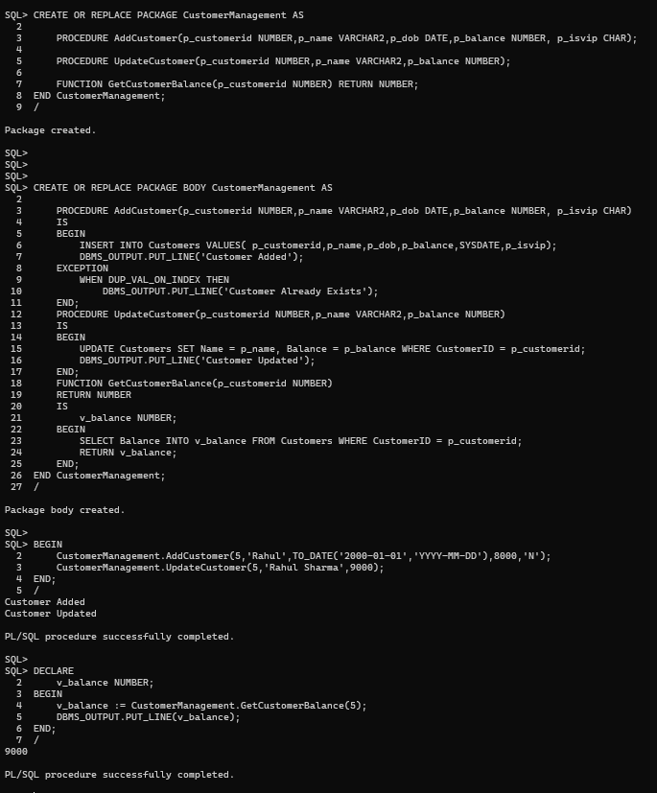
Scenario 2: Create a package to manage employee data.
  - Question: Write a package EmployeeManagement with procedures to hire new employees, update employee details, and a function to calculate annual salary.
CODE:
CREATE OR REPLACE PACKAGE EmployeeManagement AS
PROCEDURE HireEmployee(p_id NUMBER,p_name VARCHAR2,p_position VARCHAR2,p_salary NUMBER,p_department VARCHAR2,p_hiredate DATE);
PROCEDURE UpdateEmployee(p_id NUMBER,p_salary NUMBER);
FUNCTION AnnualSalary(p_id NUMBER)
RETURN NUMBER;
END EmployeeManagement;
/

CREATE OR REPLACE PACKAGE BODY EmployeeManagement AS

PROCEDURE HireEmployee(p_id NUMBER,p_name VARCHAR2,p_position VARCHAR2,p_salary NUMBER,p_department VARCHAR2,p_hiredate DATE)
IS
BEGIN
INSERT INTO Employees VALUES(p_id,p_name,p_position,p_salary,p_department,p_hiredate);
DBMS_OUTPUT.PUT_LINE('Employee Added');
END;
PROCEDURE UpdateEmployee(p_id NUMBER,p_salary NUMBER)
IS
BEGIN
UPDATE Employees SET Salary = p_salary WHERE EmployeeID = p_id;
DBMS_OUTPUT.PUT_LINE('Employee Updated');
END;
FUNCTION AnnualSalary(p_id NUMBER)
RETURN NUMBER
IS
v_salary NUMBER;
BEGIN
SELECT Salary INTO v_salary FROM Employees WHERE EmployeeID = p_id;
RETURN v_salary*12;
END;
END EmployeeManagement;
/

BEGIN
EmployeeManagement.HireEmployee(10,'Amit','Developer',50000,'IT',SYSDATE);
EmployeeManagement.UpdateEmployee(10,55000);
END;
/

DECLARE
v_salary NUMBER;
BEGIN
v_salary := EmployeeManagement.AnnualSalary(10);
DBMS_OUTPUT.PUT_LINE(v_salary);
END;
/
OUTPUT: 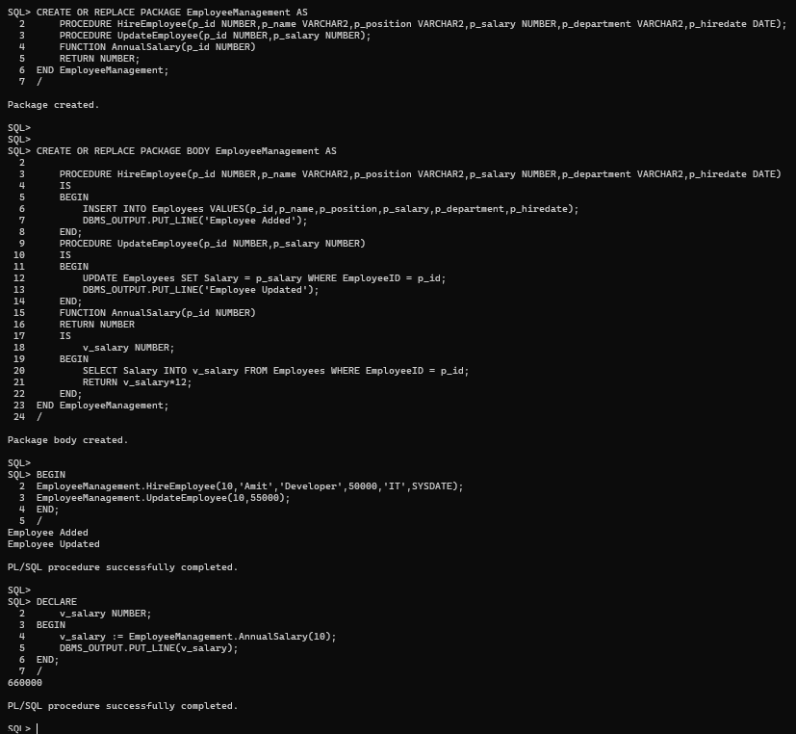
Scenario 3: Group all account-related operations into a package.
  - Question: Create a package AccountOperations with procedures for opening a new account, closing an account, and a function to get the total balance of a customer across all accounts.

Schema to be Created

CREATE TABLE Customers (
CustomerID NUMBER PRIMARY KEY,
Name VARCHAR2(100),
DOB DATE,
Balance NUMBER,
LastModified DATE
);

CREATE TABLE Accounts (
AccountID NUMBER PRIMARY KEY,
CustomerID NUMBER,
AccountType VARCHAR2(20),
Balance NUMBER,
LastModified DATE,
FOREIGN KEY (CustomerID) REFERENCES Customers(CustomerID)
);

CREATE TABLE Transactions (
TransactionID NUMBER PRIMARY KEY,
AccountID NUMBER,
TransactionDate DATE,
Amount NUMBER,
TransactionType VARCHAR2(10),
FOREIGN KEY (AccountID) REFERENCES Accounts(AccountID)
);

CREATE TABLE Loans (
LoanID INTEGER PRIMARY KEY,
CustomerID NUMBER,
LoanAmount NUMBER,
InterestRate NUMBER,
StartDate DATE,
EndDate DATE,
FOREIGN KEY (CustomerID) REFERENCES Customers(CustomerID)
);

CREATE TABLE Employees (
EmployeeID NUMBER PRIMARY KEY,
Name VARCHAR2(100),
Position VARCHAR2(50),
Salary NUMBER,
Department VARCHAR2(50),
HireDate DATE
);

Example Scripts for Sample Data Insertion

INSERT INTO Customers (CustomerID, Name, DOB, Balance, LastModified)
VALUES (1, 'John Doe', TO_DATE('1985-05-15', 'YYYY-MM-DD'), 1000, SYSDATE);

INSERT INTO Customers (CustomerID, Name, DOB, Balance, LastModified)
VALUES (2, 'Jane Smith', TO_DATE('1990-07-20', 'YYYY-MM-DD'), 1500, SYSDATE);

INSERT INTO Accounts (AccountID, CustomerID, AccountType, Balance, LastModified)
VALUES (1, 1, 'Savings', 1000, SYSDATE);

INSERT INTO Accounts (AccountID, CustomerID, AccountType, Balance, LastModified)
VALUES (3, 1, 'Savings', 2000, SYSDATE);

INSERT INTO Accounts (AccountID, CustomerID, AccountType, Balance, LastModified)
VALUES (2, 2, 'Checking', 1500, SYSDATE);

INSERT INTO Transactions (TransactionID, AccountID, TransactionDate, Amount, TransactionType)
VALUES (1, 1, SYSDATE, 200, 'Deposit');

INSERT INTO Transactions (TransactionID, AccountID, TransactionDate, Amount, TransactionType)
VALUES (2, 2, SYSDATE, 300, 'Withdrawal');

INSERT INTO Loans (LoanID, CustomerID, LoanAmount, InterestRate, StartDate, EndDate)
VALUES (1, 1, 5000, 5, SYSDATE, ADD_MONTHS(SYSDATE, 60));

INSERT INTO Employees (EmployeeID, Name, Position, Salary, Department, HireDate)
VALUES (1, 'Alice Johnson', 'Manager', 70000, 'HR', TO_DATE('2015-06-15', 'YYYY-MM-DD'));

INSERT INTO Employees (EmployeeID, Name, Position, Salary, Department, HireDate)
VALUES (2, 'Bob Brown', 'Developer', 60000, 'IT', TO_DATE('2017-03-20', 'YYYY-MM-DD'));

