**Advance Database Management System**

**Practical 2: Performing Subquery-Join Operations on Relational Schema**

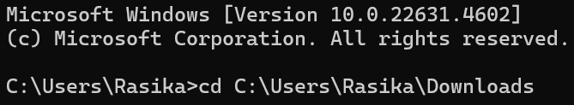

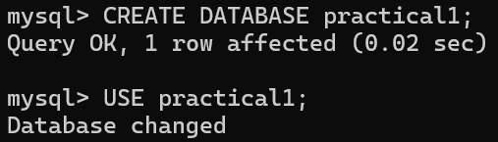



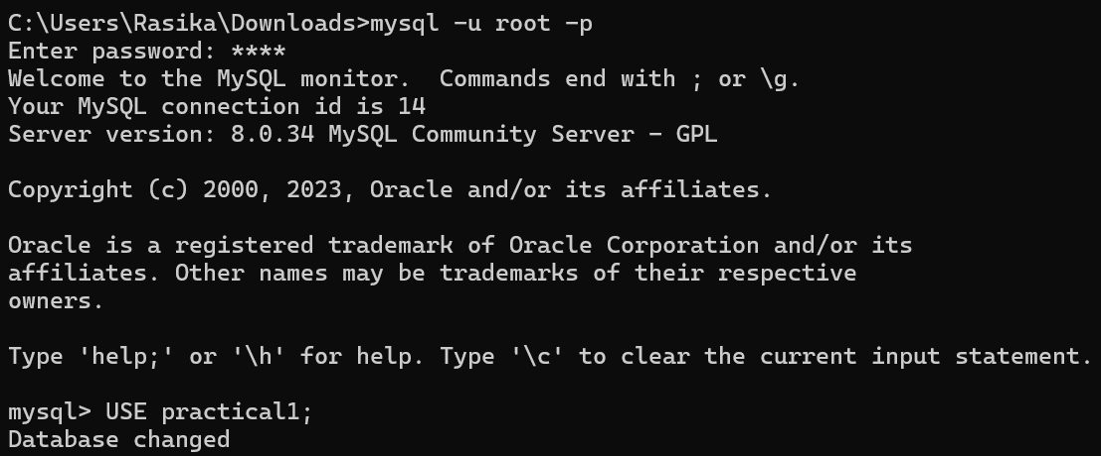

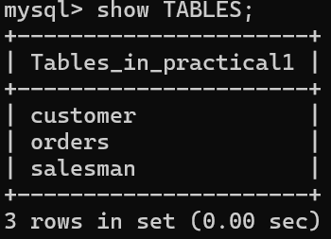

**TABLES:**

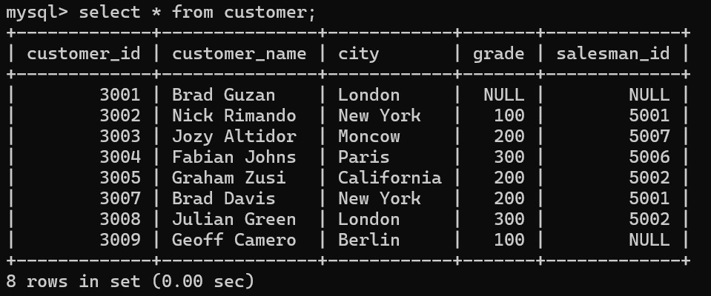

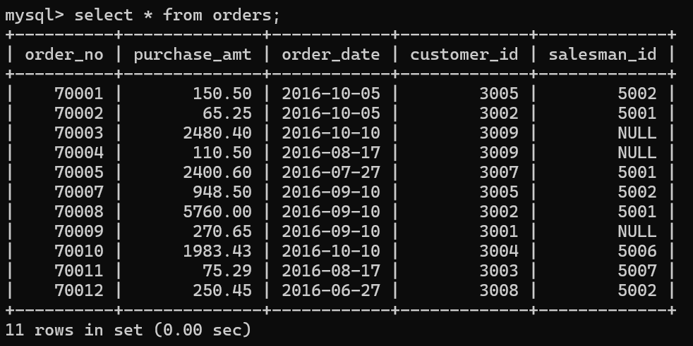

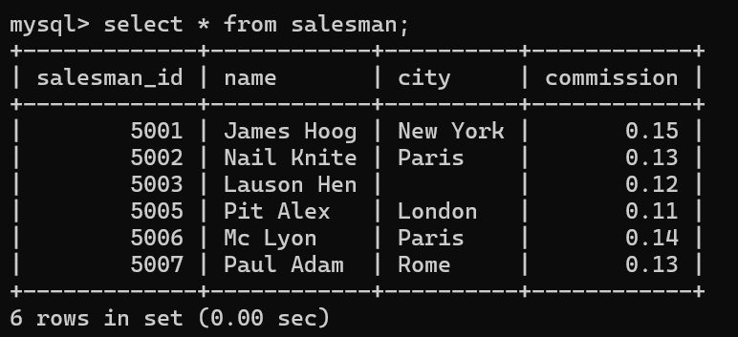

1. **USING (practical 1):**
2. Count the customers with grades above Bangalore’s average.

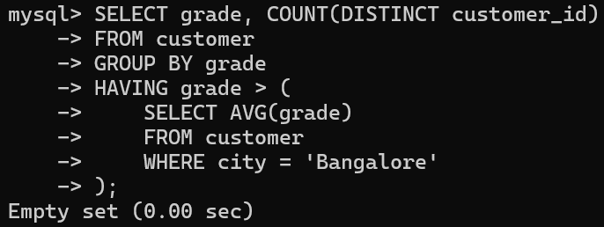

1. Find the name and numbers of all salesmen who had more than one customer.

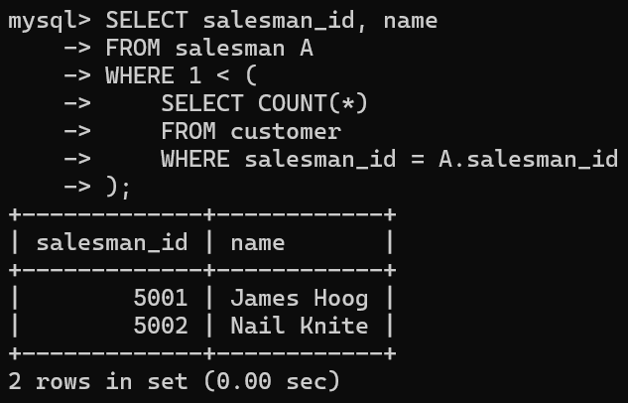

1. List all salesmen and indicate those who have and don’t have customers in their cities (Use UNION operation).

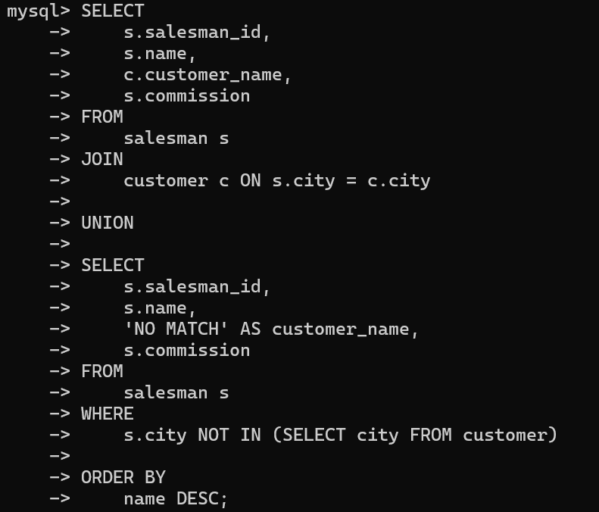

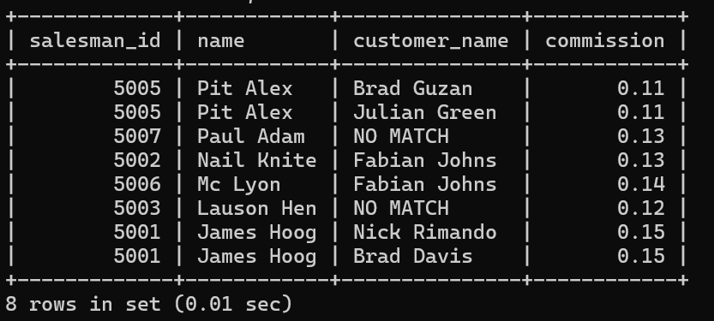

1. Create a view that finds the salesman who has the customer with the highest order of a day.

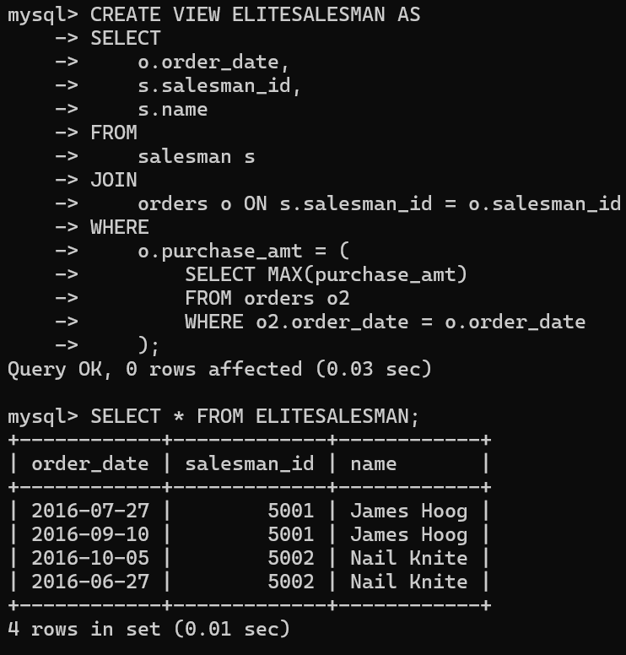

1. Demonstrate the DELETE operation by removing salesman with id 1000. All his orders must also be deleted.

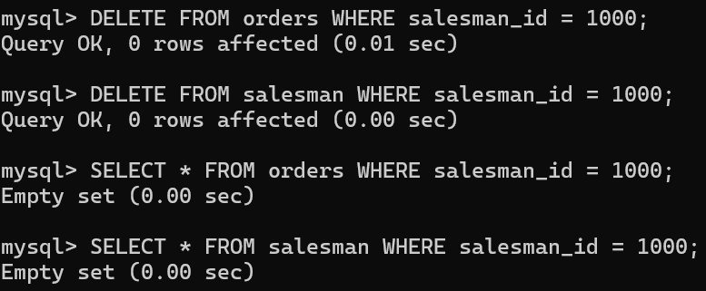

1. Design ERD for the following schema and execute the following Queries on it:

* Consider the schema for Movie Database:
  + 1. ACTOR (Act_id, Act_Name, Act_Gender)
    2. DIRECTOR (Dir_id, Dir_Name, Dir_Phone)
    3. MOVIES (Mov_id, Mov_Title, Mov_Year, Mov_Lang, Dir_id)
    4. MOVIE_CAST (Act_id, Mov_id, Role)
    5. RATING (Mov_id, Rev_Stars)

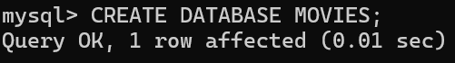

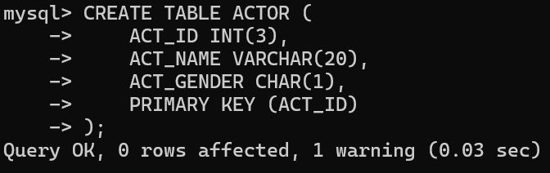

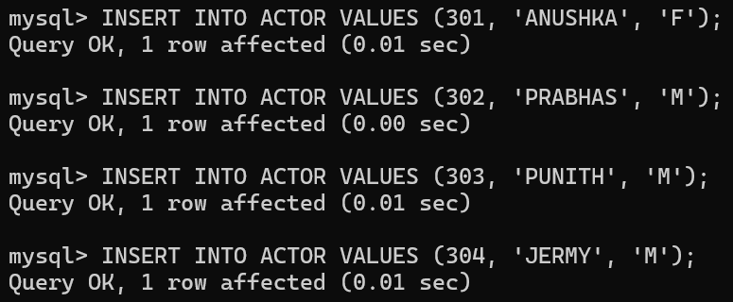

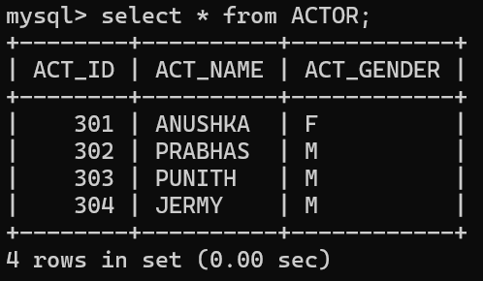

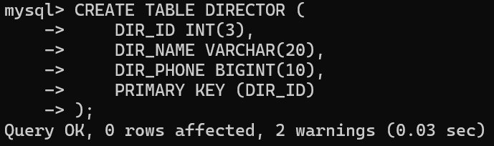

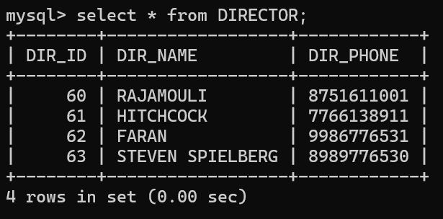

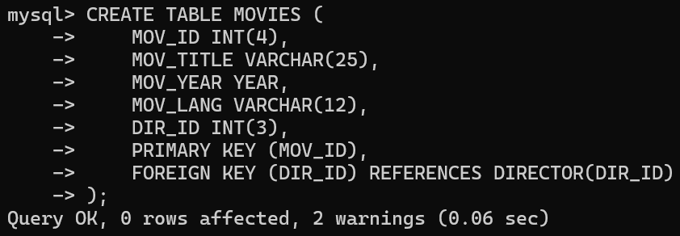

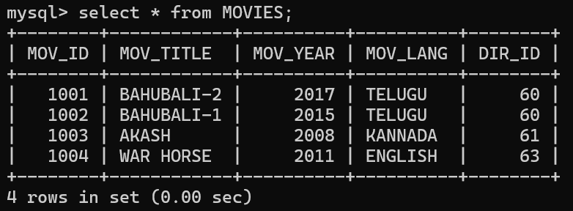

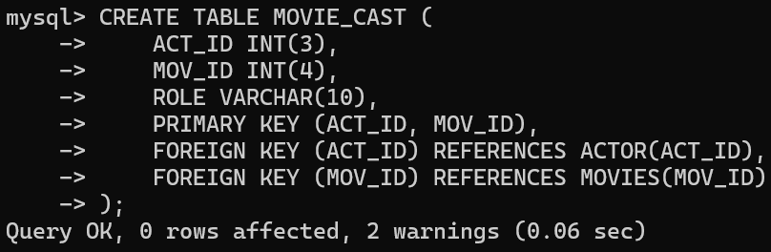

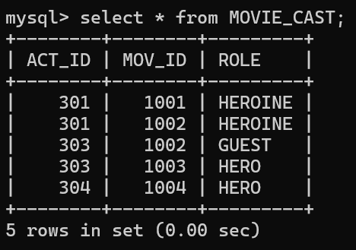

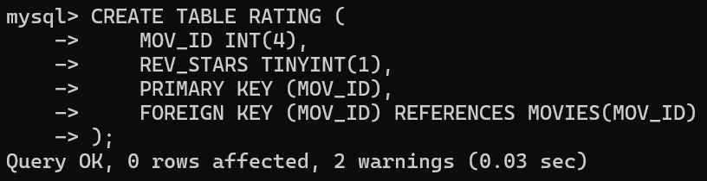

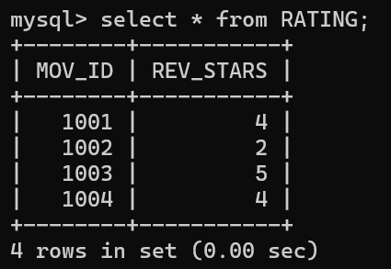

**List the titles of all movies directed by ‘Hitchcock’:**

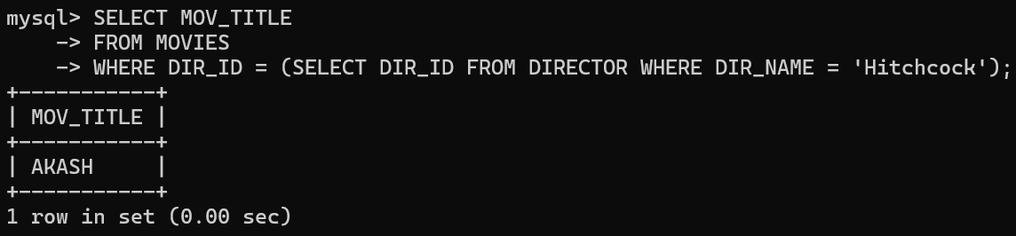

1. **Find the movie names where one or more actors acted in two or more movies:**

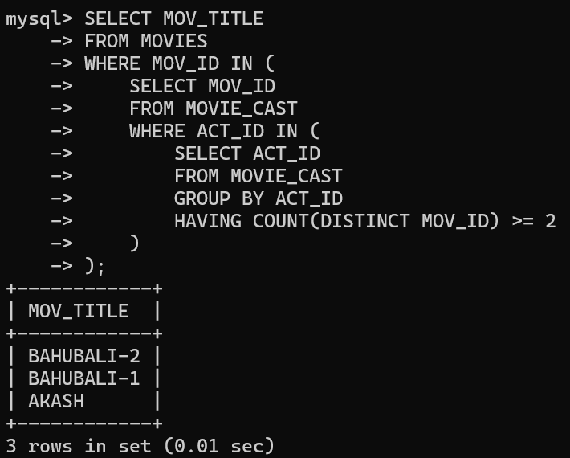

1. **List all actors who acted in a movie before 2000 and also in a movie after 2015 (use JOIN operation):**

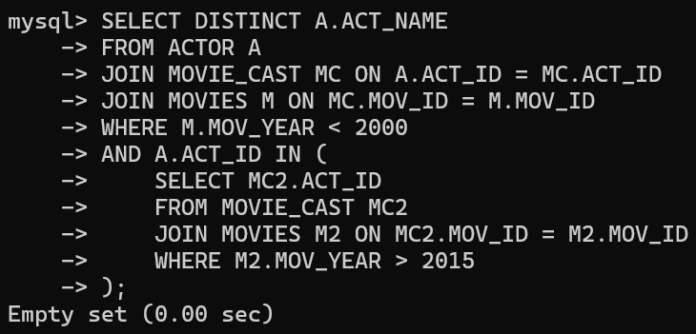

1. **Find the title of movies and number of stars for each movie that has at least one rating and find the highest number of stars that movie received. Sort the result by movie title:**

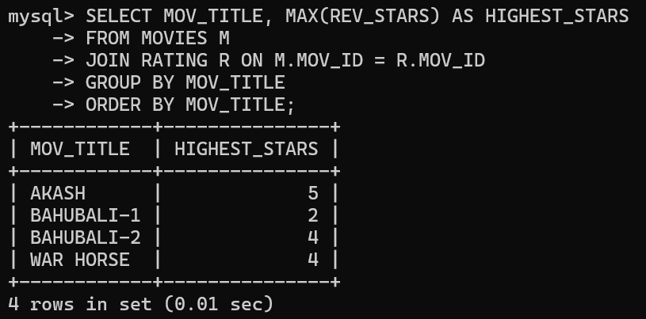

1. **Update the rating of all movies directed by ‘Steven Spielberg’ to 5:**

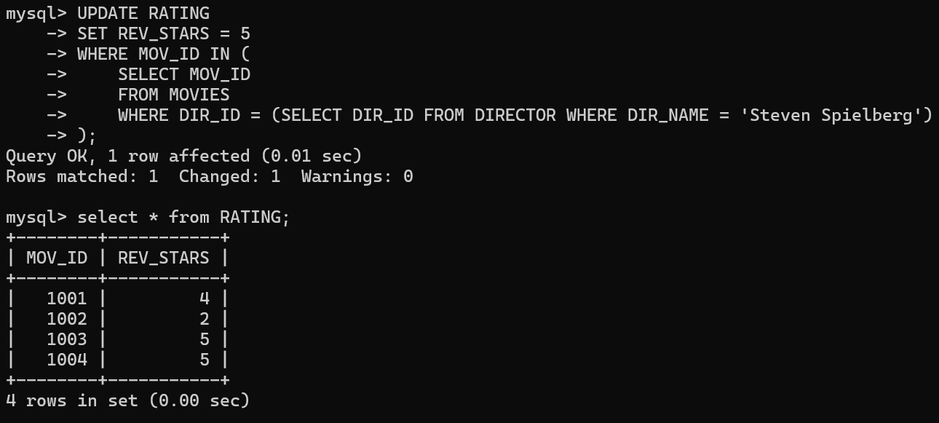

1. **Design ERD for the following schema and execute the following Queries on it:**

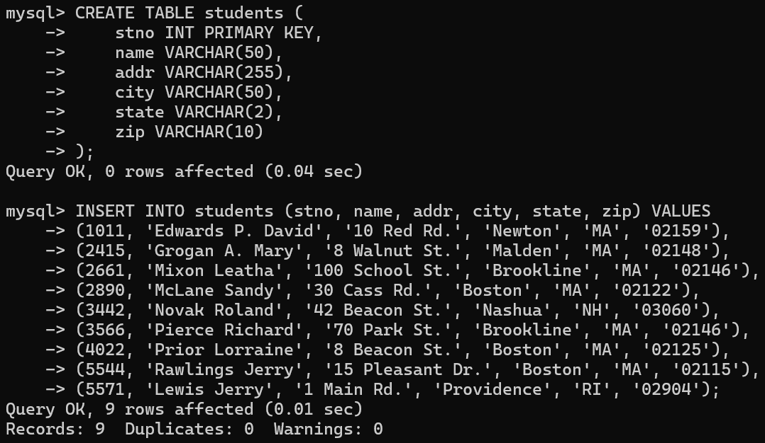

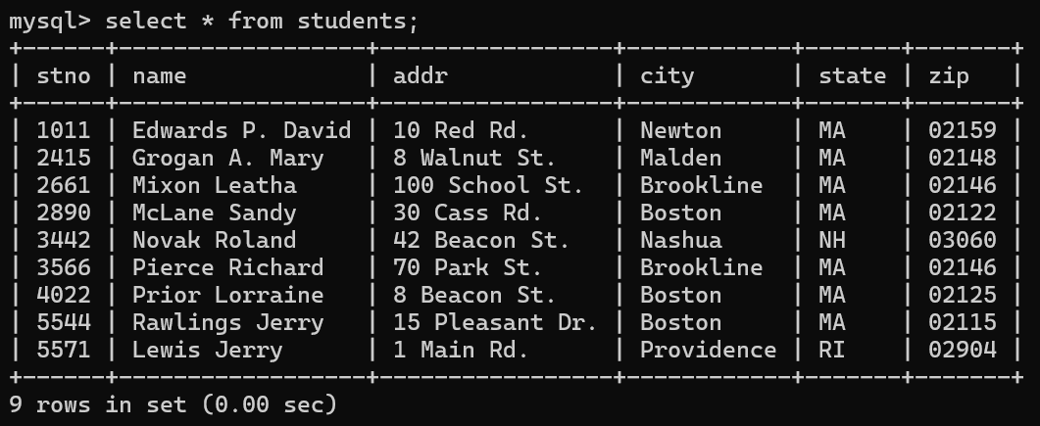

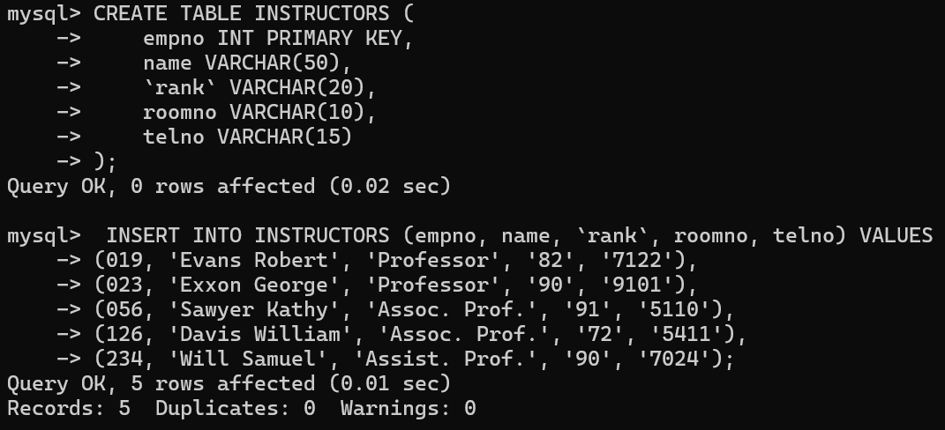

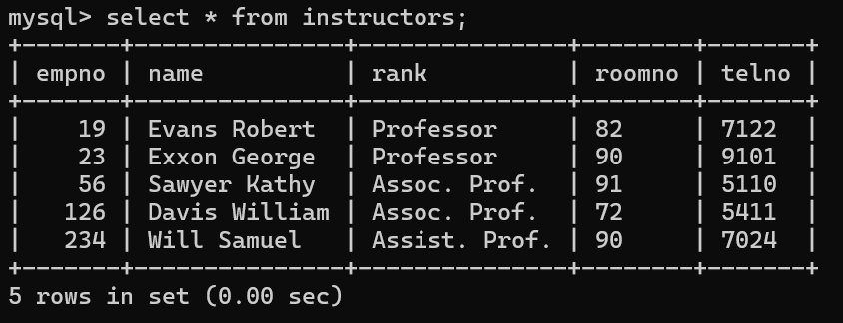

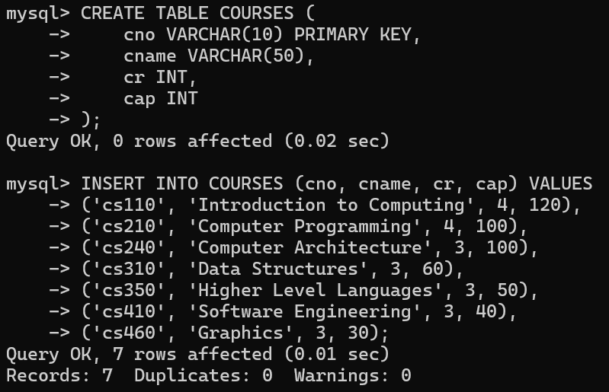

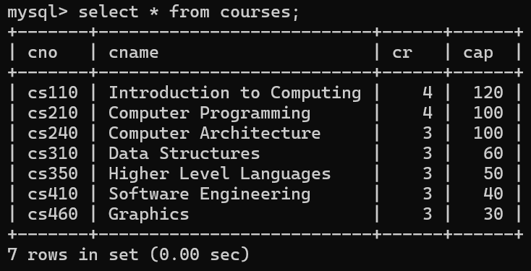

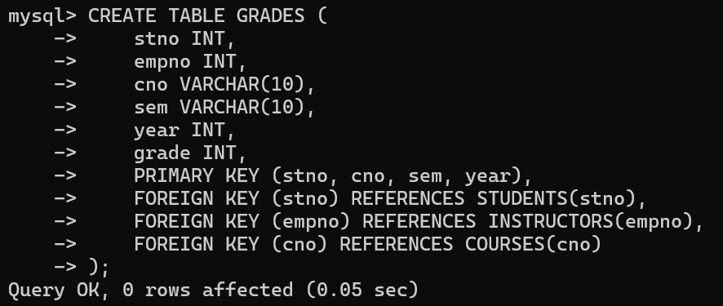

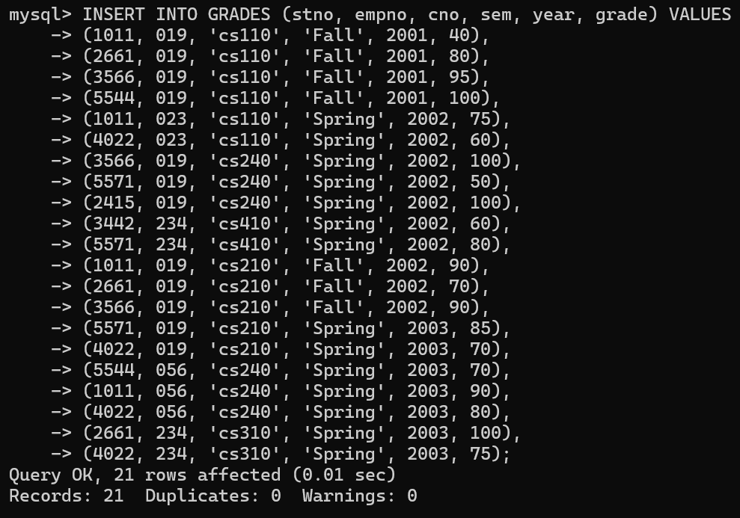

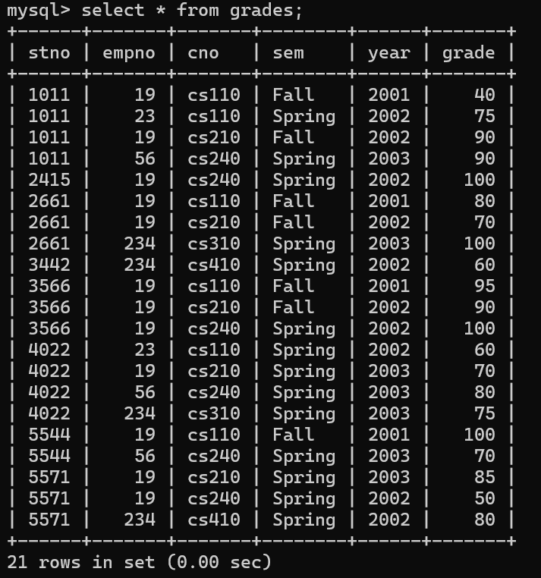

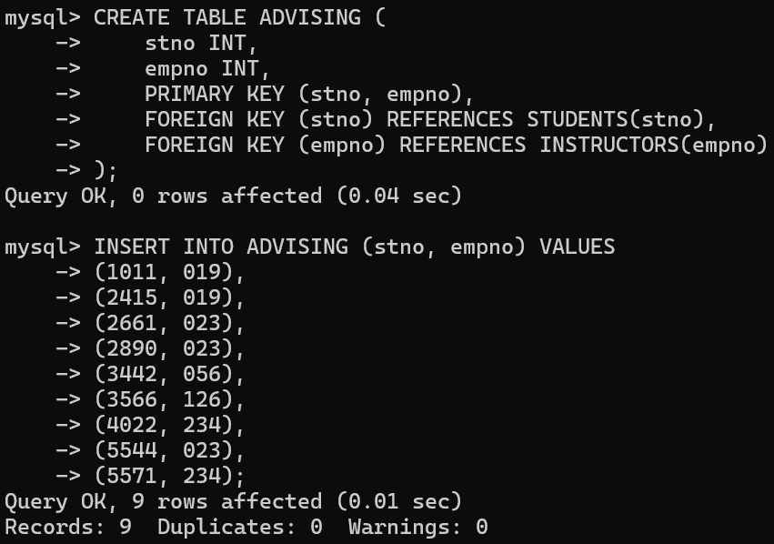

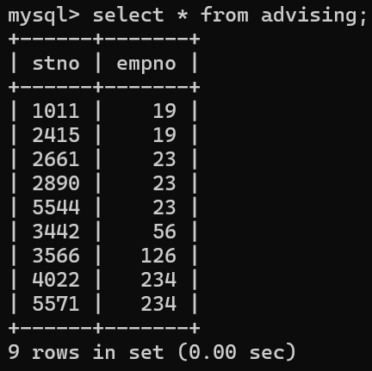

*For odd roll numbers(any 10 )*

1. Names of students who took some four-credit courses:

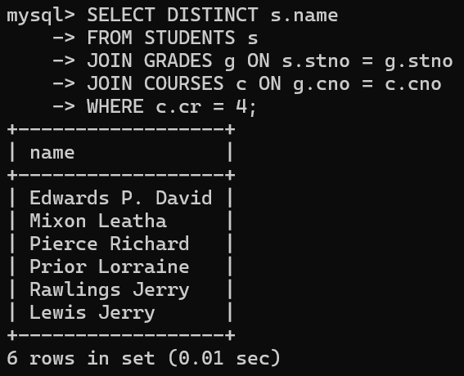

Names of students who took every four-credit course:

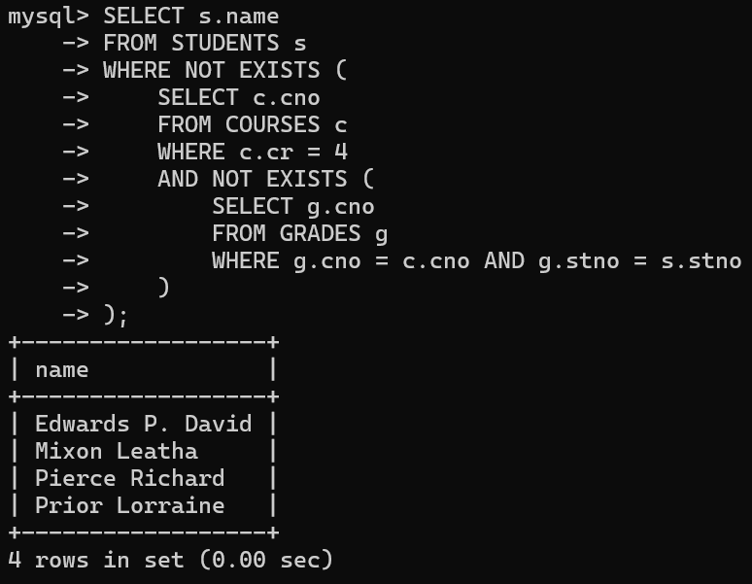

Names of students who took a course with an instructor who is also their advisor:

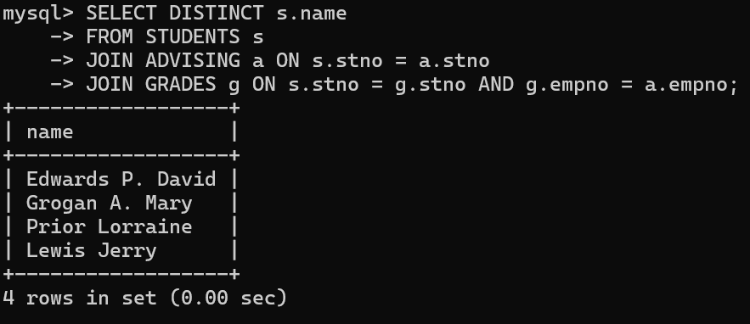

Names of students who took both cs210 and cs310:

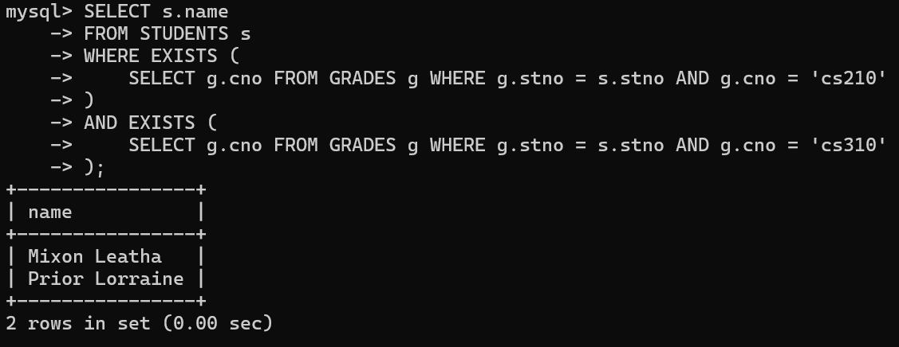

Names of students whose advisor is not a full professor:

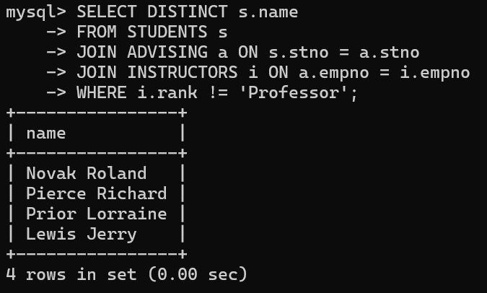

Instructors who taught students advised by another instructor in the same room:

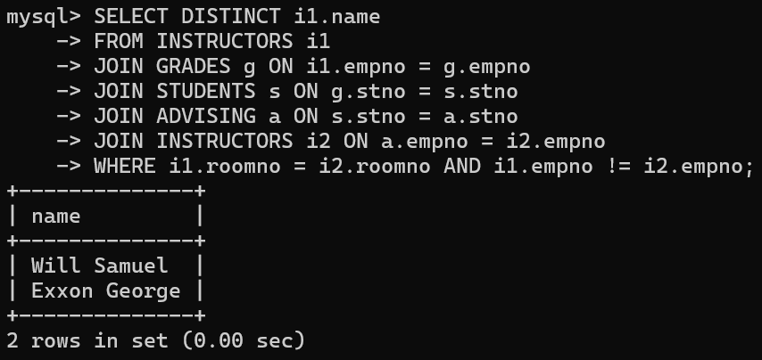

Course numbers for courses that enroll exactly two students:

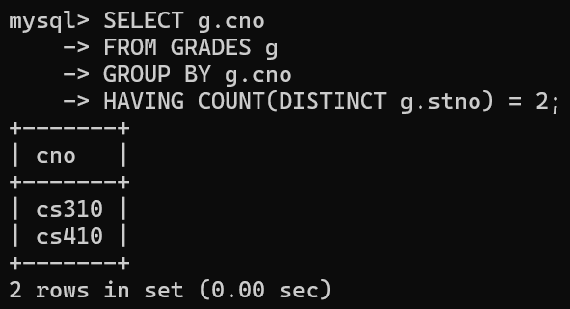

Names of students for whom no other student lives in the same city:

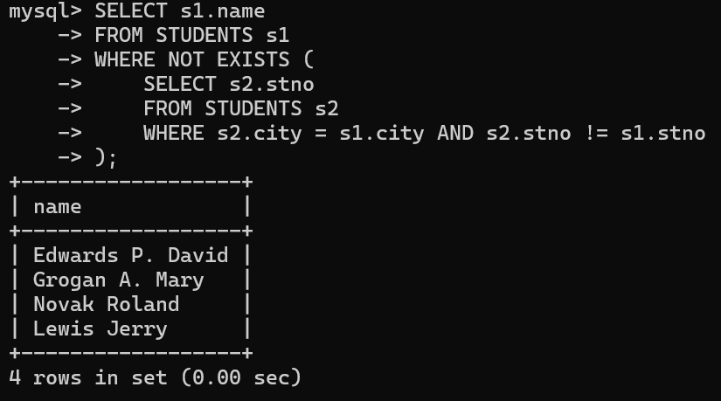

Course numbers taken by students living in Boston taught by an associate professor:

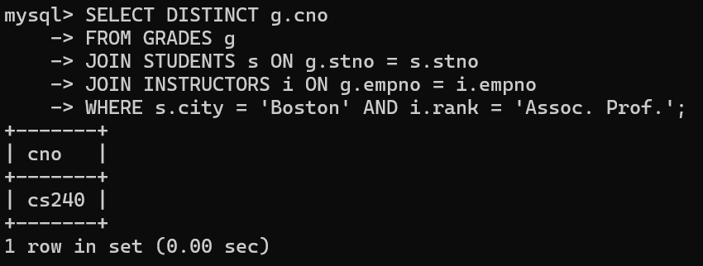

Telephone numbers of instructors teaching courses taken by Boston students:

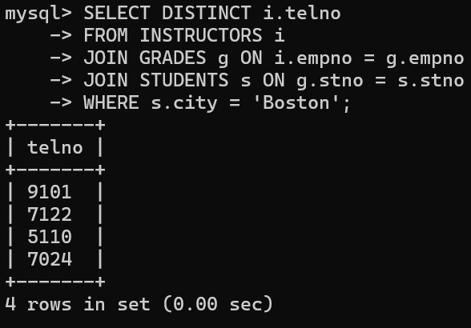

Names of students who took every course taken by Richard Pierce:

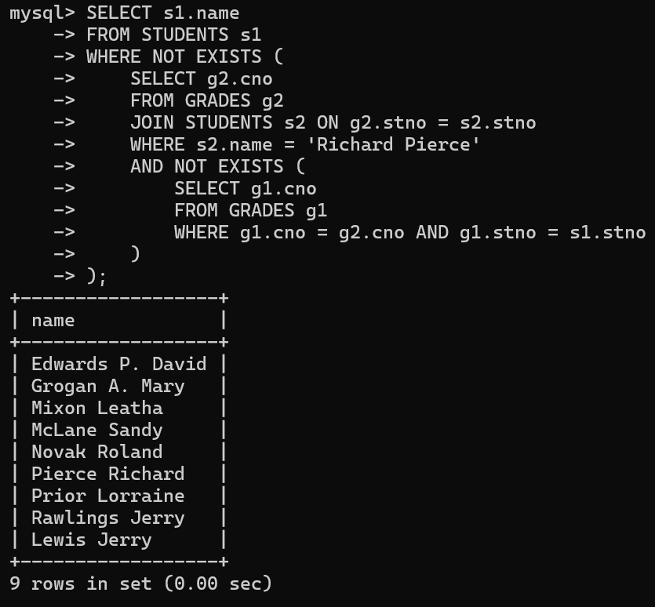

Names of students who took only one course:

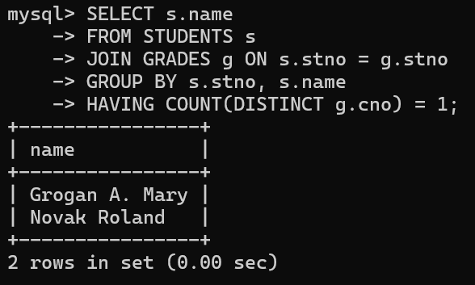

Names of instructors who teach no course:

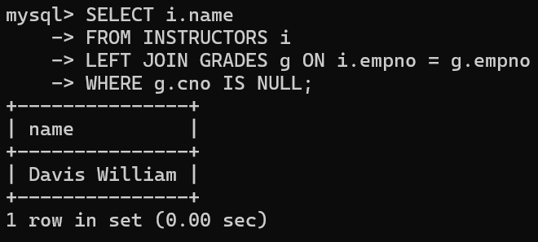

Names of instructors who taught only one course in Spring 2001:

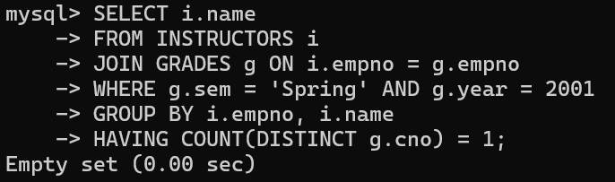

*For even roll numbers(any 10)*

1. Find the names of students who took only four-credit courses.

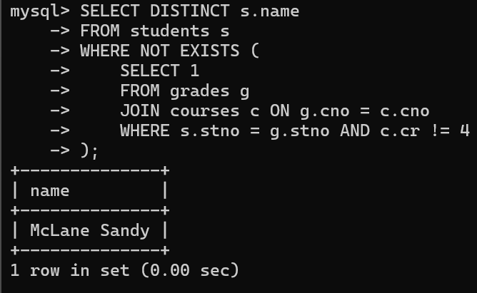

1. Find the names of students who took no four-credit courses.

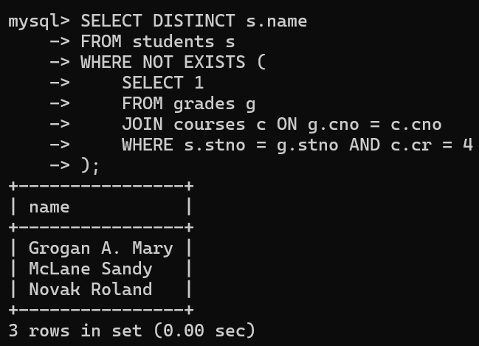

1. Find the names of students who took cs210 or cs310.

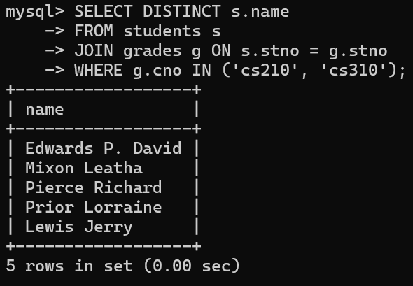

1. Find names of all students who have a cs210 grade higher than the highest grade given in cs310 and did not take any course with Prof. Evans.

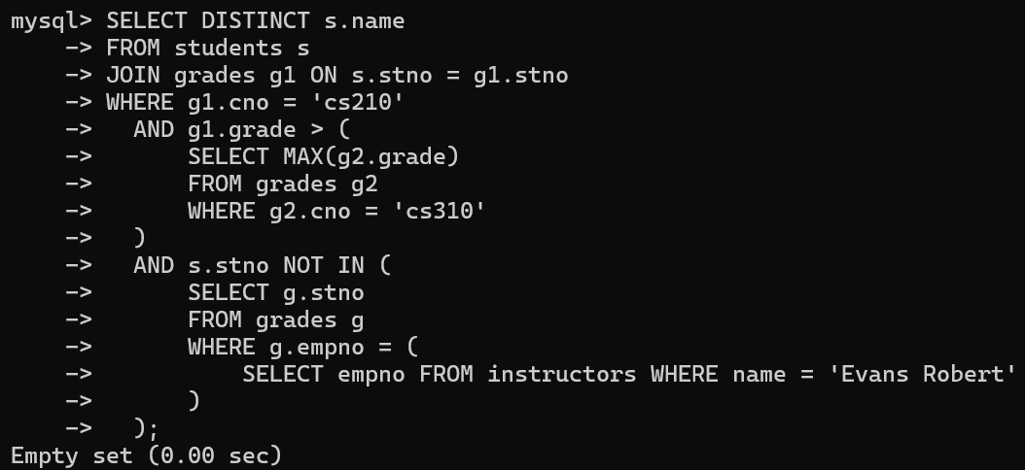

1. Find course numbers for courses that enrol at least two students; solve the same query for courses that enroll at least three students.

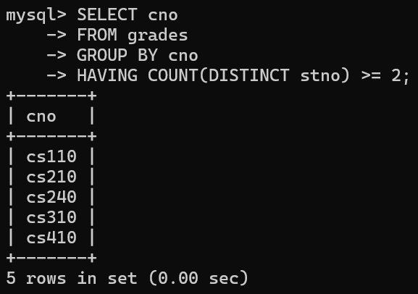

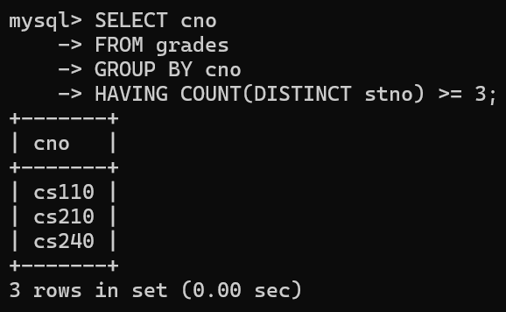

1. Find the names of students who obtained the highest grade in cs210.

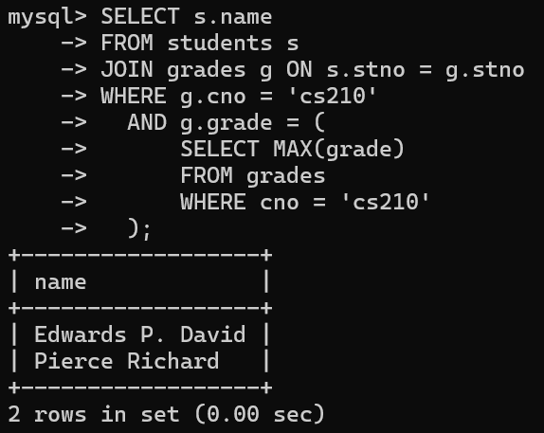

1. Find the names of instructors who teach courses attended by students who took a course with an instructor who is an assistant professor.

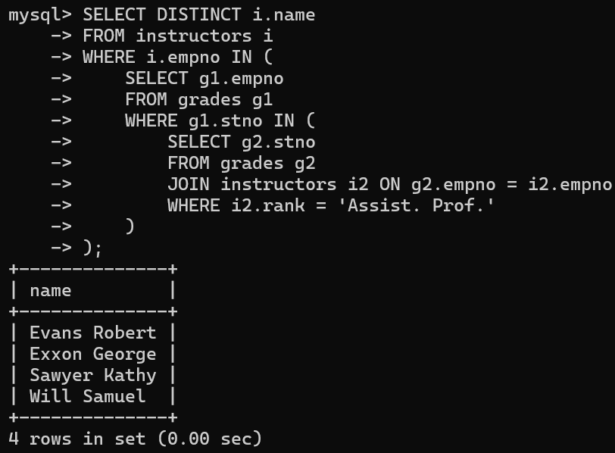

1. Find the lowest grade of a student who took a course during the spring of 2003.

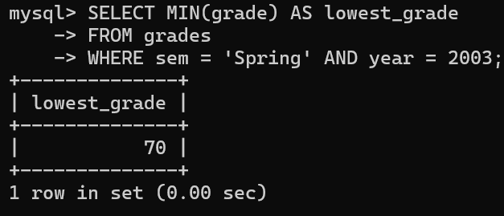

1. Find the names for students such that if prof. Evans teaches a course, then the student takes that course (although not necessarily with prof. Evans).

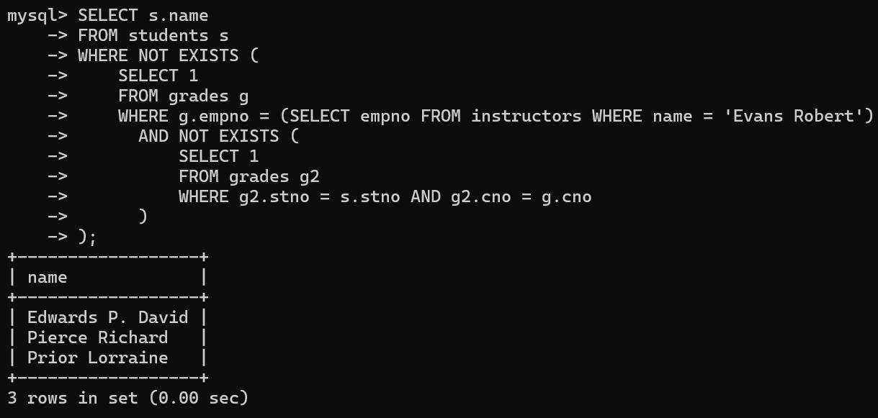

1. Find the names of students whose advisor did not teach them any course.

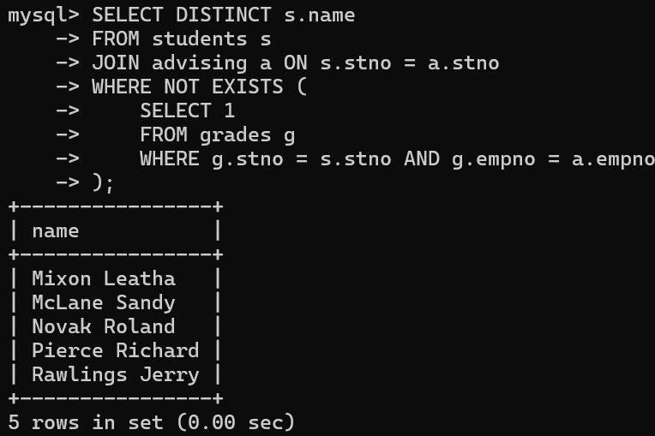

1. Find the names of students who have failed all their courses (failing is defined as a grade less than 60).

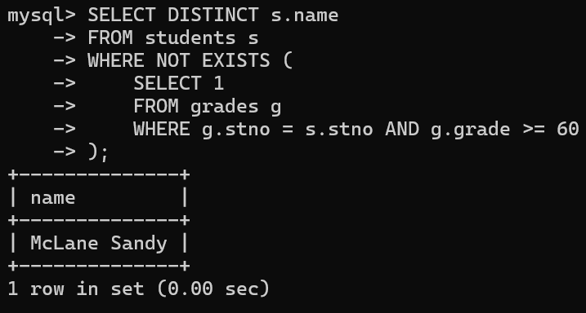

1. Find the highest grade of a student who never took cs110.

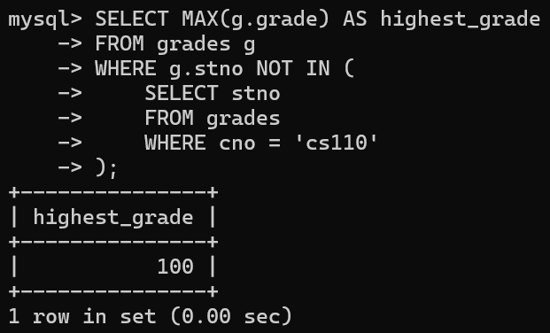

1. Find the names of students who do not have an advisor.

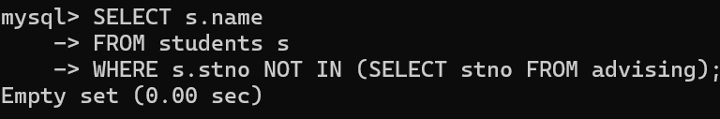

14. Find names of courses taken by students who do not live in Massachusetts (MA).

