**Advance Database Management System**

**Practical 6: Replication in MongoDB**

**1. Create Folders**

* Create three folders to store data for each MongoDB instance:
  + primary
  + secondary1
  + secondary2

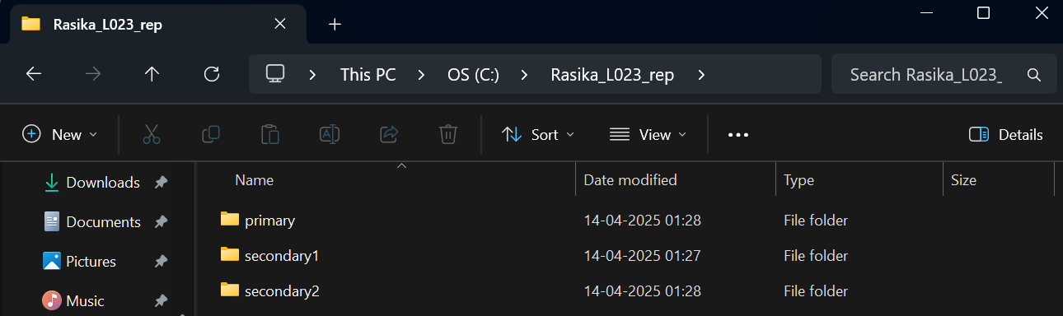

**2. Start MongoDB Instances**

* Open Windows PowerShell ISE and run the following commands:

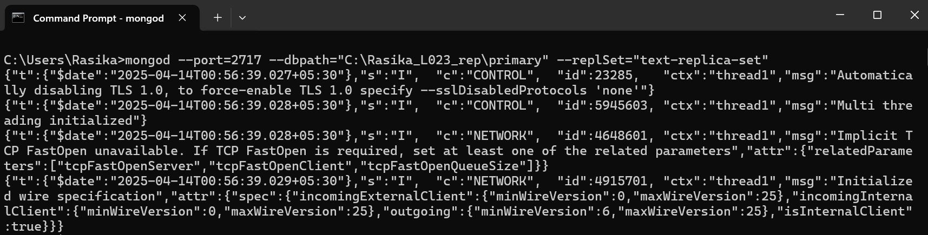

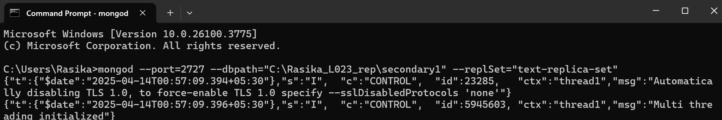

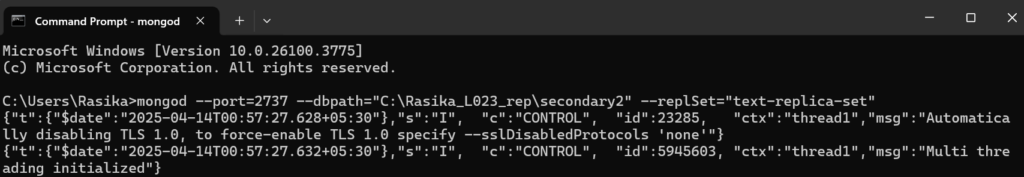

**3. Initialize Replica Set**

* Connect to the primary instance:

mongosh --host="localhost:2717"

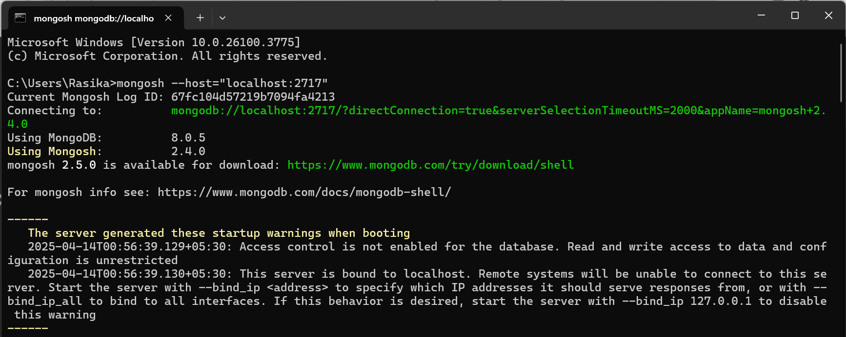

* Initiate the replica set:

rs.initiate()

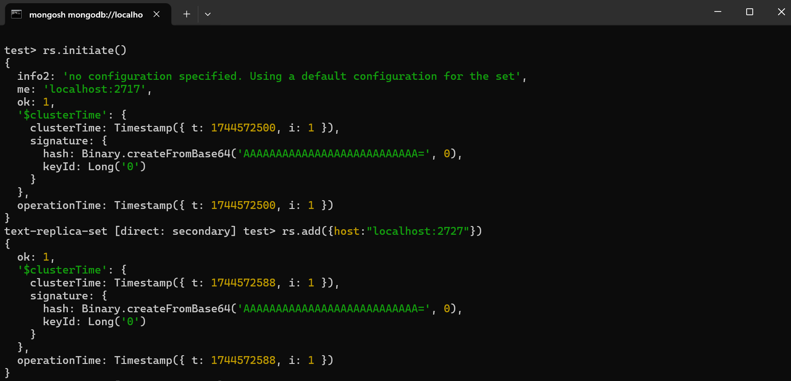

**4. Add Secondary Nodes**

* Add the secondary nodes to the replica set:

rs.add({host:"localhost:2727"})

rs.add({host:"localhost:2737"})

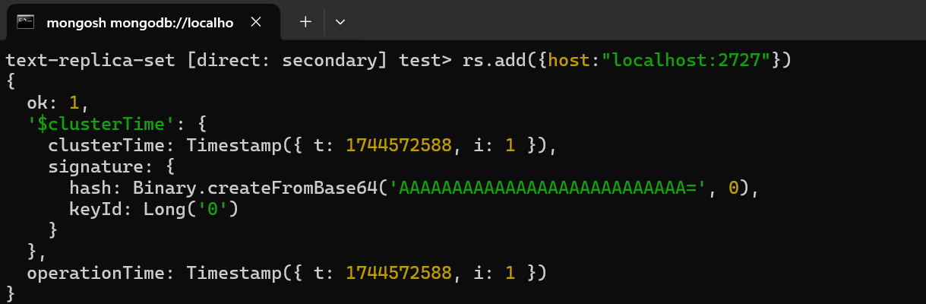

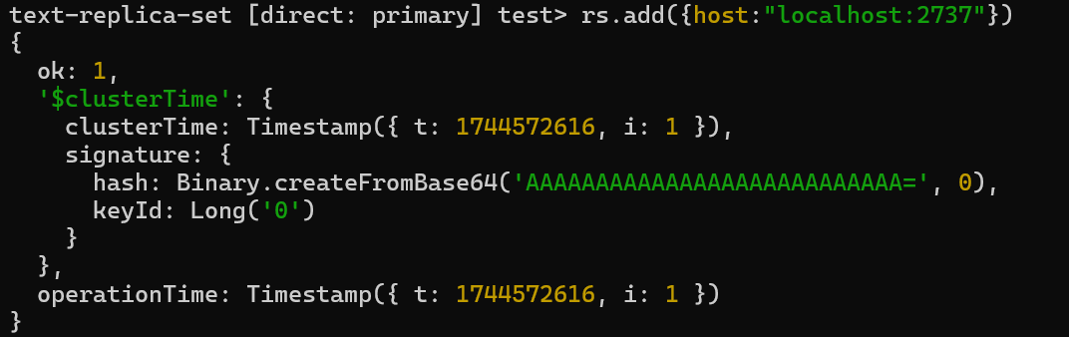

**5. Check Replica Set Status**

* Check the status of the replica set:

rs.status()

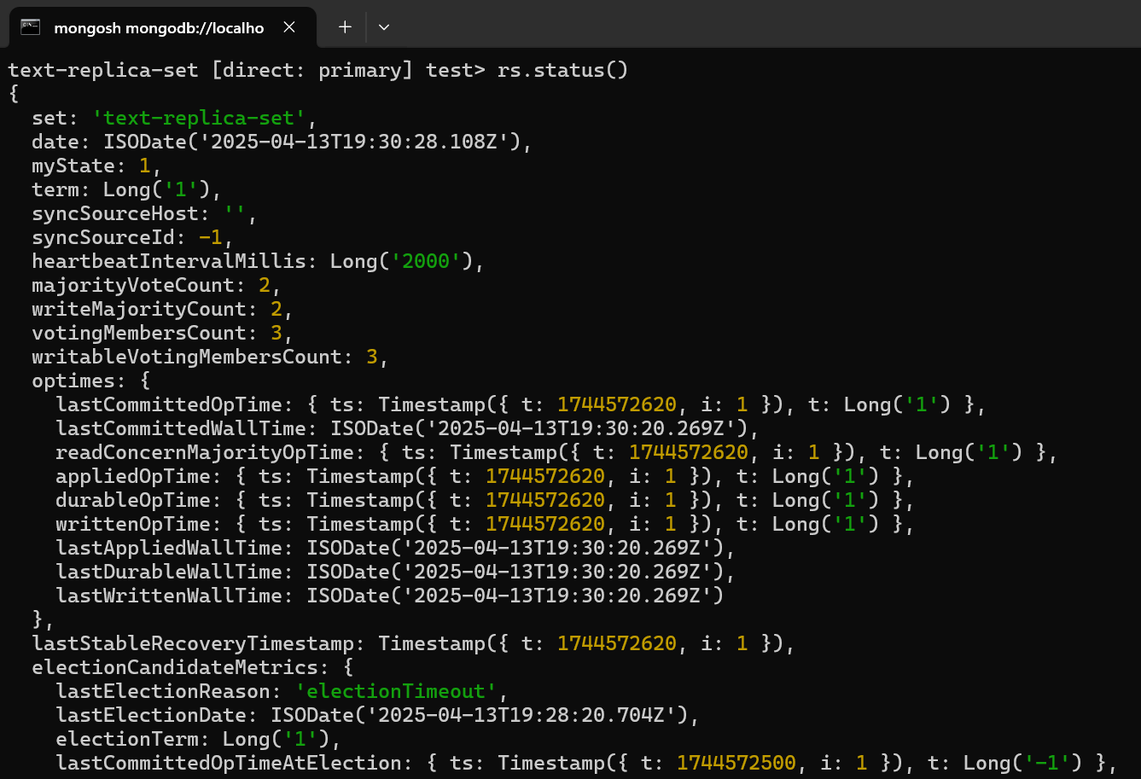

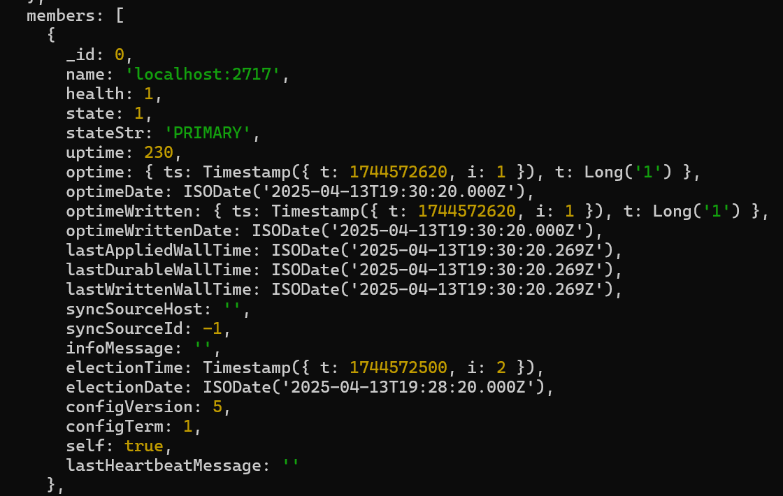

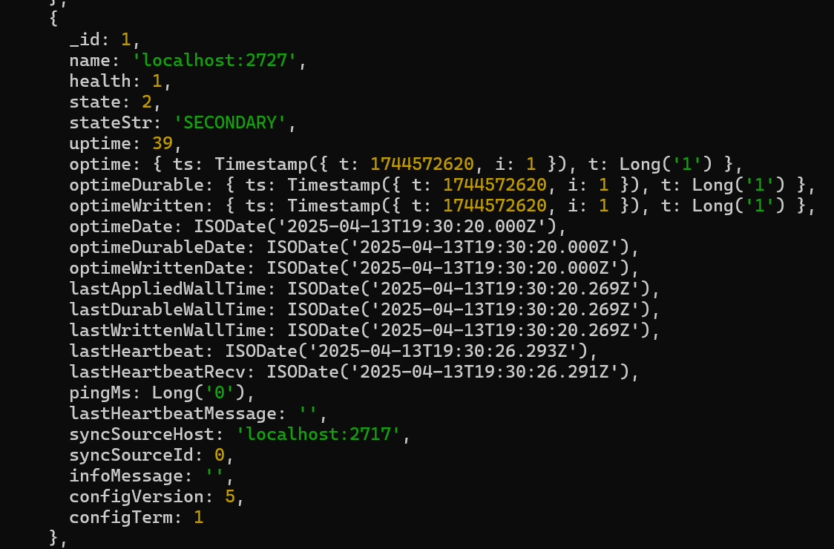

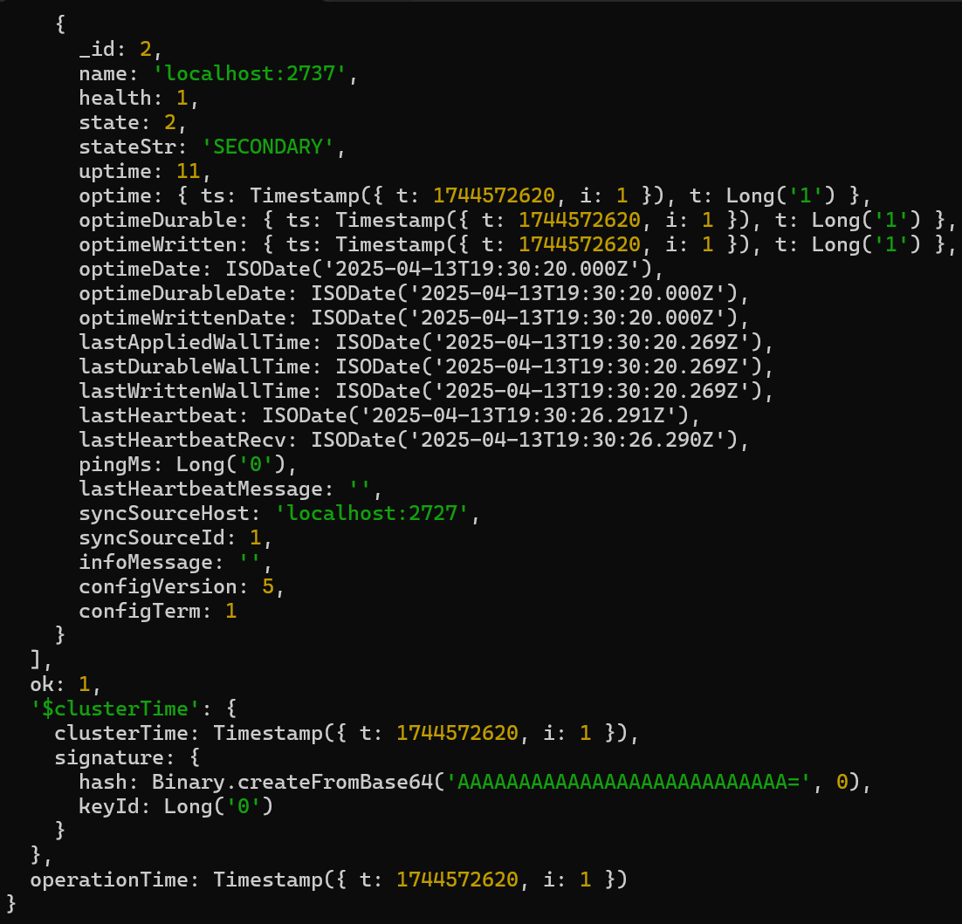

**6. Connect to Secondary Instances**

* Open new mongosh connections to the secondary instances:

mongosh --host="localhost:2727"

mongosh --host="localhost:2737"

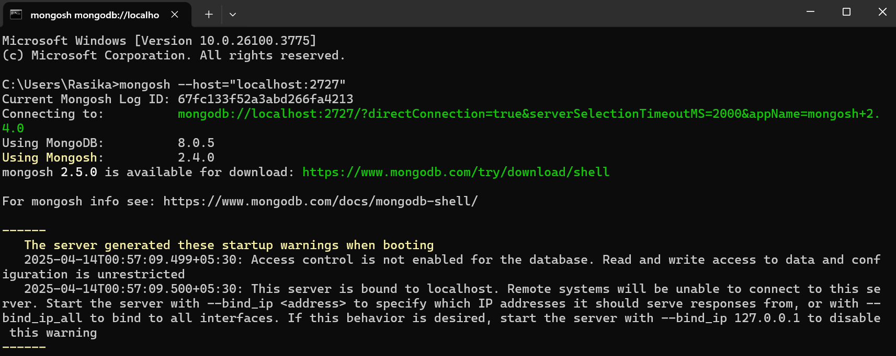

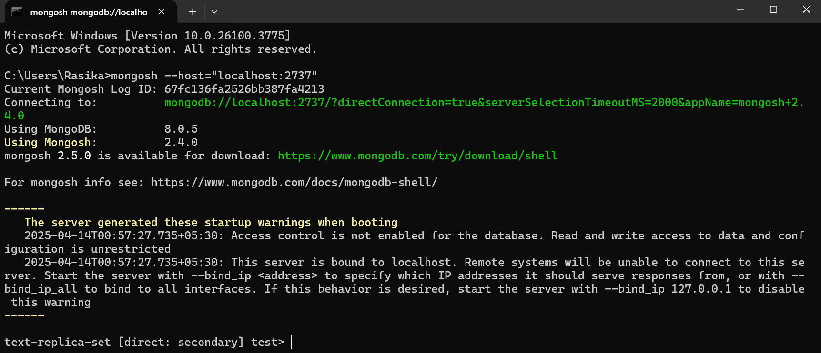

**7. Verify Replication**

* Show databases on all instances:

show dbs;

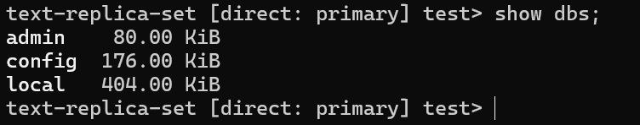

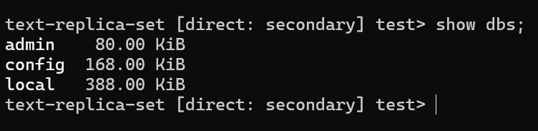

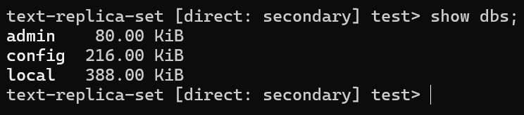

**8. Insert Data on Primary**

* Connect to the practice database on the primary instance:

use practice

1. Insert a document:

db.users.insert({name:"Rasika", age:21})

1. Find the inserted document:

db.users.find()

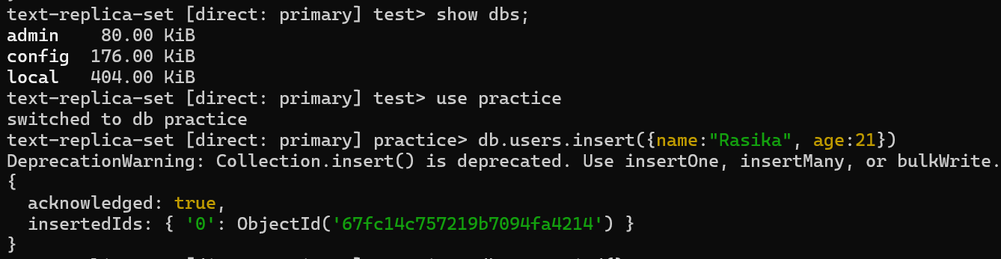

**9. Check Data on Secondaries**

* Connect to the practice database on secondary instances and find the document:

db.users.find()

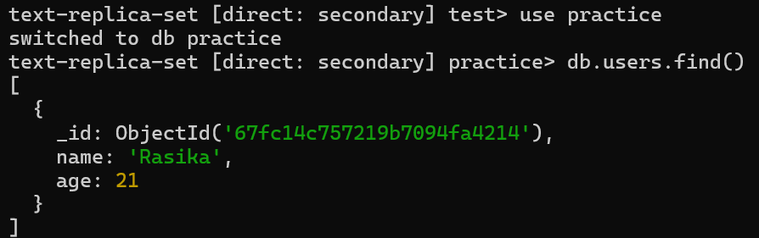

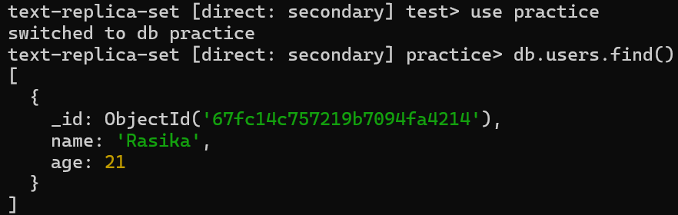

**10. Insert Multiple Documents**

* Insert multiple documents on the primary:

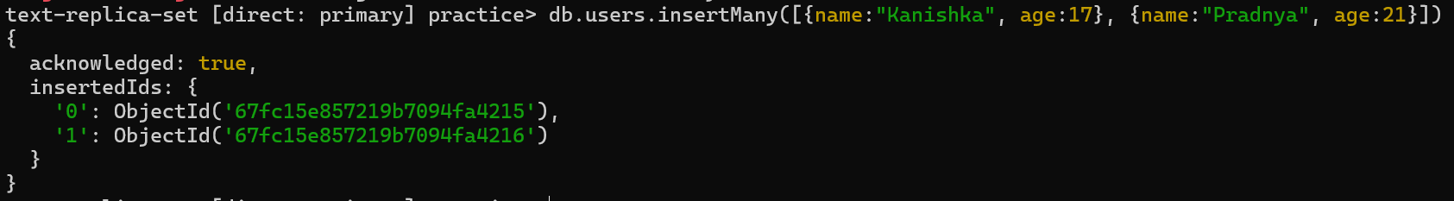

* Check if the records are visible on the secondaries.

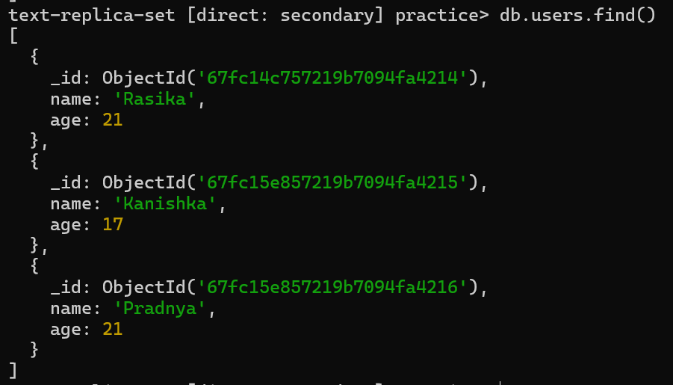

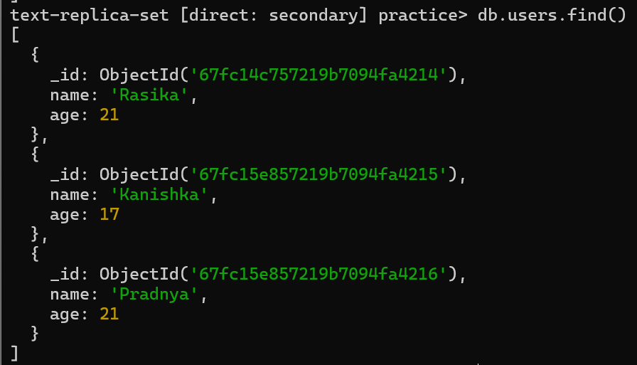

**11. Delete Data on Primary**

* Delete a document on the primary:

db.users.deleteOne({"name":"Pradnya"})

db.users.find()



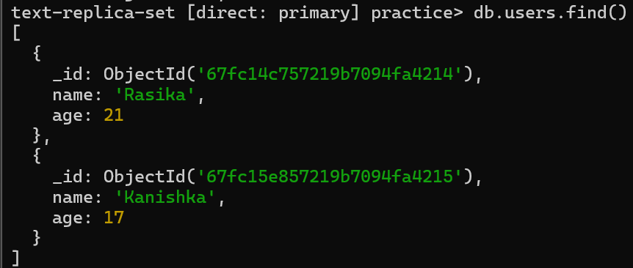

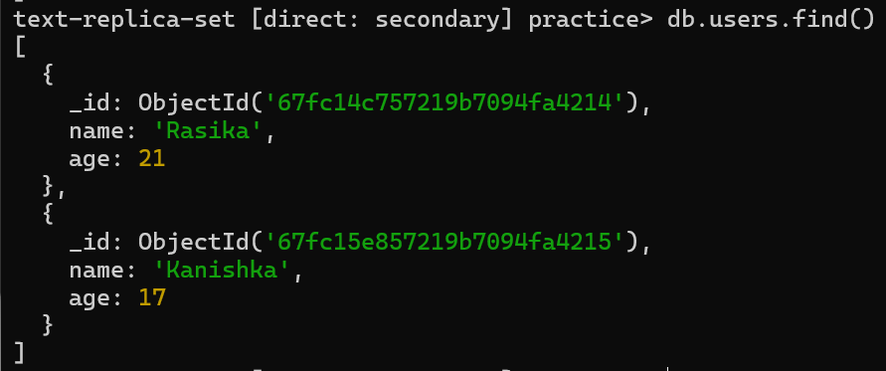

* Check if the delete happened on the secondaries.

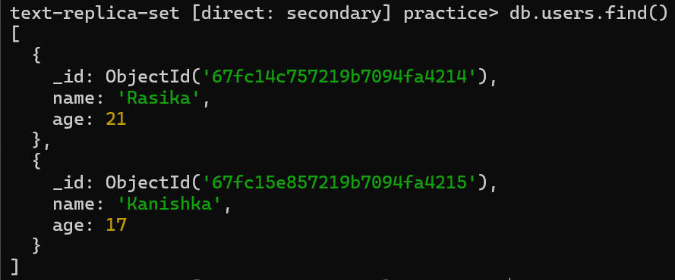

**12. Update Data on Primary**

* Update a document on the primary:

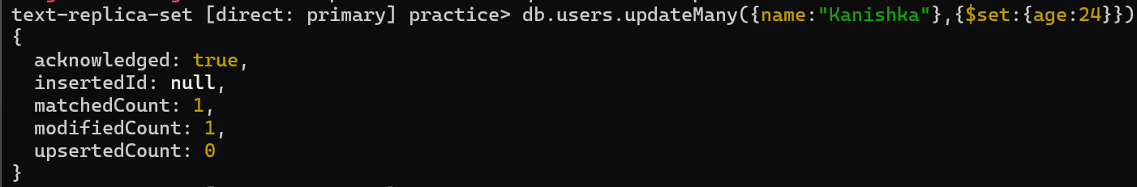

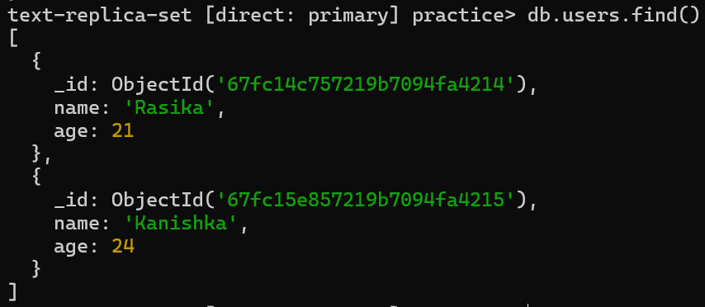

* Check if the update happened on the secondaries.

