1/16/24, 9:48 PM WorkFlowy - Organize your brain.
Docker-01 task
Create new custom image from Dockerfile
Container executed from this images must return date when request come to /date url
Example if I curl to 172.17.0.2/date container must return date and word (even or odd)
If date end with odd second return "21:59:25 ODD" if with even number then
"21:59:26 EVEN"
For scripting you can use all langueges which you now, also can use chatgpt for that After when image is done test it.
Then you need to up Sonatype nexus application (image sonatype/nexus3) Create docker hosted repository on it upload your image to it!

- Create new custom Dockerfile

vim Dockerfile

FROM python:3.14
RUN pip install flask
COPY app.py /app/app.py
WORKDIR /app
EXPOSE 2026
CMD ["python", "app.py"]

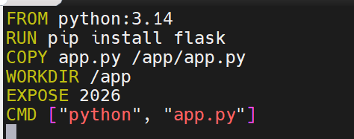

02. Create script from chatgpt

vim app.py
from flask import Flask
from datetime import datetime

app = Flask(__name__)

@app.route("/date")
def date():
now = datetime.now()
status = "EVEN" if now.second % 2 == 0 else "ODD"
return f"{now.strftime('%H:%M:%S')} {status}"

app.run(host="0.0.0.0", port=2026)
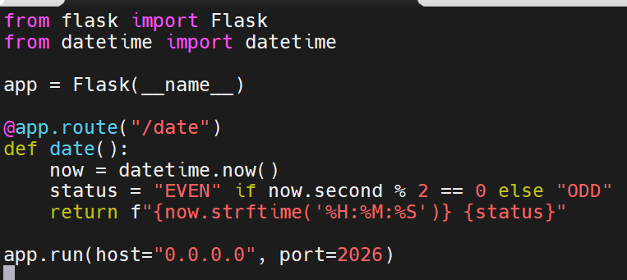

03.Build and check images

docker build -t myapp .

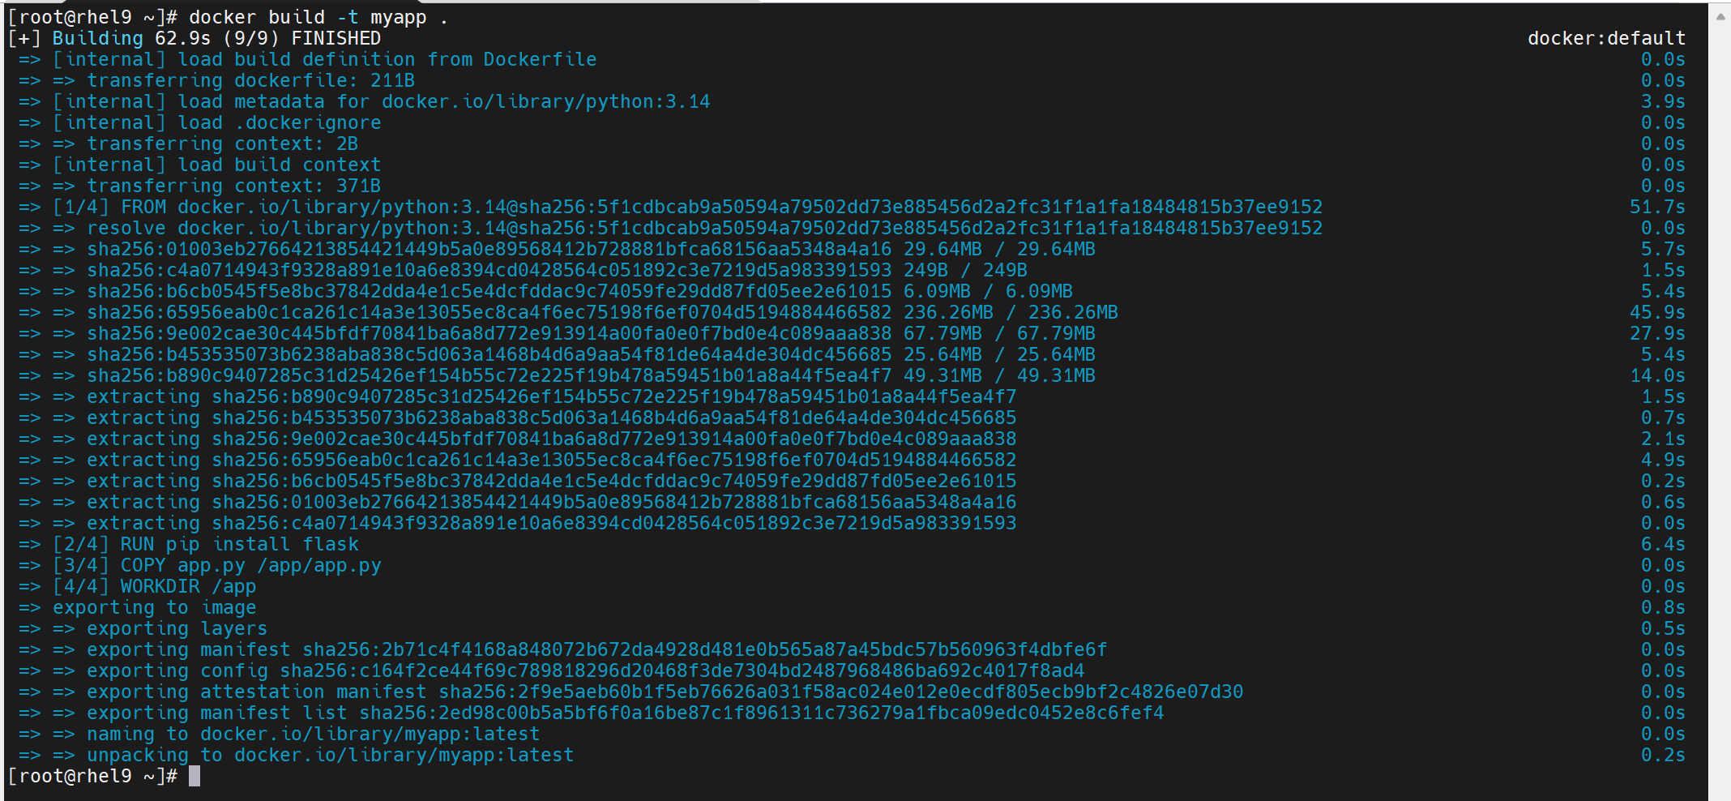

04. Run docker and check it

docker run -d --name app -p 2026:5000 myapp:latest

curl 172.17.0.2:2026/date
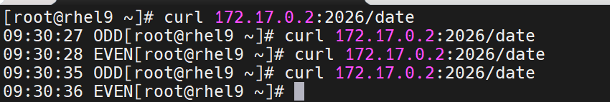

Create nexus host repository

01. Download from the Nexus repository.
docker pull sonatype/nexus3
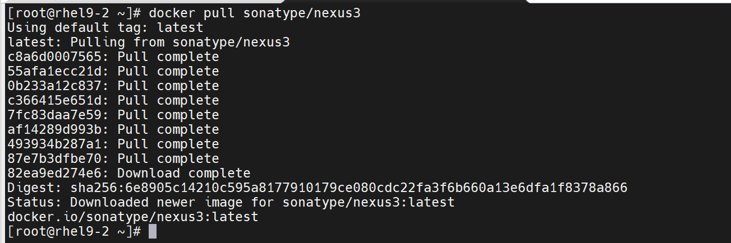

02. Run docker and check it

docker run -d --name nexus -p 8081:8081 -p 8082:8082 sonatype/nexus3:latest
docker update --restart always nexus (vm rebootdan sonrada Docker container işləsin (qalxsin))
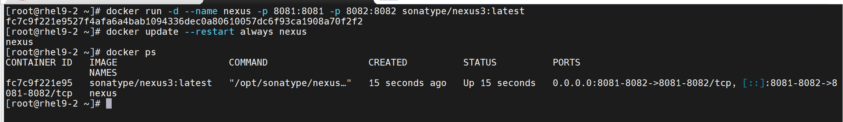

03. Go to web interface http://192.168.153.10:8081/ and change admin password
# docker exec nexus cat /nexus-data/admin.password 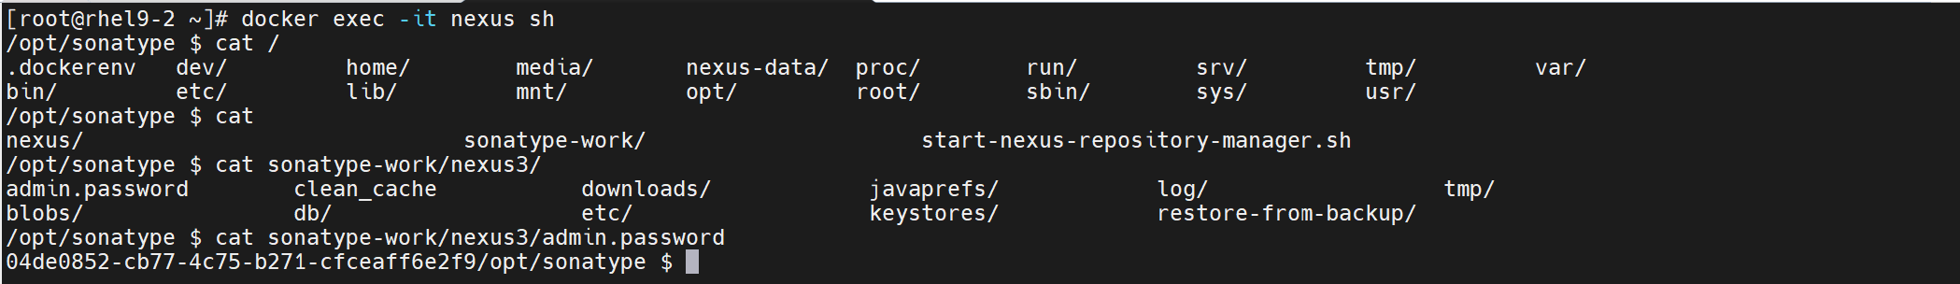

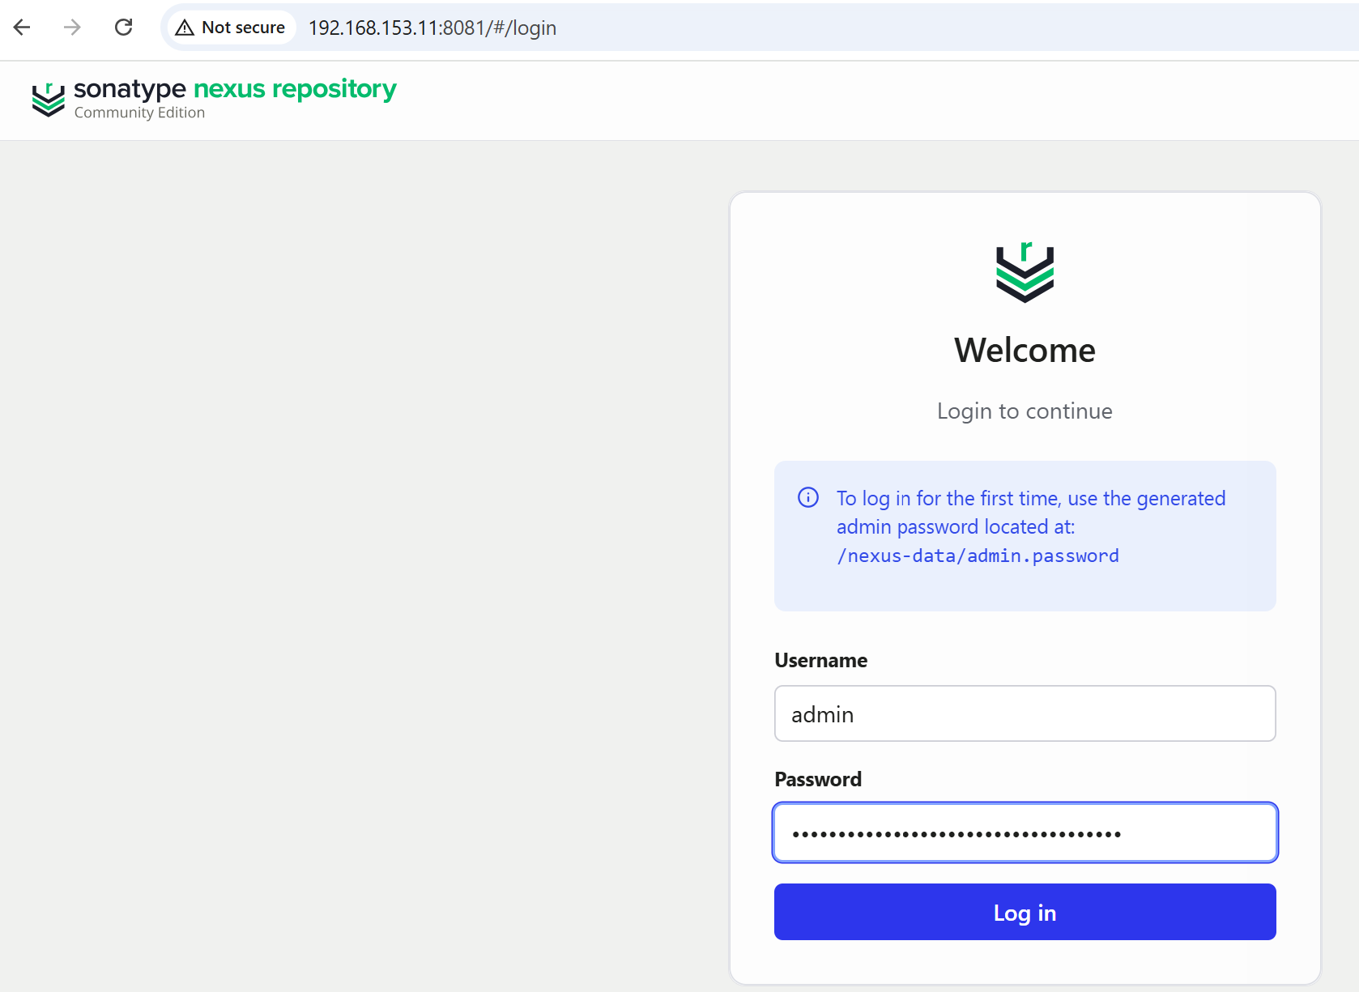

04. Create repositories Repositories→create repository→select type: Docker (hosted)→name: docker-local→on HTTP port 8082→change deploy policy: Allow redeploy→click create repository

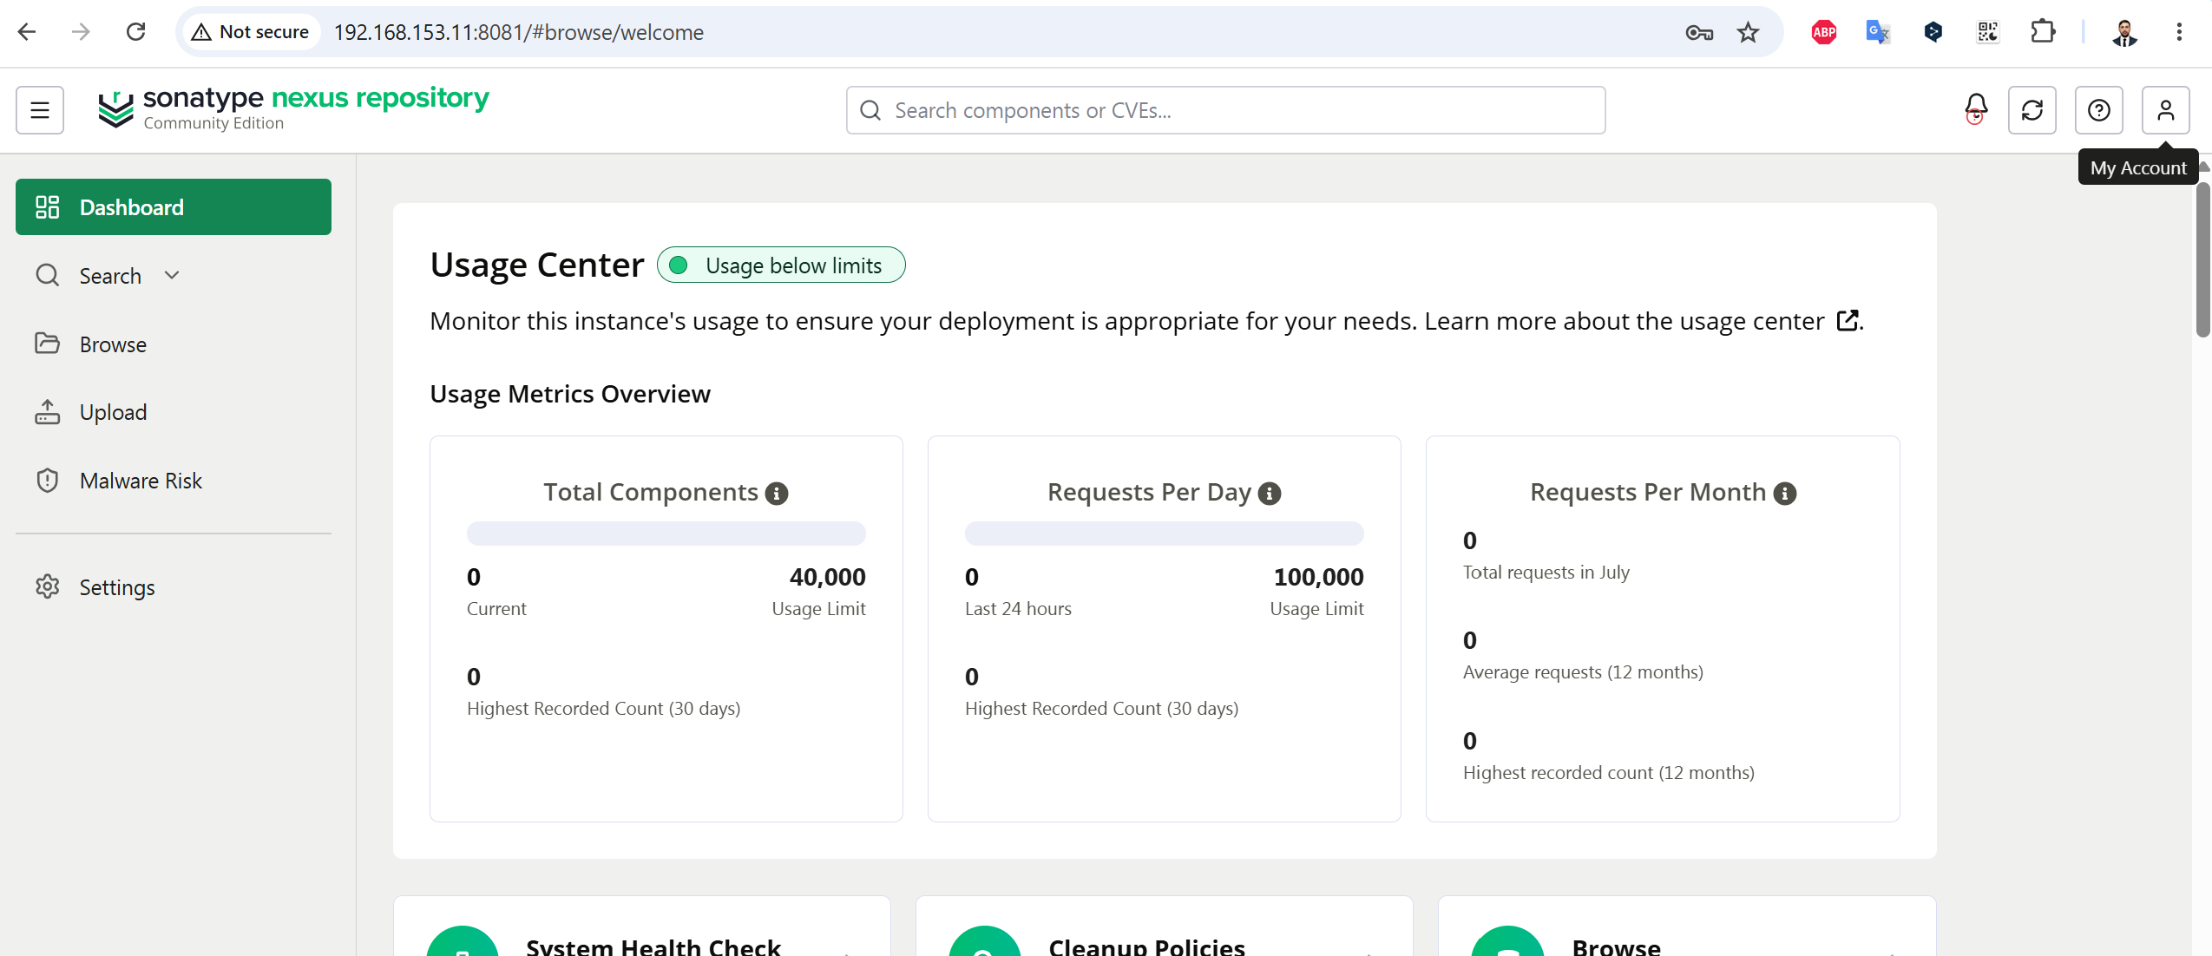

Docker repository yaradanda (Docker (hosted) secilir)
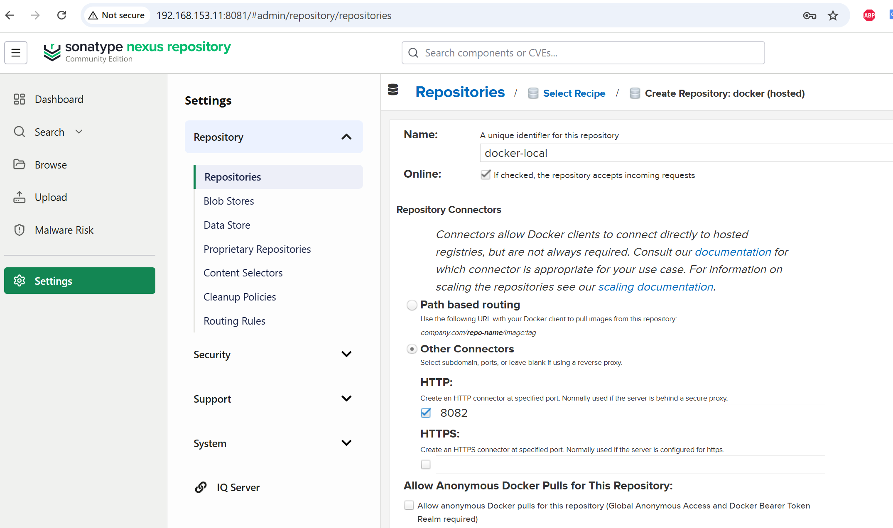

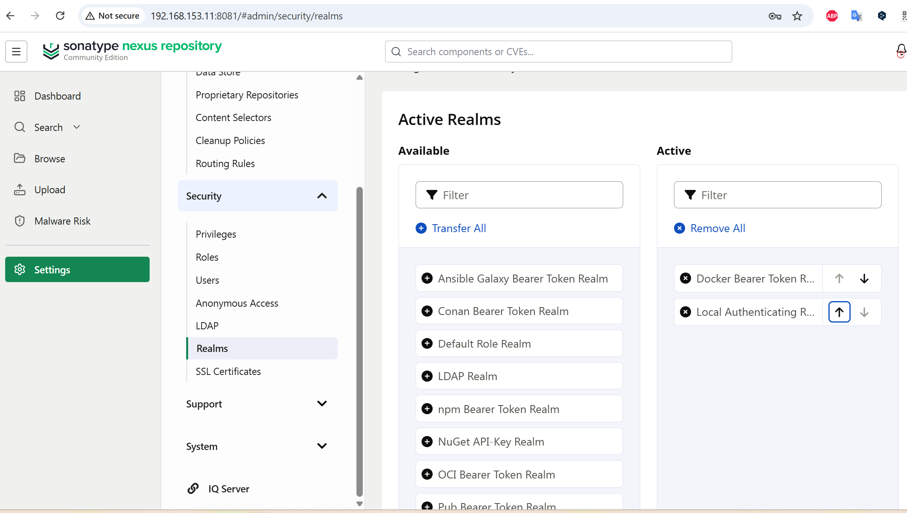

06. Add to insecure registry restart docker and run nexus
# vim /etc/docker/daemon.json
{
"insecure-registries": ["192.168.153.11:8082"]
}
# systemctl restart docker
# docker start nexus
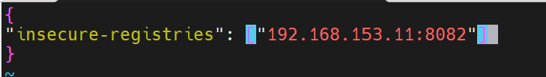

07. Check image and tag it
# docker images
# docker tag dockertask:01 192.168.153.11:8082/dockertask:01
08. Login to NEXUS and push image

# docker login 192.168.153.11:8082
# docker push 192.168.153.11:8082/dockertask:01

