k8s Task04 Resource Quota/limit Range
- Create namespace test
# mkdir 04.k8s-task
# cd 04.k8s-task
# kubectl create ns test
# kubectl get ns
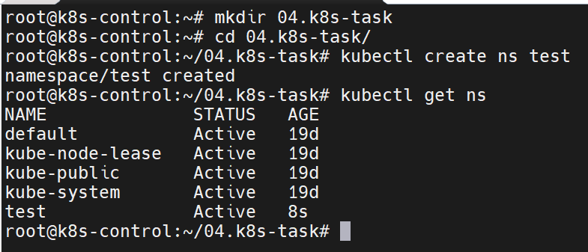

- Create pod nginx
# vim pod-nginx.yaml

apiVersion: v1
kind: Pod
metadata:
name: nginx
namespace: test
spec:
containers:
- name: nginx
image: nginx:latest
resources:
requests:
memory: "2Gi"
cpu: "500m"
limits:
memory: "2Gi"
cpu: "500m"
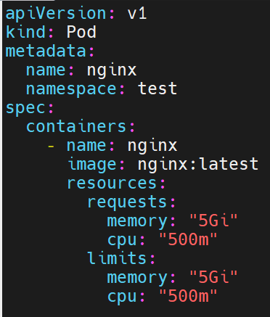

# kubectl apply -f pod-nginx.yaml
# kubectl get pods -n test
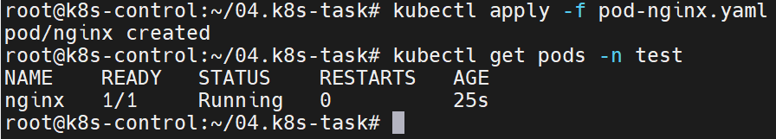

- Create ResourceQuota
# vim quota.yaml
apiVersion: v1
kind: ResourceQuota
metadata:
name: pod-limit-and-quota
namespace: test
spec:
hard:
requests.cpu: "500m"
requests.memory: "5Gi"
limits.cpu: "500m"
limits.memory: "5Gi"
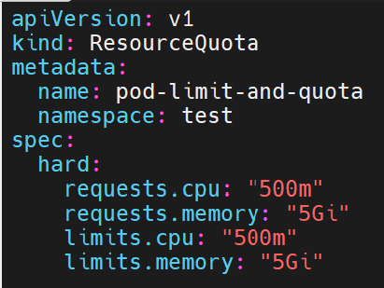
# kubectl apply -f quota.yaml
# kubectl describe quota pod-limit-and-quota -n test
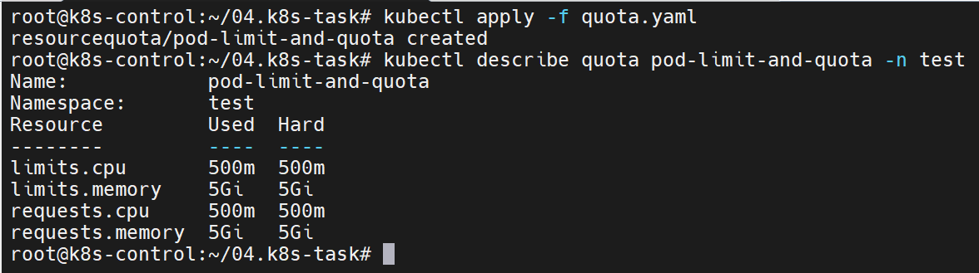

- Create pod nginx2
# vim pod-nginx2.yaml
apiVersion: v1
kind: Pod
metadata:
name: nginx-2
namespace: test
spec:
containers:
- name: nginx
image: nginx:latest
resources:
requests:
memory: "2Gi"
cpu: "500m"
limits:
memory: "2Gi"
cpu: "500m"

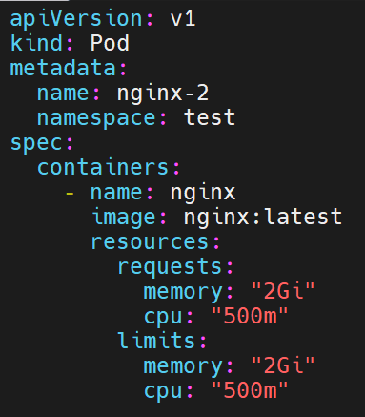

# kubectl apply -f pod-nginx2.yaml

- Create namespace limit
# kubectl create ns limit

- Create LimitRange
# vim limitrange.yaml

apiVersion: v1
kind: LimitRange
metadata:
name: cpu-resource-constraint
namespace: limit
spec:
limits:
- default:
memory: "500m"
defaultRequest:
memory: "500m"
max:
cpu: "1"
min:
cpu: "100m"
type: Container
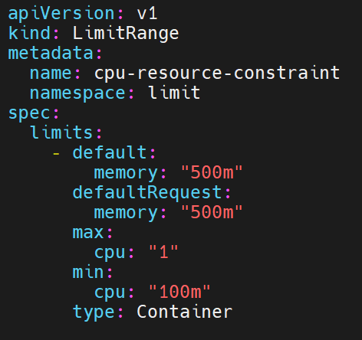

# kubectl apply -f limitrange.yaml
# kubectl describe limitranges cpu-resource-constraint -n limit
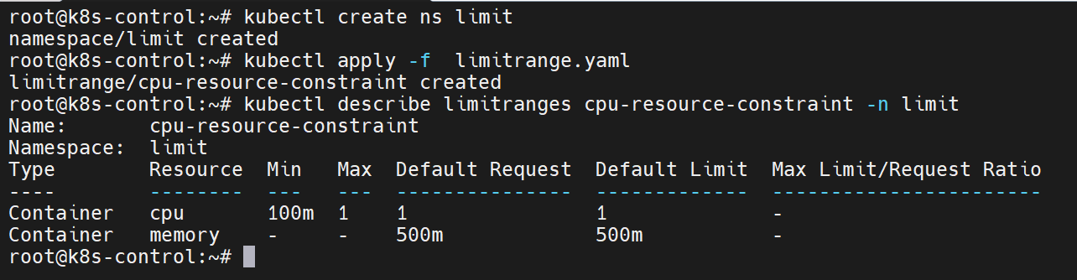

- Deploy another pod with conflicting resource requests
# vim pause-pod.yaml
apiVersion: v1
kind: Pod
metadata:
name: pause-pod
namespace: limit
spec:
containers:
- name: pause
image: registry.k8s.io/pause:2.0
resources:
requests:
cpu: 700m
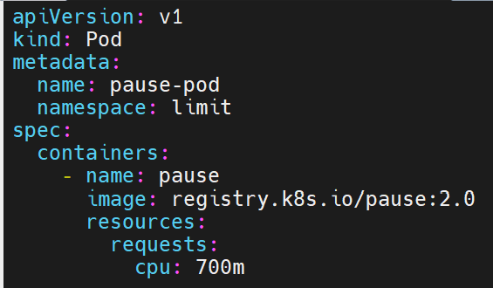

# kubectl apply -f pause-pod.yaml
- Edit pause-pod.yaml
# vim pause-pod.yaml
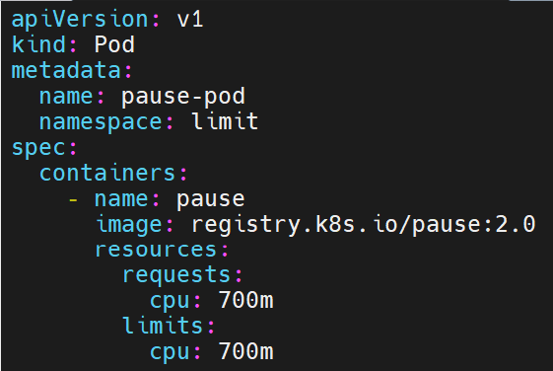

# kubectl apply -f pause-pod.yaml
