Kaniko

1. Create directory and change
# mkdir kaniko
# cd kaniko
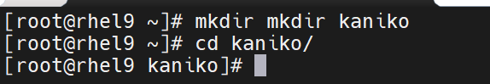
2. Create simple Doclerfile
# vim Dockerfile
FROM alpine:latest
RUN echo "Hello from Kaniko" > /hello.txt
CMD ["cat","/hello.txt"]
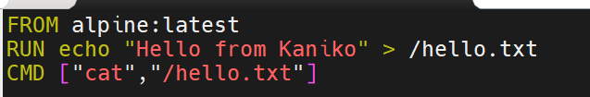

3. Create directory, login docker hub and check

Create a new token
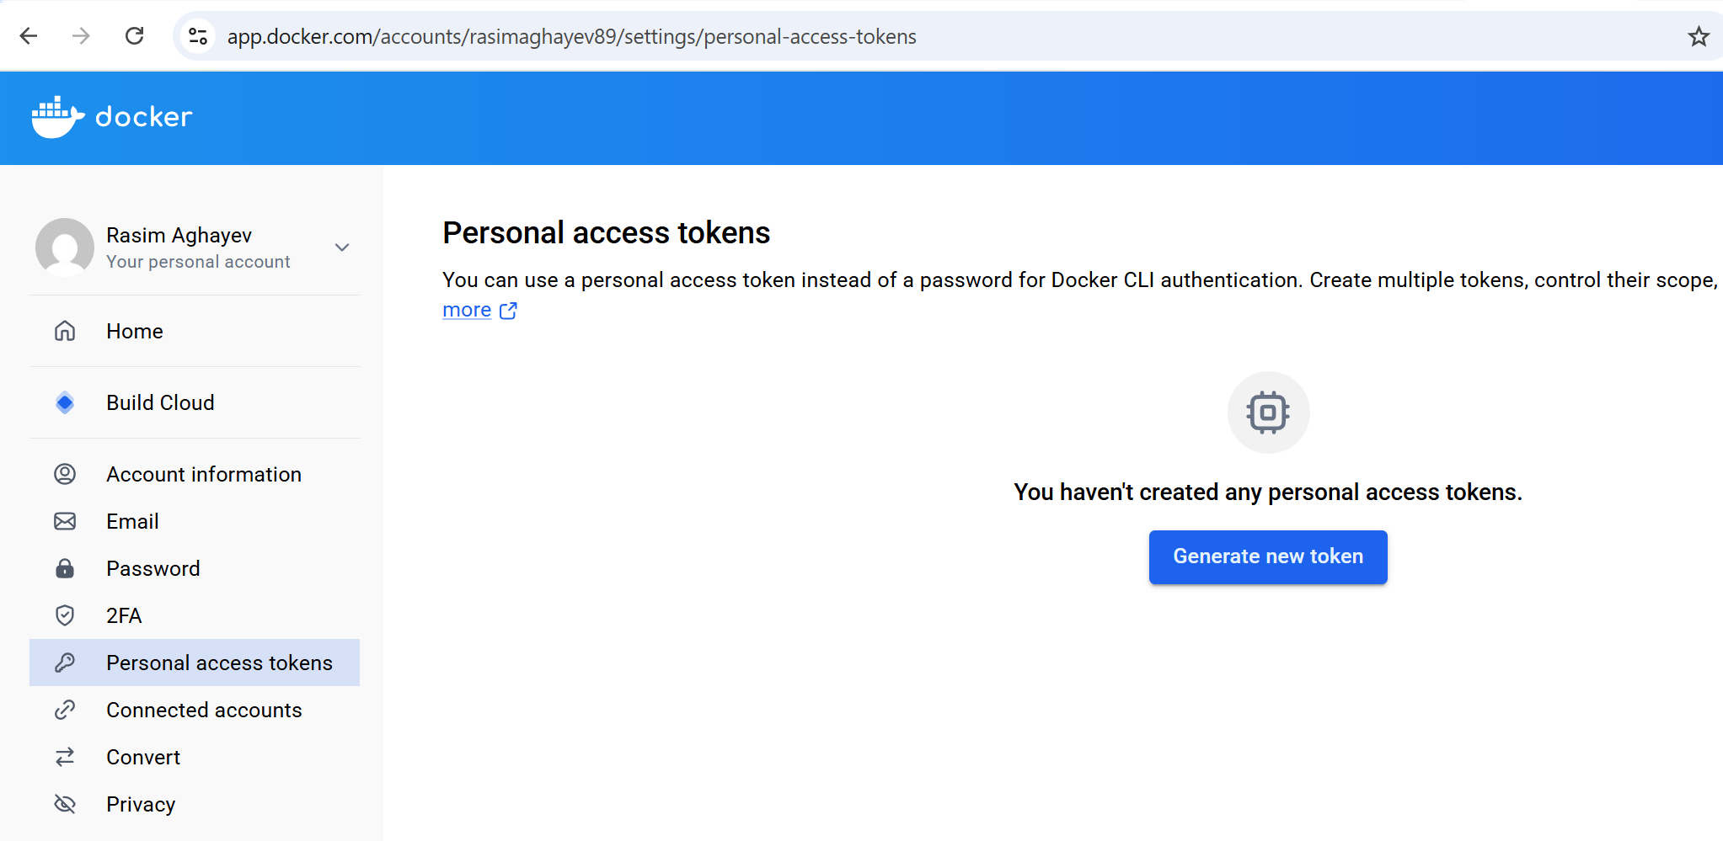
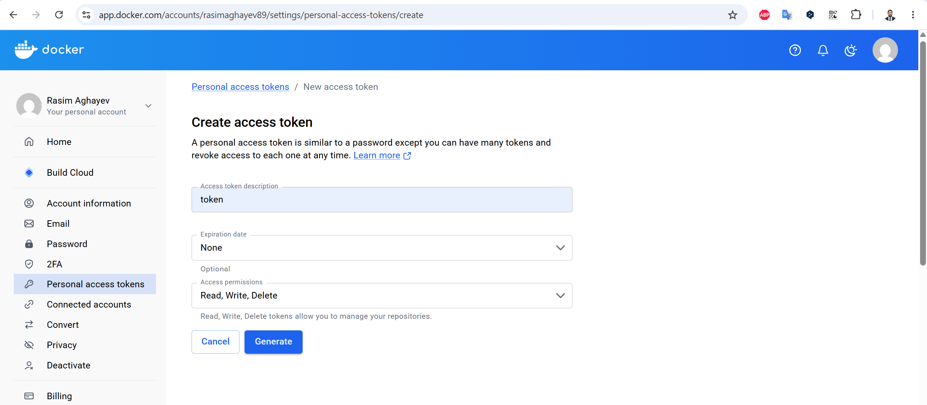
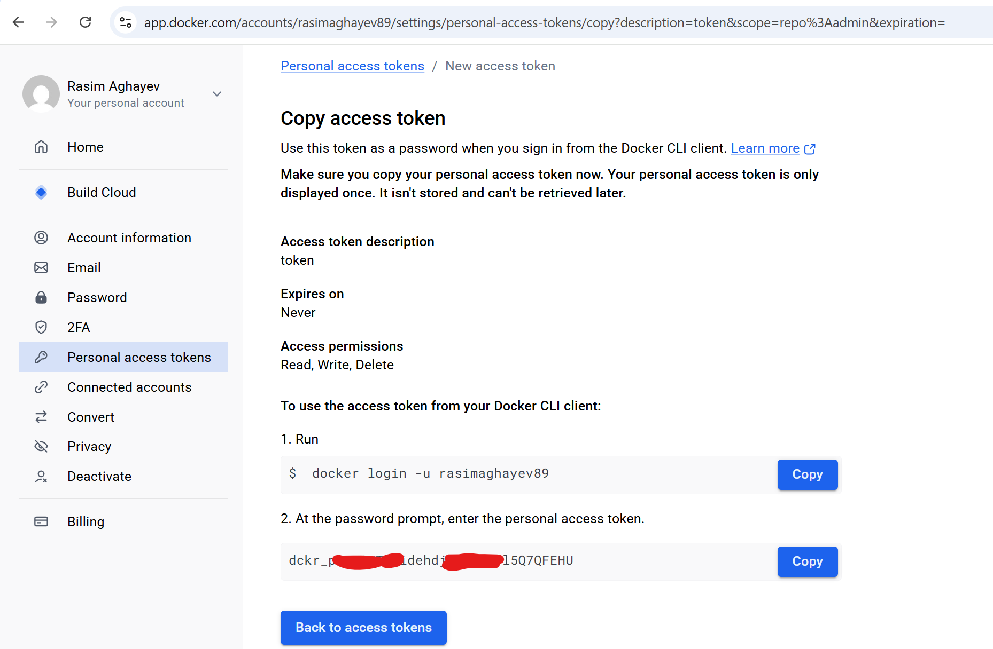

# docker login -u rasimaghayev89
# cat ~/.docker/config.json
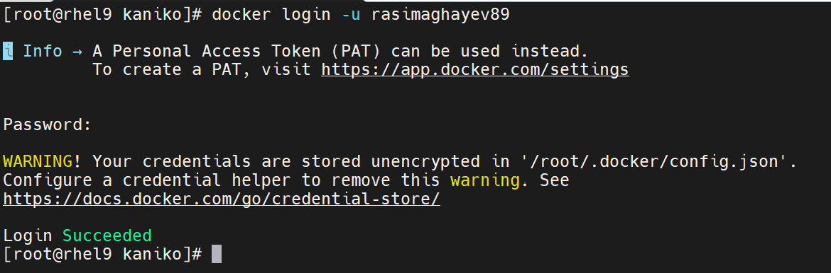
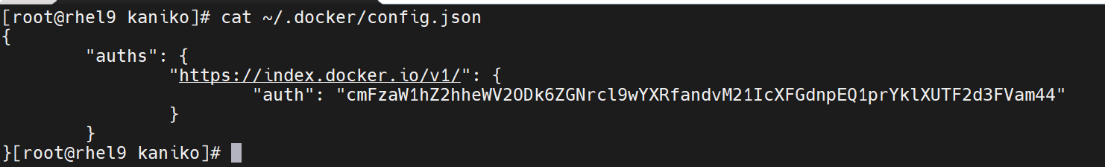

4. Create and push
# docker images
# docker tag gcr.io/kaniko-project/executor:latest docker.io/rasimaghayev89/kaniko:latest
# docker images

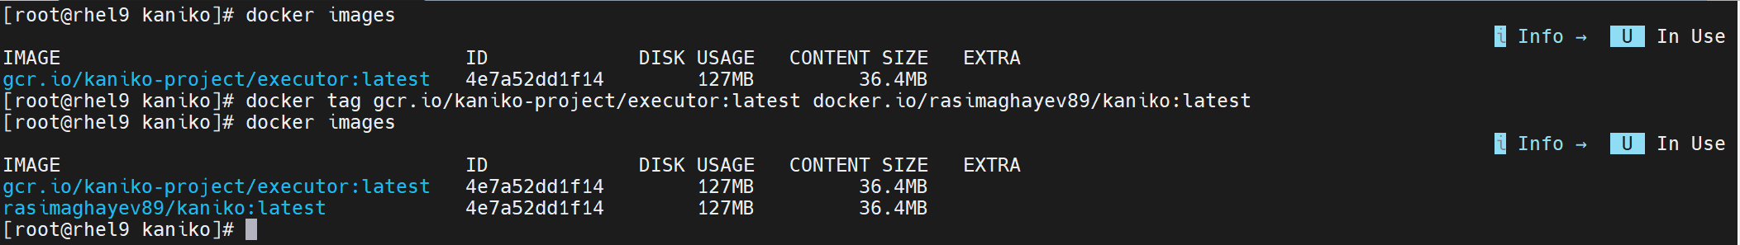

# docker run --rm \
-v /root/.docker/config.json:/kaniko/.docker/config.json:ro \
-v /root/kaniko:/workspace \
gcr.io/kaniko-project/executor:latest \
--dockerfile=/workspace/Dockerfile \
--context=dir:///workspace \
--destination=docker.io/rasimaghayev89/kaniko:latest

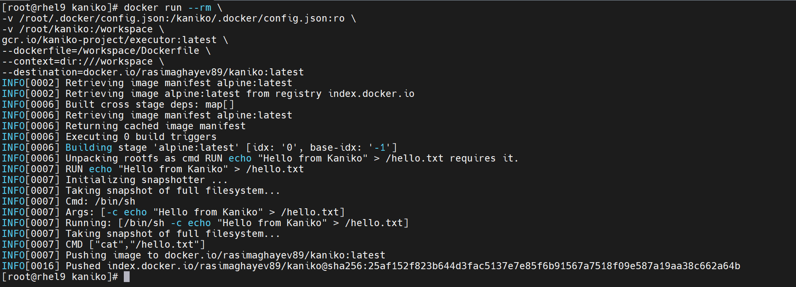
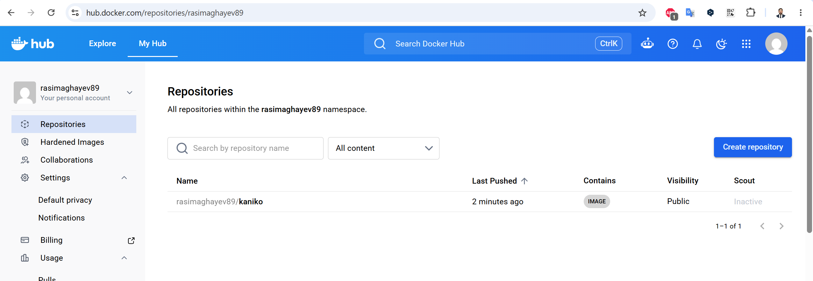

5. Pull and run kaniko

I'll delete the image and run `docker pull` so it can get the image from Docker Hub.
# docker rmi rasimaghayev89/kaniko:latest
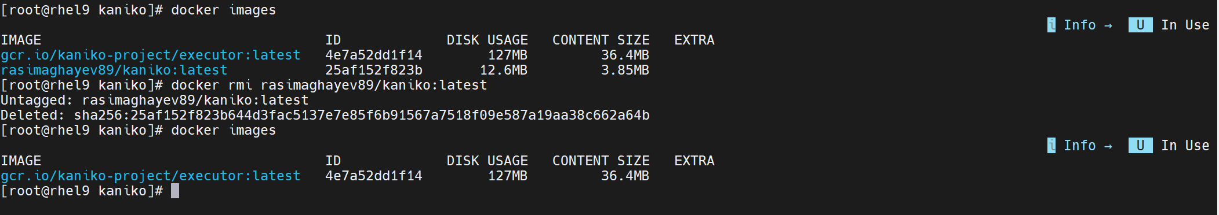
# docker pull rasimaghayev89/kaniko:latest
