Docker-compose
- Create and change directory, install docker-compose
# dnf install docker-compose-plugin -y
# mkdir docker-compose
# cd docker-compose
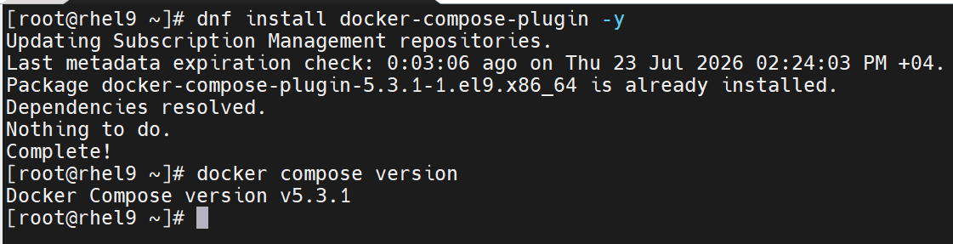
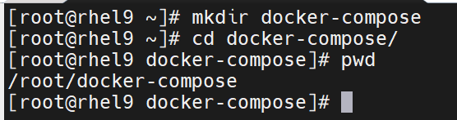
- Create docker-compose file
# vim docker-compose.yml
version: '3.9'

services:
web:
build: .
ports:
- "8000:5000"
depends_on:
- redis

redis:
image: redis:alpine

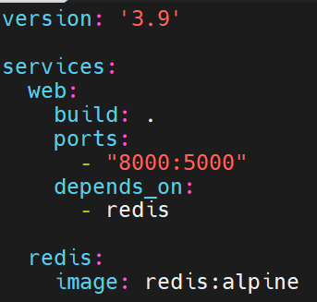
- Create Dockerfile
# vim Dockerfile

FROM python:3.7-alpine
WORKDIR /code
ENV FLASK_APP=app.py
ENV FLASK_RUN_HOST=0.0.0.0
RUN apk add --no-cache gcc musl-dev linux-headers
COPY requirements.txt requirements.txt
RUN pip install -r requirements.txt
EXPOSE 5000
COPY . .
CMD ["flask", "run"]

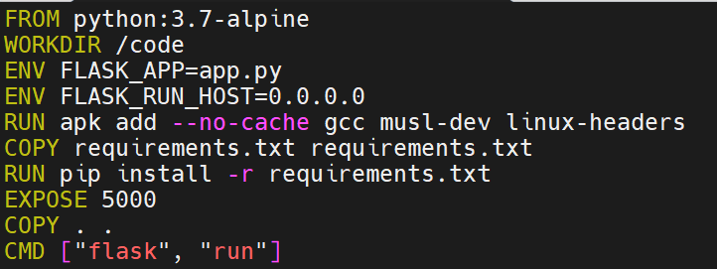

- Create app.py file
# vim app.py

import time
import redis
from flask import Flask

app = Flask(__name__)

cache = redis.Redis(host='redis', port=6379)

def get_hit_count():
retries = 5
while True:
try:
return cache.incr('hits')
except redis.exceptions.ConnectionError as exc:
if retries == 0:
raise exc
retries -= 1
time.sleep(0.5)

@app.route('/')
def hello():
count = get_hit_count()
return 'Hello World! I have been seen {} times.\n'.format(count)

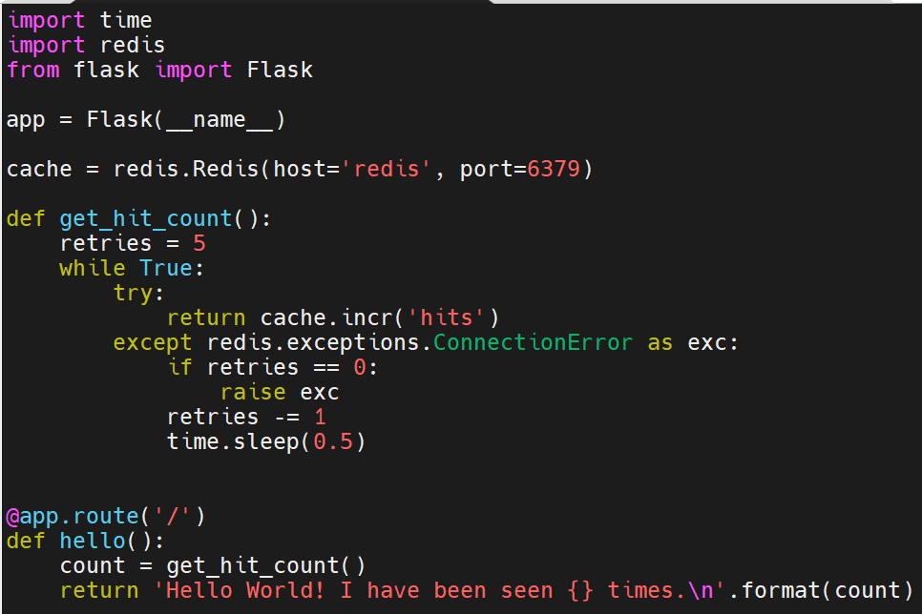

- Create requirements.txt file
# echo -e "flask\nredis" > requirements.txt

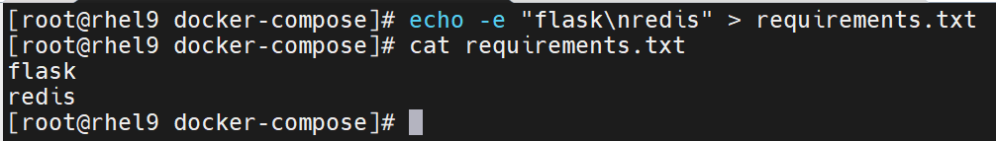

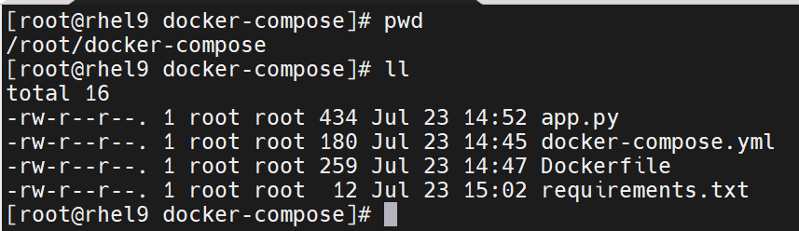

- Run project
# docker compose up -d –build

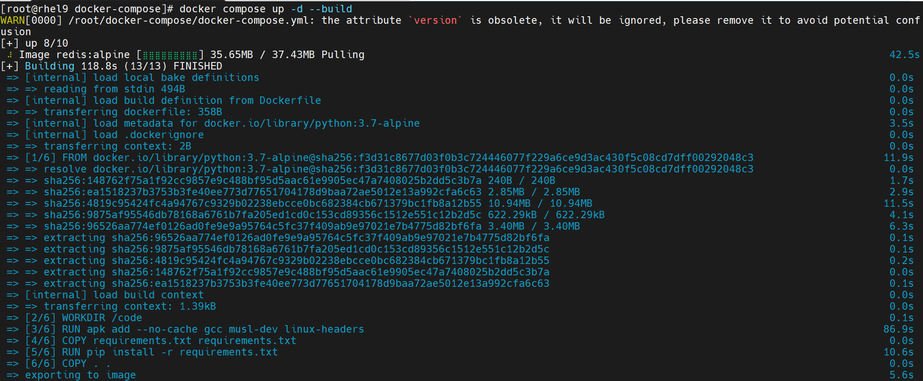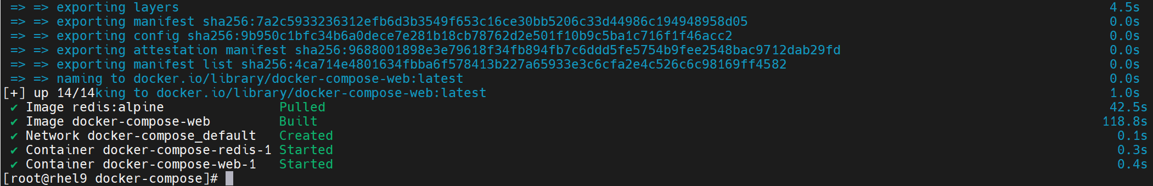

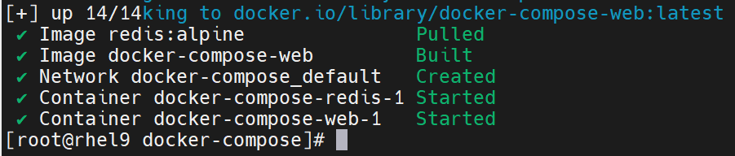

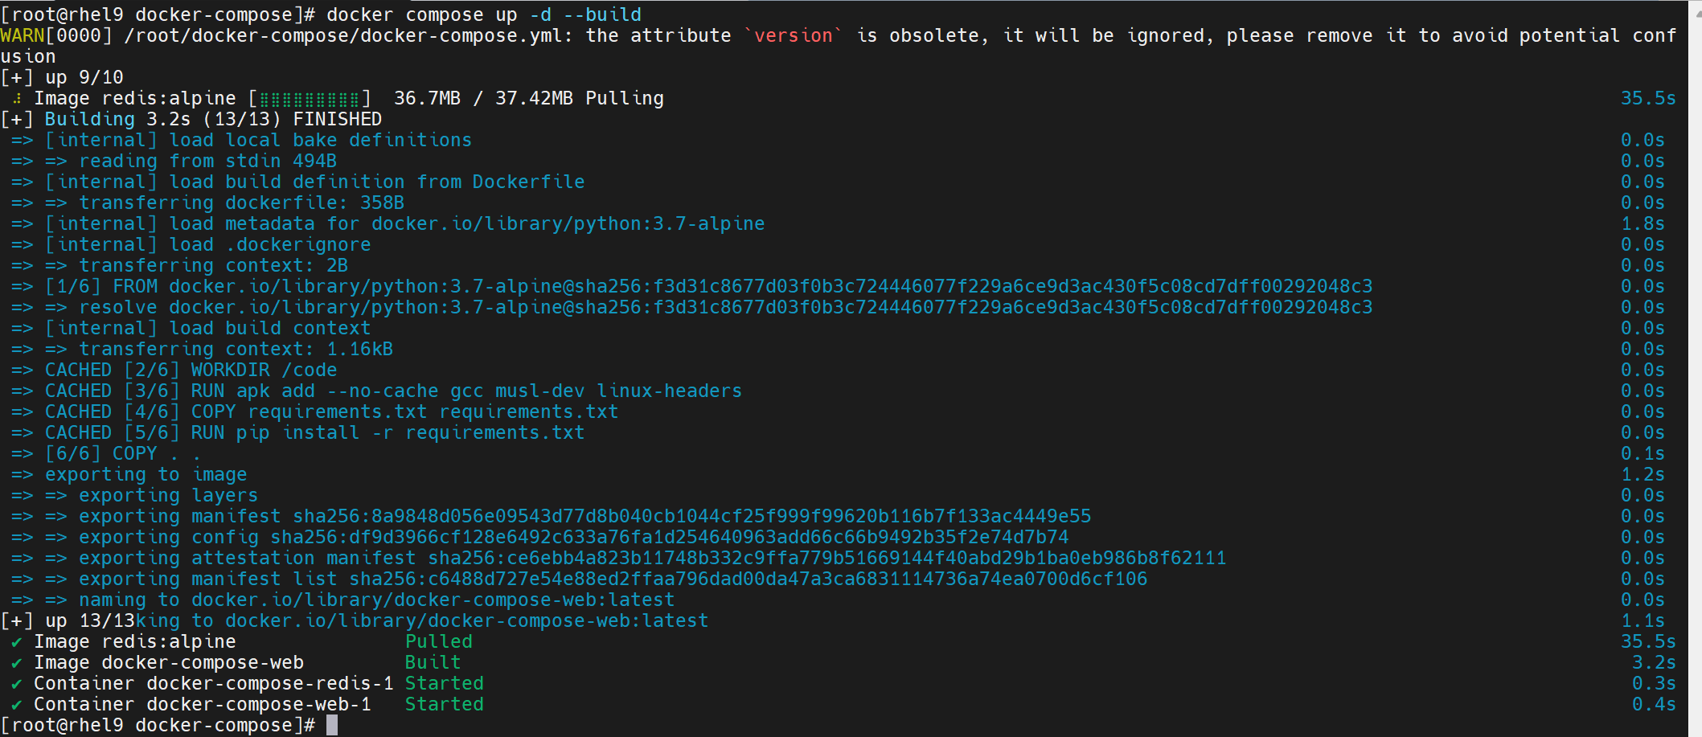

- Go to browser http://192.168.153.10:8000/

# curl http://192.168.153.10:8000

