Create k8s cluster

- Create k8s master

#vim /etc/hosts
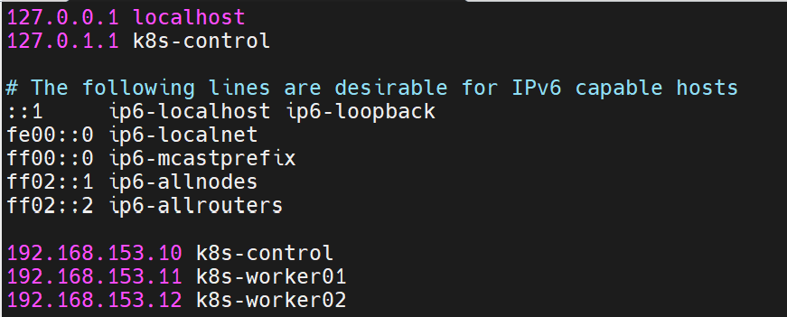

# ssh-keygen
# ssh-copy-id root@192.168.153.11
# ssh-copy-id root@192.168.153.12
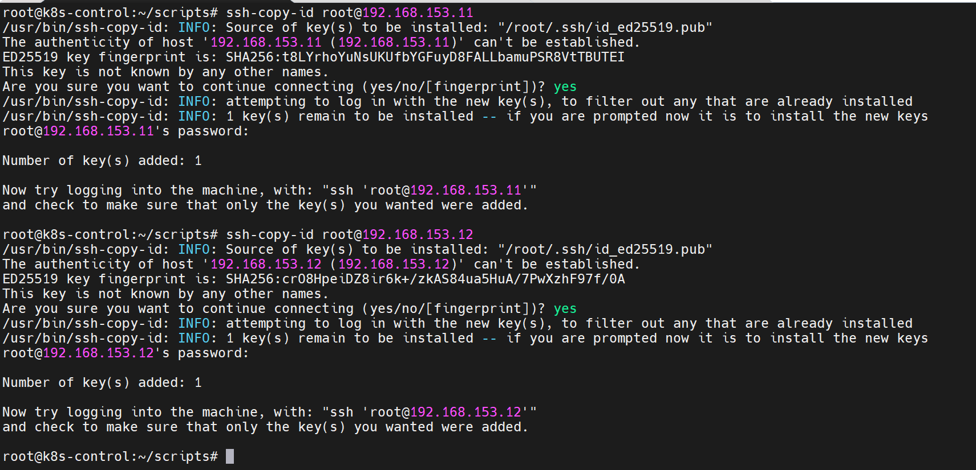

# mkdir /scripts
# vim /scripts/master.sh
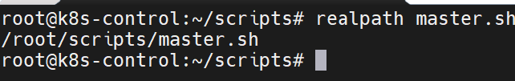
#!/bin/bash
set -euo pipefail

MASTER_IP="192.168.153.10"

echo "===== [1/10] System update and base packages ====="
apt update -y
apt install -y apt-transport-https ca-certificates curl gnupg

echo "===== [2/10] Adding Kubernetes repository ====="
mkdir -p /etc/apt/keyrings
curl -fsSL https://pkgs.k8s.io/core:/stable:/v1.30/deb/Release.key \
| gpg --dearmor -o /etc/apt/keyrings/kubernetes-apt-keyring.gpg
chmod 644 /etc/apt/keyrings/kubernetes-apt-keyring.gpg

cat <<EOF >/etc/apt/sources.list.d/kubernetes.list
deb [signed-by=/etc/apt/keyrings/kubernetes-apt-keyring.gpg] https://pkgs.k8s.io/core:/stable:/v1.30/deb/ /
EOF

apt update -y

echo "===== [3/10] Installing kubelet, kubeadm, kubectl, containerd ====="
apt install -y kubelet kubeadm kubectl containerd
apt-mark hold kubelet kubeadm kubectl

echo "===== [4/10] Disabling swap ====="
swapoff -a || true
sed -i.bak '/swap/d' /etc/fstab || true

echo "===== [5/10] Enabling kernel modules ====="
cat <<EOF >/etc/modules-load.d/k8s.conf
overlay
br_netfilter
EOF
modprobe overlay
modprobe br_netfilter

echo "===== [6/10] Configuring sysctl ====="
cat <<EOF >/etc/sysctl.d/k8s.conf
net.ipv4.ip_forward=1
net.bridge.bridge-nf-call-iptables=1
net.bridge.bridge-nf-call-ip6tables=1
EOF
sysctl --system

echo "===== [7/10] Configuring containerd ====="
mkdir -p /etc/containerd
containerd config default > /etc/containerd/config.toml

# Включаем systemd cgroups
sed -i 's/SystemdCgroup = false/SystemdCgroup = true/' /etc/containerd/config.toml
if ! grep -q 'SystemdCgroup = true' /etc/containerd/config.toml; then
sed -i '/runc.options]/a \ SystemdCgroup = true' /etc/containerd/config.toml
fi

# Фикс sandbox image для Kubernetes 1.30 (pause:3.9)
sed -i 's@sandbox_image = ".*"@sandbox_image = "registry.k8s.io/pause:3.9"@' /etc/containerd/config.toml

systemctl daemon-reload
systemctl restart containerd
systemctl enable containerd
systemctl enable kubelet

echo "===== [8/10] Initializing Kubernetes control-plane ====="

# Если кластер уже инициализирован — не ломаем его повторным init
if [ -f /etc/kubernetes/admin.conf ]; then
echo "Looks like control-plane already initialized (/etc/kubernetes/admin.conf exists)."
echo "If you want to re-init, run: kubeadm reset -f && rm -rf /etc/cni/net.d"
else
kubeadm init \
--apiserver-advertise-address="${MASTER_IP}" \
--pod-network-cidr=192.168.0.0/16
fi

echo "===== [9/10] Configuring kubectl for root ====="
mkdir -p "$HOME/.kube"
cp -i /etc/kubernetes/admin.conf "$HOME/.kube/config"
chown "$(id -u):$(id -g)" "$HOME/.kube/config"

echo "===== [10/10] Installing Calico CNI ====="
kubectl apply -f https://raw.githubusercontent.com/projectcalico/calico/v3.27.3/manifests/calico.yaml

echo ""
echo "🎉 MASTER NODE READY!"
echo "Чтобы подключить worker, на мастере выполни:"
echo " kubeadm token create --print-join-command"
echo ""

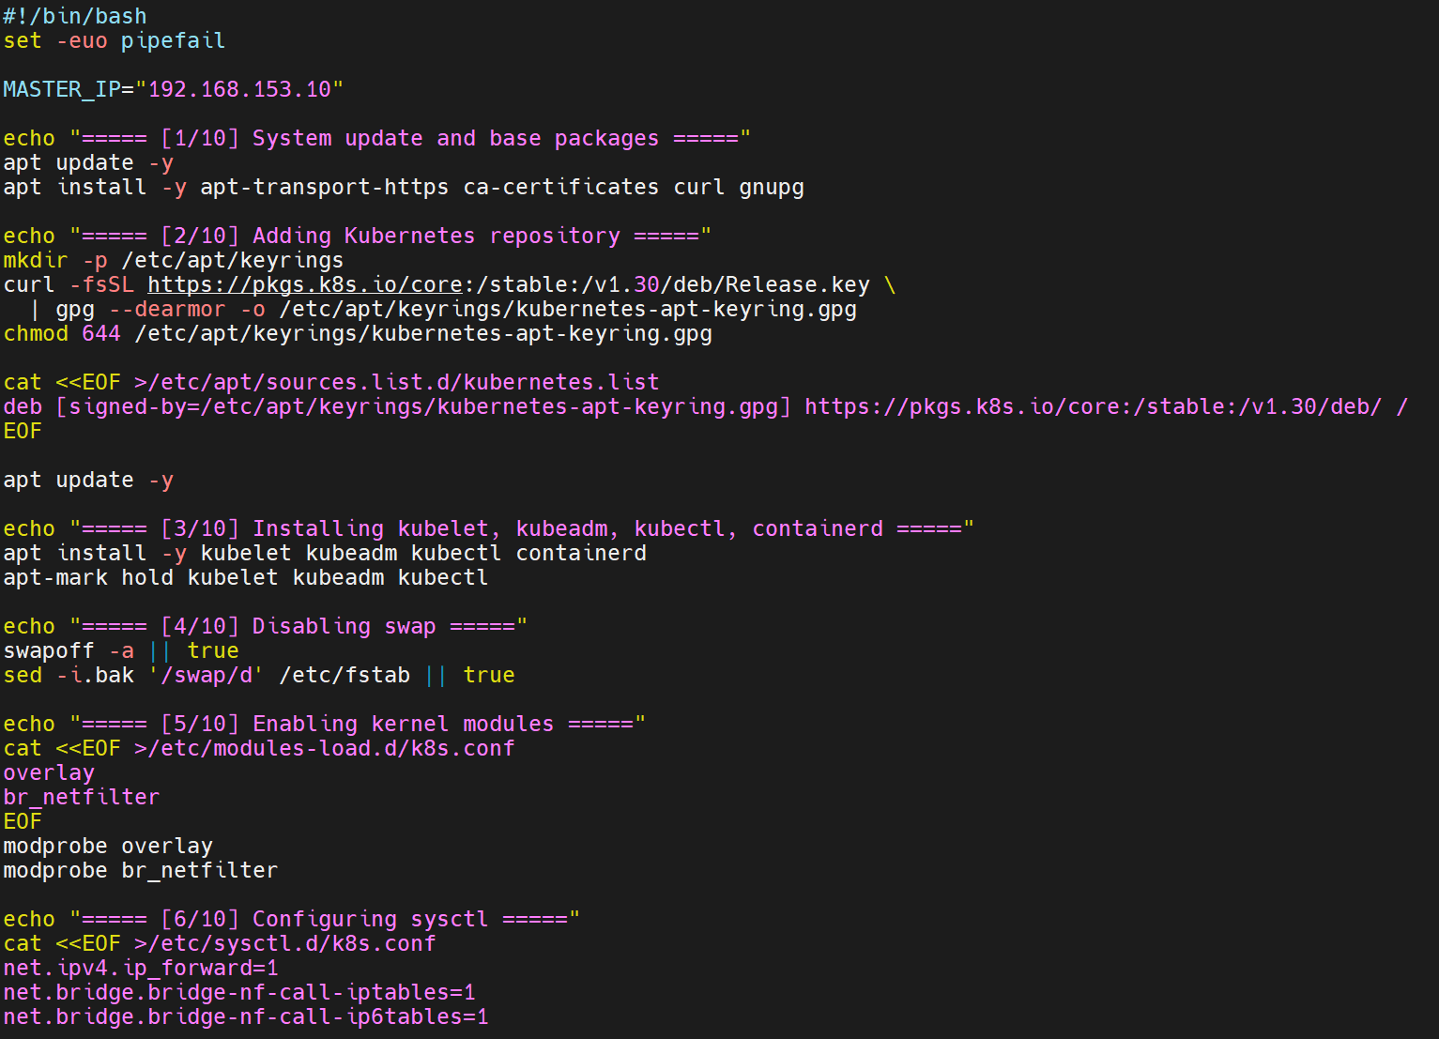
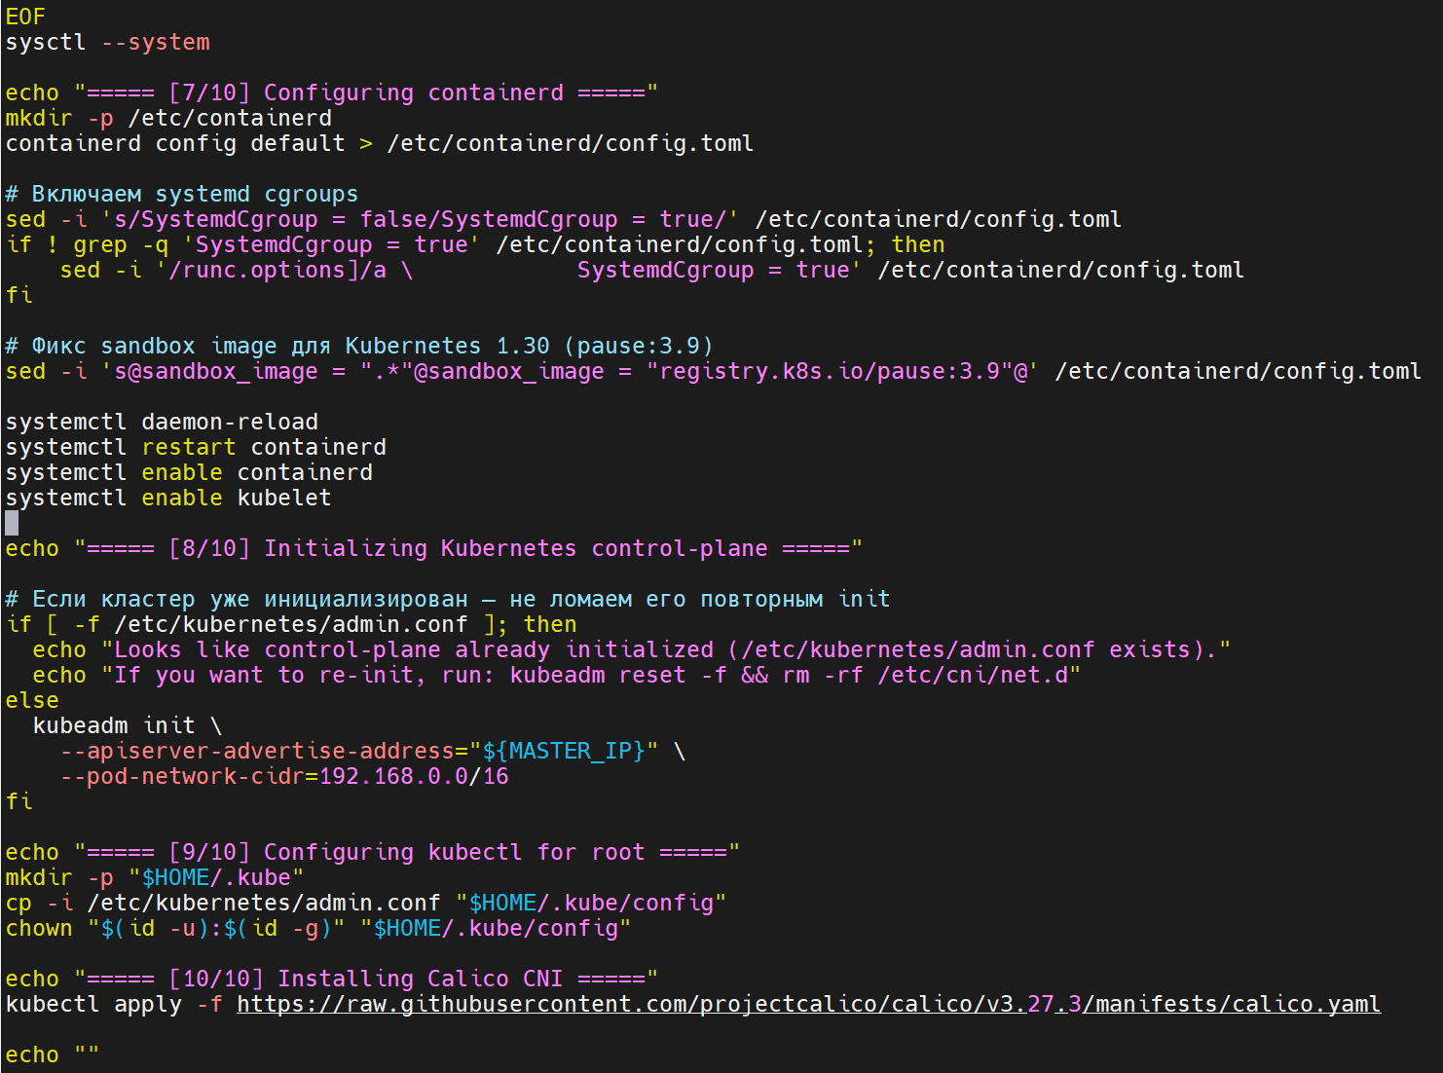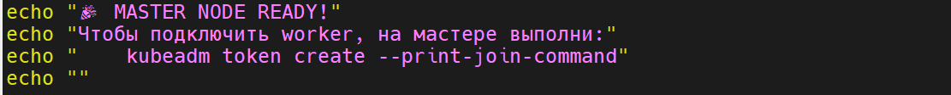

# chmod +x scripts/master.sh
# ./master.sh
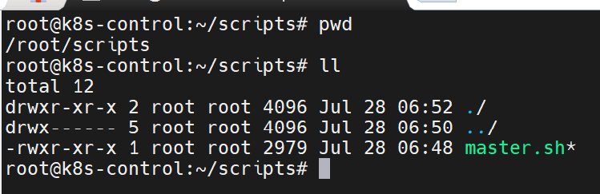

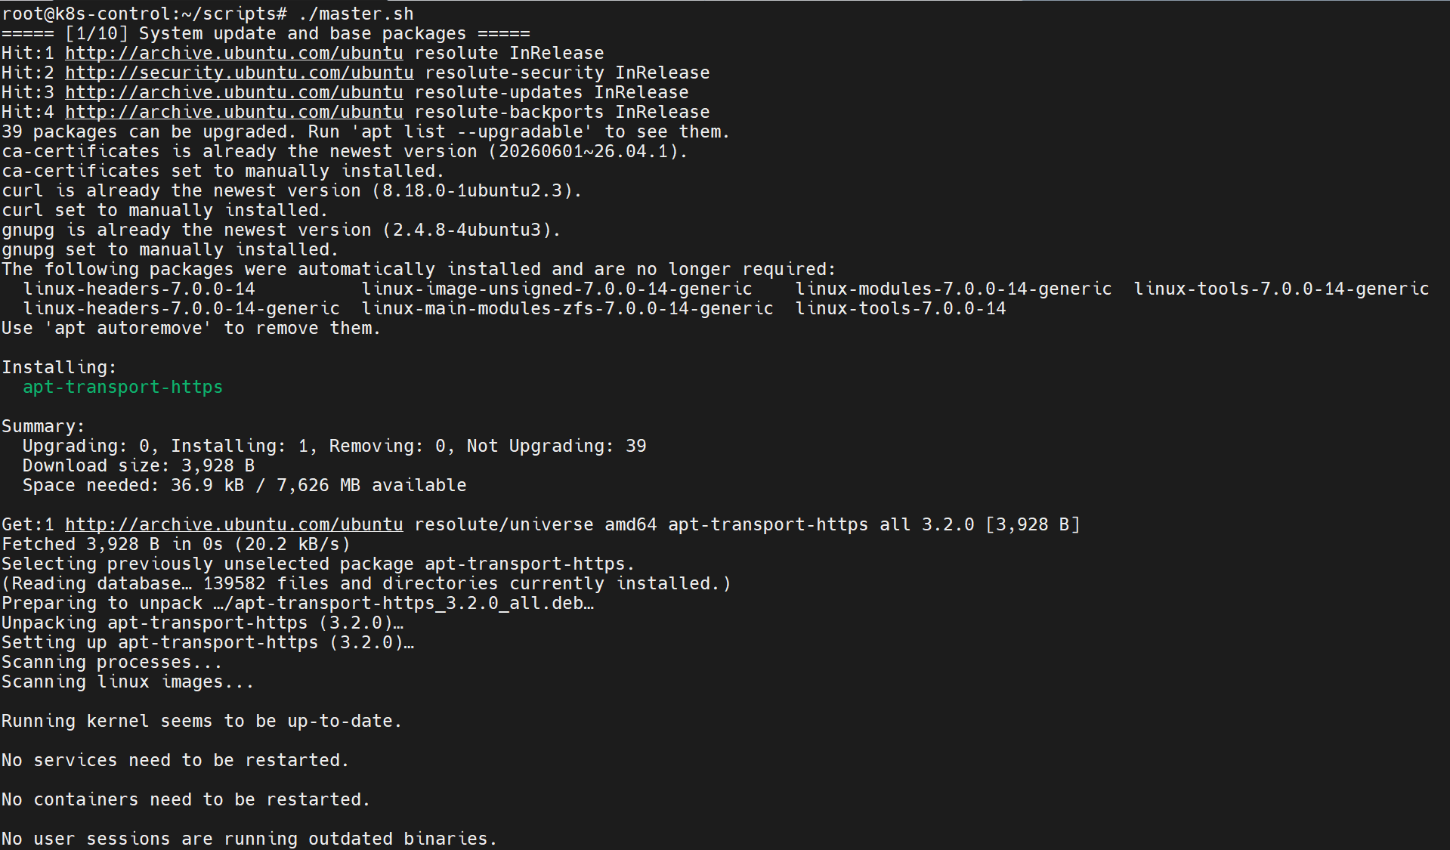
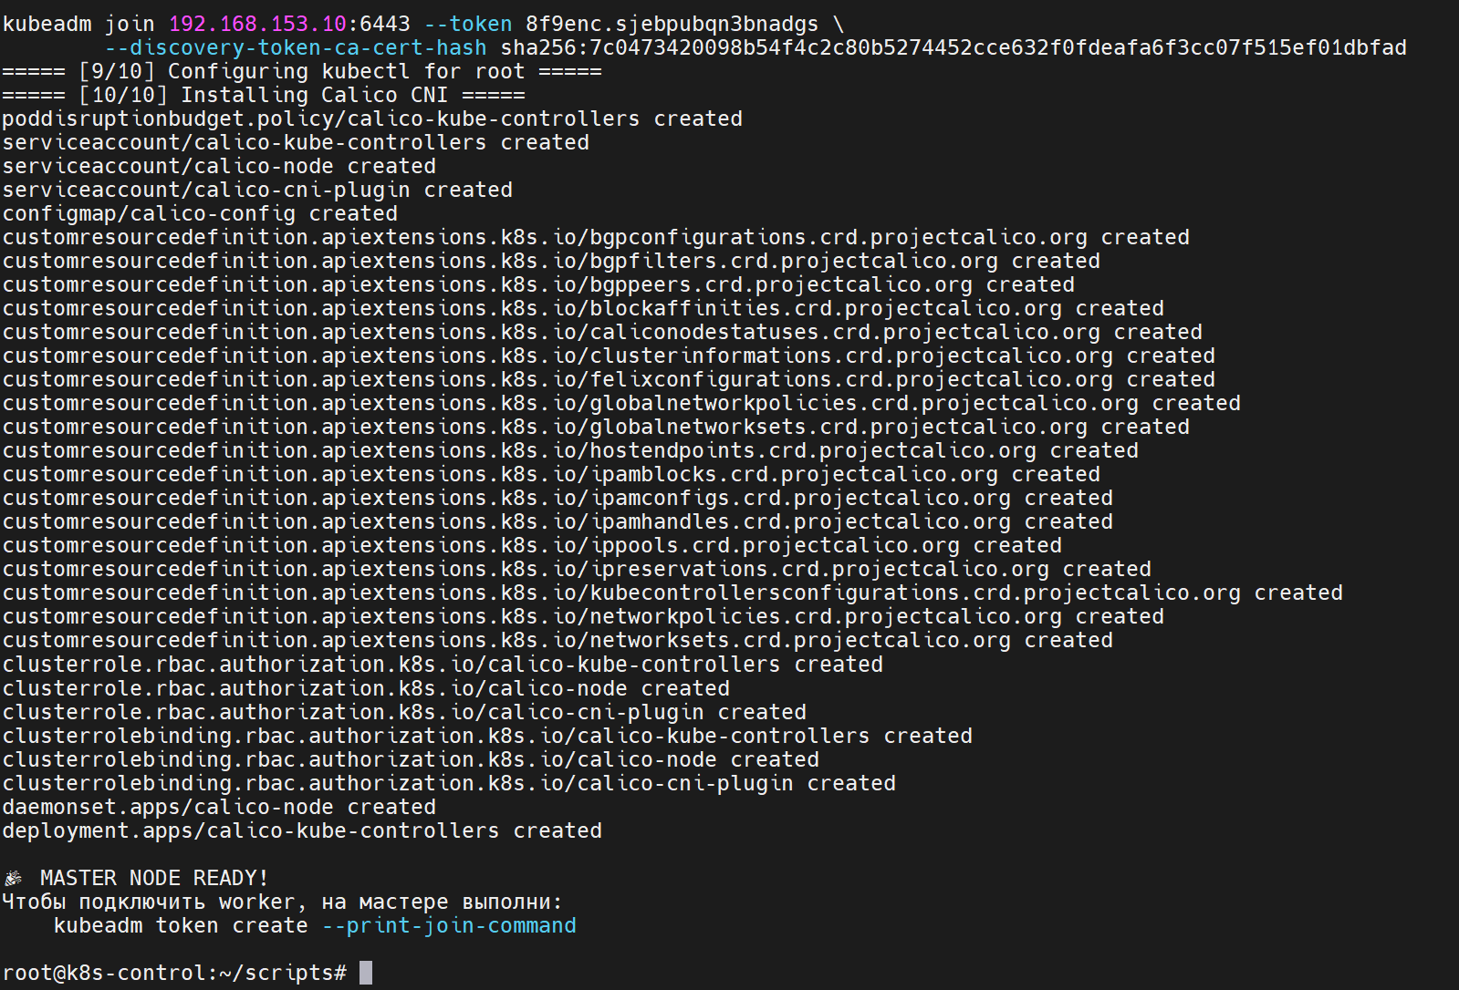

- Create k8s worker01 and worker2

# vim /etc/hosts



# mkdir scripts
# vim scripts/worker.sh

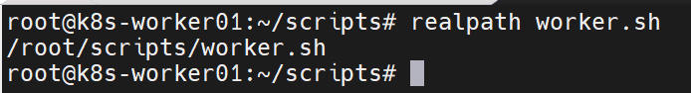

#!/bin/bash
set -euo pipefail

MASTER_IP="192.168.153.10"
KUBEADM_TOKEN="9ynbs4.g9bcv2xwvrhduj0w"
KUBEADM_DISCOVERY_HASH="d59ca20d205976951514d96cafbaed5305670a1d43917b543561f316b89bf653" # только хэш без sha256:

echo "===== [1/9] System update and base packages ====="
apt update -y
apt install -y apt-transport-https ca-certificates curl gnupg

echo "===== [2/9] Adding Kubernetes repository ====="
mkdir -p /etc/apt/keyrings
curl -fsSL https://pkgs.k8s.io/core:/stable:/v1.30/deb/Release.key \
| gpg --dearmor -o /etc/apt/keyrings/kubernetes-apt-keyring.gpg
chmod 644 /etc/apt/keyrings/kubernetes-apt-keyring.gpg

cat <<EOF >/etc/apt/sources.list.d/kubernetes.list
deb [signed-by=/etc/apt/keyrings/kubernetes-apt-keyring.gpg] https://pkgs.k8s.io/core:/stable:/v1.30/deb/ /
EOF

apt update -y

echo "===== [3/9] Installing kubelet, kubeadm, kubectl, containerd ====="
apt install -y kubelet kubeadm kubectl containerd
apt-mark hold kubelet kubeadm kubectl

echo "===== [4/9] Disabling swap ====="
swapoff -a || true
sed -i.bak '/swap/d' /etc/fstab || true

echo "===== [5/9] Enabling kernel modules ====="
cat <<EOF >/etc/modules-load.d/k8s.conf
overlay
br_netfilter
EOF
modprobe overlay
modprobe br_netfilter

echo "===== [6/9] Configuring sysctl ====="
cat <<EOF >/etc/sysctl.d/k8s.conf
net.ipv4.ip_forward=1
net.bridge.bridge-nf-call-iptables=1
net.bridge.bridge-nf-call-ip6tables=1
EOF
sysctl --system

echo "===== [7/9] Configuring containerd ====="
mkdir -p /etc/containerd
containerd config default > /etc/containerd/config.toml

# systemd cgroup driver
sed -i 's/SystemdCgroup = false/SystemdCgroup = true/' /etc/containerd/config.toml

# ensure SystemdCgroup inside runc.options
if ! grep -q 'SystemdCgroup = true' /etc/containerd/config.toml; then
sed -i '/runc.options]/a \ SystemdCgroup = true' /etc/containerd/config.toml
fi

# required fix for Kubernetes 1.30 (pause container)
sed -i 's@sandbox_image = ".*"@sandbox_image = "registry.k8s.io/pause:3.9"@' /etc/containerd/config.toml

systemctl daemon-reload
systemctl restart containerd
systemctl enable containerd
systemctl enable kubelet

echo "===== [8/9] Checking whether node is already joined ====="
if [[ -f /etc/kubernetes/kubelet.conf ]]; then
echo "Node already appears to be part of a cluster."
echo "If rejoin needed:"
echo " kubeadm reset -f"
echo " rm -rf /etc/cni/net.d"
exit 0
fi

echo "===== [9/9] Joining Kubernetes cluster ====="

if [[ "$KUBEADM_TOKEN" == "<TOKEN>" || "$KUBEADM_DISCOVERY_HASH" == "<SHA256_HASH>" ]]; then
echo "❌ ERROR: Token or discovery hash is not set."
echo "Run on master:"
echo " kubeadm token create --print-join-command"
exit 1
fi

kubeadm join "${MASTER_IP}:6443" \
--token "${KUBEADM_TOKEN}" \
--discovery-token-ca-cert-hash sha256:"${KUBEADM_DISCOVERY_HASH}"

echo ""
echo "🎉 WORKER NODE SUCCESSFULLY JOINED!"
echo ""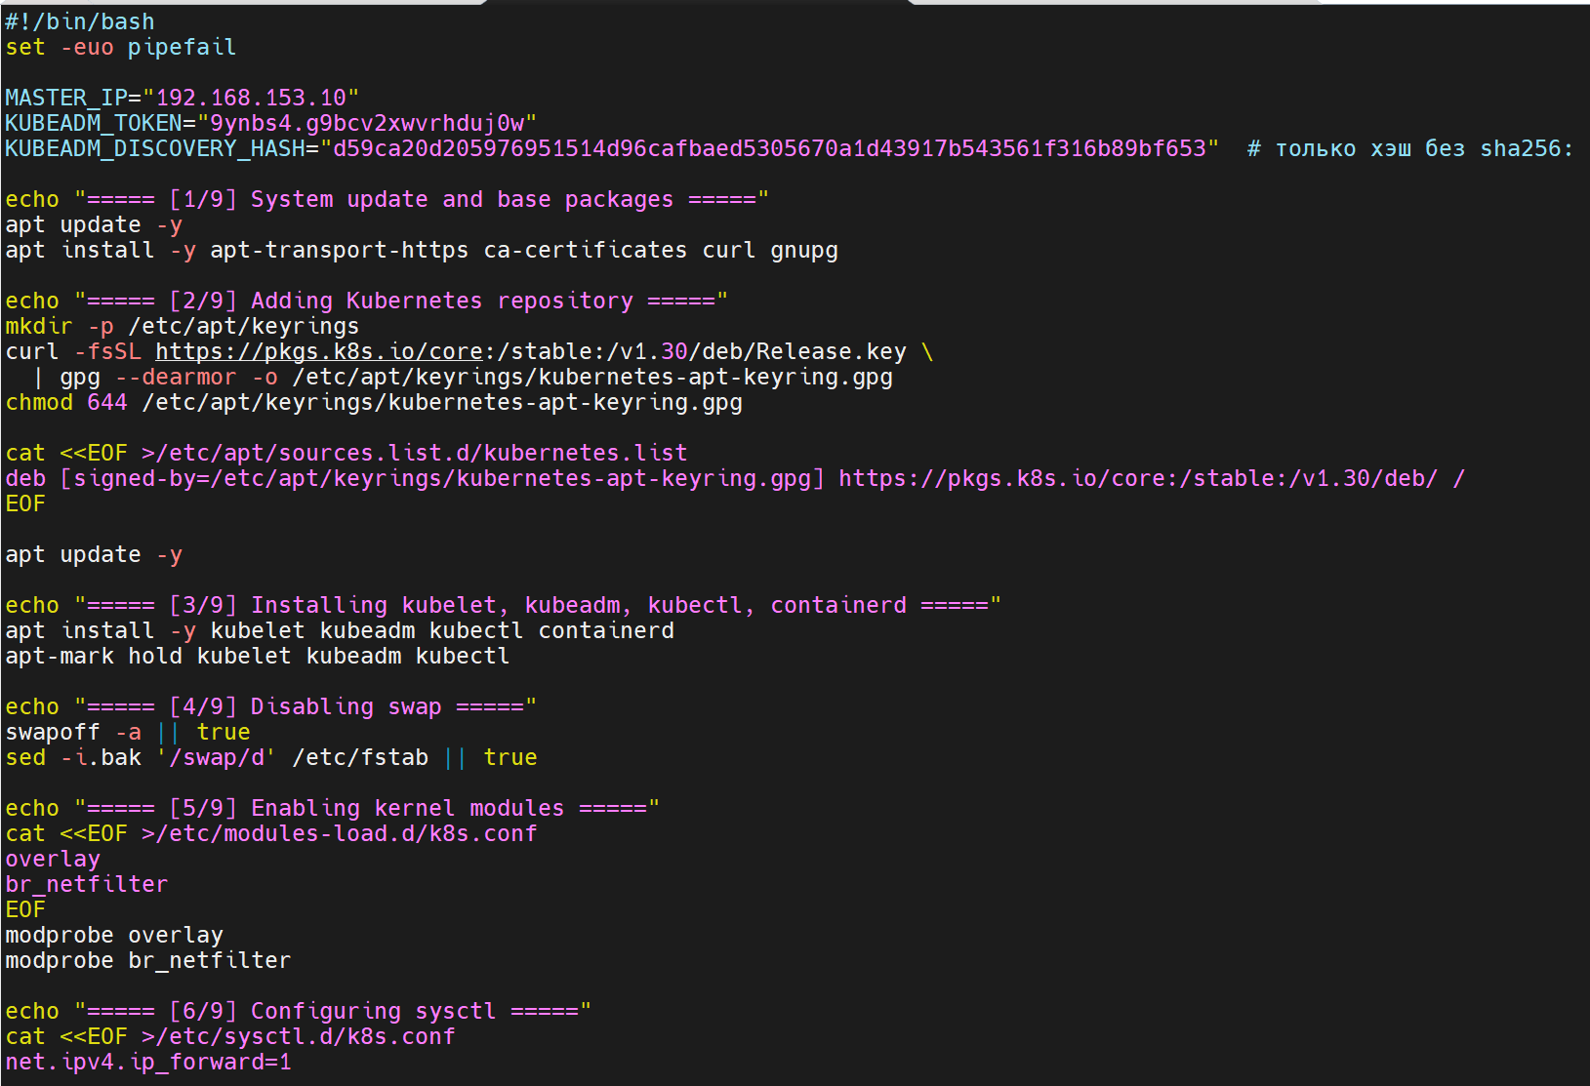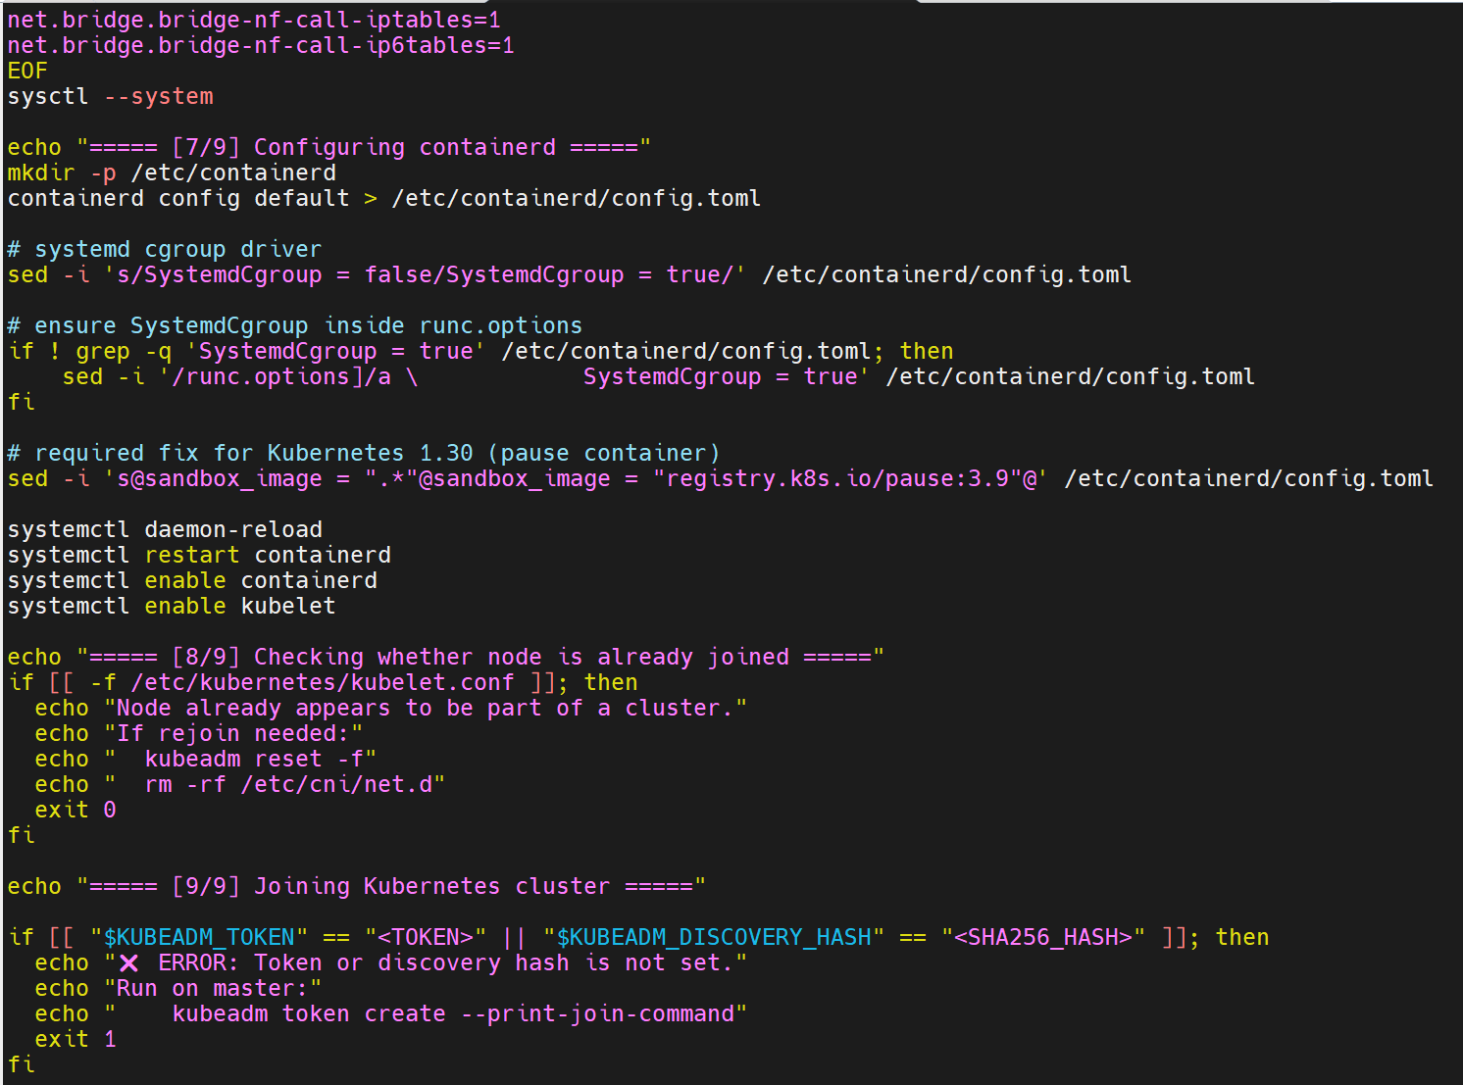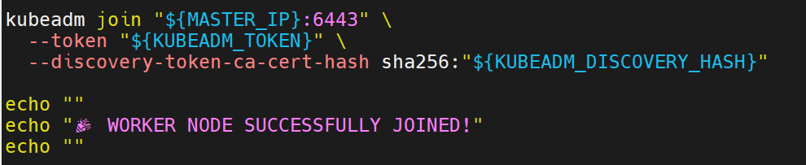

# chmod +x worker.sh
# ./worker.sh
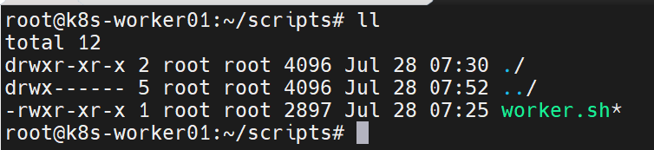

On the worker nodes, you may get this error.
On the k8s-control node, run this command:
# kubeadm token create --print-join-command
It will generate a join command with a token. Copy that command and run it on the k8s-worker nodes to join them to the Kubernetes cluster.

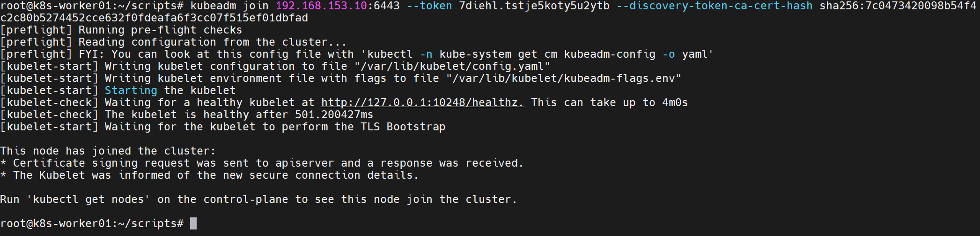
- Check on k8s master
# kubectl get nodes -o wide

- Create pod and check

# kubectl run test --image=nginx
# kubectl get pods

