DEPLOYMENT
- Create directory and change directory
# mkdir 02.k8s-task
# cd 02.k8s-task
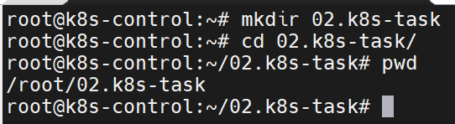

- Create manifest file
# vim game-2048.yaml

apiVersion: apps/v1
kind: Deployment
metadata:
name: game
labels:
app: game
spec:
replicas: 1
selector:
matchLabels:
app: game
template:
metadata:
labels:
app: game
spec:
containers:
- name: game
image: marcincuber/2048-game
ports:
- containerPort: 80
---
apiVersion: v1
kind: Service
metadata:
name: svc-2048
spec:
type: ClusterIP
selector:
app: game
ports:
- port: 8080
targetPort: 80
protocol: TCP
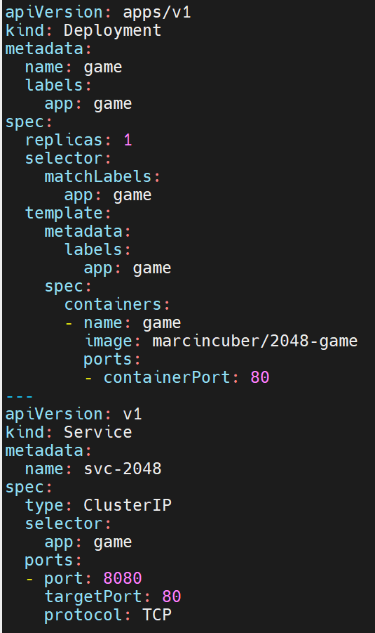

- Apply file
# kubectl apply -f game-2048.yaml
# kubectl get pods -o wide
# kubectl get svc -o wide
# kubectl get deployments.apps game -o wide
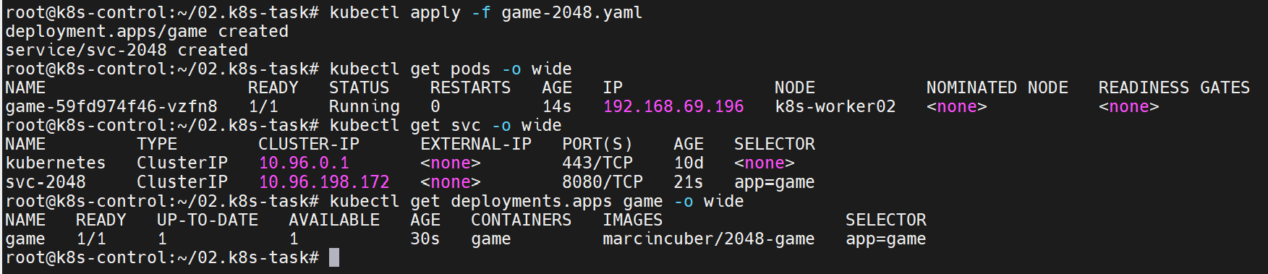

- Port forwarding
# kubectl port-forward svc/svc-2048 8080:8080 --address=0.0.0.0
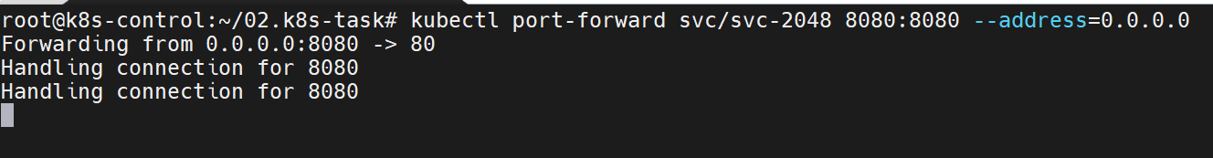

- Go to web and check http://192.168.153.10:8080

