**What is the FizzBuzz problem?**

The **FizzBuzz** problem is a frequently asked question in technical interviews. In real life, it is a game which is played by a group of people. The rules are quite straightforward.

**The Rules:**

* The sequence of turns is decided before starting the game.
* The first player starts by saying any number (usually the number 1).
* The next player says the next number, and so on. However, the following is the tricky part:
  1. Say the word **Fizz** instead of the number when it is a multiple of 3.
  2. Say **Buzz** if it is a multiple of 5.
  3. Say **FizzBuzz** if it is a multiple of both 3 and 5.
* The rules to say these words can be changed. For example, saying **FizzBuzz** when a number is a multiple of both 7 and 9.

If you say the wrong number or word, you’re out! The last player standing wins the game.

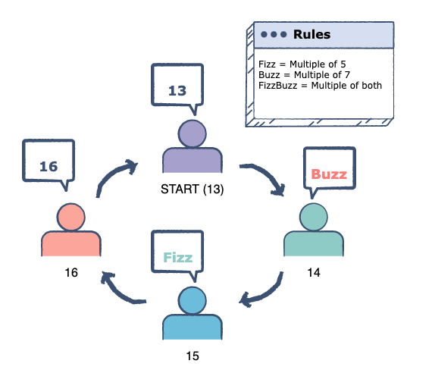

One round of FizzBuzz

**Steps**