Q_01

import javax.swing.*;  
  
public class WelcomeFrame {  
 public static void main(String[] args) {  
 // Create a frame  
 JFrame frame = new JFrame("Welcome to Java");  
  
 // Set the size of the frame  
 frame.setSize(800, 600);  
  
 // Set the default close operation  
 frame.setDefaultCloseOperation(JFrame.*EXIT_ON_CLOSE*);  
  
 // Center the frame on the screen  
 frame.setLocationRelativeTo(null);  
  
 // Make the frame visible  
 frame.setVisible(true);  
 }  
}

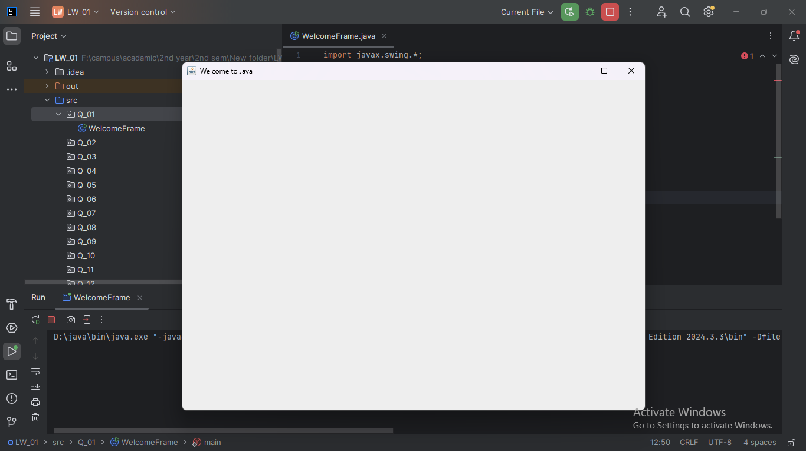

Q_02

import javax.swing.*;  
import java.awt.*;  
import java.util.Scanner;  
  
public class UserFnameLname {  
 public static void main(String[] args) {  
 // Create a Scanner object for user input  
 Scanner scanner = new Scanner(System.*in*);  
  
 // Prompt user for first and last name  
 System.*out*.print("Enter your first name: ");  
 String firstName = scanner.nextLine();  
  
 System.*out*.print("Enter your last name: ");  
 String lastName = scanner.nextLine();  
  
 // Combine first and last name to create the title  
 String fullName = firstName + " " + lastName;  
  
 // Create a frame with user's full name as the title  
 JFrame frame = new JFrame(fullName);  
  
 // Set the size of the frame  
 frame.setSize(800, 600);  
  
 // Set the default close operation  
 frame.setDefaultCloseOperation(JFrame.*EXIT_ON_CLOSE*);  
  
 // Center the frame on the screen  
 frame.setLocationRelativeTo(null);  
  
 // Create a panel with a GridBagLayout to center the label  
 JPanel panel = new JPanel(new GridBagLayout());  
 panel.setBackground(Color.*LIGHT_GRAY*);  
 frame.add(panel);  
  
 // Create a label with a welcome message  
 JLabel label = new JLabel("Welcome, " + fullName + "!");  
 label.setFont(new Font("Arial", Font.*BOLD*, 24));  
 label.setForeground(Color.*BLUE*);  
  
 // Add label to panel at the center  
 panel.add(label, new GridBagConstraints());  
  
 // Make the frame visible  
 frame.setVisible(true);  
 }  
}

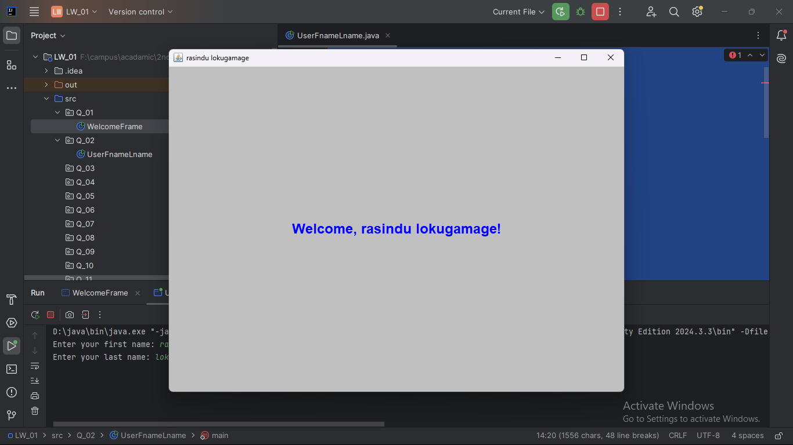

Q_03

import javax.swing.*;  
import java.awt.*;  
import java.util.Scanner;  
  
public class FMLName {  
 public static void main(String[] args) {  
 // Create a Scanner object for user input  
 Scanner scanner = new Scanner(System.*in*);  
  
 // Prompt user for first, middle, and last name  
 System.*out*.print("Enter your first name: ");  
 String firstName = scanner.nextLine();  
  
 System.*out*.print("Enter your middle name: ");  
 String middleName = scanner.nextLine();  
  
 System.*out*.print("Enter your last name: ");  
 String lastName = scanner.nextLine();  
  
 // Extract middle initial and format the name  
 String middleInitial = middleName.substring(0, 1).toUpperCase() + ".";  
 String fullName = firstName + " " + middleInitial + " " + lastName;  
  
 // Create a frame with user's formatted full name as the title  
 JFrame frame = new JFrame(fullName);  
  
 // Set the size of the frame  
 frame.setSize(800, 600);  
  
 // Set the default close operation  
 frame.setDefaultCloseOperation(JFrame.*EXIT_ON_CLOSE*);  
  
 // Center the frame on the screen  
 frame.setLocationRelativeTo(null);  
  
 // Create a panel with a GridBagLayout to center the label  
 JPanel panel = new JPanel(new GridBagLayout());  
 panel.setBackground(Color.*LIGHT_GRAY*);  
 frame.add(panel);  
  
 // Create a label with a welcome message  
 JLabel label = new JLabel("Welcome, " + fullName + "!");  
 label.setFont(new Font("Arial", Font.*BOLD*, 24));  
 label.setForeground(Color.*BLUE*);  
  
 // Add label to panel at the center  
 panel.add(label, new GridBagConstraints());  
  
 // Make the frame visible  
 frame.setVisible(true);  
 }  
}

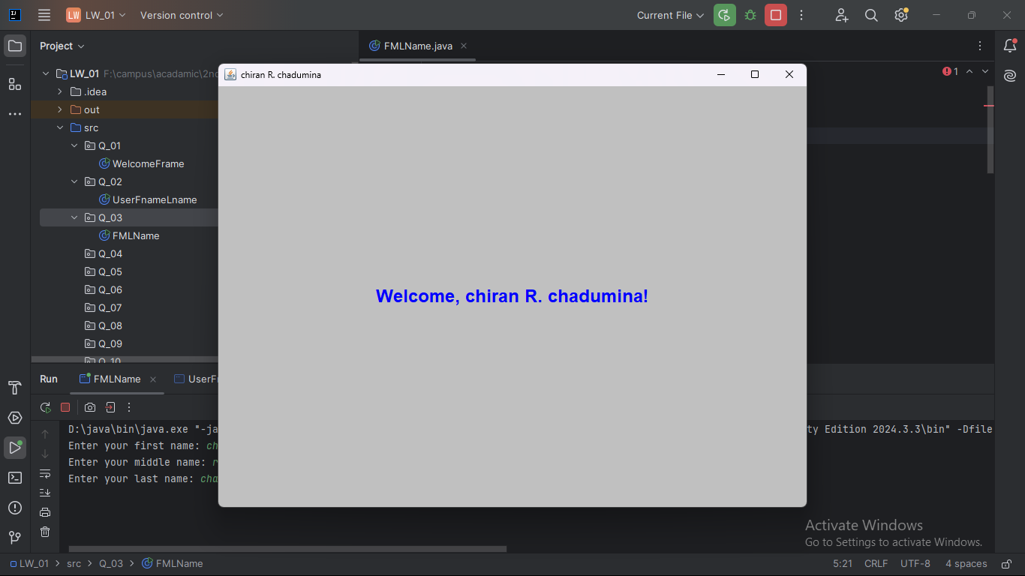

Q_04

import java.text.SimpleDateFormat;  
import java.util.Date;  
  
public class timedate {  
 public static void main(String[] args) {  
 // Create an instance of Date class to get the current date and time  
 Date currentDate = new Date();  
  
 // Define the desired format  
 SimpleDateFormat dateFormat = new SimpleDateFormat("dd MMM yyyy");  
  
 // Format the current date and print it to the console  
 System.*out*.println(dateFormat.format(currentDate));  
 }  
}

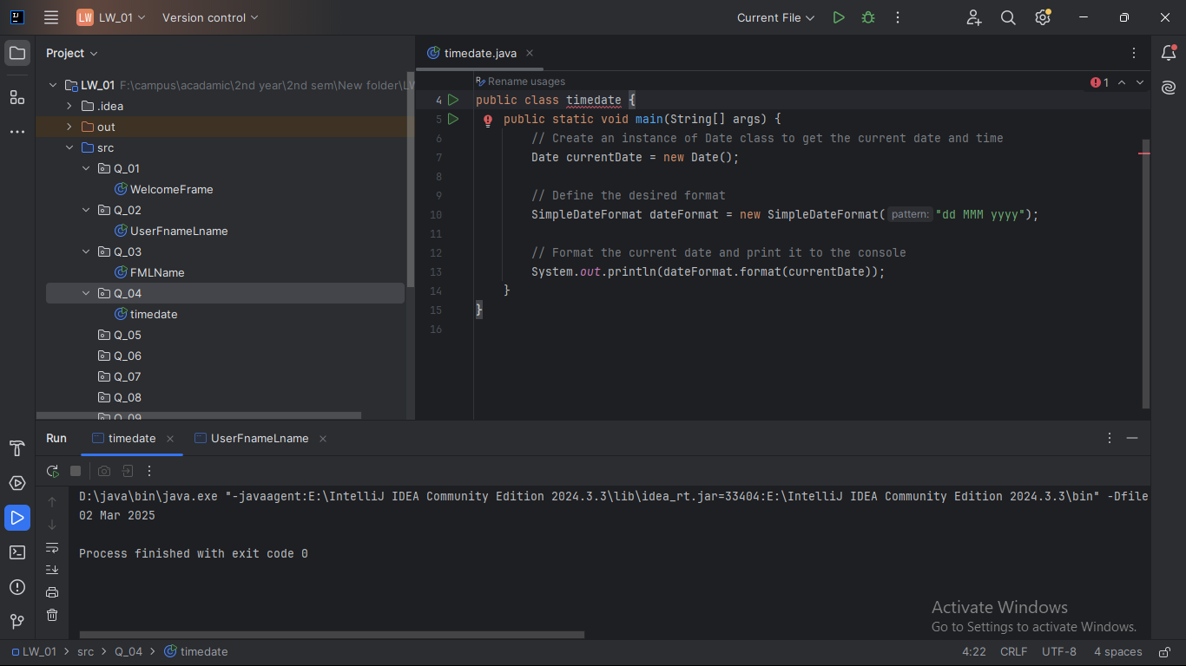

Q_05

import java.text.SimpleDateFormat;  
import java.util.Date;  
  
public class timedate_2 {  
 public static void main(String[] args) {  
 // Create an instance of Date class to get the current date and time  
 Date currentDate = new Date();  
  
 // Define the desired format  
 SimpleDateFormat dateFormat = new SimpleDateFormat("EEEE, MMM dd, yyyy");  
  
 // Format the current date and print it to the console  
 System.*out*.println(dateFormat.format(currentDate));  
 }  
}

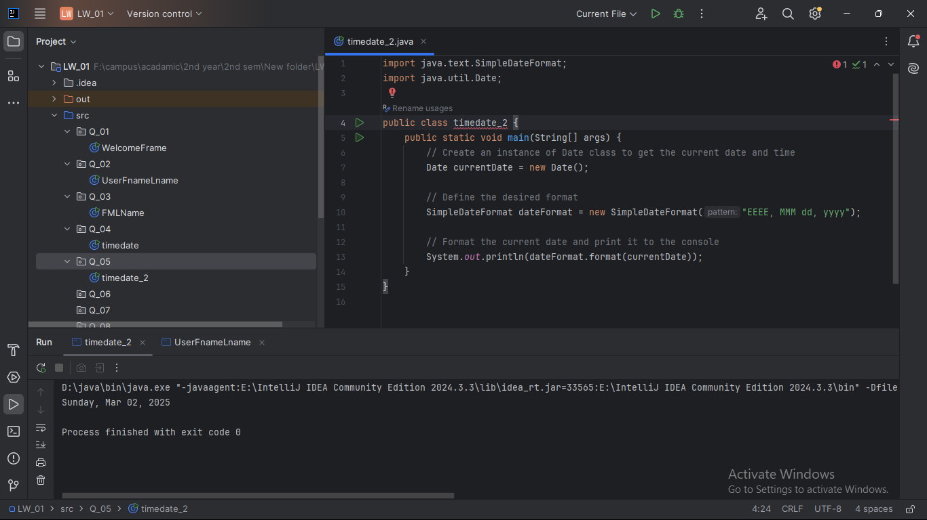

Q_06

import javax.swing.*;  
import java.util.Scanner;  
  
public class Cframe {  
 public static void main(String[] args) {  
 // Create a Scanner object to read input from the user  
 Scanner scanner = new Scanner(System.*in*);  
  
 // Prompt user for the width, height, and title of the frame  
 System.*out*.print("Enter the width of the frame (W): ");  
 int width = scanner.nextInt();  
  
 System.*out*.print("Enter the height of the frame (H): ");  
 int height = scanner.nextInt();  
  
 scanner.nextLine(); // Consume the newline character after the integer input  
  
 System.*out*.print("Enter the title of the frame: ");  
 String title = scanner.nextLine();  
  
 // Create the frame with the specified title  
 JFrame frame = new JFrame(title);  
  
 // Set the size of the frame  
 frame.setSize(width, height);  
  
 // Set the default close operation so the program exits when the frame is closed  
 frame.setDefaultCloseOperation(JFrame.*EXIT_ON_CLOSE*);  
  
 // Set the frame to be visible  
 frame.setVisible(true);  
 }  
}

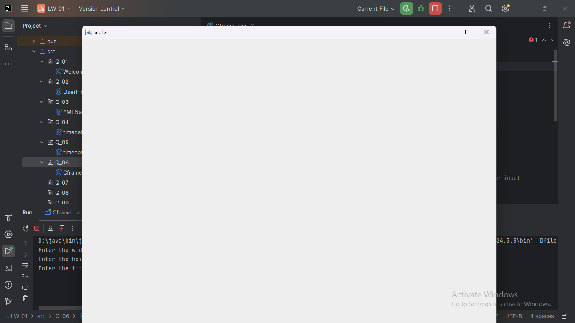

Q_07

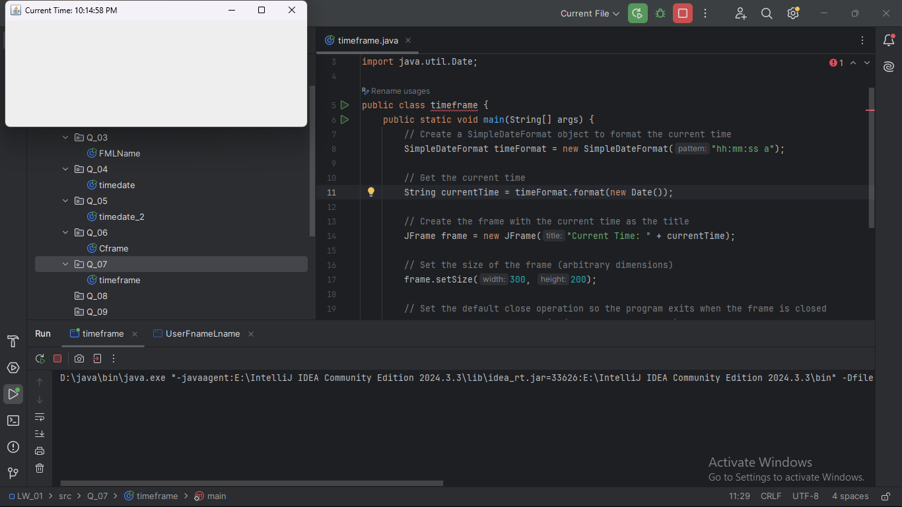

import javax.swing.*;  
import java.text.SimpleDateFormat;  
import java.util.Date;  
  
public class timeframe {  
 public static void main(String[] args) {  
 // Create a SimpleDateFormat object to format the current time  
 SimpleDateFormat timeFormat = new SimpleDateFormat("hh:mm:ss a");  
  
 // Get the current time  
 String currentTime = timeFormat.format(new Date());  
  
 // Create the frame with the current time as the title  
 JFrame frame = new JFrame("Current Time: " + currentTime);  
  
 // Set the size of the frame (arbitrary dimensions)  
 frame.setSize(300, 200);  
  
 // Set the default close operation so the program exits when the frame is closed  
 frame.setDefaultCloseOperation(JFrame.*EXIT_ON_CLOSE*);  
  
 // Set the frame to be visible  
 frame.setVisible(true);  
 }  
}

Q_08

import java.util.Scanner;  
  
public class tfomat {  
 public static void main(String[] args) {  
 // Create a Scanner object to read input from the user  
 Scanner scanner = new Scanner(System.*in*);  
  
 // Prompt user to enter a string containing a single exclamation mark  
 System.*out*.print("Enter a string containing a single exclamation mark: ");  
 String input = scanner.nextLine();  
  
 // Find the position of the exclamation mark  
 int exclamationIndex = input.indexOf('!');  
  
 // If the exclamation mark is found, split the string into two parts  
 if (exclamationIndex != -1) {  
 String beforeExclamation = input.substring(0, exclamationIndex).trim();  
 String afterExclamation = input.substring(exclamationIndex + 1).trim();  
  
 // Output the two parts without the exclamation mark  
 System.*out*.println("Before exclamation mark: " + beforeExclamation);  
 System.*out*.println("After exclamation mark: " + afterExclamation);  
 } else {  
 // If no exclamation mark is found, output an error message  
 System.*out*.println("The input string does not contain an exclamation mark.");  
 }  
 }  
}

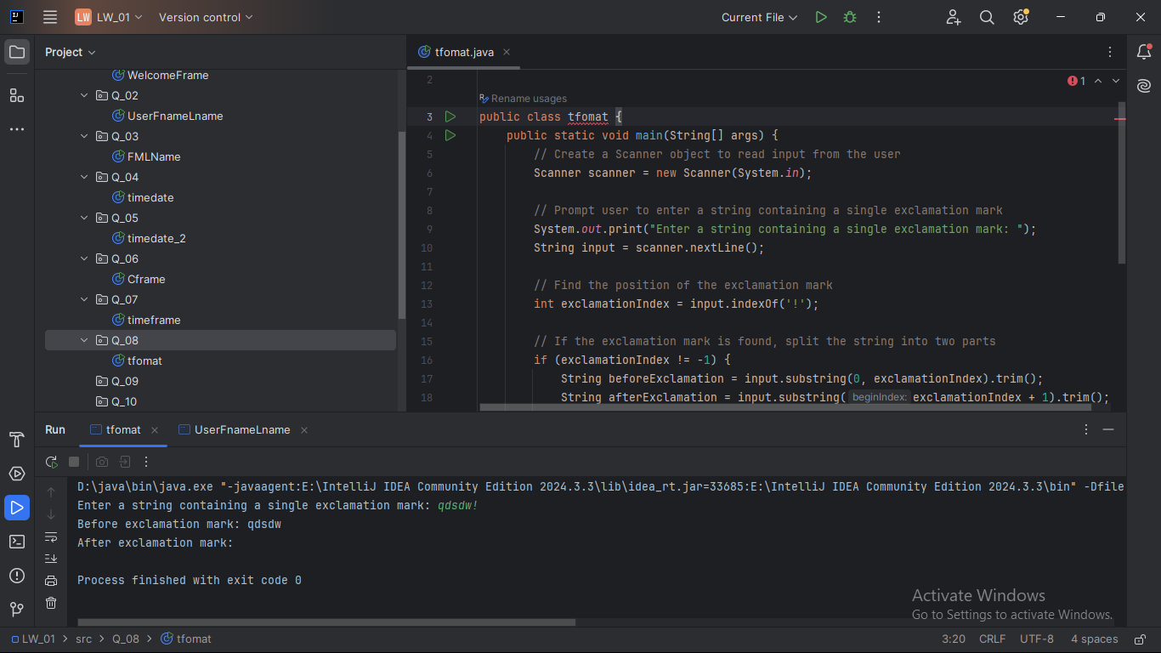

Q_09

import java.util.Scanner;  
  
public class strinfo {  
 public static void main(String[] args) {  
 // Create a Scanner object to read input from the user  
 Scanner scanner = new Scanner(System.*in*);  
  
 // Prompt user for the input string  
 System.*out*.print("Enter a string: ");  
 String input = scanner.nextLine();  
  
 // Calculate the length of the string  
 int length = input.length();  
  
 // Get the first and last characters  
 char firstChar = input.charAt(0);  
 char lastChar = input.charAt(length - 1);  
  
 // Output the results  
 System.*out*.println(length);  
 System.*out*.println(firstChar);  
 System.*out*.println(lastChar);  
 }  
}

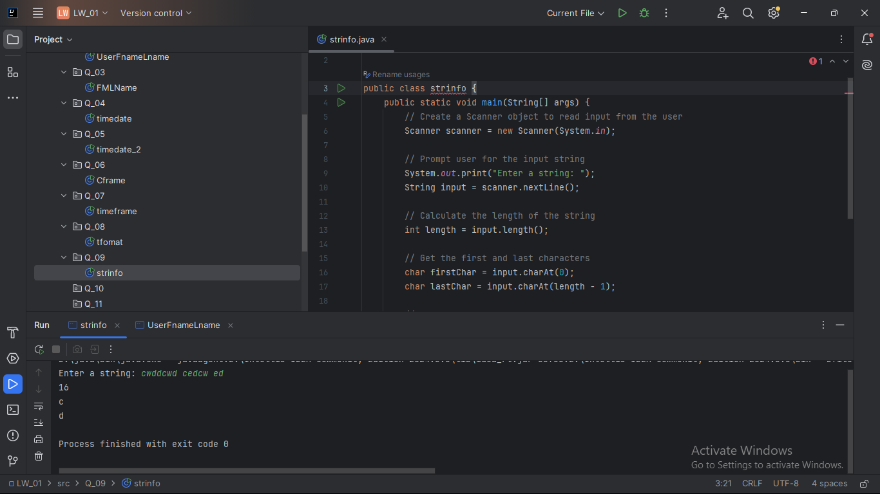

Q_10

import java.util.Scanner;  
  
public class Mchar {  
 public static void main(String[] args) {  
 // Create a Scanner object to read input from the user  
 Scanner scanner = new Scanner(System.*in*);  
  
 // Prompt the user for an odd-length word  
 System.*out*.print("Enter an odd-length word: ");  
 String input = scanner.nextLine();  
  
 // Ensure the input length is odd  
 if (input.length() % 2 != 0) {  
 // Find the middle index  
 int middleIndex = input.length() / 2;  
  
 // Get the middle character  
 char middleChar = input.charAt(middleIndex);  
  
 // Output the middle character  
 System.*out*.println("Middle character: " + middleChar);  
 } else {  
 System.*out*.println("Please enter a word with an odd length.");  
 }  
 }  
}

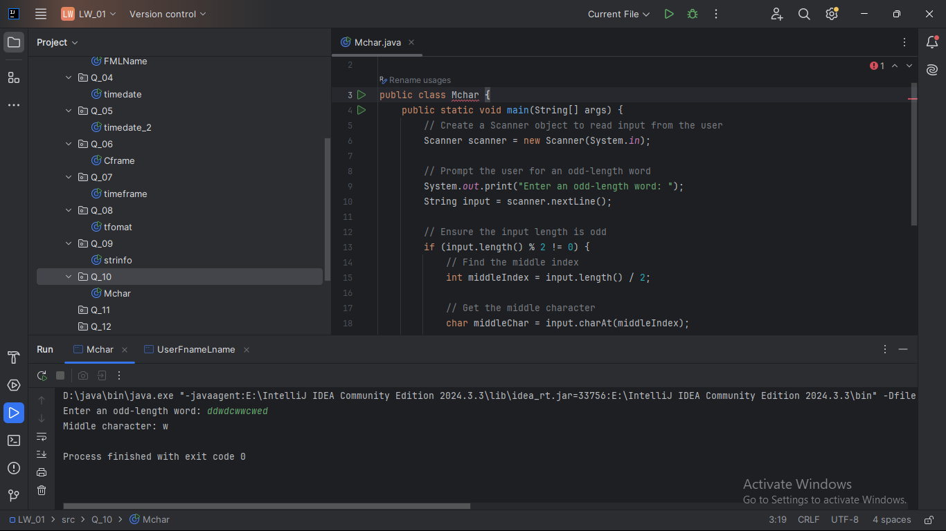

Q_11

import java.util.Scanner;  
  
public class namefomat {  
 public static void main(String[] args) {  
 // Create a Scanner object to read input from the user  
 Scanner scanner = new Scanner(System.*in*);  
  
 // Prompt the user for their full name (first middle last)  
 System.*out*.print("Enter your full name (first middle last): ");  
 String fullName = scanner.nextLine();  
  
 // Split the full name into an array of words (first, middle, last)  
 String[] nameParts = fullName.split(" ");  
  
 // Ensure the name has exactly three parts: first, middle, and last  
 if (nameParts.length == 3) {  
 String firstName = nameParts[0];  
 String middleName = nameParts[1];  
 String lastName = nameParts[2];  
  
 // Get the first letter of the middle name  
 char middleInitial = middleName.charAt(0);  
  
 // Format and print the name in the desired format: last, first middle-initial.  
 System.*out*.println(lastName + ", " + firstName + " " + middleInitial + ".");  
 } else {  
 System.*out*.println("Please enter your full name in the format: first middle last.");  
 }  
 }  
}

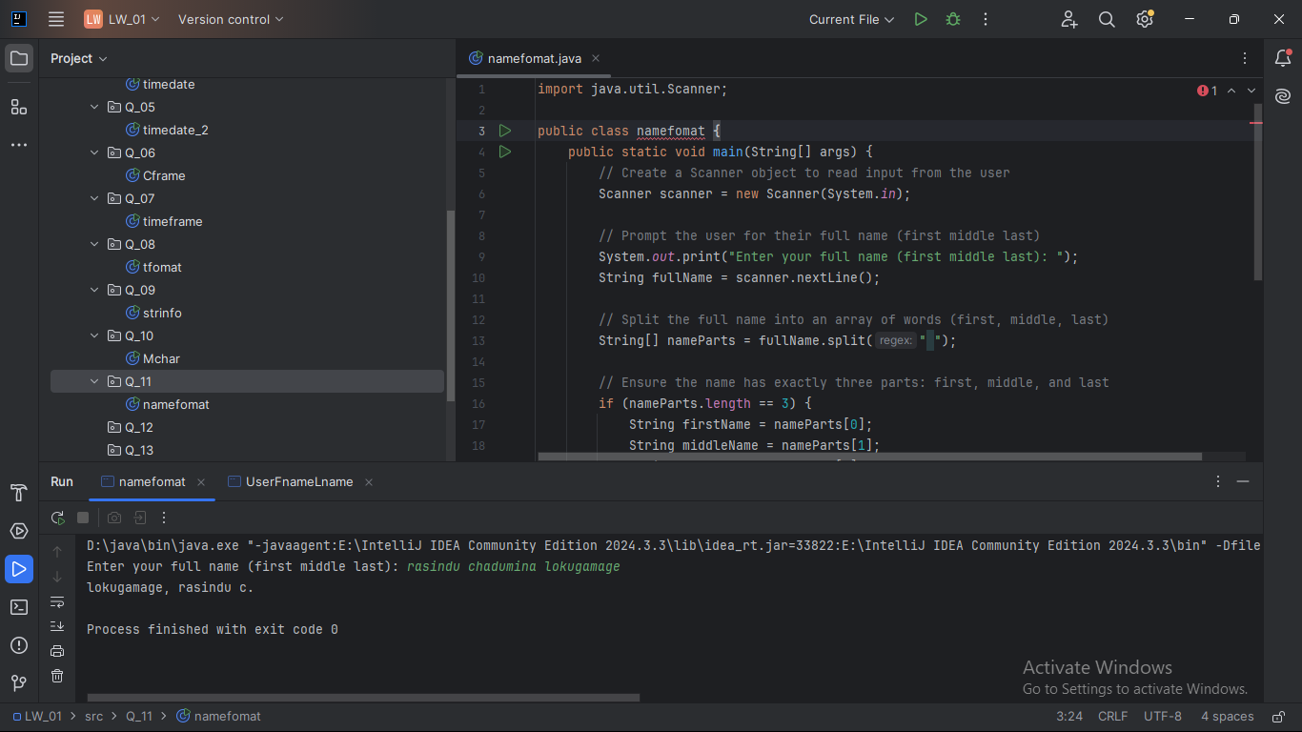

Q_12

import javax.swing.*;  
  
public class myfname {  
 public static void main(String[] args) {  
 // Create a frame with the title "My First Frame"  
 JFrame frame = new JFrame("My First Frame");  
  
 // Set the size of the frame (300 pixels wide, 200 pixels high)  
 frame.setSize(300, 200);  
  
 // Position the frame with its top-left corner at (50, 100) on the screen  
 frame.setLocation(100, 50);  
  
 // Set the default close operation to exit the program when the frame is closed  
 frame.setDefaultCloseOperation(JFrame.*EXIT_ON_CLOSE*);  
  
 // Make the frame visible  
 frame.setVisible(true);  
 }  
}

