**Lab worksheet 2:Numerical Data**

Object-Oriented Programming

CTEC 2204

**STUDENT NO:- CT/2021/036**

**1.**

**a.**

double resultA = Math.sqrt(Math.pow(B, 2) + 4 * A * C);

**b.**

double resultB = Math.sqrt(X + 4 * Math.pow(Y, 3));

**c.**

double resultC = Math.pow(X * Y, 1.0 / 3);

**d.**

double area = Math.PI * Math.pow(radius, 2);

**2.** import java.util.Scanner;  
  
public class CentimeterToFeetInches {  
 public static void main(String[] args) {  
 Scanner scanner = new Scanner(System.*in*);  
 System.*out*.print("Enter length in centimeters: ");  
 double centimeters = scanner.nextDouble();  
  
 double inches = centimeters / 2.54;  
 int feet = (int) (inches / 12);  
 double remainingInches = inches % 12;  
  
 System.*out*.printf("%.2f centimeters is equal to %d feet and %.2f inches%n", centimeters, feet, remainingInches);  
 scanner.close();  
 }  
}

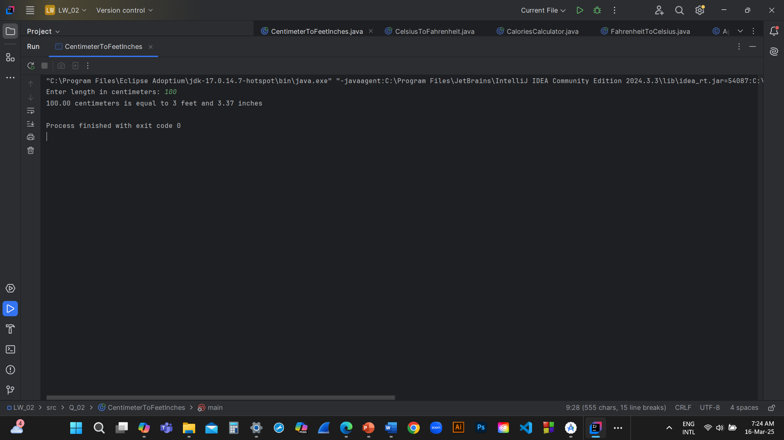

**3.**

import java.util.Scanner;

public class CelsiusToFahrenheit {

public static void main(String[] args) {

Scanner scanner = new Scanner(System.in);

System.out.print("Enter temperature in degrees Celsius: ");

double celsius = scanner.nextDouble();

double fahrenheit = (1.8 * celsius) + 32;

System.out.printf("%.2f degrees Celsius is equal to %.2f degrees Fahrenheit%n", celsius, fahrenheit);

scanner.close();

}

**4.**

import java.util.Scanner;

public class CaloriesCalculator {

public static void main(String[] args) {

Scanner scanner = new Scanner(System.in);

System.out.print("Enter your weight in pounds: ");

double bodyWeight = scanner.nextDouble();

double calories = bodyWeight * 19;

System.out.println("You need " + calories + " calories per day.");

scanner.close();

}

}

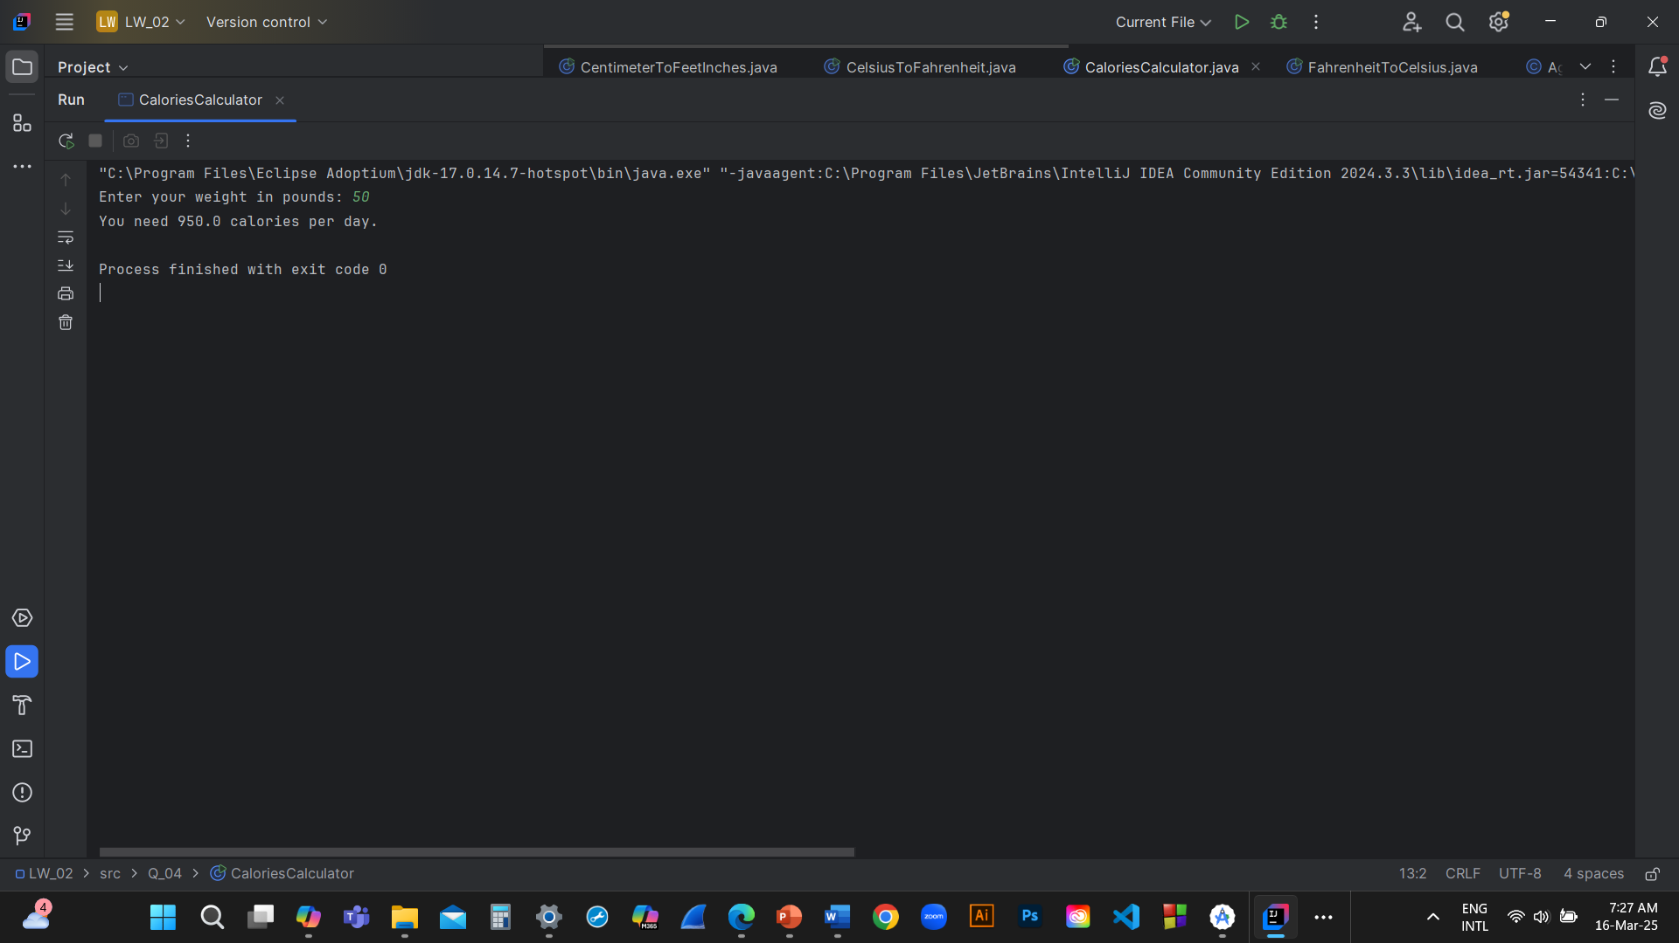

**5.**

import java.util.Scanner;

public class FahrenheitToCelsius {

public static void main(String[] args) {

Scanner scanner = new Scanner(System.in);

System.out.print("Enter temperature in degrees Fahrenheit: ");

double fahrenheit = scanner.nextDouble();

double celsius = (5.0 / 9) * (fahrenheit - 32);

System.out.printf("%.2f degrees Fahrenheit is equal to %.2f degrees Celsius%n", fahrenheit, celsius);

scanner.close();

}

}

**6.**

import java.util.Scanner;

public class AgeCalculator {

public static void main(String[] args) {

Scanner scanner = new Scanner(System.in);

System.out.print("Enter the year you were born: ");

int birthYear = scanner.nextInt();

int currentYear = java.time.Year.now().getValue();

int age = currentYear - birthYear;

String verb = (age > 0) ? "are" : "will be";

System.out.println("You were born in " + birthYear + " and " + verb + " " + Math.abs(age) + " this year.");

scanner.close();

}

}

**7.**

import java.util.Scanner;

public class BMICalculator {

public static void main(String[] args) {

Scanner scanner = new Scanner(System.in);

System.out.print("Enter your weight in kilograms: ");

double weight = scanner.nextDouble();

System.out.print("Enter your height in centimeters: ");

double height = scanner.nextDouble();

double bmi = weight / Math.pow(height / 100.0, 2);

System.out.printf("Your BMI is: %.2f%n", bmi);

if (bmi >= 20 && bmi <= 25) {

System.out.println("Your BMI is considered 'normal'.");

} else if (bmi < 20) {

System.out.println("Your BMI is considered 'underweight'.");

} else {

System.out.println("Your BMI is considered 'overweight'.");

}

scanner.close();

}

}

**8.**

import java.util.Scanner;

public class SphereVolumeCalculator {

public static void main(String[] args) {

Scanner scanner = new Scanner(System.in);

System.out.print("Enter the radius of the sphere: ");

double radius = scanner.nextDouble();

double volume = (4.0 / 3) * Math.PI * Math.pow(radius, 3);

System.out.printf("The volume of the sphere is: %.2f%n", volume);

scanner.close();

}

}

**9.**

import java.util.Scanner;

public class CompoundInterestCalculator {

public static void main(String[] args) {

Scanner scanner = new Scanner(System.in);

System.out.print("Enter the principal amount (P): ");

double principal = scanner.nextDouble();

System.out.print("Enter the annual interest rate (R) in percentage: ");

double rate = scanner.nextDouble();

System.out.print("Enter the number of years (N): ");

int years = scanner.nextInt();

double futureValue = principal * Math.pow(1 + (rate / 100), years);

System.out.printf("The future value of your investment after %d years is: %.2f%n", years, futureValue);

scanner.close();

}

}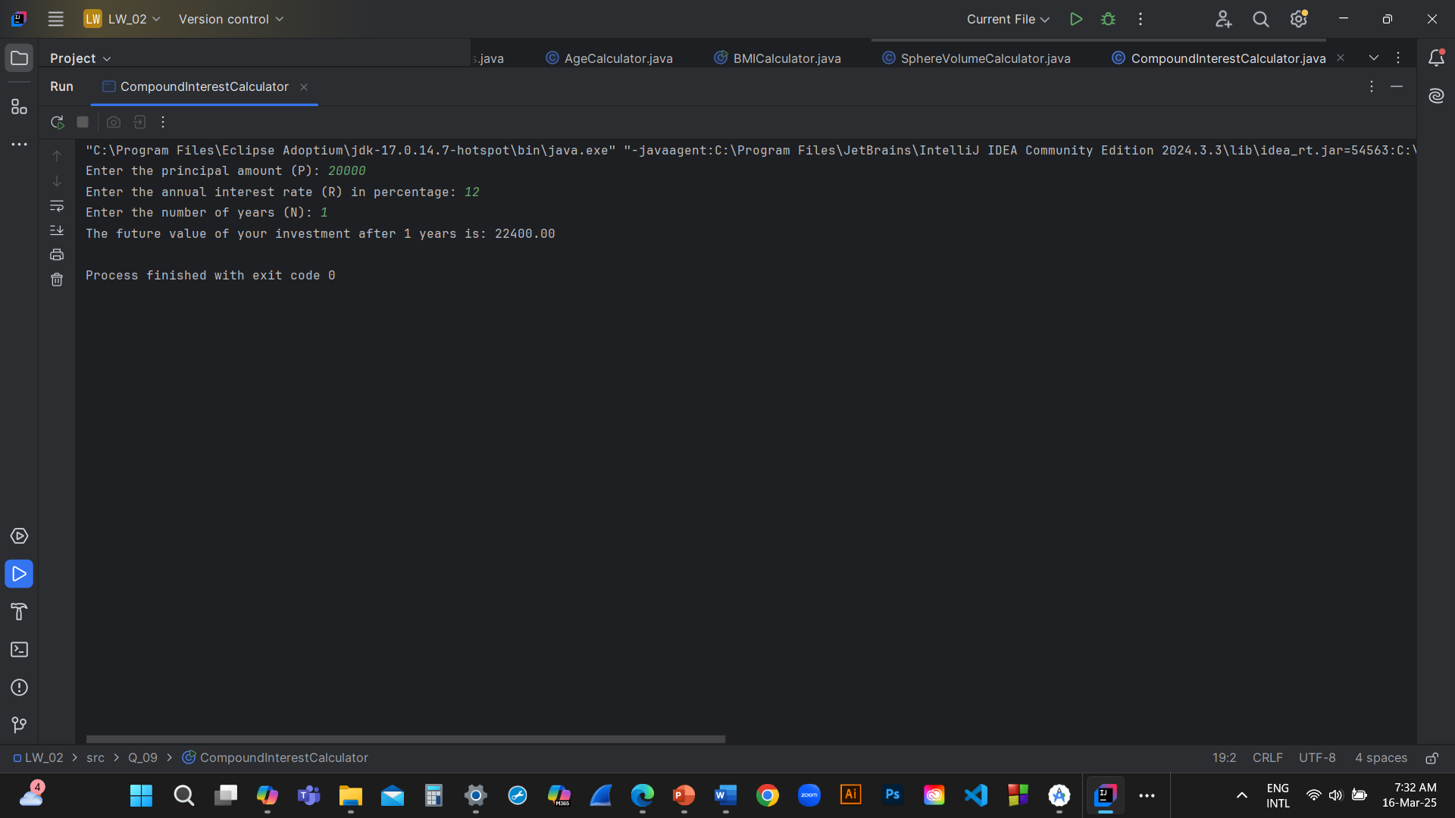

**10.**

import java.util.Scanner;

public class LoanCalculator {

public static void main(String[] args) {

Scanner scanner = new Scanner(System.in);

final int MONTHS_IN_YEAR = 12;

System.out.print("Enter the loan amount: ");

double loanAmount = scanner.nextDouble();

System.out.print("Enter the annual interest rate (in percentage): ");

double annualInterestRate = scanner.nextDouble();

System.out.print("Enter the loan period (in years): ");

int loanPeriod = scanner.nextInt();

double monthlyInterestRate = annualInterestRate / 100 / MONTHS_IN_YEAR;

int numberOfPayments = loanPeriod * MONTHS_IN_YEAR;

double monthlyPayment = (loanAmount * monthlyInterestRate) /

(1 - Math.pow(1 / (1 + monthlyInterestRate), numberOfPayments));

double totalPayment = monthlyPayment * numberOfPayments;

System.out.printf("Monthly Payment: %.2f%n", monthlyPayment);

System.out.printf("Total Payment: %.2f%n", totalPayment);

scanner.close();

}

}

