Low Level Design

Project Code | Group 4
Project Name | Expense Management System

Prepared / Modified by | Role | Date of preparation/ Modification
Neha Naik, Karuna Shree Cherupally | Designer | 29-Aug-2018
Reviewed by | Role | Date of review
Tanmaya K Acharya | Mentor
Approved by | Role | Date of Approval
Tanmaya K Acharya | Mentor
Circulation List | karuna.cherupally@capgemini.com  neha.naik@capgemini.com  tanvi.sanzgiri@capgemini.com  gourav.roy@capgemini.com  anudeep.reddy@capgemini.com  anil.saitana@capgemini.com  hasib.ahmed-n@capgemini.com  jyothsnika.k@capgemini.com | Version Number : 1.0
Version number of the work product | Version 1.0

Table of Contents

1. Description Of The Unit 3
2. References 4
3. Dependencies / Assumptions 5
4. Class Diagrams 6
5. Sequence Diagrams 7
6. Design Components 8
6.1 List of UI Components…….………………………………………….…………………………………8
6.2 List of Design Classes…………………………………………………………………………………….10

7. Reusable Routines/Components……………………………………………………. 11
8. Messages 12
9. Configuration Files 13
10. Crud Matrix Table 14
11. Data Mapping Matrix 15
12. Action Flow Matrix 16
13. Stored Procedures 17
14. Program Specification / Pseudo Code 18
REVISION HISTORY OF THE WORK PRODUCT 21
Description Of The Unit

This project is aimed at developing an Expense Management System for claiming the expenses. This is a web based application that can accessed over the web. This system can be used for claiming an expense, updating the claimed expense, deleting an expense based on the claim ID, viewing an expense. This is an integrated system that contains three modules namely, Employee module, Project module and Expense Detail module.
There are three modules which will be accessed by the system Expense Detail viz. Employee, Project & Expenses. Each one of them would have some exclusive privileges (for e.g. Employee can view his details and update them as required, but the expense detail module maintains a separate database of employee ID, project code, expense code and the amount to be claimed)

- Employee should be able to
- Claim an Expense
- Provide the Employee ID, Project Code, Expense Code
  - Update an Expense
- Provide the Expense Claim ID
  - Delete an Expense
- Provide the Expense Claim ID
  - View Expense Details by Claim ID
- Provide the Expense Claim ID

References

Reference | Description
Repository reference | https://10.219.32.200/21Dec16PLPTeam1_JEE
Class Diagram | D:\PLP\PLP_Documents\ProjectDocuments\DesignDocuments\HLD\Class_Diagram\ExpenseManagementSystem_InsertExpenseInformation_ClassDiagram.jpg
URS | D:\PLP\PLP_Documents\ProjectDocuments\DesignDocuments\HLD\Class_Diagram\ExpenseManagementSystem.doc
UTP | D:\PLP\PLP_Documents\Testing
DB Design | D:\PLP\PLP_Documents\ProjectDocuments\DesignDocuments\HLD\DB_Design\DB Design.xls

Dependencies / Assumptions
Dependencies:
The Expense Detail should be logged in.
All fields in ExpenseDetail page are filled correctly.

Assumptions:
The Expense details are stored in the database.

Class Diagrams
Class Diagram

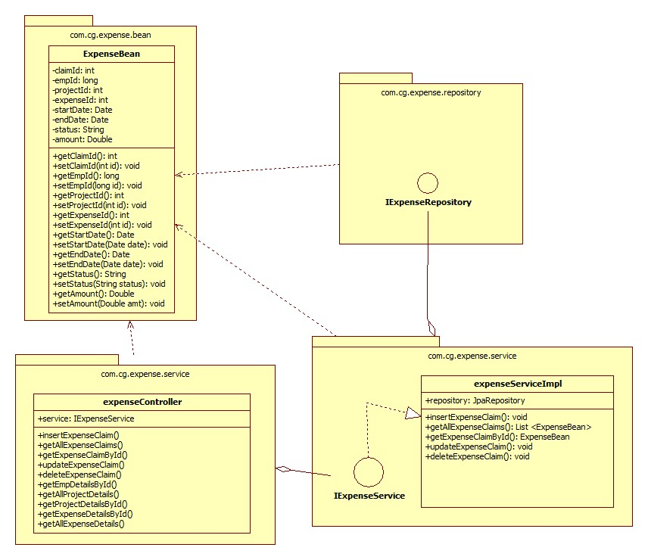

Sequence Diagrams

Sequence Diagram

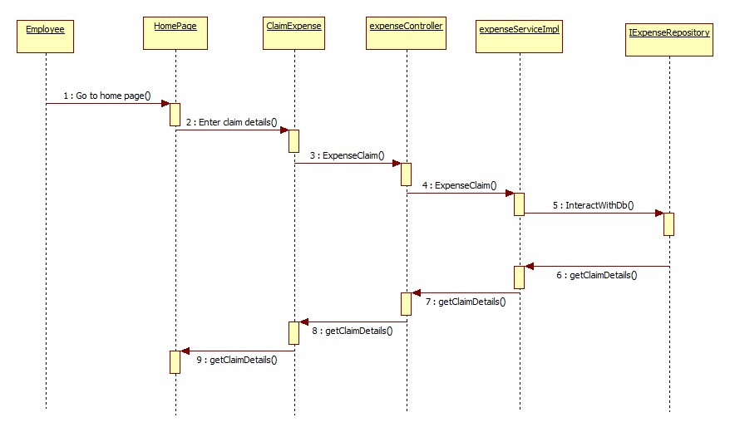

Design Components

List Of UI Components

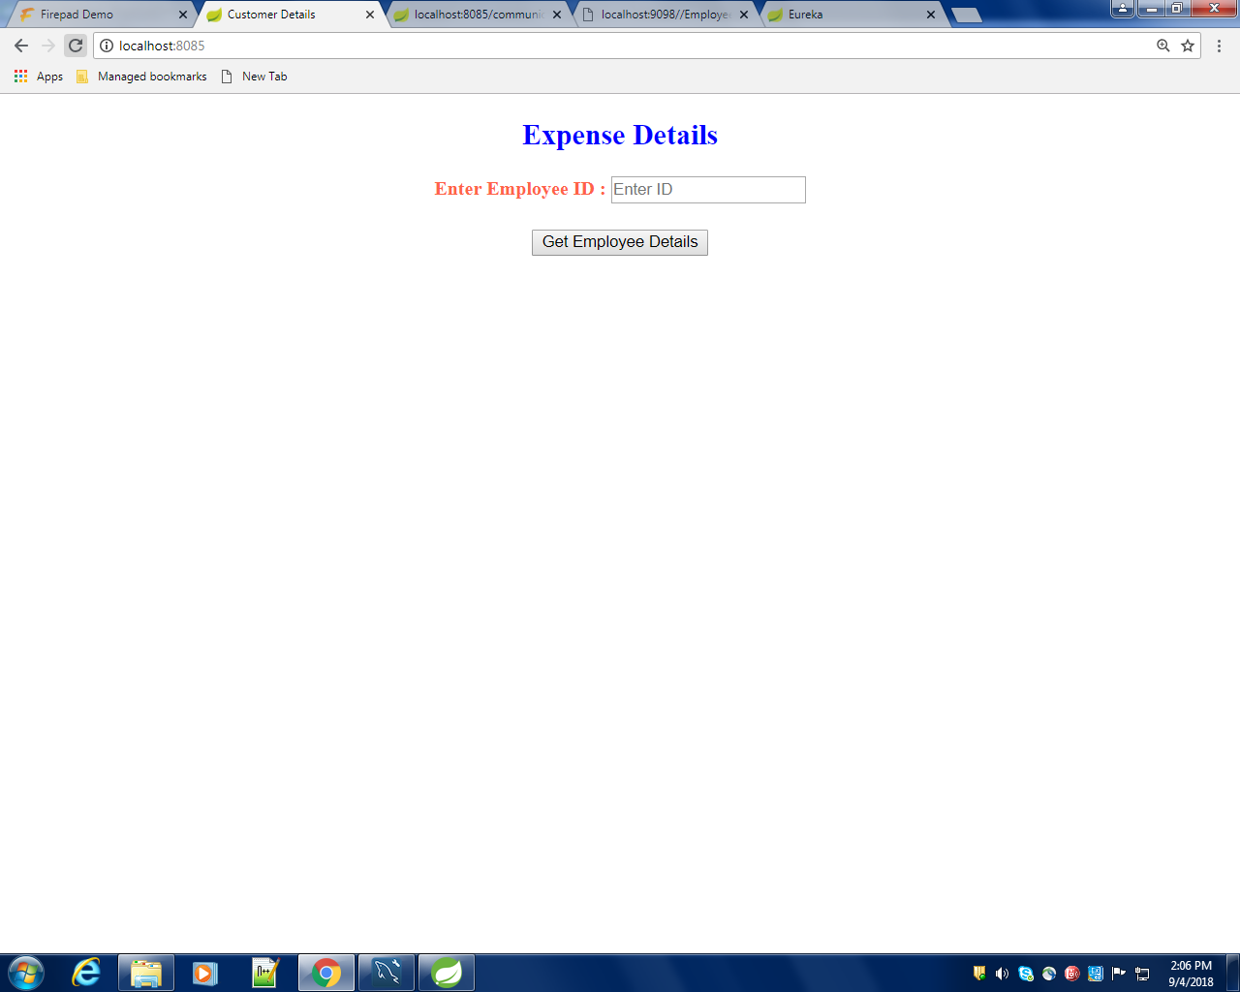

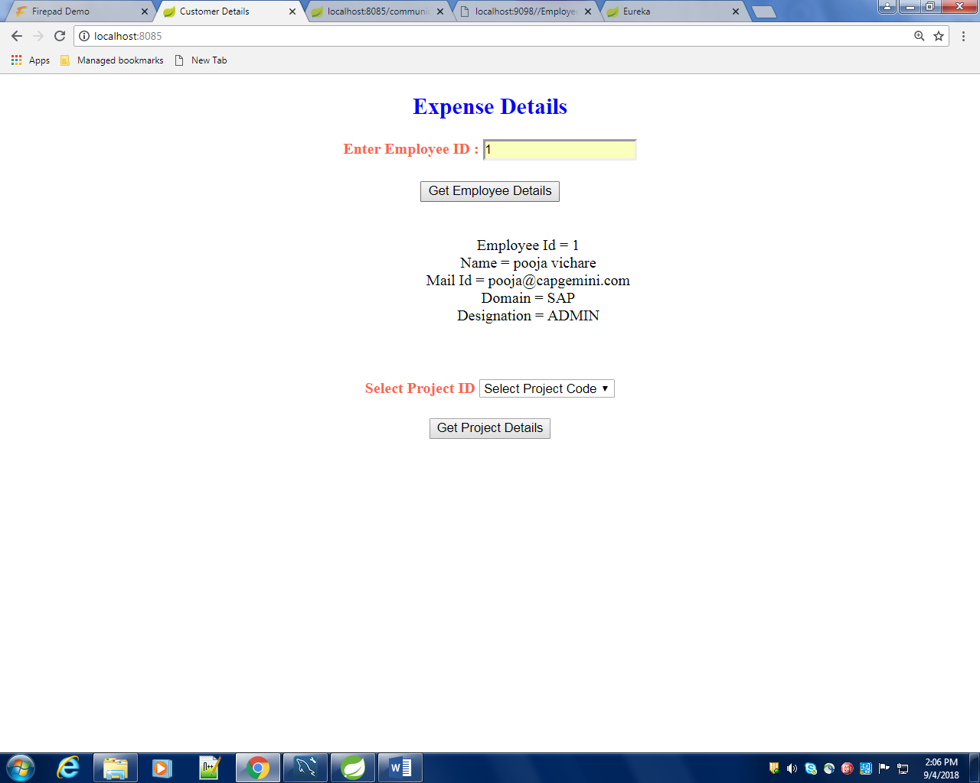

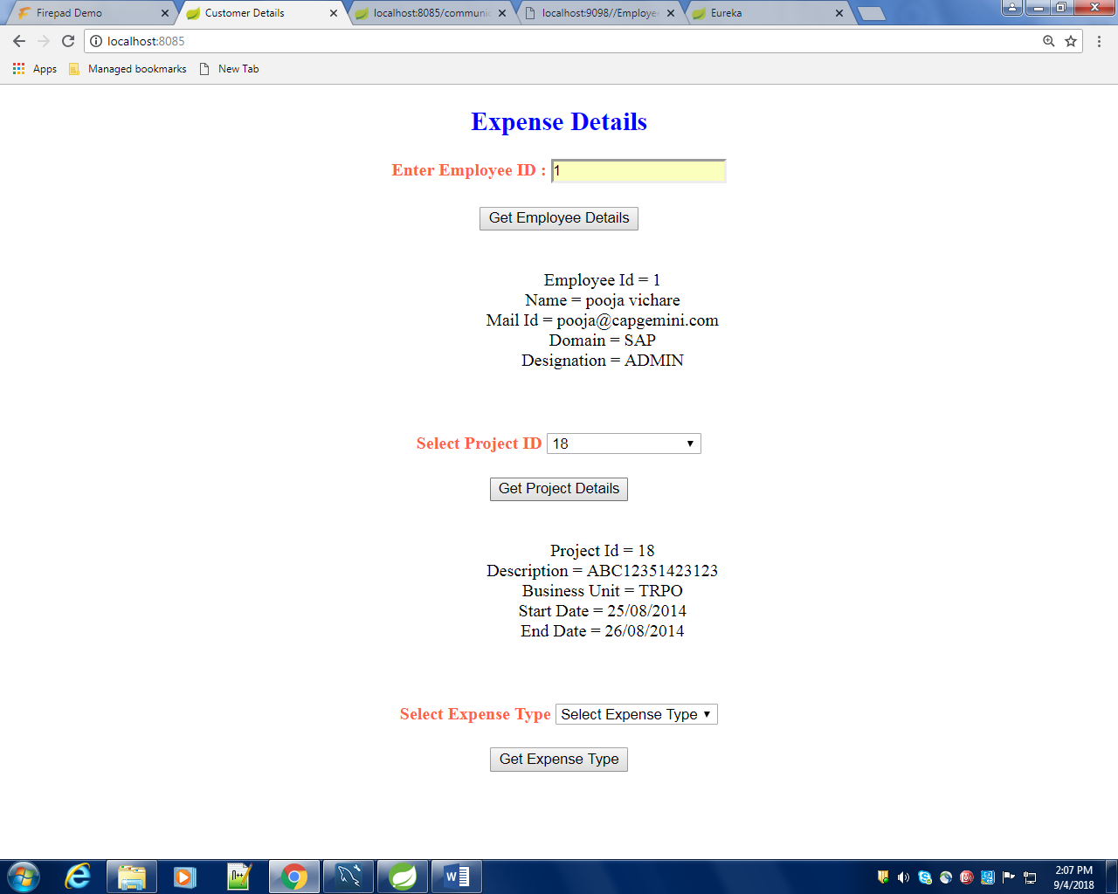

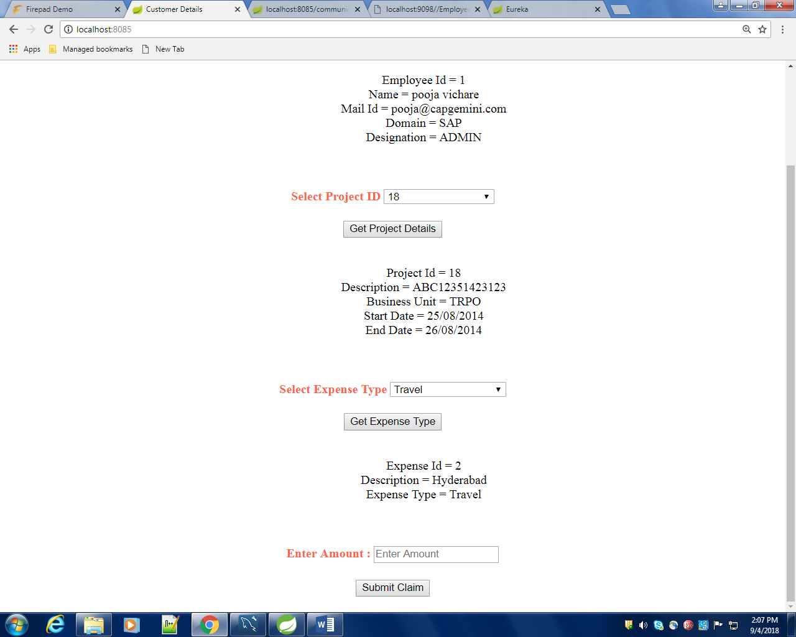

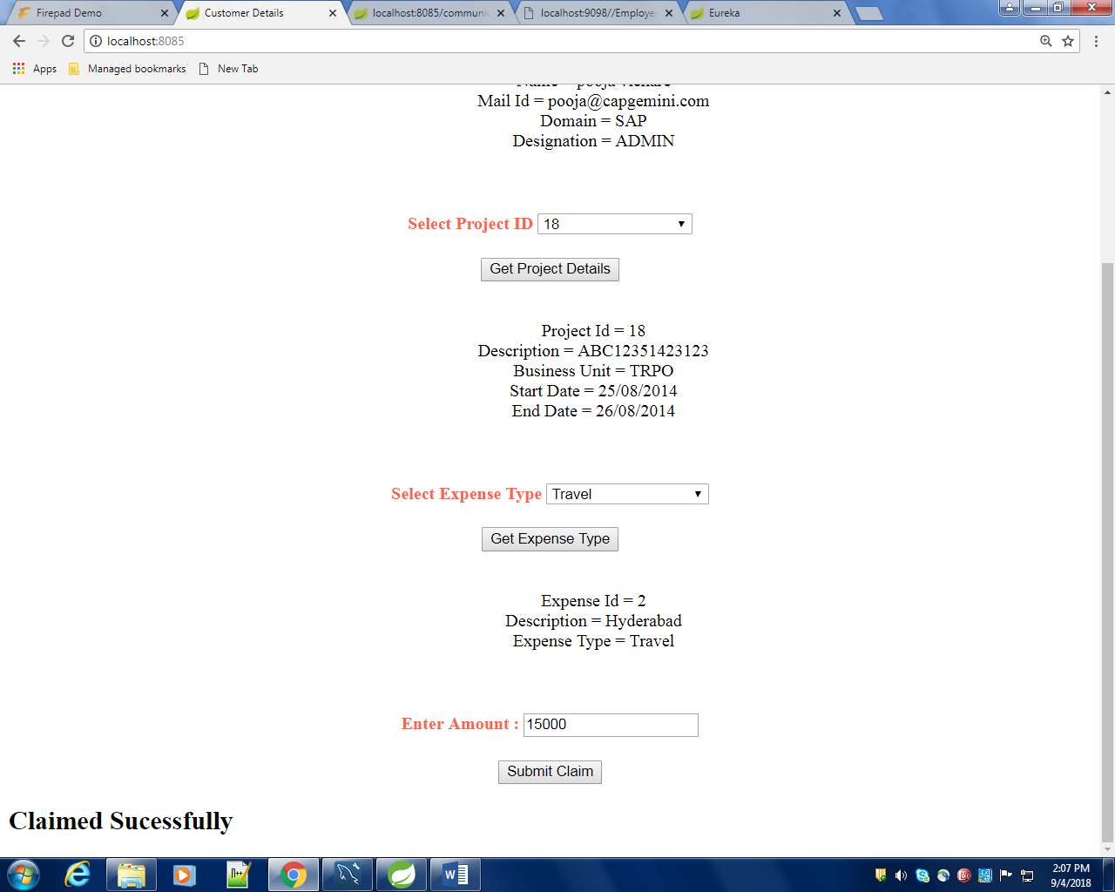
Sr. No. | LLD Name | Class Name | Method Name | Method Description
1 | createExpenseModule | ExpenseDetail | Properties and their appropriate getters and setters methods | Getters retrieve the property values and setters set the property values
2 | createExpenseModule | ExpenseDetailController | Public Employee getEmployeeDetailsById(@PathVariable Long employeeId), public List<ProjectCodeBean> getAllProjects(), public List<ExpenseCodeBean> getAllExpenses(), public void save(@RequestBody ExpenseDetail expense) | Sets the model attribute.  Calls the Service layer method to insert the Flight details in to the database
3 | createExpenseModule | ExpenseDetailServiceImpl | public boolean insertFlight(FlightInformationBean flightInfo)throws AirlineException | Calls the DAO layer method to insert the flight details in to the database
4 | createExpenseModule | IExpenseDetailRepository | This extends the JpaRepository<EnpenseDetail,Long>

List Of Design Classes

Re-Usable Routines/Components
Re-Usable Routines/Components

- Html files
- ExpenseNotFoundException class

Messages

#. | Type | Message Text
M1 | Error | Please fill out this field
M2 | Error | Must be in characters only in range of 5 to 30!!
M3 | Error | Please select an item in the list!!
M4 | Error | Must be a valid future date!!
M5 | Error | Must be entered in format: HHMM!!
M6 | Error | Must be in 2 digits only!!
M7 | Error | Must be in digits in range of 3 to 6!!

Configuration Files

File Name | Path | Description
applications.properties | /expense/src/main/resources/ | To configure database connection and specify the port.
pom.xml | /expense/ | It contains information about the project, dependencies and configuration details used by Maven to build the project.
bootstrap.properties | /eureka/src/main/resources/ | To configure the server.

Crud Matrix Table

# | Table Name | Create | Read | Update | Delete
1 | Expense Detail | Y | Y | Y | Y

Data Mapping Matrix

Sr. No. | Screen Label | Field Source | Field Type | Data Type | Max Length | Data Flow | Mandatory
1 | Employee ID | ExpenseDetail.empId | Text Box | long | NA | UI→D | Yes
2 | Project ID | ExpenseDetail.projectId | Text Box | int | NA | UI→D | Yes
3 | Expense ID | ExpenseDetail.expenseId | Text Box | int | NA | UI→D | Yes
4 | Amount | ExpenseDetail.amount | Text Box | double | NA | UI→D | Yes
5 | Status | ExpenseDetail.status | Default | String | ‘Applied’ | UI→D | Yes

Legend

UI (User Interface Only)
UI → D (User Interface to Database)

Action Flow Matrix

Sr. No. | Action | Description | Process
1 | On click get Employee details in index.html page | Communicates with the Employee microservice | The Admin clicks on the Add in the Admin Home page and gets redirected to the Insert Flight Home form.
2 | On click of Submit button in Insert Flight Home Form | The flight information is inserted into the database. | Data is entered in the fields by the Admin which gets inserted into the database when Submit button is pressed.
3 | On click Reset button in Insert Flight Home form | Redirected to Insert Flight Home page | On click reset button by the Admin in register form redirected to Insert Flight Home page

Stored Procedures

# | Stored Procedure Name  (with Description) | Input/Out Parameters | Type | Size
1. | NA

Program Specification

<ACTION: INSERT_FLIGHT_INFORMATION >

Pseudo Code:
- Client Side Scripting:
None

- Server Side Scripting:
BEGIN
Call the Service Layer for inserting the flight details into the database.
END

Pseudo Code:
14.2 <ACTION: RAISE_REQUISITION >

- Server Side Scripting:
IF Airline is Empty
Print Error Message M1
ELSE IF Airline is not in specified format
Print Error Message M2
IF Departure City is Empty
Print Error Message M1
ELSE IF Departure City is not in specified format
Print Error Message M3
IF Arrival City is Empty
Print Error Message M1
ELSE IF Arrival City is not in specified format
Print Error Message M3
IF Departure Date is Empty
Print Error Message M1
ELSE IF Departure Date is not in specified format
Print Error Message M4
IF Arrival Date is Empty
Print Error Message M1
ELSE IF Arrival Date is not in specified format
Print Error Message M4
IF Departure Time is Empty
Print Error Message M1
ELSE IF Departure Time is not in specified format
Print Error Message M5
IF Arrival Time is Empty
Print Error Message M1
ELSE IF Arrival Time is not in specified format
Print Error Message M5
IF First Seats is Empty
Print Error Message M1
ELSE IF First Seats is not in specified format
Print Error Message M6
IF First Seat Fare is Empty
Print Error Message M1
ELSE IF First Seat Fare is not in specified format
Print Error Message M7
IF Business Seats is Empty
Print Error Message M1
ELSE IF Business Seats is not in specified format
Print Error Message M6
IF Business Seat Fare is Empty
Print Error Message M1
ELSE IF Business Seat Fare is not in specified format
Print Error Message M7

- Server Side Scripting:
BEGIN
Call addFlightDetailsAction (@ModelAttribute (“insertFlight") @Valid FlightInformationBean insertFlight, BindingResult result, Model model) in Controller class in Presentation Layer
BEGIN
Call insertFlight (FlightInformationBean insertFlight) in AdminServicempl class in Service Layer
BEGIN
Call insertFlight (FlightInformationBean insertFlight) in class AirlineDaoImpl in Data Access Layer
BEGIN
Create query for inserting flight details into FlightInformation table
Return String value.
END
Return String value to Service Layer
END
Return String value to Presentation Layer

END
IF successful then navigate to AdminSuccess page and show success message.
Else navigate to Error page and show error.
END

REVISION HISTORY OF THE WORK PRODUCT
<To be maintained by projects>

# | Date | Version # | Section Changed | Details of changes made | Approved By
1
2

