First One

Rasin R S

2023-05-04

# Section

## Subsection

x = 1:10  
print(x)

## [1] 1 2 3 4 5 6 7 8 9 10

plot(x)

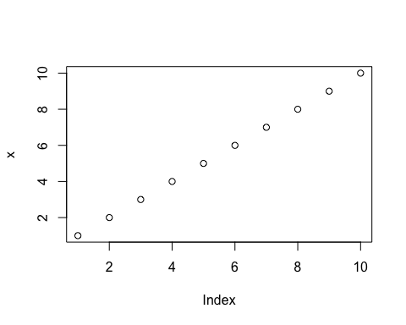

y = x  
y <- x   
x -> y

# Pipe

%>% or |>

x = 1:10  
y = sqrt(x)  
z = sum(y)  
  
sum(sqrt(1:10) )

## [1] 22.46828

# f ( g ( x ) )  
  
# x |> g() |> f()  
  
1:10 |> sqrt() |> sum()

## [1] 22.46828

CO2 |> names() |> length()

## [1] 5

length(names(CO2))

## [1] 5