Server-Side HTTP Programming using PHP

As Part of the Course

CEN225 Internet Communication Lab

by

Raşit Çolakel

Department of Computer Engineering

Çukurova University

*(2017555503@ogr.cu.edu.tr)*

Muhammet Baki Duman

Department of Computer Engineering

Çukurova University

*(2018555019@ogr.cu.edu.tr)*

İbrahim Deniz

Department of Computer Engineering

Çukurova University

*(2018555016@ogr.cu.edu.tr)*

Advised by

Res. Asst. Ferhat ALBAYRAK

12 November, 2020

**Abstract**

On the internet, there are large quantities of websites which are dynamic or static. A static website displays the same content for all visitors. On the other hand, a dynamic website shows different contents for every visitor by their interaction. The dynamic websites can be created using some languages like PHP, Java, C# or other. To test them on local server, developer or programmer should setup development environment. For creating it for PHP, there are several local web server softwares liike AMP, WAMP, LAMP, XAMPP and more. These softwares provide the development environment to create website. In this report, we will discuss about server-side http programming using PHP with XAMPP server. We will create a program that calculates the least common denominator(LCD) and the greatest common denominator(GCD)

**Contents**

**1 Introduction 2**

**2 What We Used In This Work? 2**

**3.1 What Is PHP? 2** **3.1 What Is XAMPP? 3**

**3.1 What Is HTML? 3**

**3 Client Side and Server Side Communication 3**

**3.1 LCD Calculation By Using GET Method 4**

**3.2 GCD Calculation By Using POST Method 4**

**3.3 Checking Methods On Server Side 5**

**4 Conclusion 5**

**References 6**

1. **Introduction**

HTTP is hyper text transfer protocol. It is an application layer protocol and the standard data communication protocol for World Wide Web. [1]HTTP was invented by Tim Berners-Lee at CERN. HTTP had only GET method. Also client sent request to server with GET method and server can only response as HTML document. Nowadays, HTTP can send more content such as video, images, audio, etc. Client and server are two main role on the web and HTTP is messenger between two role. Client send request to server through web server and server server response is to serve document according to request

GET and POST are two methods in HTTP to send request server but these methods has differences. [2]GET method sends only limited amount of data because data is sent in header. URL is limited by 2048 characters. It is not secure because of sending in header so it doesn’t use for sensitive information such as password or phone number. It uses where user can bookmark to result. You can not send documents which are like a word or images. POST does not have any limit for data size because POST send data in body of HTTP request. Data is not shown on URL so user can not bookmark to result. This method can send ASCII and binary data. Security depends on the HTTP protocol. POST is safer than GET because browser or web server log can not store your parameters.

1. **What We Used In This Work?**

We used Php for server-side, HTML for client side and XAMPP for testing our work.

* 1. **What Is PHP?**

[3]PHP is open source general-purpose scripting language. In 1994, Rasmus Lerdorf crated PHP as Personal Home Page but it is now called as Hypertext Preprocessor. Today, It is developed by the PHP group and Zend Technology. It is server side programming language. It works with web server. Client sends request to web server and web server runs PHP file according to request. PHP generate HTML file with data which is in request and web server sends this HTML file as response. PHP can be used in outside of web context such as graphical applications and robotic drone control.

* 1. **What Is XAMPP?**

[4]XAMPP is open source web server solution stack. It is developed by Apache Friends. XAMPP consist of Apache web server, MariaDB database and PHP or Perl programming language. It uses same components with LAMP and WAMP but XAMPP can be installed easier and more quick according to other. It is a cross-platform stack so it can be used most operating systems. It is also free so it is so popular. Most developer choose XAMPP as local test server

* 1. **What Is HTML?**

[5] HTML is the standard text markup language that used to create web pages. HTML stands for Hyper Text Markup Language.Tim Berners-Lee laid the foundations of HTML in 1980.The first prototype of HTML is called ENQUIRE. Thus, the first foundations of internet-based systems are laid and these have formed the main foundations of the web thanks to HTML. Actually HTML is not defined as a programming language becasuse no program can be written with HTML codes. Programs can be written with HTML thanks to programing language that can interpret HTML. Instead, browsers reads and interprets HTML codes. Browsers distinguishes headings, paragraphs, images etc. with HTML code. Currently used version of HTML is HTML5.

1. **Client Side and Server Side Communication**

In this work, we have created two HTML pages which are “lcd.html” and “gcd.html” for client-side and a PHP file that is “result.php” for server-side. We communicate the server and client sides with forms in figure 1. We use GET and POST for communication them. GET method is used in “lcd.hml” and POST is used in “gcd.html”.

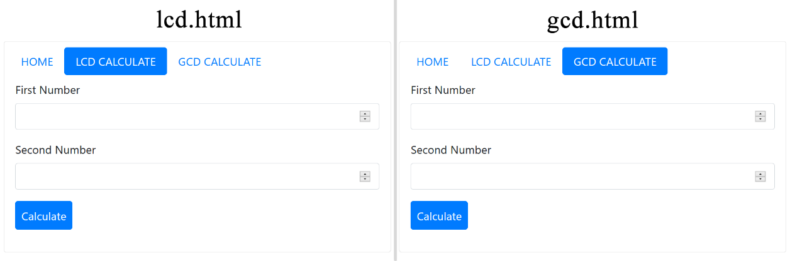  
Figure 1: LCD and GCD Forms

* 1. **LCD Calculation By Using GET Method**

When pressed “Calculate” button in “lcd.html” form in figure 1, it sends values entered by user to server-side actually “result.php”, it checks which method is used for communication. If the method is GET, it calculates LCD of entered the values and prints the result of calculation like in figure 2. Also, the program controlls whether the values are entered. If they are not entered, it shows an error.

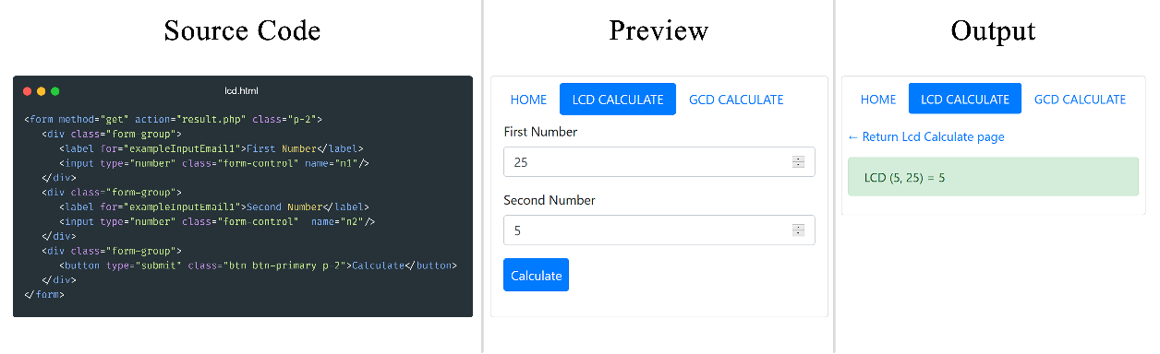

Figure 2: Source Code, Preview and Output of lcd.html file

* 1. **GCD Calculation By Using POST Method**

When pressed “Calculate” button in “gcd.html” form in figure 1, it sends values entered by user to server-side actually “result.php”, it checks which method is used for communication. If the method is POST, it calculates GCD of entered the values and prints the result of calculation like in figure 3. Also, the program controlls whether the values are entered. If they are not entered, it shows an error.

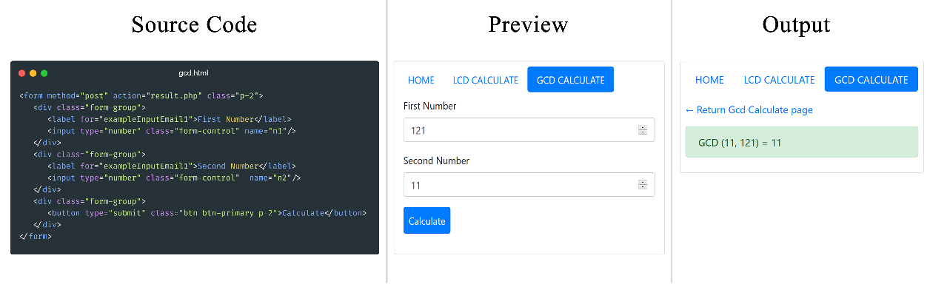

Figure 3: Source Code, Preview and Output of lcd.html file

* 1. **Checking Methods On Server Side**

When pressed a button in a form in figure 1, it sends values entered by user to server-side, it checks which method is used for communication in figure 4. If the method is allowed, it calculates lcd or gcd functions in figure 4. Otherwise, it shows an error like “The page you are looking for could not be found”.

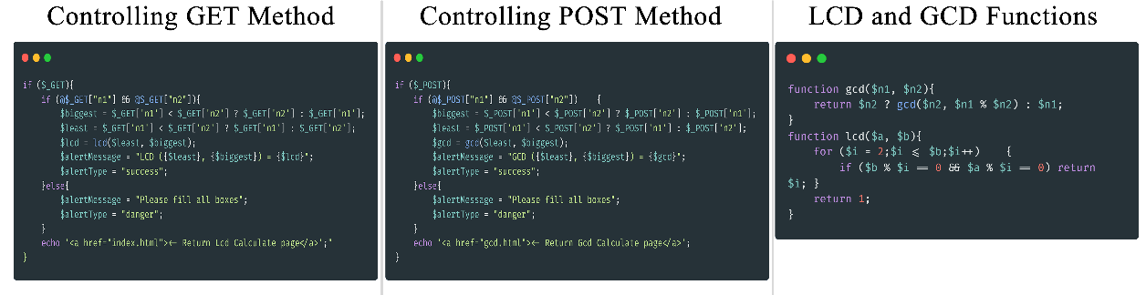

Figure 4: Controlling GET and POST method and Functions

1. **Conclusion**

[6] Get and Post methods are the best used and known HTTP methods. They are used for receiving values from client side.Even though they serve the main purpose, they are different. GET shows informations in URL, but POST does not show. That’s why POST method is more secure than GET. Because, an user can change values easily in URL when GET is used. So, there may occur a security problem. For example, user can send unallowed values. If program does not controll unallowed values, it may not work. But, an user can send values with a form when POST is used. It makes POST more secure than GET.

**References**

1. HTTP Methods <https://www.exai.com/blog/hypertext-transfer-protocol> last visited Dec. 04,2020.
2. HTTP Methods <https://www.edureka.co/blog/get-and-post-method/> last visited Dec. 04,2020.
3. PHP https://en.wikipedia.org/wiki/PHP last visited Dec. 05,2020.
4. XAMPP https://en.wikipedia.org/wiki/XAMPP last visited Dec. 05,2020.
5. HTML [https://en.wikipedia.org/wiki/HTML last visited Dec. 06,2020](https://en.wikipedia.org/wiki/HTML%20last%20visited%20Dec.%2006,2020).
6. Conclusion [https://www.quora.com/Is-either-GET-or-POST-more-secure-than-the-other last visited Dec. 06,2020](https://www.quora.com/Is-either-GET-or-POST-more-secure-than-the-other%20last%20visited%20Dec.%2006,2020).
7. For Creating Images <https://carbon.now.sh/>
8. For Theming and Styling https://getbootstrap.com/