**Topology Selection :**

AC/DC motor drive can be impelemented with various topologies. The AC input must be rectified. Diodes and thyristors are main component used in rectifier circuit. The gate control of thyristor is quite complicated and it can not controlled fixed value. They are also more expensive than diodes. So, rectification is implemented using diodes. As for number of phase of input voltage, single phase is consideration more convinient. Because, when three phase input voltage used, the voltage at the rectifier circuit is about 540V, so all components in the converter must be withstand this voltage. For this voltage level, it is hard to find commercial capacitor and mosfet etc. It is also expensive. Since the rated voltage of motor is 200V, approximately %70-80 duty cycle is enough with single phase input voltage. The inductor and capacitor at the output of buck converter act as a filter so output becomes more smoother. Also, filter capacitors are used at the rectifier output. The block diagram of selected topology is given below.

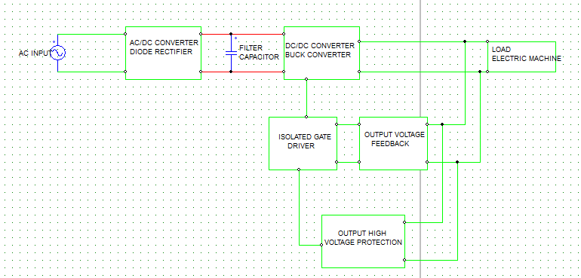

Figure 1 Block Diagram of selected topology

**PROJECT SPECIFICATIONS :**

**1. BRIDGE RECTIFIER :**

The input voltage of buck converter is produced from phase voltage using bridge rectifier. The body diodes of TO-247 mosfet’s are used as a diode. Output capacitance is calculated using simulation. 20 picies of 47uF capactior is used. The input voltage of buck converter is changing between 322V. Simulation result is shown in Figure 3.

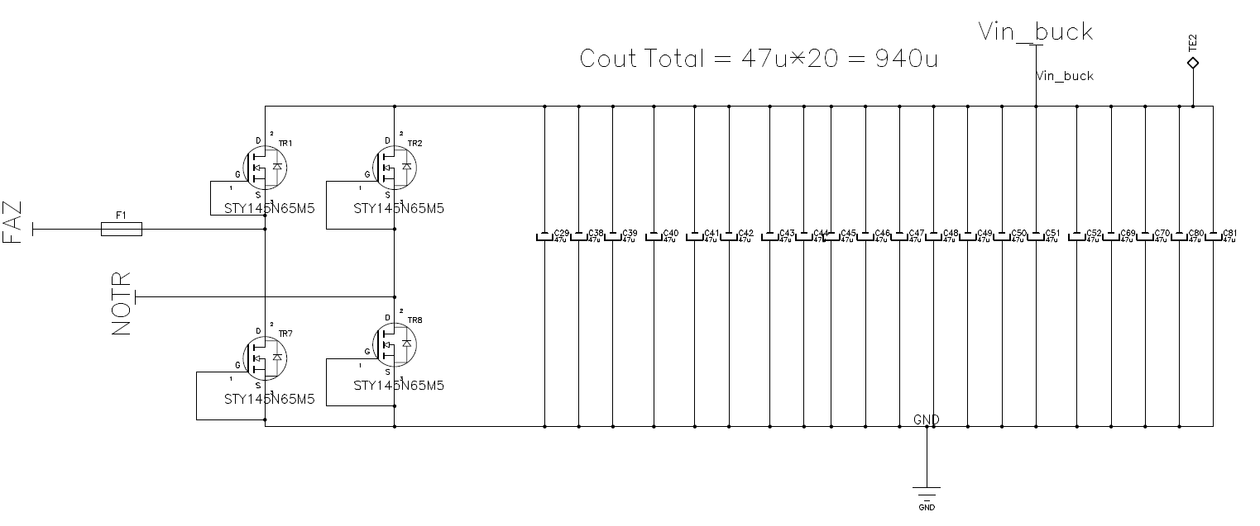

Figure 1.1 : Single Phase Bridge Rectifier

**2.BUCK CONVERTER :**

A buck converter is implemented after the bridge rectifier output. The buck converter has the filter inductor on the output side, which provides a smooth continuous output current waveform to the load. Basic diagram of buck converter is given below.



Figure 2.1 (Buck Converter – Basic Diagram)

**2.1 Component Selection :**

The filter inductor value and its peak current are determined based on the specified maximum inductor

current ripple.



From our specification table 1 . The inductor value is calculated :

L = $\frac{Vout}{fsw}$. $\frac{(1-D)}{∆IL}$ = $\frac{200}{20*10^3}$. $\frac{(1-200/320)}{6*\%50}$ = 1.25 mH

As shown below 25 pieces of 47uH inductor is used. The total inductance is 1.175 mH. The maximm rms current and saturation current of this inductor is 8.5A. For 6A output current, the maximum value of inductor current is 7.64 A which is in safety range. The curent waveform of inductor for worst case i.e for maximum input voltage and maximum output current is given below.

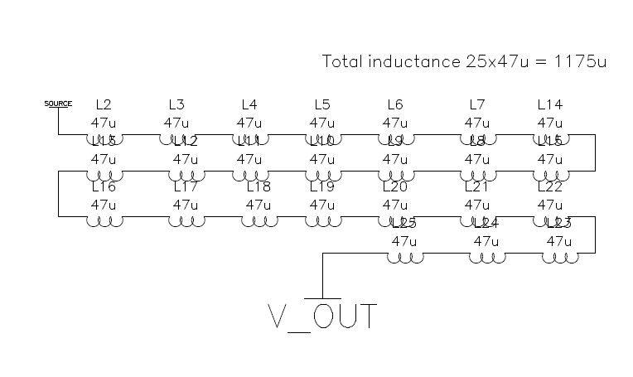

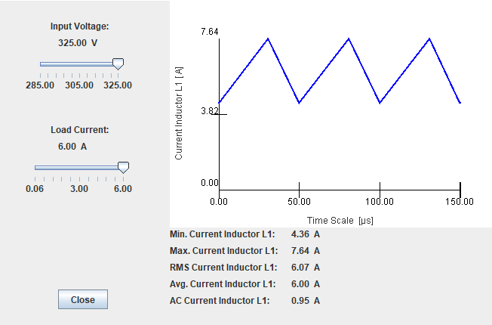

For continuous inductor current mode operation, to determine the amount ofcapacitance needed asa function of inductor current ripple, $∆IL$, switchingfrequency, fs, and desired output voltageripple, $∆$ Vo, the following equation is used assuming all the output voltage ripple is due to the capacitor’scapacitance.

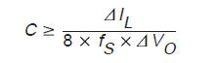

where $∆IL=7.64-4.36=3.28 A$

fs = 20 kHz

$∆$ Vo = %10 (assumed)

So C is must be greater than 205 uF. The output capacitance is choosed 20*47uF = 940uF. 20 pieces of capacitor used, because the maximum rms current rating of selected capacitor is 0.4 A . To not exceed this current rating, the output current is shared to 20 pieces of capacitor. The rms current of each capacitor ;

Iout(rms) / 20 = 6.07/20 = 0.3 A which is in safety region.

The switch is implemented by using power mosfet. This mosfet must withstand with the voltage which is observed 325 V in simulation but it may be greater in experimental enviroment due to transient overshoot. It must also be capable to carry minimum 7.64 A current. A power mosfet with x product number which is 650V,69A TO247 package is selected. Also this mosfet is used with heatsink shown below. The datasheet of this mosfet given in appendix section at the end of this report.

The selection process of free wheeling diode is same with the selection process of switch. It will be also used with heatsink.

Power losses calculation :

**Output voltage feedback control loop :**

Since the switching frequency of switching regulators is at range ten to hundered kHz , there are overshoot at the output voltage and current. To reduce this overshoots i.e to set the output voltage or current at fixed value, voltage control or current control techniques are used. In this project, our specification is speed control of dc motor. Since the speed of dc motor is proportional with its armature voltage (buck output voltage) a voltage control loop is designed.

Control Stage :

As shown below, output voltage is sampled with a resistor divider and compared with the reference voltage of error amplifier positive input. Then, the output of error amplifier is compared with a sawtooth waveform with period frequency of switching frequency. The comparator is then produce a pwm signal. This pwm signal is the input of isolated gate driver.

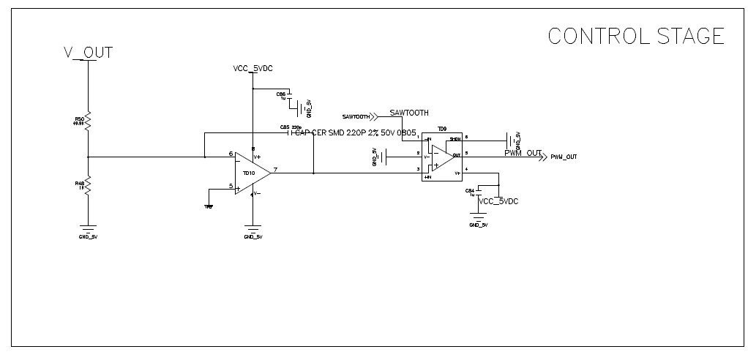

As shown below, whenever error amplifier output is greater than sawtooth wavefrom, the gate signal goes high. Similarly, whenever error amplifier output is greater than sawtooth wavefrom, the gate signal goes low. The error amplifier output changes it's states when input voltage greater or less than reference voltage (scaled set voltage). In summarize, this circuits is changes the duty cycle of gate signal of switch to keep output voltage constant. TLV3501 comparator with 4.5 ns propogation delay is used.

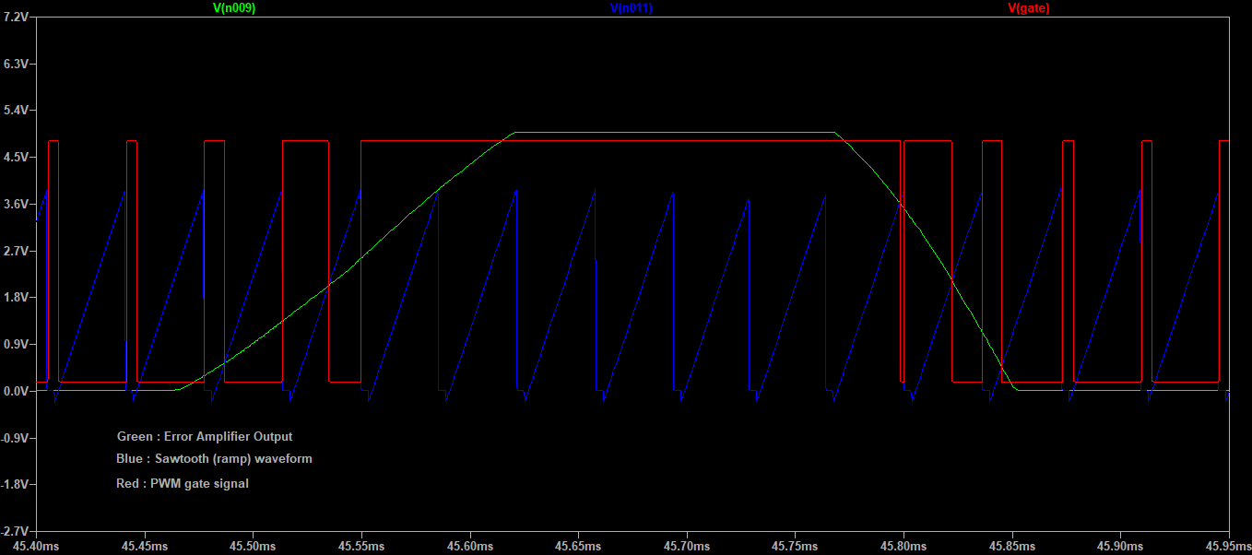

Sawtooth wavefrom generation :

A sawtooth(ramp) waveform generator circuit is given below. The left side pnp transistor is acts as a current source and charges the C5 capacitor. Whenever the voltage across this capacitor is greater than the U3 positive input capacitor is discharge through npn transistor Q5. The charge period of this capacitor is much larger than the discharge period. The total period of this waveform is almost same with the period of the converter. The output ( voltage across C5) of this circuit given below.

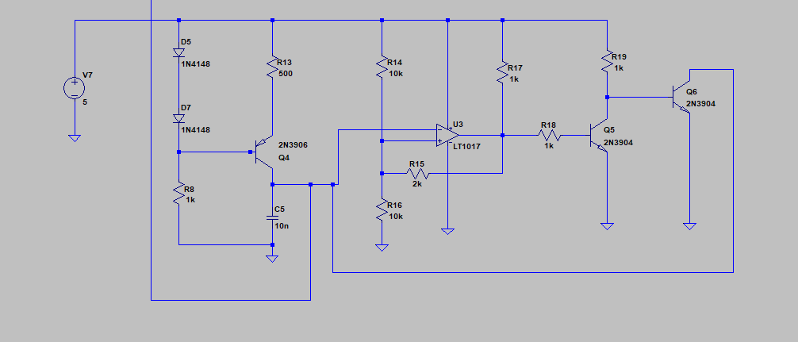

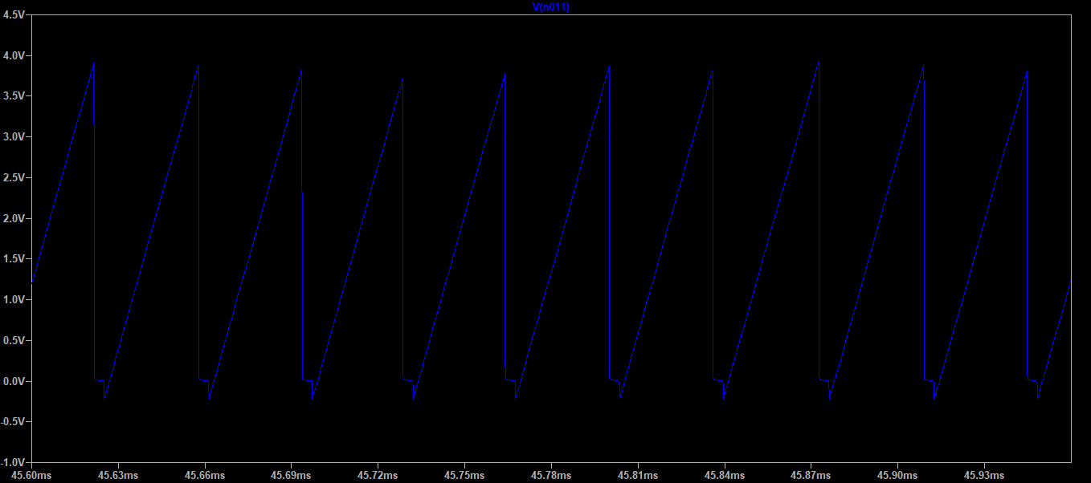

**3. SIMULATIONS :**

Single phase AC bridge rectifier :

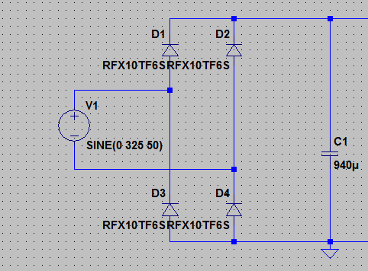

Figure 1.2 Circuit Schematic of Single-pase bridge rectifier

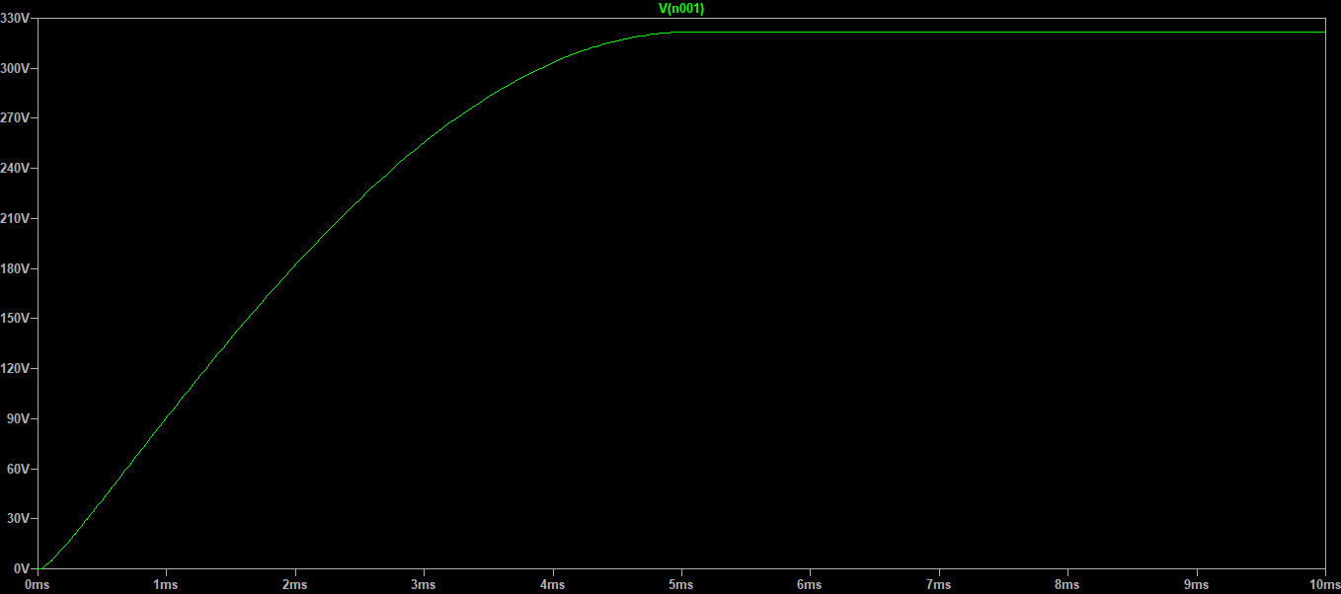

Figure 1.3 Output waveform of bridge rectifier

4. Project Implementation

Schematic

PCB

Kart resimleri

5. Test Results

Test results will be given after project demo presentation.

6.Appendix

Datasheets

kaynaklar