2-a

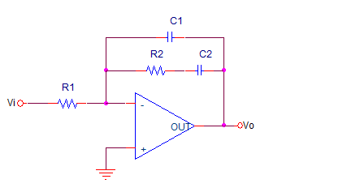

**Figure1.** Type 2 controller.

Transfer function is C1

Let’s equate this transfer function to the our controller in part c.

$$\frac{Vo}{Vi}=Gc\left(s\right)= \frac{11\left(s+909\right)}{s+110000}*21*\frac{1}{s}=\frac{s+909}{s^{2}*4.33*{10}^{-3}+476.2s}$$

$$C2R2=909$$

Let’s

$$C2={10}^{-3}F$$

R2=909Kohm

$$C1R1=4.76*{10}^{-6}$$

Lets R1=472.7Kohm

C1= ${10}^{-11}$ F

Bode plot of the controller is on following figure.

